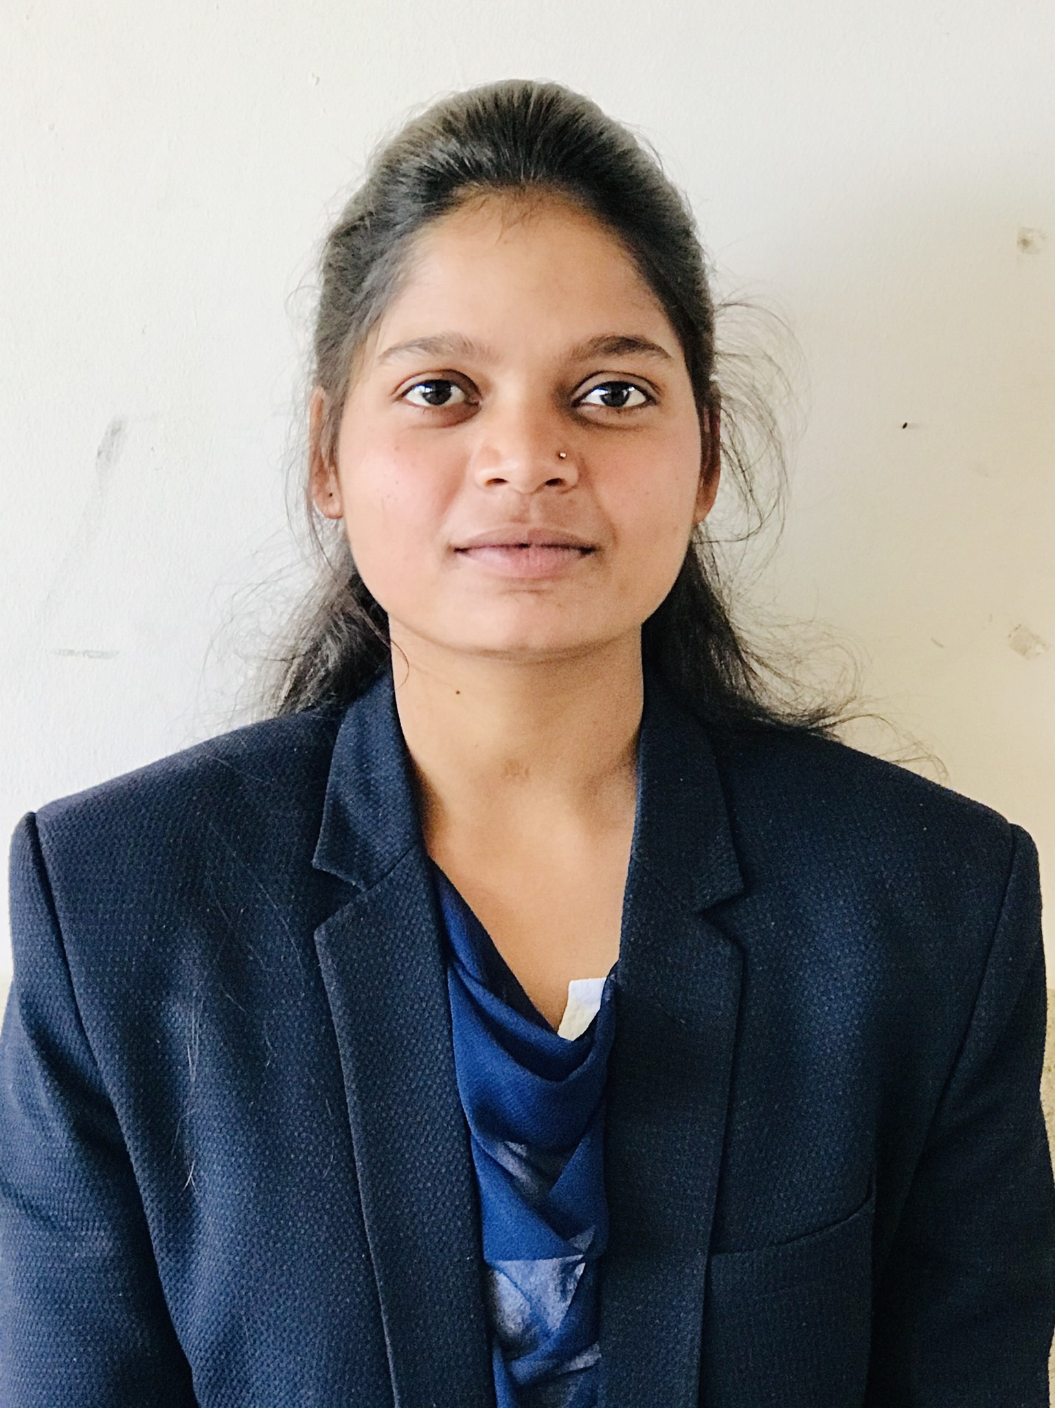 **KUMARI CHHAVI**

Mughalsari ● Chandauli, 232101. [●kumari.chhavi_cs17@gla.ac.in](mailto:●kumari.chhavi_cs17@gla.ac.in) ● +91 7376845326

# EDUCATION

**Bachelor of Technology(CSE), *GLA University, Mathura*** May 2021 **Intermediate, St. Francis School, Ramnagar, Varanasi** 2017

**High School, St. Francis School, Ramnagar, Varanasi** 2015

# TRAINING

**CETPA Infotech**, Noida June-July,2019

*Android Application Development*

* Basics of Android App Development
* Managing data through Firebase

# PROJECTS

**IMS(Institute Management System)**

* Android Application for alloting the roll numbers to the students registering.
* It can also update, delete and search the students detai**ls.**

**WallP(Wallaper Manager)**

* Android Application to set the wallpaper.

# SKILLS

**Technical**

* Basics of MongoDB
* Fundamentals of Java
* Fundamentals of Python
* Fundamentals of C
* Basics of IntelliJ IDEA

**Professional**

* Adaptabilty
* Management
* Ability to identify and solve problems
* Teamwork

# Extra/Co-Curricular Activities

* Coordinated BRIJ LITERATURE FESTIVAL (Cultural Fest, GLA)
* Participated in MAITREE (Sports Fest, GLA)
* Participated in Udghosh(Sports Fest, IIT Kanpur)

# CERTIFICATION

* Java Certified(Udemy)
* Android Training Certification