KPI’s requirments
1.Total Employee Count
select count(emp_no) total_employee_count from HR_data
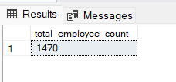

2.Attrition count
select count(case when Attrition=1 then 1 end) Attrition_count from HR_data

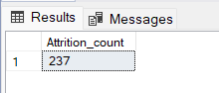

3.Active Employee Count
select count(emp_no)-(select count(Attrition) from HR_data where Attrition=1) Active_employee_count from HR_data

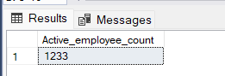

4.Average Age
select AVG(age) Avg_age from HR_data

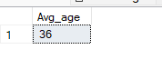

5.Attrition Rate
select concat(count(case when Attrition=1 then 1 end)*100/COUNT(emp_no),'%')Attrition_percentage from HR_data

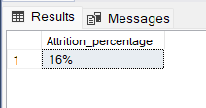

Charts

1.Attrition by Gender
select gender,count(case when Attrition=1 then 1 end) Attrition_count from HR_data
group by Gender

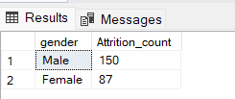

2.Attrition by Education
select Education_Field,count(case when Attrition=1 then 1 end) Attrition_count from HR_data
group by Education_Field
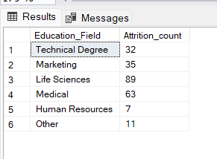

3.Attrition by Department
select Department,count(case when Attrition=1 then 1 end) Attrition_count from HR_data
group by Department

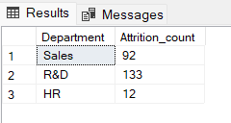

4.Employee and Attrition by Age-Band
select CF_age_band,count(case when Attrition=1 then 1 end) Attrition_count from HR_data
group by CF_age_band

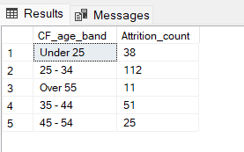

5.Job Satisfaction by Employee Role
select Job_Role,
ISNULL([1], 0) [1],
ISNULL([2], 0) [2],
ISNULL([3], 0) [3],
ISNULL([4], 0) [4],
ISNULL([1], 0) + ISNULL([2], 0) +
ISNULL([3], 0) + ISNULL([4], 0) Total
from (
select Job_Role, Job_Satisfaction
from HR_data
) SourceData
pivot (
count(Job_Satisfaction)
for Job_Satisfaction IN ([1], [2], [3], [4])
) PivotTable
order by Job_Role

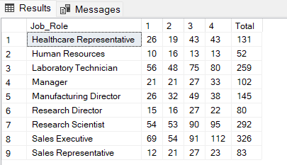

6.Employee and Attrition by Age-Band
select CF_age_band,count(emp_no) Employee_count from HR_data
group by CF_age_band

