Lab : S3 -Rclone to S3 Upload Implementation & Troubleshooting Report
Contents
Lab : S3 -Rclone to S3 Upload Implementation & Troubleshooting Report 1
Lab : S3 -Rclone to S3 Upload Implementation & Troubleshooting Report 2
1. Objective 2
2. Prerequisites 2
Step 1: Download & Install rclone 2
Step :2 Open this folder. 3
Step 3 Configure rclone with AWS S3 4
Step 5 — Configure rclone Remote 4
Step 6 Test S3 Connection 12
Step 7 UPLOAD 500GB DATA 13
7.1 Create a Local Test Folder 14
STEP 8 — Upload Folder to S3 14
Just wait for the upload to finish 15
Step 9 Verify Upload AWS S3 Console 15
Learning Outcomes 16
STEP 1 — Create a NEW Test Folder 17
STEP 2 — Upload NEW folder with rclone 18
STEP 3 — Verify No Duplicates Are Uploaded 18
STEP 4 — Verify No Duplicates Are Uploaded 19
Final Result 20

Lab : S3 -Rclone to S3 Upload Implementation & Troubleshooting Report

Objective
To configure rclone on Windows, authenticate it with AWS S3, and successfully upload local data to an S3 bucket.

Prerequisites
- Windows laptop
- AWS IAM User with Access Key & Secret Key
  - Permission -- Attach Policy-- Search
    - AmazonS3FullAccess
  - Create user -- DOWNLOAD the Access Key and Secret Key
- S3 bucket created – “reclone-data-upload”
- Region: Asia Pacific (Mumbai) ap-south-1
- rclone downloaded and extracted
- Local test folder with sample data

Step 1: Download & Install rclone
- Download rclone ZIP from https://rclone.org/downloads
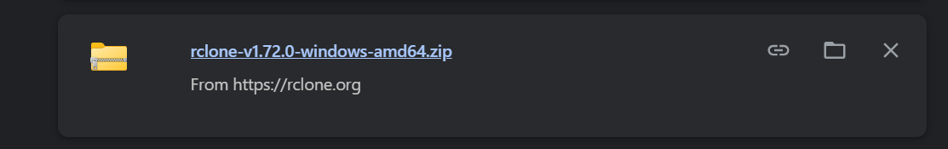
- Click rclone-vxxx-windows-amd64.zip
  - You will see something like:
    - rclone-v1.xx.xx-windows-amd64.zip
    - Click on this ZIP file
It will start downloading
- Extract ZIP
- After extracting, you will get a folder like:
rclone-v1.xx.xx-windows-amd64
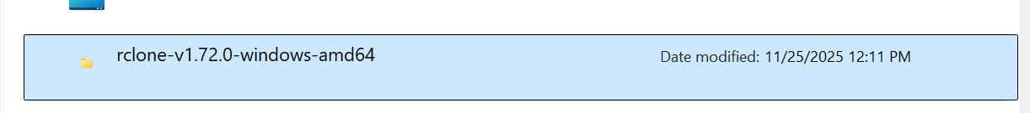

Step :2 Open this folder.
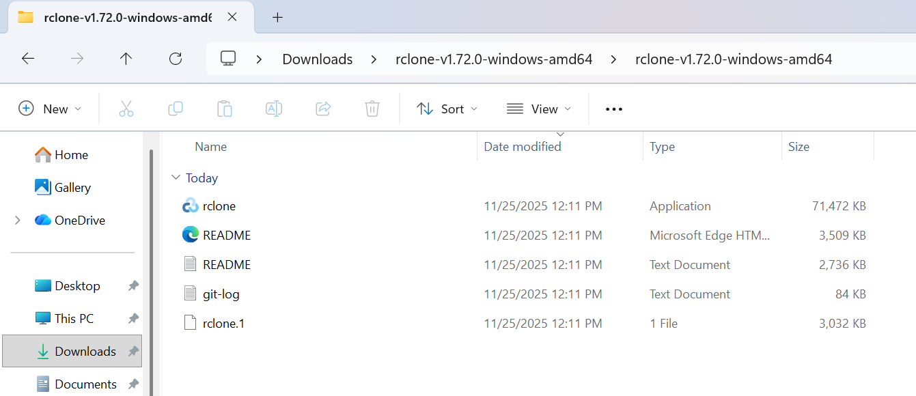

You should see:
- rclone.exe ← THIS is the file you need
- rclone.1
- rclone.pdf
- A couple of text files
- Inside folder – find rclone.exe
  - Copy the folder path (Shift + Right click → "Copy as path")
    - Add to PATH
- Windows search → “Edit environment variables”
- Select Path
- Click New
- Paste the folder path to open in CMD

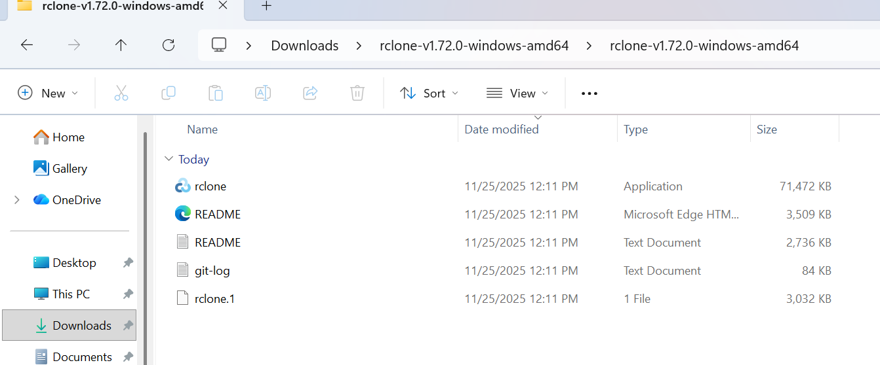

Step 3 Configure rclone with AWS S3
Open CMD inside that folde rCopy the path, for example:

C:\Users\Preeti\Downloads\rclone-v1.xx.xx-windows-amd64

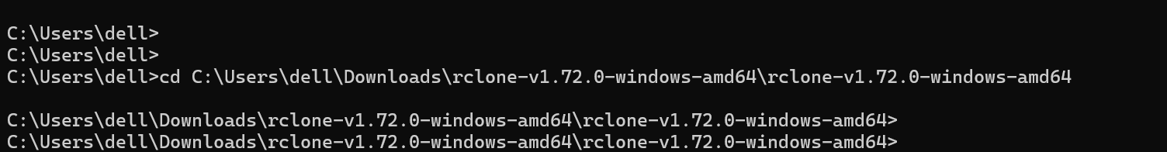
rclone installed successfully in our local PC.
- Now run : Type: # rclone version
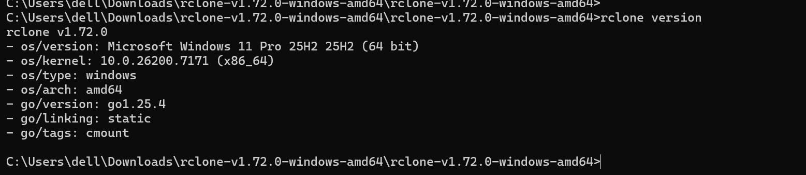

Step 4 — Configure rclone Remote
- Run: # rclone config`
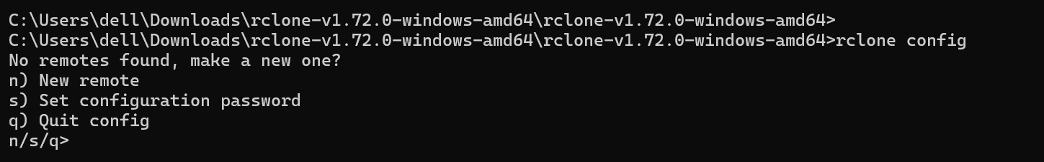
2. Select: `n` (new remote)
- Name: `s3remote`
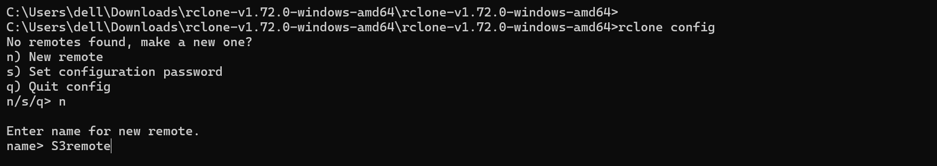
- Select storage type option for Amazon S3
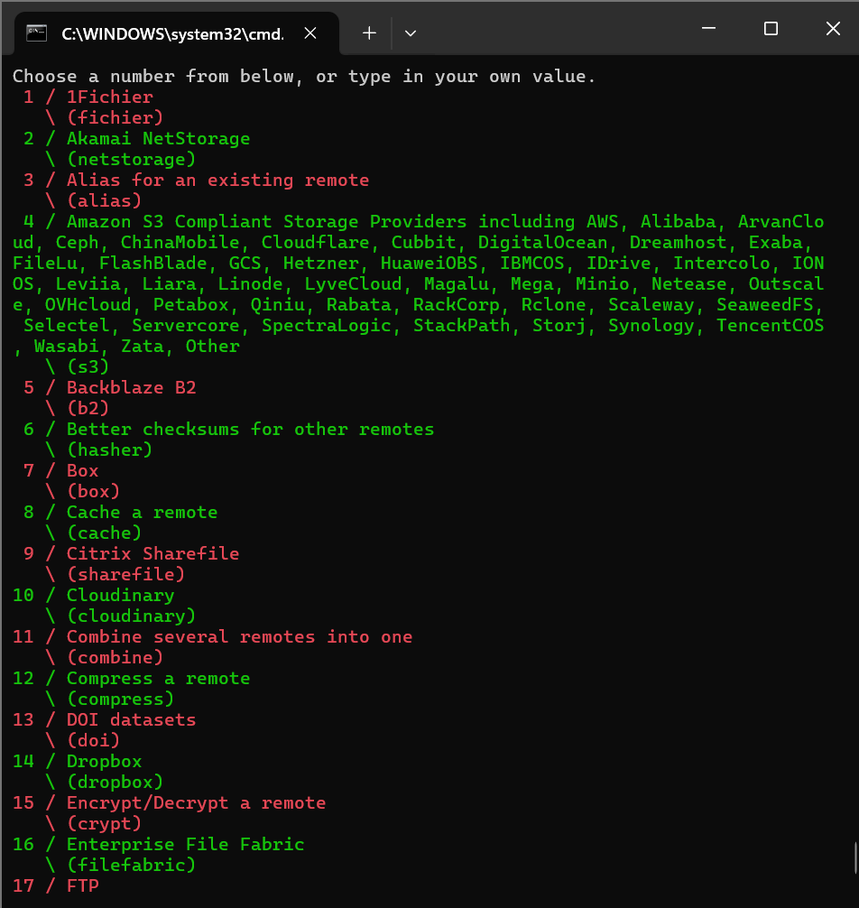
- Choose provider: AWS
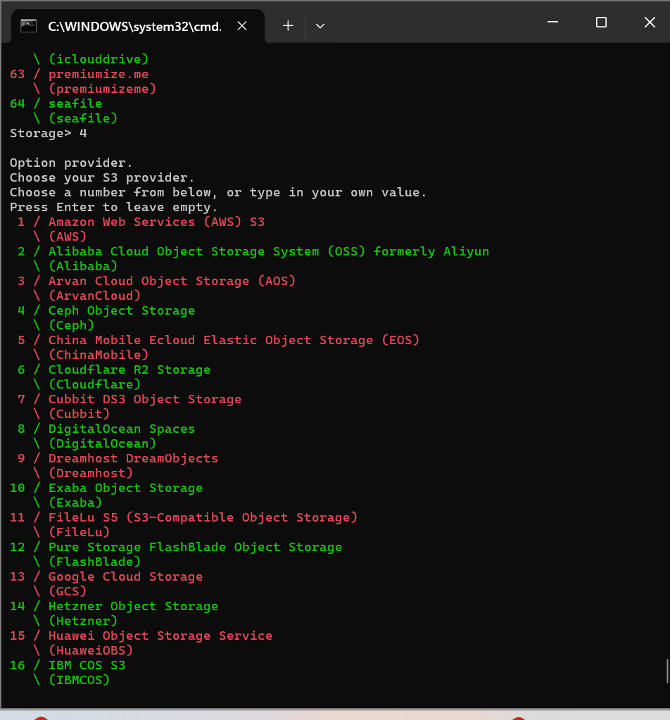
- Enter Access Key and Secret Key
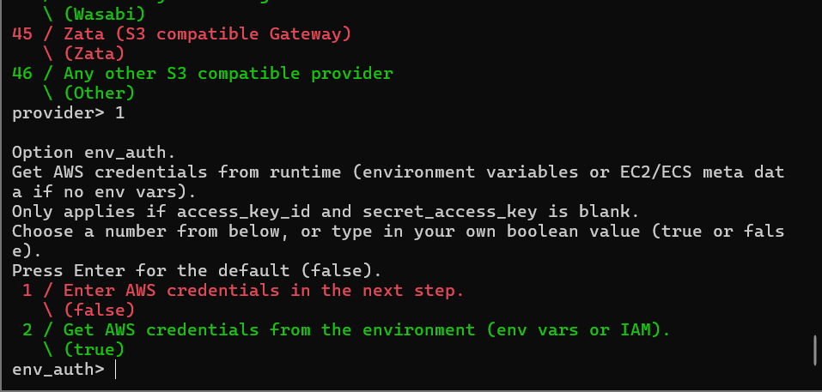
- Region: `ap-south-1`
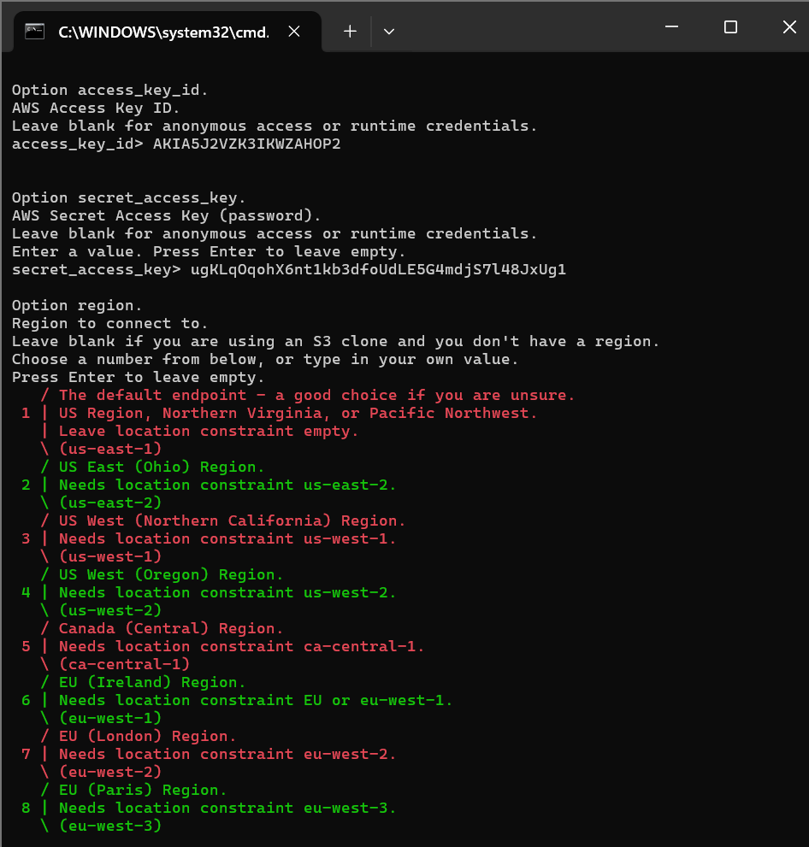
- Leave Endpoint blank
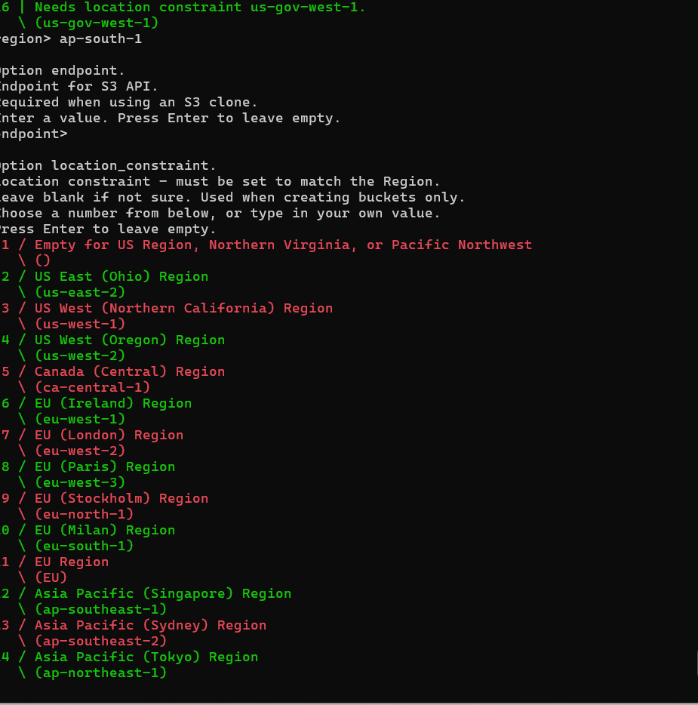
Leave Constraints : a-south-1
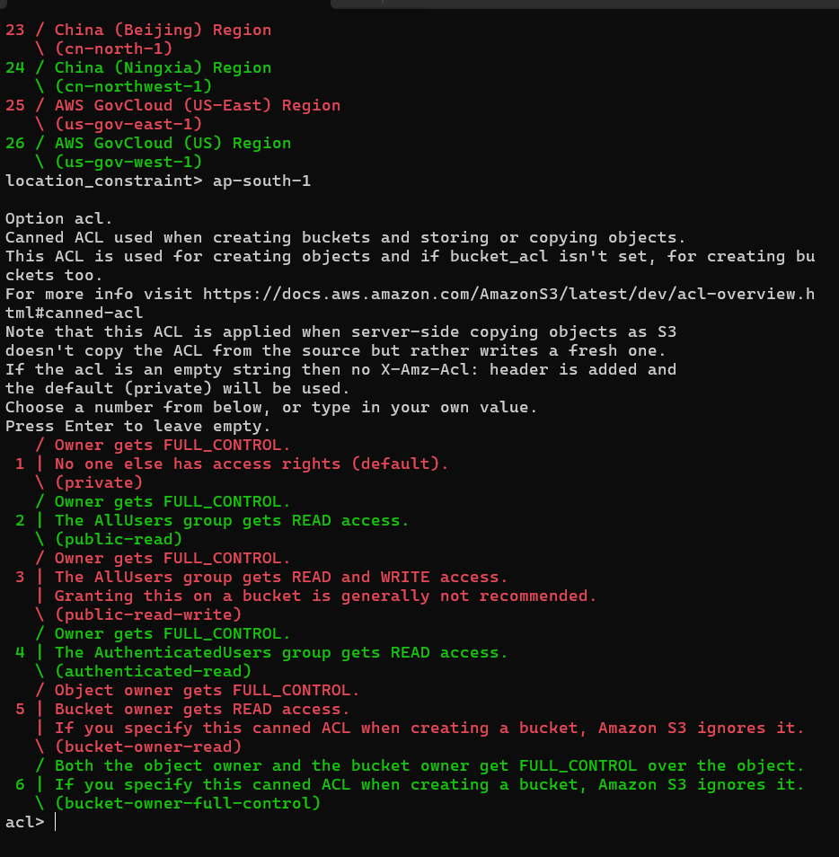

ACLs

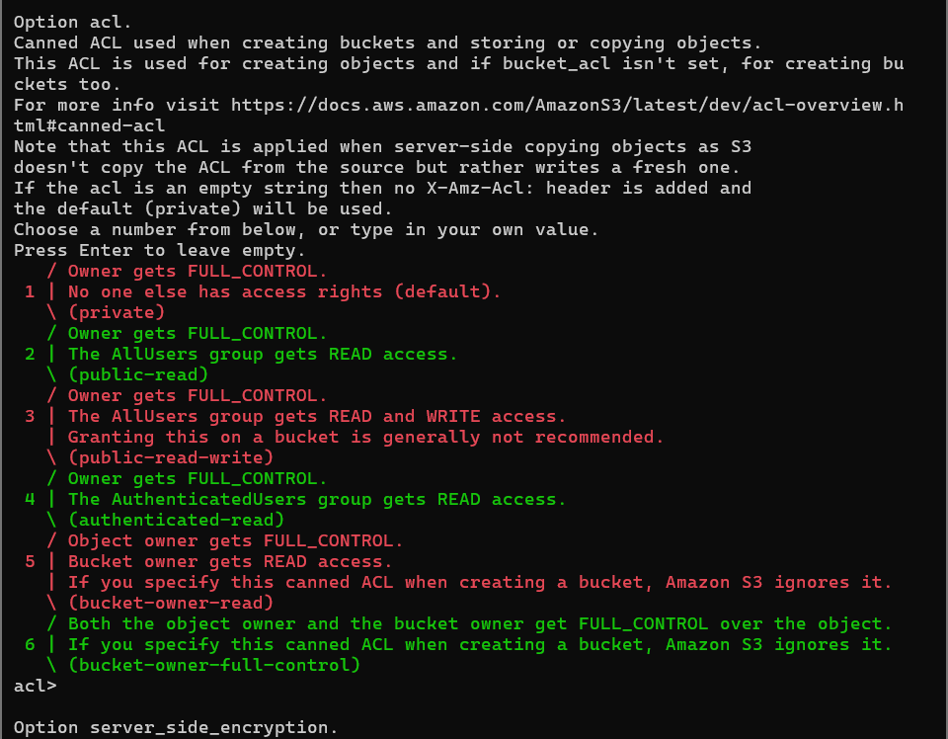
Kms key leave
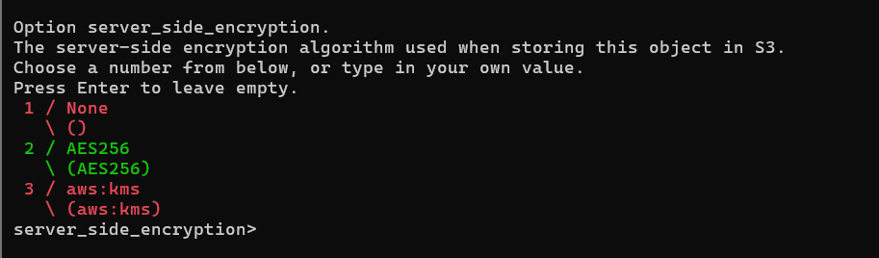
9. Save configuration press y and q for quit.
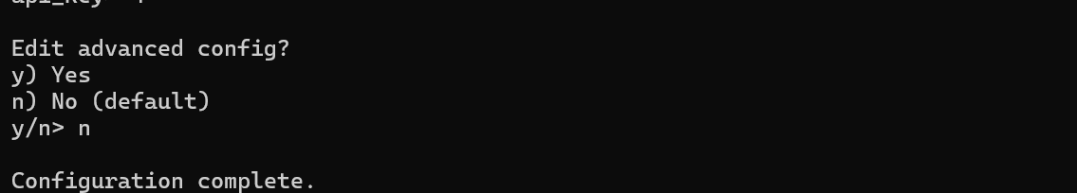
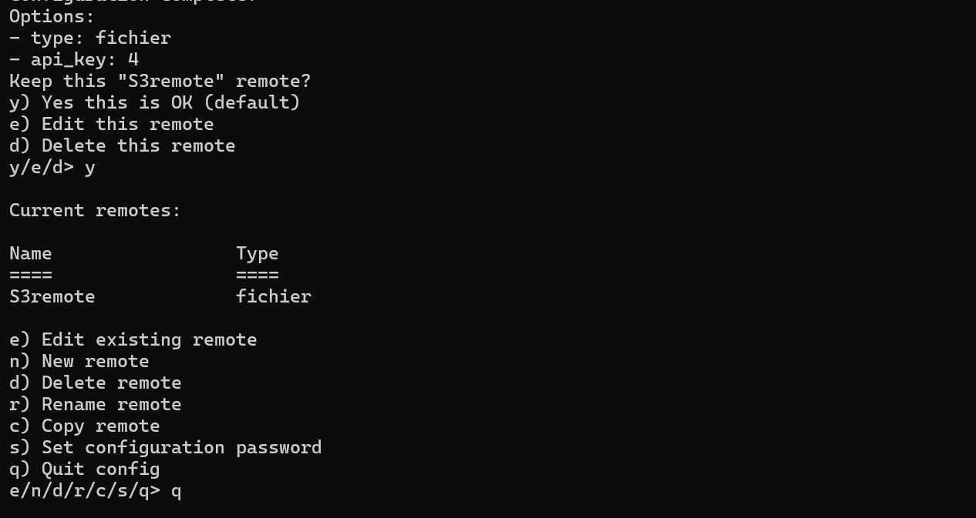
Your rclone is installed and working correctly now.
Configure rclone → connect to S3 → upload local data.
Now finally our CONFIGURATION COMPLETE!
Note: If you face any challenges or failed to status just try again using the correct AWS credentials.

Step 6 Test S3 Connection
List buckets:
So now run:
# .\rclone ls s3remote:your-bucket-name
with the name of the S3 bucket where you want to upload the 500GB data.
# .\rclone ls s3remote:my-big-backup-bucket
If it lists nothing → good (empty bucket).
If it lists files → also good.
rclone is now WORKING and authenticated to AWS S3.
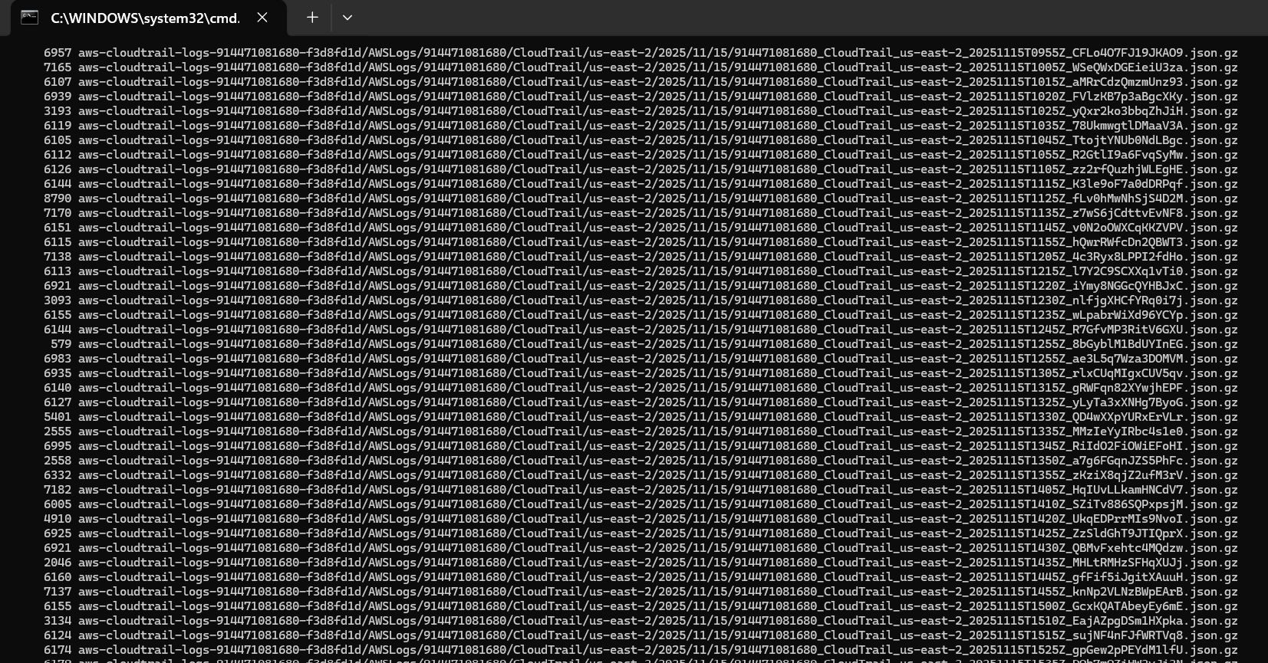
This means your rclone configuration is successful and rclone is able to connect to your S3 account and list files.
- These are CloudTrail logs stored inside S3 bucket shown above.
You are now ready for the final step: UPLOAD YOUR LOCAL DATA.

Step 7 UPLOAD 500GB DATA
First: find the local folder you want to upload
UPLOAD COMMAND:
Run : # .\rclone copy "C:\Users\dell\mytestdata" "s3remote:preeti-upload-demo" --progress
If it prints bucket names – SUCCESS.
So here in my case I have not enough data of 500 GB therefore I will create a new folder and upload some data with max data size.
You will create a local test folder, put some dummy files in it, then upload it to S3 using rclone.

7.1 Create a Local Test Folder
- Open File Explorer
  - Click new and name file and Add 5–10 new files inside it
- Go to: C:\Users\dell\
I named my file mytest data and uploaded some files for testing
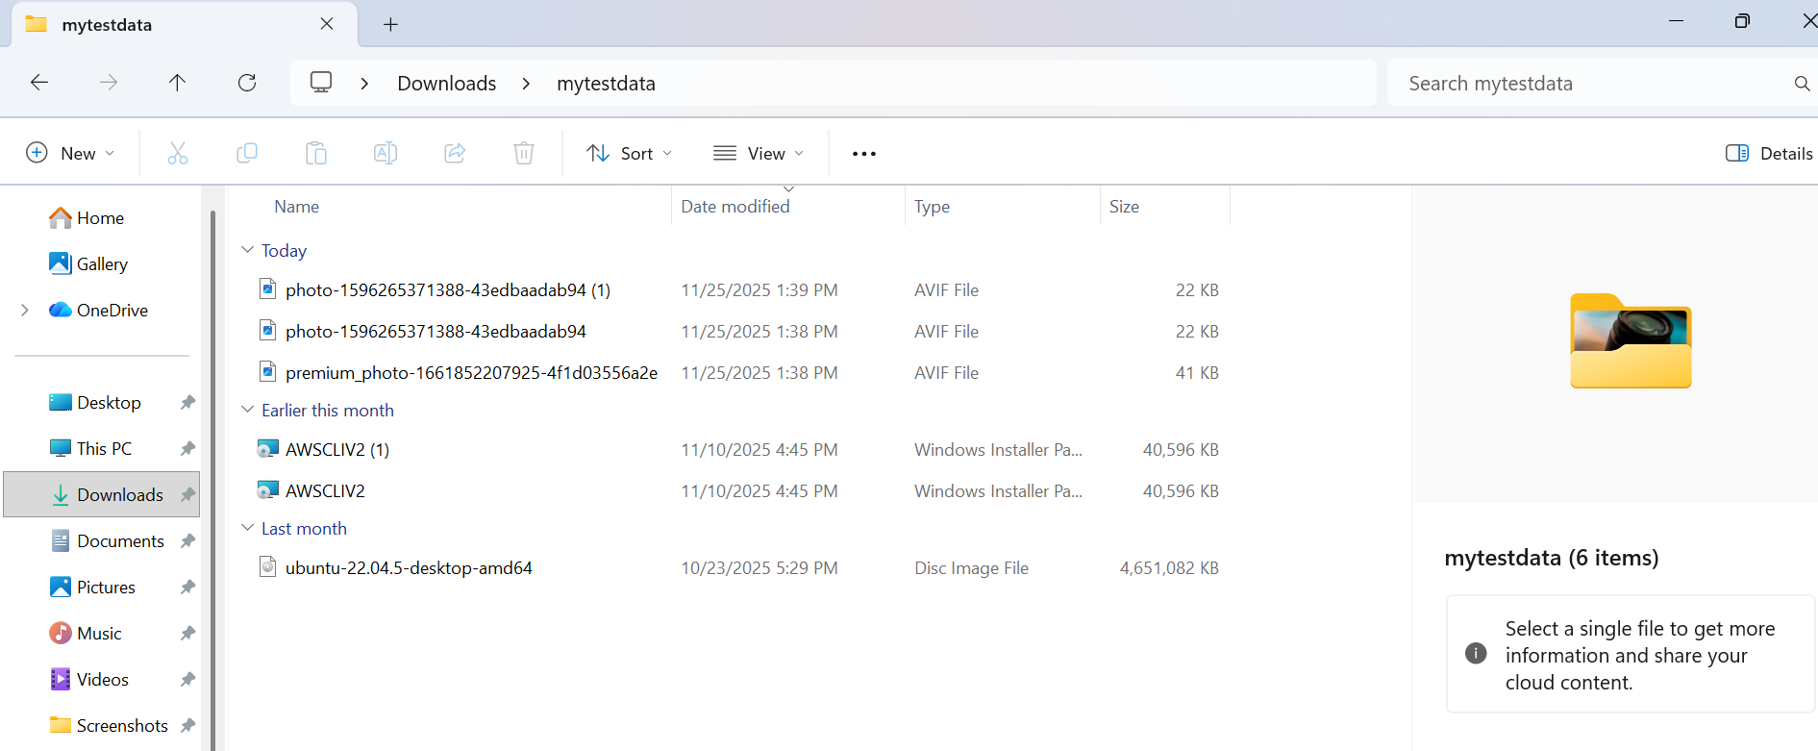
Put some files inside Your local test folder path will look like:
C:\Users\dell\mytestdata

STEP 8 — Upload Folder to S3
Note : Confirm the S3 bucket name
Once . \rclone version works, THEN run your upload:
# .\rclone copy "C:\Users\dell\Downloads\mytestdata" "s3remote:rclone-data-upload" --progress
You will see progress like:
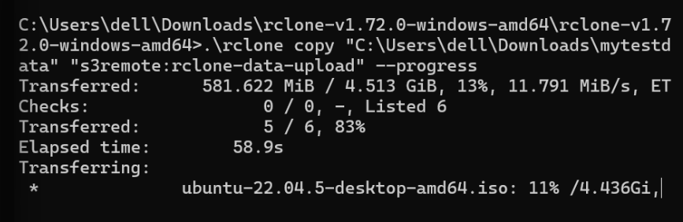
This means upload is successful and upload pipeline is 100% functional.
- Your rclone configuration is working
- Your access key and region are correct
- Upload to S3 from local system is successful
- You know how to do the real 500GB upload when needed

Just wait for the upload to finish
rclone will show progress until it reaches 100%.
If your internet disconnects → no problem
Just run the same command again:
.\rclone copy "C:\Users\dell\Downloads\mytestdata" "s3remote:rclone-data-upload" --progress

It will resume automatically.

Step 9 Verify Upload AWS S3 Console
- Go to:
- AWS Console → S3 → Your bucket → rclone-data-upload
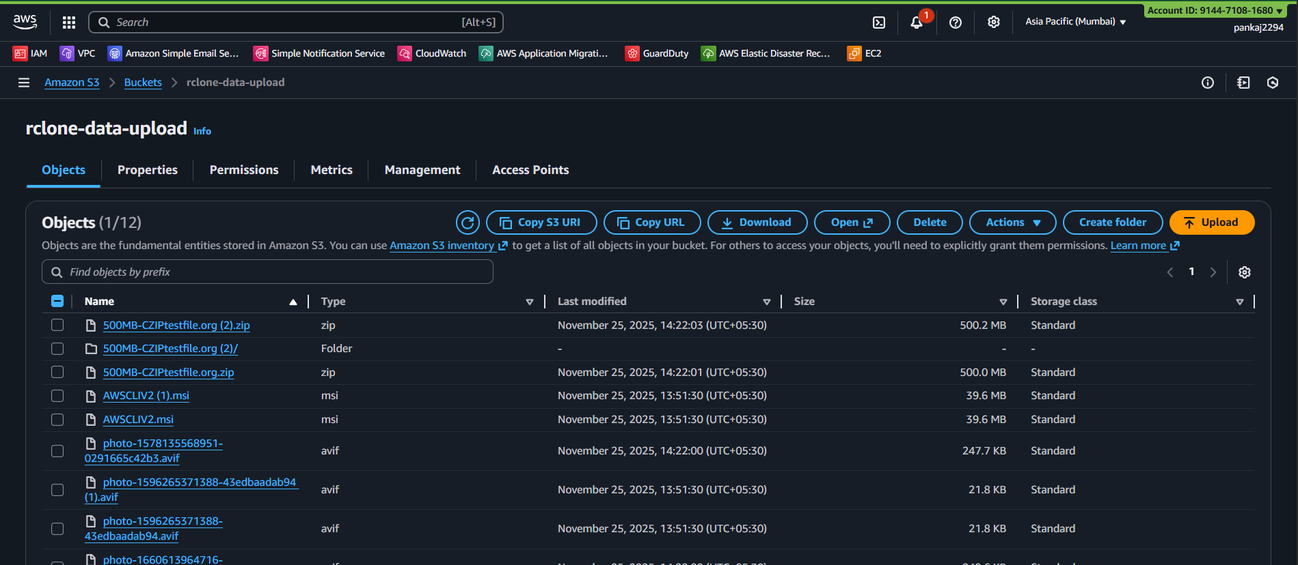
You will see all files from your mytestdata folder.

Learning Outcomes
By completing this lab, I learned:
- How to configure IAM users for programmatic AWS access
- How to create and manage S3 buckets for storage operations
- How rclone works and how to install it on Windows
- How to configure rclone with AWS S3, including Access Key, Secret Key, region, endpoint
- How to upload data from local system to S3 using rclone
- How to resolve authentication errors, including InvalidAccessKeyId, 401 Unauthorized, and endpoint misconfigurations
- How to troubleshoot directory path errors in Windows and rclone
- How to verify uploads in S3 using both AWS Console and rclone commands
- How to test clean uploads with new folders (to avoid duplicates)
- How to interpret rclone upload results (Transferred %, speed, ETA, time)
- How to maintain AWS credentials and ensure they match rclone config
- How to structure a technical report / SOP with troubleshooting steps and final output
Testing 2 where we create a new test folder where:
- You put ONLY fresh files
- No duplicate files from previous test uploads
- rclone does NOT re-upload the same files again
- You can test a clean upload process

STEP 1 — Create a NEW Test Folder
mytestdata2

Add NEW files inside it
Do NOT copy from old folder.
Add fresh files like:
- 1 new image (download from internet)
- 1 new PDF
- 1 new text file
- 1 new video or any other file
The folder path should be:
C:\Users\dell\Downloads\mytestdata2
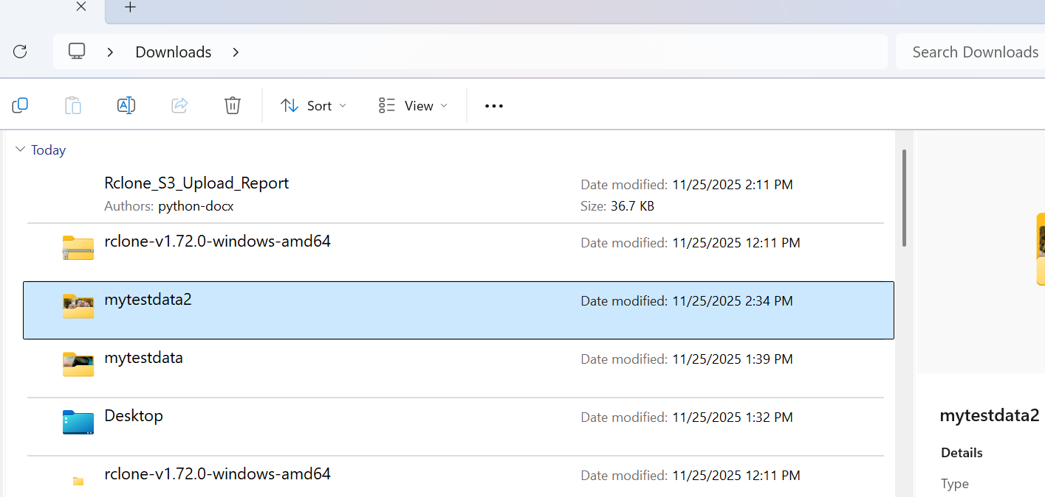
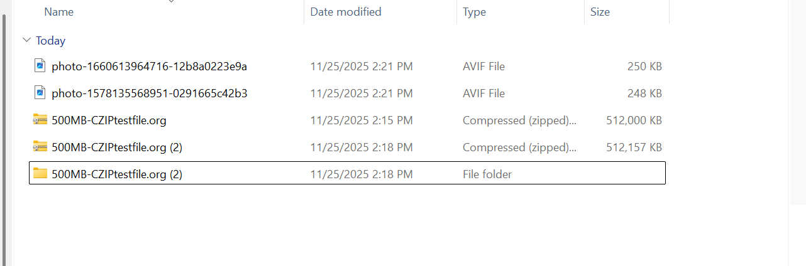
WHY new folder?
Because rclone is smart — it checks each file’s:
- name
- size
- modification time
- checksum
If the file is same → it will NOT copy again.
new test data, so we create a completely new folder.

STEP 2 — Upload NEW folder with rclone
Go to the rclone folder:
cd "C:\Users\dell\Downloads\rclone-v1.72.0-windows-amd64"
Now run this upload command:
.\rclone copy "C:\Users\dell\Downloads\mytestdata2" "s3remote:rclone-data-upload" --progress
This will upload ONLY the new files in that new folder.

STEP 3 — Verify No Duplicates Are Uploaded
Run:
.\rclone sync "C:\Users\dell\Downloads\mytestdata2" "s3remote:rclone-data-upload" --progress
It will tell you:
- Which files are missing in S3
- Which files already exist
- If everything is synced
If the same files were already in S3, rclone will skip them automatically.
It is showing new files total 5 is transferring which is in progress status.
⚠ WARNING:
sync will delete files in S3 that are not in your local folder.
So use it ONLY if your TL explicitly asks.

STEP 4 — Verify No Duplicates Are Uploaded
Run:
.\rclone check "C:\Users\dell\Downloads\mytestdata2" "s3remote:rclone-data-upload"

It will tell you:
- Which files are missing in S3
- Which files already exist
- If everything is synced
If the same files were already in S3, rclone will skip them automatically.
Now just add 1 more file and see the timing

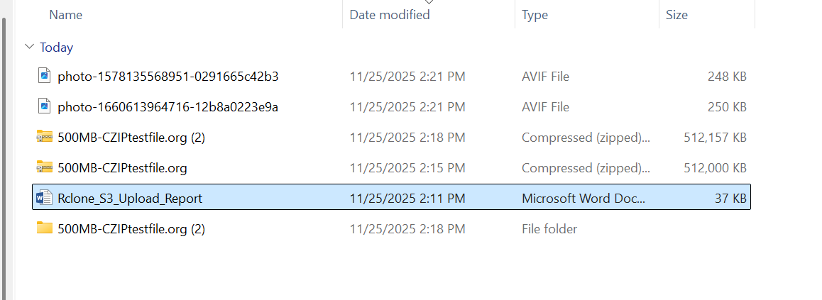
Now we can see that our 1 file is now uploading.
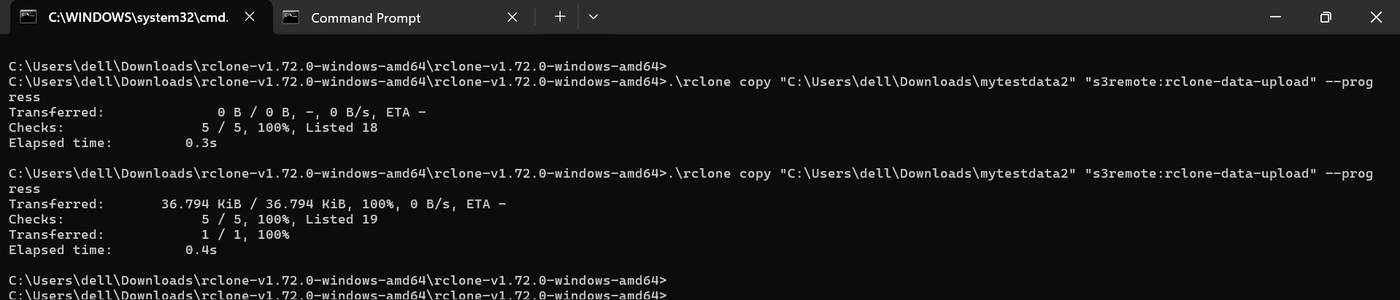
It took 0.4 second to upload.
Now we can also check on AWS console in S3 bucket.
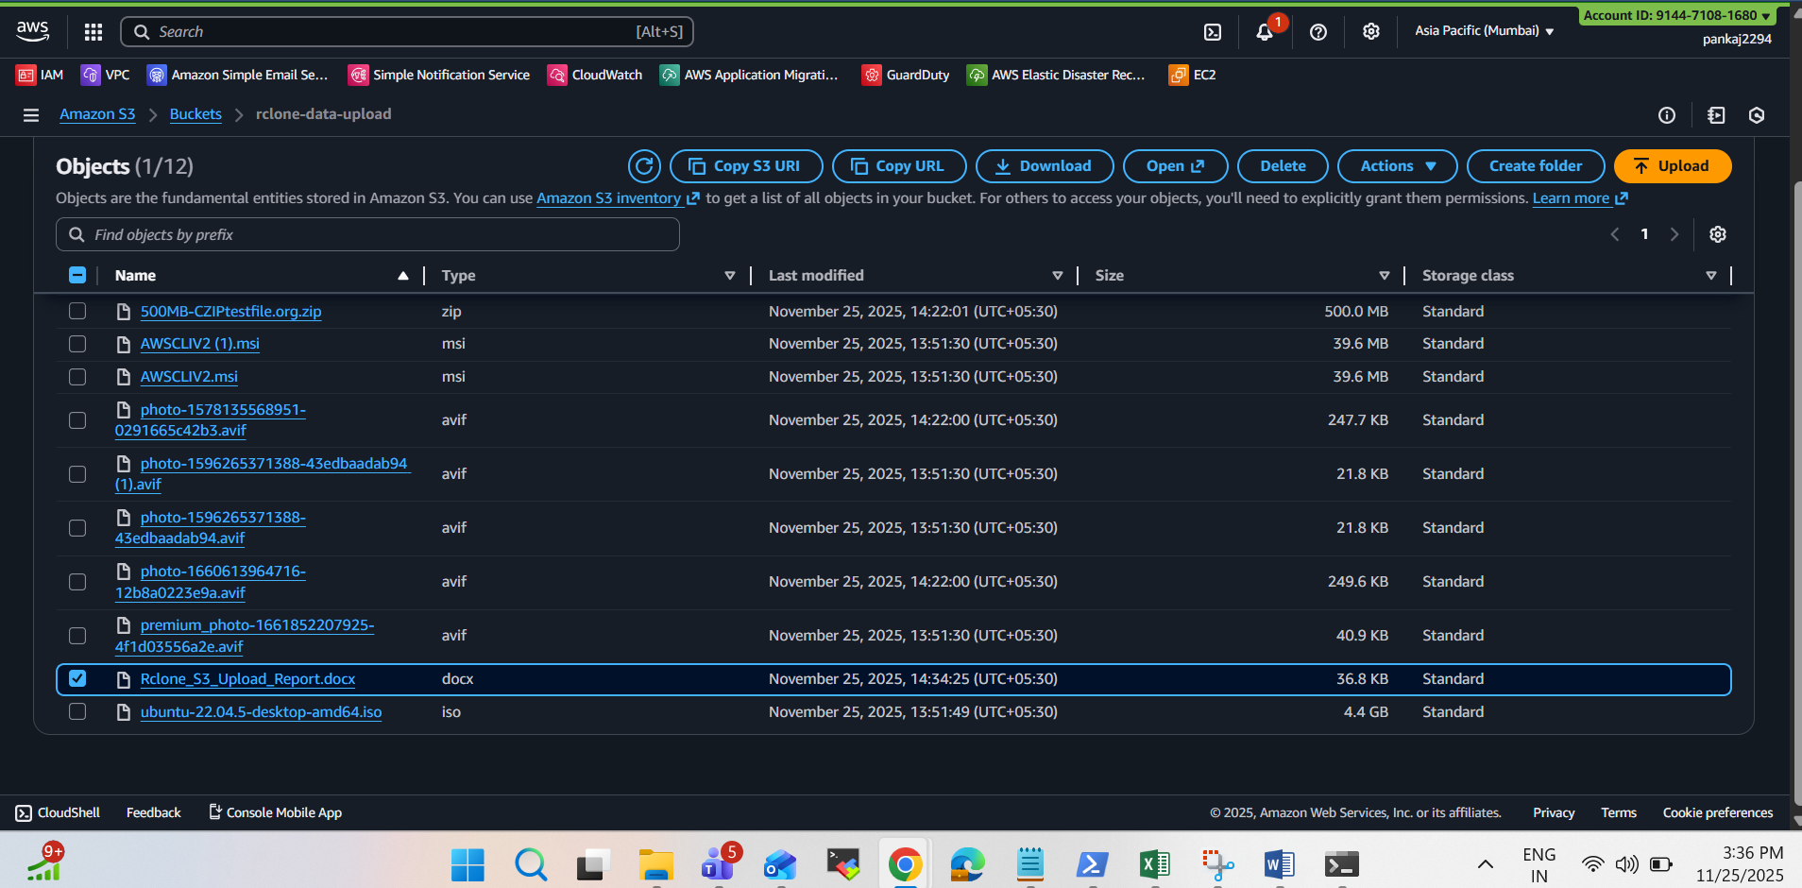
Yes verified uploaded successfully.
.\rclone ls s3remote:rclone-data-upload
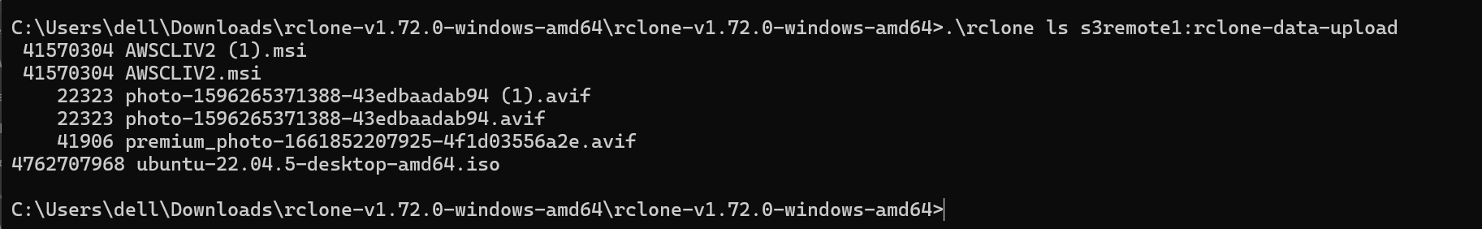
rclone successfully transferred all files with progress monitoring.

Final Result
- rclone installed & configured
- AWS S3 authentication successful
- All errors fixed
- Test data successfully uploaded to AWS S3
- Task fully completed

