Apt-install git -y

Apt-get install maven -y

Jenkins’s integration:

Go to Jenkins console: Manage Jenkins🡪Global tool configuration

JDK:

Name : localJDK

Path: /usr/lib/jvm/java-11-openjdk-amd64

GIT:

Name: localgit and path: git

Maven:

Name: localmaven

Path: /usr/share/maven

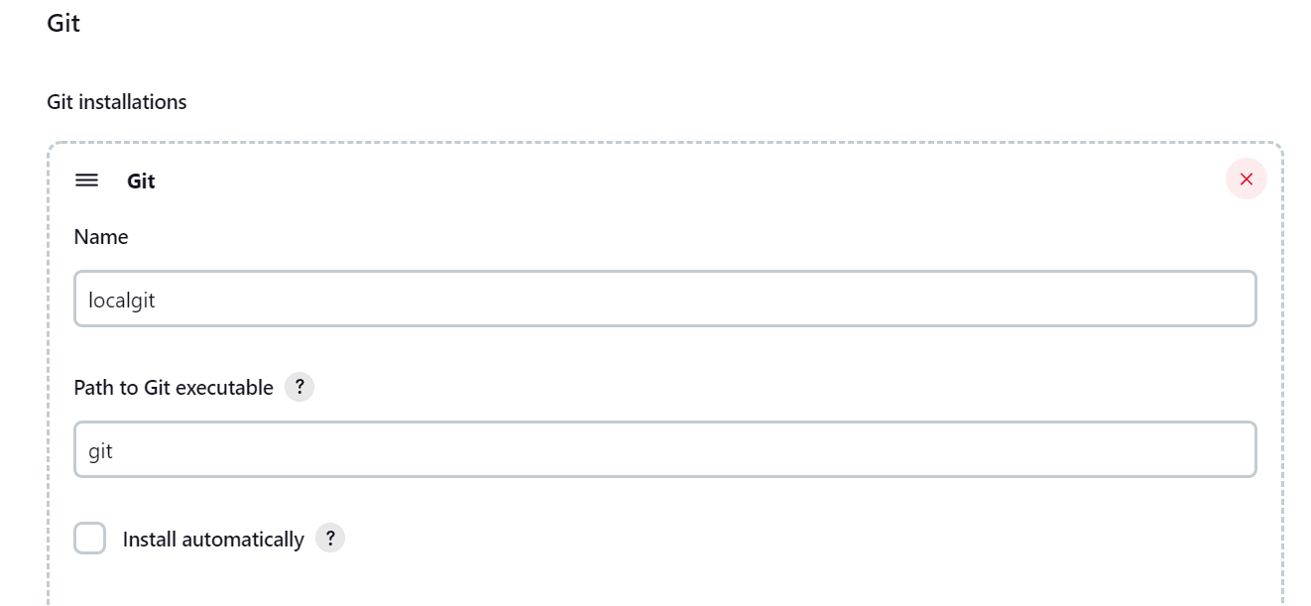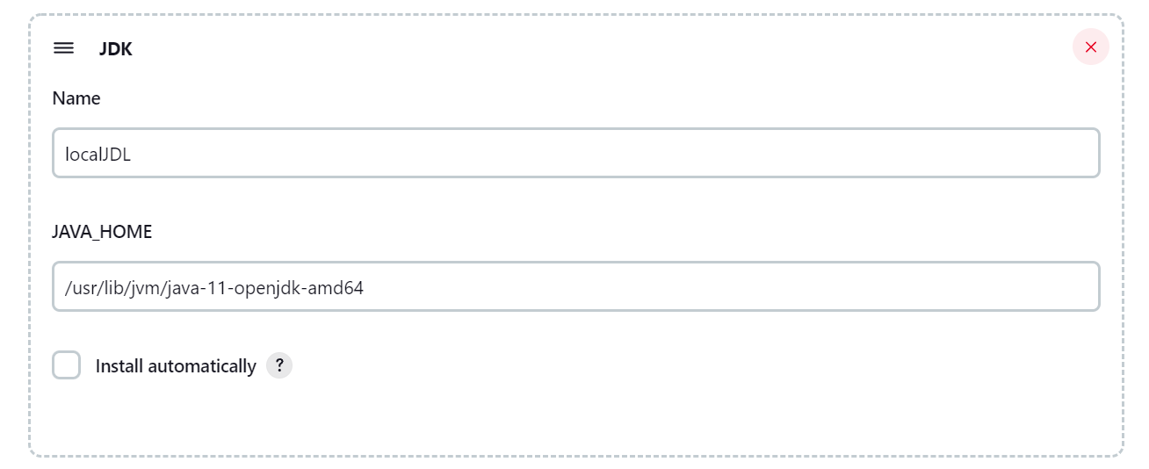

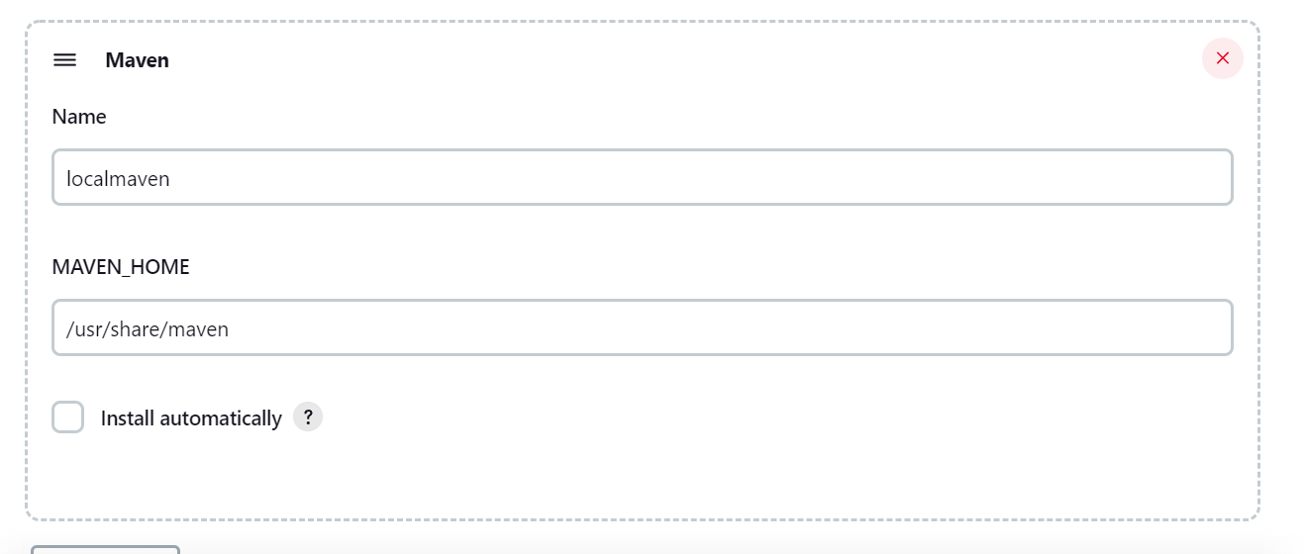

Now create new Project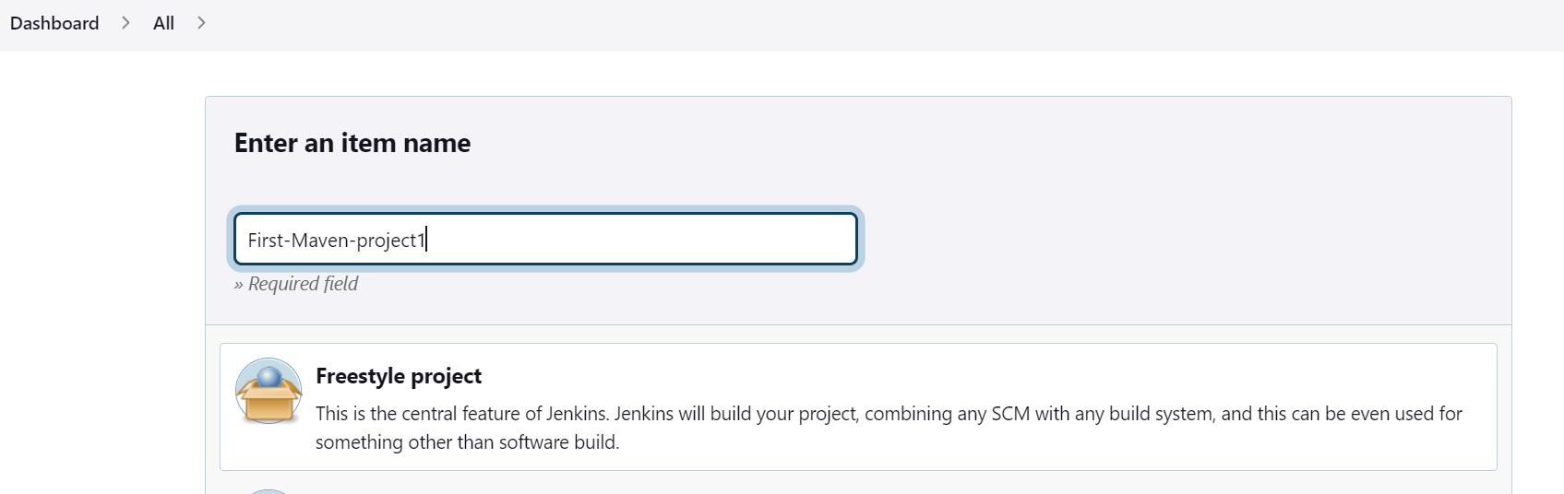

Git: <https://github.com/viswkum/maven-project.git>

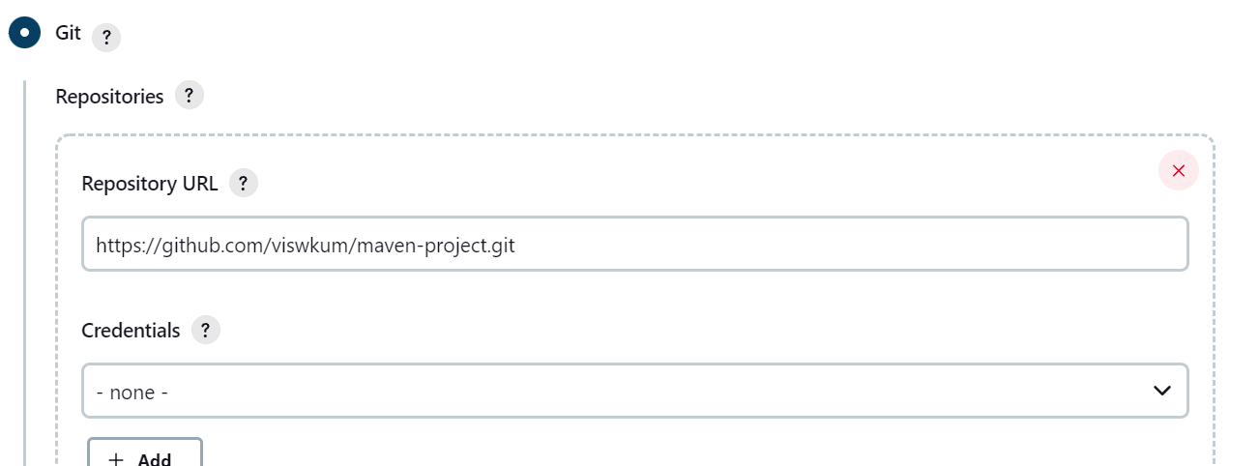

Build steps: **Invoke top-level Maven targets**

**Maven version: localmaven**

**Goals: test install**

**Advanced: here we have define proper path of xml file.**

POM: maven-project/maven-samples/single-module/pom.xml