**MAVEN INSTALATION:**

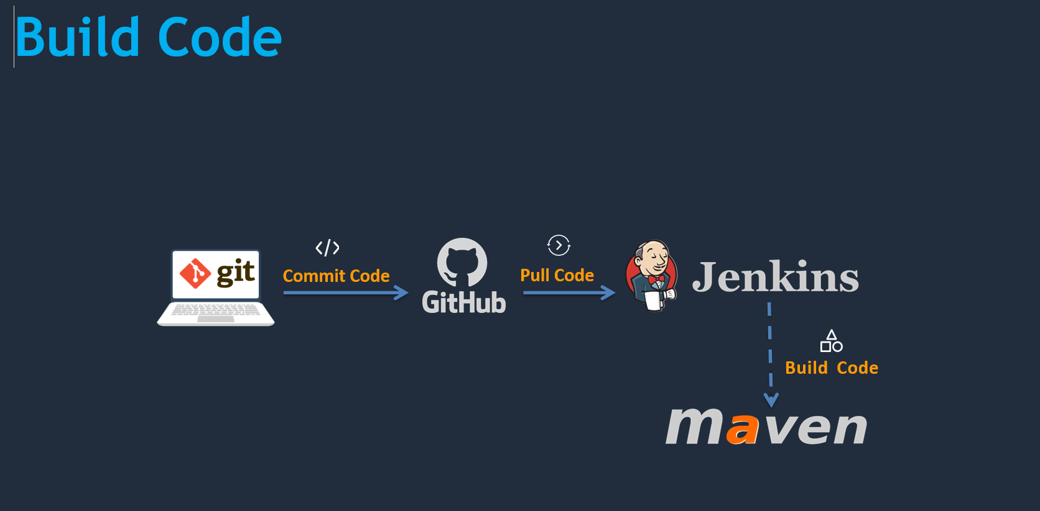

**#  Install & configure Maven build tool on Jenkins**

Maven is a code build tool which used to convert your code to artifact. this is widely used plugin to build in continuous integration

**#### Prerequisites**

jenkin server

**#### Install Maven on Jenkins**

Download maven packages https://maven.apache.org/download.cgi onto Jenkins server. In this case I am using /opt/maven as my installation directory

  - Link : https://maven.apache.org/download.cgi

```sh

  # Creating maven directory under /opt

  mkdir /opt/maven

  cd /opt/maven

  # downloading maven version 3.6.0

  wget http://mirrors.fibergrid.in/apache/maven/maven-3/3.6.0/binaries/apache-maven-3.6.0-bin.zip

  unzip /opt/maven/apache-maven-3.6.0-bin.zip

 ```

Setup M2_HOME and M2 paths in .bash_profile of user and add these to path variable

```sh

  vi ~/.bash_profile

  M2_HOME=/opt/maven/

  M2=/opt/maven/bin

x

  PAHT=<Existing_PATH>:$JAVA_HOME:$M2_HOME:$M2

```

**#### Check point**

logoff and login to check maven version

Check maven version

```sh

  mvn –version

```

So far you have completed installation of maven software to support maven plugin on jenkins console. Let's jump onto jenkins to complete remining steps.

**#### Setup maven on Jenkins console**

- Install maven plugin without restart

  - `Manage Jenkins` > `Jenkins Plugins` > `available` > `Maven Invoke`

**#### (Update) Install "Maven Integration" Plugin as well**

- Install maven Integration Plugin without restart

  - `Manage Jenkins` > `Jenkins Plugins` > `available` > `Maven Integration`

- Configure maven path

  - `Manage Jenkins` > `Global Tool Configuration` > `Maven`

**#### Next Steps**

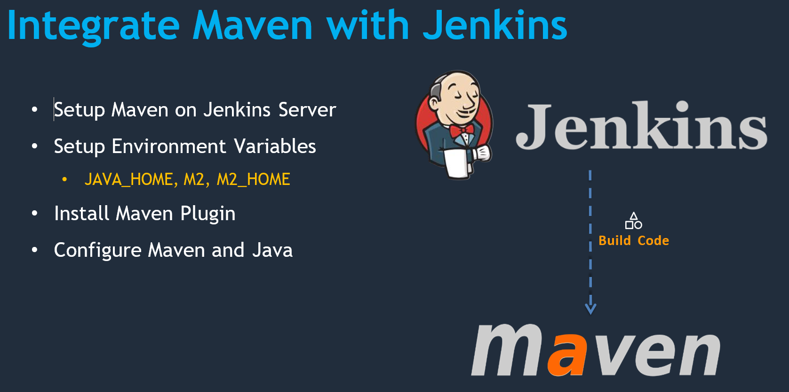

**Create new project**

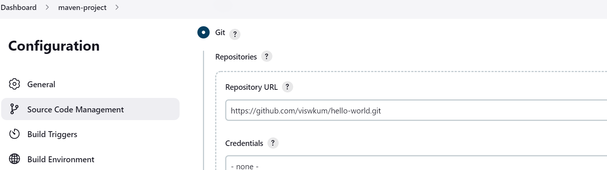

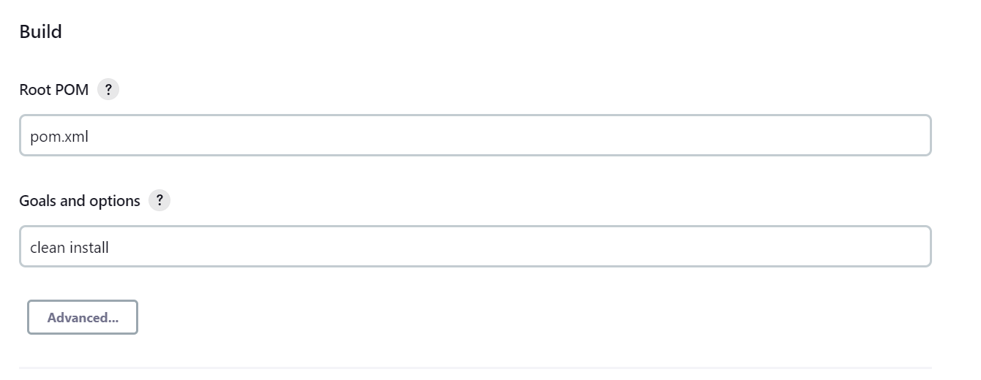

**Output:**

