DATA ANALYTICS WITH POWER BI
REPORT

ADVANCED TELECOM CUSTOMER CHURN ANALYSIS

Submitted by
Roshani Kumari

Registration No.: 12307183
Programme: BTech-CSE
Section: 9P172

Under the Guidance of
Ms. Gunjan (67224)

Discipline of CSE/IT

Lovely School of Computer Science Engineering

Lovely Professional University, Phagwara

CERTIFICATE

This is to certify that Roshani Kumari bearing Registration no. 12307183 has completed project titled, “Advanced Telecom Customer Churn Analysis” under my guidance
and supervision. To the best of my knowledge, the present work is the result of his/her original development, effort and study.

Ms. Gunjan
Professor
School of Computer Science Engineering
Lovely Professional University Phagwara, Punjab.

Date: 20 February, 2026

DECLARATION

I, Roshani Kumari, student of BTech under CSE/IT Discipline at, Lovely Professional University, Punjab, hereby declare that all the information furnished in this project report is based on my own intensive work and is genuine.

Date: 20th Feb, 2026 Signature
Registration No. 12307183 Roshani Kumari

Acknowledgment

I would like to express my deepest gratitude to Prof. Ms. Gunjan, for her exceptional mentorship and unwavering support throughout the duration of this project. Her vast knowledge in the fields of data science and machine learning, combined with her patient and thoughtful guidance, played a pivotal role in the successful completion of this work. Her insightful suggestions and feedback consistently challenged me to think critically and improve the quality of my research. I am also grateful for the learning environment she fostered, which encouraged exploration and innovation.
In addition, I sincerely thank my peers and classmates for their helpful discussions, encouragement, and collaborative spirit during this project. Their input provided fresh perspectives that contributed meaningfully to the final outcome. I am also thankful to the open-source community for providing the tools, libraries, and resources that made the implementation of this project possible. Lastly, I acknowledge the dataset contributors for making this analysis feasible.

1.Introduction

Customer churn is a critical challenge in the telecom industry, as acquiring new customers is often more expensive than retaining existing ones. With increasing competition and multiple service providers, understanding why customers leave a telecom service has become essential for improving customer
satisfaction and business sustainability.
This project aims to build an interactive Power BI dashboard using a telecom customer churn dataset to visualize and analyze key business insights such as:
- Overall churn rate and churn count
- Churn behavior across tenure and contract types
- Impact of billing, payment methods, and service usage on churn
The dashboard is designed to be dynamic and user-friendly, allowing users to explore data through interactive slicers and visuals. The objective is to present meaningful insights through effective data visualization and analytics techniques using Microsoft Power BI and DAX.

Source of Dataset

The dataset used in this project is a publicly available telecom customer churn dataset, commonly used for customer behavior and retention analysis. It contains detailed information related to customer demographics, service subscriptions, billing details, and churn status.

Dataset Features:
- Contains individual customer-level records
- Includes demographic data such as gender and senior citizen status
- Covers service usage, contract types, payment methods, and billing details • Includes churn information (Yes/No) for analysis

The dataset is suitable for analyzing customer retention patterns and identifying key factors contributing to churn.

Dataset Link:
https://github.com/KimathiNewton/Telco-Customer-Churn/blob/master/Datasets/telco_churn.csv

Dataset Preprocessing
Before creating the dashboard, the dataset was preprocessed using Power BI and basic data cleaning techniques:

- Removed unnecessary or irrelevant columns
- Standardized column names for clarity
- Ensured correct data types for numerical fields such as tenure, monthly charges, and total charges
- Handled missing or inconsistent values
- Verified categorical fields like contract type, payment method, and churn status

All preprocessing was performed using Power BI’s built-in data transformation tools, without using external scripts.

Analysis on Dataset(For each Objective)

Objective 1: Customer Demographics Analysis
- General Description:
Analyzes customer demographics to understand the composition of the telecom customer base based on factors such as gender, senior citizen status, tenure, and service subscriptions.
- Specific Requirements:
- Identify major customer groups
- Understand which demographic segments form the largest portion of customers iii. Analysis Results:
The analysis shows that the majority of customers belong to specific demographic segments, with noticeable differences in churn behavior across tenure groups and customer categories. Certain customer segments show a higher tendency to churn compared to others.
iv. Visualization:
KPI cards and categorical charts were used to summarize demographic distribution and highlight key customer segments.
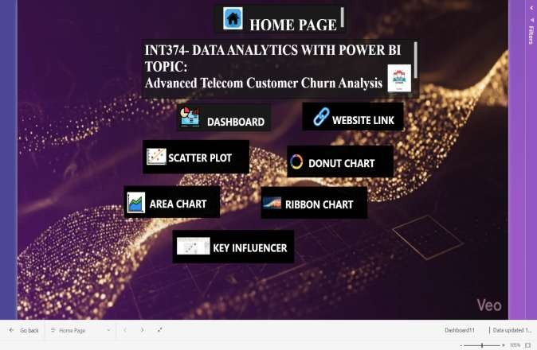

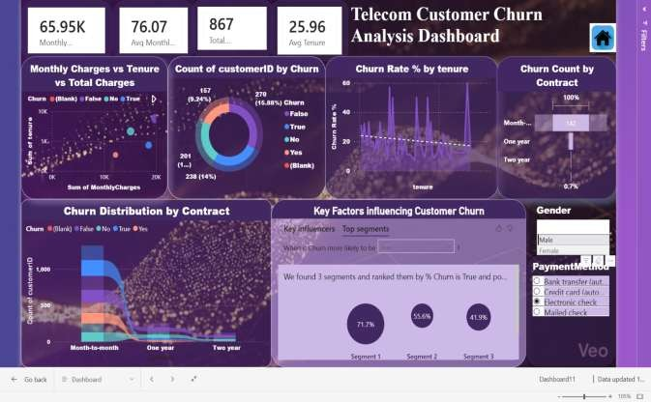

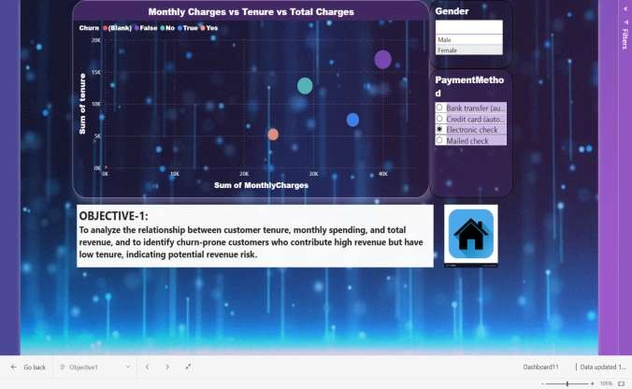

Objective 2: Overall Churn Analysis
- General Description:
Evaluates the overall churn performance by calculating churn rate and churn count across the entire customer base.
- Specific Requirements:
- Compute churn rate percentage
- Compare churned vs retained customers iii. Analysis Results:
The analysis indicates that a significant portion of customers have discontinued services, highlighting the need for improved retention strategies.
iv. Visualization:
A Donut Chart and KPI Cards were used to clearly represent churn distribution and key churn metrics.
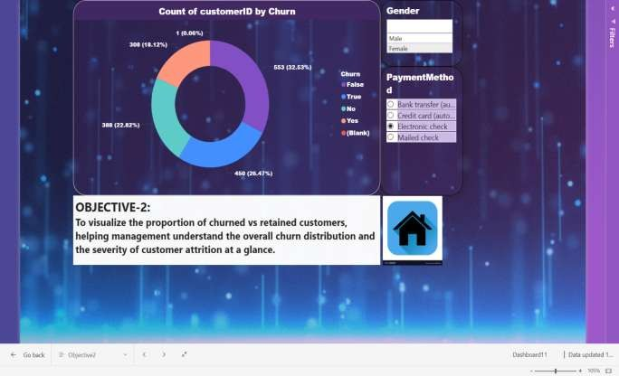

Objective 3: Churn Analysis Across Tenure
- General Description:
Examines how customer churn varies with the length of customer tenure.
- Specific Requirements:
• Identify churn trends for short-term vs long-term customers • Analyze loyalty patterns over time iii. Analysis Results:
Customers with shorter tenure show a higher churn rate, while long-term customers tend to remain more loyal, indicating that retention improves as tenure increases.
iv. Visualization:
A Line Chart was used to show churn rate trends across different tenure values.
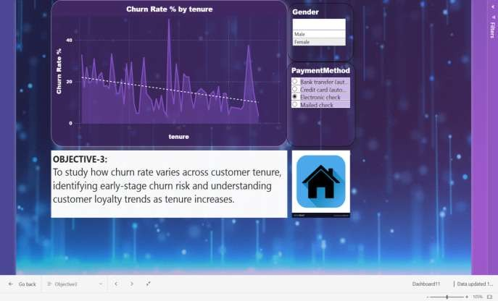

Objective 4: Impact of Contract Type on Churn
i. General Description:
Analyzes the relationship between contract type and customer churn behavior. ii. Specific Requirements:
• Compare churn across month-to-month, one-year, and two-year contracts iii. Analysis Results:
Customers on month-to-month contracts exhibit significantly higher churn compared to customers on longterm contracts, emphasizing the importance of contract stability.
iv. Visualization:
A Funnel Chart and Area Chart were used to compare churn distribution across different contract types.
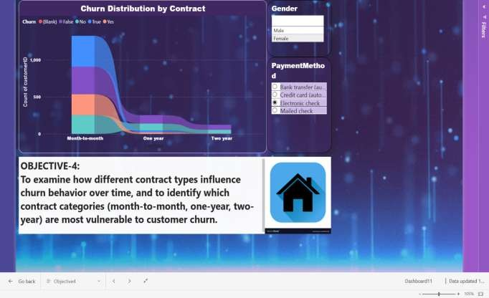

Objective 5: Billing, Charges, and Service Usage Analysis
- General Description:
Evaluates how billing behavior, monthly charges, total charges, and service usage influence customer churn.
- Specific Requirements:
• Analyze the relationship between pricing and churn • Identify high-risk customers based on billing patterns iii. Analysis Results:
Customers with higher monthly charges and limited service engagement are more likely to churn, whereas customers using multiple services tend to show better retention.
iv. Visualization:
A Scatter Plot was used to analyze relationships between tenure, monthly charges, and total charges, helping identify high-risk customer segments.
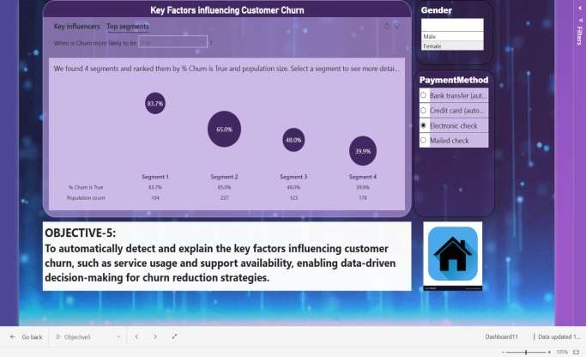

Objective 6: Identification of Key Churn Drivers

- General Description:
Identifies the most influential factors contributing to customer churn.

- Specific Requirements:
- Determine key churn drivers
- Explain why customers are more likely to churn

- Analysis Results:
Key Influencer analysis reveals that contract type, tenure, and service-related factors play a major role in determining churn probability.

- Visualization:
The Key Influencers visual was used to automatically identify and explain the factors most strongly associated with customer churn.
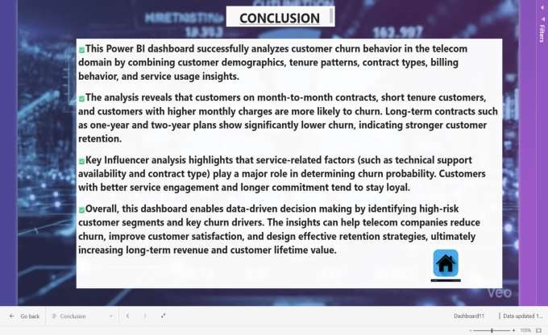

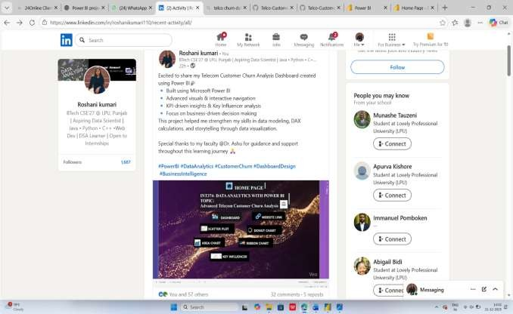

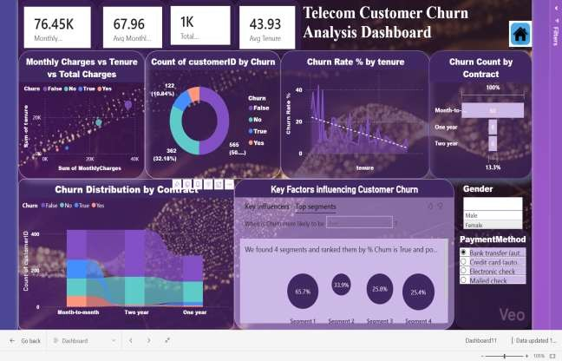

Conclusion

The Telecom Customer Churn Dashboard project provided a comprehensive platform to analyze customer behavior, service usage patterns, and churn dynamics within the telecom industry. By leveraging Power BI’s interactive visuals, DAX measures, and slicers, the project successfully transformed raw customer data into meaningful and actionable insights.
Through the first objective, customer demographics were analyzed to understand the composition of the customer base and identify key segments contributing to overall churn. The second objective focused on evaluating overall churn performance, helping quantify churn rate and churn count across the organization. Moving further, the third objective examined churn trends across customer tenure, revealing that customers with shorter tenure are more likely to discontinue services. The fourth objective highlighted the impact of contract types on churn, clearly showing higher churn rates among month-to-month customers compared to long-term contract holders. The fifth objective explored billing behavior and service usage, demonstrating how higher monthly charges and limited service adoption increase churn risk. Finally, the sixth objective utilized advanced analytics to identify key churn drivers, enabling a deeper understanding of the factors influencing customer attrition.
Overall, this project strengthened practical skills in data modeling, business analytics, and data storytelling using Power BI. The interactive dashboard format made insights accessible, visually appealing, and easy to interpret for both technical and non-technical stakeholders. This project demonstrates how data visualization can play a crucial role in improving customer retention strategies and supporting data-driven decision-making in the telecom sector.

Future Scope

While the current Power BI dashboard effectively highlights key churn trends and insights, there is significant scope to enhance and extend the analysis in future iterations.
Firstly, additional datasets such as customer satisfaction scores, call center interaction logs, network performance metrics, or geographic location data could be integrated to gain deeper insights into customer experience and its relationship with churn. This would allow organizations to move beyond descriptive analytics and understand the root causes of dissatisfaction more accurately.
Secondly, advanced analytics techniques such as predictive churn modeling using machine learning algorithms can be incorporated. By applying classification models, the dashboard could predict churn probability for individual customers, enabling proactive retention strategies.
Furthermore, the dashboard can be enhanced with real-time or near real-time data integration, allowing telecom operators to monitor churn trends continuously and respond quickly to emerging risks. Drill-through reports and automated alerts could also be added to improve decision-making efficiency.
Another potential enhancement is the deployment of the dashboard on Power BI Service, enabling role-based access, scheduled data refresh, and collaborative sharing among business teams. This would make the dashboard more scalable and suitable for enterprise-level usage.
In conclusion, the foundation built through this project can evolve into a more advanced, predictive, and business-ready analytics solution. With further enhancements, it can serve not only as an academic project but also as a practical tool for improving customer retention and business performance in the telecom industry.

References

- IBM Analytics, Telco Customer Churn Dataset, Public Dataset. [Online]. Available through open data repositories.
- Microsoft Corporation, Power BI Documentation.
[Online]. Available: https://learn.microsoft.com/power-bi
- Kimball, R., & Ross, M., The Data Warehouse Toolkit, 3rd ed. Wiley, 2013.
- Provost, F., & Fawcett, T., Data Science for Business. O’Reilly Media, 2013.

 LINKEDIN ENGAGEMENT LINK:
https://www.linkedin.com/in/roshanikumari110/recent-activity/all/

