**ASSIGNMENT DESCRIPTION**

A signup form is a user-facing HTML form that functions as one of the primary data collection methods in the BSD framework. At its most basic level, a signup form allows for the collection of the essential pieces of information for a constituent and a means to subscribe that constituent to the user’s email list.

**LANGUAGE USED FOR DEVELOPMENT**- PHP

The form is created and saved with name form.html and the database connection and other details are in signup.php file.

**PROBLEM DESCRIPTION**

The main constraint of this signup page is that you need to fill all the details to signup. If any of the field is empty the form will not be accepted by the server.

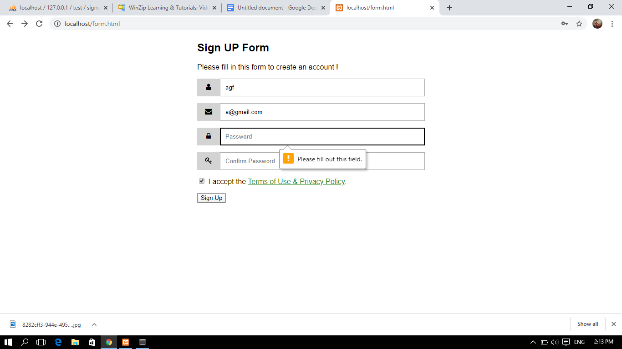

**SNAPSHOTS**

1-Taking input from user

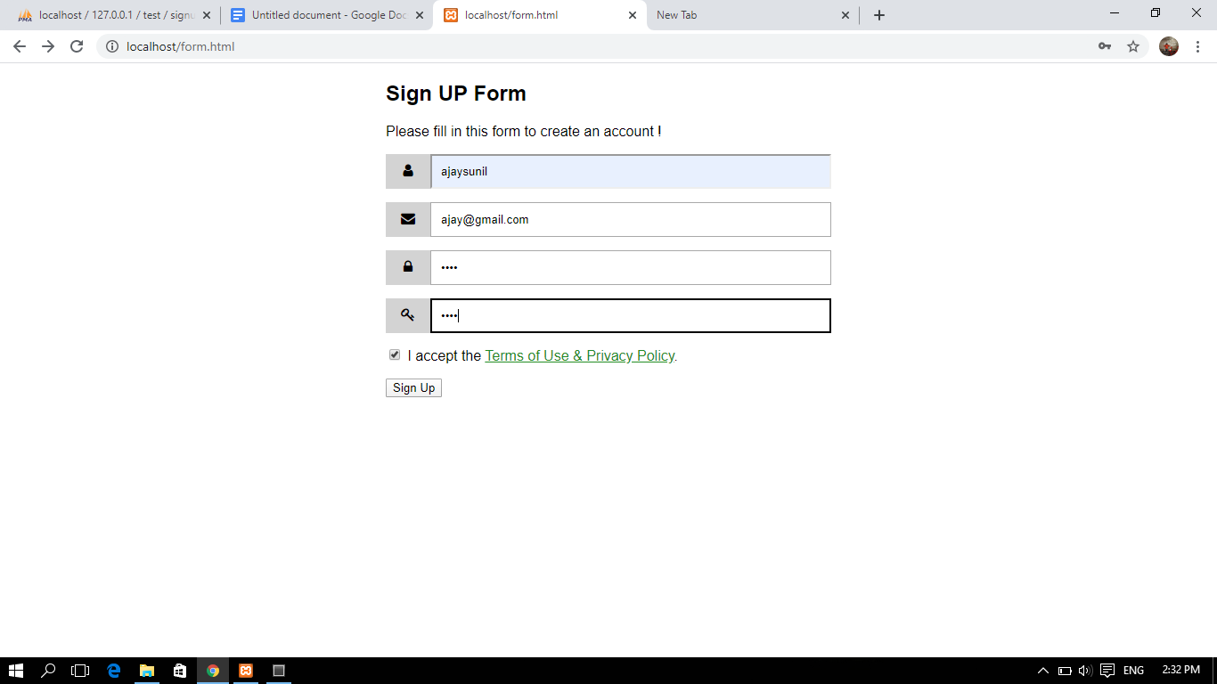

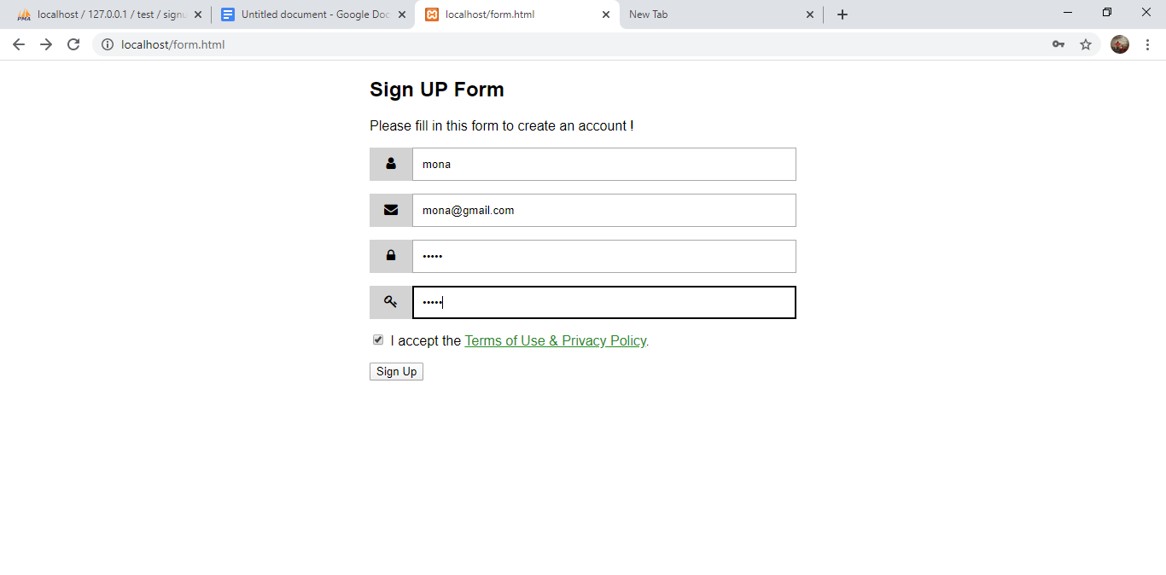

2- Data is being posted in database

