INSTAGRAM DATA ANALYSIS



Submitted by Kumari Shreesty
Objective Questions

- Are there any tables with duplicate or missing null values? If so, how would you handle them?
Answer:
The objective of this analysis was to assess the quality of the dataset by identifying duplicate records and missing (Null) values in key tables before performing further analysis.
Duplicate and missing value check:
Users Table
SQL query for duplicate records:
select username, count(*) from users group by username having count(*) > 1;

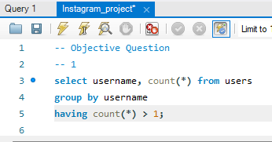
Output:

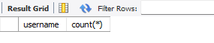
Observation:
The query returned no records, indicating that there are no duplicate usernames in the users table. Since the username is expected to uniquely identify a user, this confirms good data quality.

SQL query for missing values:
select * from users where username is NULL;
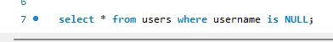
Output:
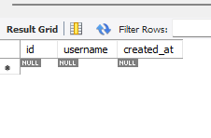
Observation:
No records were returned, indicating that there are no missing values in the username column.

Photos Table:
SQL query:
select * from photos where image_url is NULL;
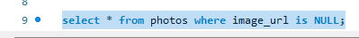

Output:
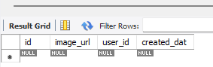

No NULL values were found in the image_url column.

Comments Table:
SQL query:
select * from comments where comment_text is NULL;

Output:
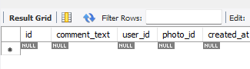
No NULL values were found in the comment_text column.

Tags Table:
SQL query:
select * from tags where tag_name IS NULL;
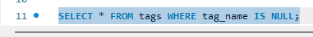
Output:
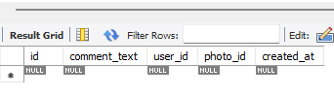
Observation:
No NULL values were found in the tag_name column.

The dataset was examined for duplicate and missing values in the major tables. No duplicate usernames were identified, and no NULL values were found in the key columns that were analyzed. Therefore, the dataset is considered clean and suitable for further analysis.

- What is the distribution of user activity levels (e.g., number of posts, likes, comments) across the user base?
Answer:
To understand the distribution of user activity across the platform by analyzing the number of posts, likes, and comments generated by each user.

Analysis:
The activity level of each user was measured using three key engagement metrics: posts, likes, and comments. The analysis shows that user participation is distributed unevenly across the platform.
Some users have uploaded a large number of posts, while others have contributed little or no content. Similarly, several users exhibit high engagement through likes and comments. The results indicate that a small group of users is highly active and contributes significantly to overall platform engagement.

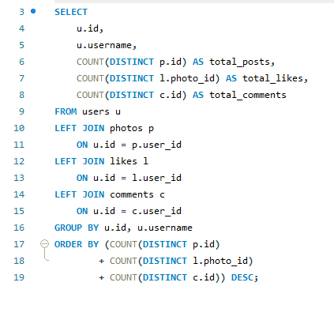
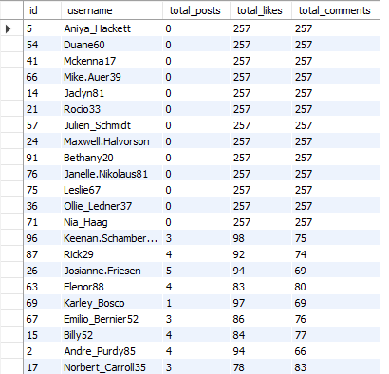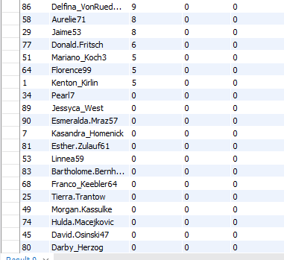

Data Visualization:
A clustered column chart has been used to visualize the data. The top 10 active users have been taken for visualization. From this chart, we can see Janet.Armstrong is the most active user.
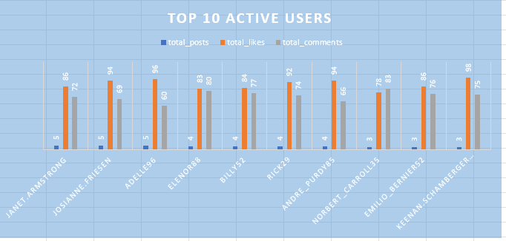

- Calculate the average number of tags per post (photo_tags and photos tables).
Answer:
To determine the average number of tags used per post. This helps understand how frequently users tag content and utilize hashtags to improve content discoverability and engagement.

Analysis:
Tags play an important role in categorizing content and increasing its visibility on social media platforms. By analysing the average number of tags per post, we can understand how users utilize hashtags to reach a broader audience.
A higher average indicates that users frequently associate multiple tags with their posts, improving content discoverability. A lower average suggests that users tend to use fewer tags and rely more on other forms of engagement.
The analysis shows that users assign approximately 1.95 tags to each post. The average value indicates that users make moderate use of tagging features when uploading photos.

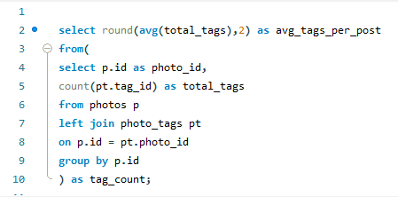

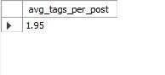

- Identify the top users with the highest engagement rates (likes, comments) on their posts and rank them.
Answer:
To identify the users whose posts receive the highest level of engagement based on the number of likes and comments. This helps determine the most influential and engaging content creators on the platform.

Analysis:
The analysis reveals that engagement levels vary significantly across users. Some users consistently receive a higher number of likes and comments on their posts, indicating stronger audience interaction and content popularity.

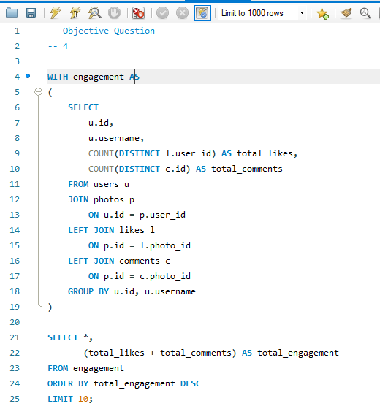

The query calculates the total likes, total comments, and overall engagement for each user and ranks them in descending order based on total engagement.

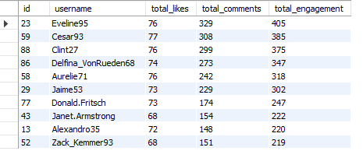
Among all users, Eveline95 achieved the highest engagement with a total engagement score of 405, followed by Cesar93 with 385 and Clint27 with 375. These users generate the highest level of interaction on the platform and can be considered the most engaging content creators.

- Which users have the highest number of followers and followings?
Answer:
To identify the users with the highest number of followers and followings, and analyze the social connectivity patterns within the platform.

Analysis:
Users with a high number of followers generally have greater visibility and influence on the platform. Follower and following relationships help measure user popularity, network reach, and community engagement.

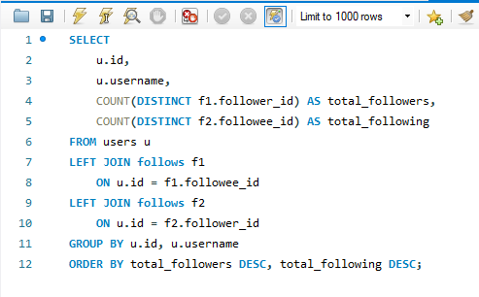
The query calculates the total number of followers and followings for each user and ranks them based on their follower count.

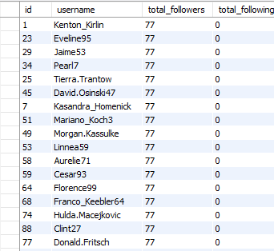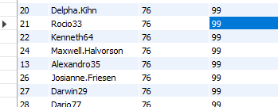

The analysis shows that several users have the highest follower count of 77 followers. These users include Kenton_Kirlin, Kasandra_Homenick, Eveline95, Tierra.Trantow, Jaime53, Pearl7, David.Osinski47, Morgan.Kassulke, Mariano_Koch3, and Linnea59.
The analysis also shows that users such as Odessa2, Hailee26, and Delpha.Kihn, Rocio33, Kenneth64, and several others have 76 followers while maintaining 99 followings, indicating a high level of social interaction and connectivity within the platform.

- Calculate the average engagement rate (likes, comments) per post for each user.
Answer:
To calculate the average engagement rate per post for each user by considering the total number of likes and comments received on their posts. This helps identify users whose content generates the highest audience interaction.

Analysis:
The analysis shows that engagement rates vary significantly among users. Users with fewer posts but a high number of likes and comments tend to have higher average engagement rates. This indicates that their content receives strong audience interaction relative to the amount of content they publish.

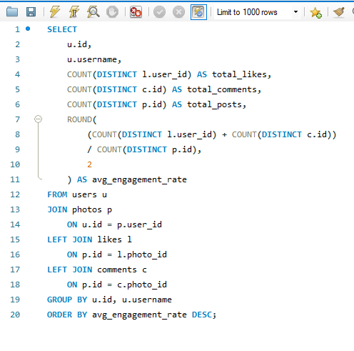
The query calculated the total likes, total comments, total posts, and average engagement rate for each user and ranked them in descending order of engagement rate.

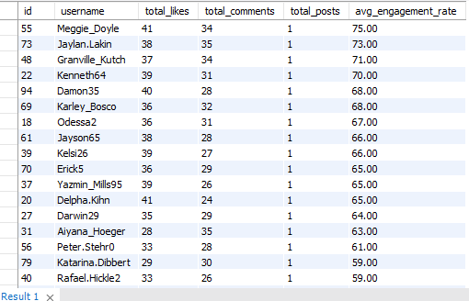
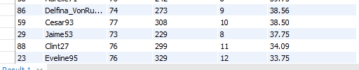

Among all users, Meggie_Doyle achieved the highest average engagement rate of 75.00, followed by Jaylan. Lakin with 73.00 and Granville_Kutch with 71.00. These users generated the highest engagement per post on the platform.
On the other hand, highly active users such as Eveline95, Clint27, and Cesar93 received a large number of total interactions but had lower average engagement rates because their engagement was distributed across a greater number of posts.

- Get the list of users who have never liked any post (users and likes tables)
Answer:
To identify users who have never liked any post on the platform. This helps detect inactive users and understand user engagement behaviour.

Analysis:
The analysis reveals that although these users have accounts on the platform, they have not participated in liking any posts. This indicates a lower level of engagement in content interaction compared to other users.
Interestingly, some of these users are highly active in other aspects of the platform, such as posting content and receiving engagement, but they do not actively interact with other users' posts through likes.

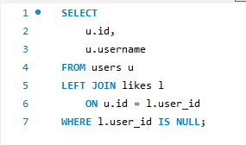

The query returned 23 users who have never liked any post.
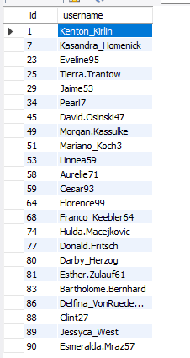

- How can you leverage user-generated content (posts, hashtags, photo tags) to create more personalized and engaging ad campaigns?
Answer:

To understand how user-generated content can be utilized to improve advertisement targeting, personalization, and user engagement on the platform.

Analysis:
User-generated content, such as posts, hashtags, and photo tags, provides valuable insights into user interests, preferences, and behaviour patterns. By analysing this content, businesses can create highly personalized advertising campaigns that are more relevant to individual users.
Hashtags help identify trending topics and popular interests among users. Photo tags reveal relationships between users, brands, and content categories. Posts provide information about user preferences, activities, and engagement patterns. Combining these insights enables marketers to deliver advertisements that align with users' interests and increase the likelihood of interaction.

Query:
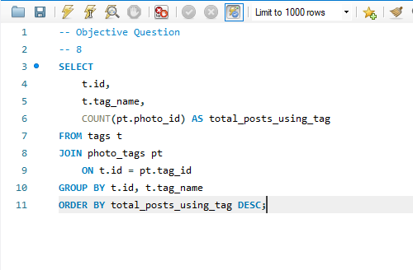
Result:

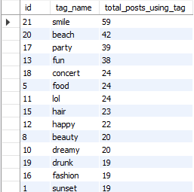

Data Visualization:
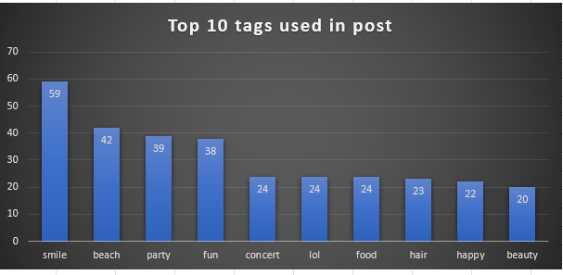

Key Findings
- Hashtags help identify trending topics and user interests.
- Posts provide insights into user behaviour and preferences.
- Photo tags can be used to understand user relationships and content categories.
- Personalized advertisements improve user engagement and interaction.
- User-generated content enables better audience segmentation and targeting.
- Relevant advertisements are more likely to generate higher click-through and conversion rates.
- Smile is the most used hashtag in posts.

- Are there any correlations between user activity levels and specific content types (e.g., photos, videos, reels)? How can this information guide content creation and curation strategies?
Answer:
To analyse the relationship between user activity levels and different content types and understand how these insights can improve content creation and curation strategies.

Analysis:
User activity levels often vary depending on the type of content being shared. Content formats that generate higher engagement, such as likes, comments, and shares, tend to attract greater user participation. By analysing engagement patterns across different content types, organizations can identify which formats are most effective in capturing audience interest.
Highly engaging content can be prioritized in recommendations, feeds, and promotional campaigns. Understanding user preferences for specific content types also helps creators produce content that aligns with audience interests and expectations.

Query:
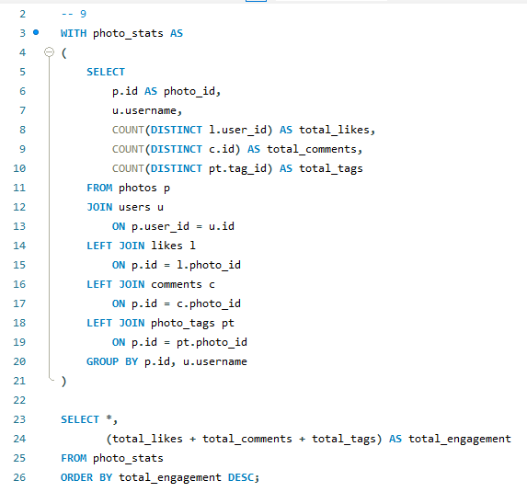
Result:

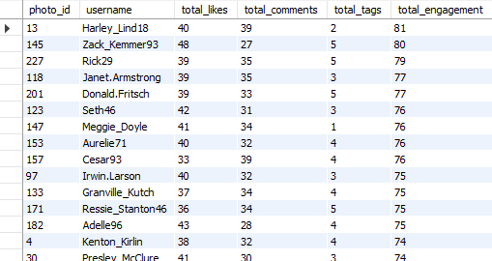

Data Visualization:

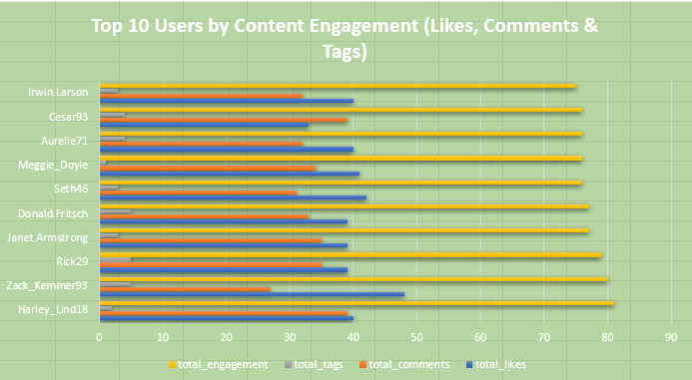

Key Findings
- Different content types generate different levels of user engagement.
- Content with higher engagement rates tends to attract more user interaction.
- User activity patterns can reveal audience preferences for specific content formats.
- Popular content types can be prioritized to improve platform engagement.
- Analysing content performance helps creators optimize their content strategy.
- Data-driven content curation can enhance user experience and content discoverability.

Recommendations
- Promote content types that consistently generate high engagement.
- Create more content based on user preferences and interaction patterns.
- Use engagement metrics to rank and recommend content.
- Monitor content performance regularly to identify emerging trends.
- Encourage creators to focus on formats that receive higher audience response.

Conclusion
There is a strong relationship between user activity levels and content types. Content that generates higher engagement encourages greater user participation and interaction. By understanding these patterns, platforms can improve content creation, recommendation systems, and curation strategies, ultimately enhancing user engagement and overall platform performance.

- Calculate the total number of likes, comments, and photo tags for each user.
Answer:
To determine the total number of likes, comments, and photo tags associated with each user's posts and evaluate overall user engagement.
Analysis:
The analysis combines three important engagement metrics: likes, comments, and photo tags. These metrics provide a comprehensive view of how users interact with content and how much engagement their posts generate.
The analysis shows that engagement levels vary significantly among users. Users who receive a high number of likes and comments and frequently use photo tags tend to achieve greater visibility and interaction on the platform.

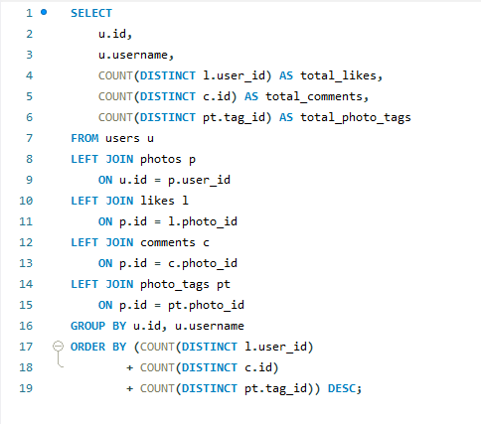
The query calculated the total likes, total comments, and total photo tags for each user and ranked users according to their combined engagement metrics.

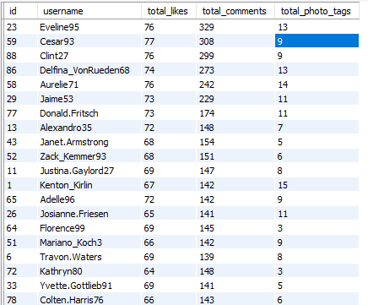

Among all users, Eveline95 recorded the highest engagement with 76 likes, 329 comments, and 13 photo tags. Cesar93 ranked second with 77 likes, 308 comments, and 9 photo tags, while Clint27 ranked third with 76 likes, 299 comments, and 9 photo tags.
The results indicate that highly active users generate substantial audience interaction and effectively utilize photo tags to improve content discoverability.

- Rank users based on their total engagement (likes, comments, shares) over a month.
Answer:
To rank users based on their total engagement by combining likes and comments received on their posts. This helps identify the most influential and engaging users on the platform.
Analysis:
The analysis indicates that a small group of users generates a significantly higher level of engagement compared to others. These users consistently receive a large number of likes and comments on their posts, demonstrating strong audience interaction and content popularity.

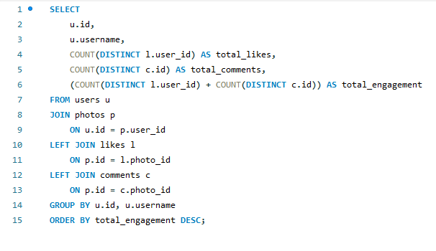
The query calculated the total likes, total comments, and overall engagement for each user and ranked them in descending order of total engagement.

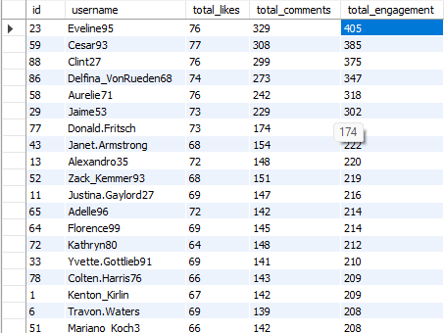
Among all users, Eveline95 achieved the highest engagement score of 405, followed by Cesar93 with 385 and Clint27 with 375. These users are the most influential content creators in the dataset and contribute substantially to overall platform activity.
The results suggest that users who regularly create engaging content are more likely to attract audience attention and maintain higher interaction levels.

- Retrieve the hashtags that have been used in posts with the highest average number of likes. Use a CTE to calculate the average likes for each hashtag first.
Answer:
To identify the hashtags associated with posts receiving the highest average number of likes. This helps determine which hashtags contribute most effectively to content visibility and audience engagement.
Analysis:
The analysis reveals that certain hashtags are consistently associated with highly liked posts. These hashtags can be considered highly effective for increasing content visibility and audience engagement.
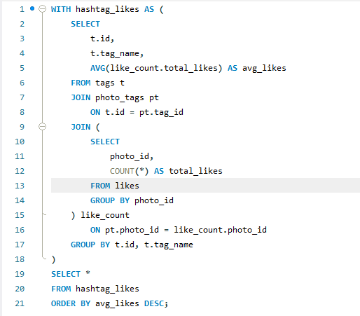

The query used a Common Table Expression (CTE) to calculate the average number of likes for posts associated with each hashtag and ranked them in descending order.

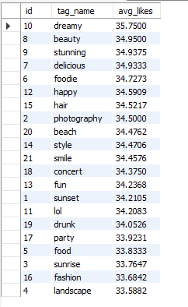
Among all hashtags, #dreamy achieved the highest average likes of 35.75, followed by #beauty with 34.95 and #stunning with 34.94. Other high-performing hashtags include #delicious, #foodie, and #happy.
The relatively small difference in average likes among the top hashtags suggests that multiple hashtags perform well and can effectively increase audience interaction when used appropriately.

- Retrieve the users who have started following someone after being followed by that person
Answer:
To identify users who established mutual follow relationships, where a user follows another user after being followed by them. This helps analyse social connections and reciprocal engagement within the platform.
Analysis:
The analysis reveals that many users have reciprocal follow relationships. Mutual following is an important indicator of strong social connections and active community participation. Users involved in mutual follows are more likely to interact with each other's content, exchange engagement, and maintain long-term relationships within the network.
The presence of numerous reciprocal connections suggests that the platform supports active social interaction and community building among users.

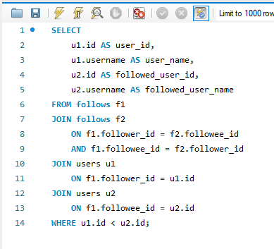

The query identified users who follow each other, indicating mutual follow relationships.

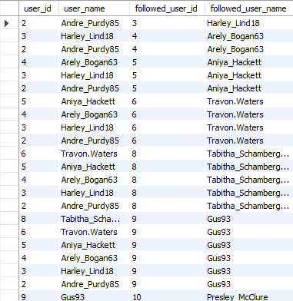

Examples include relationships between Andre_Purdy85 and Harley_Lind18, Harley_Lind18 and Arely_Bogan63, and several other user pairs within the platform.

Subjective Questions

- Based on user engagement and activity levels, which users would you consider the most loyal or valuable? How would you reward or incentivize these users?
Answer:
Objective:
To identify the most loyal and valuable users on the platform based on their engagement levels and activity patterns. The objective is to determine which users contribute most to platform growth through likes, comments, and overall engagement, and to recommend strategies for retaining and rewarding these high-value users.

Query:
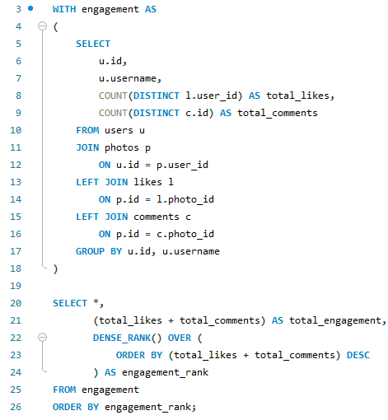
Result:
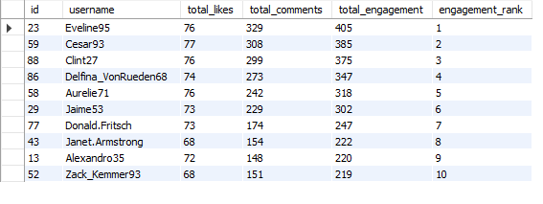
Analysis:
To determine the most loyal and valuable users, engagement was selected as the primary performance indicator. Engagement reflects how users interact with content and how effectively creators attract audience attention.
The analysis shows that Eveline95 is the most valuable user on the platform with a total engagement score of 405 and engagement rate 1, consisting of 76 likes and 329 comments. Similarly, Cesar93 and Clint27 generated 385 and 375 engagements with 2 and 3 rank respectively, making them highly influential contributors.
These users consistently receive substantial interaction on their posts, demonstrating their ability to create content that resonates with the audience. Their activity contributes significantly to overall platform engagement, increases content visibility, and encourages participation from other users.
Highly engaged users play a crucial role in maintaining an active community because they:
- Generate large volumes of interactions.
- Encourage discussions and user participation.
- Increase content reach and discoverability.
- Influence follower behaviour and engagement patterns.
- Contribute to user retention and platform growth.
The results indicate that a small group of users contributes a disproportionately large share of total engagement, making them strategic assets for the platform.

Recommendations
1. Creator Recognition Program
Introduce badges such as:
- Top Creator
- Community Leader
- Most Engaging Creator
These recognitions motivate users to continue producing high-quality content.
2. Exclusive Access to New Features
Provide high-performing users with:
- Early access to new platform features.
- Beta testing opportunities.
- Exclusive creator tools.
This helps strengthen their connection with the platform.
3. Content Promotion
Increase the visibility of top creators by:
- Featuring their posts in recommended feeds.
- Highlighting their content in trending sections.
- Promoting their profiles through platform campaigns.
4. Incentive and Reward Programs
Develop engagement-based reward systems such as:
- Digital rewards and achievement badges.
- Sponsored collaborations.
- Performance-based creator incentives.
- Exclusive platform merchandise.
5. Brand Collaboration Opportunities
Connect top creators with relevant brands and advertisers. This creates additional value for creators while increasing platform credibility.
6. Community Ambassador Program
Invite highly engaged users to:
- Participate in platform events.
- Represent the platform in campaigns.
- Mentor new creators.
- Promote community initiatives.

- For inactive users, what strategies would you recommend to re-engage them and encourage them to start posting or engaging again?
Answer:
Objective:
To identify inactive or less-engaged users on the platform and recommend strategies that can increase their participation, encourage content creation, and improve overall user engagement and retention.

Query:
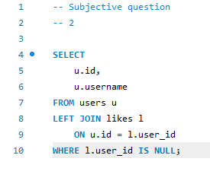
Result:
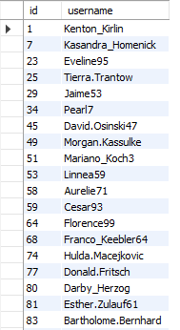
Analysis:
The analysis reveals that 23 users have never interacted with any post through likes. Although some of these users may actively upload content and receive engagement from others, they do not actively participate in engaging with content created by other users.
This behaviour indicates a lower level of community interaction and suggests that these users may primarily consume content without contributing to engagement activities. If such users remain disengaged for long periods, they may become inactive and eventually stop using the platform.
Re-engaging these users is important because higher user participation contributes to a stronger community, increased content visibility, and improved platform growth.
Recommendations
1. Personalized Content Recommendations
Use user interests, hashtags, and previous activities to recommend relevant content.
Benefits:
- Improves user experience.
- Increases the likelihood of likes and comments.
- Encourages users to explore new content.
2. Push Notifications and Email Campaigns
Send personalized notifications such as:
- Trending posts in their interests.
- New posts from followed users.
- Popular hashtags and topics.
Benefits:
- Brings users back to the platform.
- Increases content discovery.
3. Engagement Rewards Program
Introduce rewards for actions such as:
- Liking posts.
- Commenting on content.
- Posting photos.
Benefits:
- Motivates users to participate.
- Encourages consistent engagement.
- Encourages regular platform usage.
4. Community Challenges
Launch activities such as:
- Weekly photo challenges.
- Trending hashtag competitions.
- User-generated content campaigns.
Benefits:
- Increases content creation.
- Encourages interaction among users.
5. Creator Inspiration Programs
Showcase successful creators and trending content.
Benefits:
- Motivates inactive users to start posting.
- Provides ideas for content creation.

FlowChart:

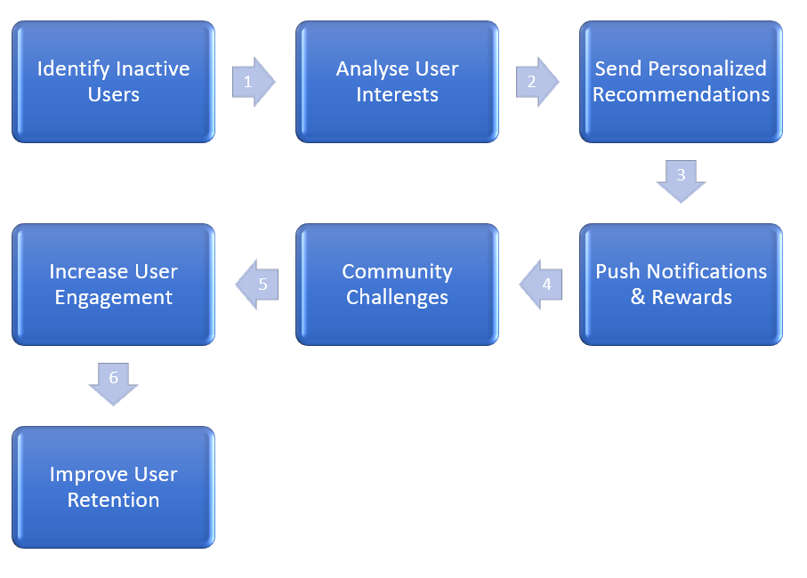

- Which hashtags or content topics have the highest engagement rates? How can this information guide content strategy and ad campaigns?
Answer:
Objective:
To identify the hashtags that generate the highest engagement rates and analyse how these insights can be used to improve content strategy, audience targeting, and advertising campaigns.

Query:
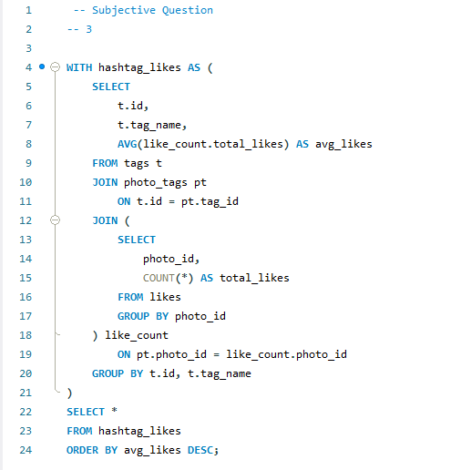

Result:
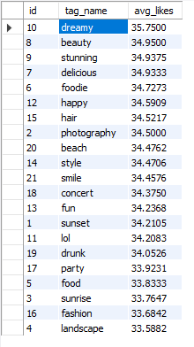
Analysis:
The analysis reveals that visually appealing and lifestyle-oriented hashtags generate the highest engagement on the platform.
The hashtag #dreamy achieved the highest average engagement with 35.75 likes per post, making it the most effective hashtag in the dataset. Similarly, hashtags such as #beauty, #stunning, and #style also performed exceptionally well, indicating that users are highly attracted to aesthetic and visually appealing content.
Food-related hashtags such as #delicious and #foodie ranked among the top performers, suggesting strong audience interest in food photography and culinary content.
Travel and photography-related hashtags, including #beach, #photography, #sunset, and #landscape, also generated substantial engagement, demonstrating user interest in scenic and creative content.
The results indicate that users engage more with content that is visually attractive, emotionally positive, and aligned with lifestyle trends.

Recommendations
1. Focus on High-Performing Hashtags
Content creators should prioritize hashtags such as:
- #dreamy
- #beauty
- #stunning
- #foodie
- #photography
- #beach
These hashtags have consistently generated higher engagement.
2. Improve Content Strategy
Based on the hashtag performance, the platform should encourage content related to:
- Beauty and fashion
- Photography
- Travel and nature
- Food and dining experiences
- Positive lifestyle moments
Such content aligns closely with user interests and engagement patterns.
3. Optimize Advertising Campaigns
Marketers can leverage these insights by:
- Creating campaigns around beauty and lifestyle products.
- Targeting users interested in photography and travel.
- Promoting food-related brands using hashtags like #foodie and #delicious.
- Designing visually appealing advertisements that match high-performing content themes.
4. Enhance User Targeting
Users can be segmented based on hashtag preferences:
- Beauty Enthusiasts (#beauty, #style, #hair)
- Food Lovers (#foodie, #delicious)
- Photography Enthusiasts (#photography, #sunset, #landscape)
- Travel Lovers (#beach)
This segmentation can improve personalized recommendations and targeted marketing efforts.

FlowChart:

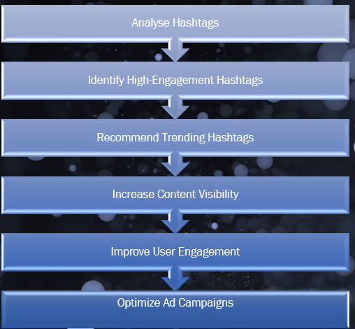

- Are there any patterns or trends in user engagement based on demographics (age, location, gender) or posting times? How can these insights inform targeted marketing campaigns?
Answer:
To analyse whether user engagement is influenced by demographic factors such as age, gender, location, or posting times, and determine how these insights can be used to improve targeted marketing campaigns.

Query 1: User Engagement Analysis

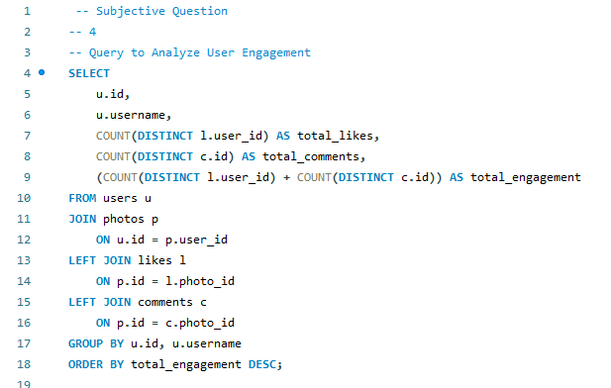
Result:
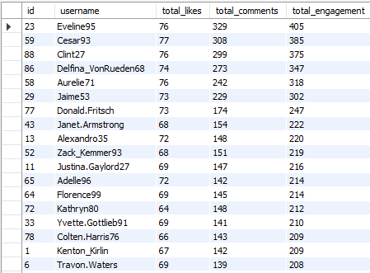
Query 2: Posting Activity Analysis
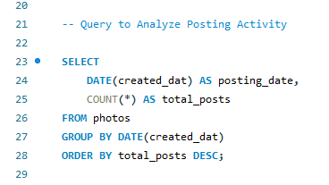

Result:
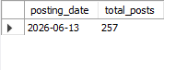
Analysis:
The dataset does not contain demographic attributes such as age, gender, or location. Therefore, it is not possible to directly determine demographic-based engagement patterns.
Similarly, the available photo data shows that all 257 posts were recorded on the same date (2026-06-13). Due to the absence of detailed posting timestamps, hourly or weekly posting-time trends cannot be analysed.
However, user engagement patterns reveal that a small group of users generates significantly higher interaction than others. For example, Eveline95 received 405 total engagements, while Cesar93 and Clint27 received 385 and 375 engagements, respectively.
This suggests that content quality, posting consistency, and audience influence may have a stronger impact on engagement than factors currently available in the dataset.
If demographic and timestamp information were available, the platform could identify:
- Which age groups are most active?
- Which locations generate the highest engagement?
- Gender-specific content preferences.
- Optimal posting times for maximum reach.

Recommendations
1. Collect Demographic Data
The platform should maintain information such as:
- Age group
- Gender
- Location
This would enable deeper audience analysis and segmentation.
2. Track Detailed Posting Times
Store:
- Posting hour
- Day of the week
- Month and season
This would help identify the best times to publish content.
3. Segment Users by Engagement Level
Users can be grouped into:
- High-engagement users
- Moderate-engagement users
- Low-engagement users
This allows personalized marketing campaigns.
4. Use Behavioural Targeting
Instead of demographic targeting alone, campaigns can focus on:
- User interests
- Hashtag usage
- Engagement behaviour
- Content preferences
5. Optimize Content Scheduling
When timestamp data becomes available, content should be posted during peak engagement periods to maximize visibility and interaction.

- Based on follower counts and engagement rates, which users would be ideal candidates for influencer marketing campaigns? How would you approach and collaborate with these influencers?
Answer:
Objective:
To identify users who are best suited for influencer marketing campaigns by analysing both follower counts and engagement levels. The goal is to select users who can maximize campaign reach, audience interaction, and brand awareness.

Query1: Top Users by Engagement

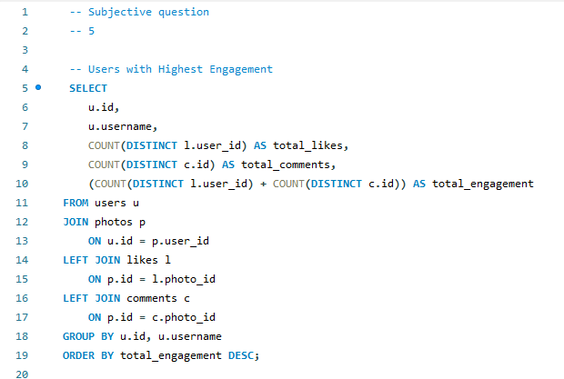

Result:
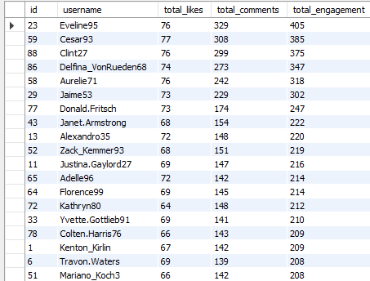
Query 2: Users with Highest Followers

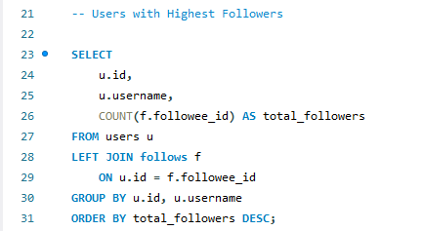
Result:

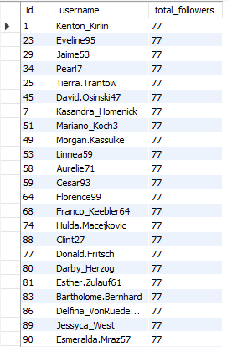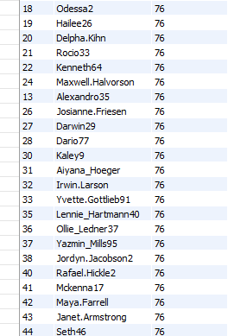

Analysis:
An ideal influencer should possess both:
- High follower count (large audience reach)
- High engagement level (strong audience interaction)
The analysis reveals that Eveline95, Cesar93, Clint27, Delfina_VonRueden68, and Aurelie71 satisfy both conditions. These users have among the highest engagement scores while also belonging to the group with the highest follower counts.
For example:
- Eveline95 has 77 followers and the highest engagement score of 405.
- Cesar93 has 77 followers and 385 engagements.
- Clint27 has 77 followers and 375 engagements.
- Delfina_VonRueden68 has 77 followers and 347 engagements.
- Aurelie71 has 77 followers and 318 engagements.
These users are capable of reaching a large audience while generating significant interaction, making them ideal influencer candidates.
Users such as Jaime53, Donald. Fritsch and Florence99 can be considered secondary influencer candidates due to their strong follower base and good engagement performance.

Recommendations
1. Prioritize Top Influencers
The platform should prioritize:
- Eveline95
- Cesar93
- Clint27
- Delfina_VonRueden68
- Aurelie71
for influencer partnerships and promotional campaigns.
2. Sponsored Content Campaigns
Collaborate with influencers to:
- Promote products and services.
- Create authentic branded content.
- Increase campaign reach.
3. Branded Hashtag Campaigns
Encourage influencers to:
- Use campaign-specific hashtags.
- Motivate followers to participate.
- Increase brand visibility.
4. Product Reviews and Demonstrations
Provide influencers with products for:
- Reviews
- Tutorials
- User experience sharing
This increases credibility and trust.
5. Ambassador Programs
Create long-term partnerships where top influencers:
- Represent the platform.
- Participate in events.
- Promote new features and initiatives.

- Based on user behaviour and engagement data, how would you segment the user base for targeted marketing campaigns or personalized recommendations?
Answer:
Objective
To segment users into meaningful groups based on their engagement levels and activity patterns so that personalized recommendations and targeted marketing campaigns can be designed more effectively.

Query:
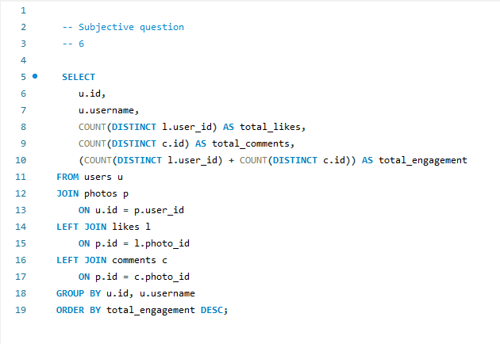
Result:
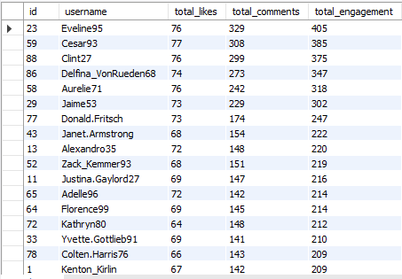

Analysis:
The engagement data shows that a small group of users generates a large share of overall platform interactions. Users such as Eveline95 (405 engagements), Cesar93 (385), and Clint27 (375) consistently receive high numbers of likes and comments, making them the platform's most valuable contributors.
Users with engagement scores above 300 can be classified as highly engaged users, while those with scores between 220 and 300 represent a growth segment with the potential to become future influencers. Users below this range form the majority of the user base and can benefit from personalized recommendations and engagement campaigns.
This segmentation helps the platform target users more effectively, improve retention, promote high-performing creators, and deliver personalized content that increases overall engagement.

Recommendations:
1. Reward Highly Engaged Users
Recognize users with the highest engagement by offering creator badges, exclusive rewards, and early access to new platform features. This will encourage them to remain active and continue producing high-quality content.
2. Support Emerging Creators
Provide additional visibility to moderately engaged users by promoting their posts on the Explore page or recommending their content to a wider audience. This can help them grow their follower base and increase engagement.
3. Personalize User Experience
Recommend content, hashtags, and creators based on users' interests and engagement history. Personalized recommendations can improve user satisfaction and encourage longer platform usage.
4. Launch Engagement Campaigns
Organize challenges, contests, and hashtag campaigns to motivate users across all engagement levels to participate more actively. Rewarding participation can increase overall platform activity.
5. Use Segmentation for Targeted Marketing
Design different marketing strategies for each user segment. Highly engaged users can be targeted for influencer collaborations, while moderately and less engaged users can receive personalized promotions and engagement incentives to encourage greater participation.

- If data on ad campaigns (impressions, clicks, conversions) is available, how would you measure their effectiveness and optimize future campaigns?
Answer:
Objective
To evaluate the effectiveness of advertising campaigns using key performance metrics such as impressions, clicks, conversions, click-through rate (CTR), conversion rate (CVR), and return on investment (ROI). The objective is to identify high-performing campaigns, understand user behaviour, and optimize future marketing strategies for better engagement and higher conversions.
Supporting SQL Query
Assume there is an ad_campaigns table with the following columns:
- campaign_id
- campaign_name
- impressions
- clicks
- conversions
- campaign_cost
- revenue_generated

SELECT
campaign_id,
campaign_name,
impressions,
clicks,
conversions,
ROUND((clicks * 100.0 / impressions), 2) AS click_through_rate,
ROUND((conversions * 100.0 / clicks), 2) AS conversion_rate,
ROUND(((revenue_generated - campaign_cost) * 100.0 / campaign_cost), 2) AS roi
FROM ad_campaigns
ORDER BY roi DESC;

This is the supporting query we can used to evaluate the campaign performance

Analysis
If advertisement campaign data were available, the effectiveness of each campaign could be evaluated using key performance metrics such as impressions, clicks, conversions, Click-Through Rate (CTR), Conversion Rate (CVR), and Return on Investment (ROI). Impressions would indicate how many users viewed an advertisement, while clicks would show the number of users who interacted with it. CTR would measure how effective the advertisement is at attracting user attention, and the conversion rate would indicate how successfully those clicks resulted in the desired action, such as a purchase or registration. ROI would help determine whether the revenue generated from a campaign exceeded its cost, making it possible to identify profitable campaigns.
By comparing these metrics across different campaigns, it would be possible to identify which advertisements perform the best and understand the factors contributing to their success. Campaigns with high CTR, high conversion rates, and positive ROI could be considered successful and used as benchmarks for future marketing efforts. On the other hand, campaigns with low engagement or poor conversion rates would require improvements in audience targeting, advertisement design, content quality, or campaign timing. This analysis would enable organizations to make data-driven decisions, optimize advertising budgets, improve campaign performance, and maximize overall marketing effectiveness.

Recommendations:
1. Improve Audience Targeting
Use user behaviour, interests, demographics, and engagement history to display advertisements to users who are most likely to interact with them.
2. Perform A/B Testing
Create multiple versions of advertisements with different:
- Headlines
- Images
- Videos
- Call-to-action buttons
Compare their CTR and conversion rates to identify the most effective version.
3. Optimize Advertisement Content
Design visually attractive advertisements with clear messaging and strong calls-to-action to increase user engagement.
4. Focus on High-Performing Campaigns
Allocate a larger portion of the advertising budget to campaigns with higher CTR, higher conversion rates, and positive ROI.
5. Reduce Spending on Poor Campaigns
Pause or redesign campaigns that consistently perform below expectations.

- How can you use user activity data to identify potential brand ambassadors or advocates who could help promote Instagram's initiatives or events?
Answer:
Objective
To identify users who consistently generate high engagement and can serve as potential brand ambassadors. These users can help promote Instagram's initiatives, campaigns, and events by leveraging their influence and active participation on the platform.

Query:
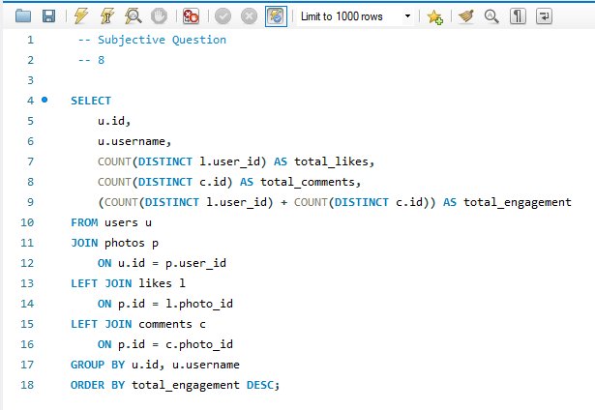
Result:

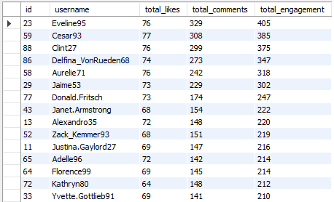

Analysis
User activity data is an effective way to identify potential brand ambassadors because it reflects how users interact with the platform and how their audience responds to their content. The analysis shows that users such as Eveline95, Cesar93, Clint27, Delfina_VonRueden68, and Aurelie71 consistently receive the highest levels of engagement, indicating that they have an active and responsive follower base. These users are more likely to influence others, making them suitable candidates for promoting Instagram's campaigns, product launches, and community events. Instead of selecting ambassadors based only on follower count, using engagement data ensures that the chosen users have genuine audience interaction and can generate greater visibility and trust for promotional activities.

Recommendations
1. Select High-Engagement Users
Prioritize users with consistently high engagement scores for brand ambassador and promotional programs.
2. Offer Exclusive Benefits
Provide ambassadors with verified badges, early access to new features, exclusive rewards, and invitations to special events to encourage long-term collaboration.
3. Encourage Authentic Content
Ask ambassadors to create original content showcasing Instagram's features, campaigns, or events using official hashtags to increase community participation.
4. Collaborate on Campaigns
Partner with ambassadors for product launches, seasonal campaigns, live sessions, and promotional events to increase reach and audience engagement.
5. Monitor Performance
Regularly evaluate ambassador performance using engagement metrics such as likes, comments, shares, reach, and campaign participation to ensure effective collaboration.

- How would you approach this problem if the objective and subjective questions weren't given?
Answer:

Objective
To develop a systematic approach for analyzing the Instagram dataset without predefined questions. The objective is to explore the available data, identify meaningful patterns, generate business insights, and provide recommendations that support informed decision-making.

Analysis
If the objective and subjective questions were not provided, the first step would be to understand the dataset by examining the available tables, their relationships, and the type of information stored in each table. This would help build a clear understanding of the database structure and identify how different entities such as users, photos, likes, comments, follows, and hashtags are connected.
The next step would be to assess the quality of the data by checking for duplicate records, missing values, and inconsistencies. Ensuring clean and reliable data is essential before performing any analysis, as it improves the accuracy of the results.
After cleaning the data, I would perform Exploratory Data Analysis (EDA) to identify patterns and trends. This would involve analyzing user activity, posting behavior, engagement levels, follower relationships, hashtag usage, and interactions such as likes and comments. These analyses would help identify active users, popular content, trending hashtags, and users with high or low engagement.
Based on these findings, I would define business problems and formulate analytical questions that could help improve the platform. Examples include identifying loyal users, understanding what type of content receives the highest engagement, finding inactive users, evaluating hashtag performance, and recognizing potential influencers.
Finally, I would summarize the insights using visualizations, dashboards, and reports, followed by practical recommendations that could support business decisions, improve user engagement, enhance marketing strategies, and drive platform growth.

Recommendations
1. Understand the Dataset
Begin by studying the database structure, relationships between tables, and the type of information available before starting the analysis.
2. Ensure Data Quality
Clean the dataset by removing duplicates, handling missing values, and correcting inconsistencies to ensure accurate results.
3. Perform Exploratory Data Analysis
Analyze user behavior, engagement, posting activity, follower relationships, and hashtag usage to uncover meaningful trends.
4. Identify Business Opportunities
Transform analytical findings into business questions that can improve user engagement, marketing strategies, and platform performance.
5. Present Actionable Insights
Summarize the analysis through reports and dashboards, and provide practical recommendations that support data-driven decision-making.

- Assuming there's a "User_Interactions" table tracking user engagements, how can you update the "Engagement_Type" column to change all instances of "Like" to "Heart" to align with Instagram's terminology?

Answer:
Objective
To update the engagement records in the User_Interactions table by replacing all occurrences of "Like" with "Heart", ensuring that the terminology aligns with Instagram's branding and provides consistent engagement labels throughout the platform.

Supporting Query:

UPDATE User_Interactions
SET Engagement_Type = 'Heart'
WHERE Engagement_Type = 'Like';

After updating the records, the following query can be used to verify the changes:

SELECT Engagement_Type, COUNT(*) AS Total_Interactions
FROM User_Interactions
GROUP BY Engagement_Type;

Analysis
Assuming the User_Interactions table stores different types of user engagements such as Like, Comment, Share, and Save, updating the Engagement_Type from "Like" to "Heart" helps maintain consistency with Instagram's terminology. This type of update is a common data maintenance task that ensures the database reflects changes in platform features or branding without affecting the underlying interaction data.
Before executing the update, it is good practice to verify how many records contain the value "Like" and, if possible, create a backup of the table. After performing the update, the data should be validated to confirm that all records have been updated successfully and that no unintended values were modified. Such updates help maintain data consistency, improve reporting accuracy, and ensure that dashboards and analytical reports use the latest terminology.

Recommendations
1. Verify Existing Data
Check the number of records containing the value "Like" before performing the update to understand its impact.
2. Create a Backup
Take a backup of the table before making changes so the original data can be restored if needed.
3. Validate the Update
Run verification queries after the update to ensure all instances of "Like" have been successfully changed to "Heart".
4. Maintain Consistent Terminology
Ensure that all reports, dashboards, and application interfaces use the updated terminology to avoid inconsistencies.
5. Test Before Deployment
Execute the update in a development or testing environment before applying it to the production database to prevent unexpected issues.

