Command to run backend – npm run dev

For frontend – npm run dev

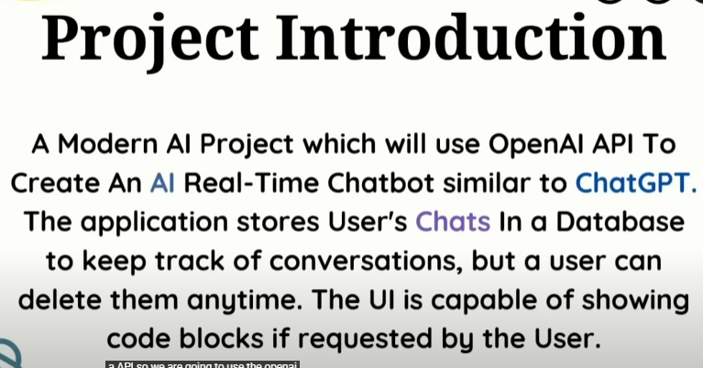

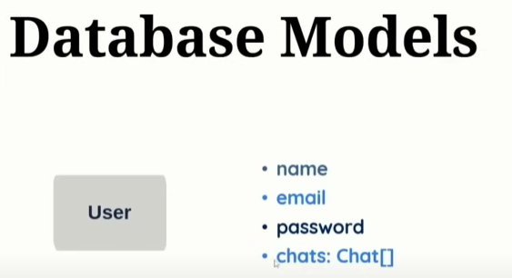

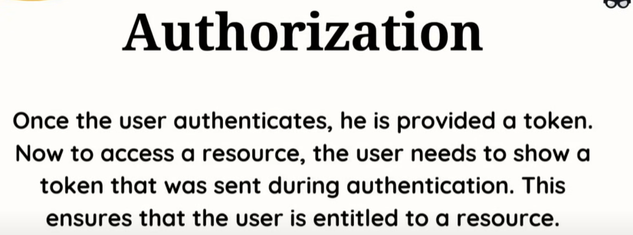

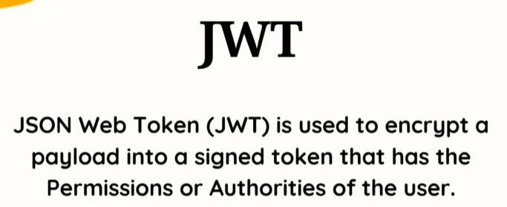

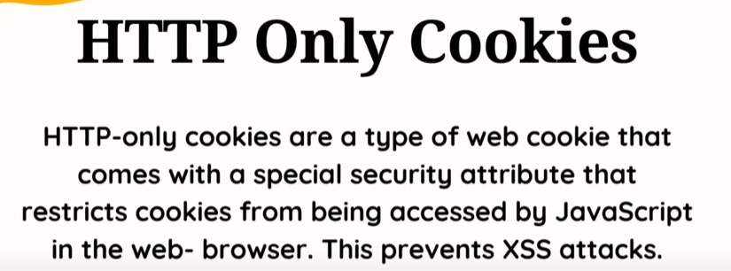

Toast package is used to get the notifications.

Context API we are using to decide what to show in the navigation bar.

Box is just like the div from the material-ui

Axios package is used to send request from frontend to backend.

**What is "Toast"?**

In user interface design, a "toast" or "toast notification" is a small, non-intrusive, temporary pop-up message that appears on the screen to provide feedback to the user, usually about an action they just performed.

One port no (backend at 5000) doesn’t allow another port no (frontend at 5173) to change it’s data through the requests and gave error. It’s a standard protocol. This issue is being resolved by cors.

Ref can be used to get the data of the input.

//@ts-ignore - to ignore the error in the next line

React-syntax-highlighter library to give the code response correct syntax form.

Made the chat route as protected route so now if the user is authorized and logged in then only the chat route is accessible else it will show not found.

**React type animation** – this library used at home page.