Spring Framework & Transactions
Hands-On Solutions Guide
Complete Code Walkthroughs & Sequence Diagrams for Every Chapter

Covers: Spring Core • Dependency Injection • MySQL Transactions • @Transactional
Propagation • Rollback Rules • Spring Events • Isolation Levels

Table of Contents

How to Use This Guide 3
Chapter 1: Spring Framework Introduction 4
1.1 Dependency Injection & IoC 4
1.2 Annotations Used in This Project 4
1.3 Creating the Spring Boot Application 5
1.4 Database Persistence — the Entity 6
1.5 Data Access Layer — the Repository 7
1.6 Service Layer 8
1.7 Presentation Layer — the Controller 9
1.8 Sequence Diagram: Request Flow Through the Layers 10
1.9 Running and Testing 11
1.10 Spring Framework Quiz — Answer Key 11
Chapter 2: Database Transactions 13
2.1 What Is a Transaction? 13
2.2 Installing Docker and MySQL 13
2.3 Setting Up the Balance-Enforcer Trigger 14
2.4 Transaction Management Using the MySQL Console 14
2.5 Sequence Diagram: Transaction with the Balance-Enforcer Trigger 15
2.6 Transaction Savepoints 16
2.7 Transaction Management Using Plain Java (JDBC) 17
2.8 Sequence Diagram: Plain Java Transaction Management 19
Chapter 3: Spring Transactions 21
3.1 Project Setup 21
3.2 The Domain Model 21
3.3 Handling the CORS Exception 23
3.4 The Repository and the @Transactional Service 24
3.5 Transactional Annotation and Transactional Updates 24
3.6 Read-Only Transactions 26
3.7 Spring Proxy — How @Transactional Actually Works 27
3.8 Demystifying Open Session in View (OSIV) 27
3.9 Eager Fetching Exposed 28
3.10 No-Session & Lazy Initialization Exceptions 29
3.11 Applied Transactions — Putting It Together 30
Chapter 4: Exceptions and Rollbacks 32
4.1 Exception Types 32
4.2 How Exceptions Affect Transactions 32
4.3 Sequence Diagram: Unchecked Exception — Automatic Rollback 33
4.4 Checked Exceptions Do Not Roll Back by Default 34
4.5 Sequence Diagram: Checked Exception — No Rollback 35
4.6 Controlling Rollback 36
4.7 Sequence Diagram: Controlling Rollback Explicitly 38
Chapter 5: Transaction Propagation 39
5.1 Propagation Types 39
5.2 PROPAGATION_REQUIRED — Joining the Caller's Transaction 39
5.3 Sequence Diagram: PROPAGATION_REQUIRED 41
5.4 PROPAGATION_REQUIRES_NEW — An Independent Inner Transaction 41
5.5 Sequence Diagram: PROPAGATION_REQUIRES_NEW 43
5.6 Transaction Boundaries 43
5.7 Data Inconsistency from Misused Propagation 43
5.8 Sequence Diagram: Data Inconsistency from Misused Propagation 45
5.9 Avoiding the Inconsistency 45
Chapter 6: Spring Events 46
6.1 Introduction to Spring Events 46
6.2 Event Listener 46
6.3 Sequence Diagram: Publishing and Handling a Basic Event 48
6.4 Conditional Event Handling 48
6.5 Sequence Diagram: Conditional Event Handling 49
6.6 Exception Propagation 49
6.7 Transactional Event Listener and the Before-Commit Phase 50
6.8 Sequence Diagram: @TransactionalEventListener Phases 52
6.9 Recovering from Failure, Listeners Gone Quiet, Fallback Execution 52
6.10 Sequence Diagram: Listener Exception Handling and Fallback 54
Chapter 7: Isolation Levels 55
7.1 Introduction to Isolation Levels 55
7.2 Hands-On Demo: READ UNCOMMITTED (Dirty Read) 55
7.3 Sequence Diagram: READ_UNCOMMITTED Dirty Read 56
7.4 Hands-On Demo: READ COMMITTED (Non-Repeatable Read) 56
7.5 Sequence Diagram: READ_COMMITTED Non-Repeatable Read 57
7.6 Hands-On Demo: REPEATABLE READ 57
7.7 Sequence Diagram: REPEATABLE_READ Preventing Non-Repeatable Reads 58
7.8 Hands-On Demo: SERIALIZABLE (Preventing Phantom Reads) 59
7.9 Sequence Diagram: SERIALIZABLE Preventing Phantom Reads 59
7.10 Setting Isolation Level from Spring 60
7.11 Chapter Summary 61

How to Use This Guide
This guide provides a complete, runnable hands-on solution for every section of the seven-chapter Spring Framework and Transactions course. Each chapter follows the same structure: a short conceptual explanation, full working Java/Spring code (entities, repositories, services, controllers, and configuration — not abbreviated snippets), at least one annotated sequence diagram showing the runtime behavior, and callout boxes highlighting common pitfalls.
All seven chapters build on a single, consistent domain: an order-processing system with Employees (Chapter 1), bank Accounts (Chapter 2 and 7), and Orders/OrderItems/Inventory/Payments/Audit logs (Chapters 3 through 6). Code from earlier chapters is referenced and extended in later chapters rather than replaced, mirroring how a real codebase evolves.
TIP
Every sequence diagram in this guide uses a consistent visual language: solid arrows are method calls or SQL statements, dashed arrows are return values, blue activation bars show how long a participant is actively processing, and yellow notes call out the specific behavior the diagram is meant to teach.

Chapter 1: Spring Framework Introduction — Hands-On Solution
This chapter builds a complete, runnable Spring Boot REST service for managing employees. It demonstrates the Inversion of Control (IoC) container, Dependency Injection (DI), core annotations, and the three classic layers of a Spring application: presentation (controller), service, and data access (repository), backed by a real MySQL database.

1.1 Dependency Injection & IoC
Spring's IoC container is responsible for creating objects (beans), wiring their dependencies together, and managing their lifecycle. Instead of a class creating its own collaborators with "new", it declares what it needs and Spring supplies ("injects") them. This is what makes Spring classes easy to test and easy to swap implementations for.
There are three common ways to inject a dependency in Spring: constructor injection, field injection, and setter injection. Constructor injection is the recommended approach because it makes dependencies explicit, allows fields to be declared final, and ensures the bean can never exist in a partially-initialized state.
// Constructor injection (recommended)
@Service
public class EmployeeService {

private final EmployeeRepository employeeRepository;

// Spring automatically injects the matching bean here.
// @Autowired is optional on a single constructor since Spring 4.3.
public EmployeeService(EmployeeRepository employeeRepository) {
this.employeeRepository = employeeRepository;
}
}
Example 1.1: Constructor-based dependency injection
PITFALL
Field injection (@Autowired on a private field) is common in tutorials but discouraged in production code: it hides dependencies, makes unit testing harder (you need reflection or a Spring context to set the field), and allows the object to be constructed in an invalid state. Prefer constructor injection.

1.2 Annotations Used in This Project
Annotation | Purpose
@SpringBootApplication | Marks the entry point class; enables auto-configuration, component scanning, and configuration support.
@RestController | Marks a class as a presentation-layer bean whose methods return data (usually JSON) rather than view names.
@Service | Marks a class as a service-layer bean holding business logic.
@Repository | Marks a class as a data-access bean; Spring also translates persistence exceptions into Spring's DataAccessException hierarchy.
@Entity | Marks a class as a JPA-managed persistent entity mapped to a database table.
@Autowired | Requests dependency injection; optional on constructors with a single candidate.
@RequestMapping / @GetMapping / @PostMapping | Map HTTP requests to controller handler methods.
@PathVariable / @RequestBody | Bind parts of the HTTP request (URL segments, JSON body) to method parameters.

1.3 Creating the Spring Boot Application
The project uses Maven with the following key dependencies: spring-boot-starter-web (for the embedded Tomcat server and REST support), spring-boot-starter-data-jpa (for Hibernate/JPA), and mysql-connector-j (the MySQL JDBC driver).
<!-- pom.xml (relevant excerpt) -->
<dependencies>
<dependency>
<groupId>org.springframework.boot</groupId>
<artifactId>spring-boot-starter-web</artifactId>
</dependency>
<dependency>
<groupId>org.springframework.boot</groupId>
<artifactId>spring-boot-starter-data-jpa</artifactId>
</dependency>
<dependency>
<groupId>com.mysql</groupId>
<artifactId>mysql-connector-j</artifactId>
<scope>runtime</scope>
</dependency>
<dependency>
<groupId>org.springframework.boot</groupId>
<artifactId>spring-boot-starter-test</artifactId>
<scope>test</scope>
</dependency>
</dependencies>
Example 1.2: Maven dependencies
# src/main/resources/application.properties
spring.datasource.url=jdbc:mysql://localhost:3306/employee_db
spring.datasource.username=root
spring.datasource.password=root
spring.jpa.hibernate.ddl-auto=update
spring.jpa.show-sql=true
spring.jpa.properties.hibernate.format_sql=true
server.port=8080
Example 1.3: application.properties
package com.example.employeeapp;

import org.springframework.boot.SpringApplication;
import org.springframework.boot.autoconfigure.SpringBootApplication;

@SpringBootApplication
public class EmployeeAppApplication {
public static void main(String[] args) {
SpringApplication.run(EmployeeAppApplication.class, args);
}
}
Example 1.4: EmployeeAppApplication.java — the entry point

1.4 Database Persistence — the Entity
package com.example.employeeapp.entity;

import jakarta.persistence.*;

@Entity
@Table(name = "employee")
public class Employee {

@Id
@GeneratedValue(strategy = GenerationType.IDENTITY)
private Long id;

@Column(nullable = false)
private String name;

@Column(nullable = false)
private String department;

@Column(name = "salary")
private Double salary;

public Employee() {
}

public Employee(String name, String department, Double salary) {
this.name = name;
this.department = department;
this.salary = salary;
}

// Getters and setters
public Long getId() { return id; }
public void setId(Long id) { this.id = id; }

public String getName() { return name; }
public void setName(String name) { this.name = name; }

public String getDepartment() { return department; }
public void setDepartment(String department) { this.department = department; }

public Double getSalary() { return salary; }
public void setSalary(Double salary) { this.salary = salary; }
}
Example 1.5: Employee.java — JPA entity mapped to the employee table

1.5 Data Access Layer — the Repository
Spring Data JPA generates the implementation of this interface at runtime — no SQL or boilerplate CRUD code is required for standard operations. Custom finder methods are derived from the method name.
package com.example.employeeapp.repository;

import com.example.employeeapp.entity.Employee;
import org.springframework.data.jpa.repository.JpaRepository;
import org.springframework.stereotype.Repository;

import java.util.List;

@Repository
public interface EmployeeRepository extends JpaRepository<Employee, Long> {

// Derived query: Spring Data JPA generates
// "SELECT * FROM employee WHERE department = ?" automatically.
List<Employee> findByDepartment(String department);
}
Example 1.6: EmployeeRepository.java

1.6 Service Layer
The service layer contains business rules and orchestrates repository calls. Controllers should never talk to repositories directly; this keeps business logic in one place and out of the HTTP-handling code.
package com.example.employeeapp.service;

import com.example.employeeapp.entity.Employee;
import com.example.employeeapp.exception.EmployeeNotFoundException;
import com.example.employeeapp.repository.EmployeeRepository;
import org.springframework.stereotype.Service;

import java.util.List;

@Service
public class EmployeeService {

private final EmployeeRepository employeeRepository;

public EmployeeService(EmployeeRepository employeeRepository) {
this.employeeRepository = employeeRepository;
}

public List<Employee> getAllEmployees() {
return employeeRepository.findAll();
}

public Employee getEmployeeById(Long id) {
return employeeRepository.findById(id)
.orElseThrow(() -> new EmployeeNotFoundException(id));
}

public Employee createEmployee(Employee employee) {
return employeeRepository.save(employee);
}

public Employee updateEmployee(Long id, Employee updated) {
Employee existing = getEmployeeById(id);
existing.setName(updated.getName());
existing.setDepartment(updated.getDepartment());
existing.setSalary(updated.getSalary());
return employeeRepository.save(existing);
}

public void deleteEmployee(Long id) {
Employee existing = getEmployeeById(id);
employeeRepository.delete(existing);
}

public List<Employee> getEmployeesByDepartment(String department) {
return employeeRepository.findByDepartment(department);
}
}
Example 1.7: EmployeeService.java
package com.example.employeeapp.exception;

public class EmployeeNotFoundException extends RuntimeException {
public EmployeeNotFoundException(Long id) {
super("Employee not found with id: " + id);
}
}
Example 1.8: EmployeeNotFoundException.java

1.7 Presentation Layer — the Controller
package com.example.employeeapp.controller;

import com.example.employeeapp.entity.Employee;
import com.example.employeeapp.service.EmployeeService;
import org.springframework.http.HttpStatus;
import org.springframework.http.ResponseEntity;
import org.springframework.web.bind.annotation.*;

import java.util.List;

@RestController
@RequestMapping("/api/employees")
public class EmployeeController {

private final EmployeeService employeeService;

public EmployeeController(EmployeeService employeeService) {
this.employeeService = employeeService;
}

@GetMapping
public List<Employee> getAllEmployees() {
return employeeService.getAllEmployees();
}

@GetMapping("/{id}")
public ResponseEntity<Employee> getEmployeeById(@PathVariable Long id) {
return ResponseEntity.ok(employeeService.getEmployeeById(id));
}

@GetMapping("/department/{department}")
public List<Employee> getByDepartment(@PathVariable String department) {
return employeeService.getEmployeesByDepartment(department);
}

@PostMapping
@ResponseStatus(HttpStatus.CREATED)
public Employee createEmployee(@RequestBody Employee employee) {
return employeeService.createEmployee(employee);
}

@PutMapping("/{id}")
public ResponseEntity<Employee> updateEmployee(@PathVariable Long id,
@RequestBody Employee employee) {
return ResponseEntity.ok(employeeService.updateEmployee(id, employee));
}

@DeleteMapping("/{id}")
@ResponseStatus(HttpStatus.NO_CONTENT)
public void deleteEmployee(@PathVariable Long id) {
employeeService.deleteEmployee(id);
}
}
Example 1.9: EmployeeController.java

1.8 Sequence Diagram: Request Flow Through the Layers
The diagram below traces a single GET request from the client through the controller, service, and repository layers down to MySQL, and back. Notice that at this point the IoC container has already done its work — every bean (controller, service, repository) was instantiated and wired together once, at application startup, not on every request.
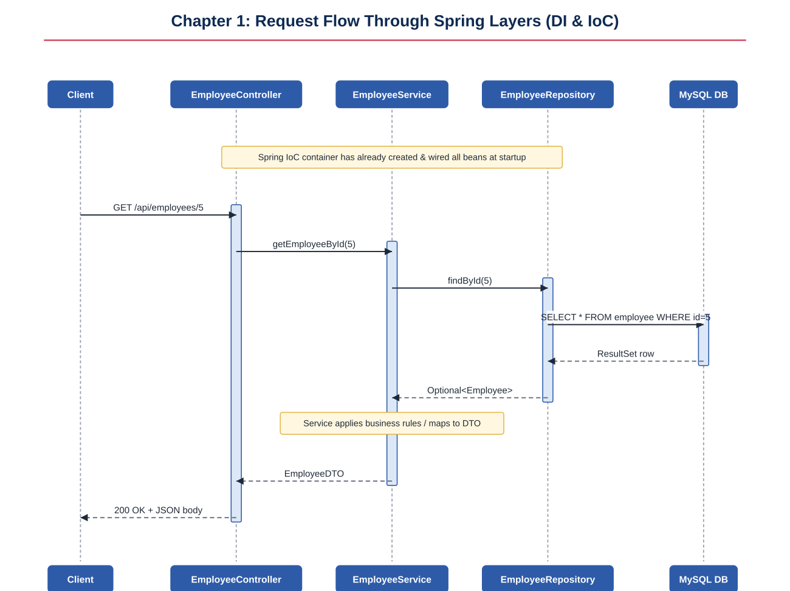
Figure 1.1: GET /api/employees/{id} request flow across the presentation, service, and data access layers

1.9 Running and Testing
- Start MySQL and create the database: CREATE DATABASE employee_db;
- Run the application: mvn spring-boot:run
- Create an employee: POST http://localhost:8080/api/employees with body {"name":"Asha Rao","department":"Engineering","salary":95000}
- Fetch it back: GET http://localhost:8080/api/employees/1

1.10 Spring Framework Quiz — Answer Key
Below are representative quiz questions for this chapter along with explanations, useful as a self-check before moving on to transactions.
- Q: What problem does Dependency Injection solve? A: It removes the responsibility of creating and locating collaborators from a class, so the class only declares what it needs (loose coupling), which makes the code easier to test, extend, and reconfigure.
- Q: What is the default scope of a Spring bean? A: Singleton — one shared instance per Spring container, not one per HTTP request.
- Q: Why does @Repository also translate exceptions? A: It is itself a specialization of @Component, and Spring's persistence-exception-translation post-processor wraps it so that database-specific exceptions (like SQLException subclasses) are converted into Spring's unified DataAccessException hierarchy.
- Q: Why should controllers avoid calling repositories directly? A: It bypasses the service layer, scattering business logic and validation rules into the HTTP layer and making the logic hard to reuse or test independently of HTTP.

Chapter 2: Database Transactions — Hands-On Solution
This chapter steps away from Spring entirely and works directly against MySQL, using Docker for the database, the MySQL console for raw SQL transaction control, and plain Java JDBC code. Understanding transactions at this low level makes Spring's @Transactional (Chapter 3) far easier to reason about, because Spring is ultimately just automating the same COMMIT/ROLLBACK calls shown here.

2.1 What Is a Transaction?
A transaction is a sequence of one or more SQL operations that the database treats as a single unit of work: either all of the operations succeed and are made permanent (COMMIT), or none of them are applied (ROLLBACK). Transactions are usually described by the ACID properties:
- Atomicity — the transaction is all-or-nothing.
- Consistency — the database moves from one valid state to another; constraints and triggers are never violated at commit time.
- Isolation — concurrent transactions do not see each other's uncommitted changes (the exact guarantee depends on the isolation level; see Chapter 7).
- Durability — once committed, changes survive crashes and restarts.

2.2 Installing Docker and MySQL
Running MySQL in Docker gives a disposable, reproducible database without installing MySQL natively. The following commands pull and start a MySQL 8 container with a persistent named volume.
# Pull and run MySQL 8 in Docker
docker pull mysql:8.0

docker run --name mysql-txn-demo \
-e MYSQL_ROOT_PASSWORD=root \
-e MYSQL_DATABASE=bank_demo \
-p 3306:3306 \
-v mysql_txn_data:/var/lib/mysql \
-d mysql:8.0

# Confirm the container is running
docker ps

# Open an interactive MySQL console inside the container
docker exec -it mysql-txn-demo mysql -uroot -proot bank_demo
Example 2.1: Starting MySQL 8 in Docker and opening the console
CREATE TABLE accounts (
id INT PRIMARY KEY AUTO_INCREMENT,
owner_name VARCHAR(100) NOT NULL,
balance DECIMAL(12,2) NOT NULL DEFAULT 0
) ENGINE=InnoDB;

INSERT INTO accounts (owner_name, balance) VALUES
('Alice', 1000.00),
('Bob', 500.00);
Example 2.2: Schema used throughout this chapter (InnoDB is required — MyISAM does not support transactions)

2.3 Setting Up the Balance-Enforcer Trigger
A BEFORE UPDATE trigger lets the database itself reject any update that would push a balance negative, regardless of which application or script issued the SQL. This is a defense-in-depth measure: even if application code has a bug, the database refuses to corrupt the invariant balance >= 0.
DELIMITER //

CREATE TRIGGER balance_enforcer
BEFORE UPDATE ON accounts
FOR EACH ROW
BEGIN
IF NEW.balance < 0 THEN
SIGNAL SQLSTATE '45000'
SET MESSAGE_TEXT = 'Insufficient funds: balance cannot go negative';
END IF;
END//

DELIMITER ;
Example 2.3: balance_enforcer trigger
NOTE
SIGNAL SQLSTATE '45000' raises a generic application-defined error. MySQL automatically aborts the statement that fired the trigger, and — if you are inside an explicit transaction — the transaction remains open but that statement's effect is undone, so your application code must still issue ROLLBACK or retry.

2.4 Transaction Management Using the MySQL Console
With the trigger installed, the following session demonstrates a normal commit and a trigger-blocked update.
START TRANSACTION;

UPDATE accounts SET balance = balance - 200 WHERE owner_name = 'Alice';
UPDATE accounts SET balance = balance + 200 WHERE owner_name = 'Bob';

-- Verify before committing
SELECT * FROM accounts;

COMMIT;
Example 2.4: A balanced transfer that commits successfully
START TRANSACTION;

-- Alice only has 800 left; this would drive her balance to -300
UPDATE accounts SET balance = balance - 1100 WHERE owner_name = 'Alice';
-- ERROR 1644 (45000): Insufficient funds: balance cannot go negative

ROLLBACK;
Example 2.5: The trigger blocks an overdraft; the session rolls back

2.5 Sequence Diagram: Transaction with the Balance-Enforcer Trigger
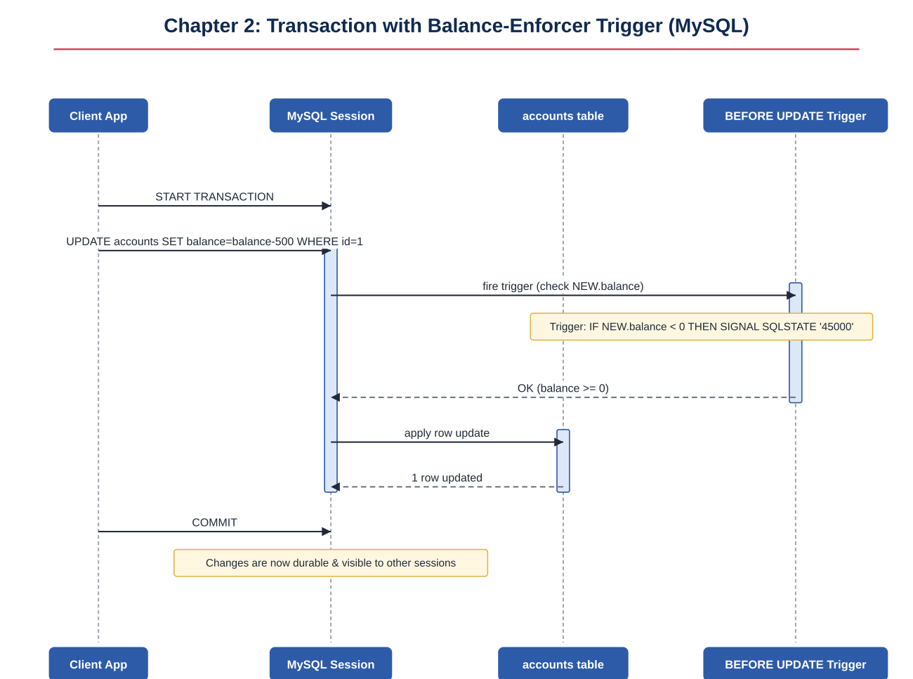
Figure 2.1: A successful UPDATE passing through the BEFORE UPDATE trigger inside an explicit transaction

2.6 Transaction Savepoints
A SAVEPOINT marks a point inside a transaction that you can roll back to without discarding the entire transaction. This is useful for multi-step operations where one step might fail but earlier steps should be preserved.
START TRANSACTION;

UPDATE accounts SET balance = balance - 100 WHERE owner_name = 'Alice';

SAVEPOINT sp1;

UPDATE accounts SET balance = balance - 50 WHERE owner_name = 'Bob';
-- Suppose application logic now discovers Bob's withdrawal violates
-- a business rule that is not enforced by the database itself.

ROLLBACK TO sp1;
-- Only Bob's update is undone; Alice's debit of 100 remains pending.

COMMIT;
-- Final result: Alice -100, Bob unchanged.
Example 2.6: Using SAVEPOINT to partially roll back a transaction
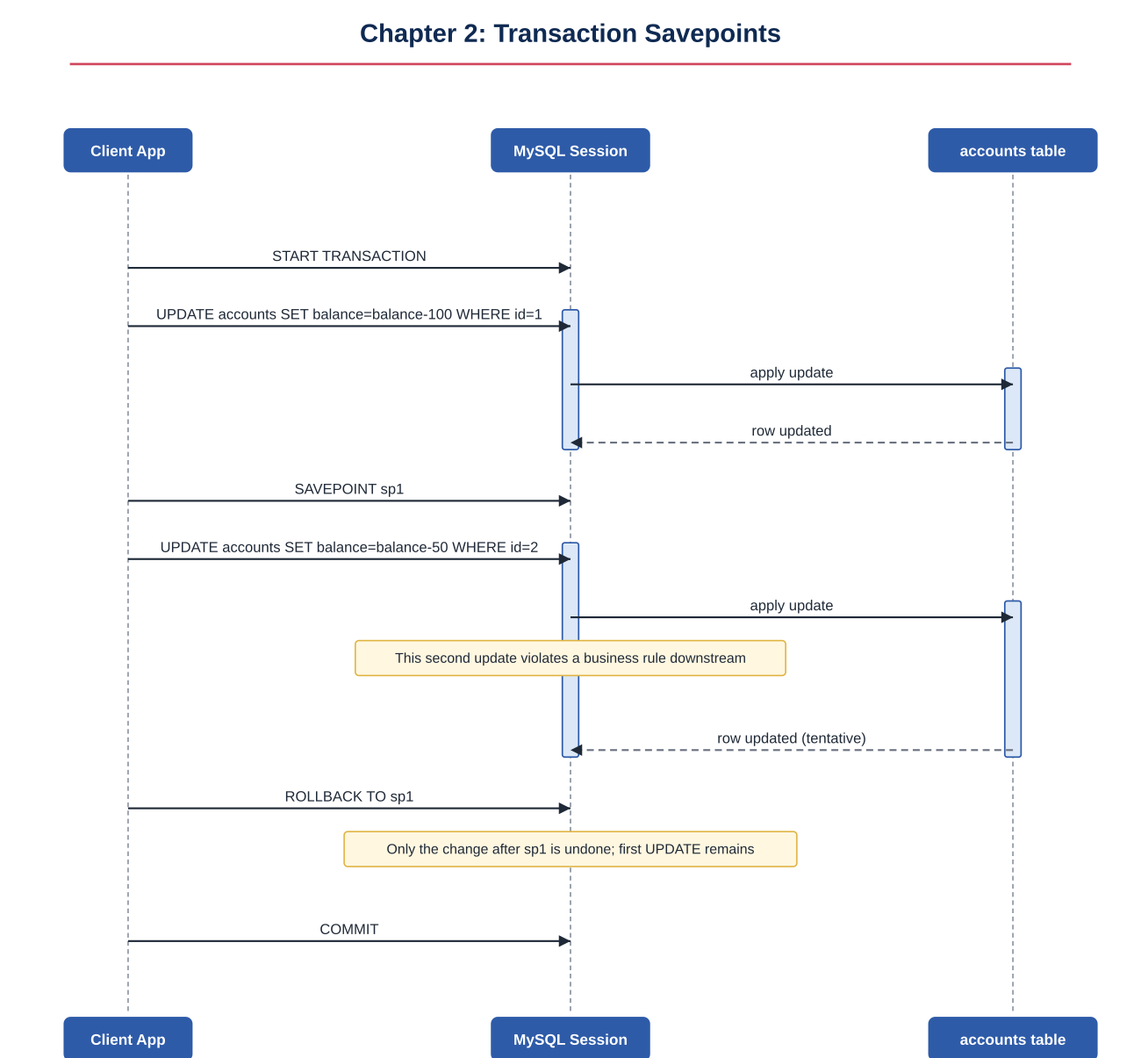
Figure 2.2: ROLLBACK TO sp1 undoes only the work performed after the savepoint
TIP
RELEASE SAVEPOINT sp1; removes a savepoint without rolling back to it. Savepoints are also automatically released when the enclosing transaction commits or rolls back entirely.

2.7 Transaction Management Using Plain Java (JDBC)
Before frameworks like Spring existed, Java developers managed transactions directly through java.sql.Connection. Spring's @Transactional (next chapter) is essentially a more convenient, declarative wrapper around the exact same setAutoCommit(false) / commit() / rollback() calls shown below.
import java.sql.*;

public class PlainJdbcTransferDemo {

private static final String URL =
"jdbc:mysql://localhost:3306/bank_demo";
private static final String USER = "root";
private static final String PASSWORD = "root";

public static void transfer(int fromId, int toId, double amount) {
Connection connection = null;
try {
connection = DriverManager.getConnection(URL, USER, PASSWORD);

// 1. Disable auto-commit to start a manual transaction.
connection.setAutoCommit(false);

// 2. Debit the sender.
try (PreparedStatement debit = connection.prepareStatement(
"UPDATE accounts SET balance = balance - ? WHERE id = ?")) {
debit.setDouble(1, amount);
debit.setInt(2, fromId);
debit.executeUpdate();
}

// 3. Credit the receiver.
try (PreparedStatement credit = connection.prepareStatement(
"UPDATE accounts SET balance = balance + ? WHERE id = ?")) {
credit.setDouble(1, amount);
credit.setInt(2, toId);
credit.executeUpdate();
}

// 4. Both statements succeeded: make the changes permanent.
connection.commit();
System.out.println("Transfer committed successfully.");

} catch (SQLException e) {
// Something failed (e.g. the trigger rejected an overdraft).
// Undo every change made since the transaction began.
if (connection != null) {
try {
connection.rollback();
System.out.println("Transfer rolled back: " + e.getMessage());
} catch (SQLException rollbackEx) {
rollbackEx.printStackTrace();
}
}
} finally {
if (connection != null) {
try {
connection.setAutoCommit(true); // restore default behavior
connection.close();
} catch (SQLException closeEx) {
closeEx.printStackTrace();
}
}
}
}

public static void main(String[] args) {
transfer(1, 2, 200.00); // Alice -> Bob, 200
}
}
Example 2.7: PlainJdbcTransferDemo.java — manual transaction management with JDBC

2.8 Sequence Diagram: Plain Java Transaction Management
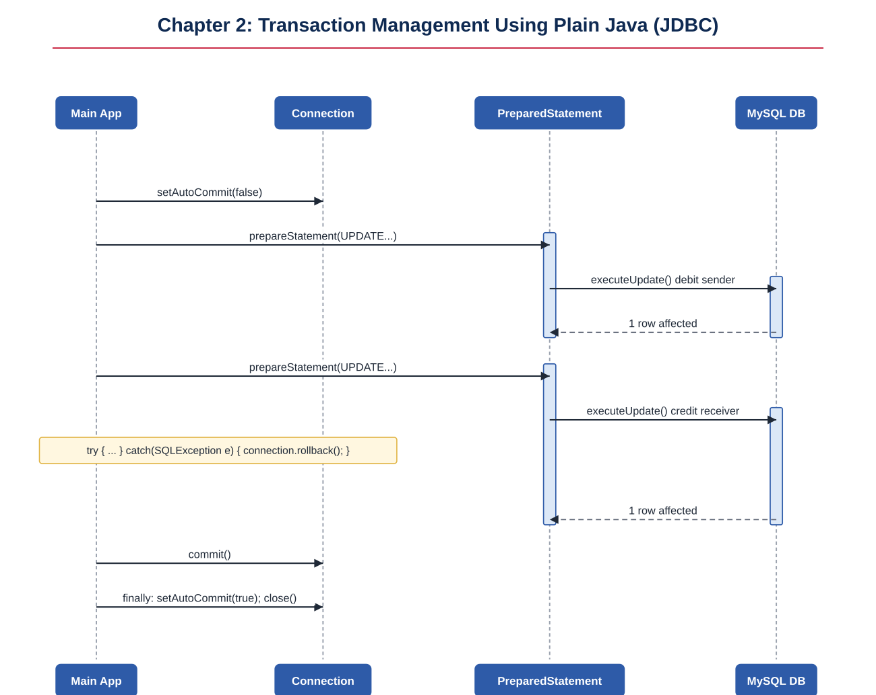
Figure 2.3: setAutoCommit(false), two executeUpdate() calls, then commit() or rollback() in a catch block
TIP
Notice everything Spring's @Transactional will automate in the next chapter: opening a connection, turning off auto-commit, committing on success, rolling back on failure, and restoring the connection state in a finally block. Every one of those manual steps becomes a single annotation.

Chapter 3: Spring Transactions — Hands-On Solution
This chapter brings transaction management into Spring itself using @Transactional. The running example is an order-processing service: an Order has many OrderItems (a classic one-to-many relationship), which is exactly the kind of model that exposes lazy-loading and Open-Session-in-View behavior.

3.1 Project Setup
The project extends the layered structure from Chapter 1 with a richer domain model and a frontend running on a different origin (for the CORS section). The Maven dependencies add spring-boot-starter-validation for request validation.
com.example.orderapp
├─ entity
│ ├─ Order.java
│ └─ OrderItem.java
├─ repository
│ └─ OrderRepository.java
├─ service
│ └─ OrderService.java
├─ controller
│ └─ OrderController.java
├─ config
│ └─ CorsConfig.java
└─ OrderAppApplication.java
Example 3.1: Project layout for the order-processing demo
TIP
Stuck? Here's the final code for every section: every code listing in this chapter is complete and self-contained. If your own implementation diverges, compare it section by section against these listings rather than rewriting from scratch.

3.2 The Domain Model
package com.example.orderapp.entity;

import jakarta.persistence.*;
import java.util.ArrayList;
import java.util.List;

@Entity
@Table(name = "orders")
public class Order {

@Id
@GeneratedValue(strategy = GenerationType.IDENTITY)
private Long id;

private String customerName;

private String status; // PENDING, CONFIRMED, SHIPPED

// LAZY is the JPA default for collections, and the recommended setting:
// items are only fetched from the DB when .getItems() is first accessed.
@OneToMany(mappedBy = "order", cascade = CascadeType.ALL, fetch = FetchType.LAZY)
private List<OrderItem> items = new ArrayList<>();

public Order() {}
public Order(String customerName, String status) {
this.customerName = customerName;
this.status = status;
}

public Long getId() { return id; }
public void setId(Long id) { this.id = id; }
public String getCustomerName() { return customerName; }
public void setCustomerName(String customerName) { this.customerName = customerName; }
public String getStatus() { return status; }
public void setStatus(String status) { this.status = status; }
public List<OrderItem> getItems() { return items; }
public void setItems(List<OrderItem> items) { this.items = items; }

public void addItem(OrderItem item) {
items.add(item);
item.setOrder(this);
}
}
Example 3.2: Order.java
package com.example.orderapp.entity;

import jakarta.persistence.*;

@Entity
@Table(name = "order_items")
public class OrderItem {

@Id
@GeneratedValue(strategy = GenerationType.IDENTITY)
private Long id;

private String productName;
private Integer quantity;
private Double price;

@ManyToOne(fetch = FetchType.LAZY)
@JoinColumn(name = "order_id")
private Order order;

public OrderItem() {}
public OrderItem(String productName, Integer quantity, Double price) {
this.productName = productName;
this.quantity = quantity;
this.price = price;
}

public Long getId() { return id; }
public void setId(Long id) { this.id = id; }
public String getProductName() { return productName; }
public void setProductName(String productName) { this.productName = productName; }
public Integer getQuantity() { return quantity; }
public void setQuantity(Integer quantity) { this.quantity = quantity; }
public Double getPrice() { return price; }
public void setPrice(Double price) { this.price = price; }
public Order getOrder() { return order; }
public void setOrder(Order order) { this.order = order; }
}
Example 3.3: OrderItem.java

3.3 Handling the CORS Exception
When the frontend (e.g. served from http://localhost:5173) calls the API on http://localhost:8080, the browser blocks the response unless the server explicitly allows that origin via CORS headers. A global WebMvcConfigurer bean is the cleanest way to configure this once for the whole application, instead of annotating every controller individually.
package com.example.orderapp.config;

import org.springframework.context.annotation.Bean;
import org.springframework.context.annotation.Configuration;
import org.springframework.web.servlet.config.annotation.CorsRegistry;
import org.springframework.web.servlet.config.annotation.WebMvcConfigurer;

@Configuration
public class CorsConfig {

@Bean
public WebMvcConfigurer corsConfigurer() {
return new WebMvcConfigurer() {
@Override
public void addCorsMappings(CorsRegistry registry) {
registry.addMapping("/api/**")
.allowedOrigins("http://localhost:5173")
.allowedMethods("GET", "POST", "PUT", "DELETE", "OPTIONS")
.allowedHeaders("*")
.allowCredentials(true);
}
};
}
}
Example 3.4: CorsConfig.java — global CORS configuration
PITFALL
A common mistake is setting allowedOrigins("*") together with allowCredentials(true) — browsers reject this combination outright. If credentials (cookies, Authorization headers) need to cross origins, you must list specific origins explicitly.

3.4 The Repository and the @Transactional Service
package com.example.orderapp.repository;

import com.example.orderapp.entity.Order;
import org.springframework.data.jpa.repository.JpaRepository;
import org.springframework.data.jpa.repository.Query;

import java.util.List;
import java.util.Optional;

public interface OrderRepository extends JpaRepository<Order, Long> {

// Explicit JOIN FETCH: eagerly loads items in the same query,
// overriding the entity's LAZY default for this one query method.
@Query("SELECT o FROM Order o JOIN FETCH o.items WHERE o.id = :id")
Optional<Order> findByIdWithItems(Long id);

List<Order> findByStatus(String status);
}
Example 3.5: OrderRepository.java

3.5 Transactional Annotation and Transactional Updates
package com.example.orderapp.service;

import com.example.orderapp.entity.Order;
import com.example.orderapp.entity.OrderItem;
import com.example.orderapp.repository.OrderRepository;
import org.springframework.stereotype.Service;
import org.springframework.transaction.annotation.Transactional;

import java.util.List;
import java.util.NoSuchElementException;

@Service
public class OrderService {

private final OrderRepository orderRepository;

public OrderService(OrderRepository orderRepository) {
this.orderRepository = orderRepository;
}

// Default propagation = REQUIRED, default isolation = database default.
// The whole method runs in one transaction: either the order AND every
// item insert succeed together, or none of them are persisted.
@Transactional
public Order placeOrder(String customerName, List<OrderItem> items) {
Order order = new Order(customerName, "PENDING");
items.forEach(order::addItem);
return orderRepository.save(order);
}

// A transactional UPDATE: load, mutate, and let Hibernate's dirty
// checking flush the change at commit — no explicit .save() is required
// because the entity is still managed within the same transaction.
@Transactional
public Order confirmOrder(Long orderId) {
Order order = orderRepository.findById(orderId)
.orElseThrow(() -> new NoSuchElementException("Order not found: " + orderId));
order.setStatus("CONFIRMED");
return order; // dirty checking persists the status change automatically
}

// Read-only transaction: see section 3.6 below.
@Transactional(readOnly = true)
public List<Order> listOrdersByStatus(String status) {
return orderRepository.findByStatus(status);
}

// Eager fetch via JOIN FETCH — see section 3.7.
@Transactional(readOnly = true)
public Order getOrderWithItemsEager(Long orderId) {
return orderRepository.findByIdWithItems(orderId)
.orElseThrow(() -> new NoSuchElementException("Order not found: " + orderId));
}

// No transaction annotation at all — used to demonstrate
// LazyInitializationException in section 3.9.
public Order getOrderNoTransaction(Long orderId) {
return orderRepository.findById(orderId)
.orElseThrow(() -> new NoSuchElementException("Order not found: " + orderId));
}
}
Example 3.6: OrderService.java — @Transactional, transactional updates, and read-only transactions

3.6 Read-Only Transactions
@Transactional(readOnly = true) is a hint, not an enforced restriction in most JPA providers — Hibernate uses it to skip dirty-checking snapshots and avoid an unnecessary flush at commit time, which reduces memory pressure and can measurably speed up large read queries. Some database drivers also use it to route to a read replica.
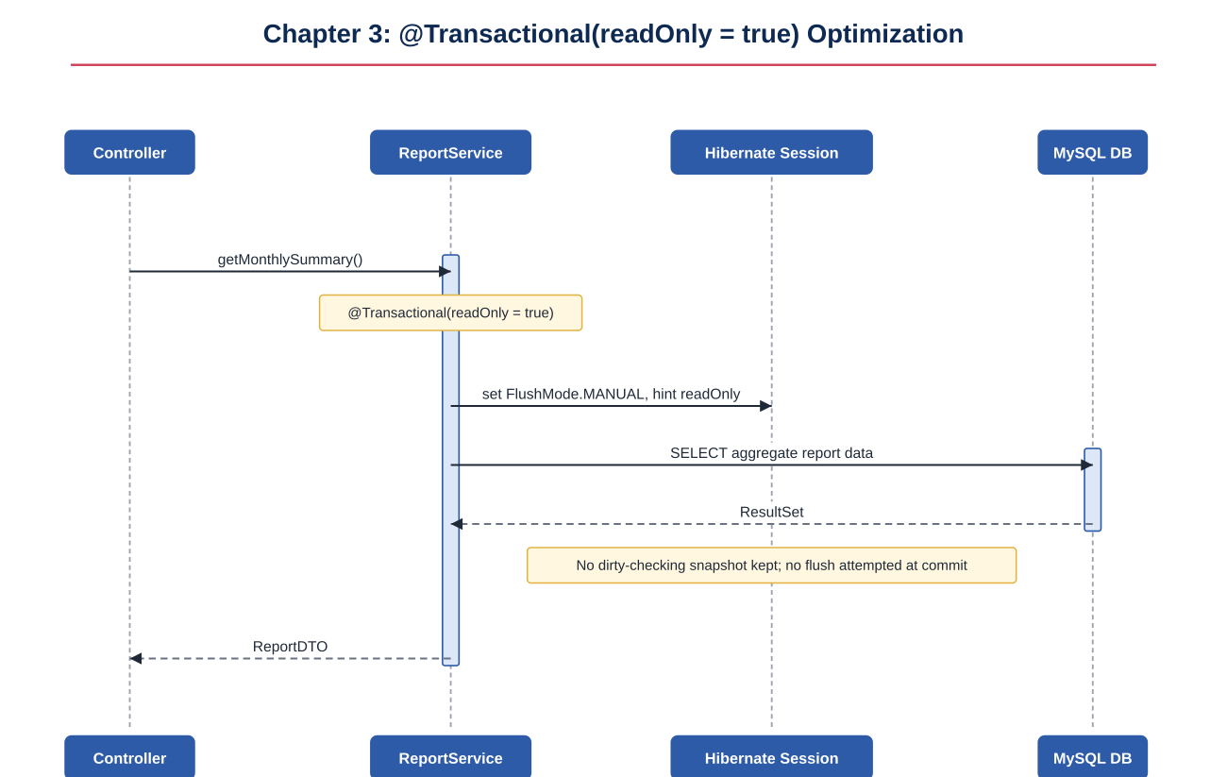
Figure 3.1: A readOnly transaction skips dirty-checking snapshots

3.7 Spring Proxy — How @Transactional Actually Works
@Transactional has no effect by itself; it is metadata that Spring's AOP infrastructure reads. When a class containing @Transactional methods is registered as a bean, Spring wraps it in a dynamic proxy. Callers (including other beans, via dependency injection) actually hold a reference to this proxy, not to the original object. The proxy's TransactionInterceptor opens a transaction, invokes the real method, and commits or rolls back based on whether the method threw an exception.
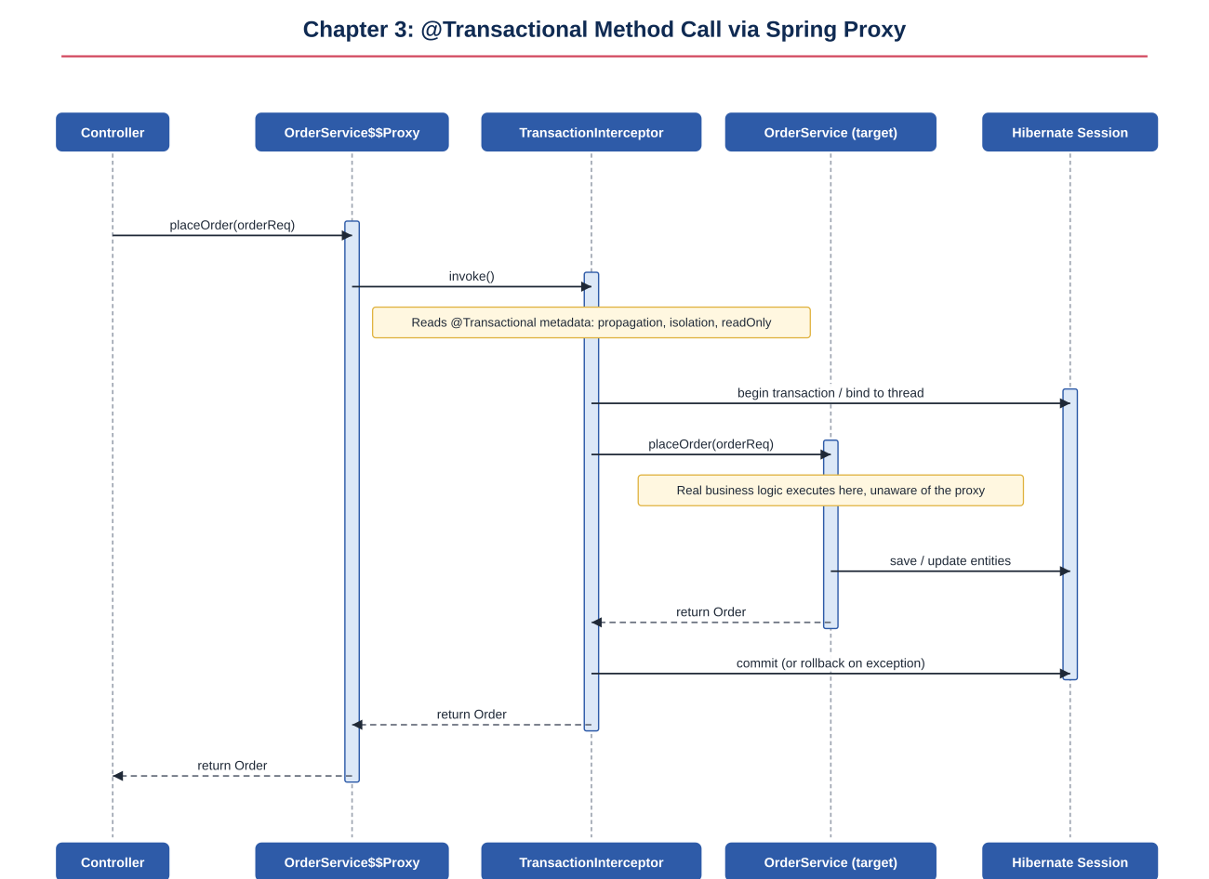
Figure 3.2: A @Transactional method call intercepted by the Spring proxy
PITFALL
Because the proxy intercepts calls coming from outside the bean, calling a @Transactional method from another method in the same class (a "self-invocation") bypasses the proxy entirely — the transactional behavior silently does not apply. This is one of the most common @Transactional bugs in real codebases.

3.8 Demystifying Open Session in View (OSIV)
Spring Boot enables Open Session in View by default (spring.jpa.open-in-view=true). A Hibernate session is opened for the entire HTTP request, not just for the duration of the @Transactional method. This means lazy associations can still be loaded later in the request — for instance, while Jackson serializes the response — even though the original transaction already committed.
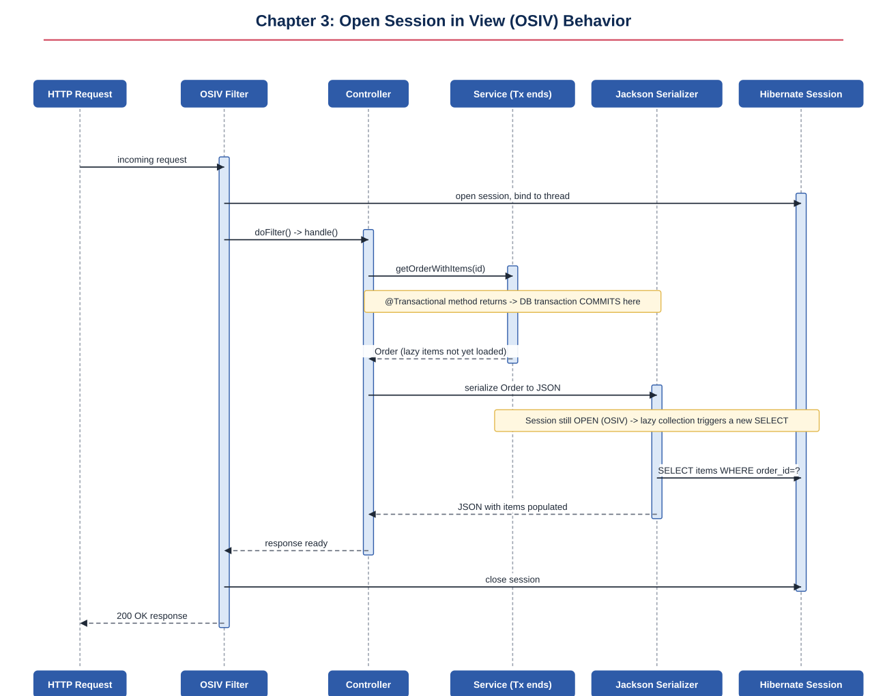
Figure 3.3: With OSIV enabled, Jackson's serialization step triggers a fresh SELECT after the transaction has already committed
NOTE
OSIV is convenient but has a real cost: it can hide N+1 query problems (since lazy loads silently succeed during serialization instead of failing loudly), and it holds a database connection for the whole request, including time spent on the network or in other non-DB work. Many teams explicitly disable it (spring.jpa.open-in-view=false) and use JOIN FETCH or DTO projections instead.

3.9 Eager Fetching Exposed
Switching fetch = FetchType.EAGER on the entity looks like an easy fix for lazy-loading exceptions, but it is almost always the wrong tool. EAGER fetching applies globally to every query that loads that entity type, including queries that have no need for the association — turning a simple findById into an unnecessary join (or, with multiple eager collections, a Cartesian-product explosion of duplicate rows).
// AVOID this on collections:
@OneToMany(mappedBy = "order", fetch = FetchType.EAGER)
private List<OrderItem> items;
// Now EVERY query that loads an Order also loads every OrderItem,
// even simple existence checks or status updates that never touch items.

// PREFER: keep the mapping LAZY, and fetch eagerly only where actually needed:
@Query("SELECT o FROM Order o JOIN FETCH o.items WHERE o.id = :id")
Optional<Order> findByIdWithItems(Long id);
Example 3.7: Why per-query JOIN FETCH is preferable to entity-level EAGER

3.10 No-Session & Lazy Initialization Exceptions
If OSIV is disabled (or the lazy collection is accessed from a context with no Hibernate session at all, such as a background thread), accessing a lazy association after the owning transaction has closed throws LazyInitializationException.
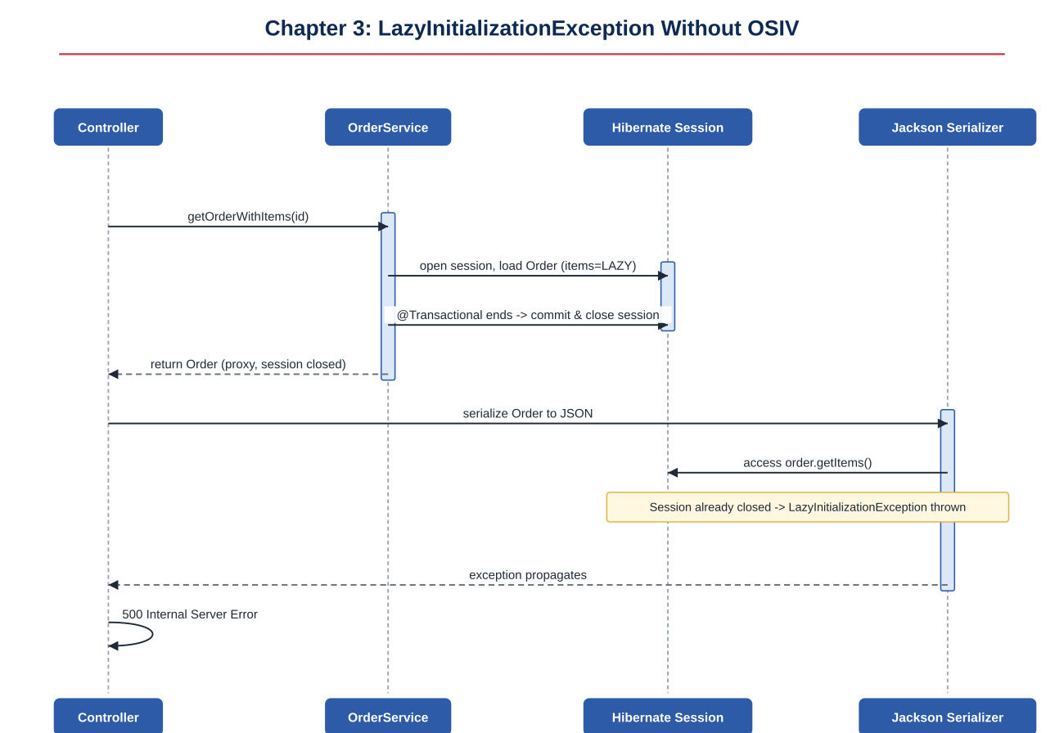
Figure 3.4: getOrderNoTransaction() returns a detached proxy; accessing .getItems() later throws LazyInitializationException
// Reproducing the exception (with spring.jpa.open-in-view=false):
Order order = orderService.getOrderNoTransaction(1L);
order.getItems().size();
// org.hibernate.LazyInitializationException:
// failed to lazily initialize a collection of role:
// com.example.orderapp.entity.Order.items: could not initialize proxy
// - no Session
Example 3.8: Triggering and reading a LazyInitializationException
- Fix 1: fetch what you need inside the transaction, using JOIN FETCH (Example 3.5), so the data is already loaded before the session closes.
- Fix 2: map to a DTO inside the @Transactional method, before the session closes, instead of returning the entity directly.
- Fix 3 (least preferred): re-enable OSIV, accepting its tradeoffs described in section 3.8.

3.11 Applied Transactions — Putting It Together
package com.example.orderapp.controller;

import com.example.orderapp.entity.Order;
import com.example.orderapp.entity.OrderItem;
import com.example.orderapp.service.OrderService;
import org.springframework.http.HttpStatus;
import org.springframework.http.ResponseEntity;
import org.springframework.web.bind.annotation.*;

import java.util.List;

@RestController
@RequestMapping("/api/orders")
public class OrderController {

private final OrderService orderService;

public OrderController(OrderService orderService) {
this.orderService = orderService;
}

@PostMapping
@ResponseStatus(HttpStatus.CREATED)
public Order placeOrder(@RequestParam String customerName,
@RequestBody List<OrderItem> items) {
return orderService.placeOrder(customerName, items);
}

@PutMapping("/{id}/confirm")
public Order confirmOrder(@PathVariable Long id) {
return orderService.confirmOrder(id);
}

@GetMapping("/{id}")
public ResponseEntity<Order> getOrder(@PathVariable Long id) {
return ResponseEntity.ok(orderService.getOrderWithItemsEager(id));
}

@GetMapping(params = "status")
public List<Order> listByStatus(@RequestParam String status) {
return orderService.listOrdersByStatus(status);
}
}
Example 3.9: OrderController.java — the presentation layer calling the transactional service
With this controller, every write path (placeOrder, confirmOrder) is wrapped in its own atomic transaction, every read path that needs associations uses an explicit JOIN FETCH rather than relying on OSIV, and the CORS configuration from section 3.3 allows a separately-hosted frontend to call all of these endpoints safely.

Chapter 4: Exceptions and Rollbacks — Hands-On Solution
This chapter extends the order-processing service with a payment step and shows exactly how different exception types interact with Spring's transaction rollback rules — a frequent source of production bugs, since the default behavior is asymmetric between checked and unchecked exceptions.

4.1 Exception Types
Java has two broad exception families relevant here: checked exceptions (subclasses of Exception, excluding RuntimeException, which the compiler forces you to declare or catch) and unchecked exceptions (subclasses of RuntimeException or Error, which require no declaration). Spring's default rollback rule treats these two families differently, described in the next section.
// Unchecked (extends RuntimeException) - no "throws" declaration required
public class InsufficientFundsException extends RuntimeException {
public InsufficientFundsException(String message) {
super(message);
}
}

// Checked (extends Exception) - callers must catch it or declare "throws"
public class MessagingException extends Exception {
public MessagingException(String message, Throwable cause) {
super(message, cause);
}
}
Example 4.1: An unchecked business exception and a checked infrastructure exception

4.2 How Exceptions Affect Transactions
By default, Spring's transaction infrastructure rolls back the current transaction only for unchecked exceptions (RuntimeException and Error) and lets checked exceptions result in a commit. This default is inherited from EJB conventions: the assumption is that checked exceptions represent expected, recoverable business outcomes, while unchecked exceptions represent unexpected failures that should undo everything.
Exception thrown | Default behavior
RuntimeException (or subclass) | Transaction is rolled back automatically.
Error (or subclass) | Transaction is rolled back automatically.
Checked Exception (extends Exception) | Transaction is committed — NOT rolled back — unless rollbackFor says otherwise.
package com.example.orderapp.service;

import com.example.orderapp.entity.Account;
import com.example.orderapp.exception.InsufficientFundsException;
import com.example.orderapp.repository.AccountRepository;
import org.springframework.stereotype.Service;
import org.springframework.transaction.annotation.Transactional;

@Service
public class PaymentService {

private final AccountRepository accountRepository;

public PaymentService(AccountRepository accountRepository) {
this.accountRepository = accountRepository;
}

@Transactional
public void transferFunds(Long fromId, Long toId, double amount) {
Account from = accountRepository.findById(fromId).orElseThrow();
Account to = accountRepository.findById(toId).orElseThrow();

if (from.getBalance() < amount) {
// Unchecked: triggers automatic rollback of this @Transactional method.
throw new InsufficientFundsException(
"Account " + fromId + " has insufficient funds for " + amount);
}

from.setBalance(from.getBalance() - amount);
to.setBalance(to.getBalance() + amount);
accountRepository.save(from);
accountRepository.save(to);
}
}
Example 4.2: PaymentService.java — an unchecked exception causing automatic rollback

4.3 Sequence Diagram: Unchecked Exception — Automatic Rollback
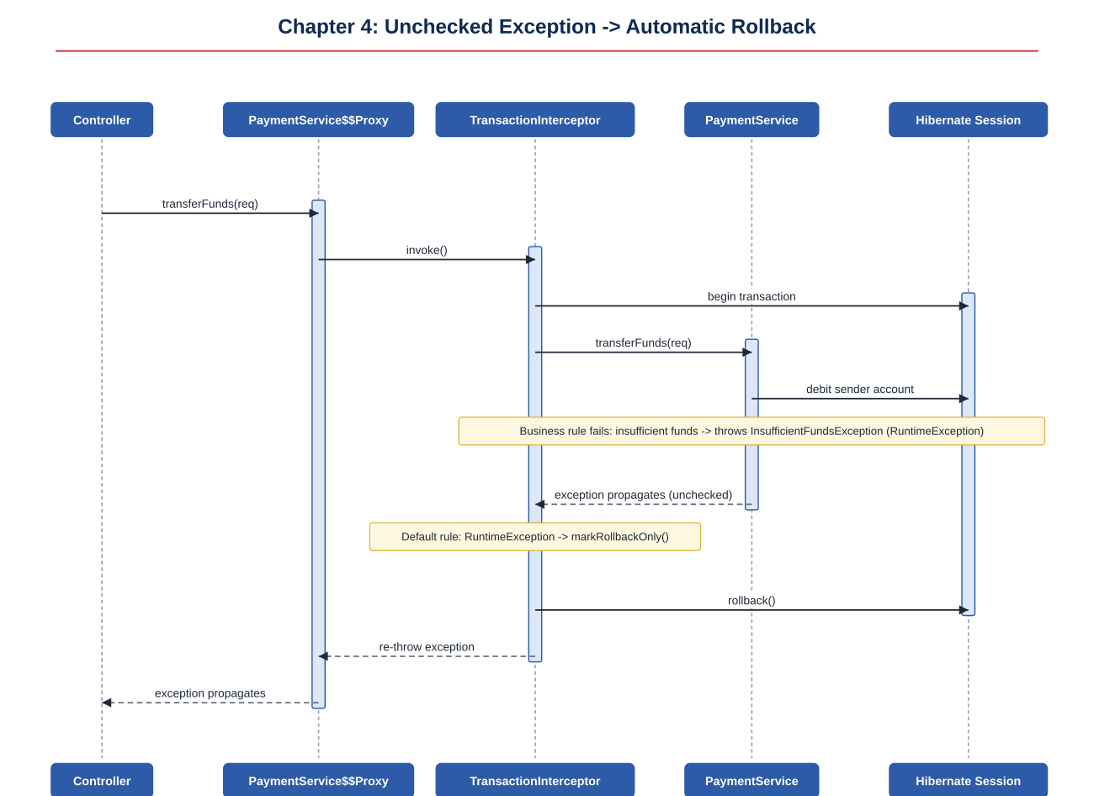
Figure 4.1: InsufficientFundsException (a RuntimeException) propagates out of the method body and the proxy automatically rolls back

4.4 The Surprising Default: Checked Exceptions Do Not Roll Back
The next example is deliberately built to surprise: a checked MessagingException is thrown after a database write, inside the same @Transactional method, with no rollbackFor configured. The write commits anyway.
package com.example.orderapp.exception;

// Extends Exception directly, NOT RuntimeException -> this is a checked exception.
public class MessagingException extends Exception {
public MessagingException(String message, Throwable cause) {
super(message, cause);
}
}
Example 4.3: MessagingException.java — a checked exception
package com.example.orderapp.service;

import com.example.orderapp.entity.InvoiceLog;
import com.example.orderapp.exception.MessagingException;
import com.example.orderapp.repository.InvoiceLogRepository;
import org.springframework.stereotype.Service;
import org.springframework.transaction.annotation.Transactional;

@Service
public class NotificationService {

private final InvoiceLogRepository invoiceLogRepository;
private final EmailGateway emailGateway; // hypothetical SMTP client wrapper

public NotificationService(InvoiceLogRepository invoiceLogRepository,
EmailGateway emailGateway) {
this.invoiceLogRepository = invoiceLogRepository;
this.emailGateway = emailGateway;
}

// NOTE: declares "throws MessagingException" -- a checked exception.
// No rollbackFor is specified.
@Transactional
public void sendInvoice(Long orderId) throws MessagingException {
invoiceLogRepository.save(new InvoiceLog(orderId, "ATTEMPTED"));

try {
emailGateway.send(orderId);
} catch (Exception smtpFailure) {
// Checked exception: by default this will NOT roll back the
// invoiceLogRepository.save() above -- it COMMITS.
throw new MessagingException("Failed to email invoice for order "
+ orderId, smtpFailure);
}
}
}
Example 4.4: NotificationService.java — a checked exception that commits by default

4.5 Sequence Diagram: Checked Exception — No Rollback by Default
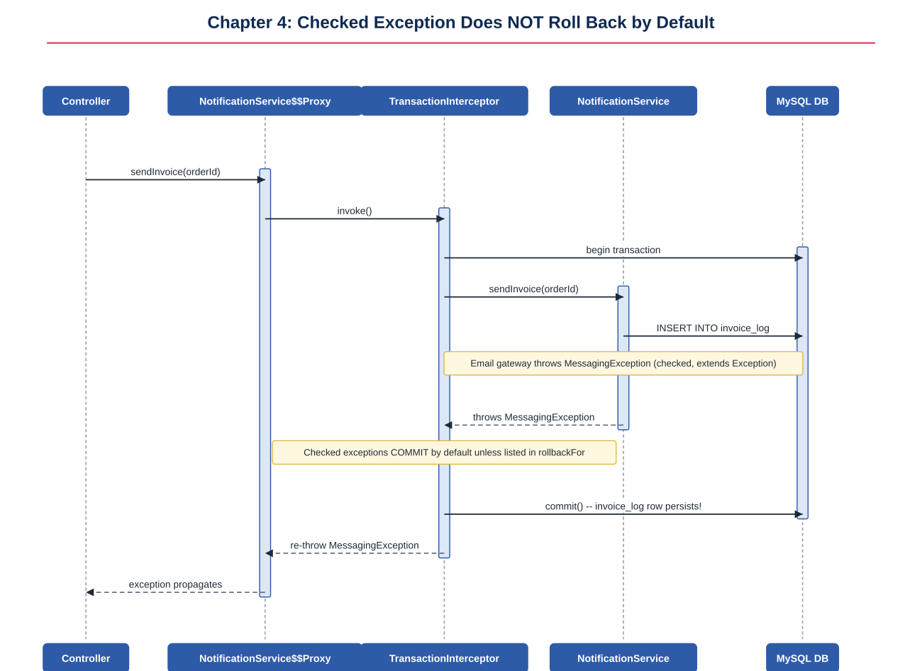
Figure 4.2: The invoice_log INSERT commits even though sendInvoice() throws, because MessagingException is checked
PITFALL
This is a genuinely dangerous default in real systems: a checked exception representing a failed email, failed webhook, or failed external call can silently let a partially-completed business operation commit. Always decide deliberately, per method, whether a checked exception should roll back — don't rely on the default.

4.6 Controlling Rollback
Spring gives three explicit tools to override the default rollback behavior: rollbackFor (force a rollback for specific exception types, including checked ones), noRollbackFor (suppress rollback for specific unchecked exception types), and programmatic TransactionAspectSupport.currentTransactionStatus().setRollbackOnly() (mark the current transaction for rollback without throwing anything at all).
// 1. rollbackFor: force a checked exception to roll back.
@Transactional(rollbackFor = MessagingException.class)
public void sendInvoiceStrict(Long orderId) throws MessagingException {
invoiceLogRepository.save(new InvoiceLog(orderId, "ATTEMPTED"));
try {
emailGateway.send(orderId);
} catch (Exception smtpFailure) {
throw new MessagingException("Failed to email invoice", smtpFailure);
}
}

// 2. noRollbackFor: suppress rollback for a specific unchecked exception
// that you consider non-fatal (e.g. a soft validation warning).
@Transactional(noRollbackFor = NonCriticalValidationException.class)
public void updatePreferences(Long customerId, Preferences prefs) {
// ... saves succeed even if a non-critical validation warning is thrown
}

// 3. Programmatic rollback: mark the transaction for rollback without
// throwing an exception at all, letting the method return normally
// (the caller must still check the result / status to know it happened).
@Transactional(rollbackFor = MessagingException.class)
public OrderResult checkout(Cart cart) {
Order order = orderRepository.save(new Order(cart));
boolean inventoryOk = inventoryService.reserve(cart.getItems());
if (!inventoryOk) {
TransactionAspectSupport.currentTransactionStatus().setRollbackOnly();
return OrderResult.failed("Insufficient inventory");
}
return OrderResult.success(order);
}
Example 4.5: Three ways to control rollback behavior explicitly

4.7 Sequence Diagram: Controlling Rollback Explicitly
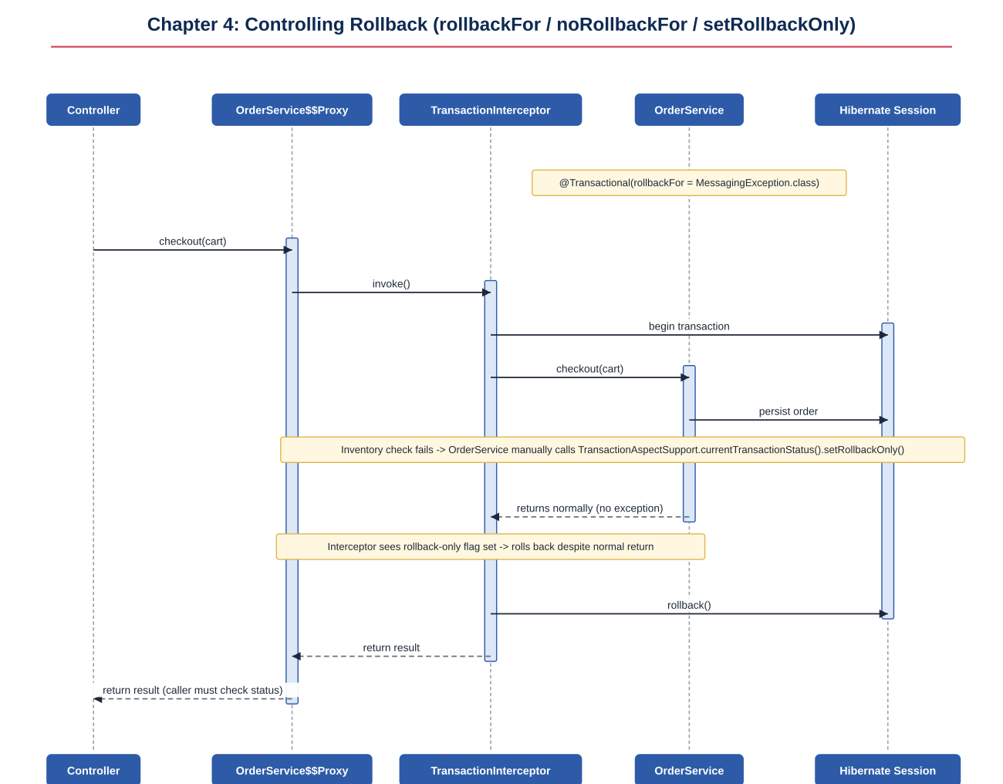
Figure 4.3: setRollbackOnly() forces a rollback even though the method returns normally with no exception
NOTE
setRollbackOnly() only marks the CURRENT transaction (the one the proxy you are inside is managing). It has no effect if called outside of an active Spring-managed transaction, and once called, the transaction cannot be "un-marked" — it will always roll back at commit time, even if the rest of the method appears to succeed.

Chapter 5: Transaction Propagation — Hands-On Solution
Propagation defines what happens when a @Transactional method is called from inside another method that already has an active transaction. This chapter builds three services — OrderService, InventoryService, PaymentService — and wires them together with different propagation settings to show exactly when work shares a transaction boundary and when it does not.

5.1 Propagation Types
Propagation | Behavior
REQUIRED (default) | Joins the caller's existing transaction if one exists; otherwise starts a new one.
REQUIRES_NEW | Always suspends any existing transaction and starts a brand-new, independent one with its own commit/rollback outcome.
NESTED | Runs within a savepoint of the existing transaction (if the driver/JPA provider supports it); a rollback in the nested unit can be contained to that savepoint.
SUPPORTS | Joins an existing transaction if present; otherwise runs non-transactionally.
NOT_SUPPORTED | Suspends any existing transaction and runs without one.
MANDATORY | Requires an existing transaction; throws an exception if none is active.
NEVER | Requires that NO transaction is active; throws an exception if one is.

5.2 PROPAGATION_REQUIRED — Joining the Caller's Transaction
REQUIRED is the default and the right choice for most internal collaborators: it ensures that the order write and the inventory write either both succeed or both fail together, as a single atomic unit.
package com.example.orderapp.service;

import com.example.orderapp.entity.Order;
import com.example.orderapp.entity.OrderItem;
import com.example.orderapp.repository.OrderRepository;
import org.springframework.stereotype.Service;
import org.springframework.transaction.annotation.Propagation;
import org.springframework.transaction.annotation.Transactional;

import java.util.List;

@Service
public class OrderService {

private final OrderRepository orderRepository;
private final InventoryService inventoryService;

public OrderService(OrderRepository orderRepository, InventoryService inventoryService) {
this.orderRepository = orderRepository;
this.inventoryService = inventoryService;
}

@Transactional // starts Tx-A
public Order placeOrder(String customerName, List<OrderItem> items) {
Order order = new Order(customerName, "PENDING");
items.forEach(order::addItem);
Order saved = orderRepository.save(order);

// InventoryService.reserveStock is REQUIRED -> joins Tx-A.
// If it throws, Tx-A (including the order insert above) rolls back too.
items.forEach(item ->
inventoryService.reserveStock(item.getProductName(), item.getQuantity()));

return saved;
}
}
Example 5.1: OrderService.placeOrder — calling a REQUIRED collaborator
package com.example.orderapp.service;

import com.example.orderapp.entity.StockItem;
import com.example.orderapp.exception.OutOfStockException;
import com.example.orderapp.repository.StockRepository;
import org.springframework.stereotype.Service;
import org.springframework.transaction.annotation.Propagation;
import org.springframework.transaction.annotation.Transactional;

@Service
public class InventoryService {

private final StockRepository stockRepository;

public InventoryService(StockRepository stockRepository) {
this.stockRepository = stockRepository;
}

// Explicit for clarity, though REQUIRED is the default anyway.
@Transactional(propagation = Propagation.REQUIRED)
public void reserveStock(String productName, int quantity) {
StockItem stock = stockRepository.findByProductName(productName)
.orElseThrow(() -> new OutOfStockException(productName));
if (stock.getQuantity() < quantity) {
throw new OutOfStockException(productName);
}
stock.setQuantity(stock.getQuantity() - quantity);
stockRepository.save(stock);
}
}
Example 5.2: InventoryService.reserveStock — PROPAGATION_REQUIRED

5.3 Sequence Diagram: PROPAGATION_REQUIRED
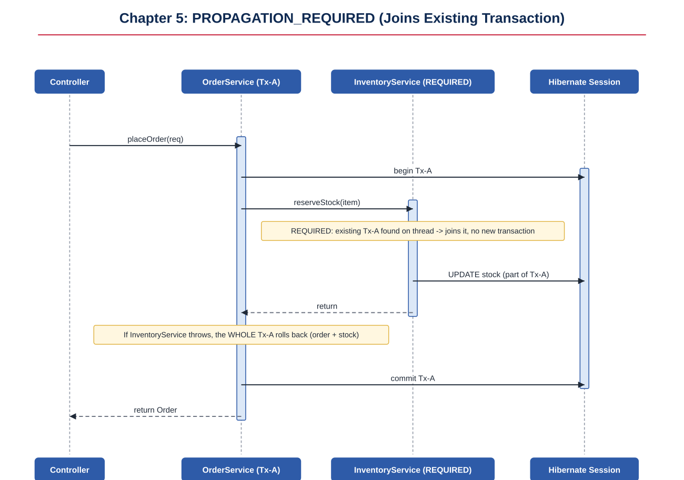
Figure 5.1: InventoryService joins OrderService's existing transaction — no new transaction is created

5.4 PROPAGATION_REQUIRES_NEW — An Independent Inner Transaction
Audit logging is a textbook use case for REQUIRES_NEW: you usually want the audit record to survive even if the surrounding business operation later fails and rolls back, so the suspicious or failed attempt is still recorded for compliance and debugging.
package com.example.orderapp.service;

import com.example.orderapp.entity.AuditLog;
import com.example.orderapp.repository.AuditLogRepository;
import org.springframework.stereotype.Service;
import org.springframework.transaction.annotation.Propagation;
import org.springframework.transaction.annotation.Transactional;

@Service
public class AuditLogService {

private final AuditLogRepository auditLogRepository;

public AuditLogService(AuditLogRepository auditLogRepository) {
this.auditLogRepository = auditLogRepository;
}

// REQUIRES_NEW: suspends the caller's transaction (if any) and commits
// this insert independently, on its own connection.
@Transactional(propagation = Propagation.REQUIRES_NEW)
public void logAttempt(String customerName, String details) {
auditLogRepository.save(new AuditLog(customerName, details));
// Commits here, regardless of what happens later in the caller.
}
}
Example 5.3: AuditLogService.logAttempt — PROPAGATION_REQUIRES_NEW
@Service
public class OrderService {
// ...
private final AuditLogService auditLogService;

@Transactional // Tx-A
public Order placeOrderWithAudit(String customerName, List<OrderItem> items) {
// Suspends Tx-A, opens Tx-B, commits Tx-B independently, resumes Tx-A.
auditLogService.logAttempt(customerName, "Order attempt started");

Order order = new Order(customerName, "PENDING");
items.forEach(order::addItem);
Order saved = orderRepository.save(order);

if (someDownstreamValidationFails(saved)) {
throw new IllegalStateException("Validation failed after audit logged");
// Tx-A rolls back (order insert undone) but the audit row from
// Tx-B, already committed, is NOT undone.
}
return saved;
}
}
Example 5.4: Calling the REQUIRES_NEW collaborator from within Tx-A

5.5 Sequence Diagram: PROPAGATION_REQUIRES_NEW
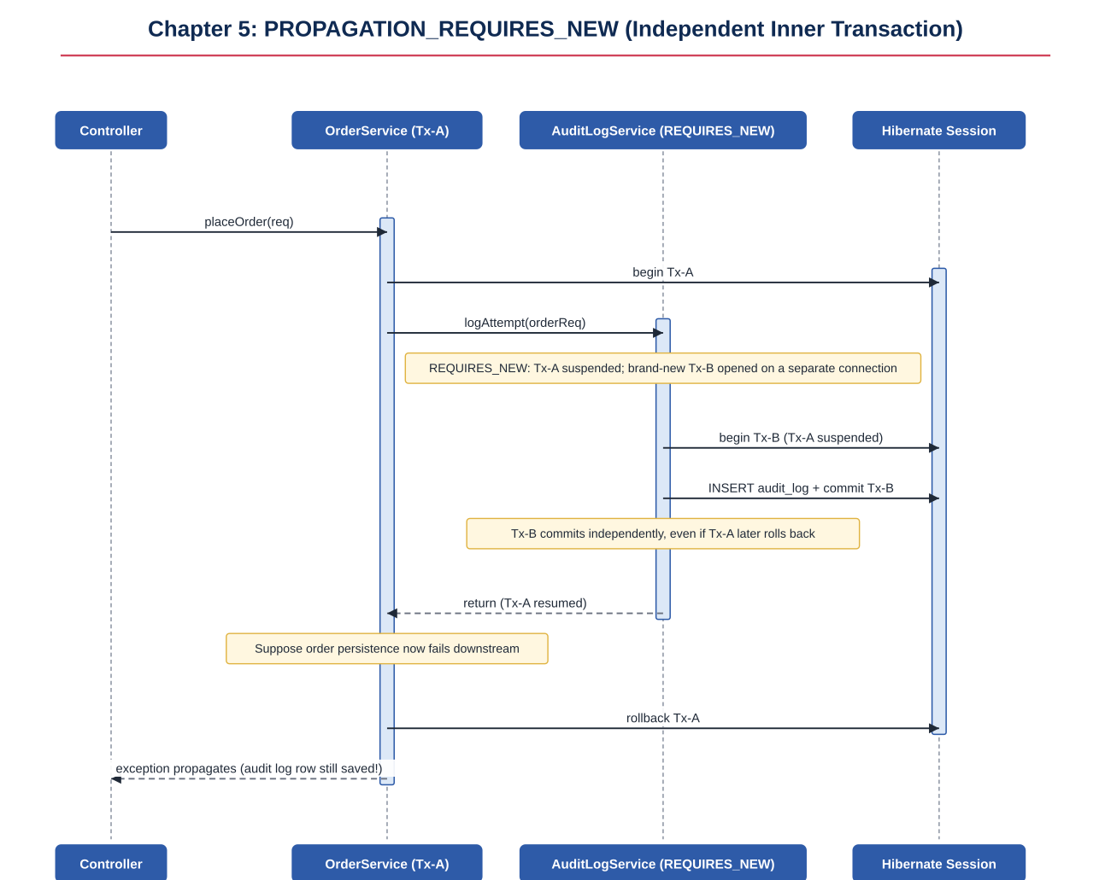
Figure 5.2: Tx-A is suspended while Tx-B runs and commits independently; the audit row survives Tx-A's later rollback

5.6 Transaction Boundaries
A transaction boundary is the start and end point within which all database operations are treated atomically. With REQUIRED, the boundary is set by whichever method in the call chain is invoked first through a proxy (the outermost @Transactional entry point) — everything called with REQUIRED beneath it shares that same boundary. With REQUIRES_NEW, a brand-new boundary is opened, nested inside the call stack but independent in the database.
PITFALL
Boundaries are determined by proxy invocation, not by source-code nesting. If a @Transactional method calls another method on the SAME bean directly (self-invocation), no proxy is involved for that inner call, so its propagation setting is silently ignored — it simply executes as part of whatever transaction (if any) is already active, exactly like a plain method call.

5.7 Data Inconsistency from Misused Propagation
This is the most important practical lesson of the chapter: combining REQUIRES_NEW with an operation that has an external, irreversible side effect (like charging a card) can create inconsistency if a later step in the same outer transaction fails.
@Service
public class OrderService {

private final PaymentService paymentService; // REQUIRES_NEW
private final ShippingService shippingService; // REQUIRED

@Transactional // Tx-A
public Order checkout(Cart cart) {
Order order = orderRepository.save(new Order(cart, "PENDING"));

// Commits independently and IMMEDIATELY -- the customer is charged
// even if everything below this line fails.
PaymentConfirmation confirmation = paymentService.charge(cart.getCard(), cart.getTotal());

// If this throws (e.g. address validation), Tx-A rolls back:
// the "orders" row disappears, but the payment is already committed.
shippingService.scheduleShipment(order);

return order;
}
}
Example 5.5: A checkout flow that can charge a customer with no corresponding order

5.8 Sequence Diagram: Data Inconsistency from Misused Propagation
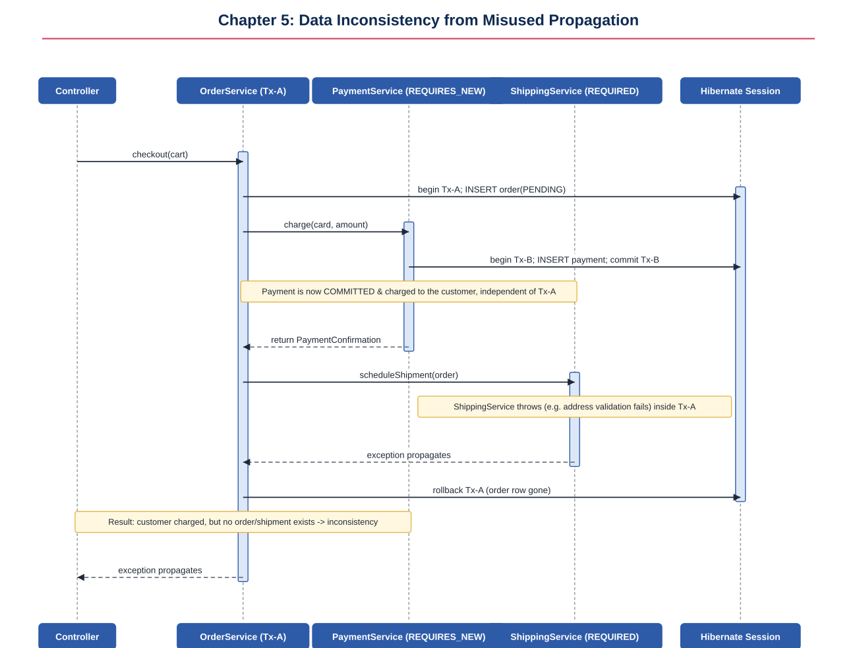
Figure 5.3: PaymentService commits independently via REQUIRES_NEW; when ShippingService later fails, Tx-A rolls back the order but the payment remains charged

5.9 Avoiding the Inconsistency
- Option A: only call REQUIRES_NEW services (payment, external charges) after every REQUIRED step that could still fail has already succeeded, minimizing the window for inconsistency.
- Option B: use the Saga pattern — if a later step fails, explicitly issue a compensating action (e.g. paymentService.refund(confirmation)) rather than relying on a database rollback, since the payment was never part of the same database transaction to begin with.
- Option C: reconsider whether REQUIRES_NEW is actually needed here at all — if the payment provider call itself is not a local database transaction (it is usually a remote HTTP call to a gateway), wrapping it in REQUIRES_NEW often adds complexity without real benefit; model it explicitly as a non-transactional external call with its own retry and compensation logic instead.

Chapter 6: Spring Events — Hands-On Solution
Spring's application event mechanism lets one part of the application announce that something happened (an event) without knowing or caring who, if anyone, reacts to it. This chapter builds an OrderPlacedEvent published after a successful checkout, and a series of listeners that demonstrate ordinary listeners, conditional handling, transactional phases, and resilient fallback handling.

6.1 Introduction to Spring Events
Three pieces make up the event mechanism: the event itself (a plain class, often extending ApplicationEvent or simply any POJO since Spring 4.2), an ApplicationEventPublisher used to publish it, and one or more @EventListener-annotated methods that receive it. By default, publishing is synchronous: the publisher's thread directly calls each matching listener, one after another, before publishEvent() returns.
package com.example.orderapp.event;

import com.example.orderapp.entity.Order;

public class OrderPlacedEvent {

private final Order order;

public OrderPlacedEvent(Order order) {
this.order = order;
}

public Order getOrder() {
return order;
}
}
Example 6.1: OrderPlacedEvent.java — a plain POJO event

6.2 Event Listener
package com.example.orderapp.service;

import com.example.orderapp.entity.Order;
import com.example.orderapp.event.OrderPlacedEvent;
import com.example.orderapp.repository.OrderRepository;
import org.springframework.context.ApplicationEventPublisher;
import org.springframework.stereotype.Service;
import org.springframework.transaction.annotation.Transactional;

@Service
public class OrderService {

private final OrderRepository orderRepository;
private final ApplicationEventPublisher eventPublisher;

public OrderService(OrderRepository orderRepository,
ApplicationEventPublisher eventPublisher) {
this.orderRepository = orderRepository;
this.eventPublisher = eventPublisher;
}

@Transactional
public Order placeOrder(Order order) {
Order saved = orderRepository.save(order);
eventPublisher.publishEvent(new OrderPlacedEvent(saved));
return saved;
}
}
Example 6.2: OrderService.placeOrder — publishing an event after saving
package com.example.orderapp.listener;

import com.example.orderapp.event.OrderPlacedEvent;
import com.example.orderapp.service.EmailService;
import org.springframework.context.event.EventListener;
import org.springframework.stereotype.Component;

@Component
public class OrderPlacedListener {

private final EmailService emailService;

public OrderPlacedListener(EmailService emailService) {
this.emailService = emailService;
}

@EventListener
public void onOrderPlaced(OrderPlacedEvent event) {
emailService.sendOrderConfirmation(event.getOrder());
}
}
Example 6.3: OrderPlacedListener.java — a basic @EventListener

6.3 Sequence Diagram: Publishing and Handling a Basic Event
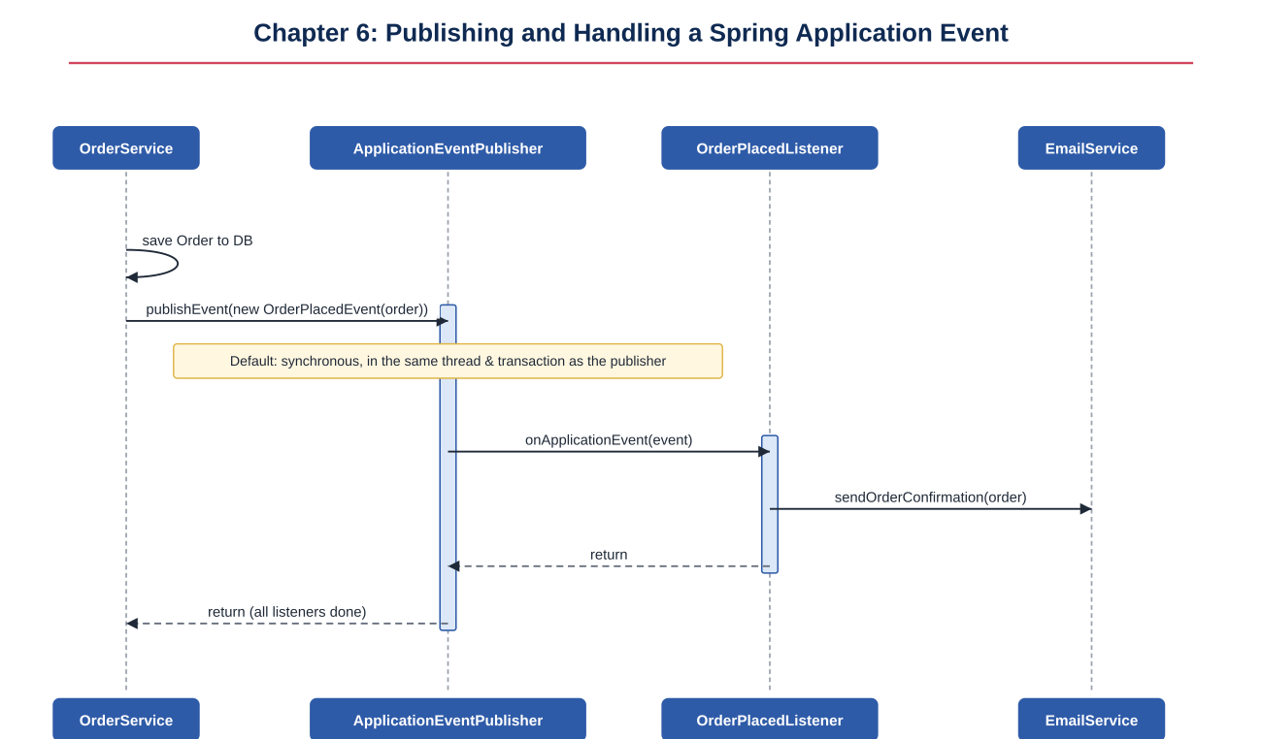
Figure 6.1: Synchronous event dispatch — the publisher's thread blocks until every matching listener returns
TIP
Because dispatch is synchronous by default, a slow listener (e.g. one calling a flaky external email API) directly slows down the original request. Adding @Async to a listener method (with @EnableAsync configured) dispatches it on a separate thread instead, decoupling listener latency from the publisher.

6.4 Conditional Event Handling
@EventListener supports a condition attribute written in Spring Expression Language (SpEL). The listener method body is skipped entirely — not even invoked — if the condition evaluates to false, which is cheaper than entering the method and returning early.
package com.example.orderapp.listener;

import com.example.orderapp.event.OrderPlacedEvent;
import com.example.orderapp.service.SalesAlertService;
import org.springframework.context.event.EventListener;
import org.springframework.stereotype.Component;

@Component
public class HighValueOrderListener {

private final SalesAlertService salesAlertService;

public HighValueOrderListener(SalesAlertService salesAlertService) {
this.salesAlertService = salesAlertService;
}

// #event refers to the OrderPlacedEvent instance itself.
@EventListener(condition = "#event.order.totalAmount > 1000")
public void onHighValueOrder(OrderPlacedEvent event) {
salesAlertService.notifySalesTeam(event.getOrder());
}
}
Example 6.4: HighValueOrderListener.java — SpEL condition on the event payload

6.5 Sequence Diagram: Conditional Event Handling
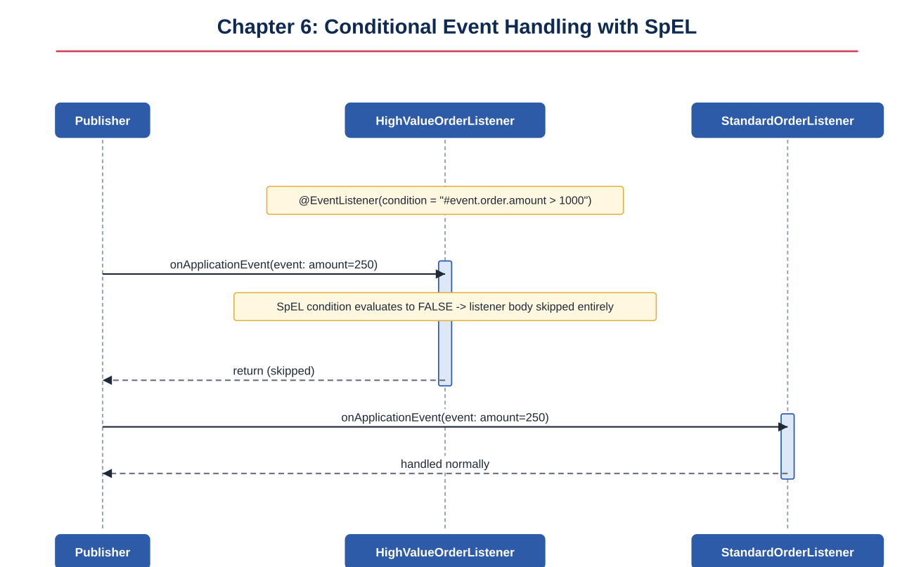
Figure 6.2: The SpEL condition is evaluated before the listener body runs; a false condition skips the listener entirely

6.6 Exception Propagation
With the default synchronous SimpleApplicationEventMulticaster, an exception thrown by one listener propagates back to the publisher's call to publishEvent() and, depending on the multicaster configuration, can prevent subsequent listeners in the same dispatch from running at all. This makes listener exception handling a deliberate design decision, not an afterthought.
package com.example.orderapp.listener;

import com.example.orderapp.event.OrderPlacedEvent;
import org.springframework.context.event.EventListener;
import org.springframework.mail.MailSendException;
import org.springframework.stereotype.Component;

@Component
public class EmailNotificationListener {

@EventListener
public void onOrderPlaced(OrderPlacedEvent event) {
// If the SMTP call throws MailSendException here and it is NOT
// caught, it propagates out of this listener back to the
// multicaster, and may abort sibling listeners.
sendConfirmationEmail(event.getOrder());
}

private void sendConfirmationEmail(com.example.orderapp.entity.Order order) {
// ... calls an SMTP client that may throw MailSendException
}
}
Example 6.5: An uncaught exception inside a listener

6.7 Transactional Event Listener and the Before-Commit Phase
@TransactionalEventListener defers (or conditions) listener execution based on the lifecycle of the transaction that was active when the event was published, rather than running immediately. The phase attribute controls exactly when: BEFORE_COMMIT (still inside the transaction, just before it commits), AFTER_COMMIT (the default — only if the commit succeeded), AFTER_ROLLBACK, or AFTER_COMPLETION (always, regardless of outcome).
package com.example.orderapp.listener;

import com.example.orderapp.event.OrderPlacedEvent;
import com.example.orderapp.service.InventorySnapshotService;
import org.springframework.transaction.event.TransactionalEventListener;
import org.springframework.transaction.event.TransactionPhase;
import org.springframework.stereotype.Component;

@Component
public class InventorySnapshotListener {

private final InventorySnapshotService inventorySnapshotService;

public InventorySnapshotListener(InventorySnapshotService inventorySnapshotService) {
this.inventorySnapshotService = inventorySnapshotService;
}

// Runs INSIDE the same transaction, just before commit -- useful when
// the listener itself needs to write something that must be part of
// the same atomic unit (e.g. a derived/denormalized snapshot row).
@TransactionalEventListener(phase = TransactionPhase.BEFORE_COMMIT)
public void onBeforeCommit(OrderPlacedEvent event) {
inventorySnapshotService.recordSnapshot(event.getOrder());
}
}
Example 6.6: InventorySnapshotListener.java — phase = BEFORE_COMMIT
package com.example.orderapp.listener;

import com.example.orderapp.event.OrderPlacedEvent;
import com.example.orderapp.service.EmailService;
import org.springframework.transaction.event.TransactionalEventListener;
import org.springframework.stereotype.Component;

@Component
public class OrderConfirmationEmailListener {

private final EmailService emailService;

public OrderConfirmationEmailListener(EmailService emailService) {
this.emailService = emailService;
}

// Default phase = AFTER_COMMIT. The confirmation email is only sent
// if the order was actually, durably saved -- never for an order
// that was rolled back.
@TransactionalEventListener
public void onAfterCommit(OrderPlacedEvent event) {
emailService.sendOrderConfirmation(event.getOrder());
}
}
Example 6.7: OrderConfirmationEmailListener.java — phase = AFTER_COMMIT (default)

6.8 Sequence Diagram: @TransactionalEventListener Phases
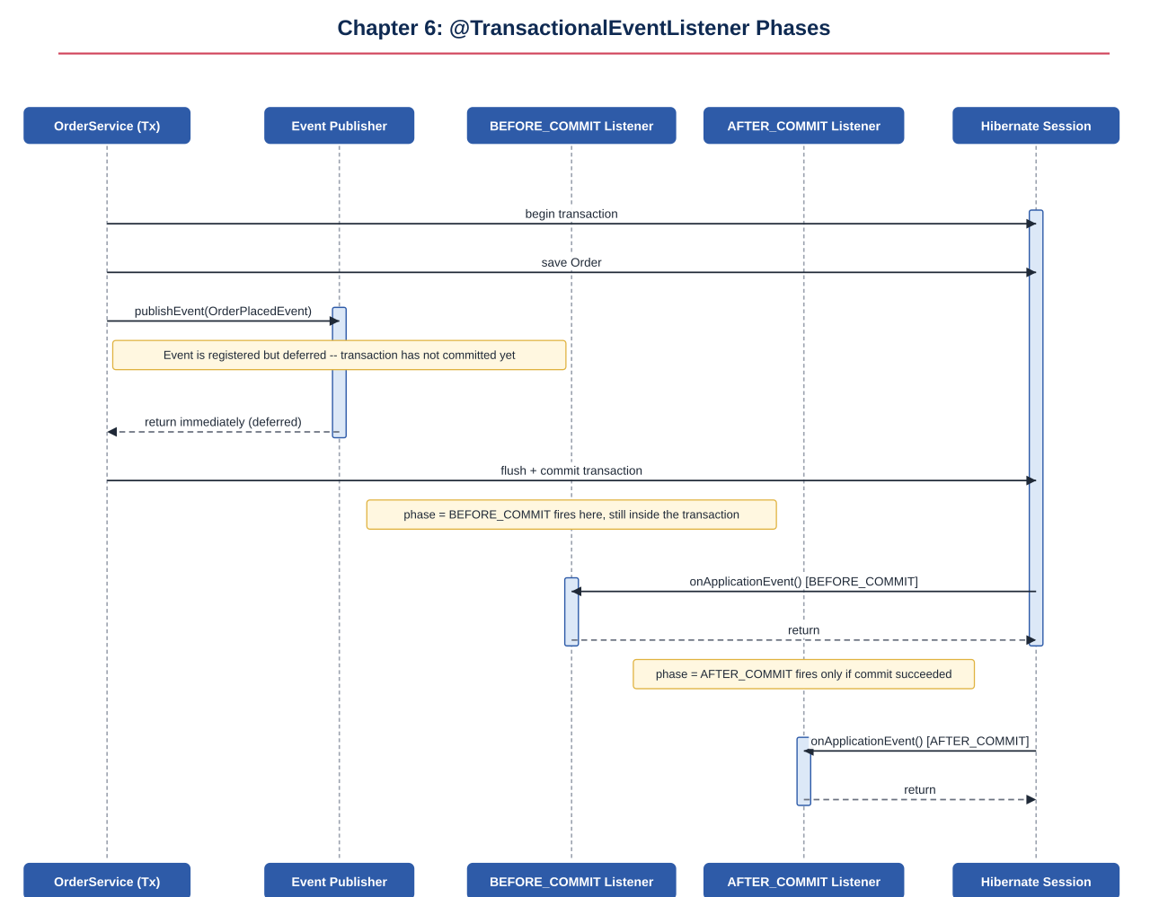
Figure 6.3: publishEvent() during the transaction only registers the event; BEFORE_COMMIT and AFTER_COMMIT listeners fire later, at their respective points in the commit sequence
PITFALL
If there is no active transaction when publishEvent() is called, a @TransactionalEventListener method with the default phase is NOT invoked at all (unless fallbackExecution = true is set on the annotation) — this is a common source of "my listener never runs" bugs in tests that do not wrap the call in a transaction.

6.9 Recovering from Failure, Listeners Gone Quiet, and Fallback Execution
Production systems need a strategy for when a listener itself fails — for example, the primary email channel is down. The pattern below catches the failure at the point of dispatch, logs it, and delegates to a fallback channel so the failure of one listener does not silently disappear ("listeners gone quiet") nor block the publisher thread.
package com.example.orderapp.listener;

import com.example.orderapp.event.OrderPlacedEvent;
import com.example.orderapp.service.EmailService;
import com.example.orderapp.service.SmsFallbackService;
import org.springframework.context.event.EventListener;
import org.springframework.stereotype.Component;

import java.util.logging.Level;
import java.util.logging.Logger;

@Component
public class ResilientNotificationListener {

private static final Logger log =
Logger.getLogger(ResilientNotificationListener.class.getName());

private final EmailService emailService;
private final SmsFallbackService smsFallbackService;

public ResilientNotificationListener(EmailService emailService,
SmsFallbackService smsFallbackService) {
this.emailService = emailService;
this.smsFallbackService = smsFallbackService;
}

@EventListener
public void onOrderPlaced(OrderPlacedEvent event) {
try {
emailService.sendOrderConfirmation(event.getOrder());
} catch (Exception emailFailure) {
// Recover from failure: log it loudly so it is never "gone quiet",
// then fall back to an alternate channel instead of losing the
// notification, and do not let the original exception propagate
// and abort other listeners or the publisher's call site.
log.log(Level.WARNING,
"Email notification failed for order " + event.getOrder().getId()
+ "; falling back to SMS", emailFailure);
smsFallbackService.notifyCustomer(event.getOrder());
}
}
}
Example 6.8: ResilientNotificationListener.java — recovery and fallback execution

6.10 Sequence Diagram: Listener Exception Handling, Recovery, and Fallback
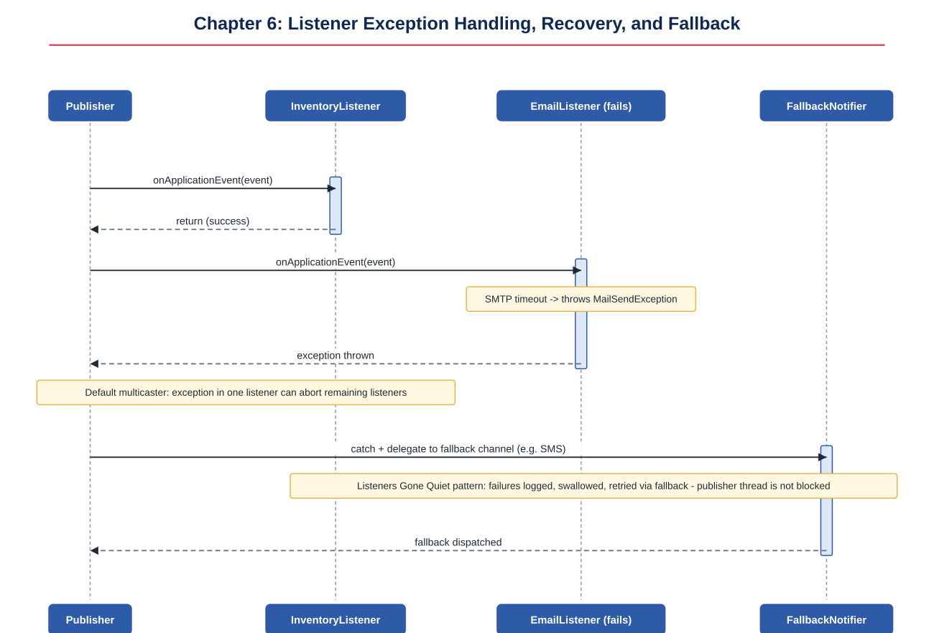
Figure 6.4: EmailListener fails; the failure is caught, logged, and a FallbackNotifier is invoked instead of letting the listener go silent
- Always log a caught listener exception with enough context (event payload identifiers) to investigate later — a silently swallowed catch block is how listeners "go quiet" in production.
- Prefer a dedicated fallback path over retry-forever loops inside the listener itself, which can block the publisher thread for synchronous listeners.
- Consider @Async plus a message queue or dead-letter mechanism for listeners with external dependencies, so failures are durable and retriable outside the original request's lifecycle entirely.

Chapter 7: Isolation Levels — Hands-On Solution
Isolation level controls how much one transaction can see of another transaction's uncommitted or concurrently-changing work. This chapter demonstrates all four standard SQL isolation levels directly in MySQL, then shows how to set them from Spring with @Transactional(isolation = ...), using the same accounts table from Chapter 2.

7.1 Introduction to Isolation Levels
The SQL standard defines four isolation levels, each permitting fewer concurrency anomalies than the one before it, generally at the cost of more locking and reduced throughput.
Isolation Level | Dirty Read | Non-Repeatable Read | Phantom Read
READ UNCOMMITTED | Possible | Possible | Possible
READ COMMITTED | Prevented | Possible | Possible
REPEATABLE READ (MySQL/InnoDB default) | Prevented | Prevented | Largely prevented by InnoDB's MVCC snapshot
SERIALIZABLE | Prevented | Prevented | Prevented
- Dirty read: seeing another transaction's uncommitted changes.
- Non-repeatable read: re-reading the same row twice within one transaction and getting different values because another transaction committed a change in between.
- Phantom read: re-running the same range query twice within one transaction and getting a different set of rows because another transaction inserted or deleted matching rows in between.

7.2 Hands-On Demo with MySQL — READ UNCOMMITTED (Dirty Read)
This demo requires two separate MySQL console sessions (Session A and Session B) connected to the same database, run side by side.
-- Session A
SET SESSION TRANSACTION ISOLATION LEVEL READ UNCOMMITTED;
START TRANSACTION;
UPDATE accounts SET balance = 900 WHERE id = 1; -- NOT committed yet
-- (do not COMMIT or ROLLBACK yet -- keep this session open)
Example 7.1: Session A — an uncommitted update
-- Session B (a separate connection)
SET SESSION TRANSACTION ISOLATION LEVEL READ UNCOMMITTED;
START TRANSACTION;
SELECT balance FROM accounts WHERE id = 1;
-- Returns 900, even though Session A has not committed -- a DIRTY READ.
COMMIT;
Example 7.2: Session B — reading Session A's uncommitted change
-- Back in Session A
ROLLBACK;
-- The balance reverts to its original value. Session B already acted on
-- a value (900) that, as far as the database is concerned, never existed.
Example 7.3: Session A rolls back, proving Session B's read was dirty

7.3 Sequence Diagram: READ_UNCOMMITTED Dirty Read
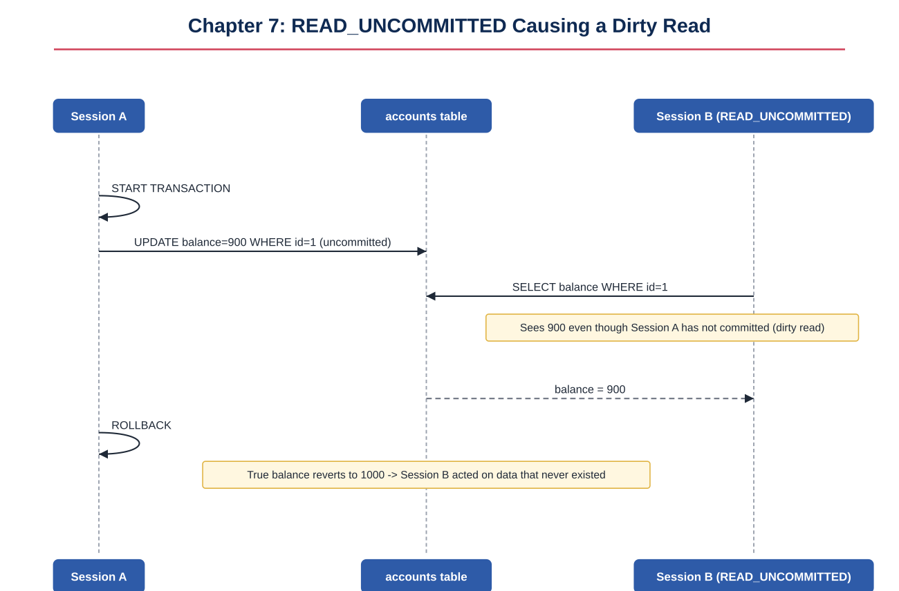
Figure 7.1: Session B reads balance = 900 before Session A commits; Session A then rolls back, leaving Session B with stale, invalid data

7.4 Hands-On Demo — READ COMMITTED (Non-Repeatable Read)
-- Session A
SET SESSION TRANSACTION ISOLATION LEVEL READ COMMITTED;
START TRANSACTION;
SELECT balance FROM accounts WHERE id = 1; -- e.g. returns 1000
-- (keep this transaction open)
Example 7.4: Session A's first read under READ COMMITTED
-- Session B
START TRANSACTION;
UPDATE accounts SET balance = 700 WHERE id = 1;
COMMIT;
Example 7.5: Session B commits a change while Session A's transaction is still open
-- Back in Session A, same transaction, no commit yet
SELECT balance FROM accounts WHERE id = 1; -- now returns 700
-- Two reads in the SAME transaction returned different values:
-- a NON-REPEATABLE READ. READ COMMITTED only blocks DIRTY reads,
-- not this.
COMMIT;
Example 7.6: Session A's second read sees Session B's now-committed change

7.5 Sequence Diagram: READ_COMMITTED Non-Repeatable Read
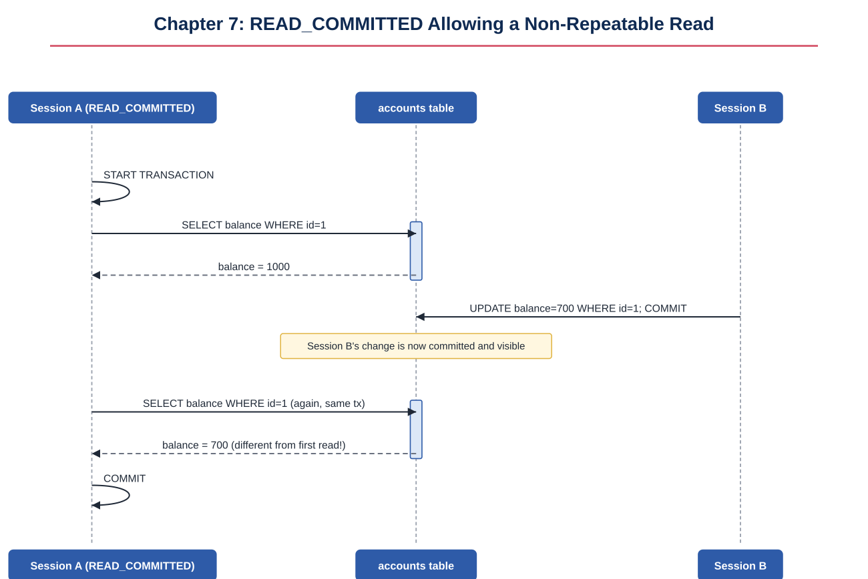
Figure 7.2: Session A reads 1000, then 700, within the same transaction, because READ COMMITTED re-reads the latest committed value every time

7.6 Hands-On Demo — REPEATABLE READ (MySQL/InnoDB Default)
-- Session A
SET SESSION TRANSACTION ISOLATION LEVEL REPEATABLE READ;
START TRANSACTION;
SELECT balance FROM accounts WHERE id = 1; -- returns 1000; InnoDB takes
-- an MVCC snapshot at this point
-- (keep open)
Example 7.7: Session A's first read under REPEATABLE READ
-- Session B
START TRANSACTION;
UPDATE accounts SET balance = 700 WHERE id = 1;
COMMIT;
Example 7.8: Session B commits a change, same as before
-- Back in Session A, same transaction
SELECT balance FROM accounts WHERE id = 1; -- STILL returns 1000
-- InnoDB's snapshot, established at the first read, is preserved for
-- the lifetime of this transaction. The non-repeatable read is prevented.
COMMIT;
-- After COMMIT, a fresh transaction WOULD see 700.
Example 7.9: Session A's second read returns the same, consistent value

7.7 Sequence Diagram: REPEATABLE_READ Preventing Non-Repeatable Reads
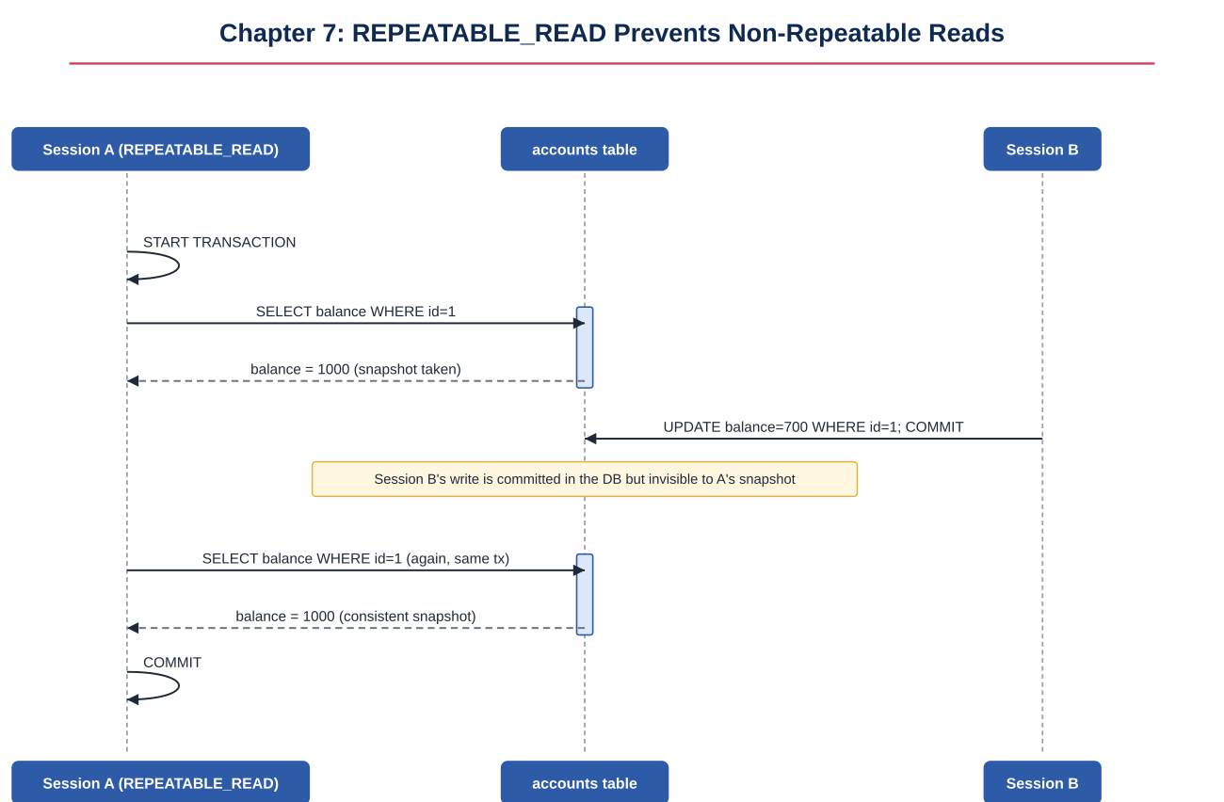
Figure 7.3: Both reads in Session A return 1000 because InnoDB serves them from a consistent snapshot taken at the first read, isolating Session A from Session B's committed write

7.8 Hands-On Demo — SERIALIZABLE (Preventing Phantom Reads)
-- Session A
SET SESSION TRANSACTION ISOLATION LEVEL SERIALIZABLE;
START TRANSACTION;
SELECT * FROM orders WHERE status = 'PENDING'; -- e.g. returns 3 rows;
-- InnoDB takes range/gap locks
-- (keep open)
Example 7.10: Session A's range query under SERIALIZABLE
-- Session B (separate connection)
START TRANSACTION;
INSERT INTO orders (customer_name, status) VALUES ('New Customer', 'PENDING');
-- This INSERT BLOCKS -- it waits for Session A's range lock to be released,
-- rather than succeeding and creating a phantom row.
Example 7.11: Session B's insert blocks instead of introducing a phantom row
-- Back in Session A
COMMIT; -- releases the range lock

-- Session B's INSERT now proceeds and its own COMMIT can complete.
Example 7.12: Session A commits, releasing the lock and unblocking Session B

7.9 Sequence Diagram: SERIALIZABLE Preventing Phantom Reads
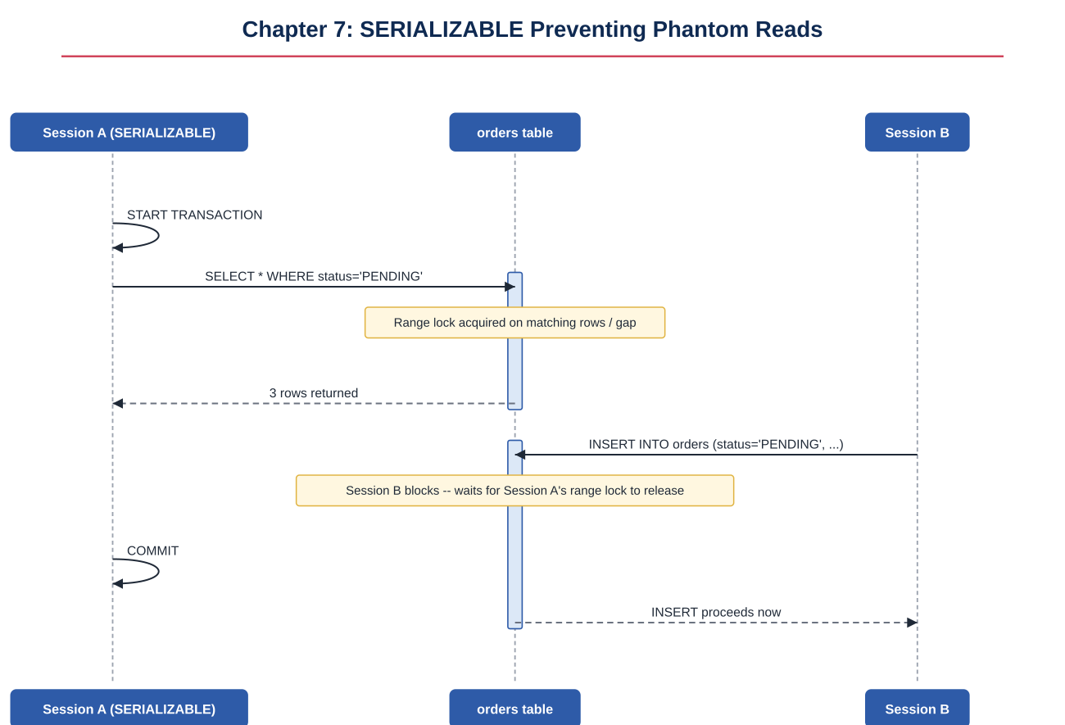
Figure 7.4: Session B's INSERT blocks on Session A's range lock until Session A commits, preventing a phantom row from appearing in Session A's result set
PITFALL
SERIALIZABLE gives the strongest guarantees but the worst concurrency: range locks can cause noticeable contention and blocking under load. It is normally reserved for specific operations with strict correctness requirements (e.g. financial reconciliation jobs), not applied blanket across an entire application.

7.10 Setting Isolation Level from Spring
@Transactional(isolation = ...) lets you override the database's default isolation level for a specific method. This setting only has an effect when it starts a NEW transaction (propagation REQUIRED creating a fresh transaction, or REQUIRES_NEW); it has no effect when joining an already-active transaction, since the isolation level was already fixed when that transaction began.
package com.example.orderapp.service;

import com.example.orderapp.entity.Account;
import com.example.orderapp.repository.AccountRepository;
import org.springframework.stereotype.Service;
import org.springframework.transaction.annotation.Isolation;
import org.springframework.transaction.annotation.Transactional;

@Service
public class AccountService {

private final AccountRepository accountRepository;

public AccountService(AccountRepository accountRepository) {
this.accountRepository = accountRepository;
}

// Strongest isolation for a sensitive financial reconciliation read,
// even though the rest of the application uses the database default
// (REPEATABLE READ on MySQL/InnoDB).
@Transactional(isolation = Isolation.SERIALIZABLE)
public java.math.BigDecimal reconcileTotalBalance() {
return accountRepository.findAll().stream()
.map(Account::getBalance)
.map(java.math.BigDecimal::valueOf)
.reduce(java.math.BigDecimal.ZERO, java.math.BigDecimal::add);
}

// Explicit, even though it matches MySQL's own default -- documents
// the intent for readers of the code.
@Transactional(isolation = Isolation.REPEATABLE_READ)
public Account getAccountSnapshot(Long id) {
return accountRepository.findById(id).orElseThrow();
}
}
Example 7.13: AccountService.java — overriding isolation level per method
NOTE
Not every JDBC driver and database supports every isolation level identically; always verify behavior against the actual database you deploy to (here, MySQL/InnoDB) rather than assuming the SQL standard's textbook definitions apply exactly — InnoDB's REPEATABLE READ, for instance, prevents most phantom reads via MVCC even though the SQL standard only requires this at SERIALIZABLE.

7.11 Chapter Summary
Across this course, the same underlying mechanism has been viewed from three increasingly convenient angles: raw SQL transaction control in MySQL (Chapter 2), manual JDBC transaction management in plain Java (also Chapter 2), and Spring's declarative @Transactional built on top of both (Chapters 3 through 7). Understanding the lower layers makes every higher-layer abstraction — proxies, propagation, rollback rules, isolation levels, and events — something you can reason about precisely instead of treating as "magic."

