**TREE**

* **Tree is Non-Linear Data Structure.**
* **Tree Represent the Relationship Between Nodes.**
* **Collection of Entities are called Nodes.**
* **Nodes are Connected by Edges.**

**NODE:**

* **The Individual Element of Tree is called as Node.**
* **Every Node contains Data (or) Value as well as Links to Others Nodes.**

**ROOT NODE:**

* **The Top Most Node of the Tree is called as Root Node (or) Root.**
* **It is the Origin of the Tree Data Structure.**
* **In Any Tree, There must be only One Root Node. Not Multiple Roots.**

**EDGE (or) LINK:**

* **The Link (or) Connection Between Two Nodes.**

**PARENT NODE:**

* **The Parent Node is a Node which has Child Node.**
* **The Node which has a Branch (or) Edge from Other Node.**
* **The Node Except the ‘ROOT NODE’ has Parent Node.**

**CHILD NODE:**

* **The Link from its Parent Node is Known as Child Node.**
* **A Node can Contains any No.of Child Nodes.**
* **In the Tree Except ‘ROOT NODE’ are the Child Nodes.**

**SIBILINGS:**

* **Nodes that Belong to Same Parent Node.**

**LEAF NODE (or) TERMINAL NODE:**

* **The Node that Doesn’t have the Child Node is known as Leaf Node.**

**INTERNAL NODE:**

* **The Node which has Atleast One Child Node.**

**PATH:**

* **The Sequence of Node and Edge from One Node to Another Node is known as Path Between Two Nodes.**

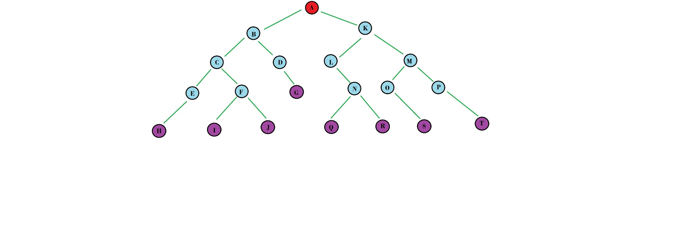

**ROOT NODE**

**NODE**

**LINK**

**LEAF NODE**