Distillation Column Simulation
Separation of a Benzene–Toluene Mixture using DWSIM
A Process Simulation Study
Kislay Kumar
B.Tech Chemical Engineering, National Institute of Technology, Warangal
kk24chb0a29@student.nitw.ac.in
Tools used: DWSIM · NRTL Property Package · Rigorous Distillation Column

1. Objective
This study presents the design and simulation of a continuous binary distillation column for the separation of a Benzene–Toluene mixture, carried out in the open-source process simulator DWSIM. The objective was to apply fundamental mass and energy balance principles, together with a rigorous vapour–liquid equilibrium (VLE) model, to achieve a target distillate purity of greater than 98% Benzene, and to validate the simulated result against the classical McCabe–Thiele graphical method.
Benzene–Toluene was chosen as the system of study because it is a well-characterised, industrially relevant binary pair with a moderate relative volatility, making it a standard benchmark case for evaluating distillation column design and simulation methodology.

2. Methodology

2.1 Components and Property Package
The simulation was built using Benzene and Toluene as the two components. The NRTL (Non-Random Two-Liquid) activity coefficient model was selected as the thermodynamic property package, since it accurately represents the non-ideal liquid-phase behaviour of this hydrocarbon pair while remaining consistent with the ideal-solution limit for closely related species such as Benzene and Toluene.

2.2 Process Flowsheet
The flowsheet consists of a single equimolar feed stream entering a rigorous tray-by-tray distillation column, with a total condenser at the top and a partial reboiler at the bottom, producing a Benzene-rich distillate and a Toluene-rich bottoms product.
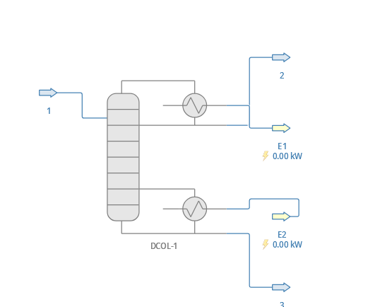
Figure 1: DWSIM process flowsheet — feed, distillation column, distillate and bottoms product streams with condenser and reboiler duty.

2.3 Feed Specification
Parameter | Value
Benzene (mole fraction) | 0.50
Toluene (mole fraction) | 0.50
Temperature | 80 °C (near bubble point)
Pressure | 101.325 kPa (1 atm)
Total molar flow rate | 11.75 mol/s (≈ 100 kmol/h basis)
Feed condition | Saturated liquid (q = 1)

2.4 Column Configuration
Parameter | Value
Number of stages | 12 (including condenser and reboiler)
Feed stage | Stage 6
Tray efficiency (Murphree) | 0.70 for all trays; 1.0 for condenser/reboiler
Condenser type | Total condenser
Condenser specification | Reflux ratio = 5
Reboiler specification | Bottoms product molar flow = 5.8 mol/s
Column pressure drop | 0 Pa (no pressure drop assumed)
Property package | NRTL
Column solver | Wang–Henke (Bubble Point) method

A realistic Murphree tray efficiency of 70% was applied instead of assuming ideal (100%) equilibrium stages, since real trays never achieve perfect vapour–liquid equilibrium. This is a more defensible engineering assumption than treating every tray as a theoretical stage.

3. Base Case Results
The column was solved using the Wang–Henke Bubble-Point algorithm and converged successfully in 74 iterations, well within the 500-iteration limit.
Stream / Property | Result
Feed composition | Benzene 0.500 / Toluene 0.500
Distillate composition | Benzene 0.975 / Toluene 0.025
Bottoms composition | Benzene 0.013 / Toluene 0.987
Condenser duty | 1091.99 kW
Reboiler duty | 1223.05 kW
Estimated column height | 7.0 m
Estimated column diameter | 1.39 m
Iterations to converge | 74

The distillate achieved 97.5% Benzene purity, close to the 98% target, while the bottoms product reached 98.7% Toluene purity. Benzene, having the lower boiling point (≈80 °C), correctly concentrates in the overhead distillate, while Toluene (≈111 °C) concentrates in the bottoms — confirming physically consistent separation behaviour.
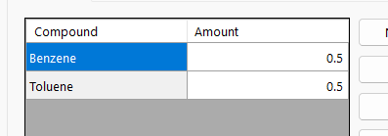
Figure 2: Feed composition (50/50 Benzene/Toluene).
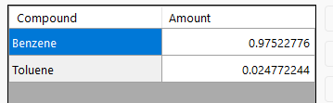
Figure 3: Distillate composition (97.5% Benzene).
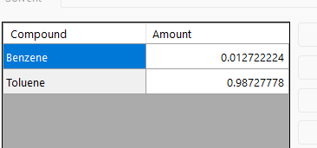
Figure 4: Bottoms composition (98.7% Toluene).
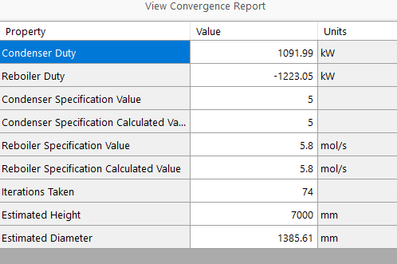
Figure 5: Column convergence report — specification values match calculated values exactly, confirming a fully converged mass and energy balance.

4. Sensitivity Analysis
A two-variable sensitivity study was performed using DWSIM's built-in Sensitivity Analysis tool, examining the effect of:
- Feed-stage tray efficiency (Stage 6, the feed entry point), varied from 0.5 to 0.9
- Feed composition (Benzene mole fraction), varied from 0.3 to 0.7
The feed stage was specifically chosen for the efficiency study because it is the point where the rectifying and stripping sections meet, giving it a disproportionate influence on overall column performance compared with other trays.
The dependent variables tracked across this sweep were:
- Distillate purity (Benzene mole fraction)
- Bottoms purity (Toluene mole fraction)
- Condenser duty (kW)
- Reboiler duty (kW)
General trend observed: increasing feed-stage efficiency improves both distillate and bottoms purity for a given reflux ratio and stage count, since each tray more closely approaches true vapour–liquid equilibrium. Increasing the Benzene fraction in the feed shifts more load onto the rectifying section, generally raising the achievable distillate purity while reducing the relative separation burden on the stripping section. As expected, higher separation duty (via higher purity targets) is accompanied by increased condenser and reboiler duties, reflecting the classic capital-cost/operating-cost trade-off in distillation design.

5. Validation Against the McCabe–Thiele Method
To validate the DWSIM simulation independently, VLE data for the Benzene–Toluene system was generated in DWSIM using the NRTL property package at 101.325 kPa, and used to construct a McCabe–Thiele diagram.
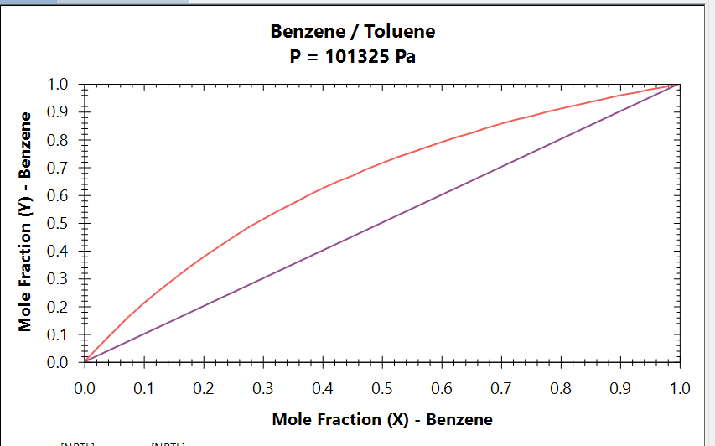
Figure 6: Benzene–Toluene x-y equilibrium diagram generated in DWSIM using NRTL at 101.325 kPa. The equilibrium curve lies well above the y = x reference line across the full composition range, indicating a favourable (relatively easy) separation.

5.1 Operating Lines
Line | Equation / Basis
Rectifying line | y = 0.833x + 0.163 (slope = R/(R+1), R = 5, xD = 0.975)
q-line | x = 0.5 (vertical, saturated liquid feed, q = 1)
Stripping line | Through (xB, xB) = (0.013, 0.013) and the q-line intersection (0.5, 0.579)

5.2 Stage Count Comparison
Stepping off stages graphically between the equilibrium curve and the two operating lines, from the distillate composition (xD = 0.975) down to the bottoms composition (xB = 0.013), yields approximately 11 theoretical stages.
Method | Theoretical Stages
McCabe–Thiele (graphical) | ≈ 11
DWSIM rigorous simulation (12 trays × 0.7 efficiency) | ≈ 8.4 (effective)

The two results agree to within the same order of magnitude, which is a reasonable validation of the DWSIM model. The remaining difference is expected and attributable to two known limitations of the McCabe–Thiele method: it assumes constant molar overflow (equal molar liquid and vapour flow within each section), whereas DWSIM performs a full rigorous energy balance at every stage; and it assumes ideal (100%) stage efficiency, whereas the DWSIM model explicitly applies a realistic 70% Murphree efficiency to every physical tray.

6. Conclusion
- A rigorous DWSIM simulation of Benzene–Toluene distillation was successfully built and converged, using the NRTL property package and the Wang–Henke Bubble-Point solver.
- The base case achieved 97.5% Benzene distillate purity and 98.7% Toluene bottoms purity from an equimolar feed, closely matching the >98% purity target.
- A realistic 70% tray efficiency was applied rather than assuming ideal equilibrium stages, reflecting real-world mass transfer limitations.
- Sensitivity analysis showed that feed-stage efficiency and feed composition both meaningfully affect product purity and heat duties, illustrating the trade-off between separation performance and energy consumption.
- Independent validation via the McCabe–Thiele graphical method (≈11 theoretical stages) agreed reasonably well with the DWSIM rigorous result (≈8.4 effective theoretical stages), with the gap explained by McCabe–Thiele's constant-molar-overflow and ideal-stage assumptions.
This study demonstrates the application of core chemical engineering principles — thermodynamics, mass and energy balances, and staged-separation theory — to a practical process simulation problem, using both rigorous simulation and classical graphical validation methods.

