**Project;**

Our Project aim is; to provide a similar service to LogoGrab (<https://www.logograb.com/)> company’s in our country.

Folowing to this we want to create a service which can automatically recognize previously described brand logos in video and jpeg files.

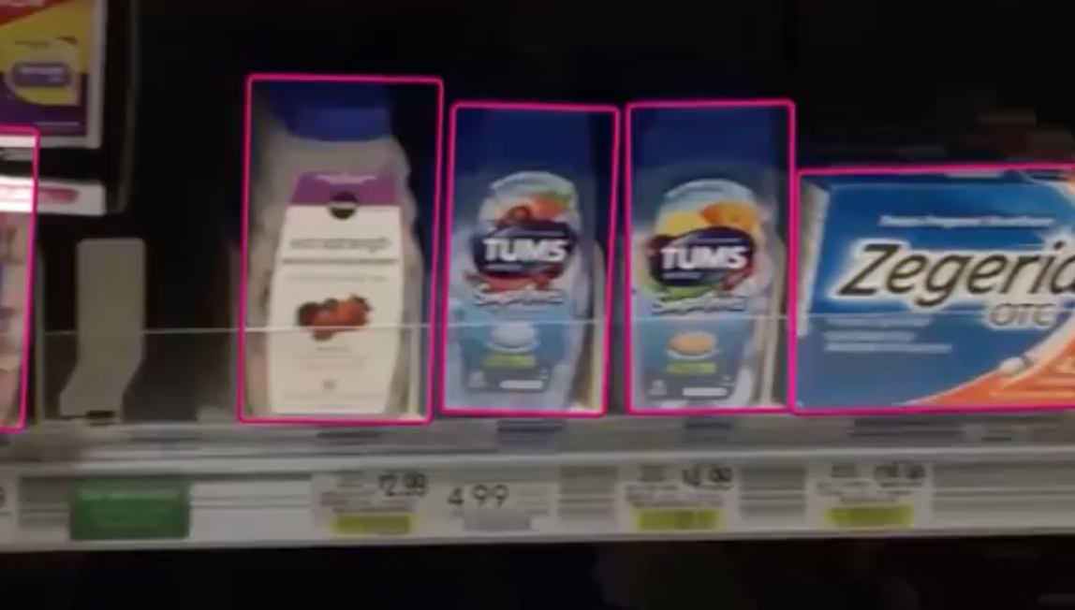

Videos and pictures can be retrieved from diverse channels at the same time. For example we can have a crawler APP and we can tell our customers where,how many times and when their brands are displayed.If requested our customers can also see where their logos are displayed in videos marked and in a box as it is shown in above Picture.This can also be be viewed as marked in a live stream.In a different example, let’s consider now a live TV broadcast, we can display tarcking results of many brands at the same time live and as marked.

Our plan according to our general working principles is; to have a core code which is enable to transform various results scanning automatically unlimited logos in pictures and videos in order to produce many relative products.

While transferring this system in cloud, we will be able to provide detailed analysis about their brand logos and their rivals to our customers.

This Project has 4 steps;

During all steps and phases we kindly ask all documentation of every steps is delivered to us.Thus, we will be able to use your experience and we gain experience on technics such as e ImageRecognation – Machine Learning etc. We will be in contact with you in every steps and include one of our engineer in this Project.

Steps will not be considered as completed untill detailed documentation (Engineering) is delivered.

1. Creating the main model
   1. In this model, a main code should be created for logo recognation on videos and pictures including SIFT and all other technics.
   2. Since you are more experienced in necessity of realated/different code and constitution it is better that you guide us and we ask you to help us to complete the file.
   3. This initial model does not have to include dynamic parts. But there should be a test enviroment with at least 3-4 logo sets.
   4. Initial model will be created as to recognize all logos in all aspects.(Straight,Vertical, On a cup or on a jersey in a football game etc.)
   5. One of the feature of the initial model is to be able with training sets.
   6. The first step considered as completed as soon as a logo set which we will send you later will be tested with the latest version of the code and a obvious success rate is achieved.
   7. As soon as the first step is completed, the initial codes are submitted and previously agreed fees are released.
2. Creating an automatic working model and enforcement (Enhancing Accuracy )
   1. In this model the output received in initial step and sharpness sensivity rate ı (the accuracy enhancing) will be improved.
   2. In this model , TrainingSet tools will be developed for new brand recognition technics. Therefore system will have a tachnique to recognize a new logo while dowloading a new Logo Training Set with a command into it.
   3. System will be designed as ENGINE in a way to be able to iclude empowered Machine Learning System technics to recognize unlimited logos Sistem with capabilities gained in the initial Project.
   4. In the 2 nd part of this Project, a system which is able to recognize %85 of the logos from videos or pictures whatever its shape and independently of enviroment will be produced.
   5. **Bu projede üretilmiş, full otomatik öğrenebilen, dışarıdan yeni data setleriyle bilgi seviyesi arttırılabilen Tanıma Motorunun (Recognition Engine) ‘in, çıktılarının bir REST API arkasında çalışacağı hesaplanarak, Response mantığına uygun çıktılar vermesi planlanacaktır**. **Video/Resim ve tanınan logolar bir JSON çıktısında Koordinatlar, kaç kez göründüğü, ne kadar göründüğü, ne zaman göründüğü, tanınan logonun olasılık skorları dahil çok ayrıntılı sonuçların elde edilebilmesi sağlanacaktır.** **(Burası teknik çeviri gerektiriyor)**
   6. Recognition Engine, will mark recognized logos either in videos or in pictures in a box and also a DB (In a local disc maybe untill 3 rd Project) while editing and marking. Then where and when actually it is marked can be tracked.
   7. In this model logo recognition will be realtime . Necessary documentation will be made as it is suggested by engineers. (x gpu + cpu – worker nodes etc. )
   8. System will be capable to recognize 100 s of the logos in the same time.The request will be planned to be displayed following to their workloads.
   9. GUI will be made ready to download the TrainingSet in command line.
   10. The projest budget will be released as soon as above mentioned items are working properly and after confirmation of the logos are captured and marked.
3. Bug Fixes – Enhancements, Server Architecture
   1. In order that the code got at the end of two initial Project Works fully automatically behind a rest apı a REST API application will be developped.
   2. All components such as end points cache throttle and security will be ready in REST API
   3. This Rest API, will be developped preferably with PHP Laravel 5.x
   4. As soon as Rest API receives requests it sends them to a queue manager. (AWS SMP etc)
   5. Body will be designed on AWS as a code system.It will be created in a engineering as to be scale and fully balanced
   6. A necessary infrasturcture on bakground on AWS Hadoop + MapReduce, Elastic Search etc.that a SaaS should contain enabling Request and Response logs are maintained, processed files are stored, an SaaS for all other statistical datas will be created.
   7. The main machine and nodes where Core Code (Engine) will run will be applied considering enough necessary capacity and fail tolerances.
   8. To create a system replying 100 s of request received at the same time with a minimum recognition there will be at least 10 pieces main endpoint request. We will produce other endpoints.
   9. All servers will be planned as displayed in different location on AWS with Fail Tollerance ve Maintance Backup
   10. At this point of 3 rd Project feasibility will be made on possible cost of this planand on further AWS costs.
   11. Servers will have Centos operating system and all securities will be kept safe behind AWS Firewall. (+SSL)
   12. All architecture, should be documented in a Tutorial explaining step by step, enabling to built the system from the beginning without any problem.
   13. This Project can be divided in 4-5 milestones and payment will be released in every step as soon as the service is delivered.
   14. While all part of 3rd step of the Project continues, Engine enhancement gained in first and second part will continue.
   15. System will be continously updated with Training Sets to enable it to have more information meanwhile
4. Web Site and Delivering the service (We can do it)
   1. Design of the web site presenting the structure of the system obtained after all above steps will be delivered and it will be ensured that the site will be ready with all functionality.
   2. A package of support/training (ie 12 milestones) will be described while starting to use of this package and extra service request will be made if needed.
   3. Negotiation will be made for new assets beside Logo recognition (Face recognition,Object recognition,TV Commercial Recognition,OCR etc.)