ITM University Gwalior
School of Computing and Intelligent Systems
Project-Based Learning (PBL)
Mini Project Report — Submission Format

Course: Data Analytics Using Python
Course Code: CSL0312
Program: B.Tech. CSE (Artificial Intelligence & Machine Learning)
Semester: III Section: F
Academic Session: July–Dec 2026
Project Details
Project Title: Crop Yield Prediction Trend Analysis
Domain (as per Section 6): Agriculture Analytics
Team Leader Name & Roll No.: K. Akshith Reddy (BETN1AI25184)
Team Member Name & Roll No.: M. Kumar (BETN1AI25187)
Team Member Name & Roll No.: M. Shiva Reddy (BETN1AI25188)
Faculty Mentor: Dr. Sanjay Jain, Professor, Dept. of CSE
Date of Submission: __ – __ – 2026

Table of Contents
1. Introduction & Problem Statement 3
2. Dataset Description & Source 4
3. Data Cleaning & Preprocessing 4
4. Exploratory Data Analysis (EDA) 6
5. Data Visualization & Observations 7
6. Statistical Analysis (Basic) 11
7. Key Insights & Interpretation 12
8. Conclusion & Future Scope 13
9. References 14
10. AI Tool Usage Declaration 14
11. Project Links & Deliverables 14
12. Report Structure Checklist (Section 8 Compliance) 15
13. Declaration by Student(s) 15
14. For Faculty Use Only — PBL Final Report Evaluation 16

1. Introduction & Problem Statement
Describe the background, the real-world problem being addressed, its significance, and the scope of the project (200–300 words).
Introduction
Agriculture depends strongly on climate and soil conditions. The crop that grows well in a field is determined by a combination of soil nutrients (nitrogen, phosphorus and potassium), soil pH, temperature, humidity and rainfall. Many farming decisions are still made from past experience rather than data, which can lead to unsuitable crop choices, wasted fertiliser and water, and lower productivity, and climate variability makes these risks larger.
Problem Statement
The project, “Crop Yield Prediction Trend Analysis,” asks two questions: which soil and climate conditions are associated with which crops, and can the most suitable crop be predicted from those conditions? Answering them gives farmers and agronomists an evidence-based starting point for crop selection, fertiliser planning and irrigation planning.
Following the faculty feedback on the synopsis, the scope has been narrowed to what the stated static Kaggle dataset can support: data inspection, cleaning, exploratory data analysis (EDA), basic statistical analysis, visualization, and a baseline machine learning model built with Python. The dataset records the crop suited to a given set of conditions rather than measured yield, so “yield prediction” is treated here as predicting the most suitable crop. Real-time IoT sensing, satellite NDVI monitoring and a deployable advisory platform are outside this scope and are listed under Future Scope.

2. Dataset Description & Source
Dataset Name: Crop Recommendation Dataset (listed in the synopsis as “Crop Recommendation & Yield Prediction”)
Source / Organization: Kaggle (Atharva Ingle) — Agricultural dataset / open data community
Dataset Link (URL): https://www.kaggle.com/datasets/atharvaingle/crop-recommendation-dataset
Type of Dataset: ☒ Public ☐ Private ☐ Self-Collected
Number of Records: 2,200 (the synopsis gave an approximate figure of 2,000)
Number of Attributes/Columns: 8 (7 input features + 1 target label)
Confirm the dataset meets the minimum quality criteria specified in Section 7 of the PBL guidelines: at least 500 records, at least 5 attributes/columns, and minimal missing values (or a documented justification if extensive cleaning was required).
☒ Dataset meets minimum quality criteria (Section 7)
Brief description of attributes/columns:
The dataset combines soil nutrient levels and climate measurements with the crop label that is suitable for those conditions. It covers 22 crops, with exactly 100 records per crop. Seven columns are numerical inputs and one column (label) is the categorical target.
Column | Data type | Description | Unit / Range
N | int64 | Ratio of nitrogen content in soil | 0 – 140
P | int64 | Ratio of phosphorus content in soil | 5 – 145
K | int64 | Ratio of potassium content in soil | 5 – 205
temperature | float64 | Average temperature | °C (8.83 – 43.68)
humidity | float64 | Relative humidity | % (14.26 – 99.98)
ph | float64 | Soil acidity / alkalinity | pH (3.50 – 9.94)
rainfall | float64 | Rainfall received | mm (20.21 – 298.56)
label | object | Crop suited to the conditions (22 classes, e.g. rice, maize, coconut, apple) | Categorical

3. Data Cleaning & Preprocessing
Document the steps taken to clean and prepare the dataset — handling missing values, duplicates, outliers, data type conversions, encoding, normalization/scaling, etc. Include relevant code snippets or summaries.
The dataset was loaded and checked with Pandas and NumPy in Google Colab. The steps and their outcomes are summarised below.
- Dataset inspection: The file loads as 2,200 rows × 8 columns. Column names are consistent and short; no column renaming was needed.
- Missing-value analysis: No missing values were found in any column (total = 0), so no imputation was required.
- Duplicate removal: No duplicate rows were found (0 duplicates), so all 2,200 records were retained.
- Data type correction: Seven numerical columns are stored as int64 / float64 and the label as text; no conversion was needed.
- Inconsistent-value checking: The label column has 22 unique lower-case crop names with exactly 100 records each, so there are no spelling or case inconsistencies. All numerical values fall in plausible agronomic ranges (e.g. pH 3.5–9.94, humidity ≤ 100 %).
- Outlier inspection: Box plots and the 1.5 × IQR rule flagged some values in most columns (Table 3). They were reviewed and retained: they reflect genuine differences between crops (for example, apple and grapes need very high potassium) rather than data-entry errors.
- Data preparation: All seven numerical features were kept. The label was used as the target for the baseline model. Scaling was not required because the model used (Random Forest) is insensitive to feature scale.

import pandas as pd
import numpy as np

# Load the dataset
df = pd.read_csv('Crop_recommendation.csv')

# Basic exploration
print('Dataset shape:', df.shape)
print(df.head())
print(df.info())
print('Missing values per column:')
print(df.isnull().sum())
print('Duplicate rows:', df.duplicated().sum())
print(df['label'].value_counts())

Table 1: Structure and missing values (output of df.info() and df.isnull().sum())
Column | Non-null count | Data type | Missing values
N | 2200 | int64 | 0
P | 2200 | int64 | 0
K | 2200 | int64 | 0
temperature | 2200 | float64 | 0
humidity | 2200 | float64 | 0
ph | 2200 | float64 | 0
rainfall | 2200 | float64 | 0
label | 2200 | object | 0

Table 2: Dataset dimensions before and after cleaning
Item | Original | After cleaning
Rows | 2,200 | 2,200
Columns | 8 | 8
Missing values | 0 | 0
Duplicate rows | 0 | 0

Table 3: Outliers flagged by the 1.5 × IQR rule (retained)
N | P | K | temperature | humidity | ph | rainfall
0 | 138 | 200 | 86 | 30 | 57 | 100

The preprocessing results show that the dataset was already clean: dimensions, missing-value counts and duplicate counts were unchanged by cleaning.

4. Exploratory Data Analysis (EDA)
Summarize the exploratory analysis performed — summary statistics, distributions, correlations, group-wise comparisons, and any patterns identified.
EDA was carried out with Pandas, NumPy, Matplotlib and Seaborn to understand the structure, distributions and relationships in the data.
Descriptive statistics (Table 4) show that the nutrient columns have wide spreads: N ranges from 0 to 140, P from 5 to 145 and K from 5 to 205. K is clearly right-skewed (mean 48.15 against a median of 32). Temperature is close to symmetric (mean 25.62 °C, median 25.60 °C, standard deviation 5.06 °C). Humidity is skewed to the high side (median 80.47 % against a mean of 71.48 %) because a few crops grow in dry air. Rainfall has a mean of 103.46 mm, a median of 94.87 mm and a range of 20.21 to 298.56 mm. Soil pH is concentrated between 5.97 and 6.92 (quartiles) and averages 6.47, which is slightly acidic.
Group-wise comparison by crop shows large differences in conditions: rice has the highest mean rainfall (236.2 mm), while muskmelon has the lowest (24.7 mm). Apple and grapes have very high P and K (about 133 and 200), whereas banana, cotton, coffee and muskmelon have high nitrogen (about 100 or more). Chickpea grows in the driest air (mean humidity 16.9 %), and papaya in the hottest conditions (mean 33.7 °C).
Code:
print('--- Descriptive Statistics for Numerical Variables ---')
display(df.describe())

print('--- Group-wise mean by crop ---')
display(df.groupby('label').mean().round(1))

Table 4: Descriptive statistics of numerical variables (output of df.describe())
 | N | P | K | temperature | humidity | ph | rainfall
count | 2200 | 2200 | 2200 | 2200 | 2200 | 2200 | 2200
mean | 50.55 | 53.36 | 48.15 | 25.62 | 71.48 | 6.47 | 103.46
std | 36.92 | 32.99 | 50.65 | 5.06 | 22.26 | 0.77 | 54.96
min | 0.00 | 5.00 | 5.00 | 8.83 | 14.26 | 3.50 | 20.21
25% | 21.00 | 28.00 | 20.00 | 22.77 | 60.26 | 5.97 | 64.55
50% | 37.00 | 51.00 | 32.00 | 25.60 | 80.47 | 6.43 | 94.87
75% | 84.25 | 68.00 | 49.00 | 28.56 | 89.95 | 6.92 | 124.27
max | 140.00 | 145.00 | 205.00 | 43.68 | 99.98 | 9.94 | 298.56

5. Data Visualization & Observations
Insert key charts/plots (bar charts, histograms, scatter plots, heatmaps, etc.) generated using Matplotlib/Seaborn/Plotly, along with a short observation for each visualization.
Setup code:
import matplotlib.pyplot as plt
import seaborn as sns
sns.set_theme(style='whitegrid')
num = ['N','P','K','temperature','humidity','ph','rainfall']

Code:
plt.figure(figsize=(7, 3.4))
sns.histplot(df['rainfall'], bins=30, kde=True, color='#2E74B5')
plt.axvline(df['rainfall'].mean(), color='r', ls='--', label='Mean')
plt.axvline(df['rainfall'].median(), color='g', ls='--', label='Median')
plt.xlabel('Rainfall (mm)'); plt.ylabel('Number of records')
plt.legend(); plt.tight_layout(); plt.show()

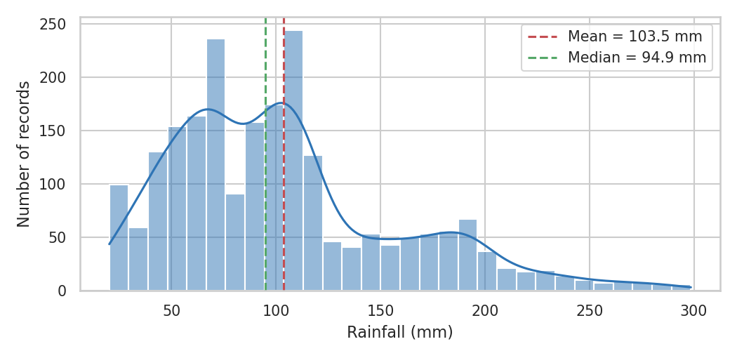
Figure 1: Distribution of Rainfall
Purpose: To examine how rainfall values are distributed across the records.
Observation: Rainfall is right-skewed. Most records lie between about 65 and 125 mm (quartiles 64.55 and 124.27 mm), but a long tail extends to nearly 300 mm. The mean (103.5 mm) is higher than the median (94.9 mm), which reflects that tail. The high values come mainly from rice, coconut and jute.
Code:
crop_rain = df.groupby('label')['rainfall'].mean().sort_values()
crop_rain.plot.barh(figsize=(7, 4), color='#2E74B5')
plt.xlabel('Mean rainfall (mm)'); plt.ylabel('')
plt.tight_layout(); plt.show()

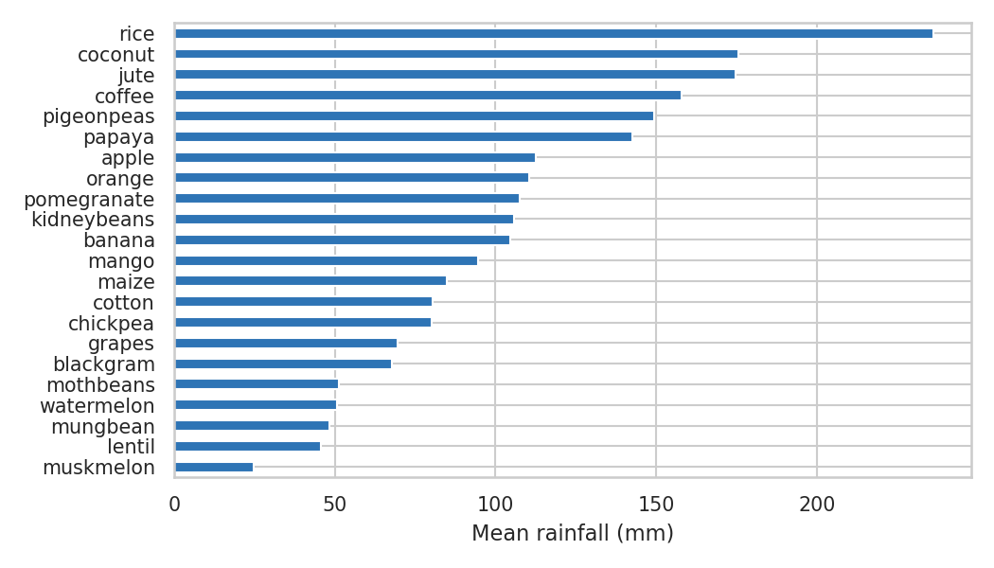
Figure 2: Crop-wise Mean Rainfall Comparison
Purpose: To compare the rainfall conditions associated with different crops (mean rainfall in mm per crop).
Observation: Rice has the highest mean rainfall (236.2 mm), followed by coconut (175.7 mm) and jute (174.8 mm). Muskmelon (24.7 mm), lentil (45.7 mm) and mungbean (48.4 mm) have the lowest. Crops therefore fall into clearly different rainfall groups, from very dry-tolerant to water-intensive.
Code:
plt.figure(figsize=(7, 3.8))
sns.scatterplot(data=df, x='P', y='K', s=14, alpha=0.6, color='#2E74B5')
plt.xlabel('Phosphorus (P)'); plt.ylabel('Potassium (K)')
plt.tight_layout(); plt.show()

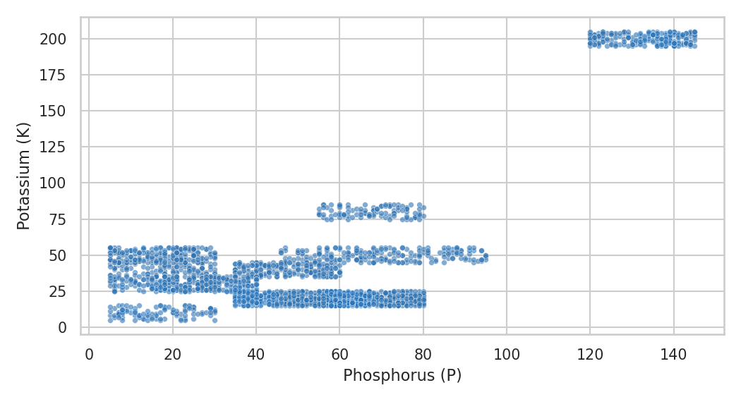
Figure 3: Phosphorus vs Potassium
Purpose: To explore the relationship between two soil nutrients that appeared strongly related in the correlation analysis.
Observation: The points form distinct clusters rather than a single line, but the overall direction is positive (r = 0.74). The cluster at very high P and K (P above 120, K about 200) belongs to apple and grapes. A middle cluster (P about 68, K about 80) is chickpea, and most other crops sit at low-to-moderate P and K.
Code:
plt.figure(figsize=(6.4, 4.8))
sns.heatmap(df[num].corr(), annot=True, fmt='.2f', cmap='coolwarm', center=0)
plt.tight_layout(); plt.show()

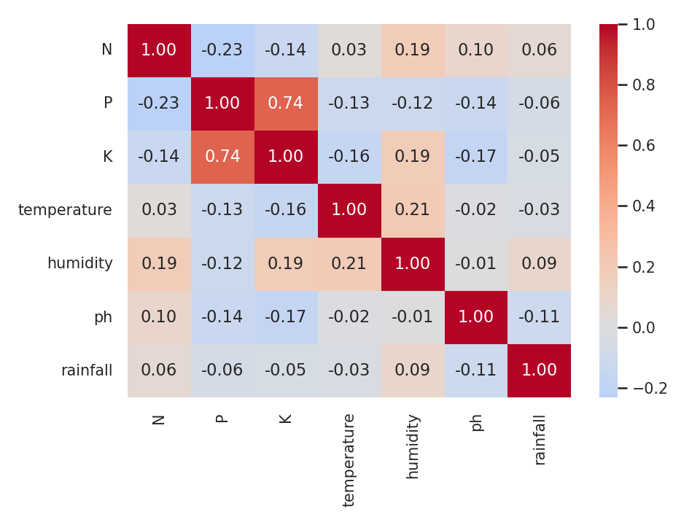
Figure 4: Correlation Heatmap
Purpose: To visualize correlations among the numerical variables.
Observation: The strongest positive correlation is between P and K (r = 0.74). The strongest negative correlation is between N and P (r = −0.23), followed by K and pH (r = −0.17). Climate variables are only weakly related to each other (for example, temperature and humidity r = 0.21), and rainfall has no correlation above 0.11 in absolute value with any other feature.
Code:
order = df.groupby('label')['ph'].median().sort_values().index
plt.figure(figsize=(7.2, 4))
sns.boxplot(data=df, x='label', y='ph', order=order, color='#9DC3E6', fliersize=2)
plt.xticks(rotation=70); plt.xlabel(''); plt.ylabel('Soil pH')
plt.tight_layout(); plt.show()

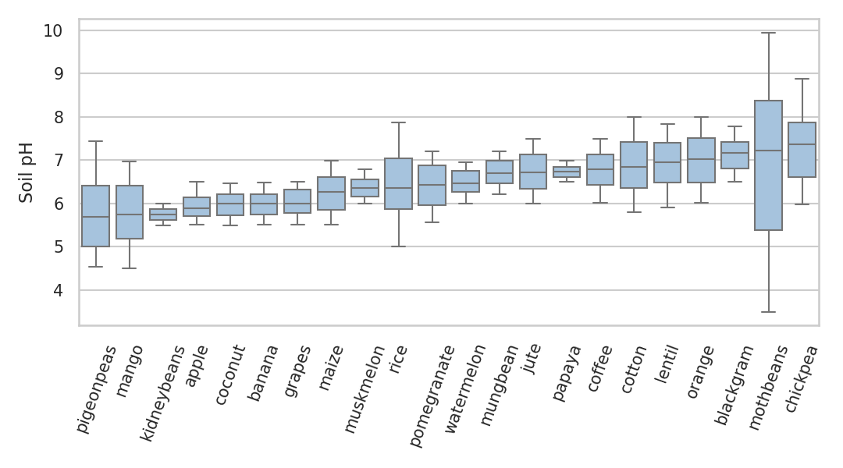
Figure 5: Soil pH Comparison across Crops
Purpose: To compare the distribution of soil pH across the crops in the dataset.
Observation: Pigeonpeas, mango and kidneybeans have the lowest median pH (about 5.7), meaning they are associated with more acidic soil. Chickpea (7.36), mothbeans (7.22) and blackgram (7.17) have the highest medians, in the neutral-to-slightly-alkaline range. Several crops show wide spreads and outliers, while others are tightly grouped.

6. Statistical Analysis (Basic)
Present basic statistical interpretation — measures of central tendency and spread, correlation coefficients, hypothesis tests, or other relevant statistical techniques used to support the analysis.
Statistical analysis summarised the numerical attributes and tested relationships between them. Correlation is not treated as proof of causation, and every statement below is based on values calculated from the dataset.
Code:
from scipy import stats
num = ['N','P','K','temperature','humidity','ph','rainfall']

stats_df = df[num].agg(['mean','median','std','min','max'])
stats_df.loc['skew'] = df[num].skew()
display(stats_df.round(2))

corr = df[num].corr()
display(corr.round(2))

# One-way ANOVA: does mean rainfall differ between crops?
groups = [g['rainfall'].values for _, g in df.groupby('label')]
print(stats.f_oneway(*groups))
print(stats.pearsonr(df['P'], df['K']))

Table 5: Central tendency, spread and skewness
Statistic | N | P | K | temperature | humidity | ph | rainfall
mean | 50.55 | 53.36 | 48.15 | 25.62 | 71.48 | 6.47 | 103.46
median | 37.00 | 51.00 | 32.00 | 25.60 | 80.47 | 6.43 | 94.87
std | 36.92 | 32.99 | 50.65 | 5.06 | 22.26 | 0.77 | 54.96
min | 0.00 | 5.00 | 5.00 | 8.83 | 14.26 | 3.50 | 20.21
max | 140.00 | 145.00 | 205.00 | 43.68 | 99.98 | 9.94 | 298.56
skewness | 0.51 | 1.01 | 2.38 | 0.18 | -1.09 | 0.28 | 0.97

Central tendency and spread. Skewness shows K is the most right-skewed variable (2.38), and humidity is the only strongly left-skewed one (−1.09). Temperature and pH are close to symmetric (0.18 and 0.28).
Correlation. The Pearson correlation between P and K is r = 0.74 (p < 0.001), a strong positive linear relationship. All other pairs are weak (|r| ≤ 0.23). Rainfall and humidity, for example, have r = 0.09, which is statistically detectable with 2,200 records (p < 0.001) but practically very small.
Hypothesis test (one-way ANOVA). The null hypothesis is that mean rainfall is the same for all 22 crops. The test gives F = 605.5 with p < 0.001, so the null hypothesis is rejected: average rainfall differs significantly between crops. This supports using rainfall as a predictor of crop suitability.
Baseline prediction model
As the prediction step of the work plan, a Random Forest classifier (200 trees) was trained to predict the crop label from the seven features, using a stratified 80 / 20 train–test split (random_state = 42).
from sklearn.model_selection import train_test_split, cross_val_score
from sklearn.ensemble import RandomForestClassifier
from sklearn.metrics import accuracy_score

X, y = df[num], df['label']
X_tr, X_te, y_tr, y_te = train_test_split(X, y, test_size=0.2,
stratify=y, random_state=42)
rf = RandomForestClassifier(n_estimators=200, random_state=42).fit(X_tr, y_tr)
print('Test accuracy:', accuracy_score(y_te, rf.predict(X_te)))
print(cross_val_score(rf, X, y, cv=5))
print(pd.Series(rf.feature_importances_, num).sort_values(ascending=False))

Table 6: Baseline model results
Measure | Result
Test accuracy (20 % hold-out, 440 records) | 99.55 %
5-fold cross-validation accuracy | 99.09 % – 99.77 % (mean 99.46 %)

Table 7: Feature importance (Random Forest)
rainfall | humidity | K | P | N | temperature | ph
0.220 | 0.217 | 0.181 | 0.151 | 0.103 | 0.075 | 0.052

The very high accuracy shows that the 22 crops are well separated by these seven features. It should be read with caution: the dataset was built by augmenting rainfall, climate and fertiliser data, is perfectly balanced (100 records per crop), and contains no measured yield, so the score reflects how cleanly the crops separate in this dataset and is not a guarantee of field performance.

7. Key Insights & Interpretation
List the key insights derived from the analysis and interpret what they mean in the context of the chosen problem statement.
- Rainfall patterns: Rainfall is right-skewed, with a median of 94.9 mm and a long tail up to 298.6 mm. The tail is produced by a few water-intensive crops, so rainfall varies widely across the conditions represented in the dataset.
- Rainfall as a distinguishing factor: Mean rainfall differs significantly between crops (ANOVA F = 605.5, p < 0.001) even though rainfall is almost uncorrelated with the other features (|r| ≤ 0.11). It is therefore an independent source of information, and it is the most important feature in the baseline model (importance 0.220).
- Crop-wise variation: Rice (236.2 mm), coconut (175.7 mm) and jute (174.8 mm) are associated with the highest rainfall, while muskmelon (24.7 mm), lentil (45.7 mm) and mungbean (48.4 mm) need the least. This indicates that crop choice should be matched to the local water availability.
- Soil nutrient and pH conditions: P and K are strongly correlated (r = 0.74), driven by apple and grapes, which need very high levels of both. Soil pH ranges from acidic (pigeonpeas, mango, kidneybeans, about 5.7) to neutral or slightly alkaline (chickpea, mothbeans, blackgram, above 7.1), which shows that soil testing matters when choosing a crop.
- Other relevant factors and prediction: Humidity (importance 0.217) and potassium (0.181) are the next most useful predictors, and a Random Forest reaches 99.55 % test accuracy. Climate and soil data together are enough to separate the 22 crops in this dataset, which supports the project’s data-driven approach to crop planning.

8. Conclusion & Future Scope
Summarize the overall findings of the project and suggest possible extensions or improvements for future work.
Conclusion
The project, “Crop Yield Prediction Trend Analysis,” used Python-based data analytics to study how soil nutrients, soil pH and climate conditions relate to crop suitability. The Kaggle dataset of 2,200 records and 8 attributes was clean, with no missing values or duplicates. EDA, correlation analysis and visualization showed clear differences between crops, especially in rainfall (rice about 236 mm against muskmelon about 25 mm), potassium and phosphorus (apple and grapes) and soil pH. A one-way ANOVA confirmed that mean rainfall differs significantly between crops.
A baseline Random Forest model predicted the suitable crop with 99.55 % test accuracy, with rainfall, humidity and potassium as the most important features. The project therefore turns agricultural data into usable information for crop selection. Its limits are that the dataset is static, augmented and balanced, and has no measured yield, so conclusions apply to crop suitability and not to field yield.
Future Scope
- True yield prediction: Combine this data with district-level yield records (for example from data.gov.in) so that yield in tonnes per hectare can be modelled directly.
- Real-time monitoring: Add IoT soil-moisture and temperature sensors so that the model uses live field conditions.
- Satellite monitoring: Use satellite imagery (NDVI) to track crop vigour and detect stress early.
- Resource recommendations: Extend the analysis to irrigation and fertiliser recommendations that reduce input costs.
- Advisory dashboard: Build an interactive web or mobile dashboard that presents predictions, trends and alerts to farmers and agronomists.

9. References
List all references, datasets, articles, and tools cited in the project (use a consistent citation style).
- Ingle, A. Crop Recommendation Dataset. Kaggle. https://www.kaggle.com/datasets/atharvaingle/crop-recommendation-dataset
- Government of India (2024). Open Government Data (OGD) Platform India. National Informatics Centre (NIC). https://data.gov.in
- Ministry of Statistics and Programme Implementation (MOSPI), Government of India (2023). National Accounts Statistics and Economic Indicators. https://mospi.gov.in
- Python Software Foundation. Python Documentation. https://docs.python.org/3/
- pandas Development Team. pandas Documentation. https://pandas.pydata.org/docs/
- Matplotlib Development Team. Matplotlib Documentation. https://matplotlib.org/stable/
- Waskom, M. seaborn: statistical data visualization. https://seaborn.pydata.org/
- scikit-learn developers. scikit-learn Documentation. https://scikit-learn.org/stable/

10. AI Tool Usage Declaration
As per Section 4 & 15 of the PBL guidelines, any use of AI tools (e.g., ChatGPT, GitHub Copilot, Google Colab AI, Gemini, Claude) must be transparently declared below.
☐ No AI tools were used in this project.
☒ AI tools were used, as detailed below:
AI Tool Used | Purpose (e.g., debugging, documentation) | Extent of Use / Section Applied
Claude (Anthropic) | Drafting the report from the approved synopsis; generating and checking Python code for EDA, statistics and the baseline model | Report text and Python code (Sections 1–9); reviewed and run by the team

11. Project Links & Deliverables
GitHub Repository Link: ______________________________________________
Python Notebook (.ipynb) File Name: Crop_Yield_Prediction_Trend_Analysis.ipynb
PBL Report File Name: Crop_Yield_Prediction_Trend_Analysis_Report.docx
Confirm that the GitHub repository includes the code, notebook, and a PBL report as required.
☐ GitHub repository includes code, notebook, and a PBL report and README

12. Report Structure Checklist (Section 8 Compliance)
S. No. | Report Section (as per Section 8 format) | Included (✓)
1 | Title Page | ✓
2 | Introduction & Problem Statement | ✓
3 | Dataset Description & Source | ✓
4 | Data Cleaning & Preprocessing | ✓
5 | Exploratory Data Analysis (EDA) | ✓
6 | Data Visualization & Observations | ✓
7 | Statistical Analysis (Basic) | ✓
8 | Key Insights & Interpretation | ✓
9 | Conclusion & Future Scope | ✓
10 | References | ✓

13. Declaration by Student(s)
I/We hereby declare that this Mini Project Report is our own original work, prepared using publicly available/open datasets. All sources of data, references, and AI tool assistance have been duly acknowledged. I/We understand that any instance of plagiarism in code or report will attract strict academic action, as per Section 15 of the PBL guidelines.
Team Leader Signature: _________________________________
Team Member Signature(s): _________________________________
Date: _________________________________

14. For Faculty Use Only — PBL Final Report Evaluation
Evaluation Component B — PBL Final Report Submission | Mid-Term (PBL Based): 10 Marks (Section 10 of PBL Guidelines)
Evaluation Criteria | Max Marks | Marks Awarded
Data Cleaning & Preprocessing | 2
Exploratory Data Analysis (EDA) | 2
Visualization & Observations | 2
Statistical Analysis | 2
Insights, Interpretation & Conclusion | 2
Total (out of 10) | 10

Faculty Remarks:
Faculty Mentor Signature: _________________________________
Date: _________________________________

