Setup Virtualbox ubuntu vm as below:

sudo apt-get update

sudo apt-get install openssh-server

sudo apt-get install net-tools

Change Network Adaptor type- Attached to - "Bridge Adaptor" and name - "Qualcom Atheros.....".

restart the vm and run ifconfig in terminal to check ip address.

Install curl -- sudo apt-get install curl

**Install kubernetes on virtualbox ubuntu vm:**

**Setup ssh remote client on Visual studio code and connect to the vm-**

**Minikube installation --**

1. grep -E --color 'vmx|svm' /proc/cpuinfo

2. curl -Lo minikube https://storage.googleapis.com/minikube/releases/latest/minikube-linux-amd64 \

&& chmod +x minikube

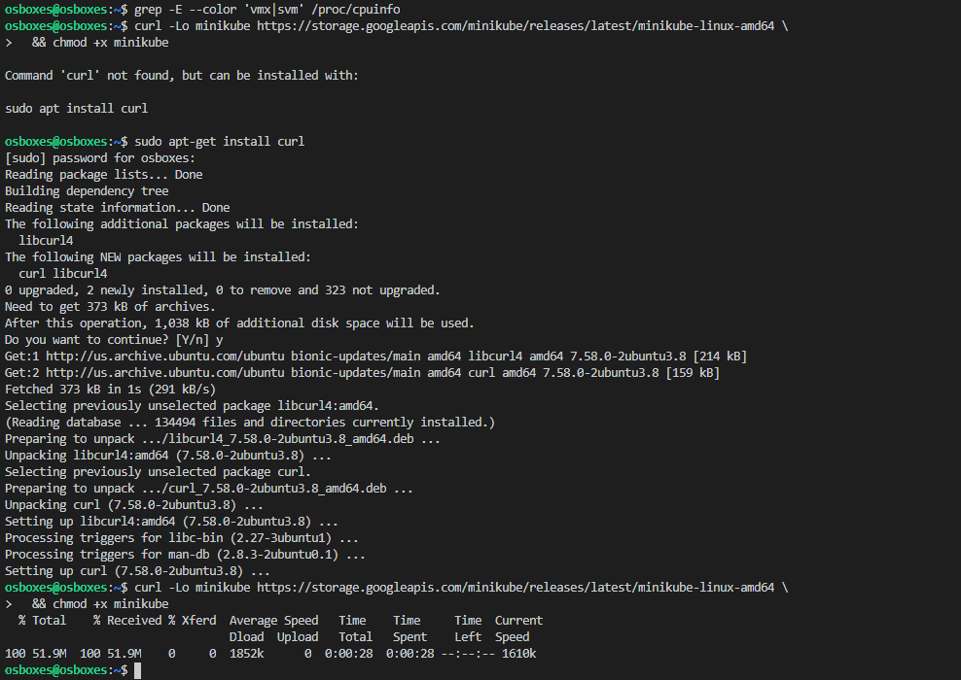

sudo mkdir -p /usr/local/bin/

sudo install minikube /usr/local/bin/



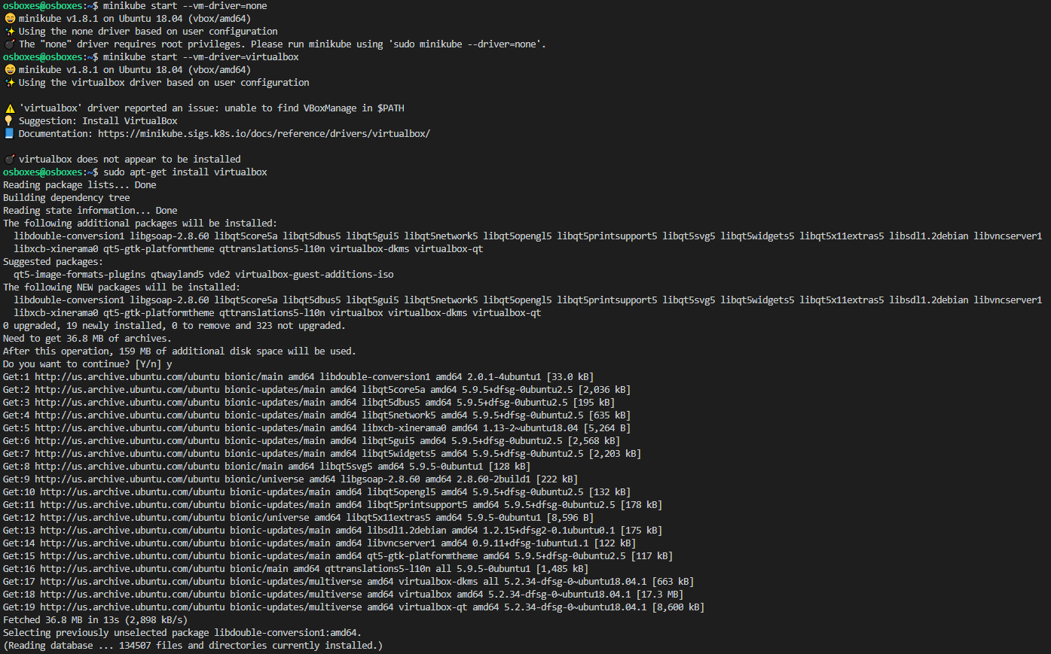

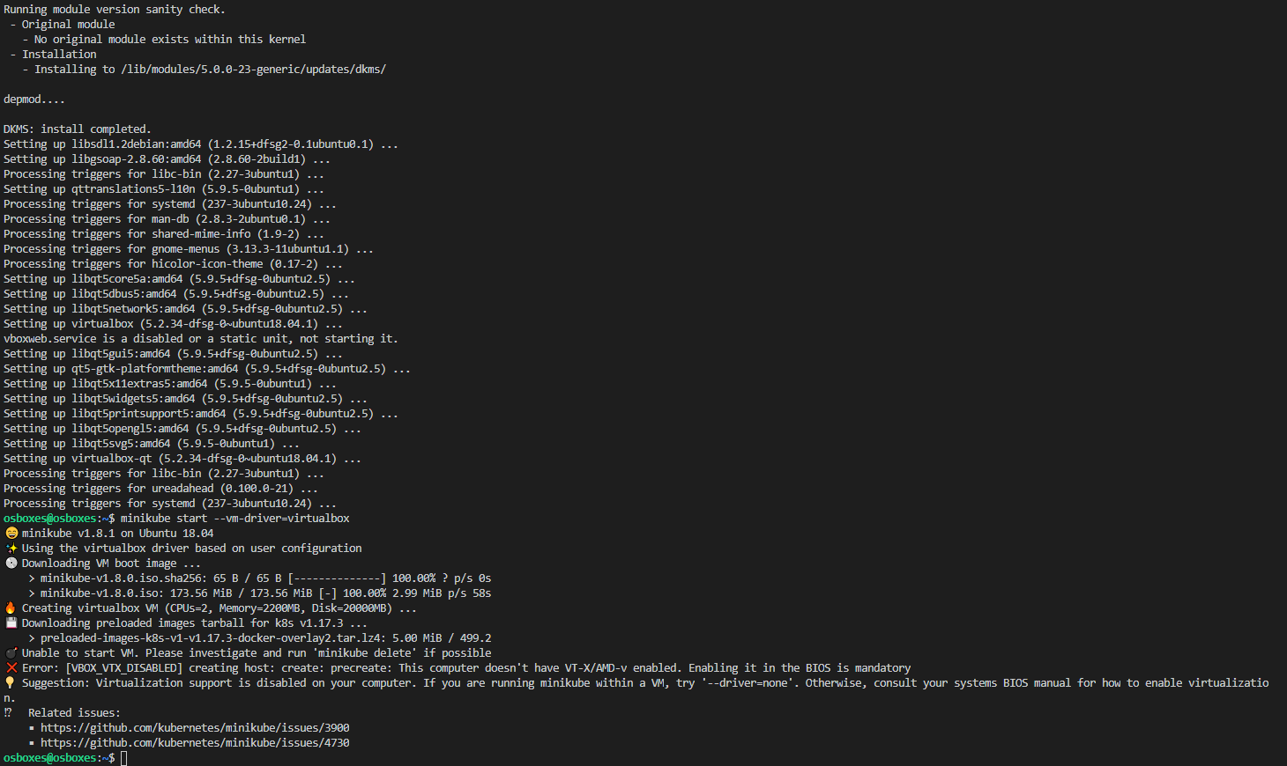

Install docker to use driver=none due to previous error:

sudo curl -sSSL https://get.docker.io/ | sh

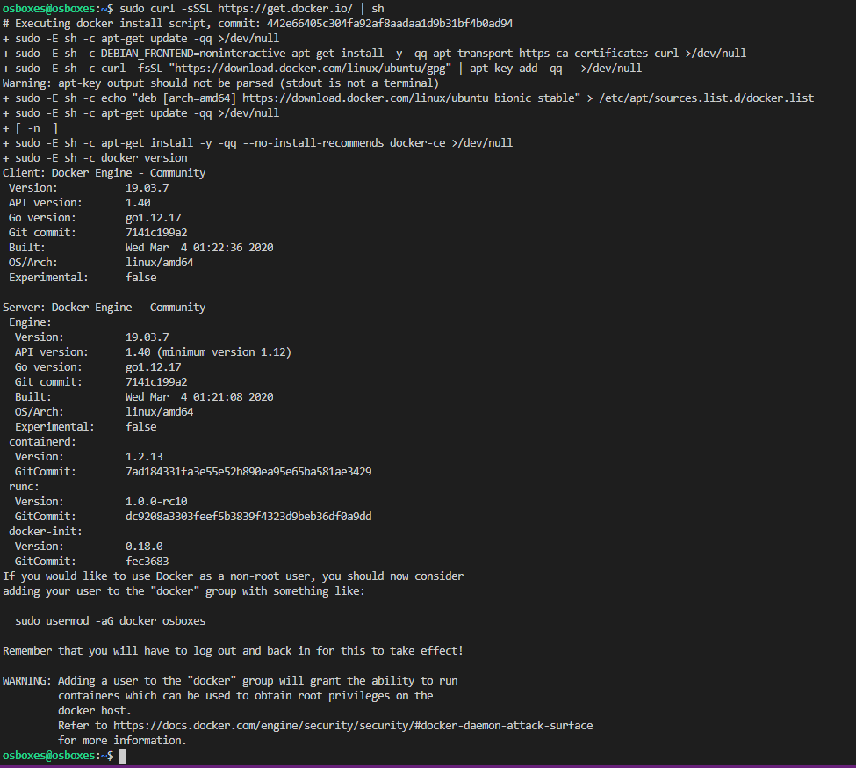

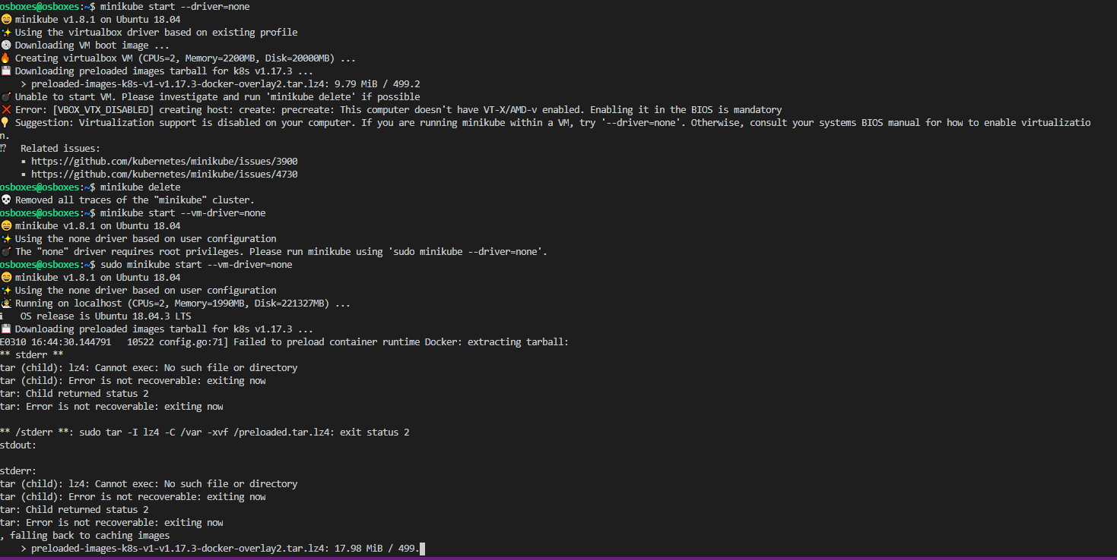

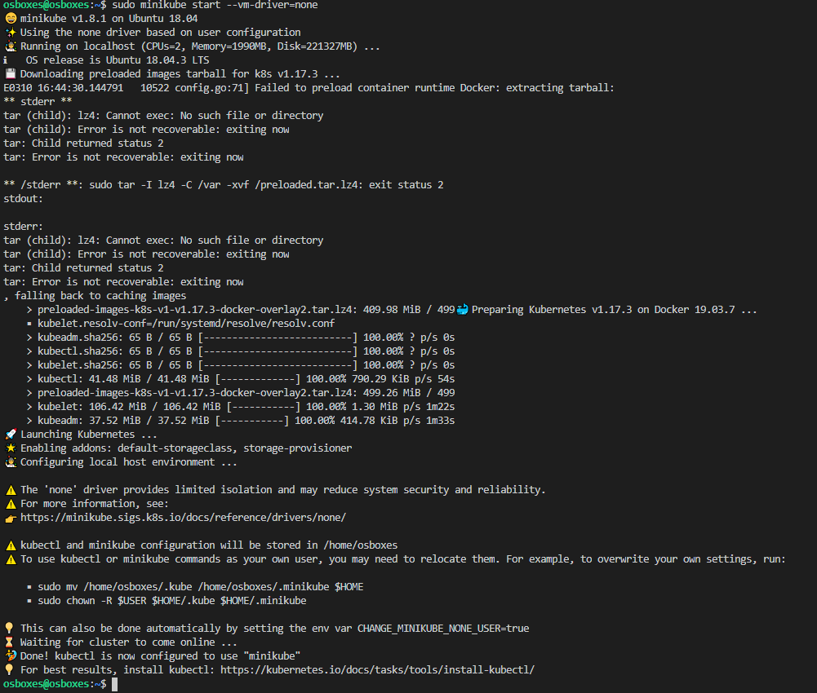

Check the status

minikube status

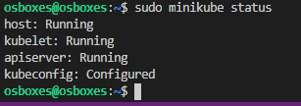

Install kubectl

curl -LO https://storage.googleapis.com/kubernetes-release/release/`curl -s https://storage.googleapis.com/kubernetes-release/release/stable.txt`/bin/linux/amd64/kubectl



chmod +x ./kubectl

sudo mv ./kubectl /usr/local/bin/kubectl

kubectl version --client



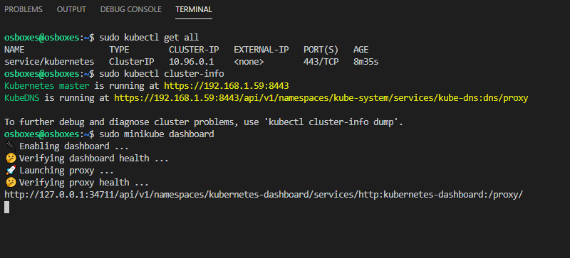

Verify the url:

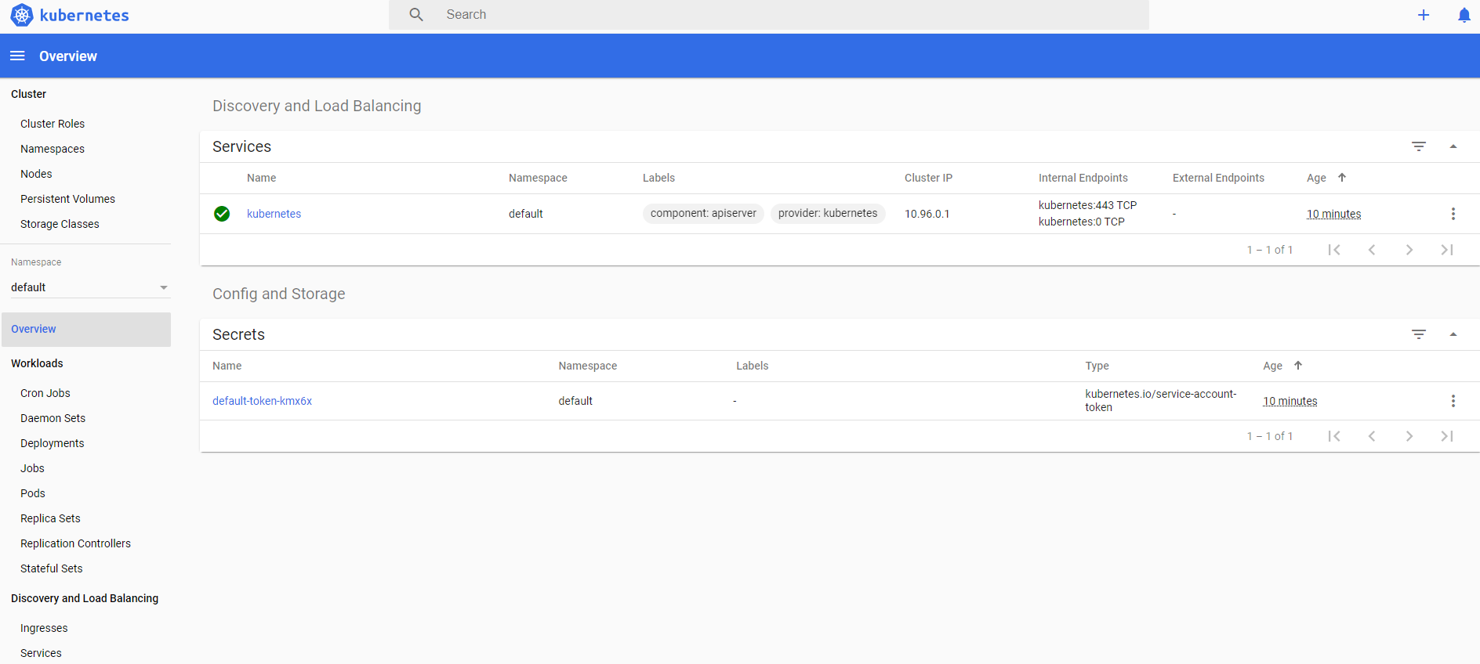

Deploy sample application:

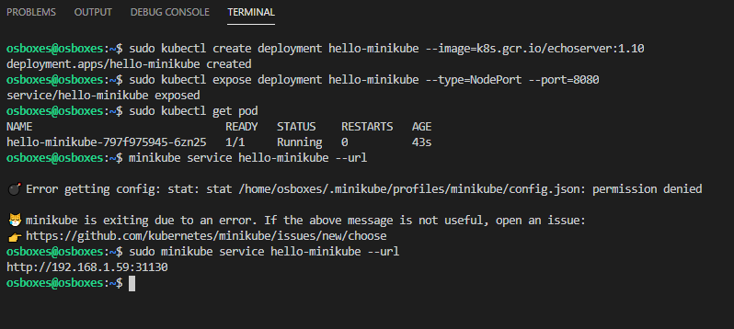

Access minikube url in browser:

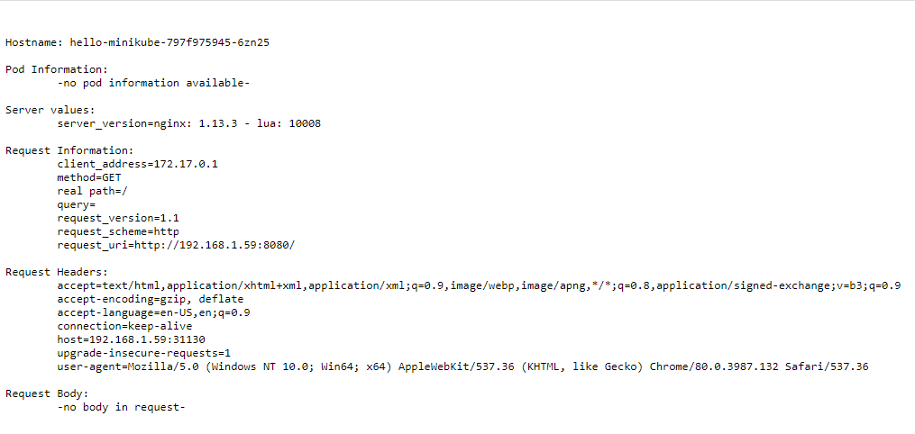

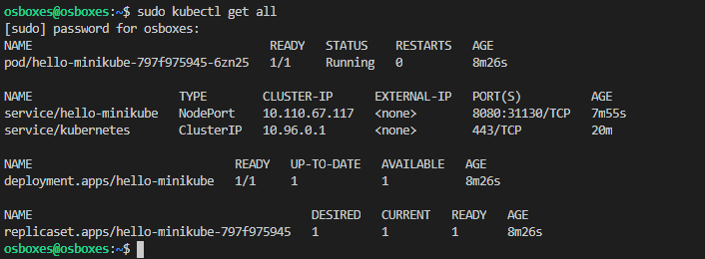

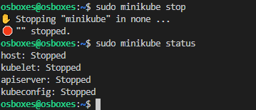

Sudo minikube dashboard

