Amazon Ecommerce Sales Analysis
Project Report
Source: Amazon Ecommerce Dataset.csv

1. Executive Summary
This project is designed to analyze an Amazon ecommerce order dataset and convert raw transaction records into reliable business insights. The analysis focuses on sales performance, products, categories, brands, customers, sellers, payment methods, order status, discounts, tax, shipping, and geography.
The executable analysis is provided in Amazon_Ecommerce_Analysis.ipynb. The notebook reads the original CSV and performs all transformations in memory. The source dataset is not overwritten or modified.

2. Project Objectives
- Measure overall revenue, order volume, units sold, and average order value.
- Understand sales trends across years, quarters, and months.
- Identify high-performing and underperforming products, categories, and brands.
- Analyze customer value, repeat activity, and geographic distribution.
- Compare seller and payment-method performance.
- Evaluate discounts, taxes, shipping costs, and order-status outcomes.
- Create a reusable and documented analysis workflow for future updates.

3. Dataset Description
The dataset is structured at order level based on the available fields. It includes identifiers and descriptive fields for orders, customers, products, brands, sellers, and locations. It also includes numeric commercial fields such as quantity, unit price, discount, tax, shipping cost, and total amount, plus payment and order-status fields.
Field Group | Representative Fields | Purpose
Identifiers | OrderID, CustomerID, ProductID, SellerID | Track orders and entities
Product | ProductName, Category, Brand | Product and assortment analysis
Commercial | Quantity, UnitPrice, Discount, Tax, ShippingCost, TotalAmount | Sales and value calculations
Operations | OrderDate, OrderStatus, PaymentMethod | Time, fulfillment, and payment analysis
Geography | City, State, Country | Market and location analysis

4. Methodology
- Load the CSV into pandas using a relative path so the notebook can be rerun in the project folder.
- Preserve the raw dataframe and work on an in-memory copy.
- Inspect structure, data types, missing values, duplicates, unique values, and numeric ranges.
- Parse OrderDate and convert commercial columns to numeric values.
- Create Year, Quarter, Month, DiscountAmount, and derived order-value fields.
- Compare the recorded TotalAmount with an independently calculated total to identify possible formula or data-quality differences.
- Aggregate KPIs by time, category, brand, product, customer, seller, payment method, order status, and geography.
- Use tables and charts to support interpretation before writing final recommendations.

5. KPI Definitions
KPI | Definition
Recorded sales | Sum of TotalAmount in the source data.
Orders | Distinct count of OrderID.
Units sold | Sum of Quantity.
Average order value | Average TotalAmount per row/order record.
Discount amount | Quantity multiplied by UnitPrice and Discount.
Realized-sales view | Delivered orders reviewed separately from cancelled and pending orders.
Total validation difference | Recorded TotalAmount minus calculated item, tax, and shipping components.

6. Planned Analysis Areas

Sales and Time
Trend sales, orders, and units by year, quarter, and month; identify growth and weaker periods.

Products and Categories
Rank products, categories, and brands by sales, units, orders, and average order value.

Customers
Identify high-value customers, repeat activity, customer order frequency, and customer locations.

Sellers
Compare sellers by sales, orders, units, average order value, and category coverage.

Pricing and Discounts
Compare discount levels with sales, units, and average order value.

Tax and Shipping
Review tax and shipping contributions by order, market, category, and order value.

Payments and Status
Compare payment methods and measure delivered, cancelled, and pending order proportions.

Geography
Rank countries, states, and cities by sales, orders, and units.

7. Data Quality Controls
- Check missing cells and report affected columns.
- Check duplicate rows and duplicate OrderID values.
- Check invalid dates and negative numeric values.
- Check category, brand, country, state, and payment-method consistency.
- Check whether TotalAmount agrees with quantity, unit price, discount, tax, and shipping within a small rounding tolerance.
- Keep cancelled and pending orders visible, but separate them from delivered-order interpretation.

8. Deliverables
- Amazon_Ecommerce_Analysis.ipynb: executable analysis notebook with tables, charts, validation checks, and final review prompts.
- requirements.txt: Python packages required to run the analysis.
- README.md: setup instructions, scope, assumptions, and file guide.
- Amazon_Ecommerce_Project_Report.docx: this project report.

9. Limitations and Assumptions
- The analysis assumes each row represents one order record unless later inspection shows line-item duplication.
- The dataset does not visibly include cost of goods sold, so true profit and margin cannot be calculated from the available fields alone.
- Customer lifetime value and retention analysis are limited by the available observation period and customer history.
- Recorded TotalAmount is treated as the source-of-truth sales field while formula differences are flagged for review.
- Business recommendations should be finalized only after running the notebook and reviewing actual outputs.

10. Recommended Next Steps
- Install the packages in requirements.txt.
- Run every notebook cell from top to bottom.
- Review all data-quality outputs before interpreting the charts.
- Export selected KPI tables and charts for a presentation or dashboard.
- Add profit, inventory, returns, and delivery-time fields if deeper operational analysis is required.
Prepared as a reproducible analysis project. The original CSV remains unchanged.

11. Actual Analysis Results
This section records the current output of Amazon_Ecommerce_Analysis.ipynb using the unchanged source CSV. Rerun the notebook after replacing or updating the source data before treating these values as current.

Core KPIs
Measure | Result
Recorded sales | $91,825,647.92
Orders | 100,000
Units sold | 300,140
Average order value | $918.26
Unique customers | 43,233
Unique products | 50
Unique sellers | 1,999
Date range | 2020-01-01 to 2024-12-29

Data Quality Results
Measure | Result
Missing cells | 0
Duplicate rows | 0
Duplicate OrderIDs | 0
Negative numeric values | 0
Total validation differences above $0.05 | 0

Category Results
Category | Sales | Orders | Units
Electronics | $15,584,217.18 | 16,853 | 50,696
Sports & Outdoors | $15,345,571.88 | 16,804 | 50,543
Books | $15,261,837.01 | 16,752 | 49,981
Clothing | $15,253,397.50 | 16,439 | 49,523
Toys & Games | $15,216,684.99 | 16,542 | 49,773
Home & Kitchen | $15,163,939.36 | 16,610 | 49,624

Top Products by Recorded Sales
Product | Sales | Orders | Units
P00047 - Memory Card 128GB | $1,935,138.40 | 2,039 | 6,240
P00019 - LED Desk Lamp | $1,921,948.41 | 2,098 | 6,344
P00007 - Mechanical Keyboard | $1,906,963.54 | 2,034 | 6,161
P00017 - Electric Kettle | $1,905,751.79 | 2,054 | 6,165
P00010 - Smartwatch | $1,901,275.59 | 1,989 | 5,983
P00030 - Dress Shirt | $1,896,765.36 | 2,007 | 5,960
P00022 - Water Bottle | $1,895,467.95 | 2,088 | 6,275
P00006 - Gaming Mouse | $1,895,103.98 | 2,010 | 6,170
P00031 - Kids Toy Car | $1,891,082.43 | 2,004 | 6,131
P00028 - Jeans | $1,882,591.82 | 1,969 | 6,037

Order Status Results
Status | Orders and Sales
Delivered | 74,628 orders | $68,372,677.10
Shipped | 15,192 orders | $14,083,628.99
Pending | 4,103 orders | $3,737,556.98
Returned | 3,049 orders | $2,780,662.46
Cancelled | 3,028 orders | $2,851,122.39

Payment Method Results
Payment method | Orders and Sales
Credit Card | 35,038 orders | $32,122,158.69
Debit Card | 20,024 orders | $18,538,678.53
UPI | 15,066 orders | $13,896,028.55
Amazon Pay | 15,017 orders | $13,697,498.42
Net Banking | 9,927 orders | $9,055,674.57
Cash on Delivery | 4,928 orders | $4,515,609.16

Country Results
Country | Orders and Sales
United States | 70,058 orders | $64,310,048.50
India | 15,051 orders | $13,875,839.12
Canada | 5,818 orders | $5,323,757.00
United Kingdom | 4,943 orders | $4,526,896.86
Australia | 4,130 orders | $3,789,106.44

Notebook Output Visuals
These figures are generated by the notebook analysis and embedded here as a report snapshot. The notebook remains the reproducible source for regenerating them.
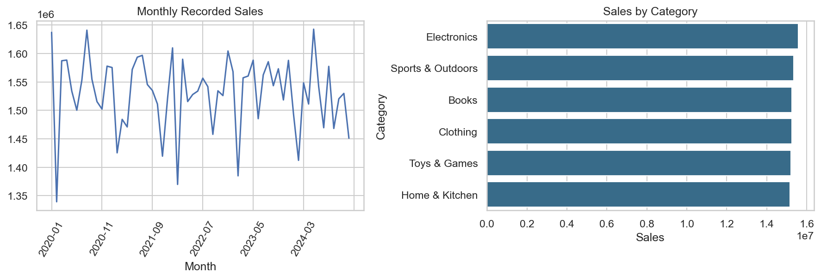
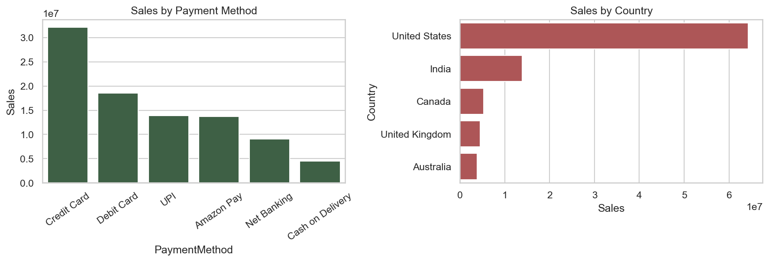

12. Output Interpretation
The current run records $91,825,647.92 in sales across 100,000 orders and 300,140 units. Delivered orders account for 74.63% of records. Electronics is the highest-sales category, the United States is the highest-sales country, and Credit Card is the highest-sales payment method.
These statements describe the current dataset snapshot only. Rerun the notebook whenever the CSV changes, then regenerate this output section to keep the documentation synchronized.

