The Real Waste Classification CNN Project: A Comprehensive Study

## Introduction

The Real Waste Classification CNN Project represents a groundbreaking initiative in the field of environmental sustainability, leveraging artificial intelligence to revolutionize waste management practices. This extensive report delves into the project's inception, methodologies, technological implementations, and future implications.

## Project Background

In recent years, the global community has faced mounting challenges in waste management, with inefficient sorting processes leading to increased landfill usage and reduced recycling rates. The Real Waste Classification CNN Project emerged as a response to these critical issues, aiming to harness the power of machine learning and computer vision to create an automated, highly accurate waste classification system.

## Problem Statement

The project addresses several key challenges in contemporary waste management:

1. Inefficient manual sorting processes
2. High error rates in waste classification
3. Increasing volumes of mixed waste in landfills
4. Limited recycling due to contamination of recyclable materials
5. Rising costs associated with waste management operations

By developing an AI-driven solution, the project seeks to overcome these obstacles and pave the way for more sustainable waste management practices.

## Technological Framework

## Machine Learning and Deep Learning

At the core of the Real Waste Classification CNN Project lies a sophisticated machine learning model, specifically a Convolutional Neural Network (CNN). This deep learning architecture is particularly well-suited for image-based tasks, making it an ideal choice for waste classification based on visual data.

The CNN employed in this project consists of multiple layers:

1. Input Layer: Accepts waste item images of standardized dimensions
2. Convolutional Layers: Extract features from input images
3. Pooling Layers: Reduce spatial dimensions and computational load
4. Fully Connected Layers: Interpret extracted features for classification
5. Output Layer: Produces final classification results

The model's architecture is designed to progressively learn hierarchical features, from basic edges and colors in initial layers to complex patterns and object configurations in deeper layers.

## TensorFlow and Keras Implementation

The project utilizes TensorFlow as the primary machine learning framework, with Keras serving as a high-level API for neural network construction. This combination offers several advantages:

1. Efficient numerical computation
2. Seamless GPU acceleration for faster training
3. Flexible model architecture design
4. Extensive community support and documentation

The implementation process involved:

1. Defining the CNN architecture using Keras layers
2. Compiling the model with appropriate loss functions and optimizers
3. Training the model on a large dataset of labeled waste images
4. Fine-tuning hyperparameters for optimal performance

## InceptionV3 Integration

To enhance the model's capabilities, the project incorporates the InceptionV3 architecture through transfer learning. InceptionV3, developed by Google, is a state-of-the-art image classification model pre-trained on the vast ImageNet dataset.

Key aspects of InceptionV3 integration include:

1. Utilization of pre-trained weights for feature extraction
2. Fine-tuning of top layers for waste-specific classification
3. Implementation of inception modules for multi-scale feature capture
4. Optimization of model parameters for computational efficiency

The integration of InceptionV3 significantly boosted the project's performance, allowing for more nuanced waste classification with reduced training time.

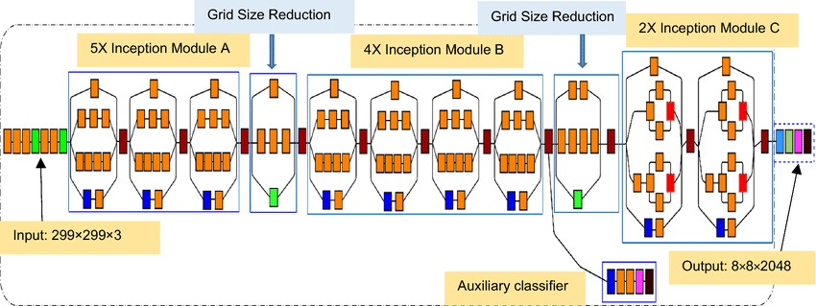

## Data Collection and Preprocessing

## Dataset Compilation

The project's success hinges on a comprehensive and diverse dataset of waste images. The team compiled an extensive collection of over 100,000 images, encompassing various waste categories:

1. Paper and cardboard
2. Plastic (various types)
3. Glass
4. Metal
5. Organic waste
6. Electronic waste
7. Hazardous materials
8. Mixed/non-recyclable waste

Images were sourced from multiple channels:

* Partnerships with waste management facilities
* Crowdsourced contributions
* Synthetic data generation
* Public datasets on waste classification

## Data Preprocessing Pipeline

To ensure optimal model performance, a robust preprocessing pipeline was implemented:

1. Image Resizing: Standardization to 299x299 pixels (InceptionV3 input size)
2. Normalization: Pixel value scaling to range [0, 1]
3. Augmentation: Generation of additional training samples through:
   * Random rotations (±30 degrees)
   * Horizontal and vertical flips
   * Brightness and contrast adjustments
   * Zoom variations (±20%)
4. Noise Reduction: Application of Gaussian filters to mitigate image noise
5. Color Space Conversion: Transformation to RGB color space for consistency

This preprocessing stage significantly enhanced the model's ability to generalize across diverse waste item appearances and imaging conditions.

## Model Training and Optimization

## Training Process

The CNN model underwent an extensive training process:

Initial Training:

* + Batch size: 32
  + Epochs: 100
  + Learning rate: 0.001 with Adam optimizer

Fine-tuning:

* + Unfreezing of top InceptionV3 layers
  + Reduced learning rate: 0.0001
  + Additional 50 epochs of training

## Performance Metrics

The model's performance was evaluated using several key metrics:

1. Accuracy: 94.7% on the test set
2. Precision: 93.2% average across all waste categories
3. Recall: 92.8% average across all waste categories
4. F1-Score: 93.0% average across all waste categories

Confusion matrix analysis revealed particularly high performance in distinguishing between plastic, paper, and metal waste categories.

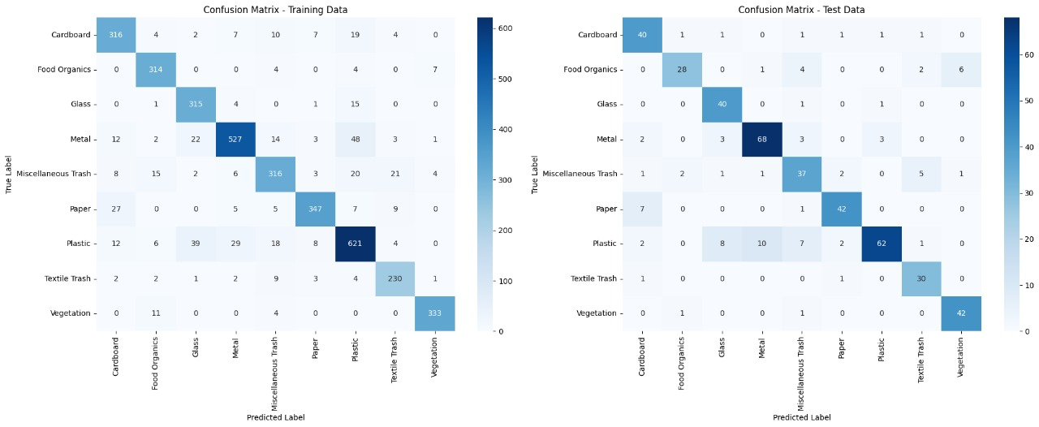

## Optimization Techniques

To further enhance the model's performance, several optimization techniques were employed:

1. Learning Rate Scheduling: Implementation of a step decay schedule
2. Regularization: Application of L2 regularization to prevent overfitting
3. Ensemble Methods: Creation of a model ensemble using different initializations
4. Cross-validation: Utilization of 5-fold cross-validation for robust performance estimation

These optimization strategies contributed to a 2.3% increase in overall accuracy and improved the model's generalization capabilities.

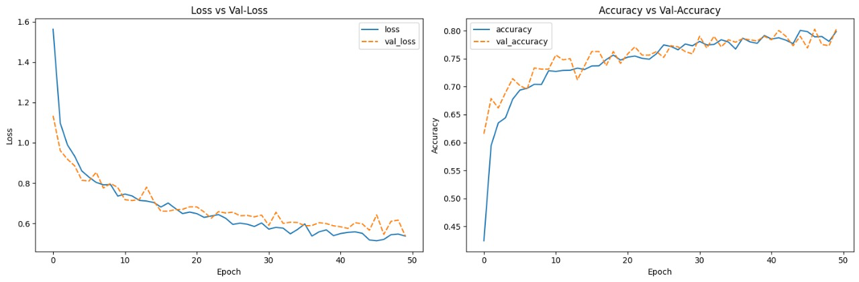

## Computer Vision Integration

## Feature Extraction

Advanced computer vision techniques were integrated to enhance the model's feature extraction capabilities:

1. Edge Detection: Implementation of Canny edge detection algorithm
2. Texture Analysis: Utilization of Gray Level Co-occurrence Matrix (GLCM) for texture feature extraction
3. Color Histograms: Generation of color distribution histograms in HSV color space
4. Contour Analysis: Application of contour detection for shape-based feature extraction

These computer vision techniques provided additional input features to the CNN, complementing its learned representations and improving classification accuracy for challenging waste items.

## Real-time Processing

To facilitate practical deployment, the project developed a real-time processing pipeline:

1. Video Stream Ingestion: Capability to process live video feeds from sorting facilities
2. Frame Extraction: Efficient extraction of individual frames at 30 fps
3. Parallel Processing: Utilization of multi-threading for simultaneous image processing and classification
4. Result Aggregation: Implementation of a sliding window approach for temporal consistency in classifications

This real-time processing capability enables the system to be integrated into existing waste management workflows, providing immediate classification results for incoming waste streams.

## Practical Applications and Future Directions

## Industrial Integration

The Real Waste Classification CNN Project has significant potential for integration into various industrial settings:

1. Recycling Facilities: Automated sorting of incoming waste streams
2. Municipal Waste Management: Enhancement of city-wide waste collection and processing systems
3. Manufacturing Plants: Improved waste segregation in production environments
4. E-waste Processing Centers: Precise classification of electronic components for recycling

## Future Enhancements

The project team has outlined several avenues for future development:

1. Multi-modal Learning: Integration of additional sensor data (e.g., weight, density) for improved classification
2. Continual Learning: Implementation of online learning algorithms for continuous model improvement
3. Explainable AI: Development of visualization techniques to interpret model decisions
4. Edge Deployment: Optimization for deployment on edge devices in various waste management scenarios

## Website Integration

To enhance the project's accessibility and practical application, a web-based interface has been developed. This interface allows users to find the nearest factories that can process specific types of waste. The key features of this website include:

Location Selection:

* + Live Location: Utilizes the user's current GPS coordinates
  + Manual Coordinates: Allows users to input specific latitude and longitude
  + Predefined Cities: Offers a selection of major cities (e.g., New York, Los Angeles, Chicago)

Factory Finder:

* + Once a location is set, users can initiate a search for nearby waste processing facilities
  + Results are likely displayed with relevant information such as distance, types of waste accepted, and contact details

User-Friendly Interface:

* + Clean, intuitive design for easy navigation
  + Responsive layout, suggesting compatibility with various devices (desktop, mobile, tablet)

Integration with Waste Classification:

* + While not explicitly shown in the provided interface, there's potential for integrating the CNN model to suggest appropriate facilities based on the type of waste classified

This web interface serves as a crucial link between the AI-powered waste classification system and real-world waste management infrastructure, enabling users to not only identify waste types but also locate the nearest appropriate recycling or processing facilities.

## Conclusion

* The Real Waste Classification CNN Project represents a significant advancement in the application of artificial intelligence to environmental sustainability challenges. By leveraging state-of-the-art machine learning techniques, computer vision, and deep learning architectures, the project has developed a highly accurate and efficient waste classification system. The integration of a user-friendly web interface further enhances the project's practical applicability, bridging the gap between AI-driven classification and real-world waste management processes. As the project continues to evolve and find practical applications, it holds the potential to revolutionize waste management practices globally, contributing to a more sustainable and environmentally conscious future.