PayFlow REST API Assignment Report

1. Project Overview
PayFlow is a simplified payment backend application developed using Spring Boot, Spring Data JPA, and H2 Database. The application provides REST APIs that allow users to register themselves, retrieve user information, and record money transfer transactions between users.
The project follows a layered architecture consisting of Controller, Service, Repository, and Entity layers. Data is stored in an H2 in-memory database and managed using Spring Data JPA.

2. Project Setup

Dependencies Used
- Spring Web: Used for creating REST APIs and handling HTTP requests
- Spring Data JPA: Simplifies database operations using repositories and ORM
- H2 Database : Lightweight in-memory database used during development

Package Structure

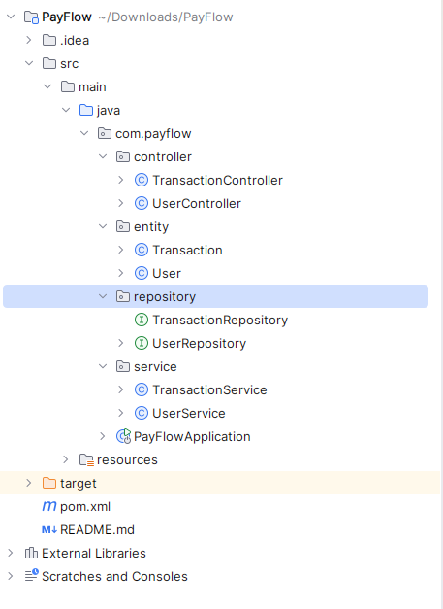

Entity Package
Contains JPA entity classes that represent database tables.

Repository Package
Contains repository interfaces that interact with the database using Spring Data JPA.

Service Package
Contains business logic and acts as a bridge between controllers and repositories.

Controller Package
Contains REST controllers that expose APIs to external clients.

3. Database Tables

Generated SQL
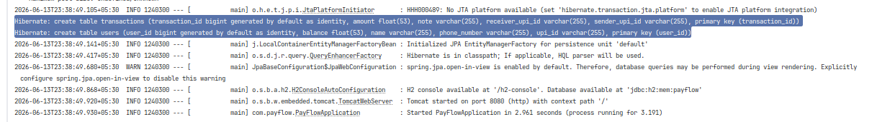

H2 Console Screenshots

Before Insert
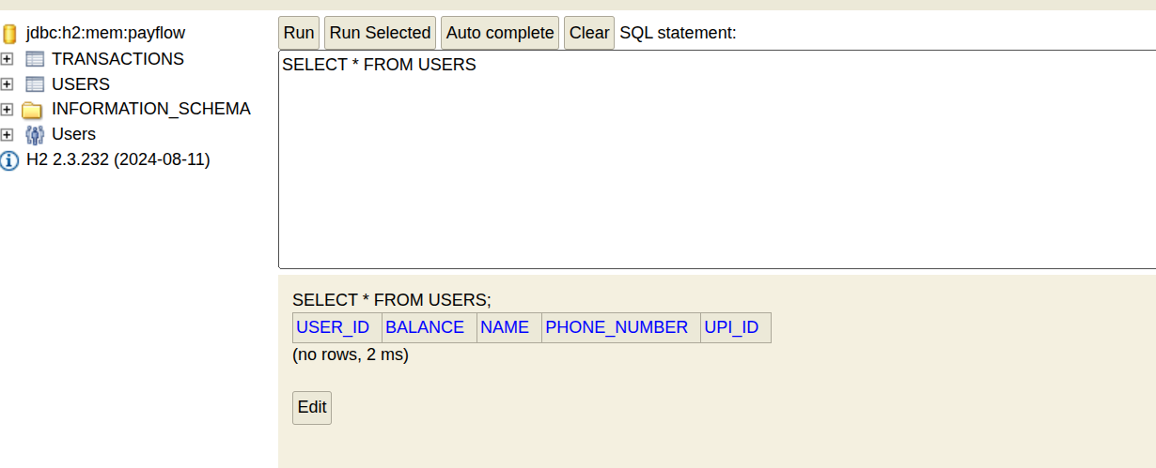

After Insert

4. Repository Layer
The repository layer is responsible for performing database operations.

UserRepository
public interface UserRepository
extends JpaRepository<User, Long> {

User findByUpiId(String upiId);

}

Explanation
UserRepository extends JpaRepository, which automatically provides CRUD operations such as save(), findAll(), findById(), and delete().

TransactionRepository
public interface TransactionRepository
extends JpaRepository<Transaction, Long> {

}

Explanation
TransactionRepository provides CRUD operations for Transaction entities without requiring any additional implementation.

Derived Query Method

Method
findByUpiId(String upiId)

SQL Generated by JPA
select *
from users
where upi_id = ?

Explanation
Spring Data JPA automatically derives SQL queries from repository method names. The method name findByUpiId instructs JPA to generate a query that searches for a User using the upiId field.
The ? symbol is a parameter placeholder. At runtime, Spring Data JPA replaces this placeholder with the actual UPI ID value passed to the method.

5. Service Layer

UserService

UserService
Responsibilities:
- Register a user
- Retrieve all users
- Retrieve a user by ID
- Retrieve a user by UPI ID

TransactionService
Responsibilities:
- Record money transfer transactions

Dependency Injection
Spring's Dependency Injection mechanism automatically creates repository objects and injects them into service classes.
Example:
@Autowired
private UserRepository userRepository;
When the application starts, Spring scans for repository interfaces, creates their implementations, and injects them wherever @Autowired is used. This reduces manual object creation and promotes loose coupling between components.

6. REST Endpoints
Method | Endpoint
POST | /users
GET | /users
GET | /users/{id}
POST | /transactions
GET | /users/upi/{upiId}

7. API Testing Using Curl

Create User

Curl Command
curl -X POST http://localhost:8080/users \
-H "Content-Type: application/json" \
-d '{
"name":"Navneet Kumar",
"upiId":"navneet@okaxis",
"balance":10000,
"phoneNumber":"8984789546"
}'

Output
{
"userId": 1,
"name": "Navneet Kumar",
"upiId": "navneet@okaxis",
"balance": 10000.0,
"phoneNumber": "8984789546"
}

Create Second User:
curl -X POST http://localhost:8080/users \
-H "Content-Type: application/json" \
-d '{
"name":"Pawan Kumar",
"upiId":"pawan@oksbi",
"balance":40000,
"phoneNumber":"8745712345"
}'
Output
{"userId":2,"name":"Pawan Kumar","upiId":"pawan@oksbi","balance":40000.0,"phoneNumber":"8745712345"}

Get All Users
curl http://localhost:8080/users/1
{"userId":1,"name":"Navneet Kumar","upiId":"navneet@okaxis","balance":10000.0,"phoneNumber":"8984789546"}

Get User By ID
curl http://localhost:8080/users/1
{"userId":1,"name":"Navneet Kumar","upiId":"navneet@okaxis","balance":10000.0,"phoneNumber":"8984789546"}

Get User By UPI
curl http://localhost:8080/users/upi/navneet@okaxis
{"userId":1,"name":"Navneet Kumar","upiId":"navneet@okaxis","balance":10000.0,"phoneNumber":"8984789546"}

Output screenshot.
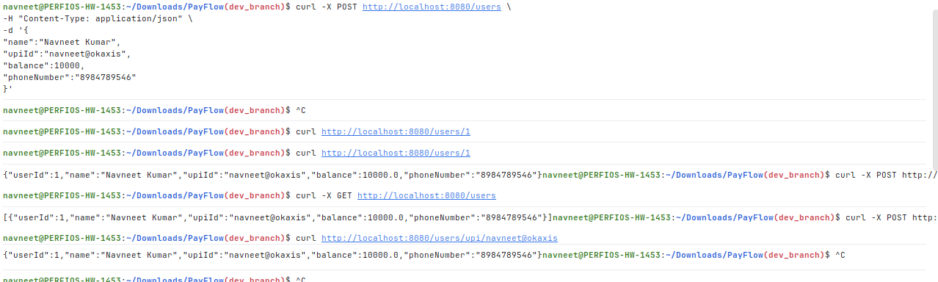

Record Transaction :

curl -X POST http://localhost:8080/transactions \
-H "Content-Type: application/json" \
-d '{
"senderUpiId":"pawan@oksbi",
"receiverUpiId":"navneet@okaxis",
"amount":1000,
"note":"Personal Use"
}'

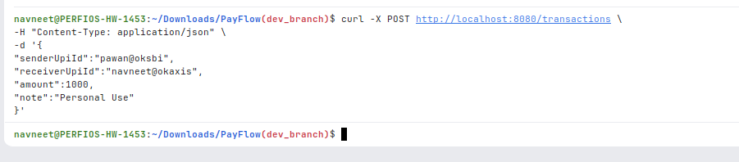

8. @RequestBody Demonstration

The @RequestBody annotation is used to convert incoming JSON request data into a Java object.

With @RequestBody

Controller Method:

@PostMapping

public User registerUser(@RequestBody User user)

Console Output:

WITH @RequestBody

User{
"name":"Pawan Kumar",
"upiId":"pawan@oksbi",
"balance":40000,
"phoneNumber":"8745712345"

}

Screenshot

Without @RequestBody

Controller Method:

@PostMapping("/without-request-body")

public User withoutRequestBody(User user)

Console Output:

WITHOUT @RequestBody

User{

name=null,

upiId=null,

balance=null,

phoneNumber=null

}

Screenshot

Explanation

When @RequestBody is present, Spring uses Jackson ObjectMapper to deserialize the JSON request body into a Java User object.

Without @RequestBody, Spring does not read the JSON body. Instead, it attempts to bind values from request parameters or form data. Since the request contains JSON and not form parameters, all fields remain null.

9. Custom Query

JPQL Query
@Query( "SELECT u FROM User u WHERE u.balance > :amount" ) List<User> findUsersWithBalanceGreaterThan( @Param("amount") Double amount );

Explanation.
JPQL (Java Persistence Query Language) operates on entity objects rather than database tables.
Instead of writing SQL using table names and column names, JPQL uses entity names and field names.
Example:
User
balance
instead of
users
balance
This makes JPQL database independent and easier to maintain.

Query Approaches Comparison
Derived Query vs JPQL vs Native SQL.

10. Conceptual Questions

Question 1 – Request Lifecycle
Answer. When a client sends a post request using curl to a specific url and port, the request first reaches the embedded Tomcat server where the port is already binded. Tomcat forwards the request to Spring MVC's DispatcherServlet, which acts as the front controller.
The DispatcherServlet consults the Handler Mapping to identify the appropriate controller method and uses a Handler Adapter to invoke it. The controller then calls the service layer, which interacts with the repository layer to perform database operations. Finally, the response is returned through the DispatcherServlet back to the client as JSON.

Question 2 – Serialization
Answer: When a JSON request is sent to the application, Spring Boot uses the Jackson library to convert the JSON data into a Java object. For example, the JSON payload received in POST /users is converted into a User object automatically.If the JSON key is written as upi_id instead of upiId, Spring may not be able to match it with the Java field name. As a result, the value may not be populated correctly and could remain null.

Question 3 – Spring Boot Features
Answer: Embedded Server
Spring Boot comes with an embedded Tomcat server. Because of this, the application can run directly using mvn spring-boot:run without installing any external server.
Auto Configuration
Spring Boot automatically configures many components such as the database connection, Hibernate, and Spring MVC based on the dependencies added to the project.
Production Ready Defaults
Spring Boot provides useful default configurations such as logging, error handling, and dependency management. This reduces the amount of manual setup required by developers.

Question 4 – Spring vs Spring Boot
Answer: If plain Spring Framework was used, we would have to manually configure many things such as the web server, database connection, and application settings. This requires more code and configuration files.
Spring Boot simplifies development by providing auto-configuration, starter dependencies, and an embedded server. This makes application development faster and easier.

Question 5 – Stateless REST
Answer: A REST API is stateless, which means the server does not remember information from previous requests. Every request must contain all the information needed to process it.
This is useful when the application runs on multiple servers behind a load balancer. Since no server stores client-specific state, any server can handle any request without issues.

Question 6 – Persistence
Answer: In this project, user and transaction data are stored in an H2 database. If a Java List had been used instead, all data would be lost whenever the application stopped or restarted.
Using a database provides persistent storage, which is important for payment applications because transaction records must be stored safely and should not disappear after a restart.

11. Conclusion
Summary of implementation and learning outcomes.
In this assignment, a REST API called PayFlow was developed using Spring Boot, Spring Data JPA, and H2 Database. The application allows users to register, retrieve user details, and record money transfer transactions.
The project helped in understanding important backend concepts such as REST APIs, dependency injection, database persistence, JPA repositories, and Spring Boot architecture. It also provided hands-on experience in building and testing a real-world style backend application.

