IBG RPA Production Environment Overview

Overview
This document provides a detailed overview of the IBG RPA Production environment setup, including user access, infrastructure layout, application flow, and data management. The environment supports RPA operations across multiple regions (Kuwait, KSA, UAE, BH, SIN & CHN.), ensuring secure, reliable, and monitored bot execution.

Blue Prism runtime Resource implementation Workflow
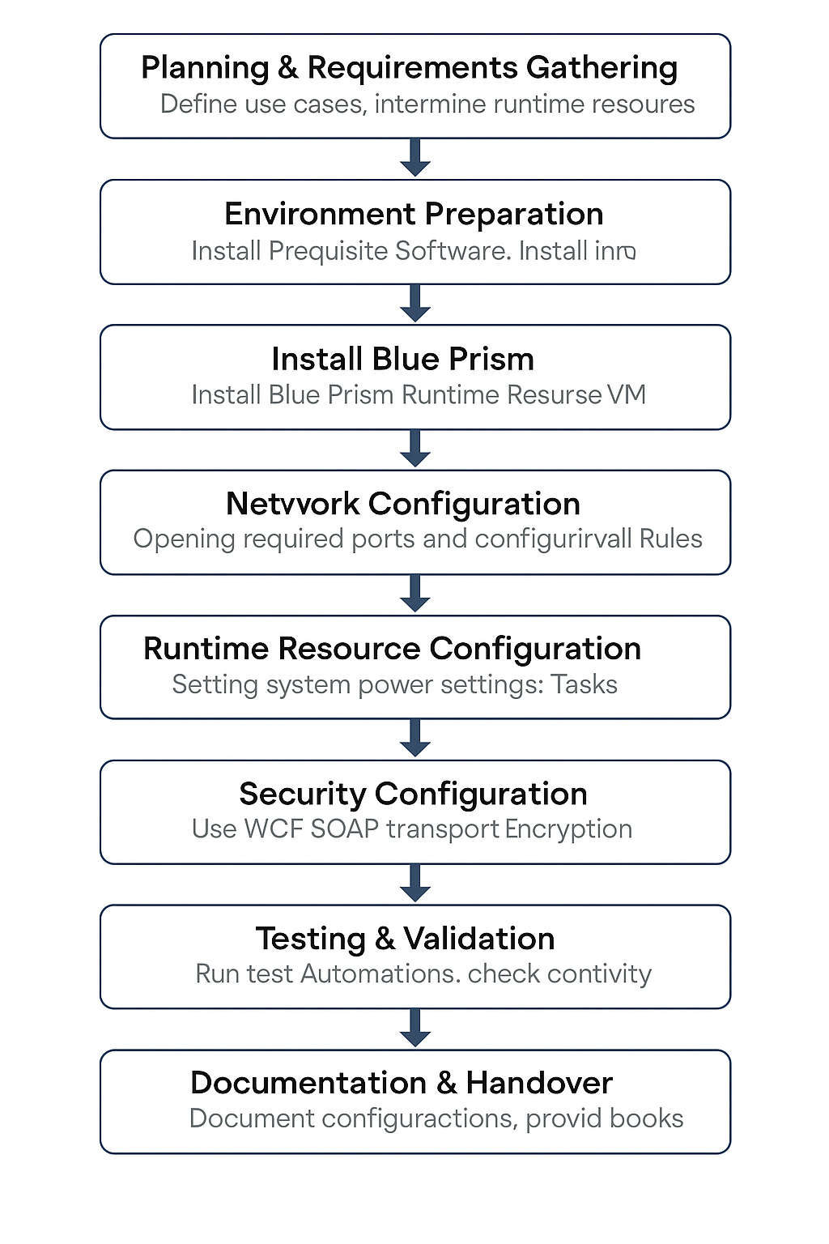

Planning & Requirements Gathering for IBG Location
IBG Application Hosting Overview
IBG RPA interacts with applications that are hosted both centrally in Kuwait and locally within respective IBG countries. This setup ensures optimized performance, compliance with regional policies, and efficient access for automated processes.
1. Centralized Applications (Hosted in Kuwait)
These applications are hosted in Kuwait and accessed by runtime resources from all IBG regions via secure network channels:
Application Name | Hosting Location | Purpose
Equation | Kuwait | Core banking system
Blue Prism App Servers | Kuwait | RPA control and execution
SQL Database (BP DB) | Kuwait | RPA logs and configuration storage
Document Repositories | Kuwait | Central document storage for bots
Note: we can add the details here once received centralized application list
2. Decentralized Applications (Hosted in IBG Countries)
Some region-specific or sensitive applications are hosted locally in their respective IBG countries:
Application Name | Hosting Region | Country-Specific Notes
Active Directory (AD) | KSA, UAE, BR, SG | Each country maintains its own AD domain
HR Systems | Country-Specific | Localized for compliance
Email Gateways | Country-Specific | Routed through local infrastructure
Custom Legacy Systems | UAE, BR | Specific to local business processes
Note: we can add the details here once received centralized application list

- KSA Blue Prism Runtime Setup
This section outlines the current configuration of the KSA Blue Prism Runtime setup, which is hosted and managed from the Kuwait environment.

- Bharain Blue Prism Runtime Setup
This section outlines the current configuration of the Bharain Blue Prism Runtime setup, which is hosted and managed from the Kuwait environment.

- UAE Blue Prism Runtime Setup
This section outlines the current configuration of the UAE Blue Prism Runtime setup, which is hosted and managed from the Kuwait environment.

- Singapore Blue Prism Runtime Setup
This section outlines the current configuration of the Singapore Blue Prism Runtime setup, which is hosted and managed from the Kuwait environment.

- China Blue Prism Runtime Setup
This section outlines the current configuration of the China Blue Prism Runtime setup, which is hosted and managed from the Kuwait environment.

- IBG RPA infrastructure Diagram
The following diagram illustrates the overall IBG RPA infrastructure, depicting regional runtime resource deployments, centralized components in Kuwait, network connectivity.

Environment Preparation
- Provision Virtual Machines (BOT)
- Install Operating System and Updates
- Install Prerequisites (e.g., .NET, C++ Redistributable)
🟢 Responsibility: IT Infrastructure / Server Support

Install Blue Prism Runtime Resource
a. Install Blue Prism
Install Blue Prism software on every machine designated as a Runtime Resource.
b. System Requirements
Ensure each machine meets all necessary hardware and software prerequisites.
Attach PDF: Hardware and Software Requirements

Network Configuration
Using Application Server Architecture:
Runtime Resource → Load Balancer → Blue Prism Application Server
- Runtime Resource to Load Balancer Configuration
Go to:
C:\ProgramData\Blue Prism Limited\Automate V3\Automate.config
Open the Automate.config file in a text editor.
Set the <connection> element to use the load balancer address:
xml
<connection name="Production" connectionmode="WCF:SOAP with Transport Encryption">
<server>bp-loadbalancer.domain.com</server>
<port>8199</port>
</connection>

- Load Balancer to Application Server Configuration
Port Configuration: - Default Port (SSL): 8199 - Non-SSL Port: 8181
Firewall Rule:
The Application Server must allow inbound traffic on port 8199 or 8181

- Interactive / Control Room Access
Interactive Client → Load Balancer → Application Server → Database Server
Use Case:
Enables the Control Room to communicate with Runtime Resources and trigger automated processes.

- Firewall and Routing
- Open the Following Ports:
- Between Runtime Resource and Load Balancer: - 8181 and 8199
- Between Control Room (Interactive Client) and Load Balancer: - 8181 or 8199
- Between Load Balancer and Application Server: -8181 and 8199
- Between Control Room (Interactive Client) and Load Balancer: The solution will be provided.
- Firewall Rule: App Server must allow inbound traffic on this ports.
🟢 Responsibility: Client Support / Network Security Team

Runtime Resource Configuration
- Create Runtime Resource User Accounts
- Disable Sleep/Auto-lock
- Install and Configure Login Agent
- Disable CTRL+ALT+DELETE
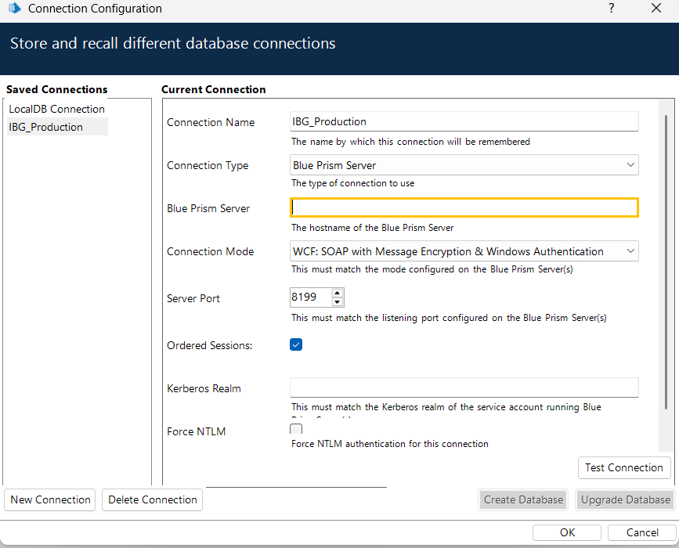
- Configure Task Scheduler for reboot & BP Listener
🟢 Responsibility: Automation Team / IT Support

Security Configuration
- Use WCF SOAP with Transport Encryption
- Ensure Certificates and Policies are in place
- Validate Group Policy Settings
Adding an SSL Certificate Configuration for Application Sever
Attach PDF: SSL Certificate Configuration
Adding an SSL Certificate Configuration for Blue Prism Runtime Resource
Attach PDF: SSL Certificate Configuration
🟢 Responsibility: Security / Automation COE

Testing & Validation
- Run Test Automations
- Validate Login Agent behavior
- Simulate Failover/Recovery scenarios
🟢 Responsibility: Automation QA / Support

Documentation & Handover
- Document Hostnames, IPs, Configurations
Description | Hostname | IP Address | NAT IP
Load Balancer – WAF/F5 | F5 VIP (Load Balancer) | 10.10.10.10 | ?
Production App Server 1 | kuwait-bp-app01.local | 10.10.10.10 | 192.168.1.100
Production App Server 2 | kuwait-bp-app02.local | 10.10.10.11 | 192.168.1.101
DB Server | kuwait-bp-db01.local | 10.10.20.10 | 192.168.2.100

-Port Configuration: - 8181 (non-SSL) and - 8199 (SSL)
- SSL Certificate:
🟢 Responsibility: Automation COE / Operations

Blue Prism Runtime Resource Setup & Configuration Checklist

Checklist Item | Responsible Department | Completed (✔/✘)
Install Blue Prism on Runtime Resource Machines | IT Support / Infrastructure
Verify Hardware and Software Requirements | IT Support / Infrastructure
Attach Hardware and Software Documentation PDF | IT Support
Configure Network Access (App Server, Ports) | Network / Infrastructure
Set Up Load Balancer Routing | Network Team
Open Firewall Ports (8181/8199) | Network / Security
Ensure DNS & Name Resolution | IT Support / Network
Configure Login Agent on Runtime Machines | Automation / IT Support
Disable CTRL+ALT+DEL Requirement | IT Support
Disable Sleep Mode / Auto-lock on Runtime Machines | IT Support
Set Daily Reboot Task via Task Scheduler | IT Support / Automation
Schedule BP Listener Trigger on Startup | Automation
Configure WCF SOAP with Transport Encryption | Automation / Security
Execute Blue Prism in Resource Mode via CLI | Automation
Verify Firewall Connectivity for BP Ports | Network / Security
Document Kuwait BP Server Hostnames and IPs | Automation
Attach Blue Prism Login Agent Documentation | Automation / Documentation

