Docker Micro Service Configuration Assignment

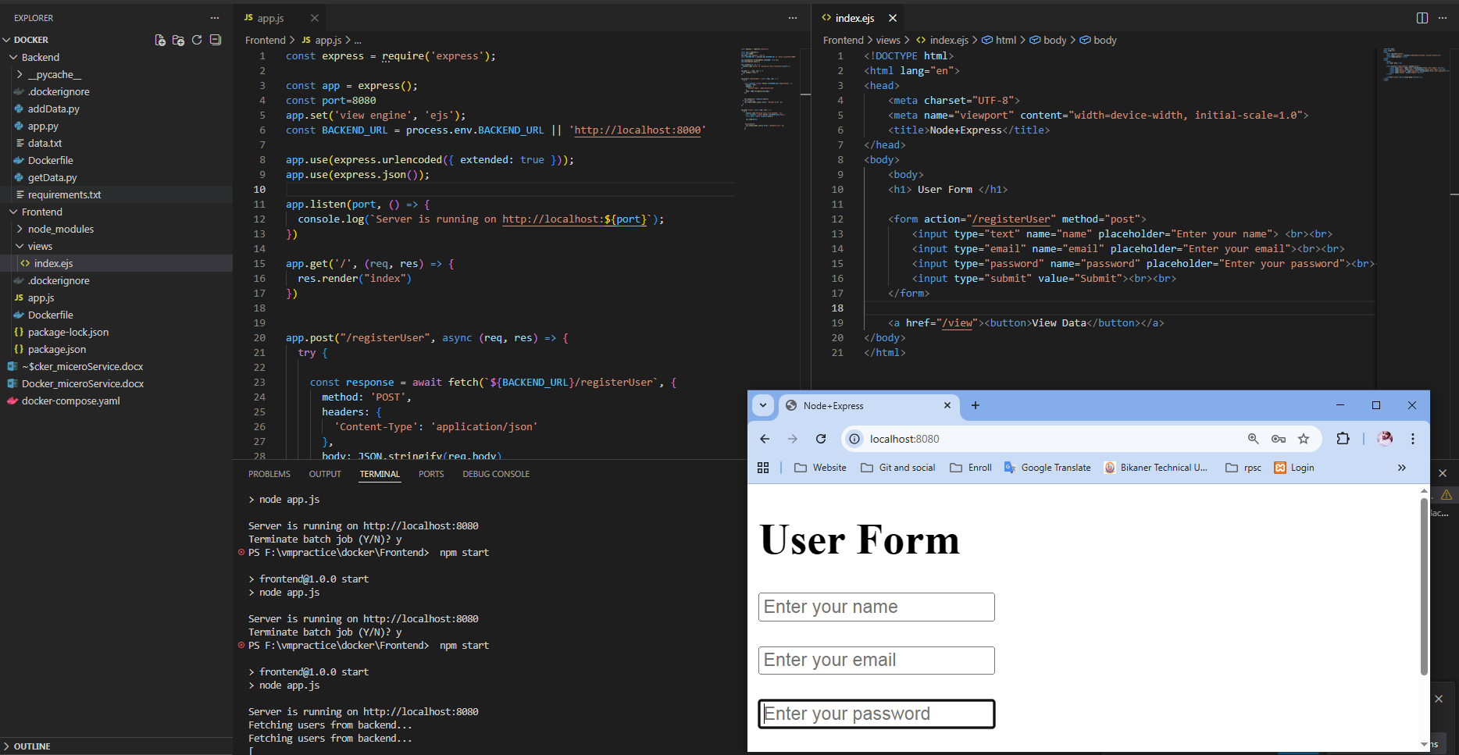
Establish front-end using node(ejs templet) + express ( for handling get / post request) for front end.
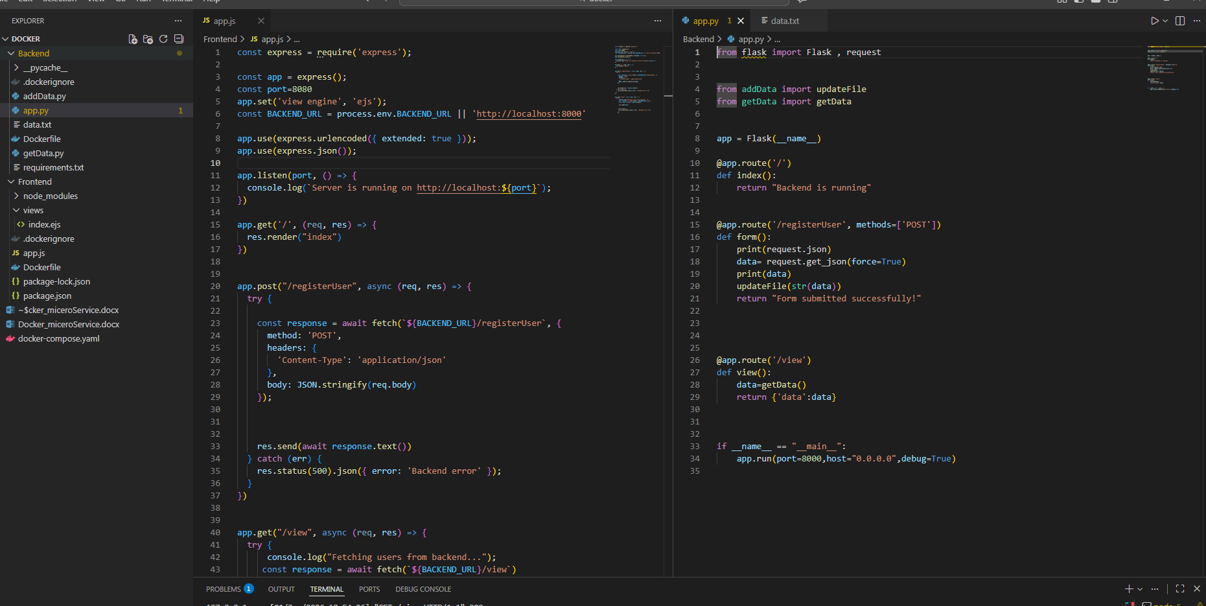
Backend configured using flask and for store data we use data.txt file for store data received from frontend

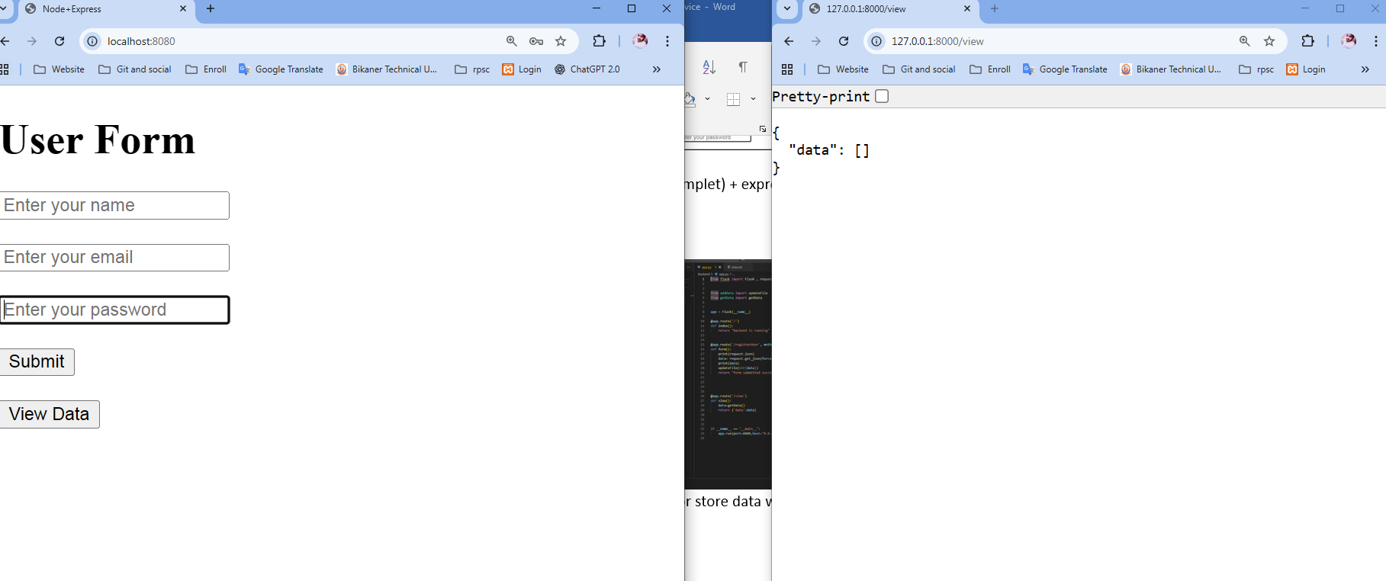
Initially DB is empty
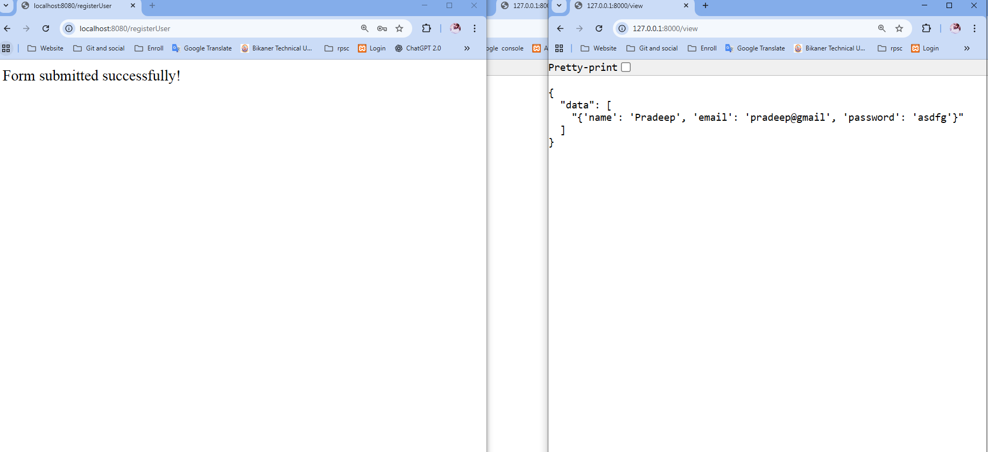
After submit form data it store in DB successfully
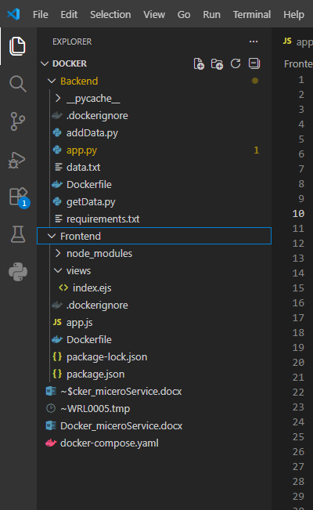 Project folder Structure
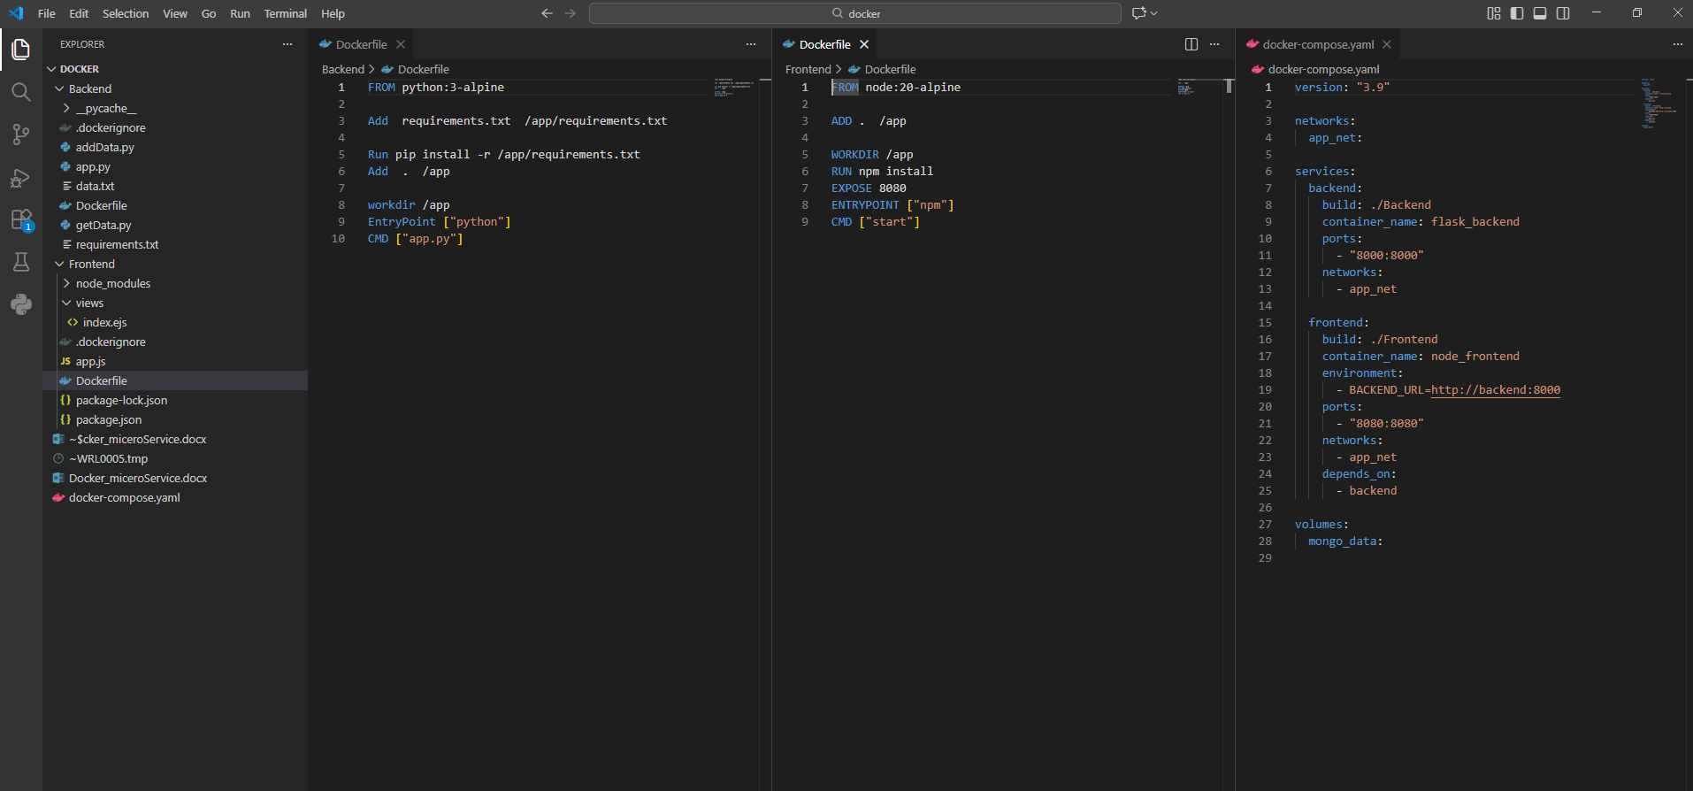
Docker file configuration for frontend, backend, docker-compose
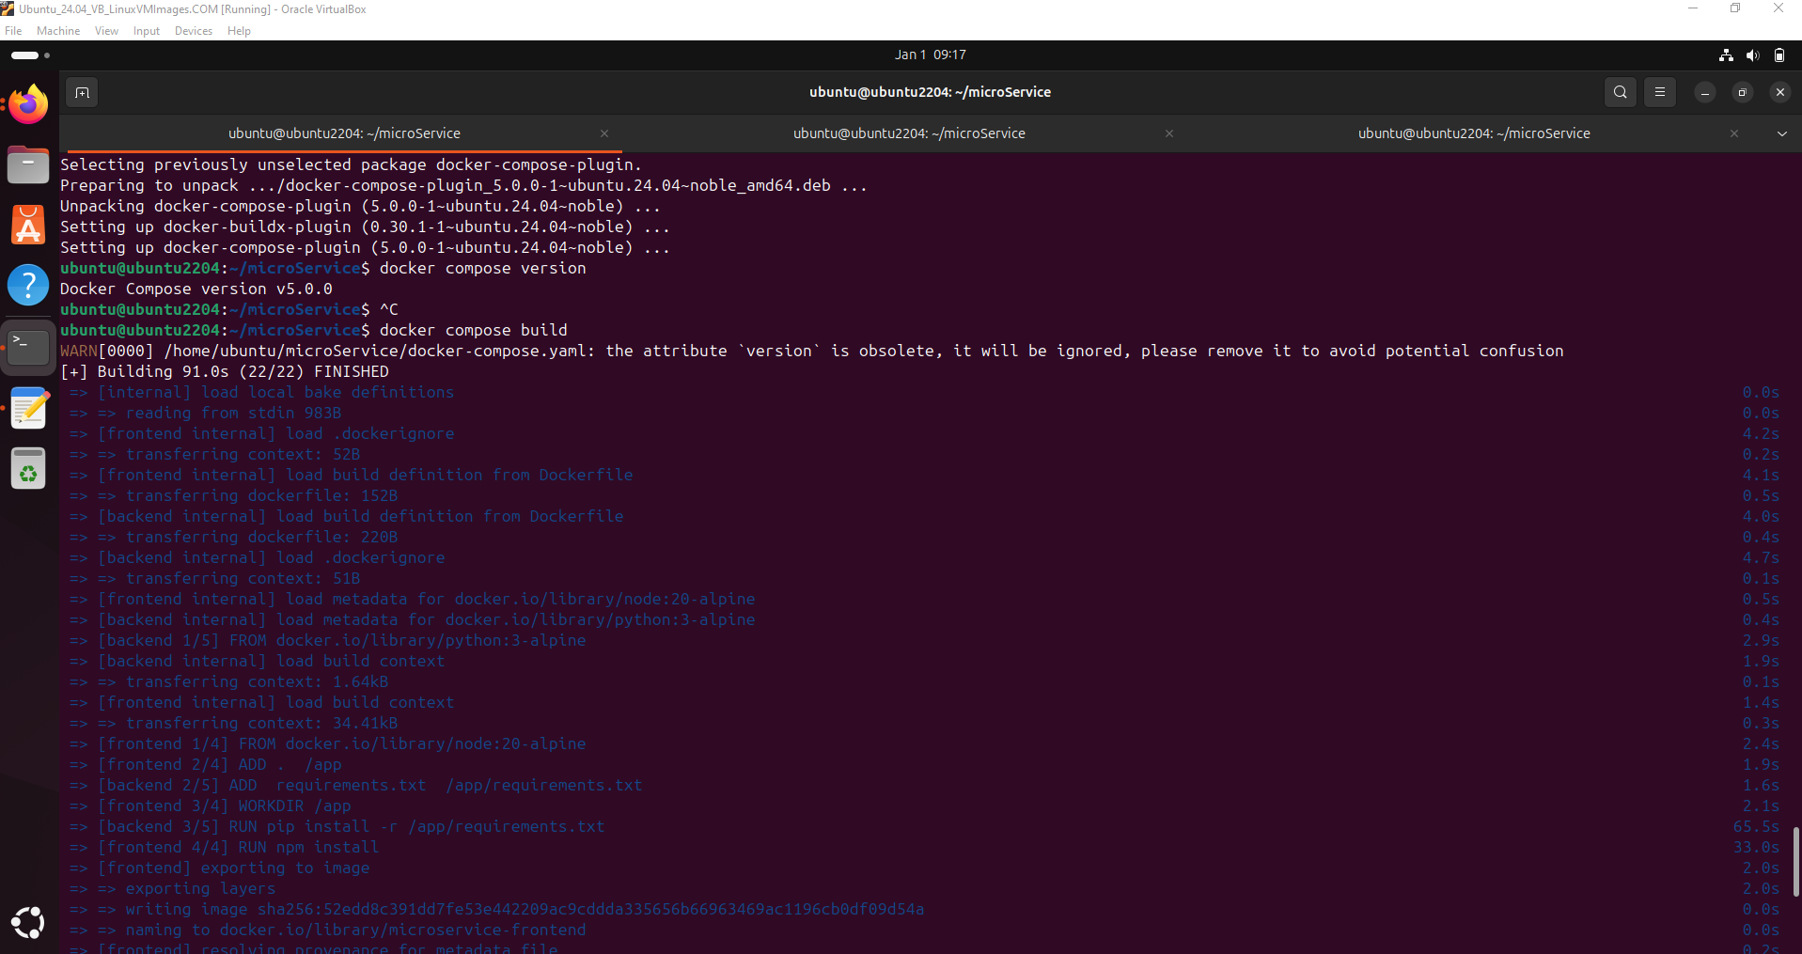
build/create image from docker compose file
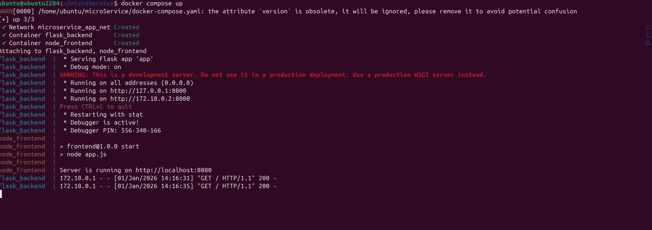
Start up container /mic

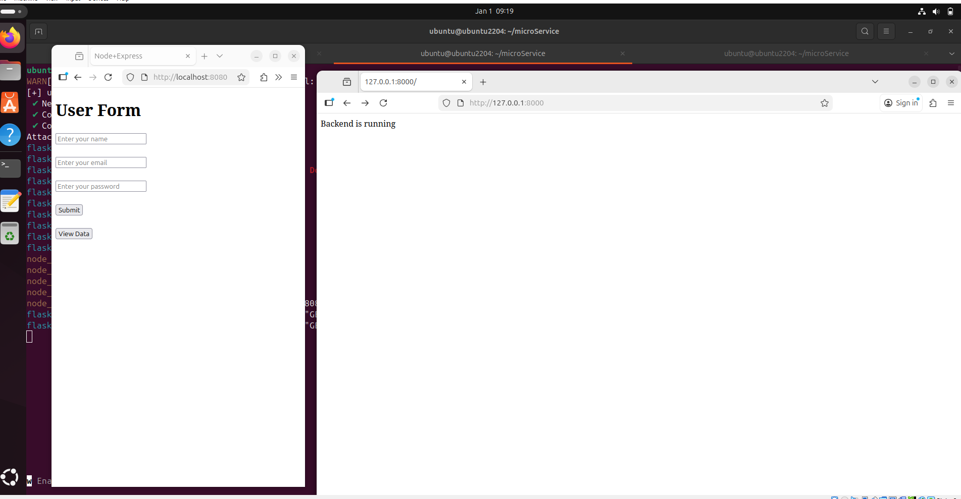
Both service running on container fine
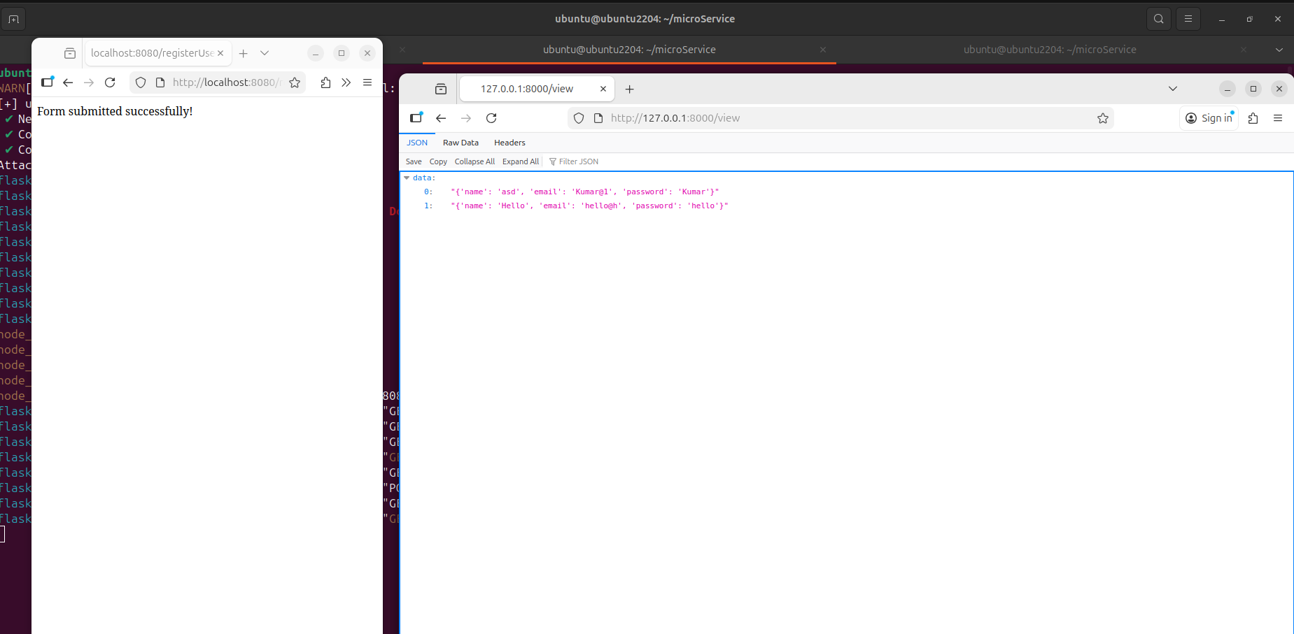
Dats sent from frontend and recived at backend successfully
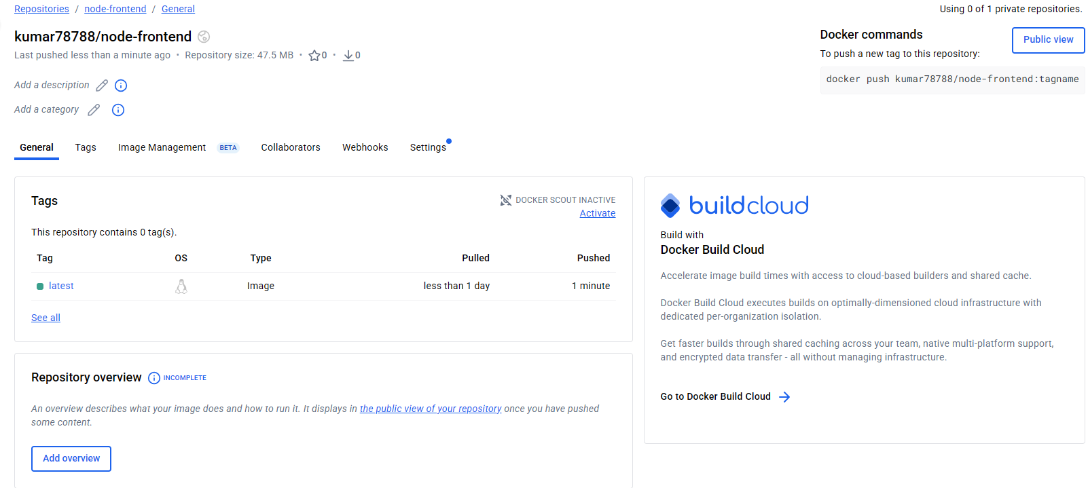
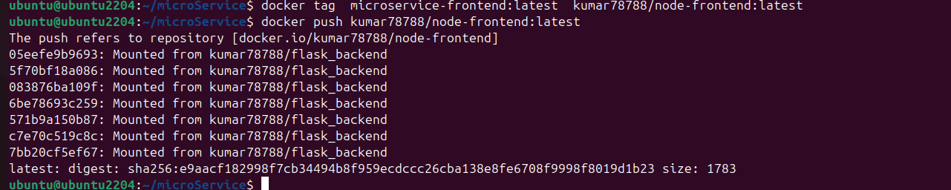
Image pushed to remote from local

