1.
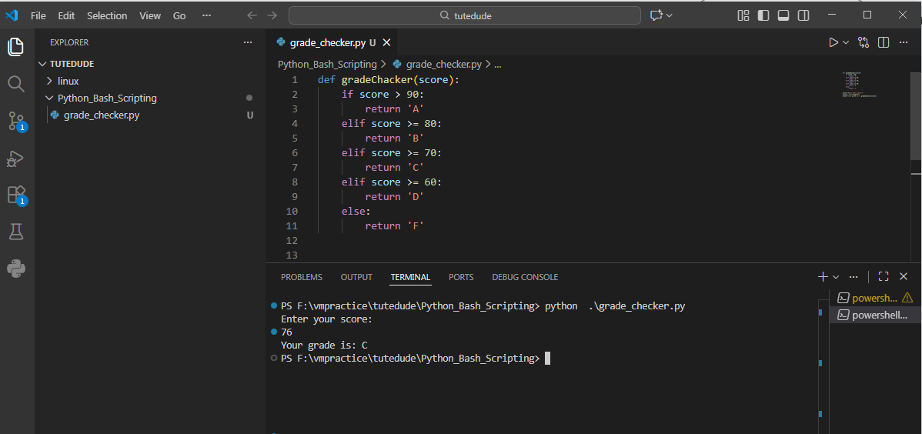

2.
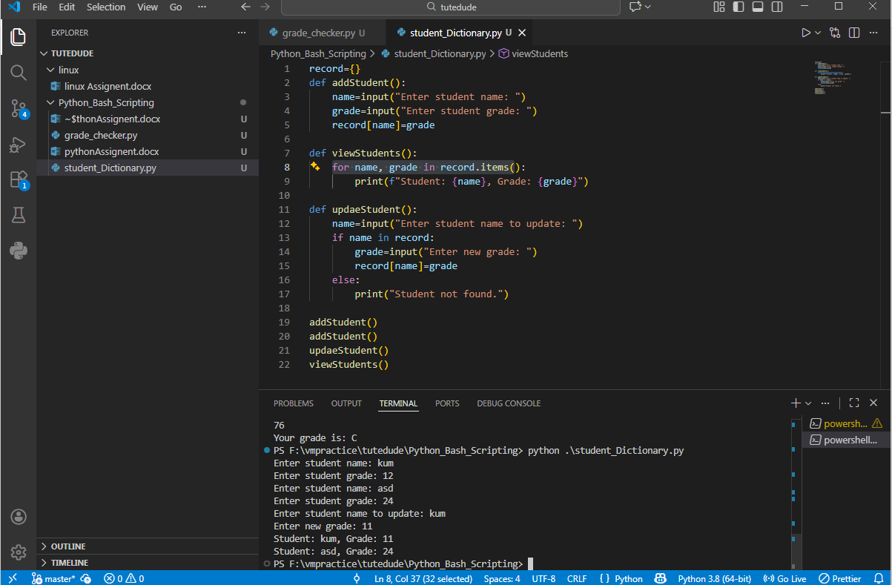

3 ,4 .
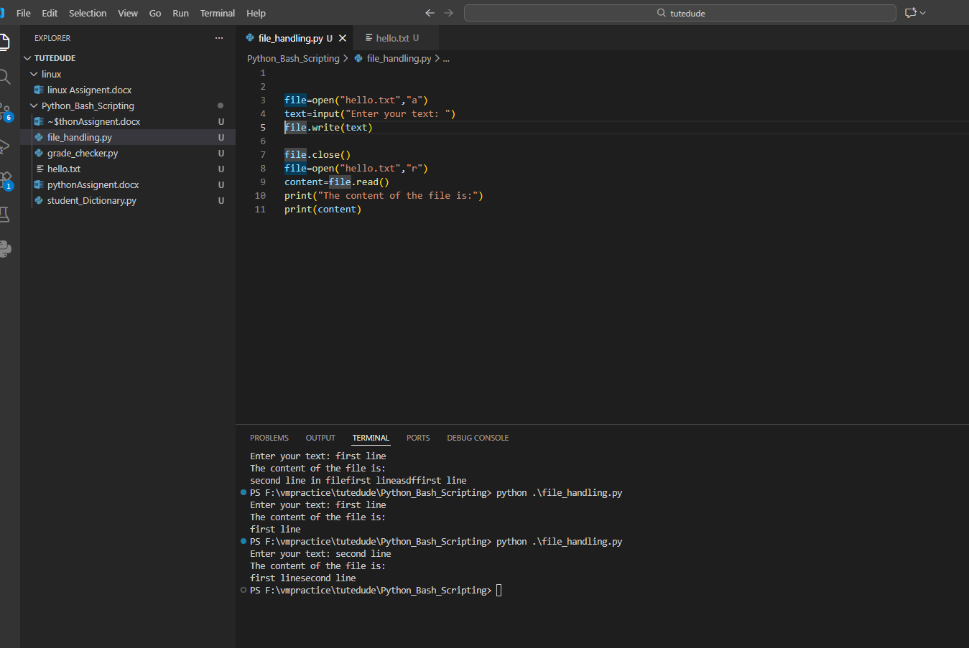
Explanation: open() method open a file if exist , id not exist it first create a file then open it
I open in append mode of write in which it not over ride the content of file , it append new content at the end of file

