1.
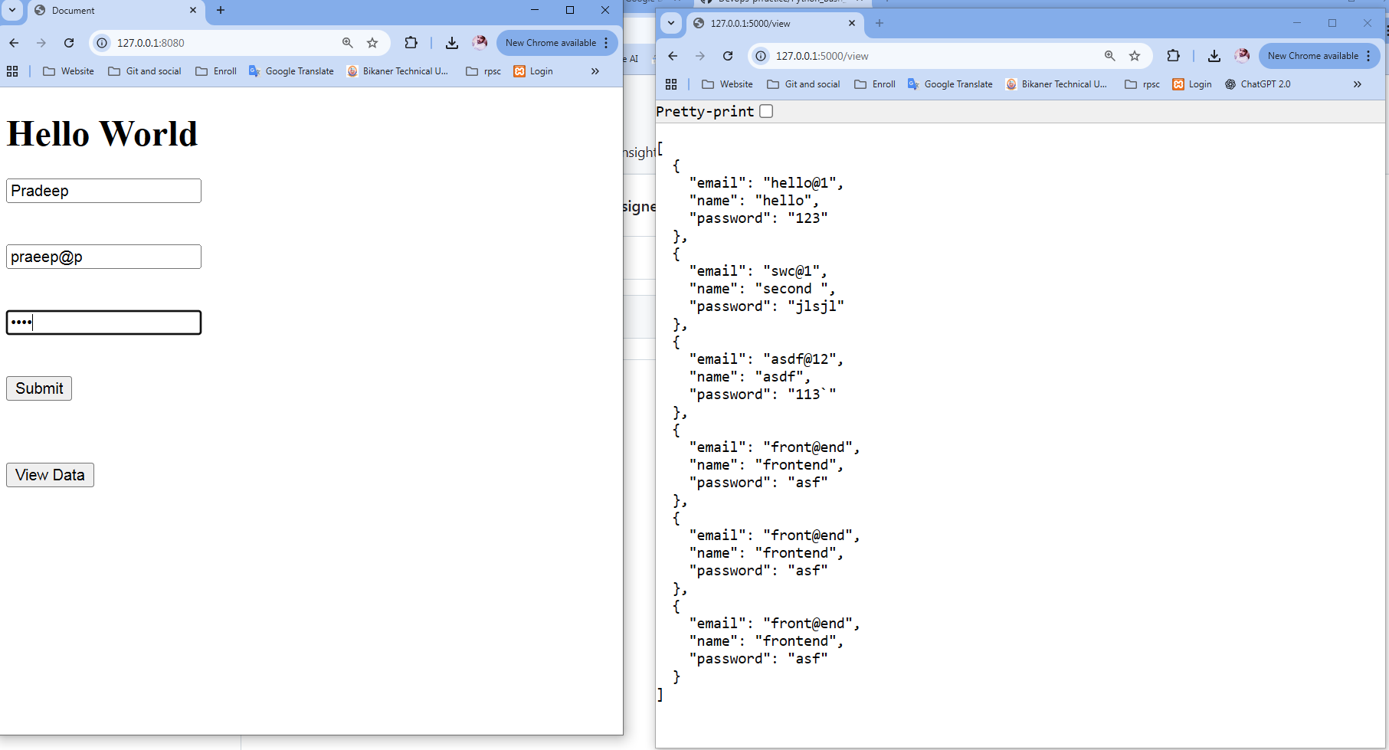
Explanation: First window for front end it render html form and second one is backend Mongo DB
(I use local mongo storage not ATLAS cloud )
When I submit form it send data to mongo DB
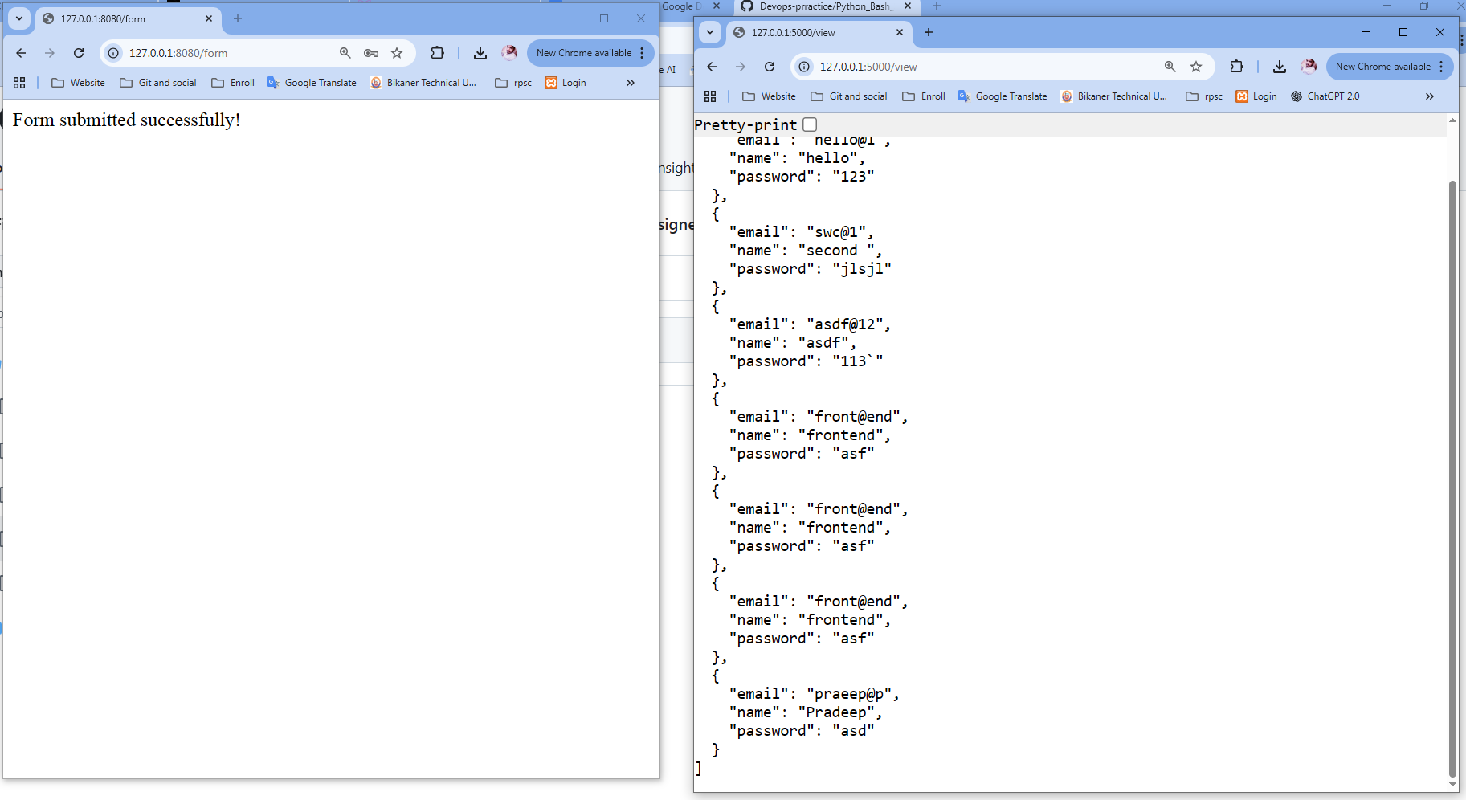
And front end route return form submitted successfully and store in database

I add a button on Form page View Data when I click on it, it send request to /api route of frontend then front end route send request to backend and it return all record/document in DataBase
