1.
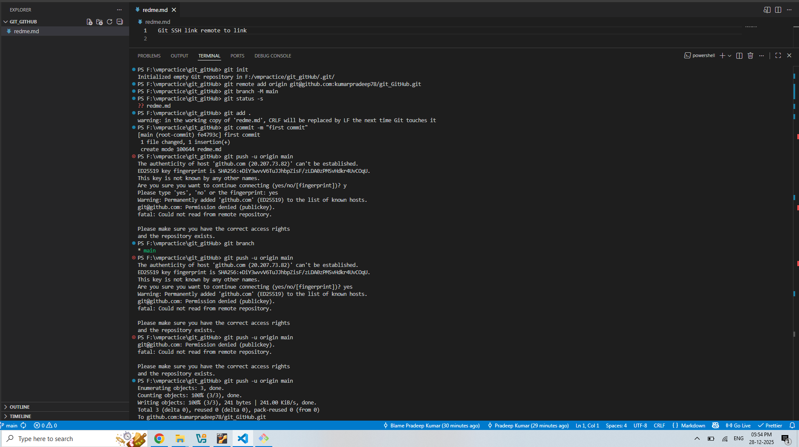
Create a git hub repo and configure it in local git environment (using ssh key )
2.
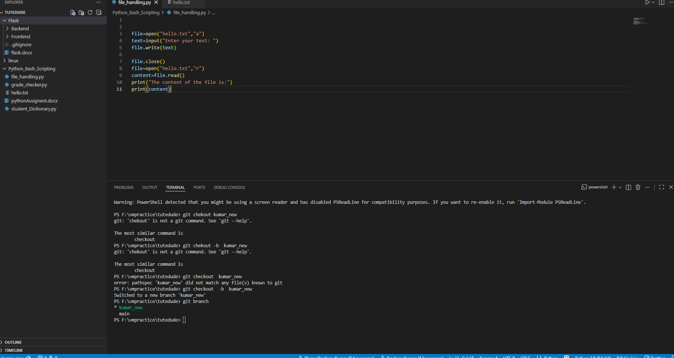
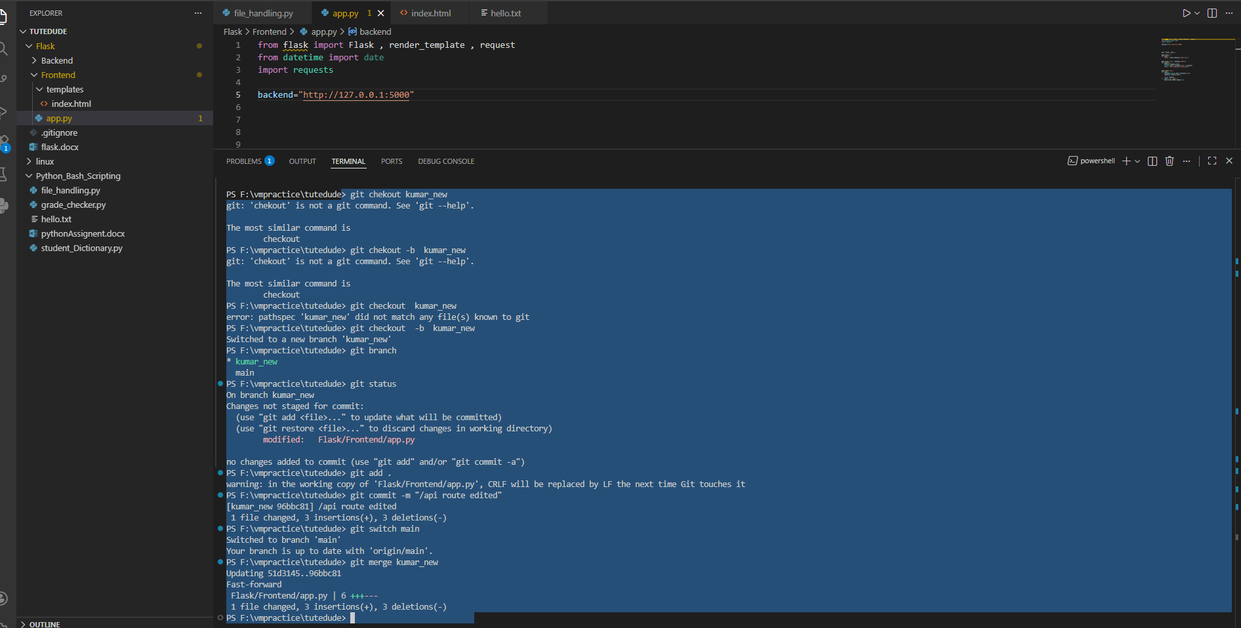
new branch created and them merged into main again.

3.
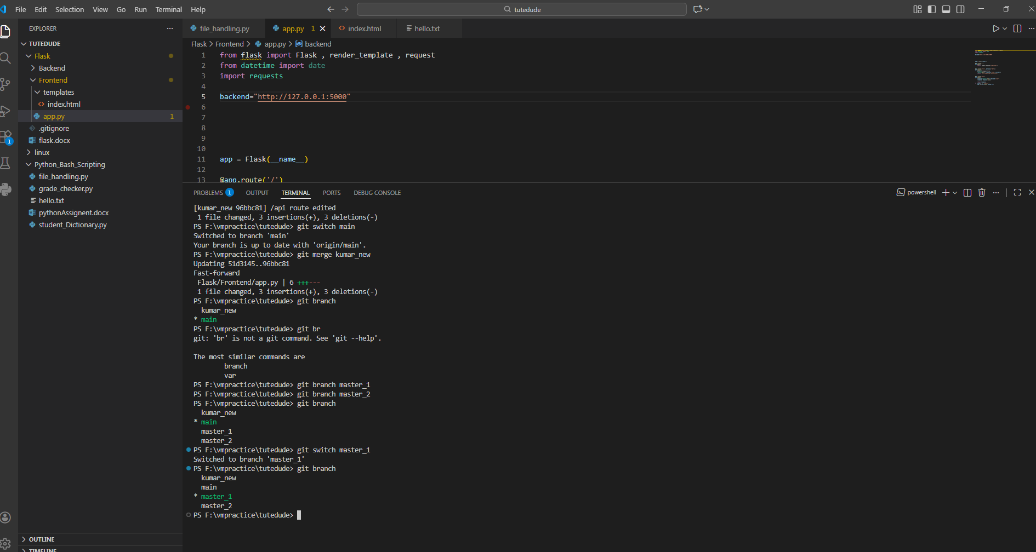
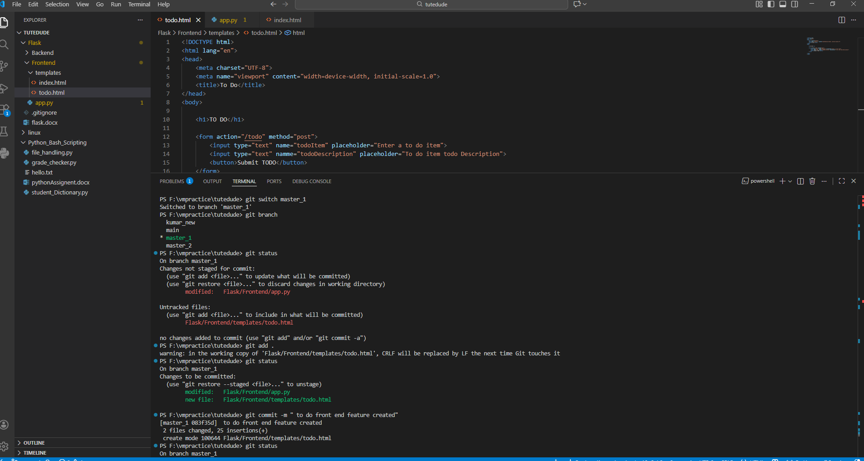
Front end to do feature added
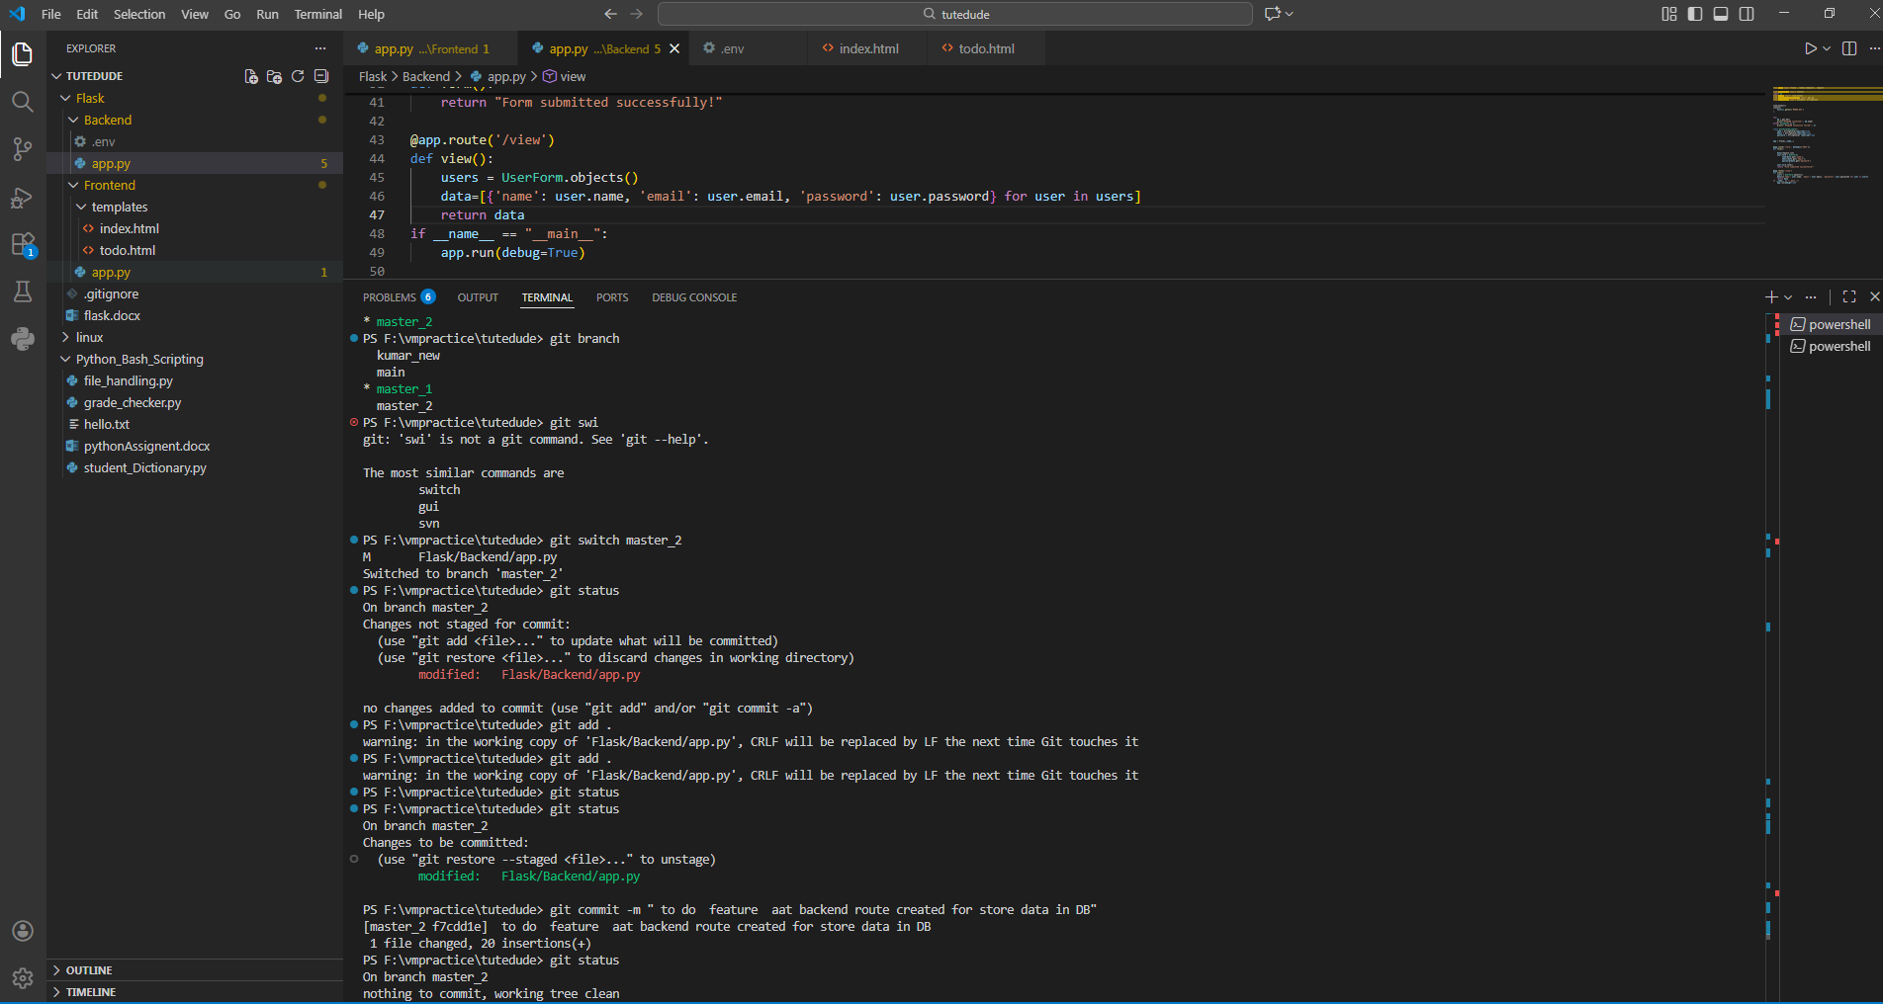
to do for data handling at backend
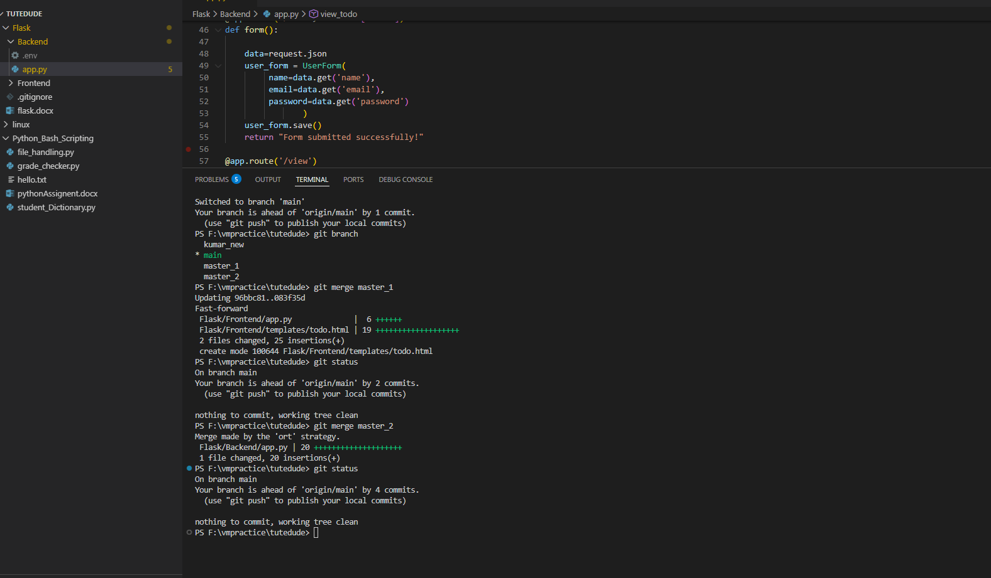
merge both branch master_1 and master_2 in main
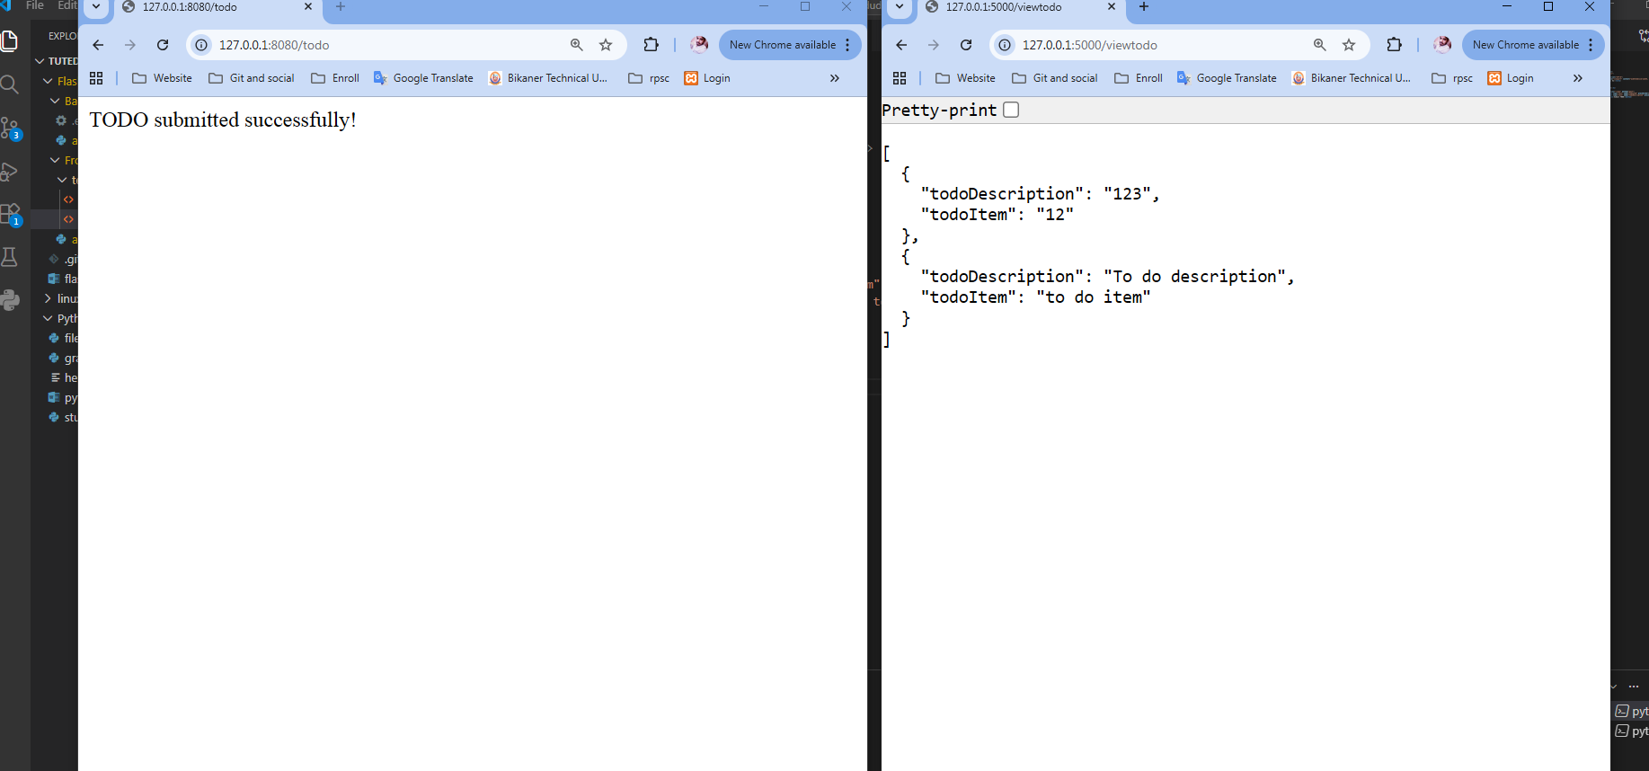

- 4.
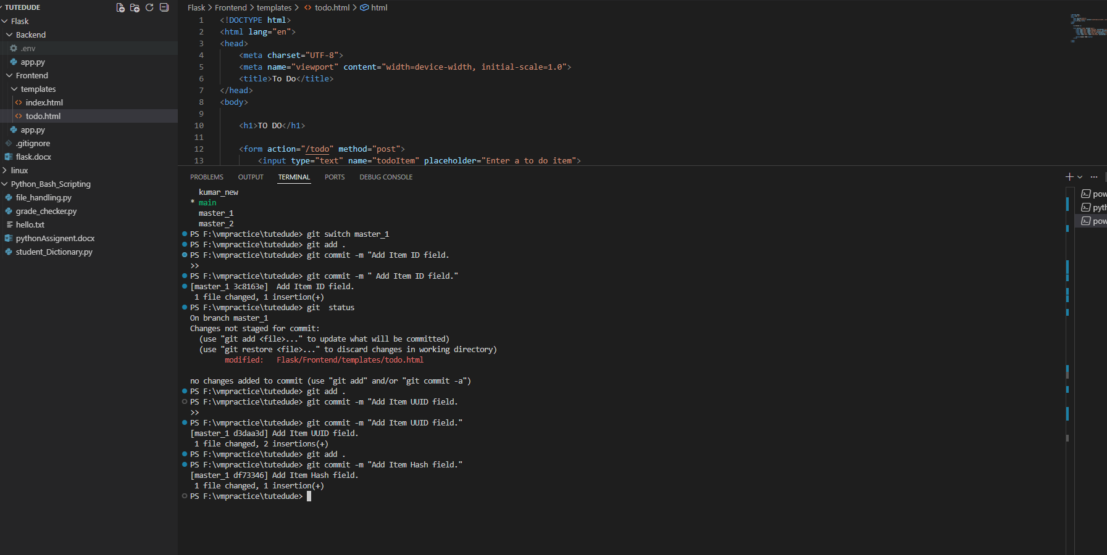
First commit: Add Item ID field.
- Second commit: Add Item UUID field.
- Third commit: Add Item Hash field.

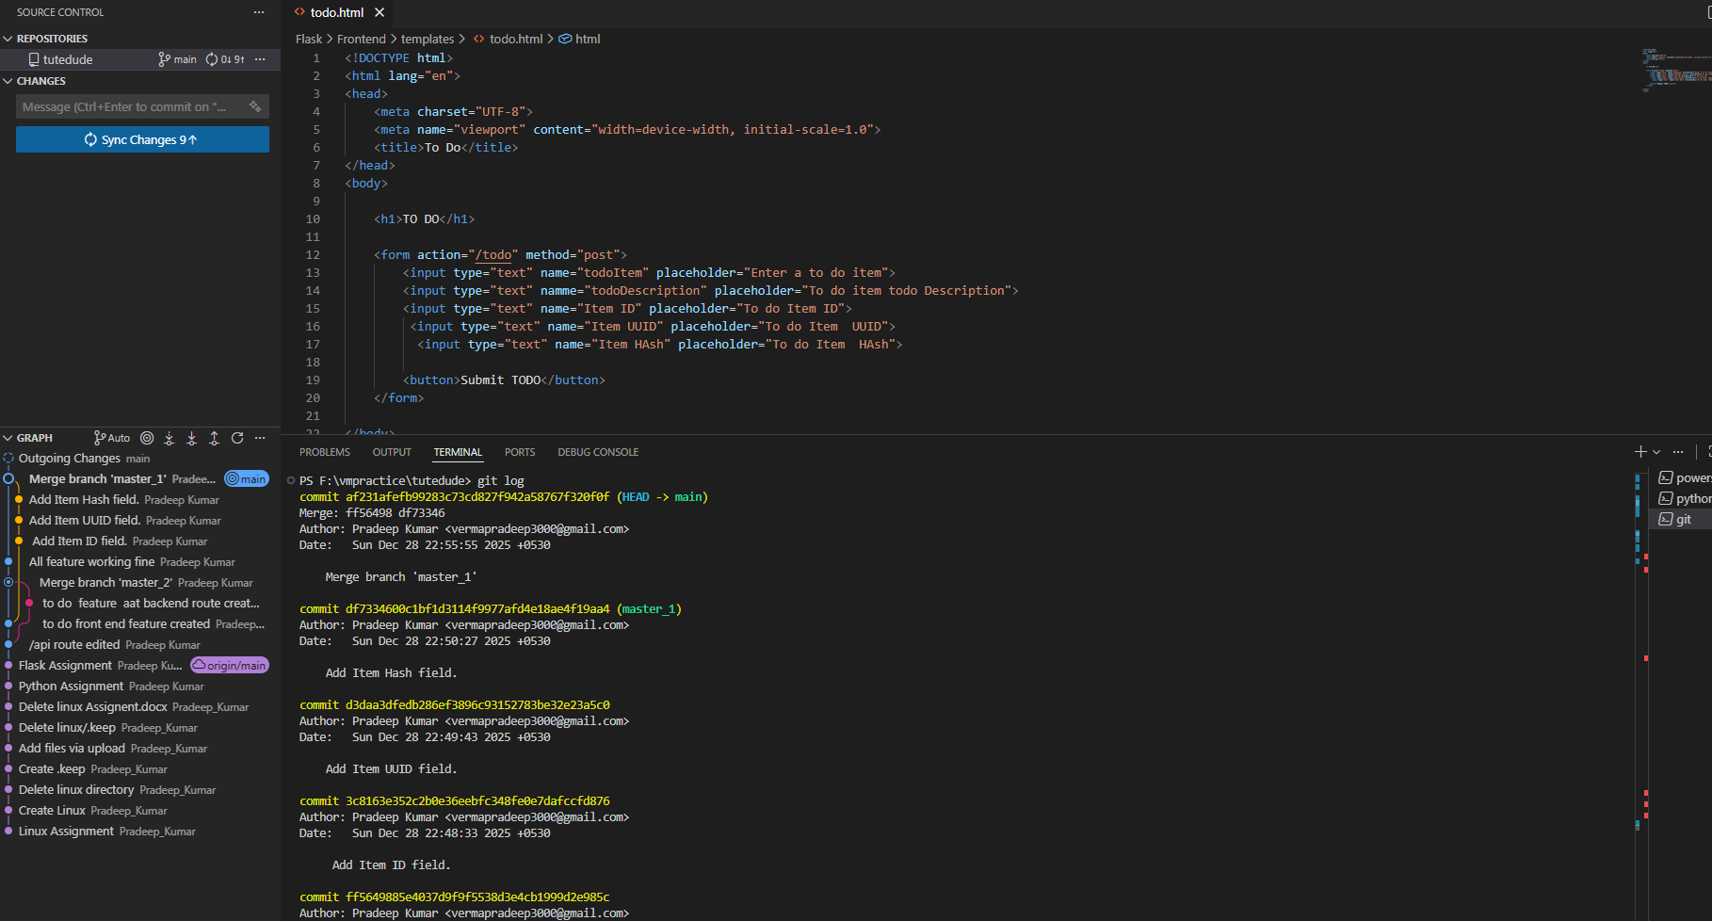
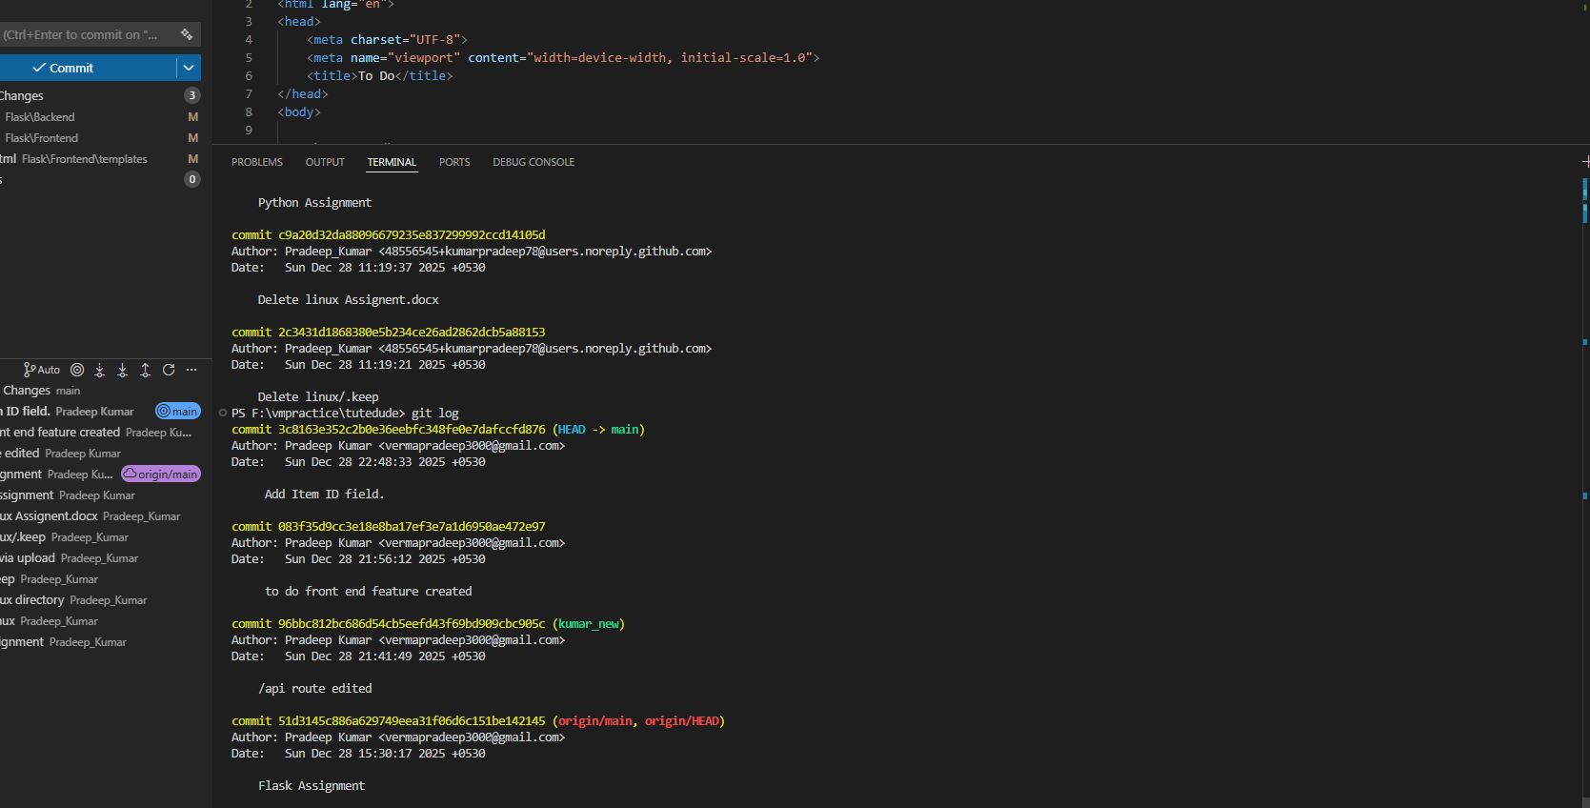
After git reset –soft “commit id” then head move to that commit
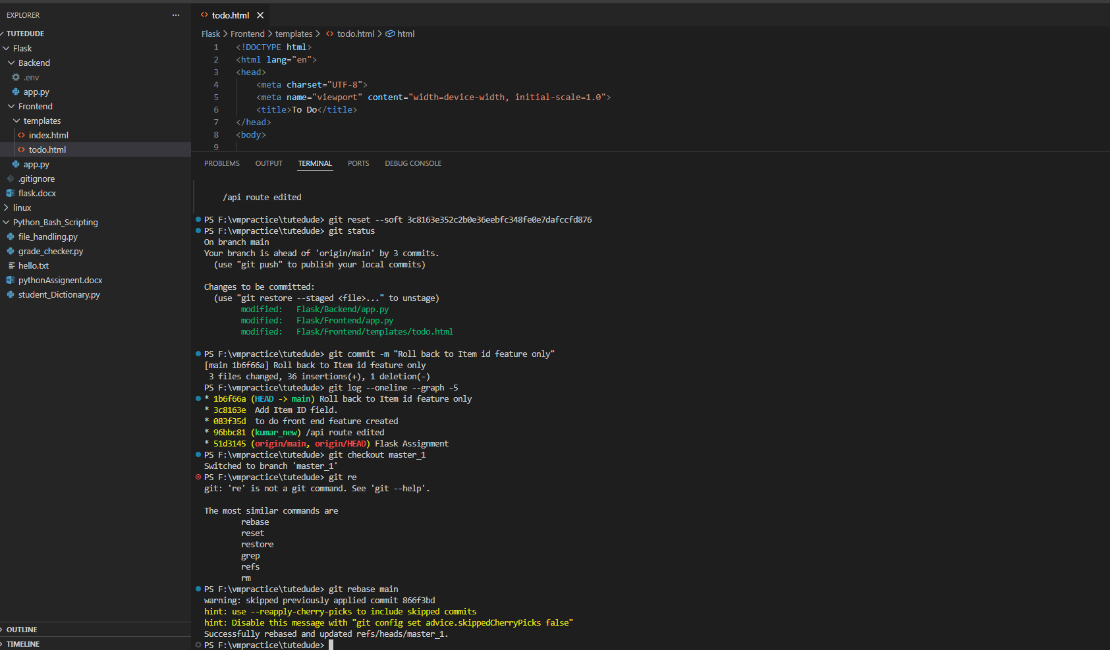
after roll back to Item Id commit , Again commit then switch master1 and rebase master with current main

