BRIGHTMIND MEDIA

About the company:
BrightMind Media is a cutting-edge marketing agency that specializes in providing comprehensive digital solutions. Our mission is to empower businesses with the tools and strategies they need to thrive in the digital world. We offer a range of services including website development and maintenance, SEO & Content Creation for social media pages, logo and thumbnail designing, and digital marketing. Additionally, we utilize the best sort of tools and equipment required for photo shoots, videography like camera, mic, lighting setup, studio and softwares for video editing.

Meet Our Team:
Raju Kumar Kumar Prakhar Karishma Verma
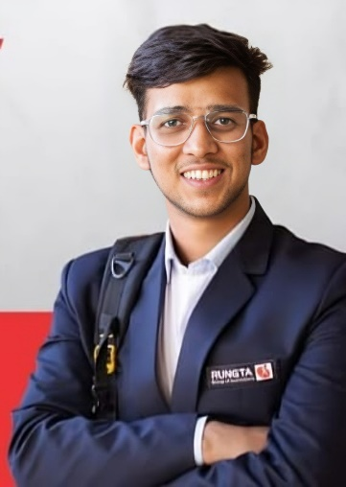
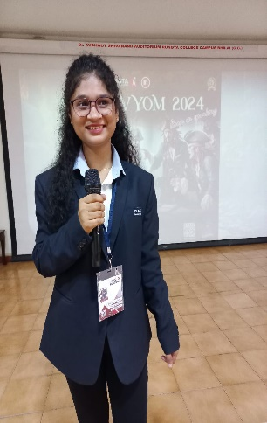
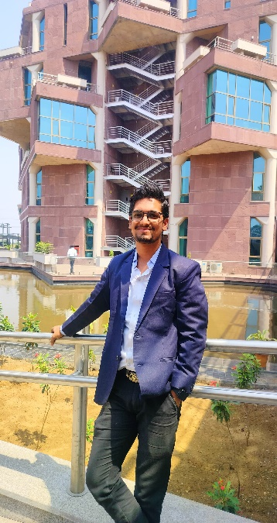

Graphic Designer UI/UX Designer Content Creator
Content Creator Front-end Developer Marketing Strategist
Digital Marketing Backend Developer Business Analyst
SEO

Kundan Kumar Virendra Vikram
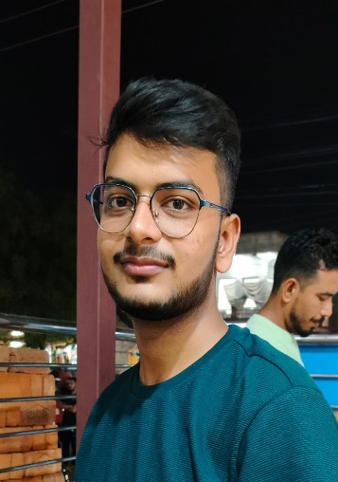
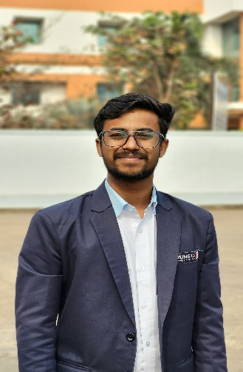

Figma Designer Digital Marketing
Video Editor Content Creator
Web Developer Communication Maestro
Photographer

Our Services:
- Website Development
- Maintenance and Search Engine Optimization
- Content Creation for Social Media Pages (Instagram & Youtube)
- Logo, Poster, Carousel and Thumbnail Designing
- Digital Marketing

Our Works:
- Thumbnail and poster designing
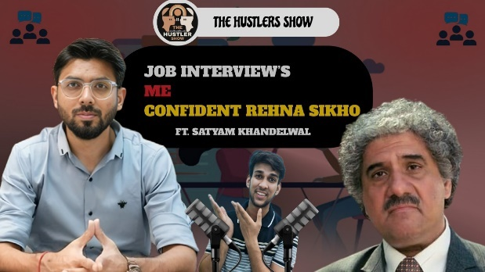 | 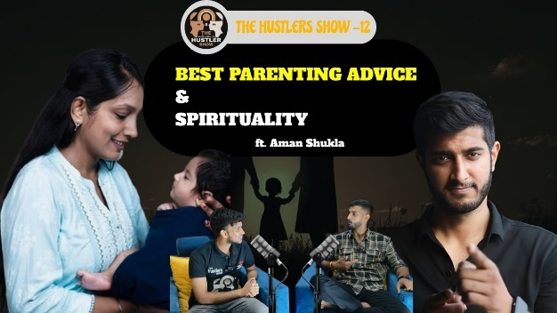
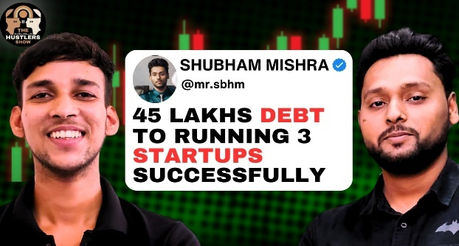 | 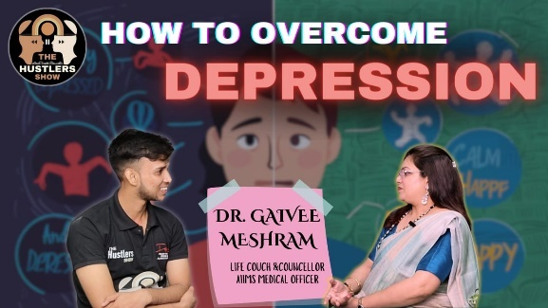
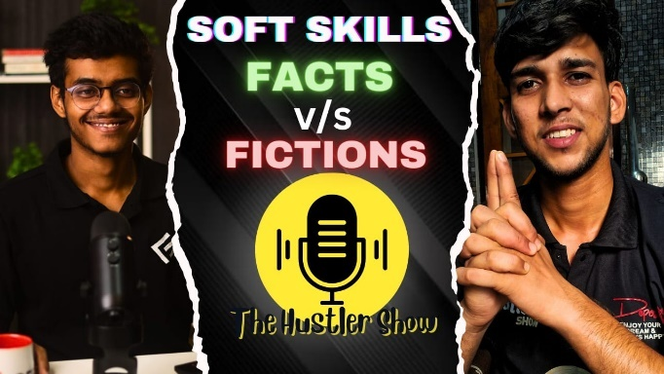 | 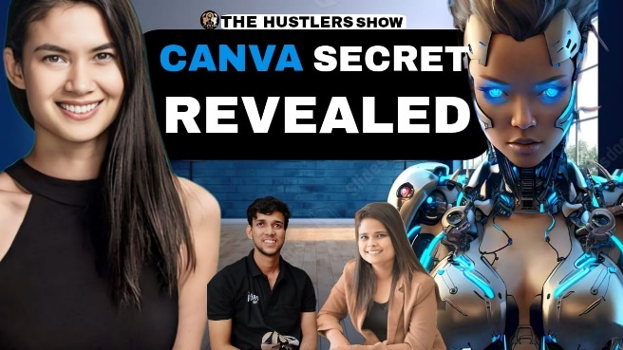

- Content Creation for Social Media
  - https://www.instagram.com/reel/C9eApfJyYHG/?igsh=MWY2a2ZqbjgyMThiaQ==
  - https://www.instagram.com/reel/C9usWmTM1TT/?igsh=MTB0NG1ic2RzNDhpZg==
  - https://www.instagram.com/reel/C9EH_SHSykJ/?igsh=MWlocHlyOWgybXJ2bw==
  - https://www.instagram.com/reel/C8bpha_SoiW/?igsh=YjVrd2FqYXJlMzBr
  - https://www.instagram.com/reel/C7a0ir7S09o/?igsh=OThoY2VlYnMweW92
  - https://www.instagram.com/reel/C6wJnVDSrgO/?igsh=MWJlaGFpbWc1cG0zOQ==

- Youtube Videos
  - https://youtu.be/YloqhBqejwg?si=FUU2zLecF57WWAKs
  - https://youtu.be/o1gYLCkDwuo?si=Ua50kMYuC5F8vaVl
  - https://youtu.be/rz48GbbmpmI?si=kKka6qPteNrcKeQK
  - https://youtu.be/sHnZRpmAU_0?si=sy9yXG27Eb7LQmLJ

- Carousel
  - https://www.canva.com/design/DAGKq-MmrRo/6gUjBZ_SNvM-XWGg7MohGA/edit?utm_content=DAGKq-MmrRo&utm_campaign=designshare&utm_medium=link2&utm_source=sharebutton
  - https://www.canva.com/design/DAGK6kC6Suk/4ORcy-naIDrQVSXDcGhM5w/edit?utm_content=DAGK6kC6Suk&utm_campaign=designshare&utm_medium=link2&utm_source=sharebutton
  - https://www.canva.com/design/DAGKt5z3v2g/EkMeJD1YE_zMJWIFh154CQ/edit?utm_content=DAGKt5z3v2g&utm_campaign=designshare&utm_medium=link2&utm_source=sharebutton
  - https://www.canva.com/design/DAGKA1eMEDM/xZCa463lpt_dOuVTEIweTA/edit

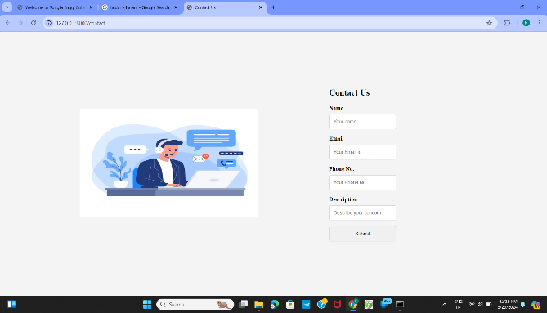
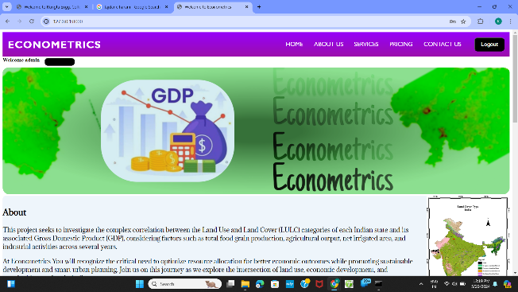
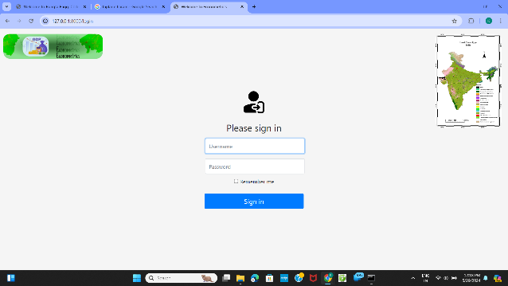
- Websites

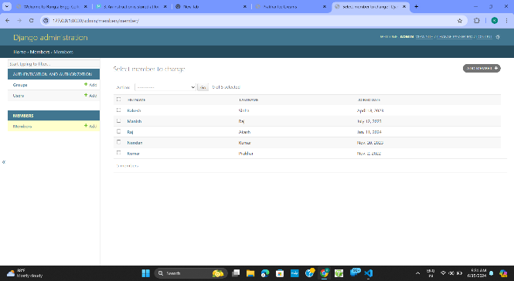
- Studio Setup
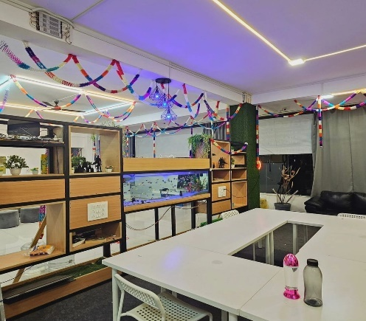
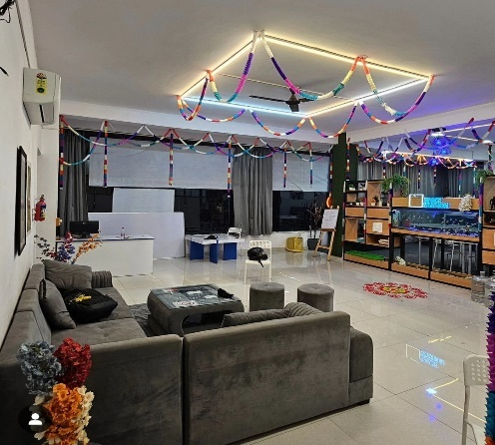
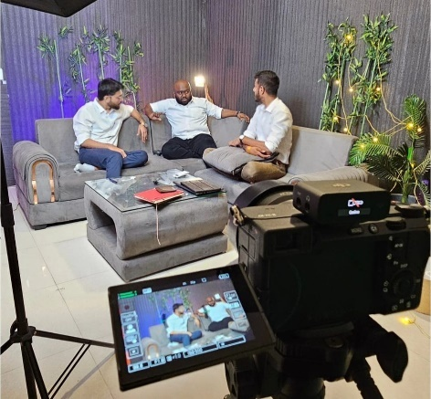

Pricing:

- Instagram Plans

- Youtube Plans

Plan | Services | Original Price (INR) | Discount(%) | Discounted Price (INR)
1 Month | 10 reels, 10 posters, 10 carousel | 2300 | 10% | 2070
2 Months | 20reels, 15 posters, 15 carousel | 4500 | 12% | 4000
3 Months | 40 reels, 25 posters, 20 carousel | 6850 | 5% | 6500

Plan | Services | Original Price (INR) | Discount(%) | Discounted Price (INR)
1 Month | 5 videos, 10 posters, 5 carousel, 15 shorts | 3400 | 12% | 3000
2 Months | 10 videos, 20 posters, 10 carousel, 24 shorts | 6300 | 10% | 5600
3 Months | 15 videos, 30 posters, 15 carousel, 35 shorts | 9200 | 10% | 8300
- Youtube + Instagram Plan:
Plan | Services | Original Price (INR) | Discount(%) | Discounted Price (INR)
1 Month | Instagram & youtube combined services | 5700 | 11% | 5000
2 Months | Instagram & youtube combined services | 10800 | 11% | 9600
3 Months | Instagram & youtube combined services | 16050 | 10% | 14500

- Webpage Services:
Services | Price (INR)
Webpage design and deployment | 8000
Webpage Maintence | 2000
Search Engine Optimization | 2000

NOTE: Webpage services charges are just for referential purpose and may vary depending upon the need of the customer and complexity of the website.

Contact Us:
 kumarprakharkp143@gmail.com
 8863929725, 7739307314
 9064201805

