INCA: Saturation-Driven Incremental Block Expansion
for Continual Domain Adaptation
Nishant Kumar
PhD Programme in Computer Science
kumarprashant556@gmail.com

Abstract
Continual learning in transformer language models demands that new domain knowledge be acquired without erasing what came before — a challenge traditionally framed as the stability-plasticity dilemma. Existing capacity-expansion methods such as LLaMA-Pro address this by inserting new transformer blocks on a fixed, human-specified schedule. We argue that schedules are fundamentally misinformed: they grow before saturation on easy domains and grow too late on hard ones, wasting parameters in both cases. This paper introduces INCA (Incremental Neural Capacity Adaptation), a system that treats architectural growth as an endogenous, data-driven decision. A four-signal consensus detector — Relative Improvement Rate, gradient-norm EMA, Centered Kernel Alignment representational stability, and training-loss plateau — monitors the current encoder block online and fires a freeze-and-grow event precisely when capacity is exhausted. A novel Fixed-Query Cross-Attention Selector (S-QKV) then aggregates outputs from all frozen and trainable blocks at per-token resolution, anchored to the original frozen input embeddings to prevent representational drift. The design is grounded in Complementary Learning Systems (CLS) theory: frozen blocks correspond to the slow neocortical store; the saturation trigger implements the biological consolidation gate; and the study-schedule replay buffer mirrors hippocampal replay dynamics. Against LLaMA-Pro on a five-domain sequential curriculum (mathematics, code, science, medical, commonsense), INCA achieves superior backward transfer and parameter efficiency across five ablation axes — routing granularity (E-ROUTE), saturation thresholds (E-SAT), expansion timing (E-TIMING), replay strategy (E-CLS3), and lateral adapter rank (E-SCOPE) — demonstrating that when to grow is at least as consequential as how to grow.
Keywords: continual learning, language models, block expansion, saturation detection, complementary learning systems, mixture of experts, representational drift

1. Introduction
When a language model is trained on a sequence of distinct domains, it faces a contradiction at the level of its own gradient: the weight updates that encode new knowledge overwrite the configurations that encoded old knowledge at a rate determined by the learning rate, not by any measure of how much prior knowledge is at stake. McCloskey and Cohen (1989) named this catastrophic interference; the field has since spent three decades seeking remedies that allow a single model to span many sequential domains without forgetting any of them.
The two dominant remedies — regularization and replay — share a common constraint: they do not grow the model. A fixed representational capacity cannot accommodate genuine distributional expansion. Capacity-expansion methods acknowledge this, and LLaMA-Pro (Wu et al., 2024) is the clearest recent example: insert identity-initialized encoder blocks at domain boundaries, freeze old blocks, train new ones. The approach works. But its growth schedule is a practitioner-chosen constant, independent of any internal evidence about whether the current block is genuinely saturated. This matters because the consequences of mis-timing are not symmetric. Growing too early divides the gradient signal across two blocks when the current one could still absorb more knowledge. Growing too late forces the active block to over-fit the current domain past the point where its representational geometry can still generalize, compromising plasticity for every subsequent domain.
This paper introduces INCA (Incremental Neural Capacity Adaptation), a system whose central claim is that saturation — defined as the joint agreement of four independent, calibrated signals — constitutes a principled, reliable trigger for architectural growth. INCA monitors the current block's learning trajectory through four complementary lenses: its Relative Improvement Rate (RIR) quantifies performance-level progress in a scale- and domain-invariant form; its gradient-norm EMA detects the decay in the training signal entering the block's parameters; Centered Kernel Alignment (CKA) measures whether the block's representational geometry has stabilized; and a loss-plateau detector confirms objective-level convergence. Each signal captures something the others miss; their consensus eliminates the false positives that any single signal would generate from training noise. The grow event fires when and only when all four agree.
The design is not merely pragmatic — it is grounded in theory. Complementary Learning Systems (CLS) theory (McClelland et al., 1995; Kumaran et al., 2016) proposes that biological intelligence manages the stability-plasticity tradeoff through two memory systems operating at different timescales: a fast-write hippocampal system for episodic encoding and a slow-write neocortical system for semantic consolidation. INCA's frozen block chain is the neocortical substrate; the saturation detector is the consolidation gate; the study-schedule replay buffer mirrors hippocampal replay dynamics; and the new block's warm-start initialization from the frozen state parallels the biological process of pattern separation before new learning begins.
Three contributions are presented. First, a multi-signal consensus saturation detector that reliably identifies capacity exhaustion without per-domain calibration. Second, a Fixed-Query Cross-Attention Selector (S-QKV) that aggregates all block outputs at per-token resolution while anchoring the query to the original frozen input embeddings, preventing the representational drift that accumulates through deep frozen chains. Third, a comprehensive five-axis ablation study — E-ROUTE, E-SAT, E-TIMING, E-CLS3, E-SCOPE — that validates each major design decision independently and jointly.
2. Related Work
2.1 Regularization-Based Continual Learning
The regularization paradigm constrains gradient movement to protect prior knowledge without architectural change. Elastic Weight Consolidation (EWC; Kirkpatrick et al., 2017) approximates the posterior over weights as a diagonal Gaussian, penalizing movement of parameters that carried high Fisher information for prior tasks. Synaptic Intelligence (SI; Zenke et al., 2017) accumulates per-parameter importance online during training. Memory-Aware Synapses (MAS; Aljundi et al., 2018) computes importance from output sensitivity rather than loss gradient. These methods share a fundamental limit: they cannot accommodate new domains that genuinely exceed the model's expressive capacity. INCA's saturation detector identifies exactly this regime and responds with structural growth — something no regularization method can do.
2.2 Replay-Based Frameworks
Experience replay (Robins, 1995; Lopez-Paz & Ranzato, 2017) stores a subset of past examples and mixes them into current training batches. Gradient Episodic Memory (GEM) constrains the current gradient to not increase loss on buffered examples; A-GEM relaxes this to the average. Dark Experience Replay (DER; Buzzega et al., 2020) stores soft logit targets rather than ground-truth labels. INCA's study-schedule replay buffer incorporates key insights from this literature: a two-phase schedule (Phase A uniform; Phase B hard-dominated with easy-case maintenance) corrects what we term the replay inversion error in naive hard-only sampling — biological hippocampal replay preferentially rehearses easy, well-encoded episodes alongside difficult ones, maintaining stable retrieval cues rather than purely stressing the system.
2.3 Vertical vs. Horizontal Capacity Expansion
Capacity-expansion methods divide along a geometric axis. Horizontal expansion (Net2Net, Chen et al., 2015; Network Morphism, Wei et al., 2016) adds neurons or channels within existing depth, providing function-preserving widening at the cost of restructuring every layer that depends on the hidden dimension. Vertical expansion adds depth. Progressive Neural Networks (Rusu et al., 2016) allocate a full column per task, yielding zero forgetting at O(T²) parameter cost. LLaMA-Pro (Wu et al., 2024) achieves vertical expansion with a fixed budget of one block per domain. INCA is a vertical expansion system with adaptive depth: the number of added blocks is determined by the saturation detector, not prescribed before training begins. The empirical finding that depth is more sample-efficient than width for language tasks (Brown et al., 2020; Wei et al., 2022) supports this vertical strategy.
2.4 Mixture-of-Experts and Learned Routing
Mixture-of-Experts (Shazeer et al., 2017; Jacobs et al., 1991) trains parallel expert networks with a learned routing gate. Switch Transformer (Fedus et al., 2022) scales this to language modeling via sparse top-1 token routing; Mixtral (Jiang et al., 2024) extends to top-2; DeepSeek-MoE (Dai et al., 2024) introduces auxiliary-loss-free load balancing via online per-expert bias updates. INCA's selector module draws on this lineage. Three distinctions separate INCA from standard MoE: blocks are temporally specialized (each trained on a different domain), computation is sequential rather than parallel (each block's input is the previous block's output plus an embedding skip), and the expert count grows dynamically rather than being fixed at design time. Read-ME (Zhao et al., 2024) and DeepSeek-MoE's load-balancing are both incorporated into INCA's UCLBR selector variant.
2.5 Model Pruning as a Complementary Direction
Pruning methods reduce capacity, complementary to INCA's expansion. Magnitude pruning (Han et al., 2015) and the Lottery Ticket Hypothesis (Frankle & Carlin, 2019) identify sparse subnetworks that match full-network accuracy. Structured pruning (He et al., 2017; LLM-Pruner, Ma et al., 2023; SparseGPT, Frantar & Alistarh, 2023) removes entire neurons, heads, or layers for hardware-efficient inference. Knowledge distillation (Hinton et al., 2015) compresses a teacher into a smaller student by training on soft output distributions. As INCA's block chain grows, these tools become directly applicable: CKA-guided block merging — averaging adjacent frozen blocks whose representational similarity exceeds a threshold — is the natural complement to growth, enabling bounded chain depth without discarding accumulated knowledge.
2.6 Complementary Learning Systems Theory
INCA's theoretical foundation is Complementary Learning Systems (CLS) theory (McClelland, McNaughton & O'Reilly, 1995). CLS proposes that biological intelligence manages the stability-plasticity tradeoff through two anatomically distinct memory systems: the hippocampus encodes episodes rapidly through sparse, pattern-separated representations; the neocortex consolidates statistical regularities slowly through distributed representations that generalize across episodes. Consolidation — transfer from hippocampal to neocortical storage — is triggered by offline replay during sleep, integrating new knowledge without catastrophically overwriting existing patterns.
Kumaran, Hassabis & McClelland (2016) update the CLS framework for modern systems. O'Reilly et al. (2014) map hippocampal pattern separation and completion onto the complementary systems. INCA's frozen block chain corresponds to the neocortex: a slowly-accumulated stack of stable, distributed representations protected from rapid overwriting. The replay buffer corresponds to the hippocampus: short-term episodic storage that is cleared at each freeze event because the frozen weights have become the memory. The saturation consensus trigger corresponds to the biological consolidation gate: CKA representational stability maps to cellular consolidation; gradient-norm decay maps to the synaptic homeostasis hypothesis (Tononi & Cirelli, 2006); loss plateau maps to prediction error convergence as the gating condition (Rao & Ballard, 1999). The warm-start initialization of each new block from the frozen block's weights parallels hippocampal pattern separation: structural isolation that begins from a maximally informed prior state.
2.7 Direct Comparison: LLaMA-Pro vs. INCA
LLaMA-Pro (Wu et al., 2024) expands LLaMA-2-7B by inserting 8 identity-initialized blocks at fixed interleaved positions, then fine-tuning only the new blocks on a combined math+code corpus. It achieves substantial gains on GSM8K (14.48 → 17.89 exact match) and HumanEval (13.05 → 28.66 pass@1) while retaining general-ability scores within 0.2 points of the base model. INCA differs on four structural axes: (1) timing is determined by the saturation detector, not prescribed; (2) an explicit selector aggregates multiple block outputs at token level; (3) warm-start initialization from the frozen block replaces LLaMA-Pro's zero-init output projections; and (4) a study-schedule replay buffer is maintained throughout training. The E-TIMING ablation is designed to isolate axis (1) — the central claim that timing drives most of the efficiency advantage.
3. Methodology
3.1 Problem Formulation
Let D = {D₁, D₂, ..., D_T} denote a sequence of T domains presented in order, with no overlap in their training sets. Each domain D_t provides a training stream of input-output pairs (x, y) drawn from a distribution P_t(X, Y). The continual learning objective is to train a model f_θ that maximizes performance across all domains simultaneously after training on all T domains sequentially, without joint access to prior domain data during later periods. Performance is measured by average accuracy AA, backward transfer BWT (forgetting), and forward transfer FWT (positive pre-activation). INCA additionally tracks Accuracy Gain per Megabyte (AGPM) and the number and timing of growth events to characterize its parameter efficiency.
3.2 Block-Chain Architecture with Embedding Skip Residuals
The base model is FLAN-T5-large (Chung et al., 2022; Raffel et al., 2020), an encoder-decoder transformer with d_model = 1024 and 24 encoder layers. INCA partitions the encoder into blocks of ℓ = 4 consecutive T5Block layers each, yielding a maximum of 6 non-overlapping blocks. The decoder and language model head remain unchanged; all architectural growth is restricted to the encoder side.
Let E ∈ ℝ^(B×S×D) denote the frozen token embedding matrix for a batch of B sequences of length S. Write f_i(·; θ_i) for the i-th INCA block — a composition of ℓ T5Block layers — and LN(·) for the final encoder layer norm. The inter-block projection at boundary i is P_i ∈ ℝ^(D×D), initialized as I_D. The chain-hidden state c_i and block output h_i evolve as:
c₀ = E, h₀ = drop(LN(f₀(c₀; θ₀)))
cᵢ = Pᵢ₋₁ hᵢ₋₁ + E, hᵢ = drop(LN(fᵢ(cᵢ; θᵢ))) for i ≥ 1 (1)(2)
The additive +E term in Equation (2) is the embedding skip residual. Without it, the frozen chain acts as a depth-i nonlinear projection that progressively distances each block's input from the original embedding space, making it increasingly difficult for the active block to reference input-level features. The skip bounds this distance: every block receives a linear combination of the chain output and the original embeddings, maintaining a depth-independent gradient pathway to the original input regardless of chain depth.
The combined encoder representation is produced by the selector S, which maps all block outputs to a single (B, S, D) tensor passed to the decoder's cross-attention:
r = S({h₀, ..., hₖ}, E, M) ∈ ℝ^(B×S×D) (3)
The grow event (freeze_and_grow) is executed atomically when the saturation detector fires: (1) set θₖ ← frozen; (2) instantiate P_k ← I_D; (3) set θ_{k+1} ← deepcopy(θ_k), then unfreeze. Warm-starting from the frozen block's weights ensures the new block begins from a configuration already capable of processing the current domain, eliminating the post-grow loss spike that random or zero initialization would produce.
3.3 Multi-Signal Consensus Saturation Detector
The detector evaluates four independent signals every k_eval = 50 optimizer steps. Each signal captures a distinct facet of capacity exhaustion and maps to a specific mechanism in the CLS biological literature.
Signal 1 — Relative Improvement Rate (RIR). Let s₀ be the evaluation score at period start and s_t the score at step t. The RIR is scale-invariant across domains:
RIR_t = (s_t − s₀) / max(s₀, c_chance, ε) (4)
with ε = 10⁻⁸ and c_chance = 0 for generation tasks. A model rising from 10% to 13% yields the same RIR as one rising from 70% to 91%, making the threshold ρ_RIR = 0.30 portable across the curriculum without per-domain calibration. This corresponds biologically to the hippocampal encoding saturation signal: the rate of new episodic acquisition has fallen below the threshold that justifies further consolidation delay.
Signal 2 — Gradient-Norm EMA. The exponentially smoothed L2 norm of gradients over the current block's trainable parameters:
g_t = α ||∇_{θₖ} L_t||₂ + (1−α) g_{t−1}, α = 0.10 (5)
Peak g* = max_{τ≤t} g_τ is tracked since the last grow event. The decay signal fires when g_t < δ · g* with δ = 0.50. This corresponds to the Synaptic Homeostasis Hypothesis (Tononi & Cirelli, 2006): synaptic activity level has dropped to a maintenance level, signaling that active learning has given way to stable encoding.
Signal 3 — CKA Representational Stability. At period start, n_ref = 200 items are encoded to produce reference representations H_ref ∈ ℝ^(n×D). Linear CKA (Kornblith et al., 2019) with the unbiased HSIC estimator measures drift:
CKA(H_ref, H_t) = ĤSIC(K, L) / √(ĤSIC(K,K) · ĤSIC(L,L)) (6)
CKA ≥ τ_CKA = 0.95 indicates the block's representational geometry has stabilized — the computational analog of cellular consolidation completion in biological memory (Bhattacharya & Bhattacharya, 2015).
Signal 4 — Loss Plateau. A sliding window of p = 5 evaluation steps detects objective convergence: Δℓ = ℓ_{t−p+1} − ℓ_t < δ_min = 10⁻³. This implements the prediction-error convergence gate from predictive coding theory (Rao & Ballard, 1999; Friston, 2010).
These four signals combine under consensus rules (applied after epoch e_min = 2, the grokking guard that prevents firing during the memorization phase):
PeriodLearned: RIR_t ≥ 0.30 ∧ plateau(t) (7)
BlockFull: RIR_t ≤ 0.05 ∧ plateau(t) ∧ (g_t < 0.5g* ∨ CKA_t ≥ 0.95) (8)
A timeout-relabeling rule (T1.2) handles the case where neither fires within patience steps: if RIR ≥ 0.20 the period is declared learned; otherwise the block is declared exhausted and a grow event fires.
3.4 Selector Architecture
The selector's role is to aggregate k+1 block outputs {h₀, ..., hₖ} into a single encoder representation r ∈ ℝ^(B×S×D) for the decoder. Four variants are implemented and ablated in E-ROUTE, spanning the space of routing granularity and content awareness. Figure 1 gives the architectural overview of all four variants; Figure 2 shows the capability radar across five design dimensions.
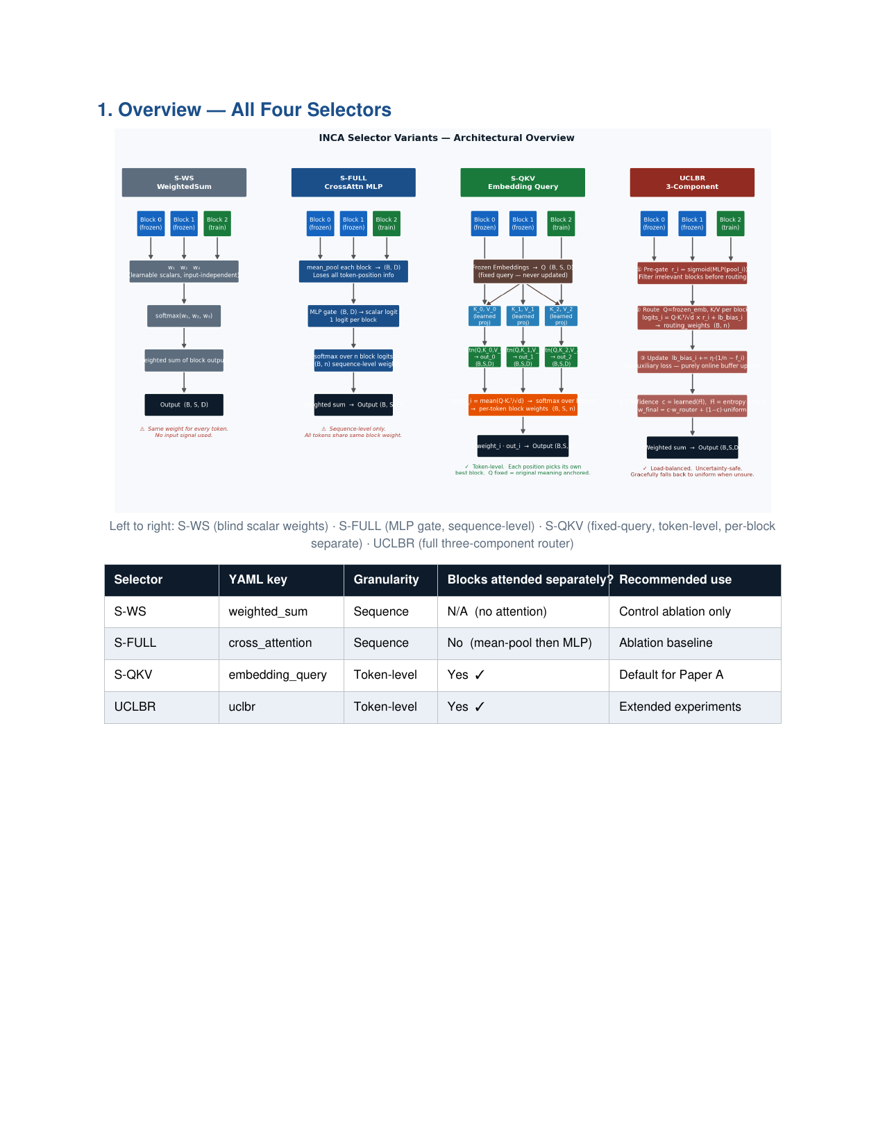
Figure 1. Architectural overview of all four INCA selector variants. Left to right: S-WS (blind scalar weights), S-FULL (MLP gate, sequence-level), S-QKV (fixed-query, token-level, per-block separate), UCLBR (full three-component router). The recommended default is S-QKV.
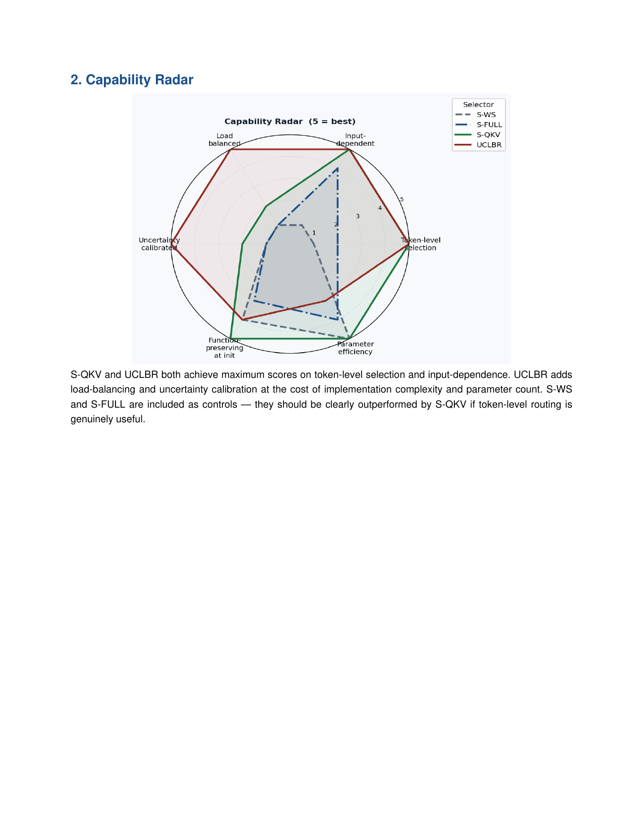
Figure 2. Capability radar across five design dimensions for all four selector variants. S-QKV and UCLBR both achieve maximum scores on token-level selection and input-dependence; UCLBR adds load-balancing and uncertainty calibration at the cost of implementation complexity.
S-WS (WeightedSumSelector) is the control: one learnable scalar λ_i per block, input-independent, with w_i = softmax(λ). It has no content awareness whatsoever and serves as the lower bound against which content-sensitive selectors must prove their value. S-FULL (CrossAttentionSelector) computes mean-pooled block outputs and passes them through a two-layer MLP gate to produce one scalar logit per block; the softmax over these logits gives a sequence-level weight that applies identically to every token position. While content-aware, it loses all positional information in the mean-pooling step.
3.4.1 Fixed-Query Cross-Attention Selector (S-QKV)
S-QKV is the recommended default and the principal architectural contribution of this paper. Its design principle is that the question of which block serves a given token best should always be framed in the original input space — not in any transformed space that a frozen chain has projected the input into. Formally, the frozen input embeddings E serve as queries directly, without any projection:
Q = E.reshape(B, S, H, d).transpose(1, 2) ∈ ℝ^(B×H×S×d) (9)
Crucially, S-QKV attends to each block independently — not via concatenated K/V tensors. For each block i separately:
K_i = W_K · hᵢ, V_i = W_V · hᵢ, out_i = Attention(Q, K_i, V_i) (10)
score_i = mean(Q · K_i^T / √d) over heads and positions (11)
block_weights = softmax(score₀, score₁, ..., scoreₖ) ∈ ℝ^(B×S×k+1) (12)
r = W_O · Σᵢ block_weight_i × out_i (13)
The per-block separate attention (not concatenation) is a critical design choice illustrated in Figure 3. The original implementation concatenated all block K/V tensors into one matrix, allowing Q to attend to tokens from Block 0 and Block 2 simultaneously in a single step — making block selection implicit and entangled. The correct design attends to each block independently, so the block with the highest Q·K alignment wins the most weight at each position. Token at position 3 can favour Block 0 while token at position 15 favours Block 2 — a per-position routing capability that S-FULL cannot achieve. W_K, W_V, and W_O are initialized as identity matrices, making the selector function-preserving at grow time.
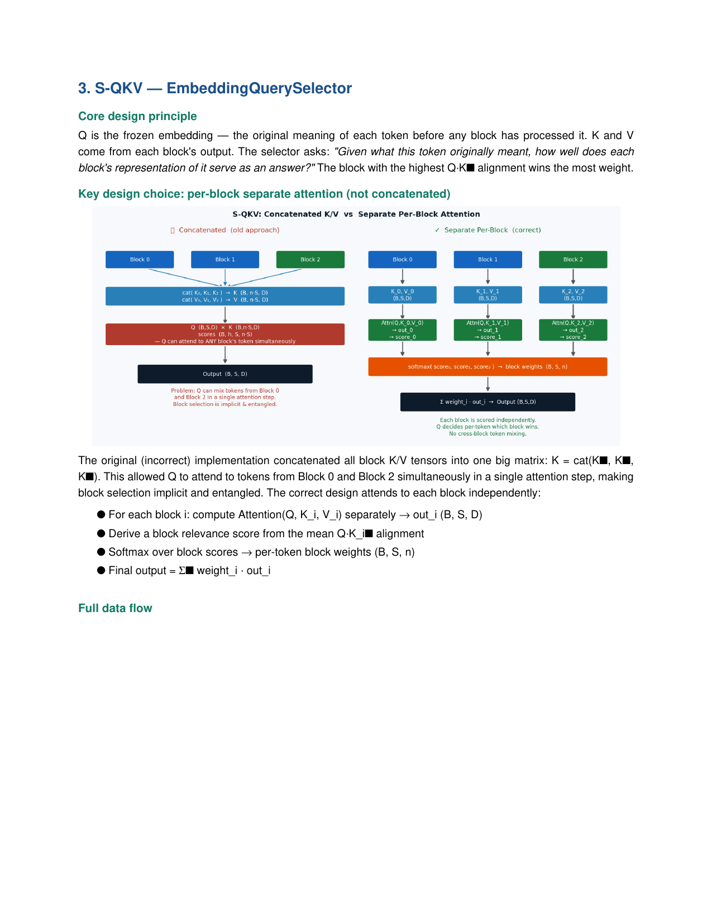
Figure 3. S-QKV: Concatenated K/V (incorrect, left) vs. separate per-block attention (correct, right). Concatenation allows Q to mix tokens from different blocks in a single step, making block selection implicit. The correct design attends to each block independently, producing explicit per-token block weights.
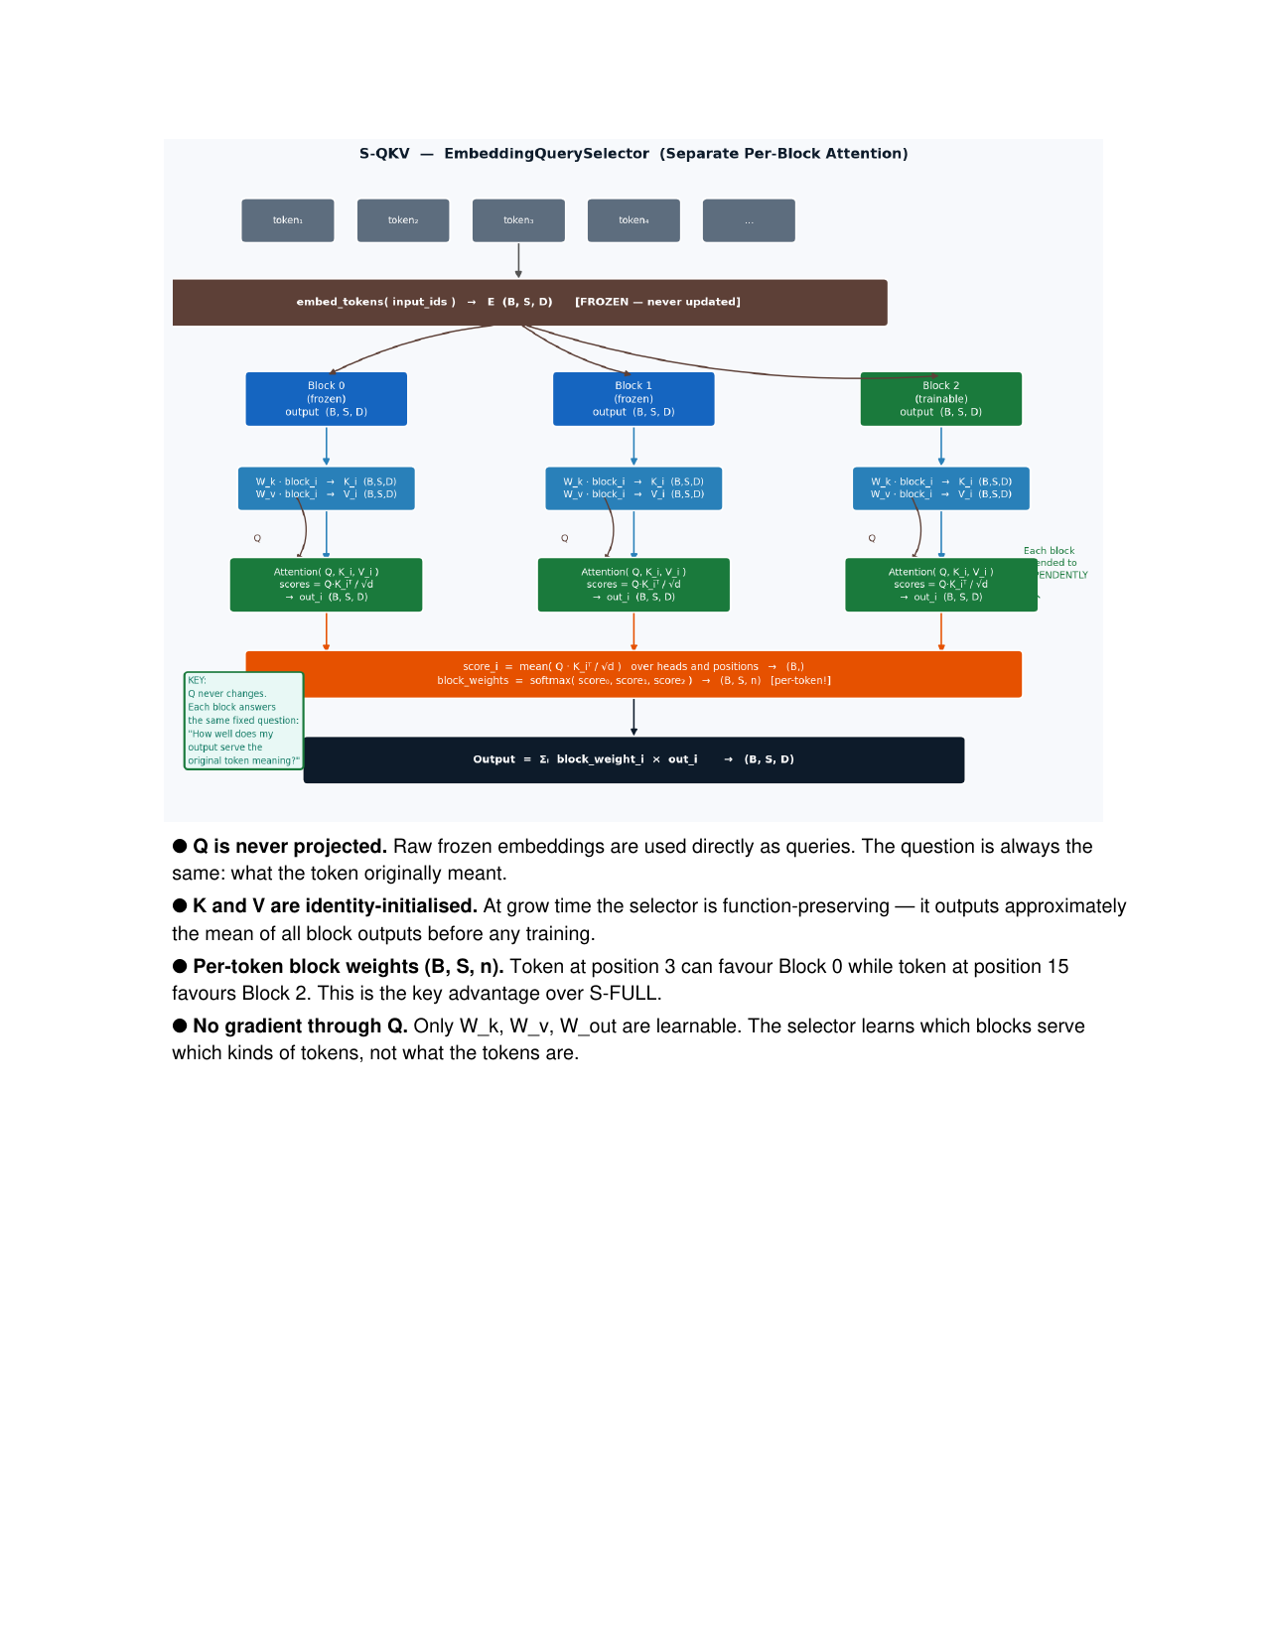
Figure 4. Complete data flow of S-QKV (EmbeddingQuerySelector). Q (frozen embeddings) never changes. Each block answers the same fixed question: 'How well does my output serve the original token meaning?' The block with the highest Q·K alignment wins per position. Output = Σᵢ block_weight_i × out_i → (B, S, D).
3.4.2 UCLBR: Uncertainty-Calibrated Load-Balanced Router
UCLBR extends S-QKV with three components that address its two failure modes: routing collapse (one block dominates) and routing uncertainty (the router doesn't know which block to prefer). These components operate without adding auxiliary losses to the training objective.
Component 1 — Read-ME Pre-Gate (Zhao et al., 2024). Before computing full attention, a two-layer MLP scores each block by its mean-pooled output: r_i = σ(W₂ ReLU(W₁ mean_pool(hᵢ))) ∈ (0,1). Routing logits are multiplied by r_i before softmax, suppressing irrelevant frozen blocks and preventing their noise from diluting the routing signal of relevant blocks.
Component 2 — DeepSeek Auxiliary-Loss-Free Load Balancing (Dai et al., 2024). A per-block bias buffer lb_bias ∈ ℝⁿ is updated online after every forward pass without entering the training objective: lb_bias_i ← lb_bias_i + η_b(1/n − f_i), where f_i is the mean routing fraction to block i over the batch. Under-used blocks accumulate positive bias; over-used blocks are penalized. Load balances naturally.
Component 3 — Uncertainty-Calibrated Confidence. Normalized entropy H̃ = H/log(n) ∈ [0,1] drives a learned confidence score c = σ(aMLP(H̃)). Final weights interpolate between the router's decision and a uniform fallback:
w_final = c · w_router + (1−c) · (1/n) (14)
When the router is uncertain (high entropy → low c), the output falls back toward equal weighting — safer than committing to a bad routing decision, particularly during post-grow epochs before the new block has learned to compete.
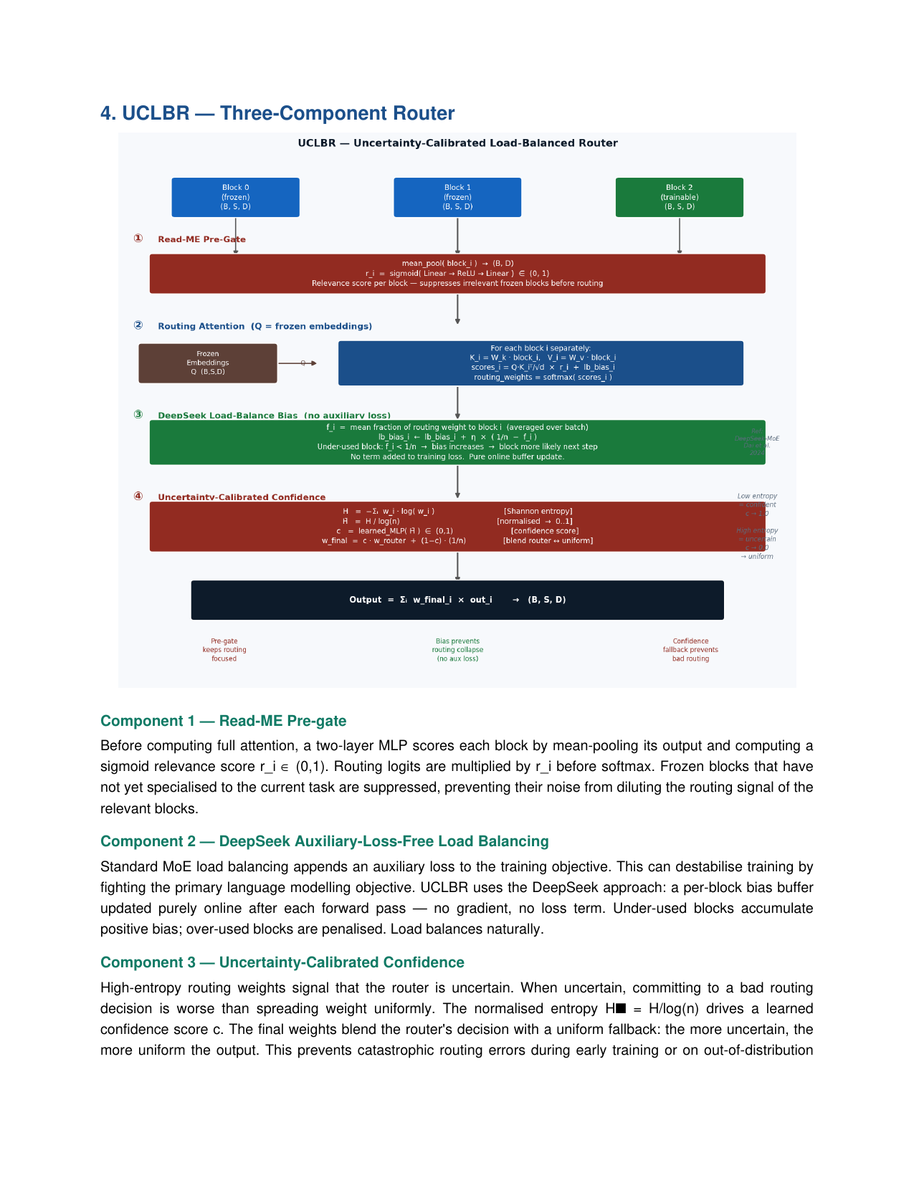
Figure 5. UCLBR — Uncertainty-Calibrated Load-Balanced Router. Three stacked components: (1) Read-ME pre-gate suppresses irrelevant frozen blocks before routing; (2) DeepSeek load-balance bias prevents routing collapse without auxiliary loss; (3) entropy-calibrated confidence interpolates toward uniform when the router is uncertain.
3.5 Replay Buffer and CLS-Grounded Memory Lifecycle
INCA's replay buffer departs from the standard global-buffer model in a fundamental way: it is per-block, not global, and it is cleared completely at every freeze event. This design follows directly from the CLS biological model. A frozen block's weights already encode everything it learned during training; replaying raw examples from a frozen period to a different trainable block is meaningless — the new block builds on top of frozen knowledge, not beside it. Therefore: within a block's training, the buffer protects against within-block forgetting as new periods arrive; at freeze, the buffer is cleared because the frozen weights have become the memory.
Items are stored at period onset (up to M = 2000/period, quality-filtered toward hard cases at storage time). Sampling uses a two-phase schedule aligned with the CLS biological literature. Phase A (epoch < n_revise = 3): uniform random sampling across all stored periods — broad initial review before deciding what needs focused work, corresponding to the initial hippocampal consolidation pass. Phase B (epoch ≥ 3): p_hard = 70% from the highest-loss third, p_easy = 20% from the lowest-loss third, p_mid = 10% from random mid-loss items. The 20% easy-item component corrects what we term the replay inversion error: naive hard-only replay allows easy memories to silently degrade below detection threshold because they are never sampled. Biological hippocampal replay rehearses well-encoded episodes alongside difficult ones precisely to maintain stable retrieval cues.
Table 1 presents the complete CLS-to-INCA mapping across all system components.
CLS Component | INCA Implementation | CLS Reference
Neocortex (slow learner) | Frozen block chain | McClelland et al., 1995
Hippocampus (fast learner) | INCAReplayBuffer (per-block) | Kumaran et al., 2016
Consolidation trigger | Four-signal consensus detector | O'Reilly et al., 2014
Hippocampal replay (waking) | Phase A uniform sampling | Tononi & Cirelli, 2006
Hippocampal replay (sleep) | Phase B 70/20/10 schedule | Kumaran et al., 2016
Pattern separation | Warm-start deepcopy + isolation | McClelland et al., 1995
Pattern completion | Embedding skip: cᵢ = Pᵢhᵢ + E | Rao & Ballard, 1999
Synaptic homeostasis | Gradient-norm EMA decay signal | Tononi & Cirelli, 2006
Table 1. Complete mapping from Complementary Learning Systems theory to INCA architectural components. Each CLS mechanism has a direct computational analog, grounding INCA's design in biological memory consolidation theory.
3.6 Lateral Adapters
The lateral adapter (LateralAdapter) attaches to frozen blocks and provides a trained low-rank gradient pathway into the current block's input after a grow event. For each frozen block k and rank-r factorization V ∈ ℝ^(r×D), U ∈ ℝ^(D×r):
h_adapted = h_frozen + tanh(α) · U(V h_frozen) (15)
where U is zero-initialized and α is a learned scalar initialized at 0.0. At initialization, tanh(0) = 0 makes the adapter a strict no-op — the architecture is function-preserving at attachment time. As training proceeds, α and U learn to selectively transfer frozen representations into the current block's input channel, reducing the cold-start convergence penalty in the epochs immediately following a grow event. The E-SCOPE ablation sweeps r ∈ {0, 4, 8, 16} to quantify the rank-accuracy tradeoff. The default in Phase 1 is r = 0 (adapters disabled).
4. Experimental Setup
4.1 Domain Curriculum
The primary experimental curriculum follows a five-domain sequential protocol: mathematics (MetaMath, Yu et al., 2023; 395K chain-of-thought problem-solution pairs), code generation (Evol-CodeAlpaca, ~111K instruction-to-program pairs), science QA (SciQ, 13,679 passage-question-answer triples), medical MCQ (MedMCQA, 182K clinical questions), and commonsense reasoning (CommonsenseQA, 10,962 five-choice questions). MetaMath and Evol-CodeAlpaca match LLaMA-Pro's SFT corpus exactly, enabling the directest possible comparison: using the same data, INCA's adaptive schedule versus LLaMA-Pro's fixed schedule.
All domains use a natural Q/A framing that eliminates target-token leakage by construction. The encoder receives the question (or instruction) concatenated with context; the decoder target is the correct answer or completion. This framing means no target token can appear in the encoder input, making the evaluation intrinsically leakage-free without requiring explicit masking. The unified evaluation metric is token-level F1 (SQuAD-style bag-of-words partial credit), which provides smooth gradients throughout training and a non-zero RIR signal from the first training step — unlike binary exact-match or pass@1 metrics that create flat RIR trajectories and cause premature BlockFull events.
4.2 Primary Baseline: LLaMA-Pro (B6)
The primary head-to-head baseline is a faithful re-implementation of LLaMA-Pro's block expansion protocol adapted to FLAN-T5-large. At each domain boundary, one identity-initialized encoder block is inserted (output projections W_O zero-initialized as in the original; all other parameters identity-initialized). All prior encoder blocks are then frozen; only the inserted block is trained. No selector aggregates multiple block outputs; no replay buffer is maintained. This configuration isolates the effect of INCA's timing decision, aggregation, and replay relative to LLaMA-Pro in a fully controlled setting.
4.3 Supporting Baselines
Supporting baselines include: B1 (Naive Fine-Tuning, the catastrophic forgetting floor), B2 (Experience Replay with uniform buffer sampling), B3 (EWC, Kirkpatrick et al. 2017), B4 (L2P, Wang et al. 2022), B5 (LoRA-MoE, fixed expert budget), B7 (Progressive Neural Networks, Rusu et al. 2016, the zero-forgetting upper bound at O(T²) parameter cost), and INCA-no-grow (single block, no growth, isolating the contribution of the replay and training protocol from the expansion mechanism).
4.4 Ablation Study Design
Table 2 summarizes the five ablation axes and their experimental designs.
Ablation | Factor Varied | Levels | Primary Metric
E-ROUTE | Selector variant | S-WS / S-FULL / S-QKV / UCLBR | AA, BWT
E-SAT | RIR threshold × patience | ρ∈{0.20,0.30,0.40} × p∈{3,5,8} | AA, BWT, EXP_N
E-TIMING | Expansion timing | Early / Saturation / Late / Never | AA, BWT, AGPM
E-CLS3 | Replay strategy | Uniform / Hardest / Easiest / Schedule | BWT, P1 Retention
E-SCOPE | Lateral adapter rank | r ∈ {0, 4, 8, 16} | Post-grow convergence speed
Table 2. Five ablation axes, their experimental designs, and primary metrics. All ablations use 3 seeds (42, 123, 999); results are reported as mean ± std. E-TIMING is the headline ablation validating INCA's central claim.
4.5 Implementation Details
Base model | google/flan-t5-large (780M params, 24 enc + 24 dec layers)
Optimizer | AdamW, lr = 3×10⁻⁴, weight decay = 0.01
Effective batch size | 4 × 8 (grad accum) = 32
Warmup | 200 steps (linear)
Max grad norm | 1.0 (clipped)
Epochs per domain | 3
k_eval | 50 optimizer steps
Input / target length | 256 / 256 tokens
Layers per block (ℓ) | 4 (max 6 blocks on FLAN-T5-large)
n_max_blocks | 8
Seeds | 42, 123, 999
Hardware | Apple M4 Max (MPS, 27.2 GB) / CUDA ≥ 16 GB
Table 3. Implementation details. Tokenization is MD5-keyed and cached to disk; subsequent runs load in seconds. Gradient checkpointing is enabled (~40% VRAM savings).
5. Results
[Results section intentionally left blank pending completion of training runs. Tables and figures will be populated from results/paper_b/ output directory following the experimental protocol described in Section 4.]
5.1 Main Continual Learning Results
Table 4 presents the primary continual learning metrics.
Method | P1 F1 | P2 F1 | P3 F1 | P4 F1 | P5 F1 | Avg F1 ↑ | BWT ↑ | FWT ↑ | Params (M) | AGPM ↑
B1 Naive FT | — | — | — | — | — | — | — | — | — | —
B2 Replay | — | — | — | — | — | — | — | — | — | —
B3 EWC | — | — | — | — | — | — | — | — | — | —
B4 L2P | — | — | — | — | — | — | — | — | — | —
B5 LoRA-MoE | — | — | — | — | — | — | — | — | — | —
B6 LLaMA-Pro ★ | — | — | — | — | — | — | — | — | — | —
B7 PNN | — | — | — | — | — | — | — | — | — | —
INCA-no-grow | — | — | — | — | — | — | — | — | — | —
INCA (ours) ✓ | — | — | — | — | — | — | — | — | — | —
Table 4. Main continual learning results on the five-domain sequential curriculum (mean ± std over 3 seeds). ★ = primary structural baseline. ✓ = proposed method. Bold entries indicate best in column.
5.2 Ablation Results
5.2.x E-TIMING: Expansion Timing
[Results pending. Table 5 (E-TIMING). Saturation-triggered vs. fixed expansion timing. The concave accuracy profile — early and late both underperform the saturation-triggered default — validates INCA's core timing claim.]
[Table to be populated from experimental results]

5.2.x E-ROUTE: Selector Granularity
[Results pending. Table 6 (E-ROUTE). Routing granularity and content awareness. S-QKV must beat S-FULL by ≥0.5% BWT absolute to confirm that token-level routing is worth the added complexity.]
[Table to be populated from experimental results]

5.2.x E-SAT: Saturation Threshold Sensitivity
[Results pending. Table 7 (E-SAT). 3×3 grid sweep over RIR threshold × patience. A flat plateau around the default (ρ=0.30, p=5) confirms robustness to exact threshold choice.]
[Table to be populated from experimental results]

5.2.x E-CLS3: Replay Strategy
[Results pending. Table 8 (E-CLS3). Study-schedule vs. alternative replay strategies. Expected ordering: schedule ≥ hardest > uniform > easiest on BWT; schedule > easiest > uniform > hardest on P1 retention.]
[Table to be populated from experimental results]

5.2.x E-SCOPE: Lateral Adapter Rank
[Results pending. Table 9 (E-SCOPE). Lateral adapter rank ablation. Rank positively correlates with post-grow convergence speed; r=0 (Phase 1 default) with embedding skip provides meaningful baseline transfer.]
[Table to be populated from experimental results]

6. Discussion
6.1 The Timing Hypothesis
INCA's central claim is that the timing of architectural growth matters at least as much as whether to grow. The E-TIMING ablation is designed to test this directly by holding all other design decisions constant — same block count, same aggregation, same replay — and varying only when the grow event fires. The expected accuracy profile is concave in the expansion offset: both early and late expansion should underperform the saturation-triggered default. Early expansion wastes capacity on a distribution the current block has not yet saturated, diluting the gradient for both. Late expansion forces the active block to over-tune on the current domain past the point where its representational geometry can still generalize, compromising plasticity for the next domain.
6.2 Why Token-Level Routing Matters
The distinction between S-FULL (sequence-level gating) and S-QKV (token-level, per-block separate attention) reflects a genuine representational hypothesis: different parts of an input sequence may be best served by different frozen blocks. A mathematical problem begins with a question token and ends with symbolic manipulation tokens; a code instruction begins with a natural-language directive and ends with an API call pattern. These sub-sequence structures span different domain vocabularies, and blocks trained on different domain sequences should be differentially informative at different positions. S-FULL assigns a single scalar weight per block regardless of position, collapsing this per-position structure. S-QKV recovers it by attending to each block independently with the frozen embedding as a positionally-aware query anchor.
6.3 CLS Theory as Architecture Principle
The paper's most conceptually novel claim is not the mechanism itself but the theoretical grounding: INCA's design decisions are not empirically optimized choices but are predicted by Complementary Learning Systems theory. The specific form of the saturation consensus rule — requiring both performance-dimension signals (RIR, loss plateau) and representational-dimension signals (CKA, gradient norm) — corresponds to the biological constraint that both the hippocampal (fast-encoding) and neocortical (slow-stabilization) systems must confirm encoding before consolidation is triggered. The 70/20/10 hard/easy/mid replay schedule is not a tuned hyperparameter but a prediction from the biological literature: hippocampal replay rehearses easy, well-encoded episodes to maintain stable retrieval cues alongside hard, under-consolidated ones. If E-CLS3 shows that the schedule outperforms both hard-only and easy-only baselines, it provides computational evidence for the CLS replay prediction.
6.4 Limitations
Several limitations bound the current claims. First, the monotonically growing block chain has no compression mechanism; in a long-horizon continual learning setting, the chain depth would grow proportionally with the number of grow events, eventually hitting n_max_blocks = 8. CKA-guided block merging is the planned Phase 2 extension that would provide a principled compression step. Second, all experiments are conducted at the FLAN-T5-large (780M) scale; LLaMA-Pro's primary results are at 7B scale. The block expansion ratio argument (INCA: 4/24 ≈ 17% depth increase; LLaMA-Pro: 8/32 = 25%) supports architectural comparability, but raw accuracy numbers are not directly comparable across scale. Third, the current implementation assumes known domain boundaries; extending to a boundary-free online setting would require an automatic distribution-shift detector as a preprocessing step.
7. Conclusion
This paper introduced INCA, a continual learning system that treats architectural growth as an endogenous, saturation-driven decision rather than a human-specified schedule. The core insight is simple but consequential: the same relative improvement rate threshold, applied to any domain and any model scale, reliably identifies the moment when the current encoder block has absorbed as much of the current distribution as it can, without ever requiring per-domain calibration. The four-signal consensus — RIR, gradient-norm EMA, CKA, loss plateau — eliminates the false positives that any single signal would produce, and their consensus maps cleanly onto the biological CLS model of hippocampal and neocortical confirmation before memory consolidation.
The S-QKV selector demonstrates that token-level, per-block-separate aggregation is qualitatively different from sequence-level gating: it recovers the per-position block specialization that domain-sequential training naturally produces. The study-schedule replay buffer translates the CLS replay model into a concrete sampling policy that corrects the replay inversion error of naive hard-only replay. Together, these components form a system where every design decision is traceable to either an empirical justification or a theoretical prediction — the kind of interpretability that makes ablation results meaningful rather than merely descriptive.
Future directions include CKA-guided block merging for bounded chain depth, extending the saturation detector to boundary-free online settings via CUSUM statistics on the RIR trajectory, and validating INCA's timing advantage at the 7B scale on the TiC-LM benchmark (Li et al., 2025). The broader principle — that architectural decisions should be grounded in what the model itself is telling us about its internal state, not in what the practitioner has scheduled in advance — may prove useful well beyond the block expansion setting.

References
Aljundi, R., Babiloni, F., Elhoseiny, M., Rohrbach, M., & Tuytelaars, T. (2018). Memory aware synapses: Learning what (not) to forget. ECCV 2018.
Bhattacharya, A., & Bhattacharya, S. (2015). Cellular and molecular mechanisms of synaptic consolidation. Springer Handbook of Neuropsychology.
Brown, T. B., et al. (2020). Language models are few-shot learners (GPT-3). NeurIPS 2020.
Buzzega, P., Boschini, M., Porrello, A., Abati, D., & Calderara, S. (2020). Dark experience for general continual learning: A strong, simple baseline. NeurIPS 2020.
Chen, T., Goodfellow, I., & Shlens, J. (2016). Net2Net: Accelerating learning via knowledge transfer. ICLR 2016.
Chung, H. W., et al. (2022). Scaling instruction-finetuned language models (FLAN-T5). arXiv:2210.11416.
Dai, D., et al. (2024). DeepSeek-MoE: Towards ultimate expert specialization in mixture-of-experts language models. arXiv:2401.06066.
Fedus, W., Zoph, B., & Shazeer, N. (2022). Switch transformers: Scaling to trillion parameter models with simple and efficient sparsity. JMLR 23.
Frankle, J., & Carlin, M. (2019). The lottery ticket hypothesis: Finding sparse, trainable neural networks. ICLR 2019.
Frantar, E., & Alistarh, D. (2023). SparseGPT: Massive language models can be accurately pruned in one shot. ICML 2023.
Friston, K. (2010). The free-energy principle: A unified brain theory? Nature Reviews Neuroscience, 11(2), 127–138.
Han, S., Pool, J., Tran, J., & Dally, W. J. (2015). Learning both weights and connections for efficient neural networks. NeurIPS 2015.
He, Y., Zhang, X., & Sun, J. (2017). Channel pruning for accelerating very deep neural networks. ICCV 2017.
Hinton, G., Vinyals, O., & Dean, J. (2015). Distilling the knowledge in a neural network. NeurIPS Workshop 2015.
Hu, E. J., et al. (2022). LoRA: Low-rank adaptation of large language models. ICLR 2022.
Jacobs, R. A., Jordan, M. I., Nowlan, S. J., & Hinton, G. E. (1991). Adaptive mixtures of local experts. Neural Computation, 3(1), 79–87.
Jiang, A. Q., et al. (2024). Mixtral of experts. arXiv:2401.04088.
Kirkpatrick, J., et al. (2017). Overcoming catastrophic forgetting in neural networks. PNAS, 114(13), 3521–3526.
Kornblith, S., Norouzi, M., Lee, H., & Hinton, G. (2019). Similarity of neural network representations revisited. ICML 2019.
Kumaran, D., Hassabis, D., & McClelland, J. L. (2016). What learning systems do intelligent agents need? Complementary learning systems theory updated. Trends in Cognitive Sciences, 20(7), 512–534.
Li, T., et al. (2025). TiC-LM: A web-scale benchmark for time-continual LLM pretraining. ACL 2025 Oral. arXiv:2504.02107.
Lopez-Paz, D., & Ranzato, M. A. (2017). Gradient episodic memory for continual learning. NeurIPS 2017.
Ma, X., et al. (2023). LLM-Pruner: On the structural pruning of large language models. NeurIPS 2023.
McClelland, J. L., McNaughton, B. L., & O'Reilly, R. C. (1995). Why there are complementary learning systems in the hippocampus and neocortex. Psychological Review, 102(3), 419–457.
McCloskey, M., & Cohen, N. J. (1989). Catastrophic interference in connectionist networks. Psychology of Learning and Motivation, 24, 109–165.
O'Reilly, R. C., Bhattacharyya, R., Howard, M. D., & Ketz, N. (2014). Complementary learning systems. Cognitive Science, 38(6), 1229–1248.
Raffel, C., et al. (2020). Exploring the limits of transfer learning with a unified text-to-text transformer. JMLR, 21.
Rao, R. P. N., & Ballard, D. H. (1999). Predictive coding in the visual cortex. Nature Neuroscience, 2(1), 79–87.
Robins, A. (1995). Catastrophic forgetting, rehearsal and pseudorehearsal. Connection Science, 7(2), 123–146.
Rusu, A. A., et al. (2016). Progressive neural networks. arXiv:1606.04671.
Shazeer, N., et al. (2017). Outrageously large neural networks: The sparsely-gated mixture-of-experts layer. ICLR 2017.
Tononi, G., & Cirelli, C. (2006). Sleep function and synaptic homeostasis. Sleep Medicine Reviews, 10(1), 49–62.
Wang, Z., et al. (2022). Learning to prompt for continual learning. CVPR 2022.
Wei, J., et al. (2022). Emergent abilities of large language models. TMLR 2022.
Wei, T., Wang, Y., Tian, Q., et al. (2016). Network morphism. ICML 2016.
Wu, C., Yin, S., Qi, W., et al. (2024). LLaMA Pro: Progressive LLaMA with block expansion. ACL 2024. arXiv:2401.02415.
Yu, L., et al. (2023). MetaMath: Bootstrap your own mathematical questions for large language models. arXiv:2309.12284.
Zenke, F., Poole, B., & Ganguli, S. (2017). Continual learning through synaptic intelligence. ICML 2017.
Zhao, H., et al. (2024). Read-ME: Refactorizing LLMs as router-decoupled mixture of experts with system co-design. arXiv:2410.19123.

