This is a SpringBoot Project running on port 9898

I am using java 11 for this

If u have 1.8 u change java.version in pom.xml as 1.8

I am using mysql 8

I have mysql 8

My

mysql database is test ( U CAN CREATE ‘TEST ‘ database)

& uname is root &

pass is 123456

U can also use oracle 11g 12c 19c 21c

STEPS

1. IMPORT PROJECT IN STS
2. Run it by right clicking on it
3. Run as--🡪 spring boot app

Once it starts on 9898 go to

MYSQL 8

Go to test database

Check **user_detail** table is created or not

It is created

Now insert following command in mysql console

insert into

test.user_detail(contact_number,email,enabled,first_name,last_name,password,role) values ('9876543210','admin@gmail.com',true,'admin','admin','$2a$10$6UVHQoHhpoYZxBB.k9r.deSLTT0RD1Yk8GdggRywGw0Snr8syRDtG','ADMIN')

**Password = 123456(in encoded Form)**

**Now run project again**

**Goto browser**

**Hit following url**

<http://localhost:9898/>

u will get following screen

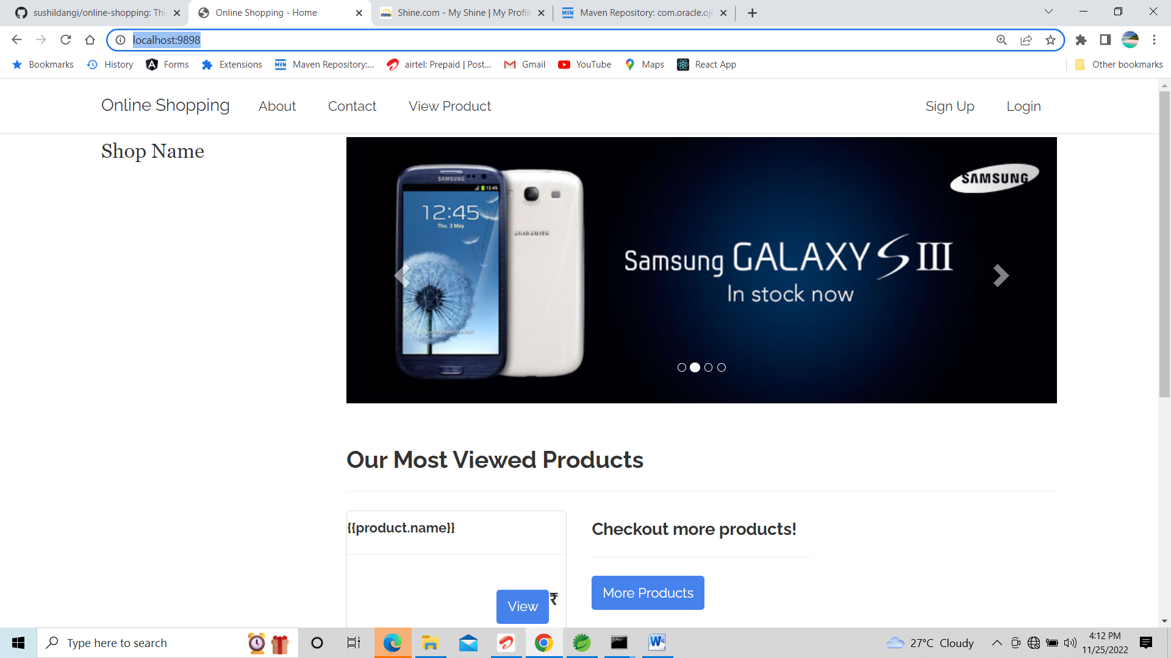

Click on sign up

U will get following screen

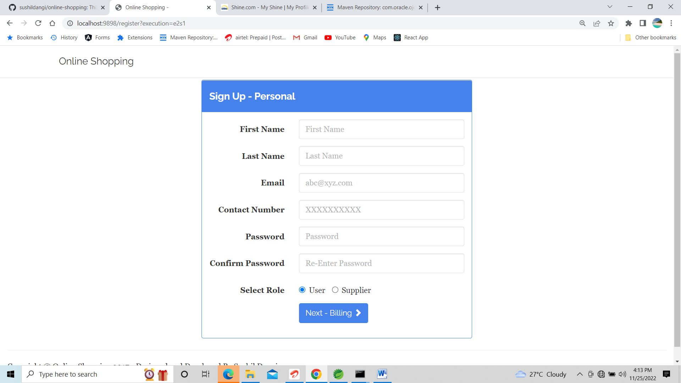

Start registering

Check product table is created or not in mysql command conole

By typing

desc product

Then manually insert all column values in product table (don’t insert value for id)

Then start purchasing!!!

GOOD LUCK