Competition Commission of India

1st Source: Combinations orders from the CCI

Source URL: <https://www.cci.gov.in/combination/orders-section31>

Types of Orders:

1. Orders under Section 31 / Form III
2. Orders under Section 43A and 44
3. Cases approved with modifications

I. Section 31: relates to orders of the commission on combinations proposed between two entities. Combinations could be related to mergers and acquisitions of companies/entities.

Under this source, there are following sub-sections:

1. Approved
2. Notice not valid
3. Deemed approved
4. No AAEC
5. Approved with modification
6. Transaction called off
7. Notice withdrawn

Fields to be captured:

1. Combination registration number
2. Notifying parties
3. FORM
4. Date of notification
5. Status
6. Decision date
7. Summary of proposed combination
8. Order document (where applicable)

Fields to be captured from the Order document for **“Orders under Section 31 / Form III”**:

Additionally, we should collect the Names of the Parties to the Combination from inside the order document.

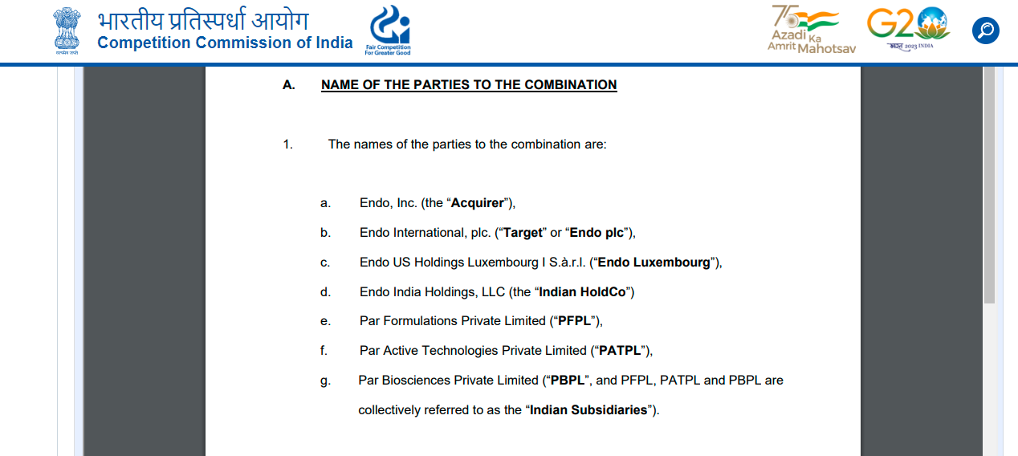

II. Section 43A and 44: penalties that are applied to companies/entities for not furnishing necessary information with respect to combinations or for making false statements

Fields to be captured:

1. Combination registration number
2. Description
3. Under section
4. Decision date
5. Order document

III. Cases approved with Modifications: *(similar to Section 31- approved with modifications)

We need not work on this section.

Competition Commission of India

2nd Source: Anti profiteering orders by the competition commission

Source URL: https://www.naa.gov.in/news.php?cat=2

Anti profiteering orders deal with instances where a company has received a reduction in GST Tax on any supply of goods or services or has been given the benefit of input tax credit and these benefits have not been passed onto the recipient through a reduction in prices.

The cases are decided by the Director General of Anti-profiteering and involves the imposition of monetary penalties where there is a violation

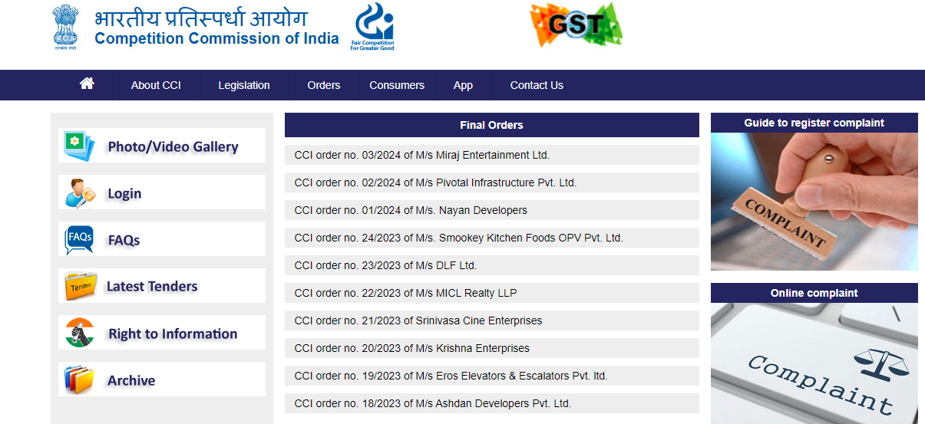

Fields to be captured:

1. Final orders
2. Title of the case along with the case document which can be accessed by clicking on the title and then on the “Download” option on the next page

