Market data / Probe agile data Dashboard User Handbook

Version 1.0



10-JAN-24

***Change Log***

|  |  |  |  |
| --- | --- | --- | --- |
| Date | Prepared By | Reviewed By | comments |
| 10 JAN 24 | Udhaya kumar G  Prem Kumar K | Surya S |  |

***CONFIDENTIAL***

This document is being submitted on the understanding that the contents would not be divulged to any third party without prior written consent.



Contents

|  |  |  |
| --- | --- | --- |
| S.No | Content | Page number |
|  | MARKET DATA |  |
| 1. | Introduction | 5 |
| 2. | Home Page | 5 |
| 3. | Card view | 6 |
| 4. | Individual Historic View | 8 |
|  | PROBE AGILE DATA |  |
| 5. | Introduction | 10 |
| 6. | Color details of data scraped count | 10 |
| 7. | Home Page for Probe Agile data: | 10 |
| 8. | Card View | 12 |
| 9. | Historic View | 13 |
| 10. | Dropdown Options | 14 |

DASHBOARD FOR MARKET DATA - DOCUMENTATION

**1. Introduction:**

The purpose of this document is to explain the interaction with dashboard as per customer requirements. The dashboard is responsible for providing data from the database. The subsequent section of this document explains detailed functioning and behaviors. The goal is to provide a clear and comprehensive guide for the users to explain how to use the dashboard.

**2. Home page:**

This is the opening page of the dashboard that provides a historic view of the past one week data from the database for all the 19data sources (at present) based on the latest trade date. This table displays the trade date on the top and the source name on the left. The number of data available and number of data scraped on a daily basis is displayed on the corresponding columns.

**URL:** <https://dashboard.nextwealth.com:5003/>

**Date display box:**

A separate box that displays the form and to date is provided in a box below the heading tag “Metrics from “from date” and “to date” ”.

**Page Navigation:**

On clicking “HOME” button the home page will be opened. Below the “HOME” button two page names “Probe agile data” and “Market data”. On clicking it the corresponding landing pages of the Dashboard displaying the corresponding data will be displayed.

**Data display table:**

The table in the center displays the data from the database. Color schema and their explanations are as follows:

**Green:** Successful scraping

**Yellow:** Failed scraping due to various reasons and needs manual intervention. ‘NA’ – will be displayed.

**Red:** failed scraping

**‘-’:** No data in the particular date

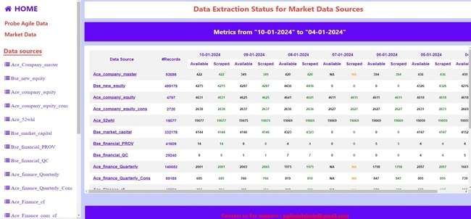

**Image:(2.a)**

**3. Card View:**

On clicking the individual underlined data source in the table a card containing all the details for the particular trade date will be displayed as a popup in the page itself for the particular source.

It can be opened for a detailed view of the particular source and will be closed once the “X” is clicked.

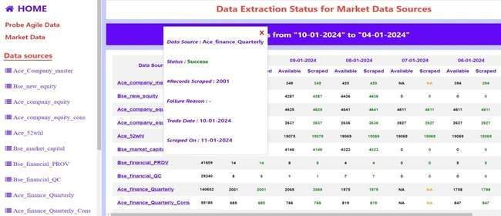

**Image:(3.a)**

**List View:**

Below the Data sources a list containing 19 data sources (at present) is provided.

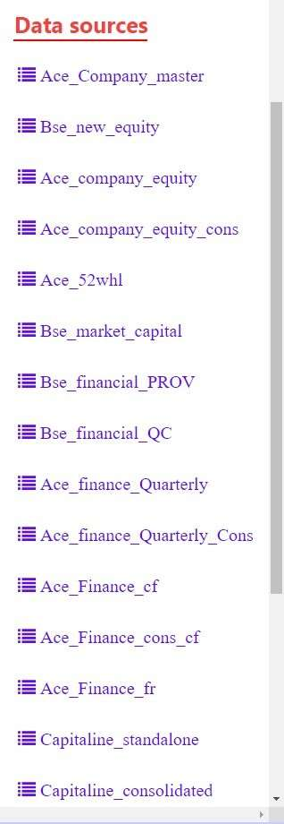––

**Image:(3.b.)**

**4. Individual Historic View:**

On clicking the particular source from the list view the page will be navigated to the individual data source page where we can perform various date range selection in the particular page. The page chosen is also highlighted.

A detailed display of the results will be provided in the page and data like “status”, “#Records available”, “#Records scraped”, “Failure reasons”, “Trade date”,“ Scraped on” date will be displayed.

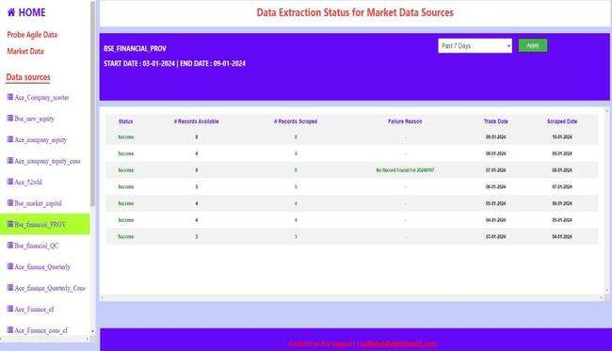

**Image:(4.a.)**

**Heading box:**

A Heading box containing the data source name along with the date range chosen is displayed.(default is 7 days.)”start date:”, "end date:”

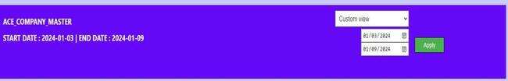

**Image:(4.b.)**

**Dropdown box:**

A dropdown containing various time ranges for selection is displayed from which we can choose the required date range. After clicking apply button corresponding results for the data source will be displayed.

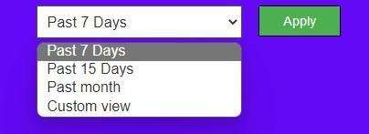

**Image:(4.c.)**

**Custom view:**

A date box will be displayed once the custom view option is chosen and we can manually enter the dates for the chosen source. Currently only previous 2 months data will be displayed from the source and the trade not greater than the current date data will be displayed beyond which an error message will be displayed.

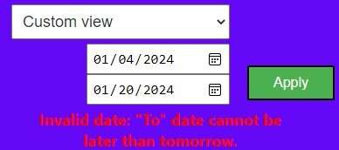

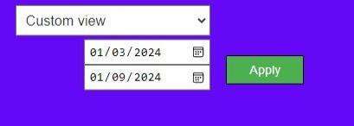

**Image:(4.d.)**

**Support Mail:**

A mail id for providing feedback and complaint is provided in the bottom of the page. On clicking the mail id a new page to write an email to the team is provided for the user’s convenience,

C:\Users\Udhaya.7483\Desktop\dash doc images\SUPPORT MAIL.jpg

**Image:(4.e)**

Probe Agile Data frond-end design

**Front End Documentation:**

**5. Introduction:**

In this application, rbi log details are displayed such as rbi_fema, rbi_ecb, rbi_odi in Probe agile data sources page from database for past 7 days. Here data available count and data scraped count are displayed for past 7 days. Total count (#Records) of data scraped is also displayed for rbi_fema, rbi_ecb, rbi_odi.

**6. Color details of data scraped count:**

1. If Script status is success then corresponding data scraped count will be highlighted in **green** color for that particular day.
2. If Script status is failure then corresponding data scraped count will be highlighted in red color for that particular day.
3. If Script status is failure and failure reason is 204 error means then corresponding data scraped count will be highlighted in **amber** (like orange) color for that particular day.

Note: for some reason if script status is failure data scraped count will be “NA”. This means null values are displayed in database for data scraped for failure reason.

1. If data is not scraped (no data) for that particular day then corresponding data scraped count will be “-” (hyphen).

**7. Home Page for Probe Agile data:**

**URL**: <https://dashboard.nextwealth.com:5003/rbinewhome/>

**Description**:

If we enter this URL then home page of probe agile data will be displayed as shown in image below. Or if we enter this URL <https://dashboard.nextwealth.com:5003/> and clicking the “Probe Agile Data” link then following home page will be displayed as shown in image below.

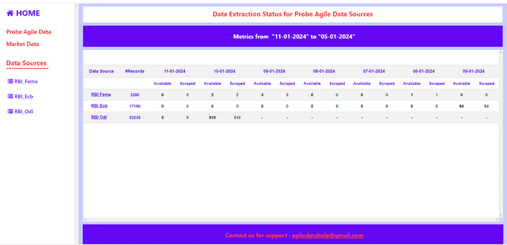

Image: (7.a)

**8. Card View**:

On clicking the RBI_Fema link in Data Source Column in table, then popup card details will be displayed as shown in image (8.a) below. Like this when click the RBI_Ecb and RBI_Odi then corresponding popup card details will be displayed.

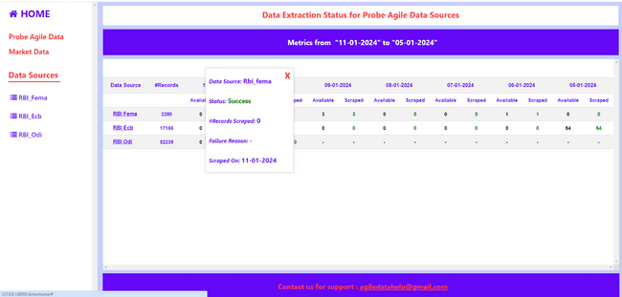

Image: (8.a)

**9. Historic** **View**:

On clicking the RBI_Fema link in left side bar then historic view of RBI_Fema will be displayed as shown in image below (9.a). Like this when we click the RBI_Ecb and RBI_Odi link then corresponding historic page view will be displayed. In Historic view past 7 days data will be displayed as default view in table format.

A detailed display of the results will be provided in the page and data like “status”, “#Records available”, and “#Records scraped”, “Failure reasons”, Scraped on date will be displayed.

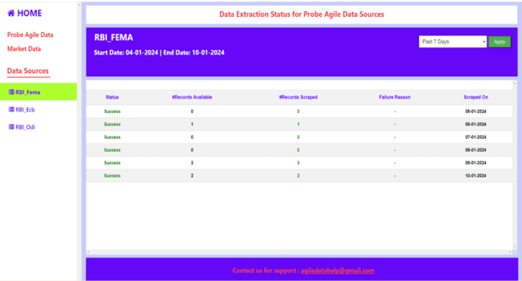

Image: (9.a)

**10. Dropdown Options:**

On clicking the dropdown options in right side following options will be displayed such as past 7 days , past 15 days , past month , custom view options.

Here past 7 days is the default view. If we selects the past 15 days options and clicking the apply button then past 15 days data will be displayed in table as shown in image below (10.a).

If we selects the past month options and clicking the apply button then past month data will be displayed as a results in table.

For custom view options we can select any two months data and clicking the apply button then corresponding months details will be displayed in table.

**Note:** we can select data only for 60 days.

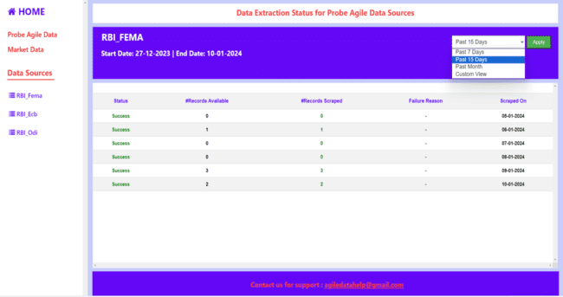

Image: (10.a)

For custom view options we can select any two months data and clicking the apply button then corresponding months details will be displayed in table.

**Note:** we can select data only for 60 days. If we select for more than 60 days in custom view options

Then following error message will be displayed as shown in image below (10.b).

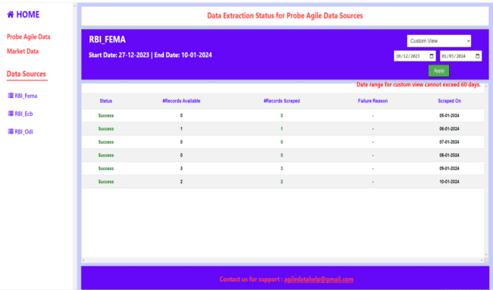

Image: (10.b)