**API Documentation**

**STARTUP-INDIA**

**1. Introduction**

In this application, we are scrapping the data’s from the source of Startupindia websiteon a daily basis and storing those data in the database. The data from the database is retrieved through the API interface. Please refer to the below steps to retrieve the data using the API Interface.

**2. Objective**

API is the acronym for application programming interface , a software intermediary that allows two applications to talk to each other. APIs are an accessible way to extract and share data within and across organizations.

**3. Supported API function**

**Get order by Date**

**HTTP Method : GET**

[http://127.0.0.1:8000/api/v1/getOrderByDate/?date=2024-09-11](http://127.0.0.1:8000/api/v1/gemEntity/Company/?date=2024-07-12)

**4. Description:**

The Get Order By Date function allows you to get the data from the given date The date format should be in “yyyy-mm-dd” . For example, if we give 2024-09-11. It will return the data from that date only.

|  |  |
| --- | --- |
| **Parameter Name** | **Description** |
| Date | The Date format should be in "yyyy-mm-dd". |
| Limit | Number of data should be returned as per the user. |
| Offset | Used to eliminate a set of records from a given table in order to retrieve a set of records according to the requirement of the database. |

**5. Request Parameters:**

**Note:**

If nothing is provided in the Limit and Offset field it takes the default Limit value 50 and Offset value 0

**JSON Response :**

<http://127.0.0.1:8000/api/v1/getOrderByDate/?date=2024-09-11&limit=5>

**JSON “result” value:**

In this function the possible values of the above JSON result field are displayed in image below . We retrieve results data from the date given by the user.

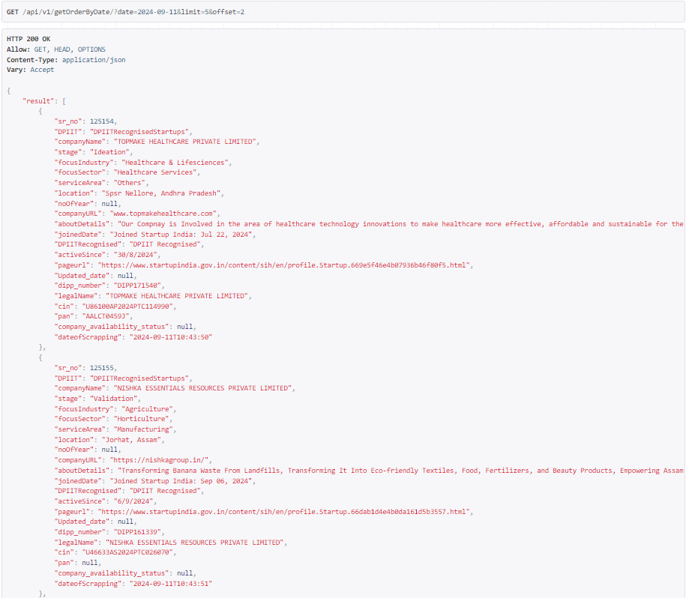

Here if we want first **500** results then we need to enter end point like this

[http://127.0.0.1:8000/api/v1/getOrderByDate/?date=2024-09-11&limit=500](%20http://127.0.0.1:8000/api/v1/getOrderByDate/?date=2024-09-11&limit=500%20%20%20)

Here if we want **500 to 1000** results then we need to enter end point like this

[http://127.0.0.1:8000/api/v1/getOrderByDate/?date=2024-09-11&limit=1000 &offset=500](http://127.0.0.1:8000/api/v1/getOrderByDate/?date=2024-09-11&limit=1000%20&offset=500)

Here if we want **1000 to 1500** results then we need to enter end point like this

[http://127.0.0.1:8000/api/v1/getOrderByDate/?date=2024-09-11&limit=1500 &offset=1000](http://127.0.0.1:8000/api/v1/getOrderByDate/?date=2024-09-11&limit=1500%20&offset=1000%20%20%20)

**6. Error Messages**

This API error occurs when a server refuses to fulfill a request from the client due to other restrictions put in place by the API provider. In that case it results also the error code and the error message.

**Here is the complete list of Error codes and Error messages:**

|  |  |
| --- | --- |
| **Error Code** | **Error Message** |
| 422 | Invalid date format, should be YYYY-MM-DD and Invalid limit or offset value , must be an integer |
| 400 | Invalid url |
| 404 | Page not found |
| 500 | An internal server error occurred |