**API Documentation**

**NGO-Darpan**

**1. Introduction**

In this application, we are scrapping and collecting the list of relevant NGOs and VOs from Darpan portal which includes **“Private Sector Companies (Sec8/25)” , “Trust (Non-Government)”, “Other Registered Entities (Non-Government)”, “Academic Institutions (Private)” & “Academic Institutions (Govt)”**. Here we are storing these data in database on daily basis. The data from the database is retrieved through the API interface. Please refer to the below steps to retrieve the data using the API Interface.

**2. Objective**

API is the acronym for application programming interface ,a software intermediary that allows two applications to talk to each other. APIs are an accessible way to extract and share data within and across organizations.

**3. Supported API function**

**HTTP Method : GET**

**Ngo_Type** : Private Sector Companies (Sec 8/25)

<http://127.0.0.1:8000/api/v1/NgoDetails/NgoPrivateSectorCompanies/>

**Ngo_Type** : Private Sector Companies (Sec 8/25) + "registration_with" details

Additionally if we want to filter records based on **"registration_with"** column we can add any one of the following values such as ,

1. Registrar of Companies,
2. Registrar of Cooperative Societies,
3. Any Other,
4. Charity Commissioner,
5. Sub-Registrar,
6. Registrar of Societies ,
7. International Organisation.

for example :

[http://127.0.0.1:8000/api/v1/NgoDetails/RegWith/NgoPrivateSectorCompanies/Registrar of Companies/](%20%20%20%20%20%20http://127.0.0.1:8000/api/v1/NgoDetails/RegWith/NgoPrivateSectorCompanies/Registrar%20of%20Companies/)

**Ngo_Type** : Other Sector Companies

1. NgoOtherRegisteredEntitiesNonGovernment
2. NgoTrustNonGovernment
3. NgoAcademicInstitutionsGovernment
4. NgoAcademicInstitutionsPrivate

for example :

[http://127.0.0.1:8000/api/v1/NgoDetails/NgoOtherRegisteredEntitiesNonGovernment/](http://127.0.0.1:8000/api/v1/NgoDetails/NgoOtherRegisteredEntitiesNonGovernment/http://127.0.0.1:8000/api/v1/NgoDetails/ NgoTrustNonGovernment/)

[http://127.0.0.1:8000/api/v1/NgoDetails/ NgoTrustNonGovernment/](http://127.0.0.1:8000/api/v1/NgoDetails/NgoOtherRegisteredEntitiesNonGovernment/http://127.0.0.1:8000/api/v1/NgoDetails/ NgoTrustNonGovernment/)

**Ngo_Type** : Other Sector Companies + Ngo_Name as either limited or ltd.

for example :

[http://127.0.0.1:8000/api/v1/NgoDetails/ NgoAcademicInstitutionsPrivate/limited/](http://127.0.0.1:8000/api/v1/NgoDetails/ NgoAcademicInstitutionsPrivate/limited/http://127.0.0.1:8000/api/v1/NgoDetails/ NgoAcademicInstitutionsPrivate/ltd/)

[http://127.0.0.1:8000/api/v1/NgoDetails/ NgoAcademicInstitutionsPrivate/ltd/](http://127.0.0.1:8000/api/v1/NgoDetails/ NgoAcademicInstitutionsPrivate/limited/http://127.0.0.1:8000/api/v1/NgoDetails/ NgoAcademicInstitutionsPrivate/ltd/)

**Ngo_Type** : Other Sector Companies + Ngo_Name as either limited or ltd.+ "registration_with" details

Additionally if we want to filter records based on **"registration_with"** column we can add any one of the following values such as

1. Registrar of Companies,
2. Registrar of Cooperative Societies,
3. Any Other,
4. Charity Commissioner,
5. Sub-Registrar,
6. Registrar of Societies ,
7. International Organisation.

for example :

[http://127.0.0.1:8000/api/v1/NgoDetails/RegWith/NgoOtherRegisteredEntitiesNonGovernment/limited /Registrar of Cooperative Societies/](http://127.0.0.1:8000/api/v1/NgoDetails/RegWith/NgoOtherRegisteredEntitiesNonGovernment/limited /Registrar of Cooperative Societies/http://127.0.0.1:8000/api/v1/NgoDetails/RegWith/NgoOtherRegisteredEntitiesNonGovernment/ltd/Any Other/)

[http://127.0.0.1:8000/api/v1/NgoDetails/RegWith/NgoOtherRegisteredEntitiesNonGovernment/ltd/Any Other/](http://127.0.0.1:8000/api/v1/NgoDetails/RegWith/NgoOtherRegisteredEntitiesNonGovernment/limited /Registrar of Cooperative Societies/http://127.0.0.1:8000/api/v1/NgoDetails/RegWith/NgoOtherRegisteredEntitiesNonGovernment/ltd/Any Other/)

like this it is applicable for following ngo_types also.

1. NgoTrustNonGovernment
2. NgoAcademicInstitutionsGovernment
3. NgoAcademicInstitutionsPrivate

**4. Request Parameters:**

|  |  |
| --- | --- |
| **Parameter Name** | **Description** |
| Limit | Number of data should be returned as per the user. |
| Offset | Used to eliminate a set of records from a given table in order to retrieve a set of records according to the requirement of the database. |

**Note:**

If nothing is provided in the Limit and Offset field it takes the default Limit value 50 and Offset value 0

**JSON Response :**

<http://127.0.0.1:8000/api/v1/NgoDetails/NgoOtherRegisteredEntitiesNonGovernment/limited/?limit=2>

**JSON “result” value:**

In this function the possible values of the above JSON result field are displayed in image below .

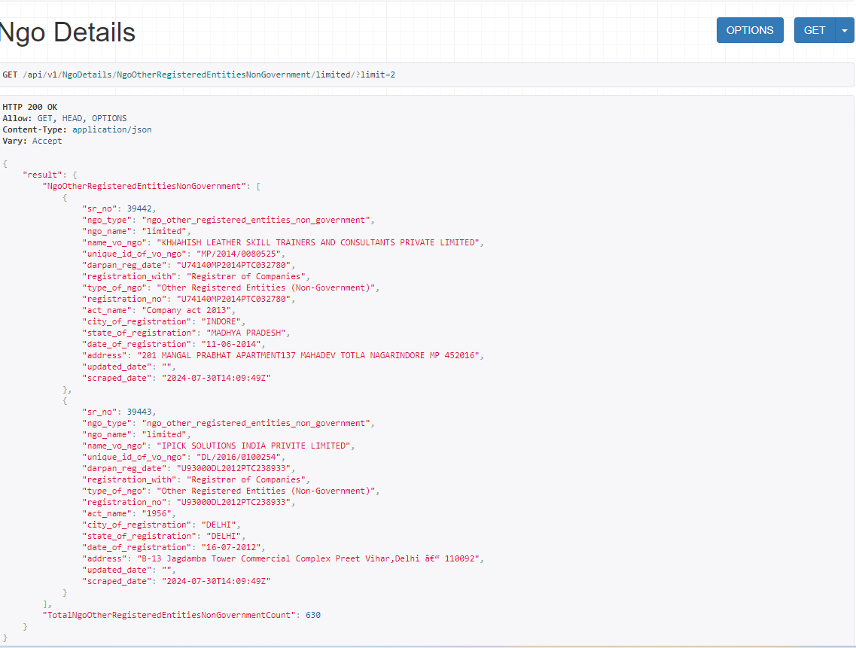

Here if we want first **500** results then we need to enter end point like this

<http://127.0.0.1:8000/api/v1/NgoDetails/NgoPrivateSectorCompanies/?limit=500>

Here if we want **500 to 1000** results then we need to enter end point like this

[http://127.0.0.1:8000/api/v1/NgoDetails/NgoOtherRegisteredEntitiesNonGovernment/limited/? limit=1000&offset=500](http://127.0.0.1:8000/api/v1/NgoDetails/NgoOtherRegisteredEntitiesNonGovernment/limited/?%20limit=1000&offset=500)

Here if we want **1000 to 1500** results then we need to enter end point like this

[http://127.0.0.1:8000/api/v1/NgoDetails/ NgoAcademicInstitutionsGovernment/ltd/?limit=1500&offset=1000](http://127.0.0.1:8000/api/v1/NgoDetails/%20NgoAcademicInstitutionsGovernment/ltd/?limit=1500&offset=1000%20%20)

**5. Error Messages**

This API error occurs when a server refuses to fulfill a request from the client due to other restrictions put in place by the API provider. In that case it results also the error code and the error message.

**Here is the complete list of Error codes and Error messages:**

|  |  |
| --- | --- |
| **Error Code** | **Error Message** |
| 422 | Invalid date format, should be YYYY-MM-DD and Invalid limit or offset value , must be an integer |
| 400 | Invalid url |
| 404 | Page not found |
| 500 | An internal server error occurred |