Command for Inserting the values in table student198:

Command = insert into student198 values(‘1/23/SET/BCS/198’, ‘Prince Kumar’, ‘CSE’ , ‘8’);

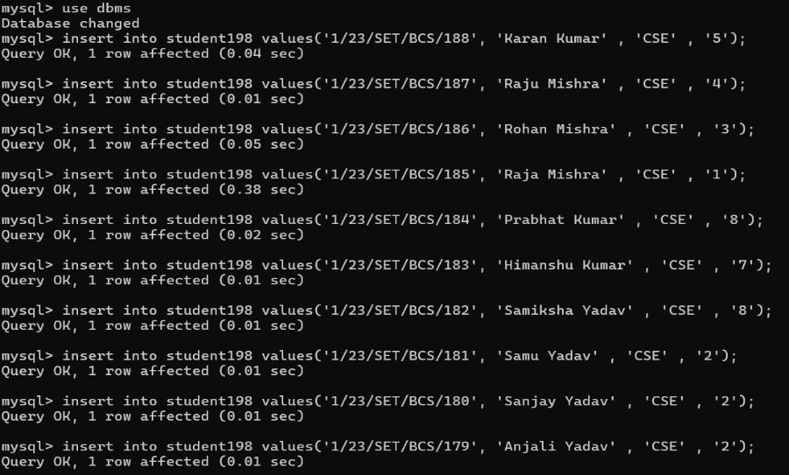

Representing the table:

Command : select * from student198;

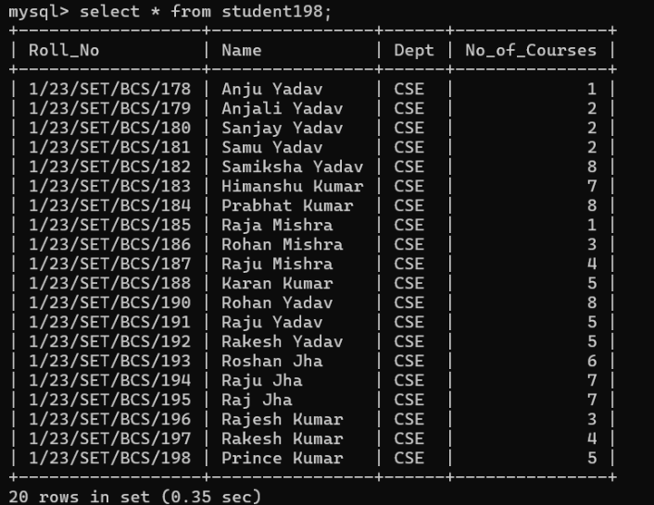

Deleting rows for no_of_course > 7:

Command = delete from student198 where no_of_courses > 7;

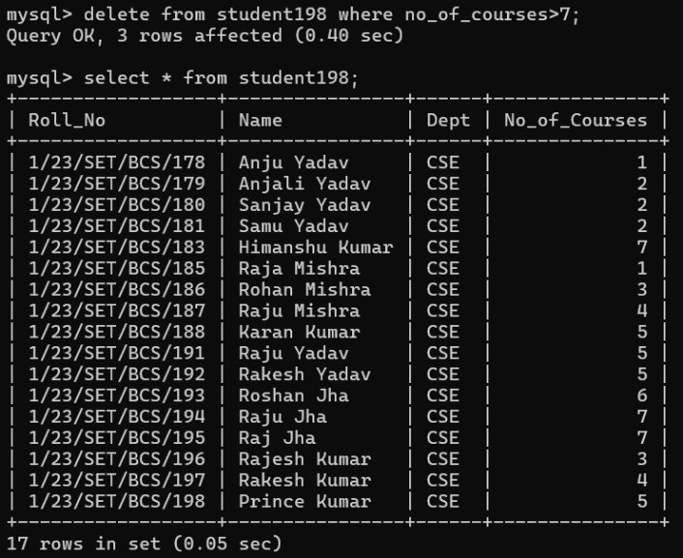

Deleting all the rows of table:

Command = truncate table student198;

Check : check all the rows by using command = select * from student198;

Result : You will get empty set if all rows are deleted.

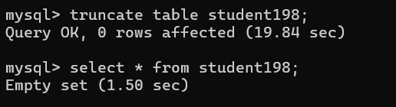

Deleting the whole table:

Command: drop table student198;

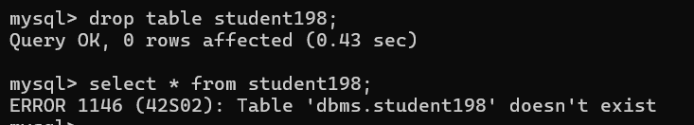

Creating table student198;

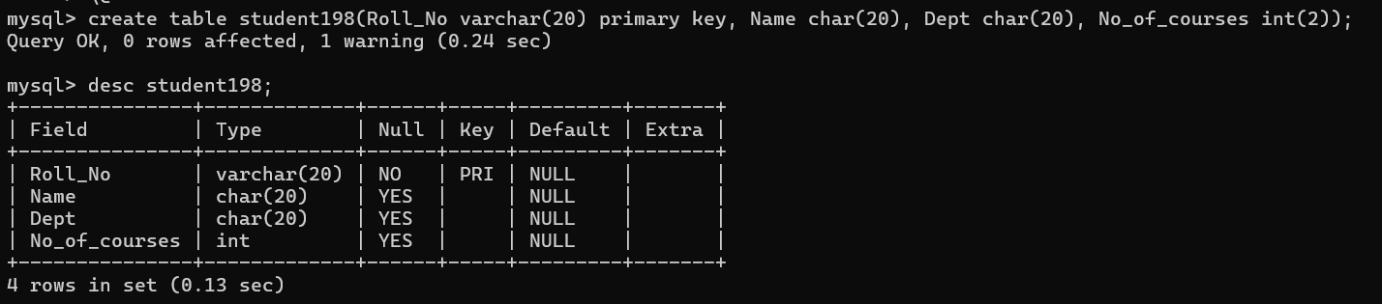Command: create table student198(Roll_No varchar(20) primary key, Name char(20), dept char(20) , No_of_courses int(2));