A Project Report on

TITLE OF THE PROJECT
Submitted in partial fulfillment of the requirements for the award of the degree of

BACHELOR OF TECHNOLOGY

In

COMPUTER SCIENCE AND ENGINEERING

Submitted by

Name 1 (Regd. no 1)

Name 2 (Regd. no 2)

Name 3 (Regd. no 3)

Name 4 (Regd. No 4)

Under the esteemed supervision of Mr. XXXX _{M.Tech., (Ph.D.)}
Associate Professor
Department of Computer Science and Engineering



Department of Computer Science & Engineering

ADITYA COLLEGE OF ENGINEERING (A)
(Affiliated to JNTUK, Kakinada & Approved by AICTE, New Delhi and accredited by NBA & NAAC)
Surampalem, ADB road, Kakinada District, A.P-533437 (2023-2024)

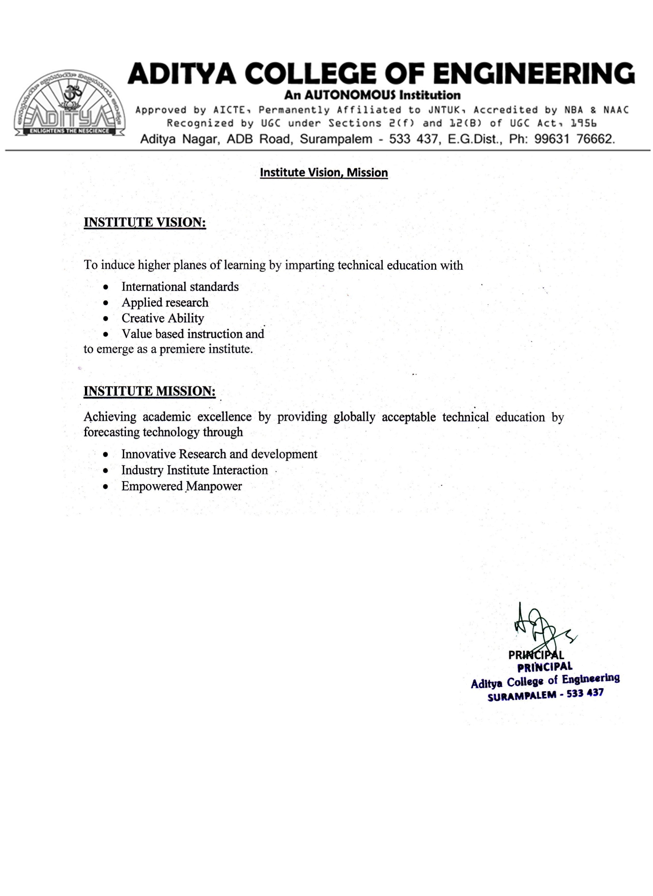

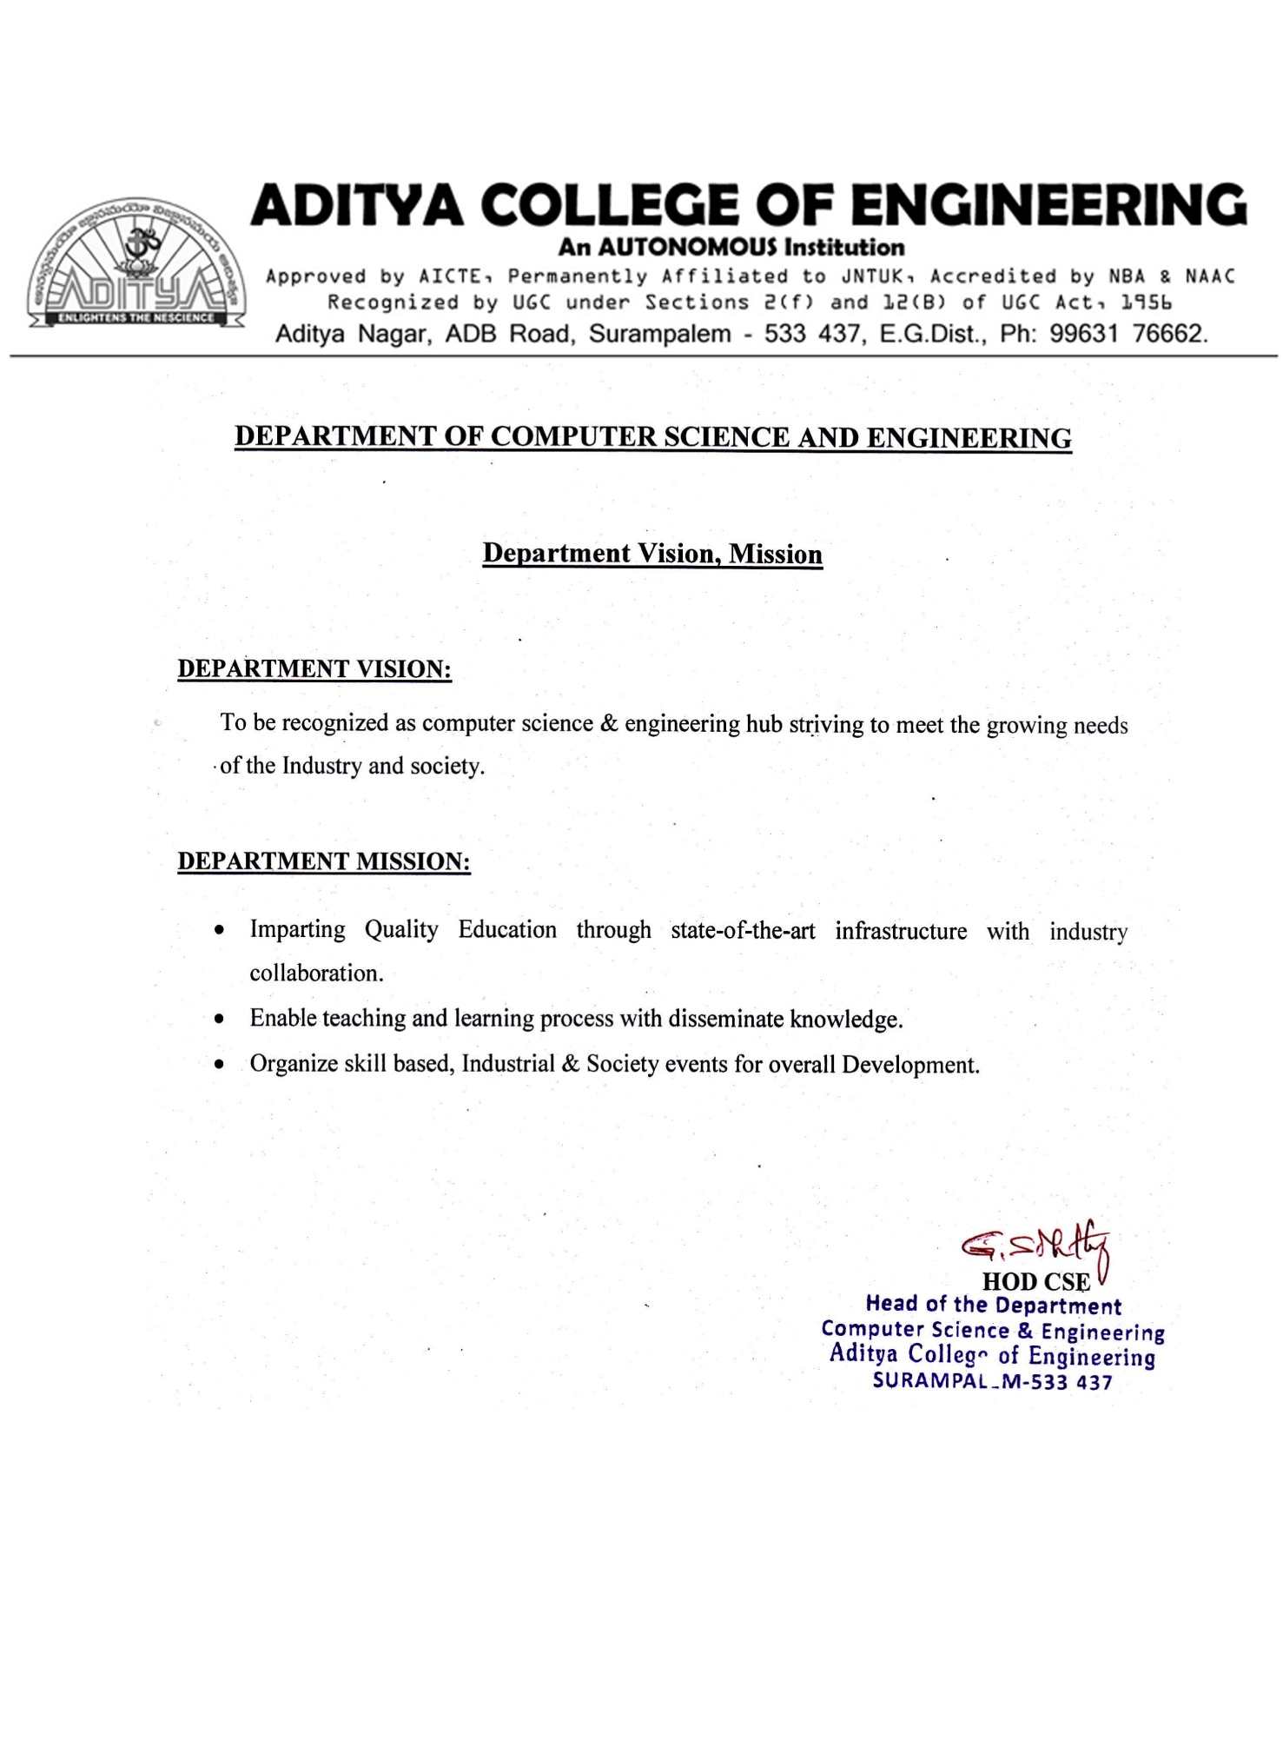

ADITYA COLLEGE OF ENGINEERING (A)
(Affiliated to JNTUK, Kakinada & Approved by AICTE, New Delhi and accredited by NBA & NAAC)
Surampalem, ADB road, Kakinada District, A.P-533437.

Department of Computer Science and Engineering

CERTIFICATE

This is to certify the project report entitled (Detection and Classification of Friut diseases using Image Processing) is a bonified work carried out by T.Raviteja bearing with reg No: 20MH5A0511, K.Gayathri bearing with reg No: 19MH1A0522, V.D.R.K.Reddy bearing with reg No: 20MH5A0512, V.V.Akhilesh bearing with reg No: 19MH1A0557 at the college for the award of Bachelor of Technology in COMPUTER SCIENCE AND ENGINEERING from ADITYA COLLEGE OF ENGINEERING during the academic year of 2019-2023..

Project Guide Head of the Department
Mr XXX M.Tech.,(Ph.D.) Dr.G.S.N.Murthy .
Dept. Of CSE Dept. Of CSE

Associate Professor Professor

EXTERNAL EXAMINER

DECLARATION

We hereby declare that this project entitled "Detection and Classification of Fruit Diseases using Image Processing" has been undertaken by us and this work has been submitted to ADITYA COLLEGE OF ENGINEERING, Surampalem affiliated to JNTUK, Kakinada, in partial fulfillment of the requirements for the award of the degree of BACHELOR OF TECHNOLOGY in COMPUTER SCIENCE AND ENGINEERING.
We further declare that this project work has not been submitted in full or part to any other University or educational institute for the award of any degree or diploma.

PROJECT ASSOCIATES

T.Raviteja (20MH5A0511)

K.Gayathri (19MH1A0522)

V.D.R.K.Reddy V.V.Akhilesh
(20MH5A0512) (19MH1A0557)

ACKNOWLEDGEMENT

It is with immense pleasure that we would like to express our indebted gratitude to my project supervisor, Mr. S. Chittibabulu, M.Tech.,(Ph.D.) who has guided us a lot and encouraged us in every step of project work, his valuable moral support and guidance has been helpful in successful completion of this Project.
We wish to express our sincere thanks to Dr. G S N MURTHY , Head of the Department of CSE, for his valuable guidance given to us throughout the period of the project work.
We feel elated to thank Dr A. Ramesh, Principal of Aditya College of Engineering for his cooperation in completion of our project and throughout our course.
We feel elated to thank Dr. P.S.V.V.S. Ravi Kumar, Dean (Academics & Administration) of Aditya College of Engineering for his cooperation in completion of our project work.
We wish to express our sincere thanks to all faculty members, and lab programmers for their valuable guidance given to us throughout the period of the project.
We avail this opportunity to express our deep sense and heart full thanks to the Management of Aditya College of Engineering for providing a great support for us by arranging the trainees, and facilities needed to complete our project and for giving us the opportunity for doing this work.

PROJECT ASSOCIATES

T.Raviteja (20MH5A0511)

K.Gayathri (19MH1A0522)

V.D.R.K.Reddy V.V.Akhilesh
(20MH5A0512) (19MH1A0557)

ABSTRACT

Early diagnosis of fruit diseases is crucial because of the potential impact on the agriculture sector. In this work, we focus on using Image Processing to detect and analyse fruit illnesses that are present in plant regions, as well as to save data about agricultural fields and characteristics in a database, from which it can be retrieved. Environmental factors, mineral levels, insect populations, and other external influences all contribute to an increase in fruit illnesses. In plants, most of the leaves and fruits are affected by diseases due to bacteria and virus. This technique is used to determine the infection on fruits of the plants.
In order to generate an automated database to examine the infections using proposed method. The database consists of data related to fruit conditions and the symptoms of disease to be affected. Image processing and Machine learning K-Means and SVM algorithms are used to identify and catalogue the information gathered in the plant area.

INDEX
CHAPTER | PAGE NO
ABSTRACT | 7
1. INTRODUCTION | 12
1.1 Existing System | 12
1.1.1 Drawback | 12
1.2 Proposed System | 12
1.3 Novelty of Proposed System | 13
2. REQUIREMENT ANALYSIS | 14
2.1 Functional Requirements | 14
2.2 Non-Functional Requirements | 14
2.2.1 User Interface and Human Factors | 14
2.2.2 Software Requirements | 14
2.2.3 Hardware Requirements | 14
2.2.4 Usability | 15
2.2.5 Reliability | 15
2.2.6 Performance | 15
2.2.7 Supportability | 15
2.2.8 Physical Environment | 16
2.2.9 Security Requirements | 16
2.2.10 Resource Requirement | 16
3. LITERATURE SURVEY | 17-19
4. SYSTEM ANALYSIS | 20
4.1 Introduction | 20
4.2 Use Cases | 20
4.2.1 Actors | 21
4.2.2 List of use cases | 22

4.3.3 Use case diagrams 23
- SYSTEM DESIGN 24
Introduction 24
System Architecture 24
System Object Model 25
Introduction 25
Subsystems 25
Object Description 26
Objects 26
Class Diagrams 26
Dynamic Model 26
Sequence Diagrams 27
Activity Diagrams 27-28
Static Model 28
Component Diagrams 28-29
Deployment Diagrams 29
- IMPLEMENTATION 30
Software environment 30
Overview of Python 30-41
Overview of Machine learning 42-45
Modules used in project 46-47
Source Code 48-53
- TESTING 54
Software testing 54
Types of testing 54-56
- SCREENSHOTS OF OUTPUT 57-64
- CONCLUSION 65
- BIBLIOGRAPHY 66

LIST OF FIGURES

S.No. | NAME OF FIGURE | PAGE No.
1 | Use case diagram | 23
2 | System Architecture | 24
3 | System object model | 25
4 | Class diagram | 26
5 | Sequence diagram | 27
6 | Activity diagram | 28
7 | Component diagram | 29
8 | Deployment diagram | 29
9 | Black box testing for ML algorithms | 56

LIST OF TABLES

S.No. | NAME OF TABLE | PAGE No.
1 | List of use cases and actors associated | 22
2 | Use cases and descriptions | 22
3 | Black box testing example | 56

INTRODUCTION

Every civilization has relied on agriculture as its foundation. It is crucial to remember that more than 60% of India's population relies on agriculture for their survival. The spread of illnesses is a common factor in the decline in modern agriculture's ability to produce crops, fruits, and vegetables. The disease has become a serious issue in a farming community. Diseases caused by bacteria and viruses harm many plant parts, including the leaves and fruits. The goal of this method is to establish the plant illness that spreads to the leaves, fruits, and stems. Create an automated database to study infections with the proposed method. The database contains information about plant leaves, fruit conditions, and disease signs. Information on the specifics and identification of the fruit symptoms of the disease detected using feature extraction. The image is compared to every single one in the database. The cell phone An application is created to handle the data and notify the farmers. So the difference in image quality between database images is an indication of fruit illness.

Existing System

As far as the correlation with the target variable ‘total cases’ is concerned, there was no obvious correlation to be found

Drawback
Farmers are using sensors and soil sampling to collect data and this data is stored on-farm management systems that allow for better processing & analysis

Proposed System

The classification and segmentation of fruit images were performed using K- Means Algorithm and SVM technique. The various features of few fruits were initially extracted and segment the respective images. After comparison with feature values, the various disease names are analysed and the optimal disease for the image is identified and the disease is indicated by an alert box and can be provided as the message through the application.

Novelty of Proposed System

Agriculture is becoming digital, AI in agriculture is emerging in three major categories which are agricultural robotics, soil & crop monitoring, and predictive analytics,.
The various features of few fruits were initially extracted and segment the respective images. After comparison with feature values, the various disease names are analysed and the optimal disease for the image is identified and the disease is indicated by an alert box and can be provided as the message through the application.

REQUIREMENT ANALYSIS

Funtional Requirements

    - Data Collection:Collect sufficient data samples and legitimate software samples.

    - Data Preporcessing:Perform effective data processing on the sample and extract the features.

    - Train and Test Modelling: Split the data into train and test data Train will be used for training the model and Test data to check the performace

    - Feature Selection:Further select the main features for classification

    - Modelling: SVM, K-means. Combine the training using machine learning algorithms and establish a classification model.

Non-Functional Requirements

User Interface and Human Factors

To insert the data set and to test and train the data we require human factor. Humans are required to insert the image. This is achieved through a user interface to interact with human factor for insertion of fruit disease image for training and testing on the data.

Software Requirements

      - Python idle 3.7 version (or)
      - Anaconda 3.7
      - Operating system : Windows

Hardware Requirements
- Processor : Minimum intel i3
- RAM : Minimum 4 GB
- Hard disk : Minimum 250GB

Usability

The system must be simple to use in terms of user interface and must avoid any complexity. It should be capable of having minimum interaction with the user to avoid much manual work, but at the same time should provide the best results possible. It should not take much time on processing or should stuck at many moments. In simple terms it should satisfy user needs with simplicity in terms of usability.

Reliability

The system must be reliable, it should not lead to unnecessary crashes and shouldn’t stuck at most cases of errors when occur, it should have good exception handling mechanisms. The system should perform well in critical situations to provide user most friendly experience in terms of handling the system with little or less failures.

Performance

The system or software designed shouldn’t slow down while performing. The system should be fast enough to produce results. Additionally, it should be able to perform well in case of more workloads. This attribute determines the overall functionality of the system in terms of resource consumption, response time and efficiency.

Supportability

This type of non-functional is concerned with characteristics such as maintainability, scalability of the solution. This includes considerations for the ability of the solution to be easily modified to accommodate enhancements and repairs.

Physical Environment

The environment includes external factors that impact how your system performs. For example, light condition, background, etc., may affect the speed or reliability of an application.

Security Requirements

Security is one of the most important non-functional requirements while building a system. Application handling user data or some other sensitive data should be responsible to handle and store it in most secure manner so that it should not fall in nefarious minds. It can be achieved by using passwords, key generations, account locking or biometric requirements.

Resource Requirements

Resource Requirements should be defined by the Project manager to establish the resources needed to execute work on the project

LITEARTURE SURVEY

Asha R.PatilVarshaI.Patil, B.S.Panchbhai, “Detection of Plant Diseases Using Image Processing Tools”. Asha R. PatilVarshaI.Patil. Int. Journal of Engineering Research and Application ISSN : 2248-9622, Vol. 7, Issue 4, ( Part - 2) April 2017, pp.44-45.
Analysis of plants disease is main goal for increase productivity of grain, fruits, vegetable. Detection of proper disease of plants using image processing is possible by different steps of it. Like image Acquisition, image enhancement, segmentation, feature extraction, and classification.RGB image is acquire and translate for processing and diagnosis of plant disease by CR-Network. Segmentation is used for which and how many areas are affected by disease using k-clustering. Future extraction by HOG algorithm, SOFM Classification is used for healthy and unhealthy plants.

Pratik Agarwal, “AGROCLOUD-Open surveillance of Indian Agriculture via cloud”2016.International Conference on Information Technology(InCITe)- The Next Generation IT Summit.
The Indian agriculture desperately is lagging behind in per hectare yield in almost all crops in comparison to other countries with respect to the population that is needed to be fed. The use of technology in agriculture may help in increasing the productivity and may improve the condition of Indian farmers and protection of their product. The major problem of Indian agriculture is of providing information to the farmers and storing the crop related information at some place for analyzing later. The present paper illustrates a scheme of keeping records on the progress of agriculture, its production and farmers in India, via Cloud, exclusively employed for the welfare of the farmer society and the agricultural practices, GDP, and the cloud being open to general public as well, for studies, and process transparency. The Indian agriculture desperately is lagging behind in per hectare yield in almost all crops in comparison to other countries with respect to the population that is needed to be fed. The use of technology in agriculture may help in increasing the productivity and may improve the condition of Indian farmers and protection of their product. The major problem of Indian agriculture is of providing information to the farmers and storing the crop related information at some place for analyzing later.

The present paper illustrates a scheme of keeping records on the progress of agriculture, its production and farmers in India, via Cloud, exclusively employed for the welfare of the farmer society and the agricultural practices, GDP, and the cloud being open to general public as well, for studies, and process transparency.

- Athmaja S1, Hanumanthappa M2, “Applications of Mobile Cloud Computing and Big Data Analytics in Agriculture Sector- A Survey”. International Journal of Advanced Research in Computer and Communication Engineering ICRITCSA M S Ramaiah Institute of Technology, Bangalore Vol. 5, Special Issue 2, October 2016. The objective of this literature survey was to identify the applications of Mobile Cloud Computing and Big Data Analytics techniques in the agriculture sector. Related literature from IEEE journals and other International journals were collected and reviewed. A conclusion is made by proposing a new model that uses mobile cloud computing and big data analytics techniques together to meet several challenges that the farmers are facing today in the agriculture sector. The proposed model helps farmers in making optimal decisions on their agricultural production and thereby reducing the post-harvest wastage of their products.

Wang-Su Jeon1 and Sang-Yong Rhee,”Plant Leaf Recognition Using a Convolution Neural Network”International Journal of Fuzzy Logic and Intelligent Systems Vol. 17, No. 1, March 2017, pp. 26-34
There are hundreds of kinds of trees in the natural ecosystem, and it can be very difficult to distinguish between them. Botanists and those who study plants however, are able to identify the type of tree at a glance by using the characteristics of the leaf. Machine learning is used to automatically classify leaf types. Studied extensively in 2012, this is a rapidly growing field based on deep learning. Deep learning is itself a self-learning technique used on large amounts of data, and recent developments in hardware and big data have made this technique more practical. We propose a method to classify leaves using the CNN model, which is often used when applying deep learning to image processing.

- Li Tan1,2†,Hongfei Hou1,Qin Zhang2.“An Extensible Software Platform for Cloud-based Decision Support and Automation in Precision Agriculture”.2016 IEEE 17th International Conference on Information Reuse and Integration. Precision agriculture is a data-driven farming practice that uses intra-and inter-field information to optimize farming operations. The "brain" of precision agriculture is a decision support system (DSS) that acquires data from various sources, analyzes them, and recommends actions to farmers. Recently cloud computing has been used to improve the scalability and reliability of a DSS. Cloud-based DSSs present some major challenges for software design:(1) how can a cloud-based DSS process a diversified profile of intra-and/or inter-field data from various sources? (2) how can a cloud-based DSS accommodate and support the diversity of farming operations? (3) how can a cloud-based DSS automate the entire decision process and control field devices directly? we proposed an extensible cloud-based software platform that integrated 3 novel components to address these questions: (1) a meta-model-based data acquisition and integration module that accepts data in different formats and semantics, (2) an adaptive software architecture supporting on-the-fly re- configuration of decision modules, and (3) software-defined control, a new software design paradigm we proposed for handling control diversity. It enables a DSS to control various field devices through unified software-defined interfaces. We implemented the platform in Agrilaxy, a cloud-based DSS, and deployed it on Amazon Web Services (AWS). An early version of Agrilaxy has been used in a USDA-sponsored project on canopy management for specialty crops.

SYSTEM ANALYSIS

Introduction

Systems analysis is "the process of studying a procedure or business to identify its goal and purposes and create systems and procedures that will efficiently achieve them". Another view sees system analysis as a problem-solving technique that breaks down a system into its component pieces, and how well those parts work and interact to accomplish their purpose. Performing an effective systems analysis often requires experts to have knowledge of a software product's or package's requirements so that they can approach their analysis effectively. There are several ways to analyze a system like constructing system usage patterns, performing feasibility analysis, etc. It is required as it-
    - Improves the user experience

    - Reduces errors or inefficiencies

    - Identifies potential issues in code

    - Helps businesses improve their systems time to time

Use Cases

Use case diagrams are usually referred to as behavior diagrams used to describe a set of actions (use cases) that some system or systems (subject) should or can perform in collaboration with one or more external users of the system (actors). A use case is a methodology used in system analysis to identify, clarify, and organize system requirements.

The use case is made up of a set of possible sequences of interactions between systems and users in a particular environment and related to a particular goal. It consists of a group of elements (for example, classes and interfaces) that can be used together in a way that will have an effect larger than the sum of the separate elements combined.

The use case should contain all system activities that have significance to the users. A use case can be thought of as a collection of possible scenarios related to a particular goal, indeed, the use case and goal are sometimes considered to be synonymous. The main purpose of a use case diagram is to show what system functions are performed for which actor.

Actors

Actors represent roles which may include human users, external hardware, or other systems. Our proposed system is quite simple in terms of user interface. It is only having two actor’s user and the system.
Following are the actors in our project-

      - User 
User is the actor who can enter into the system by entering login details for testing the diseases of fruit using images.

      - System
System is an actor that interacts with the user. The system will perform several actions like user verification , displaying messages to the user.

      - Admin

Admin can do training, run machine learning algorithms and testing on the dataset.

List of use cases

Use case name | Actors
Login | User and Admin
Upload Dataset | Admin
Process Dataset Features | Admin
Run all Machine Learning Algorithms | Admin
Average ranking graph | Admin
Upload image and test | User
Display output | System
Table 4.1 List of use cases and actors associated with

Use case name | Description
Login | The user can login into the system
Upload Dataset | The dataset is uploaded by the Admin
Process dataset features | Different features are extracted
Run all ML algorithms | After features extraction, the system should run the algorithms
Average ranking graph | A graph is produced based on classification
All train graph | The user can select the parking slot if it is available
Upload image and test | User is tests the disease of the fruit by uploading the image
Display output | The system displays the output

` Table 4.2 Use cases and descriptions

4.3.3 Use case diagrams

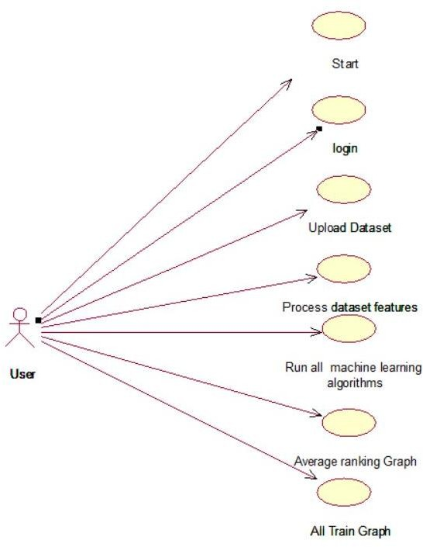

Fig. 4.1 Use case diagram

SYSTEM DESIGN

Introduction

In System Design has divided into three types like GUI Designing, UML Designing with avails in development of project in facile way with different actor and its utilize case by utilize case diagram, flow of the project utilizing sequence, Class diagram gives information about different class in the project with methods that have to be utilized in the project if comes to our project our UML Will utilizable in this way The third and post import for the project in system design is Data base design where we endeavor to design data base predicated on the number of modules in our project.

System Architecture

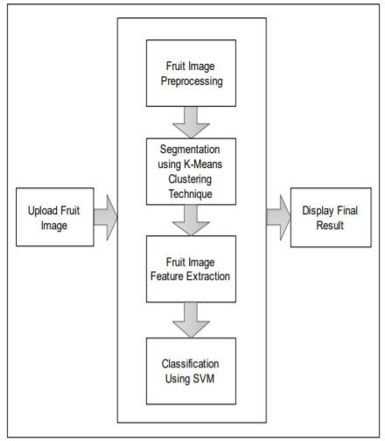

Fig.5.1.System Architecture

System Object Model

Introduction
System Object Model was intended to be used as a solution to many of the interoperability and reuse problems that occur while sharing class libraries between object-oriented and non-object-oriented languages. SOM allows for the creation of portable shrink-wrapped libraries. The class libraries can be created in a particular language, which can be accessed and used by other languages.
In the modelling of system object, we are using different.
Uploaded image
Predict disease
Run algorithm s

Fig. 5.2 System object model

Subsystems

Subsystem is an additional design in the system architecture to make the process of users interacting with the application in a friendlier and more interactive manner. This generally involves entering simple user details while checking for liveness detection of a person. This subsystem has nothing to do with the main objective of the project.

Object Description

Objects
Objects play an important role in system design for any kind of software. Object basically refers to the runtime entity of class variable with proper functionalities and properties. Properties refer to the attributes and functionalities refers to the operations. Objects have relation among themselves for combinational working. The project proposed contains two objects as described below.
      - User Registration: This object contains properties regarding user registration and functionality to give clinical features for input to the system .
      - System verification: This object contains functionality of verifying whether user, given clinical features is existed in the database and run the model for disease name.

Class Diagrams

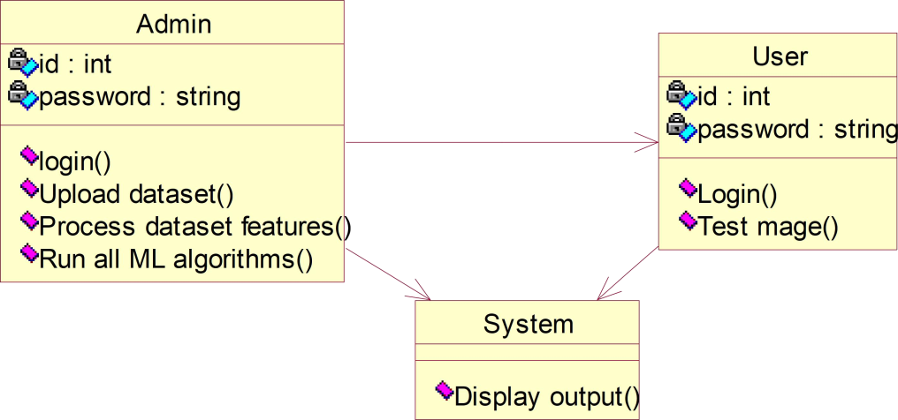

Fig. 5.3 Class diagram

Dynamic Model

The dynamic model is used to express and model the behavior of the system over time. It includes support for activity diagrams, state diagrams, sequence diagrams and extensions including business process modelling.

Sequence Diagram

Sequence diagrams are used to display the interaction between users, screens, objects, and entities within the system. It provides a sequential map of message passing between objects over time.
Sytem
User

Admin
Sytem
User

Login
Admin
All train graph

Process Dataset features

Run all ML algorithms
Upload Dataset
Login successful
Login
Display Output
Test Image
Login Successful

Fig.5.4 Sequence diagram

Activity diagrams

An activity diagram is basically a flowchart to represent the flow from one activity to another activity. The activity can be described as an operation of the system. The control flow is drawn from one operation to another. This flow can be sequential, branched, or concurrent. The flow carries from the starting of an activity to end of an activity, it performs different types of operations through the flow that are shown.

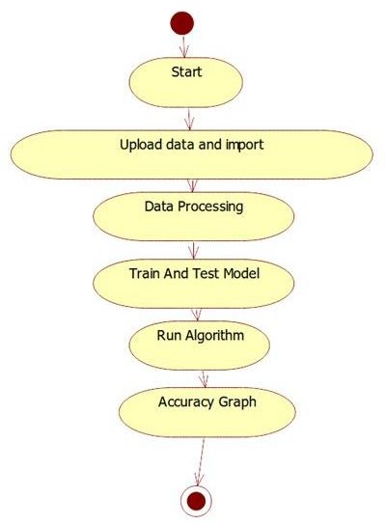
Fig.5.5 Activity diagram

Static Model

A static model defines the classes in the system, the attributes of the classes, the relationships between classes, and the operations of each class. The static model represents the relations between real-world objects in analysis and design, including their attributes and operations.

Component diagram
The component diagram for active liveness detection system is an illustration of how the system components work together to make the system operate correctly. It shows how the software’s parts are organized and how they depend on each other. This diagram also gives a high-level look at the parts of a system.

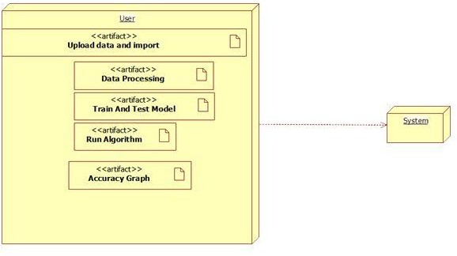

Fig.5.6 Component diagram

Deployment Diagrams

A deployment diagram is a UML diagram type that shows the execution architecture of a system, including nodes such as hardware or software execution environments, and the middleware connecting them.
Deployment diagrams are typically used to visualize the physical hardware and software of a system. Using it you can understand how the system will be physically deployed on the hardware

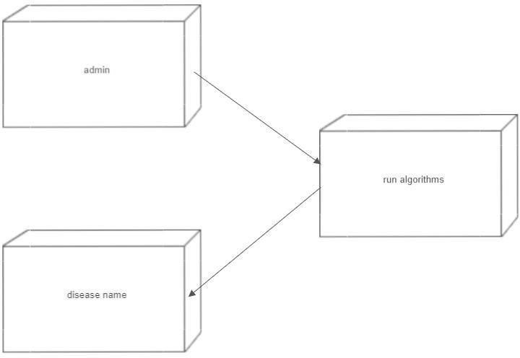

Fig.5.7 Deployment diagram

IMPLEMENTATION

Software Environment:

Overview of Python What is Python :-
Below are some facts about Python.

Python is currently the most widely used multi-purpose, high-level programming language.
Python allows programming in Object-Oriented and Procedural paradigms. Python programs generally are smaller than other programming languages like Java.
Programmers have to type relatively less and indentation requirement of the language, makes them readable all the time.
Python language is being used by almost all tech-giant companies like – Google, Amazon, Facebook, Instagram, Dropbox, Uber… etc.
The biggest strength of Python is huge collection of standard library which can be used for the following –
- Machine Learning
- GUI Applications (like Kivy, Tkinter, PyQt etc. )
- Web frameworks like Django (used by YouTube, Instagram, Dropbox)
- Image processing (like OpenCV, Pillow)
- Web scraping (like Scrapy, BeautifulSoup, Selenium)
- Test frameworks
- Multimedia

Advantages of Python :-

Extensive Libraries

Python downloads with an extensive library and it contain code for various purposes like regular expressions, documentation-generation, unit-testing, web browsers, threading, databases, CGI, email, image manipulation, and more. So, we don’t have to write the complete code for that manually.

Extensible

As we have seen earlier, Python can be extended to other languages. You can write some of your code in languages like C++ or C. This comes in handy, especially in projects.

Embeddable

Complimentary to extensibility, Python is embeddable as well. You can put your Python code in your source code of a different language, like C++. This lets us add scripting capabilities to our code in the other language.

Improved Productivity

The language’s simplicity and extensive libraries render programmers more productive than languages like Java and C++ do. Also, the fact that you need to write less and get more things done.

IOT Opportunities

Since Python forms the basis of new platforms like Raspberry Pi, it finds the future bright for the Internet of Things. This is a way to connect the language with the real world.

Simple and Easy

When working with Java, you may have to create a class to print ‘Hello World’. But in Python, just a print statement will do. It is also quite easy to learn, understand, and code. This is why when people pick up Python, they have a hard time adjusting to other more verbose languages like Java.

Readable

Because it is not such a verbose language, reading Python is much like reading English. This is the reason why it is so easy to learn, understand, and code. It also does not need curly braces to define blocks, and indentation is mandatory. This further aids the readability of the code.

Object-Oriented

This language supports both the procedural and object-oriented programming paradigms. While functions help us with code reusability, classes and objects let us model the real world. A class allows the encapsulation of data and functions into one.

Free and Open-Source

Like we said earlier, Python is freely available. But not only can you download Python for free, but you can also download its source code, make changes to it, and even distribute it. It downloads with an extensive collection of libraries to help you with your tasks.

Portable

When you code your project in a language like C++, you may need to make some changes to it if you want to run it on another platform. But it isn’t the same with Python. Here, you need to code only once, and you can run it anywhere. This is called Write Once Run Anywhere (WORA). However, you need to be careful enough not to include any system-dependent features.

Advantages of Python over Other Languages

Less Coding

Almost all of the tasks done in Python requires less coding when the same task is done in other languages. Python also has an awesome standard library support, so you don’t have to search for any third-party libraries to get your job done. This is the reason that many people suggest learning Python to beginners.

Affordable

Python is free therefore individuals, small companies or big organizations can leverage the free available resources to build applications. Python is popular and widely used so it gives you better community support.

The 2019 Github annual survey showed us that Python has overtaken Java in the most popular programming language category.

Python is for Everyone

Python code can run on any machine whether it is Linux, Mac or Windows. Programmers need to learn different languages for different jobs but with Python, you can professionally build web apps, perform data analysis and machine learning, automate things, do web scraping and also build games and powerful visualizations. It is an all-rounder programming language.

Disadvantages of Python

Let’s now see the downsides of choosing Python over another language.

Speed Limitations

We have seen that Python code is executed line by line. But since Python is interpreted, it often results in slow execution. This, however, isn’t a problem unless speed is a focal point for the project. In other words, unless high speed is a requirement, the benefits offered by Python are enough to distract us from its speed limitations.

Weak in Mobile Computing and Browsers

While it serves as an excellent server-side language, Python is much rarely seen on the client-side. Besides that, it is rarely ever used to implement smartphone-based applications. One such application is called Carbonnelle.
The reason it is not so famous despite the existence of Brython is that it isn’t that secure.

Design Restrictions

As you know, Python is dynamically-typed. This means that you don’t need to declare the type of variable while writing the code. It uses duck-typing. But wait, what’s that? Well, it just means that if it looks like a duck, it must be a duck. While this is easy on the programmers during coding, it can raise run-time errors.

Underdeveloped Database Access Layers

Compared to more widely used technologies like JDBC (Java DataBase Connectivity) and ODBC (Open DataBase Connectivity), Python’s database access layers are a bit underdeveloped. Consequently, it is less often applied in huge enterprises.

Simple

No, we’re not kidding. Python’s simplicity can indeed be a problem. Take my example. I don’t do Java, I’m more of a Python person. To me, its syntax is so simple that the verbosity of Java code seems unnecessary.

Install Python Step-by-Step in Windows and Mac:

Python a versatile programming language doesn’t come pre-installed on your computer devices. Python was first released in the year 1991 and until today it is a very popular high-level programming language. Its style philosophy emphasizes code readability with its notable use of great whitespace.
The object-oriented approach and language construct provided by Python enables programmers to write both clear and logical code for projects. This software does not come pre-packaged with Windows.

How to Install Python on Windows and Mac:

There have been several updates in the Python version over the years. The question is how to install Python? It might be confusing for the beginner who is willing to start learning Python but this tutorial will solve your query. The latest or the newest version of Python is version 3.7.4 or in other words, it is Python 3.
Note: The python version 3.7.4 cannot be used on Windows XP or earlier devices.

Before you start with the installation process of Python. First, you need to know about your System Requirements. Based on your system type i.e. operating system and based processor, you must download the python version. My system type is a Windows 64-bit operating system. So the steps below are to install python version
3.7.4 on Windows 7 device or to install Python 3. Download the Python Cheatsheet here. The steps on how to install Python on Windows 10, 8 and 7 are divided into 4 parts to help understand better.

Download the Correct version into the system
Step 1: Go to the official site to download and install python using Google Chrome or any other web browser. OR Click on the following link: https://www.python.org

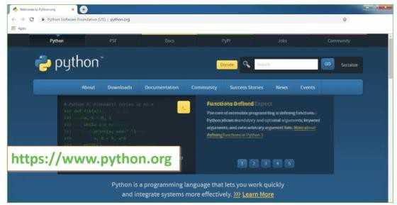

Now, check for the latest and the correct version for your operating system.

Step 2: Click on the Download Tab.

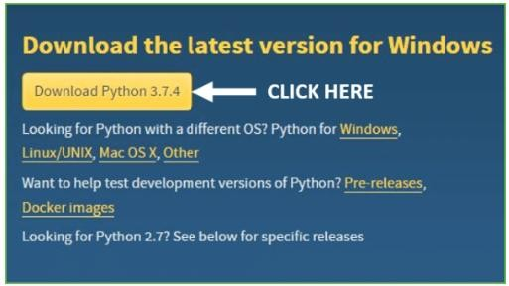

Step 3: You can either select the Download Python for windows 3.7.4 button in Yellow Color or you can scroll further down and click on download with respective to their version. Here, we are downloading the most recent python version for windows 3.7.4

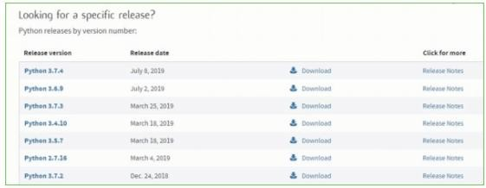

Step 4: Scroll down the page until you find the Files option.

Step 5: Here you see a different version of python along with the operating system.
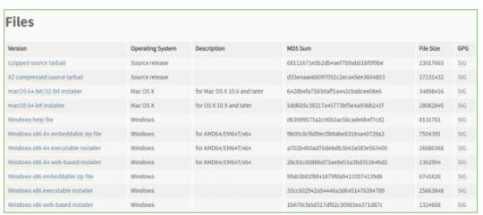

- To download Windows 64-bit python, you can select any one from the three options: Windows x86-64 embeddable zip file, Windows x86-64 executable installer or Windows x86-64 web-based installer.
Here we will install Windows x86-64 web-based installer. Here your first part regarding which version of python is to be downloaded is completed. Now we move ahead with the second part in installing python i.e. Installation
Note: To know the changes or updates that are made in the version you can click on the Release Note Option.

Installation of Python
Step 1: Go to Download and Open the downloaded python version to carry out the installation process.
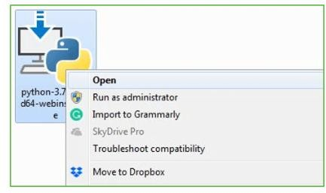

Step 2: Before you click on Install Now, Make sure to put a tick on Add Python 3.7 to PATH.
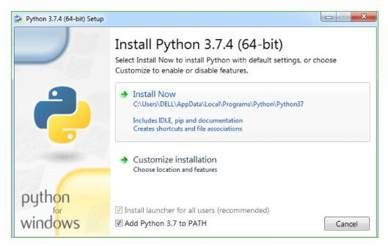

Step 3: Click on Install NOW After the installation is successful. Click on Close.
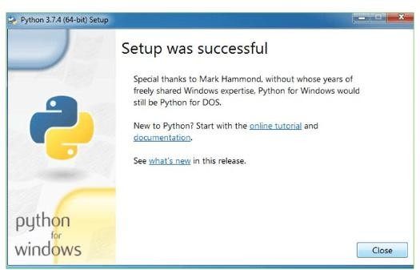

With these above three steps on python installation, you have successfully and correctly installed Python. Now is the time to verify the installation.

Verify the Python Installation
Step 1: Click on Start
Step 2: In the Windows Run Command, type “cmd”
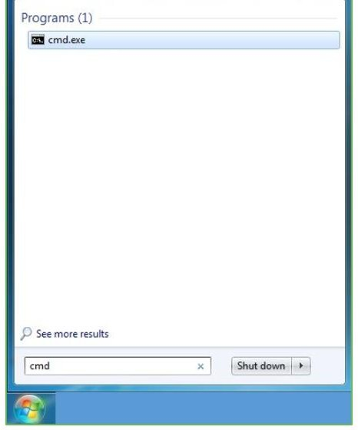

Step 3: Open the Command prompt option.

Step 4: Let us test whether the python is correctly installed. Type python –V and press Enter.
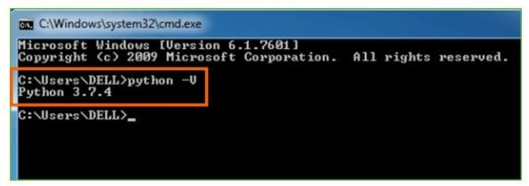

Step 5: You will get the answer as 3.7.4

Note: If you have any of the earlier versions of Python already installed. You must first uninstall the earlier version and then install the new one.

Check how the Python IDLE works Step 1: Click on Start
Step 2: In the Windows Run command, type “python idle”

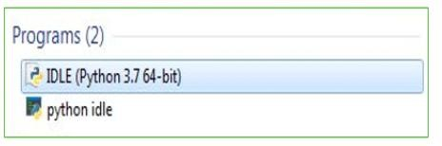
Step 3: Click on IDLE (Python 3.7 64-bit) and launch the program
Step 4: To go ahead with working in IDLE you must first save the file. Click on File > Click on Save

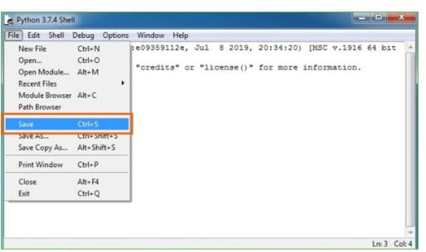

Step 5: Name the file and save as type should be Python files. Click on SAVE. Here I have named the files as Hey World.

Step 6: Now for e.g. enter print (“Hey World”) and Press Enter.

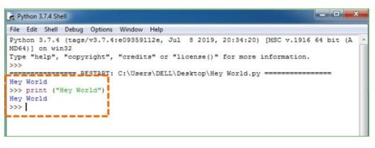

You will see that the command given is launched. With this, we end our tutorial on how to install Python. You have learned how to download python for windows into your respective operating system.
Note: Unlike Java, Python doesn’t need semicolons at the end of the statements otherwise it won’t work.

Overview of Machine Learning

What is Machine Learning : -
Before we take a look at the details of various machine learning methods, let's start by looking at what machine learning is, and what it isn't. Machine learning is often categorized as a subfield of artificial intelligence, but I find that categorization can often be misleading at first brush. The study of machine learning certainly arose from research in this context, but in the data science application of machine learning methods, it's more helpful to think of machine learning as a means of building models of data.

Fundamentally, machine learning involves building mathematical models to help understand data. "Learning" enters the fray when we give these models tunable parameters that can be adapted to observed data; in this way the program can be considered to be "learning" from the data. Once these models have been fit to previously seen data, they can be used to predict and understand aspects of newly observed data. I'll leave to the reader the more philosophical digression regarding the extent to which this type of mathematical, model-based "learning" is similar to the "learning" exhibited by the human brain.Understanding the problem setting in machine learning is essential to using these tools effectively, and so we will start with some broad categorizations of the types of approaches we'll discuss here.

Applications of Machines Learning :-

Machine Learning is the most rapidly growing technology and according to researchers we are in the golden year of AI and ML. It is used to solve many real- world complex problems which cannot be solved with traditional approach. Following are some real-world applications of ML −

- Emotion analysis
- Sentiment analysis
- Error detection and prevention
- Weather forecasting and prediction
- Stock market analysis and forecasting

- Speech synthesis
- Speech recognition
- Customer segmentation
- Object recognition
- Fraud detection
- Fraud prevention
- Recommendation of products to customer in online shopping

Types of Machine Learning
- Supervised Learning – This involves learning from a training dataset with labeled data using classification and regression models. This learning process continues until the required level of performance is achieved.
- Unsupervised Learning – This involves using unlabelled data and then finding the underlying structure in the data in order to learn more and more about the data itself using factor and cluster analysis models.
- Semi-supervised Learning – This involves using unlabelled data like Unsupervised Learning with a small amount of labeled data. Using labeled data vastly increases the learning accuracy and is also more cost- effective than Supervised Learning.
- Reinforcement Learning – This involves learning optimal actions through trial and error. So the next action is decided by learning behaviors that are based on the current state and that will maximize the reward in the future.

Advantages of Machine Learning :

- Easily identifies trends and patterns -

Machine Learning can review large volumes of data and discover specific trends and patterns that would not be apparent to humans. For instance, for an e-commerce website like Amazon, it serves to understand the browsing behaviors and purchase histories of its users to help cater to the right products, deals, and reminders relevant to them. It uses the results to reveal relevant advertisements to them.

No human intervention needed (automation)

With ML, you don’t need to babysit your project every step of the way. Since it means giving machines the ability to learn, it lets them make predictions and also improve the algorithms on their own. A common example of this is anti-virus software’s they learn to filter new threats as they are recognized. ML is also good at recognizing spam.

Continuous Improvement

As ML algorithms gain experience, they keep improving in accuracy and efficiency. This lets them make better decisions. Say you need to make a weather forecast model. As the amount of data you have keeps growing, your algorithms learn to make more accurate predictions faster.

Handling multi-dimensional and multi-variety data

Machine Learning algorithms are good at handling data that are multi-dimensional and multi-variety, and they can do this in dynamic or uncertain environments.

Wide Applications

You could be an e-tailor or a healthcare provider and make ML work for you. Where it does apply, it holds the capability to help deliver a much more personal experience to customers while also targeting the right customers.

Disadvantages of Machine Learning:

Data Acquisition

Machine Learning requires massive data sets to train on, and these should be inclusive/unbiased, and of good quality. There can also be times where they must wait for new data to be generated.

Time and Resources

ML needs enough time to let the algorithms learn and develop enough to fulfill their purpose with a considerable amount of accuracy and relevancy. It also needs massive resources to function. This can mean additional requirements of computer power for you.

Interpretation of Results

Another major challenge is the ability to accurately interpret results generated by the algorithms. You must also carefully choose the algorithms for your purpose.

High error-susceptibility

Machine Learning is autonomous but highly susceptible to errors. Suppose you train an algorithm with data sets small enough to not be inclusive. You end up with biased predictions coming from a biased training set. This leads to irrelevant advertisements being displayed to customers. In the case of ML, such blunders can set off a chain of errors that can go undetected for long periods of time. And when they do get noticed, it takes quite some time to recognize the source of the issue, and even longer to correct it.

Modules Used in Project :-

Tensorflow

Tensor Flow is a free and open-source software library for dataflow and differentiable programming across a range of tasks. It is a symbolic math library, and is also used for machine learning applications such as neural networks. It is used for both research and production at Google.
Tensor Flow was developed by the Google Brain team for internal Google use. It was released under the Apache 2.0 open-source license on November 9, 2015.

Numpy

Numpy is a general-purpose array-processing package. It provides a high- performance multidimensional array object, and tools for working with these arrays.

It is the fundamental package for scientific computing with Python. It contains various features including these important ones:
- A powerful N-dimensional array object
- Sophisticated (broadcasting) functions
- Tools for integrating C/C++ and Fortran code
- Useful linear algebra, Fourier transform, and random number capabilities
Besides its obvious scientific uses, Numpy can also be used as an efficient multi- dimensional container of generic data. Arbitrary data-types can be defined using Numpy which allows Numpy to seamlessly and speedily integrate with a wide variety of databases.

Pandas

Pandas is an open-source Python Library providing high-performance data manipulation and analysis tool using its powerful data structures. Python was majorly used for data mugging and preparation. It had very little contribution

Towards data analysis. Pandas solved this problem. Using Pandas, we can accomplish five typical steps in the processing and analysis of data, regardless of the origin of data load, prepare, manipulate, model, and analyze. Python with Pandas is used in a wide range of fields including academic and commercial domains including finance, economics, Statistics, analytics, etc.

Matplotlib

Matplotlib is a Python 2D plotting library which produces publication quality figures in a variety of hardcopy formats and interactive environments across platforms. Matplotlib can be used in Python scripts, the Python and IPython shells, the Jupyter Notebook, web application servers, and four graphical user interface toolkits. Matplotlib tries to make easy things easy and hard things possible. You can generate plots, histograms, power spectra, bar charts, error charts, scatter plots, etc., with just a few lines of code. For examples, see the sample plots and thumbnail gallery.
For simple plotting the pyplot module provides a MATLAB-like interface, particularly when combined with IPython. For the power user, you have full control of line styles, font properties, axes properties, etc, via an object oriented interface or via a set of functions familiar to MATLAB users.

Scikit – learn

Scikit-learn provides a range of supervised and unsupervised learning algorithms via a consistent interface in Python. It is licensed under a permissive simplified BSD license and is distributed under many Linux distributions, encouraging academic and commercial use.

Source Code:

from tkinter import messagebox from tkinter import *
from tkinter import simpledialog import tkinter
from tkinter import filedialog import matplotlib.pyplot as plt import numpy as np
from tkinter.filedialog import askopenfilename from tkinter.filedialog import askdirectory import cv2
from sklearn.model_selection import train_test_split from sklearn import svm
from sklearn.metrics import accuracy_score from sklearn.metrics import confusion_matrix import random

main = tkinter.Tk()
main.title("DETECTION AND CLASSIFICATION OF FRUIT DISEASES USING IMAGE PROCESSING & CLOUD COMPUTING") #designing
main screen main.geometry("1300x1200")

fruits_disease = ['Black spot', 'Canker', 'Greening', 'healthy', 'scab']

global filename global classifier global X,Y
global X_train, X_test, y_train, y_test

def uploadFruitDataset(): global filename

filename = filedialog.askdirectory(initialdir=".") text.delete('1.0', END) text.insert(END,filename+" loaded\n");

def Preprocessing(): global X,Y
'''
for i in range(len(fruits_disease)):
for root, dirs, directory in os.walk('FruitDataset/'+fruits_disease[i]): for j in range(len(directory)):
img = cv2.imread('FruitDataset/'+fruits_disease[i]+"/"+directory[j]) img = cv2.resize(img,(128,128))
img = cv2.cvtColor(img, cv2.COLOR_BGR2RGB) pixel_vals = img.reshape((-1,3))
pixel_vals = np.float32(pixel_vals)
criteria = (cv2.TERM_CRITERIA_EPS + cv2.TERM_CRITERIA_MAX_ITER, 100, 0.85)
retval, labels, centers = cv2.kmeans(pixel_vals, 6, None, criteria, 10, cv2.KMEANS_RANDOM_CENTERS)
centers = np.uint8(centers) segmented_data = centers[labels.flatten()] X.append(segmented_data.ravel()) Y.append(i)
print('FruitDataset/'+fruits_disease[i]+"/"+directory[j]+" "+str(X[j].shape))
np.save("features/features.txt",X) np.save("features/labels.txt",Y)
'''
X = np.load("features/features.txt.npy") Y = np.load("features/labels.txt.npy")
text.insert(END,"Total preprocess images are : "+str(X.shape[0])+"\n\n")

def featuresExtraction():
global X_train, X_test, y_train, y_test global X,Y
ind = random.randint(0, (len(X) - 1)) img = X[ind].reshape(128,128,3)
cv2.imshow('Image after KMEANS & Feature Extraction',cv2.resize(img,(450,450)))
cv2.waitKey(0)

indices = np.arange(X.shape[0]) np.random.shuffle(indices)
X = X[indices] Y = Y[indices]
X_train, X_test, y_train, y_test = train_test_split(X, Y, test_size = 0.2, random_state = 0)
text.insert(END,"Features Extraction Process Completed\n") text.insert(END,"Total images used to train SVM is :
"+str(X_train.shape[0])+"\n")
text.insert(END,"Total images used to test SVM is : "+str(X_test.shape[0])+"\n\n")

def svmClassifier(): global classifier
cls = svm.SVC(C=12,gamma='scale',kernel = 'rbf', random_state = 0) cls.fit(X, Y)
prediction = cls.predict(X_test)
svm_acc = accuracy_score(y_test,prediction)*100 text.insert(END,"SVM Accuracy : "+str(svm_acc)+"\n") cm = confusion_matrix(y_test, prediction) total=sum(sum(cm))
specificity = cm[1,1]/(cm[1,0]+cm[1,1])
text.insert(END,'SVM Algorithm Specificity : '+str(specificity * 100)+"\n") classifier = cls

def Classification():
name = filedialog.askopenfilename(initialdir="testImages") img = cv2.imread(name)
img = cv2.resize(img,(128,128))
img = cv2.cvtColor(img, cv2.COLOR_BGR2RGB) pixel_vals = img.reshape((-1,3))
pixel_vals = np.float32(pixel_vals)
criteria = (cv2.TERM_CRITERIA_EPS + cv2.TERM_CRITERIA_MAX_ITER, 100, 0.85)
retval, labels, centers = cv2.kmeans(pixel_vals, 6, None, criteria, 10, cv2.KMEANS_RANDOM_CENTERS)
centers = np.uint8(centers) segmented_data = centers[labels.flatten()] temp = [] temp.append(segmented_data.ravel()) temp = np.array(temp)
predict = classifier.predict(temp)[0] img = cv2.imread(name);
img = cv2.resize(img,(500,500)) disease = 'Disease'
if fruits_disease[predict] == 'healthy': disease=''
cv2.putText(img, 'Fruit classify as '+fruits_disease[predict]+" "+disease, (10, 30), cv2.FONT_HERSHEY_SIMPLEX,0.6, (0, 255, 255), 2)
cv2.imshow("Classification Result : "+'Fruit classified as '+fruits_disease[predict]+" "+disease,img)
cv2.waitKey(0)

def close(): main.destroy()

font = ('times', 16, 'bold')

title = Label(main, text='DETECTION AND CLASSIFICATION OF FRUIT DISEASES USING IMAGE PROCESSING & CLOUD COMPUTING')
title.config(bg='deep sky blue', fg='white') title.config(font=font) title.config(height=3, width=120) title.place(x=0,y=5)

font1 = ('times', 12, 'bold') text=Text(main,height=20,width=150) scroll=Scrollbar(text) text.configure(yscrollcommand=scroll.set) text.place(x=50,y=120) text.config(font=font1)

font1 = ('times', 13, 'bold')
uploadButton = Button(main, text="Upload Fruits Dataset", command=uploadFruitDataset)
uploadButton.place(x=50,y=550) uploadButton.config(font=font1)

processButton = Button(main, text="Image Preprocessing & KMEANS Segmentation", command=Preprocessing)
processButton.place(x=250,y=550) processButton.config(font=font1)

featuresButton = Button(main, text="Features Extraction", command=featuresExtraction)
featuresButton.place(x=650,y=550) featuresButton.config(font=font1)

svmButton = Button(main, text="Train SVM Classifier", command=svmClassifier)
svmButton.place(x=50,y=600)

svmButton.config(font=font1)

classifyButton = Button(main, text="Upload Test Image & Classification", command=Classification)
classifyButton.place(x=250,y=600) classifyButton.config(font=font1)

exitButton = Button(main, text="Exit", command=close) exitButton.place(x=650,y=600) exitButton.config(font=font1)

main.config(bg='LightSteelBlue3')

7. TESTING

Software testing

Testing
Testing is a process of executing a program with the aim of finding error. To make our software perform well it should be error free. If testing is done successfully it will remove all the errors from the software.

Types of Testing

      - White Box Testing
      - Black Box Testing
      - Unit testing
      - Integration Testing
      - Alpha Testing
      - Beta Testing
      - Performance Testing and so on

White Box Testing

Testing technique based on knowledge of the internal logic of an application's code and includes tests like coverage of code statements, branches, paths, conditions. It is performedby software developers

Black Box Testing

A method of software testing that verifies the functionality of an application without having specific knowledge of the application's code/internal structure. Tests are based on requirements and functionality.

Unit Testing

Software verification and validation method in which a programmer tests if individual unitsof source code are fit for use. It is usually conducted by the development team.

Integration Testing

The phase in software testing in which individual software modules are

combined and tested as a group. It is usually conducted by testing teams.

Alpha Testing

Type of testing a software product or system conducted at the developer's site. Usually it is performed by the end users.

Beta Testing

Final testing before releasing application for commercial purpose. It is typically done by end- users or others.

Performance Testing

Functional testing conducted to evaluate the compliance of a system or component with specified performance requirements. It is usually conducted by the performance engineer.

Black Box Testing

Blackbox testing is testing the functionality of an application without knowing the details of its implementation including internal program structure, data structures etc. Test cases for black box testing are created based on the requirement specifications. Therefore, it is also called as specification-based testing. Fig.4.1 represents the black box testing:

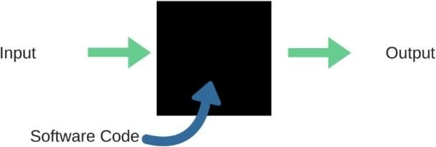

Fig.:Black Box Testing

When applied to machine learning models, black box testing would mean testing machine learning models without knowing the internal details such

as features of the machine learning
model, the algorithm used to create the model etc. The challenge, however, is to verify the test outcome against the expected values that are known beforehand.

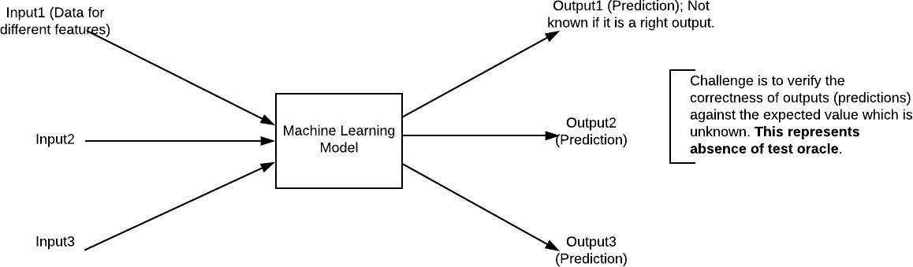

Fig.7.1:Black Box Testing for Machine Learning algorithms

The above Fig.4.2 represents the black box testing procedure for machine learning algorithms.

Table.7.1:Black box Testing

Input | Actual Output | Predicted Output
[16,6,324,0,0,0,22,0,0,0,0,0,0  ] | 0 | 0
[16,7,263,7,0,2,700,9,10,115  3,832,9,2] | 1 | 1

The model gives out the correct output when different inputs are given which are mentioned in Table 4.1. Therefore the program is said to be executed as expected or correct program.

SCREENSHOTS OF OUTPUT



The above screen is the Home page of the project Front-end.

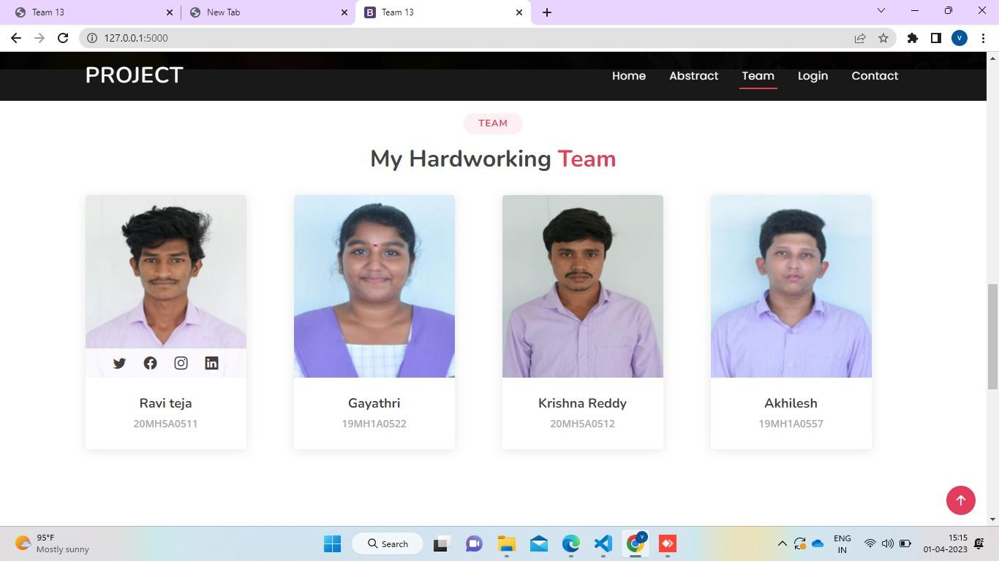

The above screen shows the team of project.

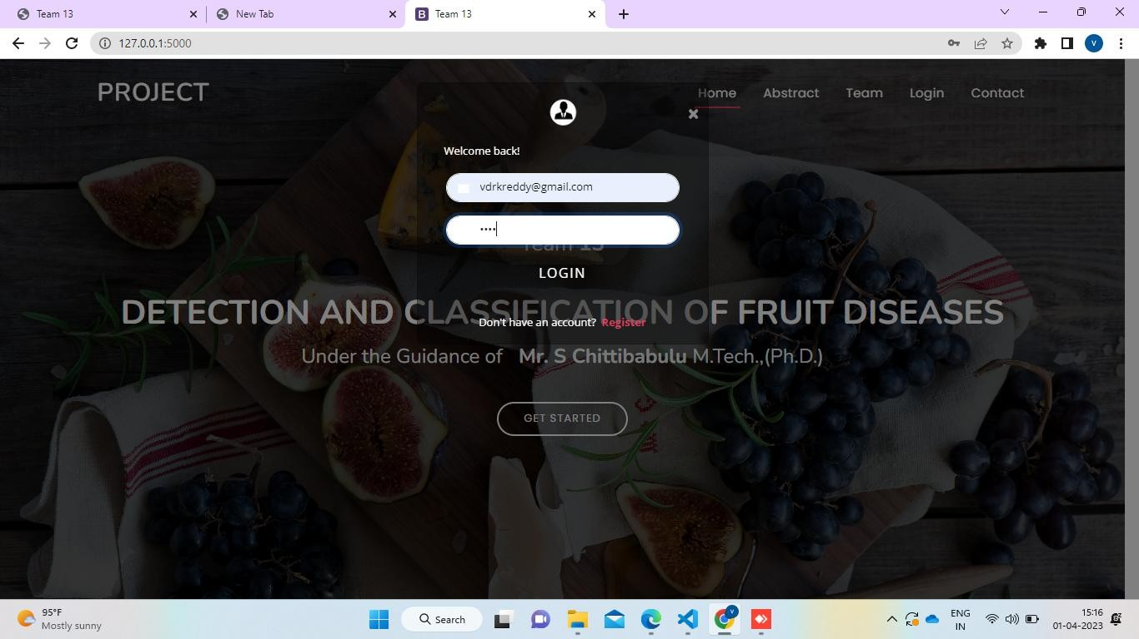

You can also register and login to access the Project data available

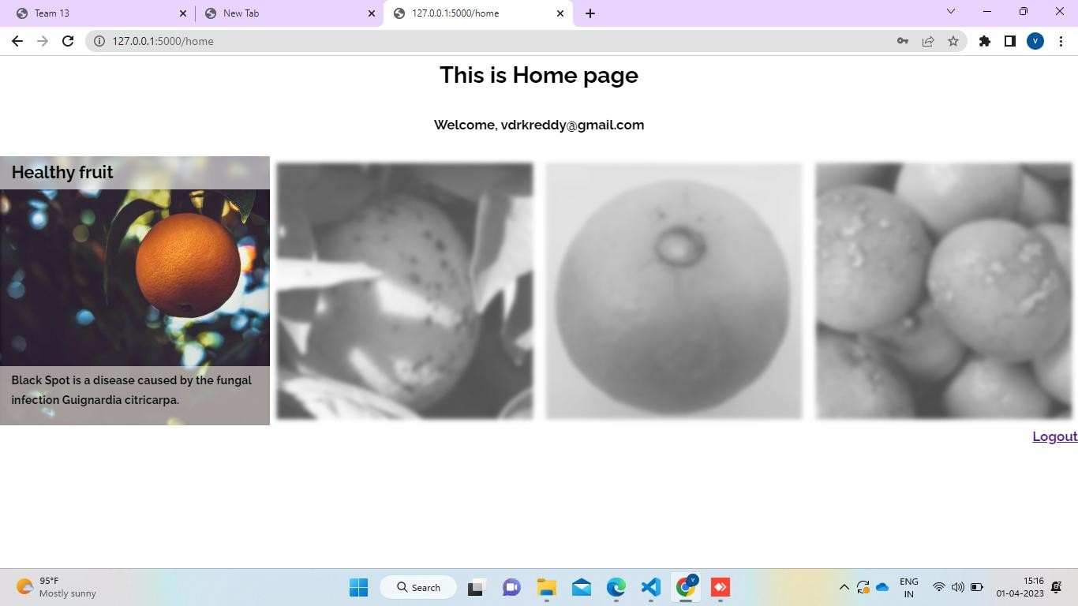
This is the further information available to the user when he registered into account.

This is the actual screen of the project designed by Tkinter.

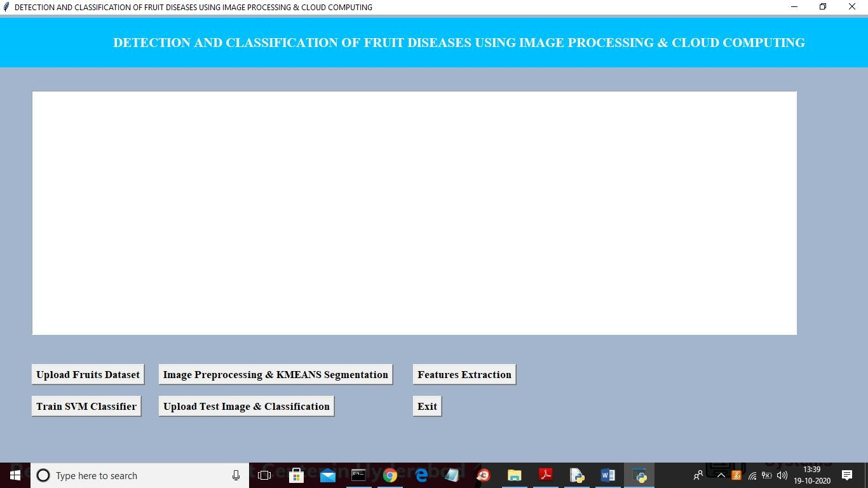

In above screen click on ‘Upload Fruits Dataset’ button and upload dataset

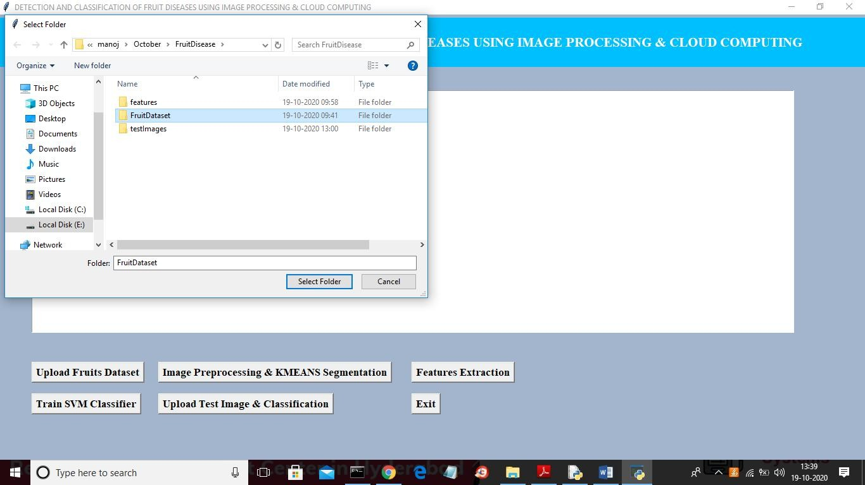
In above screen selecting and uploading ‘FruitDataset’ folder and then click on ‘Select Folder’ button to load dataset and to get below screen

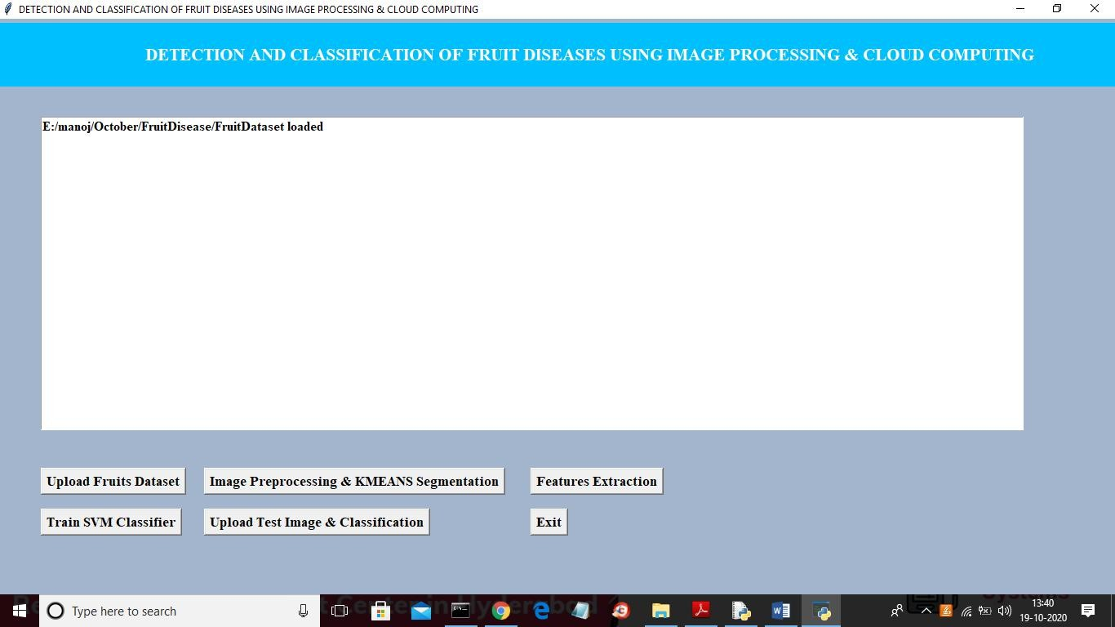
In above screen dataset is loaded and now click on ‘Image Preprocessing & KMEANS Segmentation’ button to read images and to perform segmentation

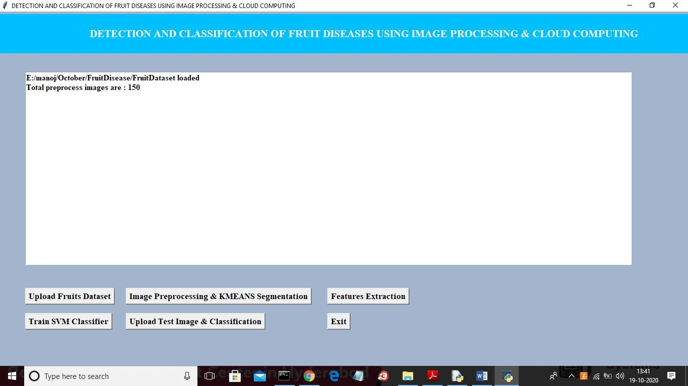
In above screen all 150 images read from dataset and then preprocess and segment it to build train model and now click on ‘Features Extraction’ button to convert image data into features

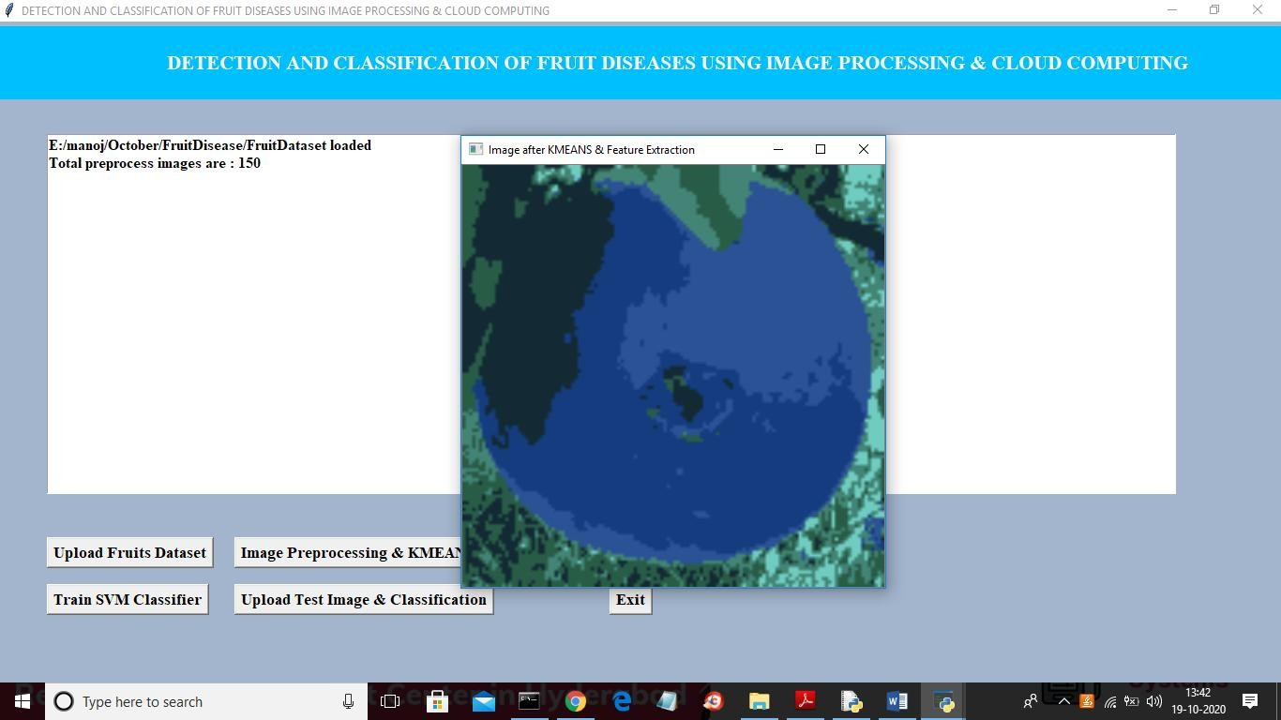
In above screen it shows one image as segmented image where u can see all similar colours pixels are in one place and now close above image to get train data details

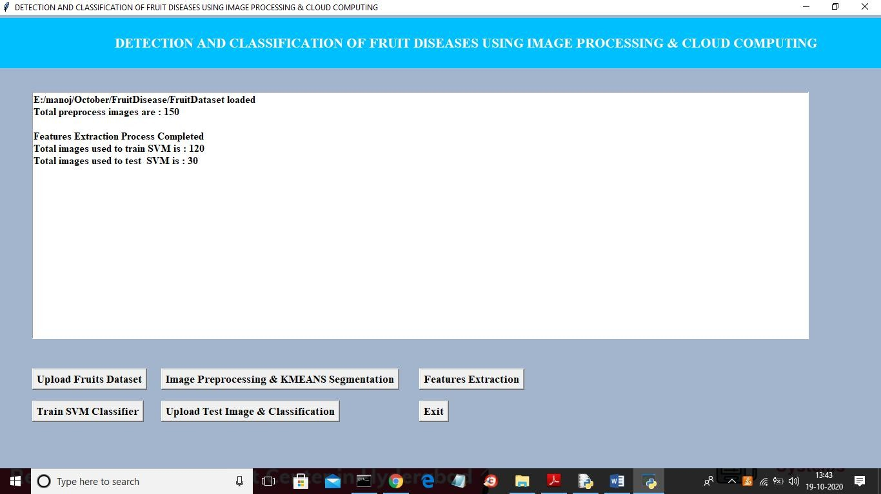
In above screen we can see out of total 150 images application using 120 (80%) images to train model and 30 (20%) images for testing. Now both train and test images data is ready and now click on ‘Train SVM Classifier’ button to train SVM with above train and test data and then calculate prediction accuracy

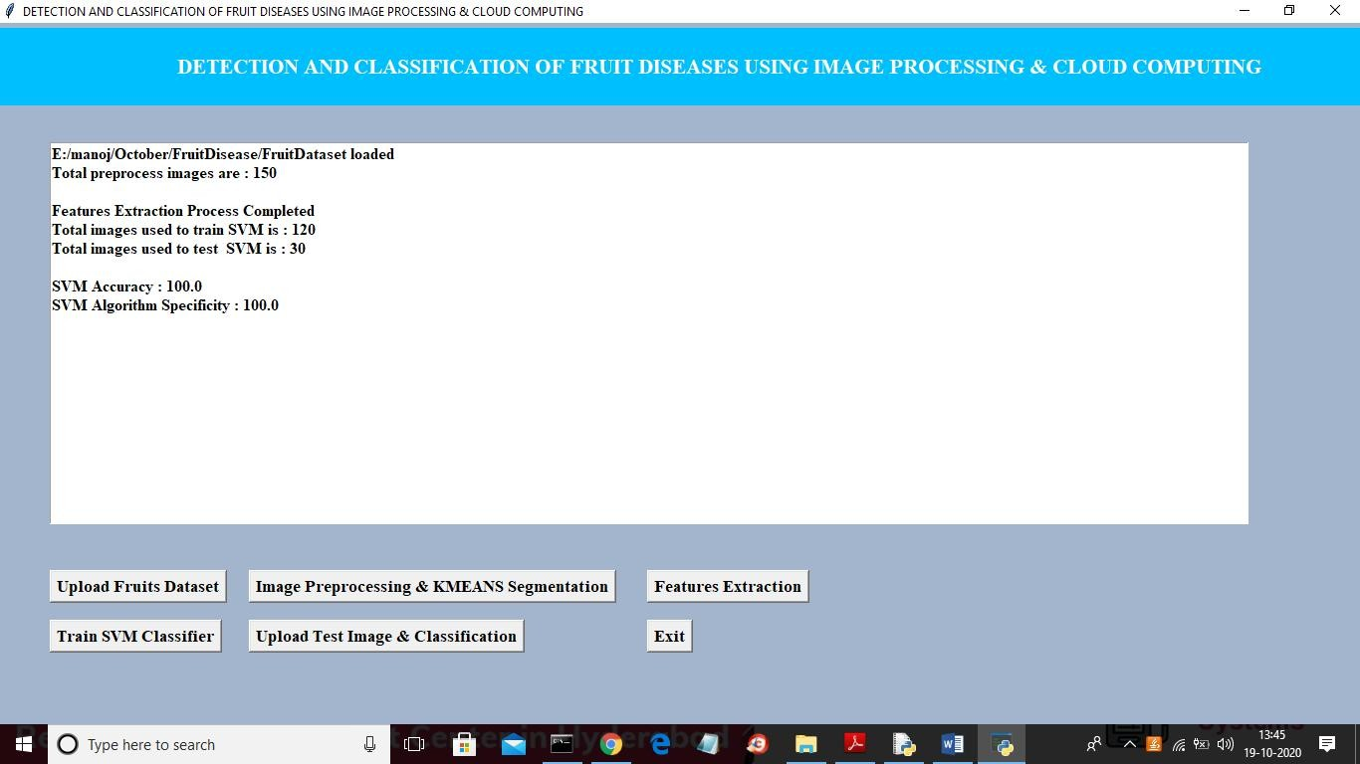
In above screen SVM classifier model is generated with prediction accuracy and specificity as 100% and now click on ‘Upload Test Image & Classification’ button to upload any test image and predict disease

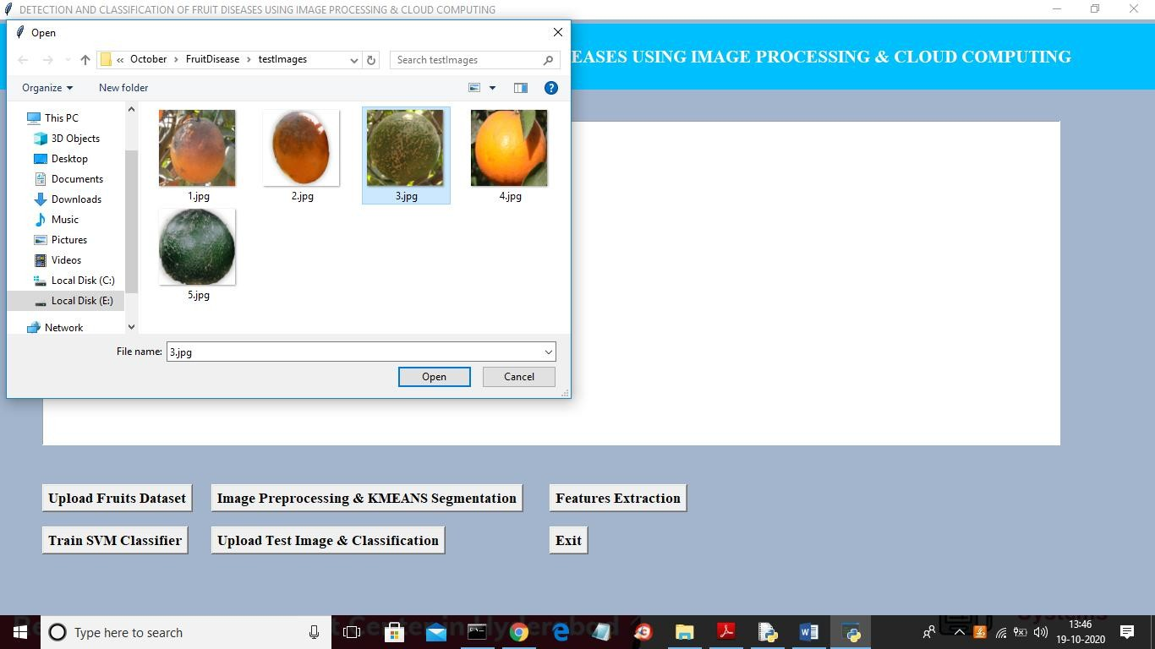
In above screen uploading test image as 3.jpg and then click on ‘Open’ button to classify image

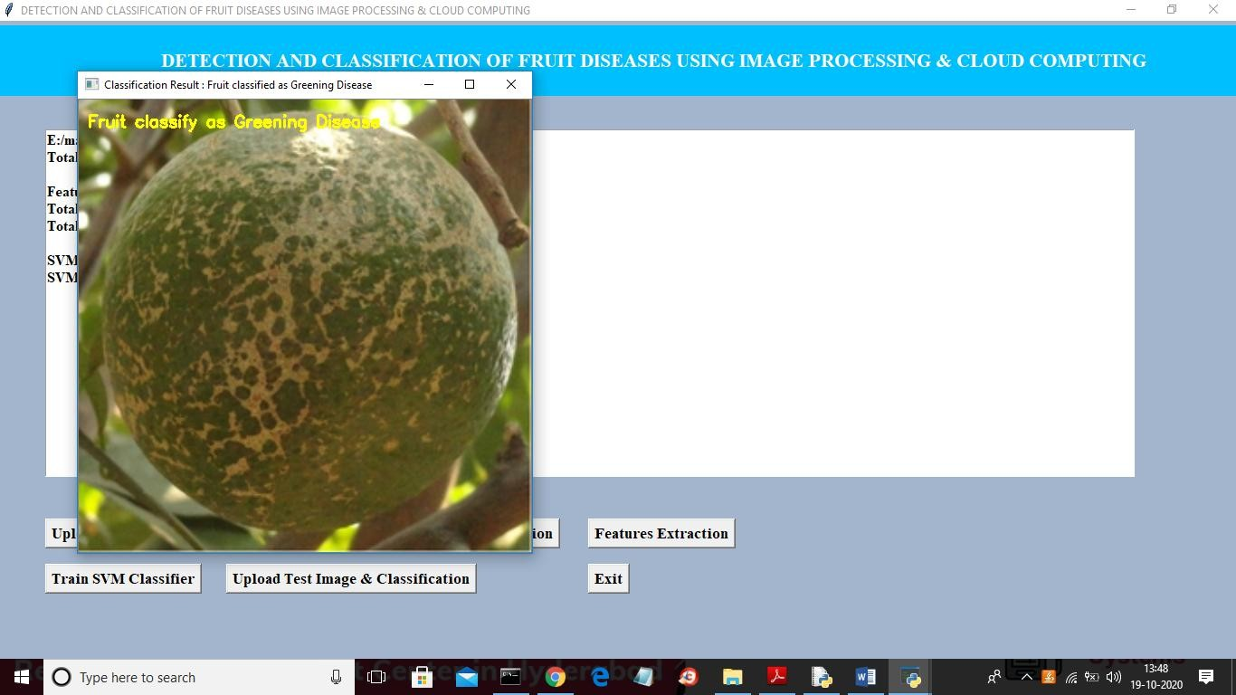
In above screen image is classified as ‘Greening Disease’ and now upload another image and test

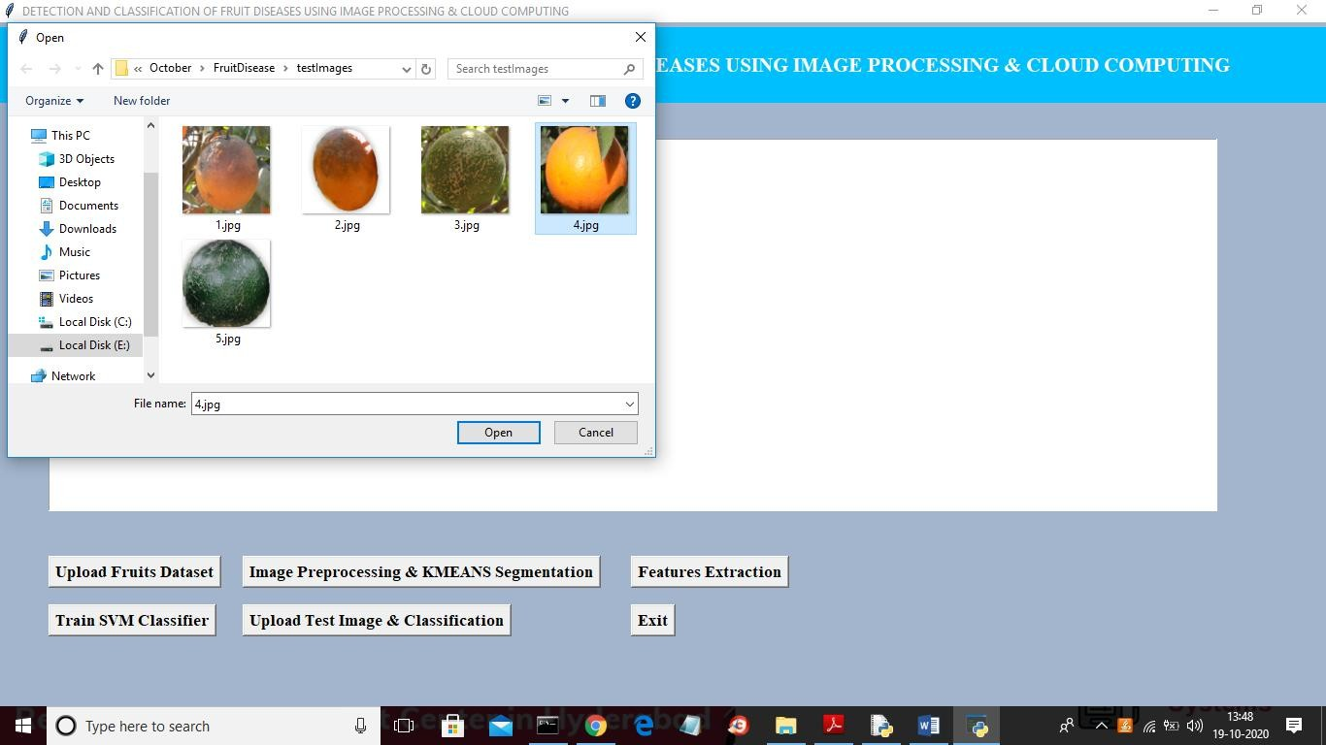
In above screen uploading ‘4.jpg’ and then click on ‘Open’ button to get below result

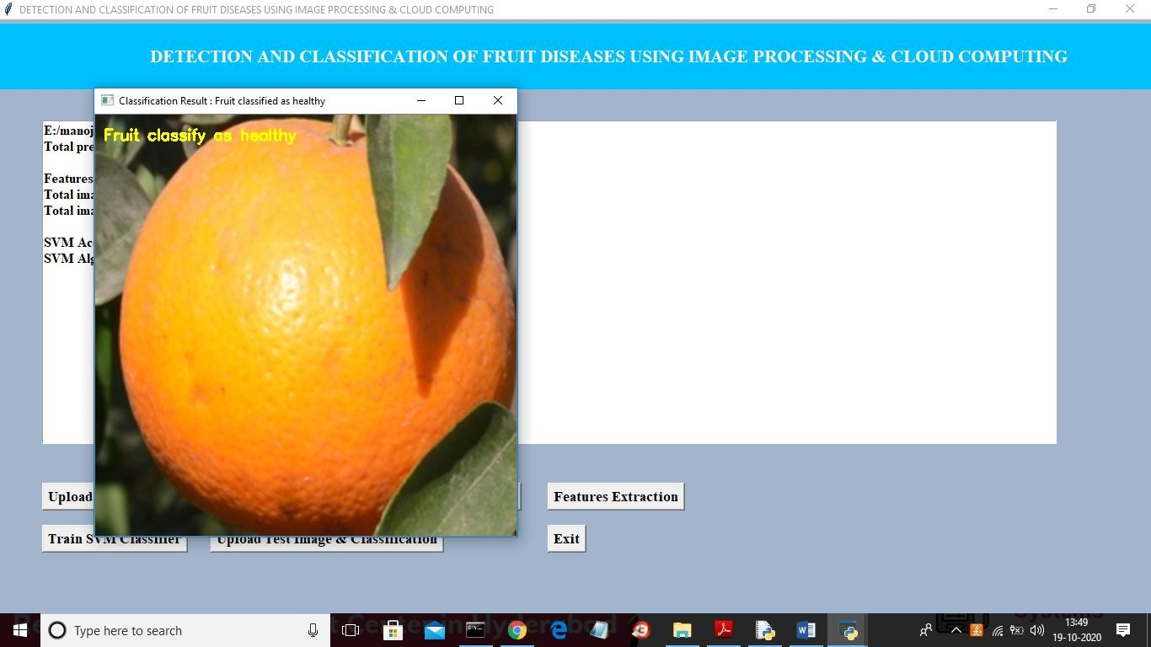
In above screen uploaded image is classified as Healthy. Similarly you can upload any image and classify it disease.

CONCLUSION

To better evaluate agriculture data, eliminate hoardings, and foster the growth of a successful, secure, and peaceful farmer society in India, a cloud- based plan was developed to aid Indian farmers and agriculture. K-Means Algorithm and the SVM method were used for the picture classification and segmentation of fruit. First, the various attributes of a small sample of fruits were retrieved and used to segment their corresponding photos. Disease names are compared with feature values to determine which is most appropriate for a given image; once this is done, the disease is flagged in an alert box and can be sent as a message via a mobile app. An alert box displays the total number of samples, the percentage of correct predictions, the percentage of negative predictions that were correct, the accuracy, and the specificity.

BIBLIOGRAPHY

- Asha R.PatilVarshaI.Patil, B.S.Panchbhai, “Detection of Plant Diseases Using Image Processing Tools”. Asha R. PatilVarshaI.Patil. Int. Journal of Engineering Research and Application ISSN : 2248-9622, Vol. 7, Issue 4, ( Part -2) April 2017, pp.44-45.
- Pratik Agarwal, “AGROCLOUD-Open surveillance of Indian Agriculture via cloud”2016.International Conference on Information Technology(InCITe)- The Next Generation IT Summit.
- Athmaja S1, Hanumanthappa M2, “Applications of Mobile Cloud Computing and Big Data Analytics in Agriculture Sector- A Survey”. International Journal of Advanced Research in Computer and Communication Engineering ICRITCSA M S Ramaiah Institute of Technology, Bangalore Vol. 5, Special Issue 2, October 2016.
- Wang-Su Jeon1 and Sang-Yong Rhee,”Plant Leaf Recognition Using a Convolution Neural Network”International Journal of Fuzzy Logic and Intelligent Systems Vol. 17, No. 1, March 2017, pp. 26-34
- Li Tan1,2†,Hongfei Hou1,Qin Zhang2.“An Extensible Software Platform for Cloud-based Decision Support and Automation in Precision Agriculture”.2016 IEEE 17th International Conference on Information Reuse and Integration.
- P. Deepan“Detection and Classification of Plant Leaf Diseases by using Deep Learning Algorithm”International Journal of Engineering Research & Technology (IJERT) ISSN: 2278- 0181Published by, www.ijert.org,ICONNECT - 2k18

