*AI Practical File*

*Name : Rakesh Kumar*

*Roll no: 5778*

*sem : 6th*

*Sec: B*

*B.sc(H) Computer Science*

**P 1. Write a prolog program to calculate the sum of two numbers.**

**Ans:**

sum(X,Y):-Z is X + Y,write("sum is: "),write(Z).

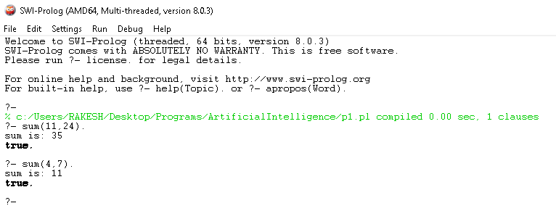

**P 2. Write a Prolog program to implement max(X, Y, M) so that M is the maximum of two numbers X and Y.**

**Ans:**

max(X,Y,M):-

(X>Y,

M is X).

max(X,Y,M):-

(Y>X,

M is Y ).

max(X,Y):-

(X>Y

-> print(X);

print(Y)

).

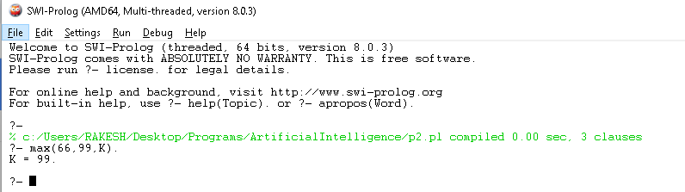

**P 3. Write a program in PROLOG to implement factorial (N, F) where F represents the factorial of a number N.**

**Ans:**

factorial(N):- factorial(N, A), print(A),!.

factorial(0,1).

factorial(N,F):-(

N > 0

-> (

N1 is N-1,

factorial(N1, F1),

F is N*F1

)

; print("Not defined"),!

).

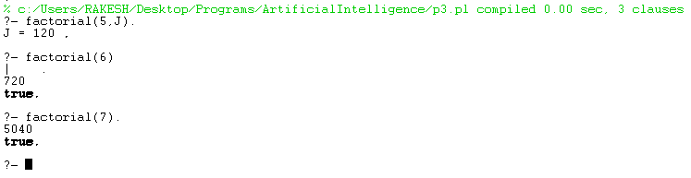

P 4. **Write a program in PROLOG to implement generate_fib(N,T) where T represents the Nth term of the fibonacci series.**

**Ans:**

fib(X):-fib(X, A), print(A),!.

fib(1,1).

fib(2,1).

fib(X,T):-

(

X > 0

->(

X1 is X-1,

X2 is X-2,

fib(X1, T1),

fib(X2, T2),

T is T1 + T2

)

; print("Not Defined"),!

).

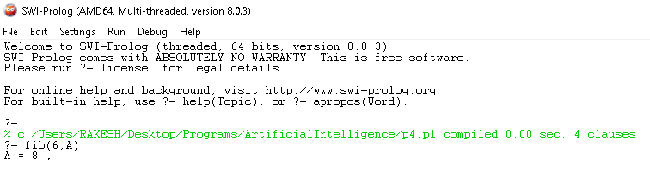

**P 5. Write a Prolog program to implement GCD of two numbers.**

**Ans:**

gcd(A,B):-A1 is abs(A), B1 is abs(B), gcd(A1, B1, N1), print(N1).

gcd(0,B,N):- N is B.

gcd(A,0,N):- N is A.

gcd(A,B,N):-

( A = B

-> N is A

; ( A > B

-> ( N1 is A-B,

gcd(N1,B, G),

N is G

)

; ( N1 is B - A,

gcd(A, N1, G),

N is G

)

)

).

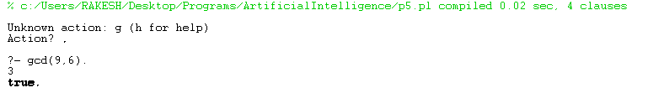

**P 6. Write a Prolog program to implement power (Num,Pow, Ans) : where Num is raised to the power Pow to get Ans.**

**Ans:**

power(N, P):- power(N, P, A), print(A),!.

power(1, _, 1).

power(0, _, 0).

power(_, 0, 1).

power(N, P, A):-

(

P > 0

-> (

P1 is P - 1,

power(N, P1, A1),

A is N*A1

)

; (

P1 is P + 1,

power(N, P1, A1),

A is 1/N*A1

)

).



**P 7. Prolog program to implement multi (N1, N2, R) : where N1 and N2 denotes the numbers to be multiplied and R represents the result.**

**Ans:**

multi(N1,N2):-multi(N1,N2,R), print(R).

multi(0, _, 0).

multi(_, 0, 0).

multi(N1,N2,R):-

( N2 > 0

-> (

N2_1 is N2 - 1,

multi(N1,N2_1,R_1),

R is N1 + R_1

)

; (

N2_1 is N2 + 1,

multi(N1,N2_1,R_1),

R is -1*N1 + R_1

)

).

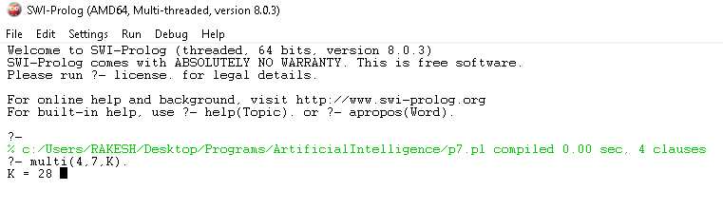

**P 8. Write a program in PROLOG to implement towerofhanoi (N) where N represents the number of discs**

**Ans:**

toh(N):-

(

N < 0

-> print("Not defined")

; power(2, N, R),

R1 is R - 1,

write("No of steps: "),write(R1),nl,

toh(N, "a","b","c")

).

toh(1, A,_,C):-write("Move from "),write(A),write(" to "),write(C),nl.

toh(N, A, B, C):-

(

N1 is N-1,

toh(N1, A,C,B),

write("Move from "),write(A),write(" to "),write(C),nl,

toh(N1, B,A,C)

).

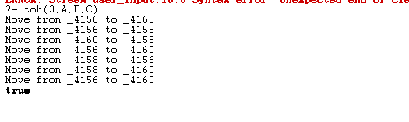

**P 9.Consider a cyclic directed graph [edge (p, q), edge (q, r), edge (q, r), edge (q, s), edge (s,t)] where edge (A,B) is a predicate indicating directed edge in a graph from a node A to a node B. Write a program to check whether there is a route from one node to another node.**

**Ans:**

node(p).

node(q).

node(r).

node(s).

node(t).

edge(p,q).

edge(q,r).

edge(r,q).

edge(q,s).

edge(s,t).

path(X,Y,R):-

(

node(X),

node(Y),

X \= Y

-> (

edge(X,Y)

-> R is 1

; (

edge(X,Z),

Y \= Z,

path(Z,Y, R2),

R2 = 1

-> R is 1

; R is 0

)

)

; R is 0

).

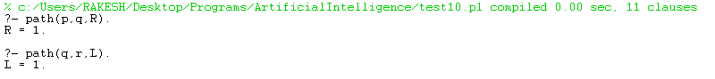

**P 10. Write a Prolog program to implement memb(X, L): to check whether X is a member of L or not.**

**Ans:**

memb(M,L):-(

memb(M,L,R),

R = 1

-> write(M), write(" is a member of list"),!

; write(M), write(" is not a member of list"),!

).

memb(H, [H|_], 1).

memb(X, [H|T], R):-

(

X = H

->R is 1

; (

memb(X, T, R1),

R is R1

)

).

len(L):-len(L,R),write("Length of list is: "),write(R).

len([], 0).

len([_|T], R):-

(

len(T, R1),

R is R1 + 1

).

append(X, L):-conc([X],L,R), print(R).

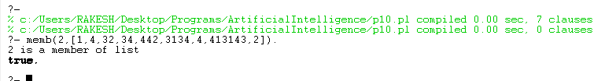

**P 11.Write a Prolog program to implement conc (L1, L2, L3) where L2 is the list to be appended with L1 to get the resulted list L3.**

**Ans:**

conc(X1,X2):-conc(X1,X2,R),write("concatenated list is: "),write(R),!.

conc([], X, X).

conc(X, [], X).

conc([H1|T1], L2, [H1|T3]):- conc(T1, L2, T3).

**O/P**



**P 12.Write a Prolog program to implement reverse (L, R) where List L is original and List R is reversed list.**

**Ans:**

rev(X):-rev(X,R),write("reversed list is: "),write(R).

rev(X, R):-rev(X,[],R).

rev([], X, X).

rev([H1|T1], PREV, REV):-rev(T1, [H1|PREV], REV).

/*equals*/

equals([], []):-print("yes").

equals([H1|T1],[H2|T2]):-

(

H1 = H2

-> equals(T1, T2)

; print("no")

).

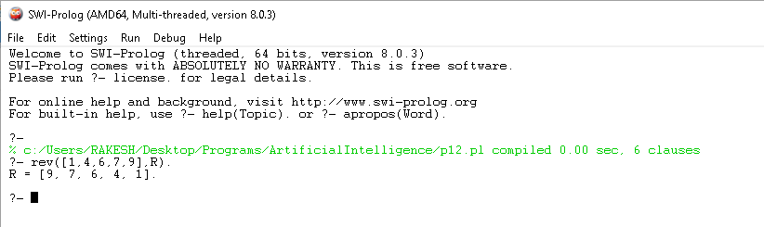

**P 13.Write a program in PROLOG to implement palindrome (L) which checks whether a list L is a palindrome or not.**

**Ans:**

palindrome(X):-rev(X,Y), X = Y.

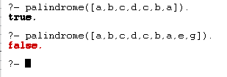

**P 14.Write a Prolog program to implement sumlist(**L, S) so that S is the sum of a given list L.

**Ans:**

list_sum(L1):-list_sum(L1,S),write("sum of list is: "),write(S).

list_sum([], 0).

list_sum([H|T], R):-

(

list_sum(T, R1),

R is H + R1

).

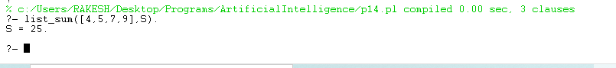

**P 15.Write a Prolog program to implement two predicates evenlength(List) and oddlength(List) so that they are true if their argument is a list of even or odd length respectively**

**Ans:**

evenlength(L1):-

(

len(L1, R1),

0 is mod(R1,2)

).

oddlength(L2):-

(

len(L2, R1),

1 is mod(R1,2),

print("true")

)



**P 16.Write a Prolog program to implement nth_element (N, L, X) where N is the desired position, L is a list and X represents the Nth element of L.**

**Ans:**

nth_element(N, L):-nth_element(N, L, X),write("element at pos "),write(N),write(" is: "),write(X),!.

nth_element(_, [], _):-print("out of bounds"),!.

nth_element(N, [H|T], X):-

(

N > 0

-> (

N = 1

->X is H

; (

N1 is N - 1,

nth_element(N1, T, X)

)

)

; print("Invalid index")

).

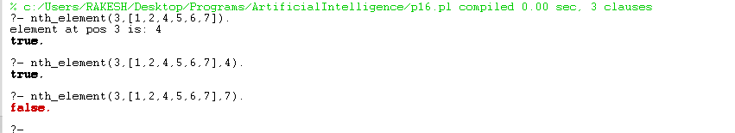

**P 17.Write a program in PROLOG to implement remove_dup (L, R) where L denotes the list with some duplicates and the list R denotes the list with duplicates removed.**

**Ans:**

remove_dup(L):-remove_dup(L, R),write("List after removing duplicates is: "),write(R),!.

remove_dup([], []).

remove_dup([H|T], [H|R]):-

(

delete_all(H, T, R1),

remove_dup(R1, R)

).

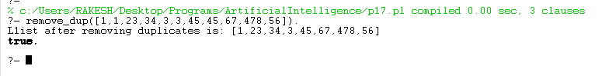

**P 18.Write a Prolog program to implement maxlist(L, M) so that M is the maximum number in the list**

**Ans:**

maxlist([H|T]):-maxlist(T, H).

maxlist([H|[]], M):-

(

M > H

-> print(M),!

; print(H),!

).

maxlist([H|T], M):-

(

M > H

->maxlist(T, M)

; maxlist(T, H)

).

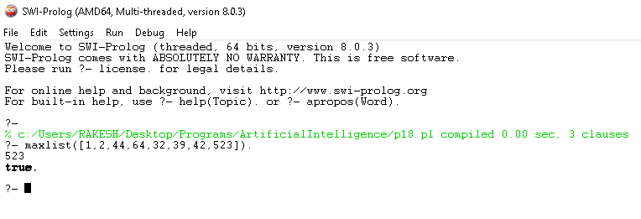

**P 19.Write a prolog program to implement insert_nth(I, N, L, R) that inserts an item I into Nth position of list L to generate a list R.**

**Ans:**

insert_nth(X, P, L):-insert_nth(X, P, L, R),print(R),!.

insert_nth(X, 1, Y, [X|Y]).

insert_nth(X, P, [H|T], [H|T1]):-

(

P1 is P - 1,

insert_nth(X, P1, T, T1)

).

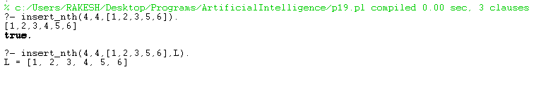

**P 20.Write a Program in PROLOG to implement sublist(S, L) that checks whether the list S is the sublist of list L or not. (Check for sequence or the part in the same order).**

**Ans:**

sublist([],[]):-print("It is a sublist").

sublist([], [_|_]):-print("It is a sublist").

sublist([_|_], []):-print("Not a sublist").

sublist([H|T], [H1|T1]):-

(

H = H1

-> sublist(T, T1)

; sublist([H|T], T1)

).

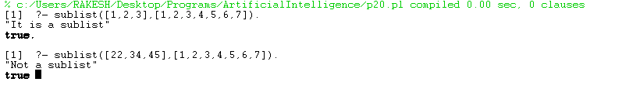

**P 21.Write a Prolog program to implement delete_nth (N, L, R) that removes the element on Nth position from a list L to generate a list R.**

**Ans:**

delete_nth(P, L):-delete_nth(P, L,R), print(R),!.

delete_nth(1, [_|T], T).

delete_nth(P, [H|T], [H|T1]):-

(

P1 is P - 1,

delete_nth(P1, T, T1)

).

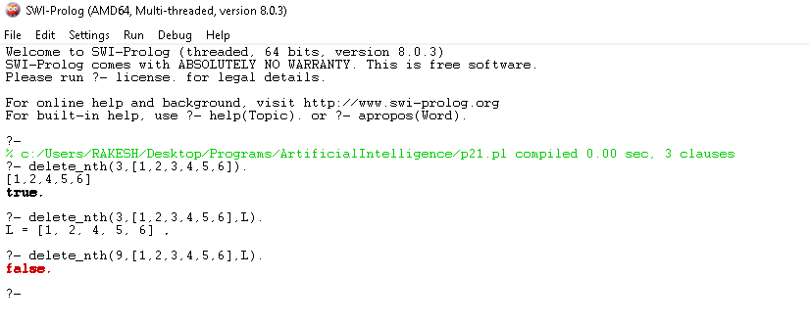

**P 22.Write a program in PROLOG to implement delete_all (X, L, R) where X denotes the element whose all occurrences has to be deleted from list L to obtain list R.**

**Ans:**

delete_all(X, L):-delete_all(X,L,R),write("List without element "), write(X),write(" is: "),write(R),!.

delete_all(_, [], []).

delete_all(X, [X|T], L):-delete_all(X, T, L).

delete_all(X, [H|T], [H|T1]):-delete_all(X, T, T1).

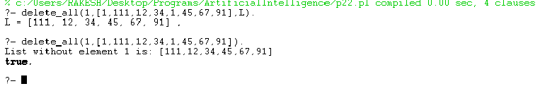

**P 23.Write a program in PROLOG to implement merge (L1, L2, L3) where L1 is first ordered list and L2 is second ordered list and L3 represents the merged list.**

**Ans:** merge(X, Y):-merge(X, Y, R), write("Merged list is: "),write(R),!.

merge([], X, X).

merge(X, [], X).

merge([H1|T1], [H2|T2], [X|R]):-

(

H1 < H2

-> X is H1,

merge(T1, [H2|T2], R)

; X is H2,

merge([H1|T1], T2, R)

).

