Mutual Fund Analytics Capstone Project
Organization: Bluestock Fintech

Prepared By: Ritik Kumar
Technology Stack: Python, Pandas, NumPy, SQLite, Power BI, Matplotlib

Executive Summary
This project developed a Mutual Fund Analytics Platform using Python, SQLite, and Power BI. The objective was to transform raw mutual fund and investor transaction data into actionable insights for performance evaluation, risk assessment, and investor behavior analysis.
The project involved data cleaning, database creation, exploratory data analysis, performance analytics, risk modeling, and dashboard development. Key metrics such as CAGR, Sharpe Ratio, Sortino Ratio, Alpha, Beta, Tracking Error, VaR, and CVaR were calculated.
A Power BI dashboard was created with four interactive pages covering Industry Overview, Fund Performance, Investor Analytics, and SIP & Market Trends.
The analysis showed that funds with strong risk-adjusted returns consistently outperformed peers, while SIP continuity played an important role in long-term wealth creation. The project demonstrates how data analytics can support investment decision-making and portfolio evaluation.

Problem Statement
The mutual fund industry generates large volumes of data related to fund performance, investor transactions, asset allocation, and market benchmarks. While this information is publicly available, it is often scattered across multiple sources and difficult to analyze effectively. Investors, fund managers, and financial analysts require a structured approach to evaluate fund performance, understand investor behavior, assess risk, and compare funds against market benchmarks.
Traditional analysis methods are often time-consuming and may not provide a comprehensive view of key performance indicators such as returns, volatility, risk-adjusted performance, tracking error, and investor participation trends. Additionally, investors need tools that can help identify suitable investment opportunities based on historical performance and risk characteristics.
The objective of this project is to build an end-to-end Mutual Fund Analytics Platform that transforms raw mutual fund data into actionable business insights. The project integrates data cleaning, database management, exploratory data analysis, advanced financial analytics, and interactive dashboards to support informed decision-making.
Using Python, SQLite, and Power BI, the solution enables users to:
- Analyze mutual fund performance across different categories and fund houses.
- Measure risk using metrics such as Sharpe Ratio, Sortino Ratio, VaR, and CVaR.
- Compare funds against benchmark indices.
- Understand investor behavior through transaction and demographic analysis.
- Track SIP trends and investor continuity.
- Generate fund rankings and recommendations based on performance metrics.
The final outcome is a centralized analytics solution that provides meaningful insights into mutual fund performance, investor participation, and risk characteristics through interactive visualizations and data-driven reporting.

Project Architecture

Data Collection → Data Cleaning → SQLite Database → EDA → Advanced Analytics → Power BI Dashboard → Reporting
│ Raw Datasets │
▼
│ Data Cleaning │
▼
│ SQLite Database │
▼
│ Exploratory Data Analysis (EDA) │
▼
│ Advanced Analytics │
▼
│ Power BI Dashboard │
▼
│ Final Report & │

Dataset Description

This project uses multiple datasets covering mutual fund scheme details, historical NAV values, investor transactions, performance metrics, and benchmark indices. Together, these datasets provide a comprehensive view of mutual fund performance, investor behavior, and market trends.
The datasets were cleaned, validated, and integrated to support exploratory analysis, advanced analytics, and dashboard development.
Dataset Name | Description | Key Columns
fund_master_clean | Master information for all mutual fund schemes | amfi_code, scheme_name, fund_house, category, benchmark, expense_ratio_pct, risk_category
nav_history_clean | Historical Net Asset Value (NAV) records for mutual funds | amfi_code, date, nav
investor_transactions_clean | Investor transaction records including SIP and lump-sum investments | investor_id, transaction_date, transaction_type, amount_inr, state, age_group
scheme_performance_clean | Fund performance metrics and return calculations | amfi_code, return_1yr_pct, return_3yr_pct, return_5yr_pct, aum_crore
benchmark_indices | Historical benchmark index values used for comparison | date, index_name, close_value
fund_rankings | Final fund rankings generated using calculated performance metrics | amfi_code, rank, fund_score
tracking_error | Benchmark tracking error analysis for selected funds | amfi_code, tracking_error
alpha_beta | Alpha and Beta values calculated against benchmark indices | amfi_code, alpha, beta
var_cvar_report | Downside risk measures for mutual funds | amfi_code, VaR_95, CVaR_95
cohort_analysis | Investor cohort analysis based on first investment year | cohort_year, investors, total_invested
sip_continuity | Analysis of investor SIP continuity and transaction gaps | investor_id, avg_gap_days, max_gap_days, at_risk
These datasets collectively enabled the calculation of return metrics, risk indicators, benchmark comparisons, investor analytics, and dashboard visualizations used throughout the project.

Data Cleaning & Preprocessing
Data cleaning and preprocessing were performed to improve data quality and ensure accurate analysis. The raw datasets were processed using Python and Pandas before being loaded into SQLite and used for analytics.
The following steps were carried out:
- Removed duplicate records across datasets.
- Handled missing and invalid values.
- Standardized date formats and data types.
- Validated key fields such as AMFI codes, NAV values, and transaction amounts.
- Prepared datasets for integration and analysis.
The cleaned datasets included:
- fund_master_clean.csv
- nav_history_clean.csv
- investor_transactions_clean.csv
- scheme_performance_clean.csv
These processed datasets provided a reliable foundation for database creation, exploratory data analysis, risk modeling, performance evaluation, and Power BI dashboard development.
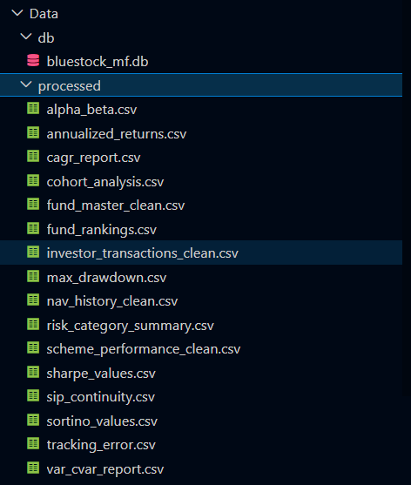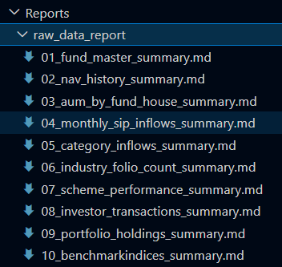

Database Design
A SQLite database was created to store and manage the cleaned mutual fund datasets. The database was designed using a fact-dimension approach to support efficient querying and analytics.
The primary key used across datasets was AMFI Code, which enabled the integration of scheme information, NAV history, transaction records, and performance metrics.
The database contains the following main tables:
- fund_master_clean – Scheme details and fund metadata
- nav_history_clean – Historical NAV records
- investor_transactions_clean – Investor transaction data
- scheme_performance_clean – Performance metrics and returns
Relationships between these tables were established using common fields such as AMFI Code, enabling comprehensive analysis of fund performance, investor behavior, and benchmark comparisons.
The database served as the central repository for all cleaned and processed data used in advanced analytics and Power BI dashboard development.
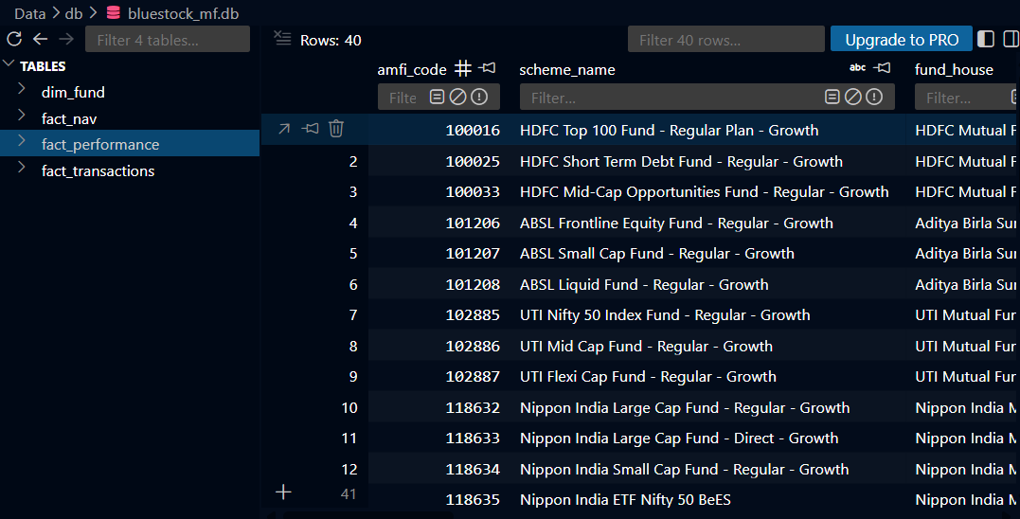

Exploratory Data Analysis
The analysis focused on fund performance, investor demographics, transaction behavior, and market trends. Various visualizations were created using Python libraries such as Matplotlib and Seaborn.
Key analyses performed included:
- Fund category distribution across different mutual fund schemes.
- Investor demographic analysis based on age group and gender.
- Geographic analysis of investors by state and city tier.
- Transaction analysis to identify investment patterns and SIP trends.
- Fund ranking and performance comparison.
- Benchmark index trend analysis.
- Correlation analysis between key financial metrics.
The insights obtained from EDA provided a strong foundation for advanced analytics, risk modeling, and dashboard development. The analysis helped identify investor participation trends, high-performing fund categories, and overall market behavior.
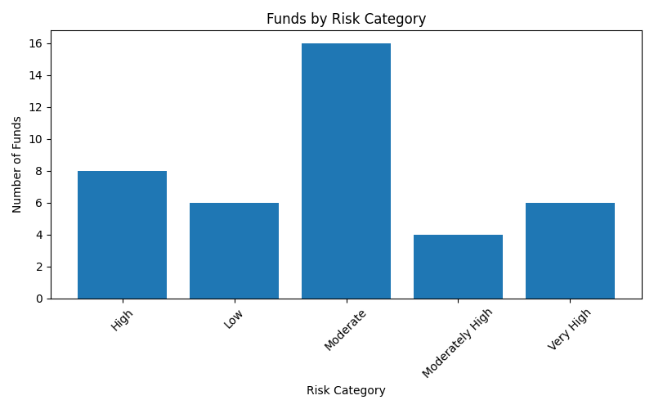
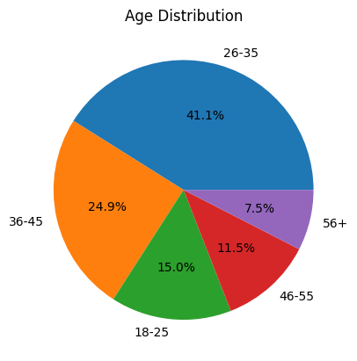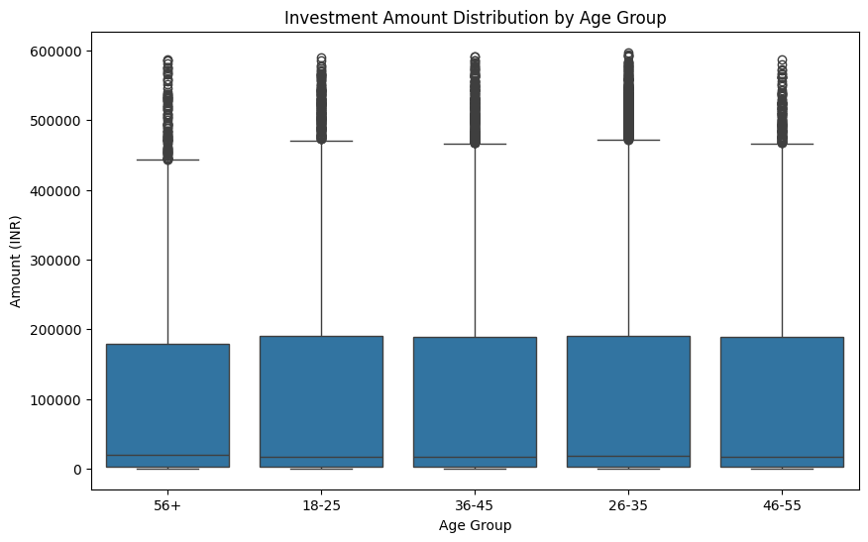
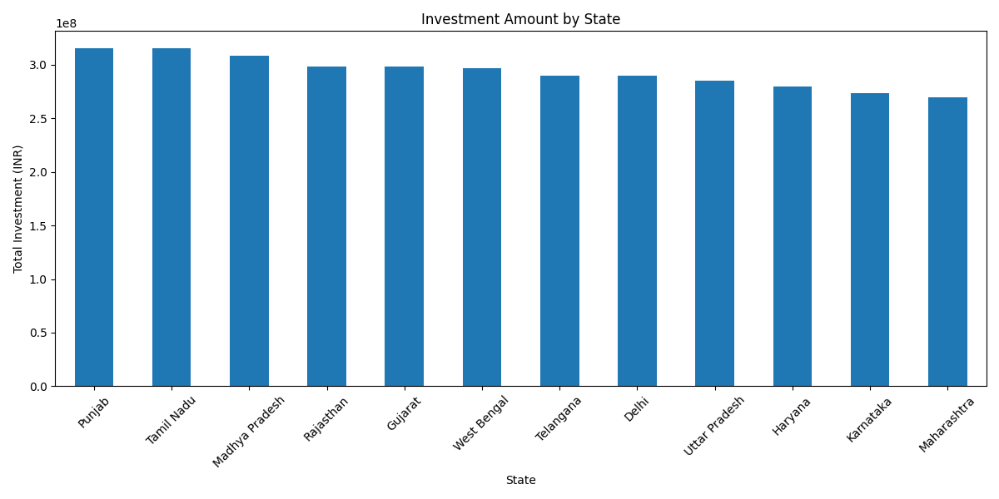
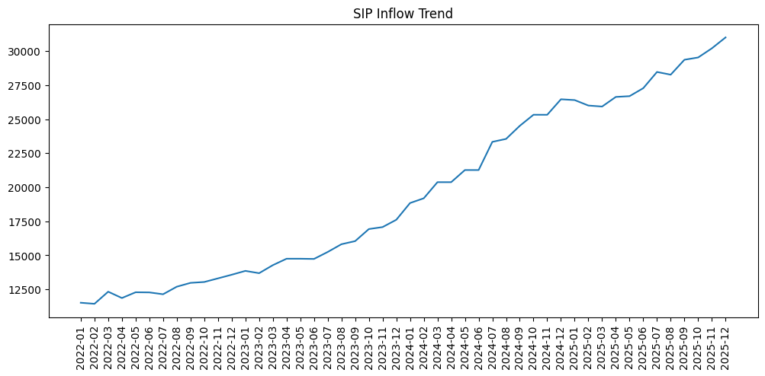

Performance Analytics
Performance analytics was conducted to evaluate the return-generating ability and efficiency of mutual funds. Historical NAV data and benchmark indices were used to calculate key performance and risk-adjusted metrics.
The following metrics were analyzed:
- Daily Returns – Measured day-to-day fund performance.
- Annualized Returns – Evaluated long-term growth potential.
- CAGR (Compound Annual Growth Rate) – Assessed wealth creation over multiple years.
- Sharpe Ratio – Measured risk-adjusted returns.
- Sortino Ratio – Evaluated returns relative to downside risk.
- Alpha – Measured excess return generated over the benchmark.
- Beta – Assessed sensitivity to market movements.
- Tracking Error – Evaluated how closely a fund followed its benchmark.
These metrics enabled comparison of mutual funds based on both absolute performance and risk-adjusted efficiency. The analysis helped identify top-performing funds, benchmark consistency, and funds offering superior returns for the level of risk undertaken. 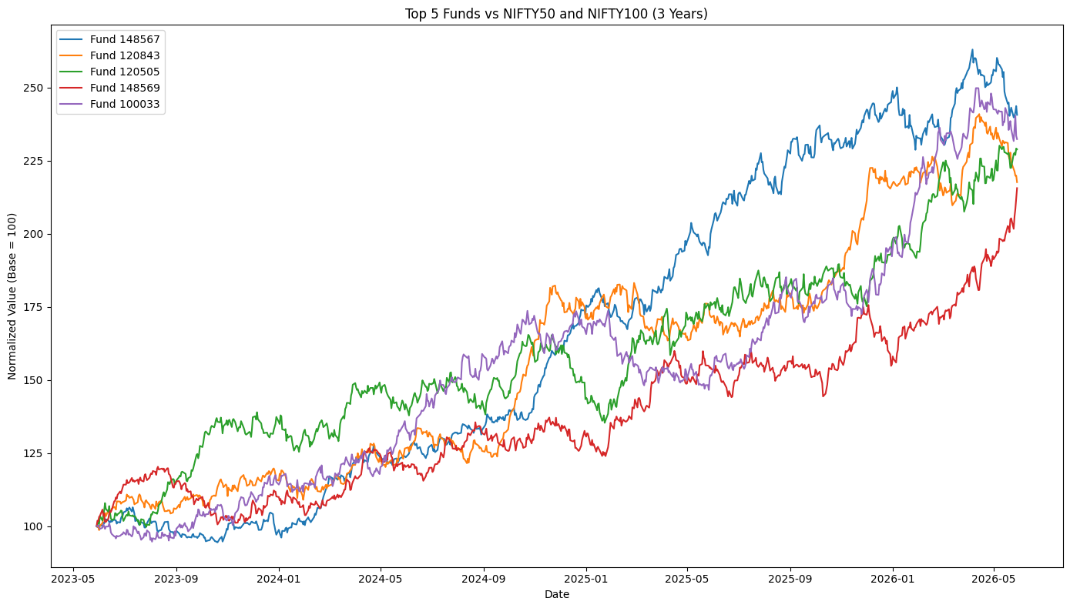
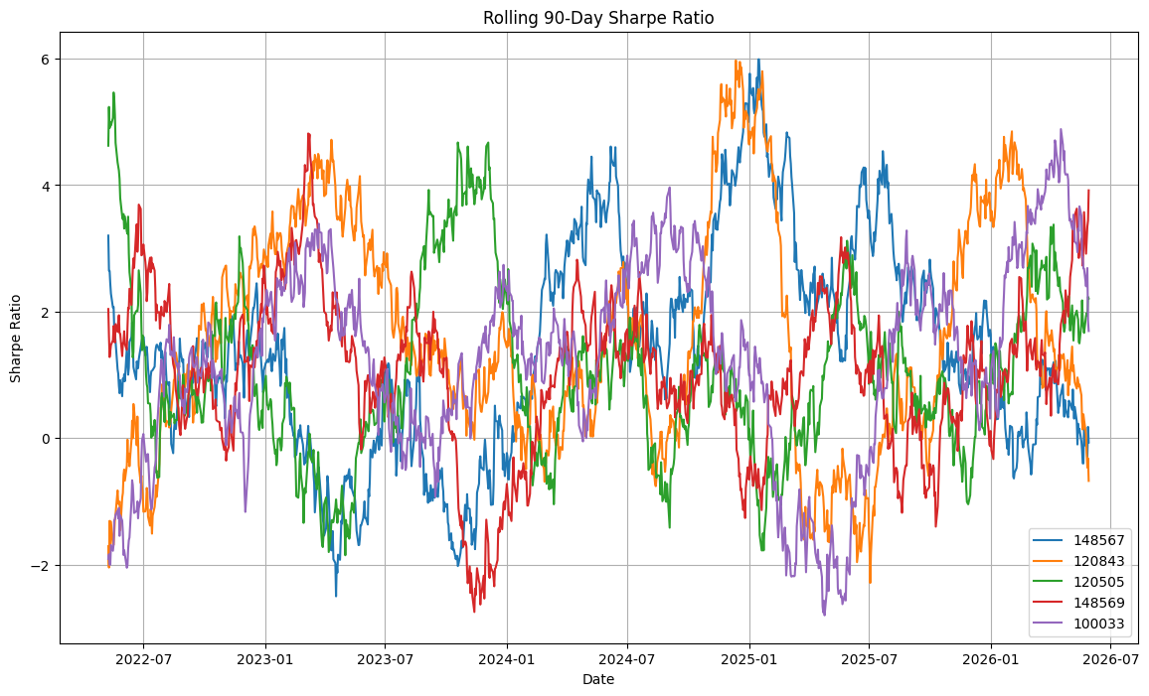
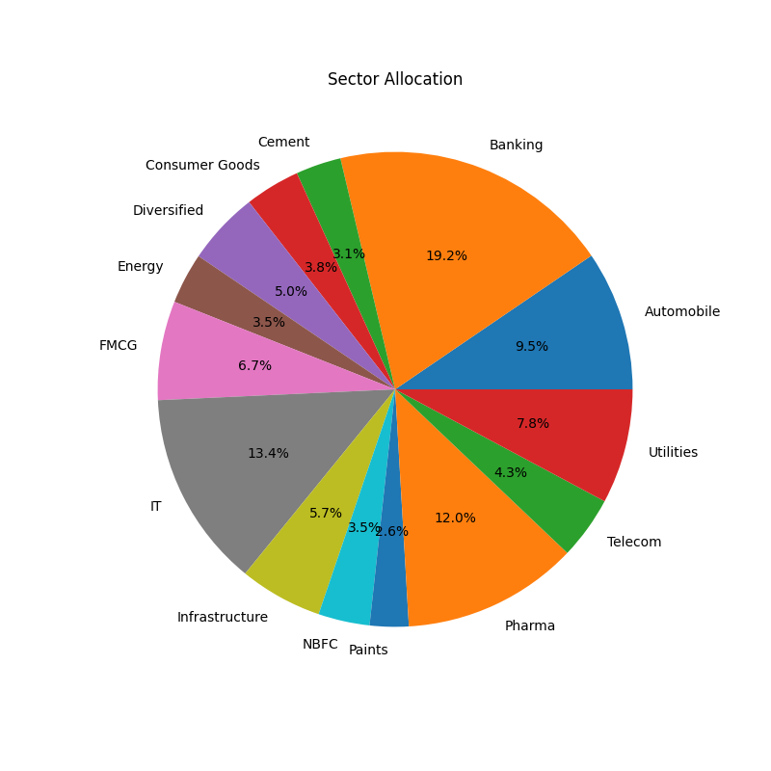

Risk Analytics
Risk analytics was performed to evaluate the downside risk and stability of mutual fund investments. In addition to traditional performance metrics, advanced risk measures were calculated to assess potential losses and risk-adjusted performance.
The following analyses were conducted:
- Value at Risk (VaR) – Estimated the maximum expected loss at a given confidence level.
- Conditional Value at Risk (CVaR) – Measured the average loss beyond the VaR threshold.
- Rolling 90-Day Sharpe Ratio – Evaluated how risk-adjusted performance changed over time.
- Investor Cohort Analysis – Analyzed investment behavior based on investor entry year.
- SIP Continuity Analysis – Identified investors with irregular investment patterns and long contribution gaps.
These analyses provided insights into fund risk, investor retention, and portfolio stability. The results highlighted the importance of consistent investing and the role of risk-adjusted metrics in evaluating mutual fund performance.
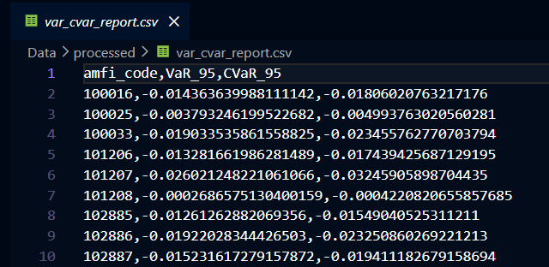
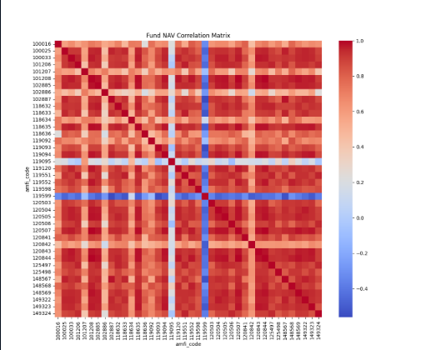
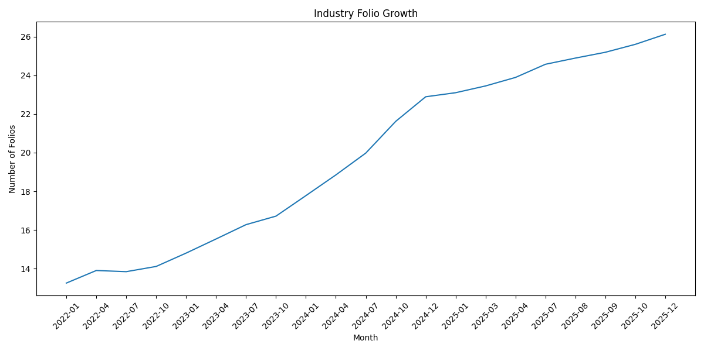

Dashboard Overview
An interactive Power BI dashboard was developed to present key insights from the mutual fund analytics project. The dashboard enables users to explore fund performance, investor behavior, market trends, and risk metrics through dynamic visualizations and filters.
The dashboard consists of four pages:

1. Industry Overview

2. Fund Performance

3. Investor Analytics

4. SIP & Market Trends
Tracks SIP inflows over time, benchmark index performance, category-wise investment trends, The dashboard incorporates interactive features such as slicers, tooltips, drill-through pages, and dynamic filtering, allowing users to perform detailed analysis and gain actionable insights.
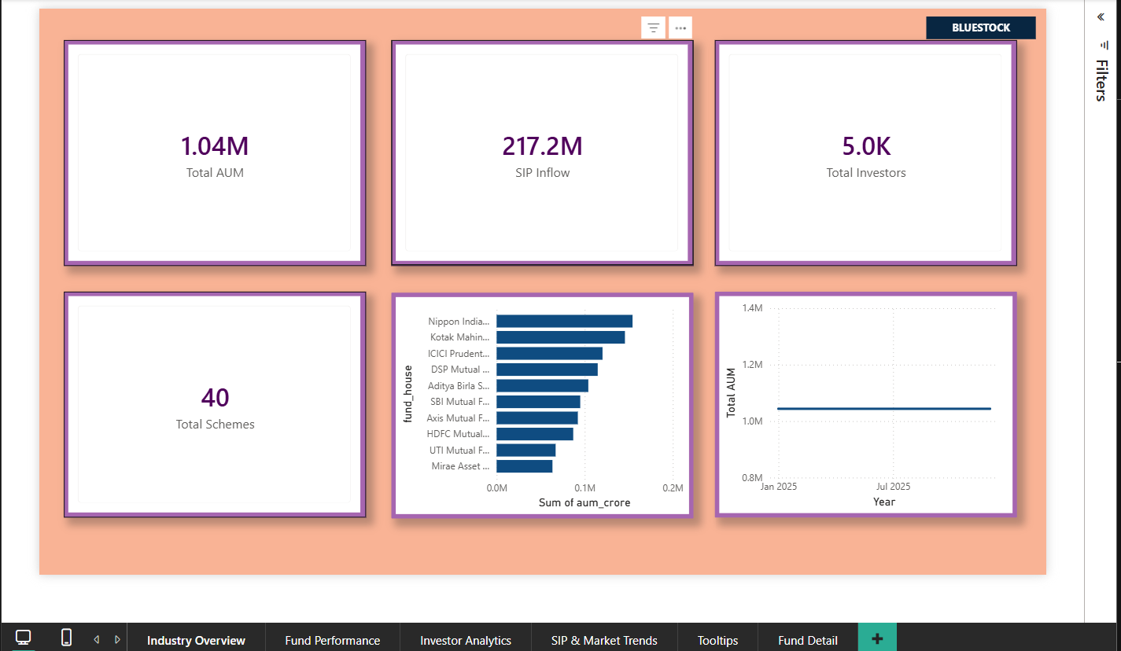
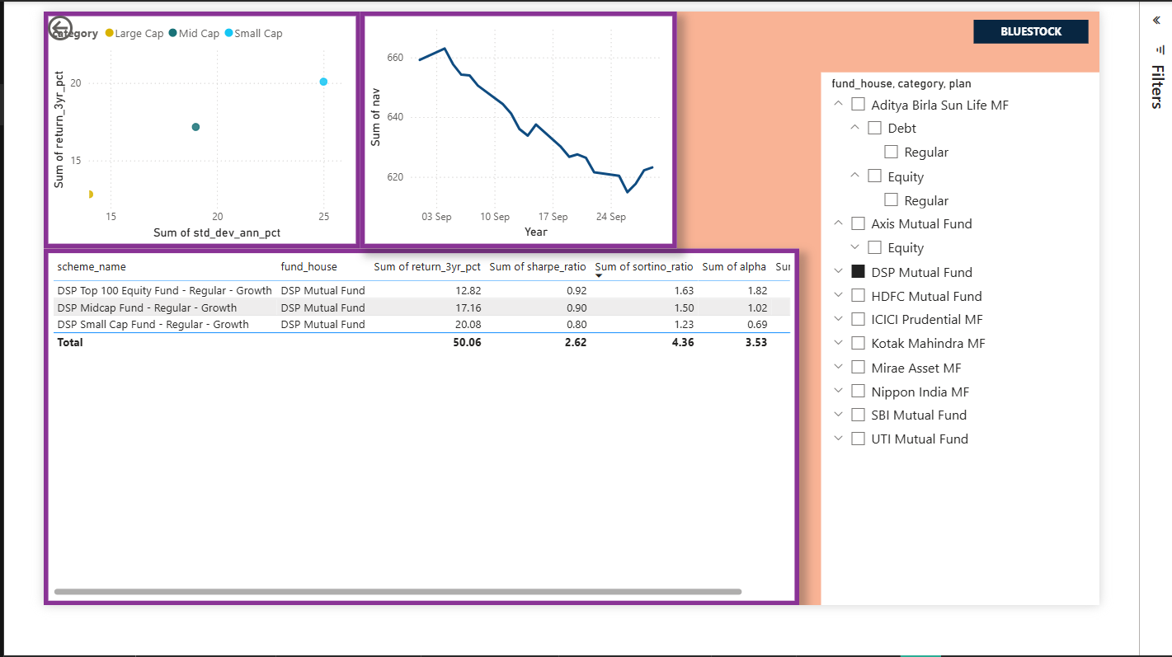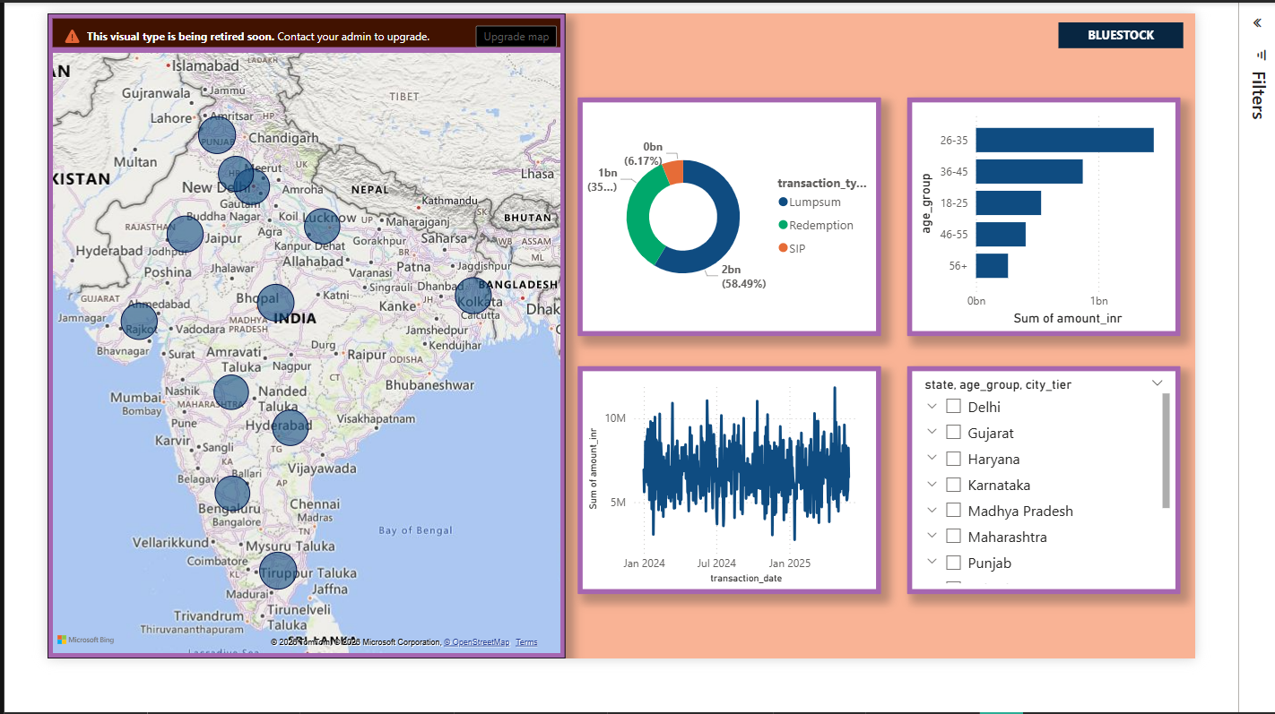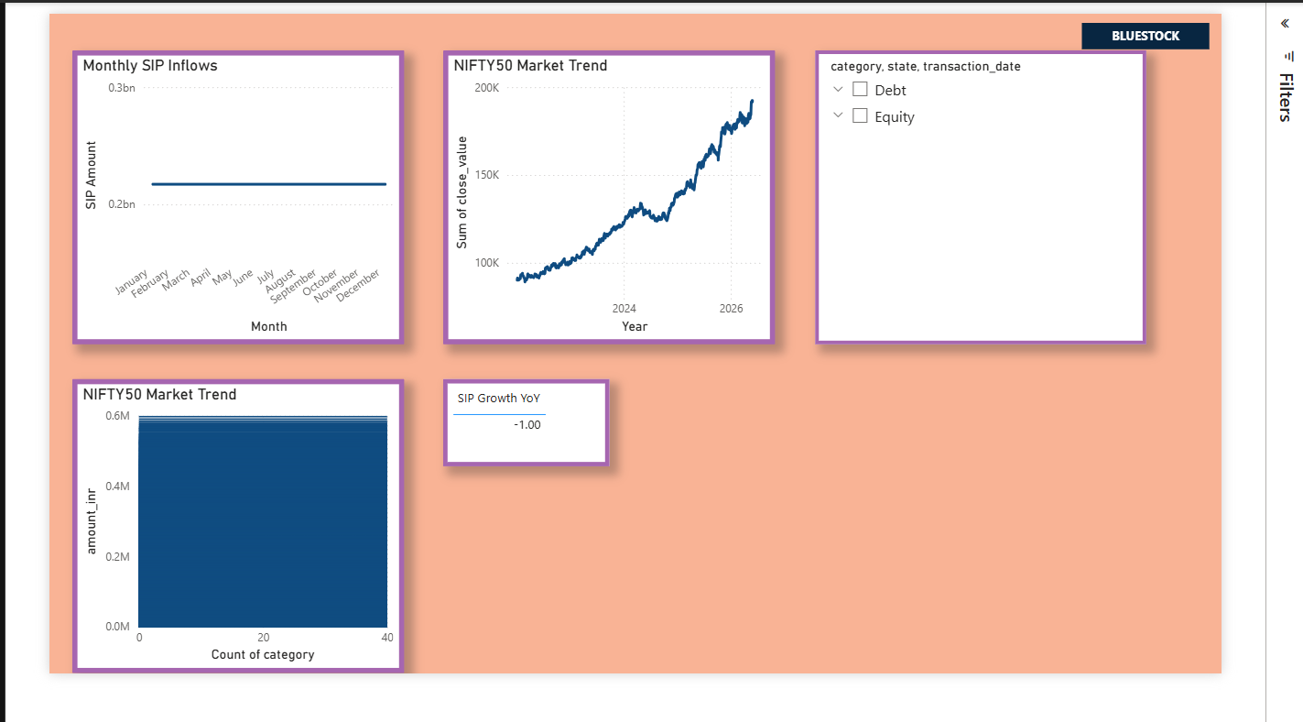

Key Findings
The analysis of mutual fund performance, investor transactions, and market trends revealed several important insights:
- Funds with higher Sharpe Ratios consistently delivered better risk-adjusted returns than their peers.
- SIP inflows showed steady growth over time, indicating increasing investor participation in mutual funds.
- Benchmark comparison revealed that some funds generated positive alpha, outperforming their respective market indices.
- Tracking error varied across funds, highlighting differences in benchmark-following efficiency.
- Investor demographics showed stronger participation from specific age groups and geographic regions.
- Cohort analysis indicated that newer investor cohorts contributed significantly to overall investment growth.
- SIP continuity analysis identified investors with irregular contribution patterns, emphasizing the importance of consistent investing.
- Risk analytics demonstrated that higher-return funds generally exhibited higher volatility and downside risk.
Overall, the project successfully identified performance drivers, risk characteristics, and investor behavior patterns, providing valuable insights for investment decision-making.

Recommendations
Based on the analysis conducted, the following recommendations are proposed:
- Prioritize Risk-Adjusted Performance: Investors should evaluate funds using metrics such as Sharpe Ratio and Sortino Ratio rather than relying solely on returns.
- Maintain SIP Discipline: Consistent SIP investments can help reduce market timing risk and improve long-term wealth creation.
- Monitor Benchmark Performance: Funds with positive alpha and lower tracking error should be preferred as they demonstrate better benchmark-relative performance.
- Diversify Investments: Investors should diversify across fund categories and risk profiles to reduce portfolio volatility.
- Consider Fund Costs: Expense ratios should be reviewed alongside performance metrics, as higher costs can impact long-term returns.
- Use Data-Driven Fund Selection: Fund rankings and performance analytics can assist investors in identifying high-performing and stable investment options.
- Enhance Investor Engagement: Fund houses can use demographic and transaction insights to design targeted investment awareness and retention programs.
Implementing these recommendations can help investors make informed decisions while improving portfolio performance and risk management.

Limitations
While the project successfully delivered a comprehensive mutual fund analytics platform, a few limitations were identified:
- Limited Dataset Availability: Certain analyses, such as sector concentration (HHI), could not be performed due to the absence of portfolio holdings and sector allocation data.
- Historical Data Dependency: The analysis was based on historical data and may not accurately predict future fund performance.
- Limited Benchmark Coverage: Benchmark comparisons were restricted to the benchmark indices available in the dataset.
- Rule-Based Recommendation Engine: The fund recommendation system uses predefined rules and does not incorporate machine learning or personalized investor preferences.
- No Real-Time Data Integration: The platform operates on static datasets and does not include live NAV or market data feeds.
Despite these limitations, the project provides valuable insights into mutual fund performance, risk characteristics, and investor behavior.

Conclusion
The Mutual Fund Analytics Capstone Project successfully developed an end-to-end analytics solution for evaluating mutual fund performance, investor behavior, and risk characteristics. Using Python, SQLite, and Power BI, raw datasets were transformed into meaningful insights through data cleaning, database management, exploratory analysis, advanced financial analytics, and interactive dashboards.
Key performance metrics such as CAGR, Sharpe Ratio, Sortino Ratio, Alpha, Beta, Tracking Error, VaR, and CVaR were calculated to assess fund performance and risk. Investor-focused analyses, including cohort analysis and SIP continuity assessment, provided valuable insights into investment patterns and participation trends.
The Power BI dashboard consolidated these insights into an interactive platform, enabling users to explore fund performance, market trends, and investor analytics effectively. Overall, the project demonstrates how data analytics can support informed investment decisions, improve fund evaluation, and enhance understanding of mutual fund market dynamics.
The resulting platform provides a strong foundation for future enhancements such as real-time data integration, machine learning-based recommendations, and portfolio optimization tools.

