**Assignment -3**

**1 –Program to write the first 10 numbers.**

Public static void main(String[] args)

{

int I;

System.out.println(‘’ the first 10 numbers are:\n” );

For(i=1;i<=10;i++)

{

System.out.println(i);

}

System.out.println(“\n”);

}

}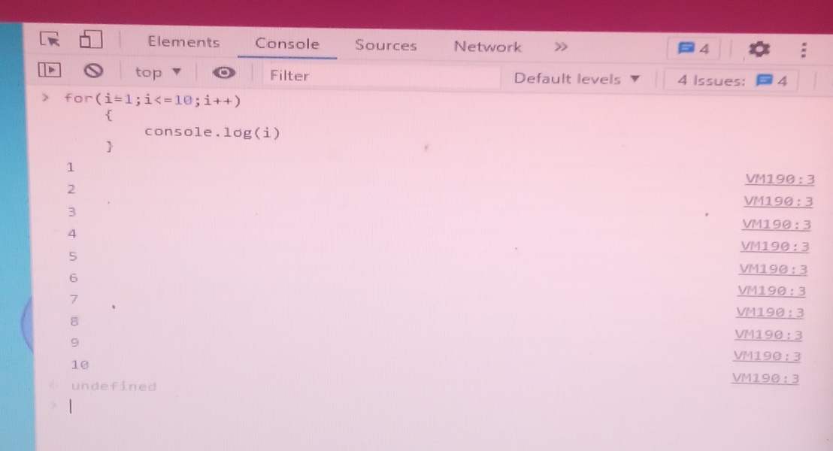

**2-program to calculate the sum of first 10 numbers.**

Class Number

{

Public static void main(String[] args)

{

Int i,sum=0;

For(i=1;i<=10;i++)

{

Sum=sum+I;

}

System.out.println(sum);

}

}

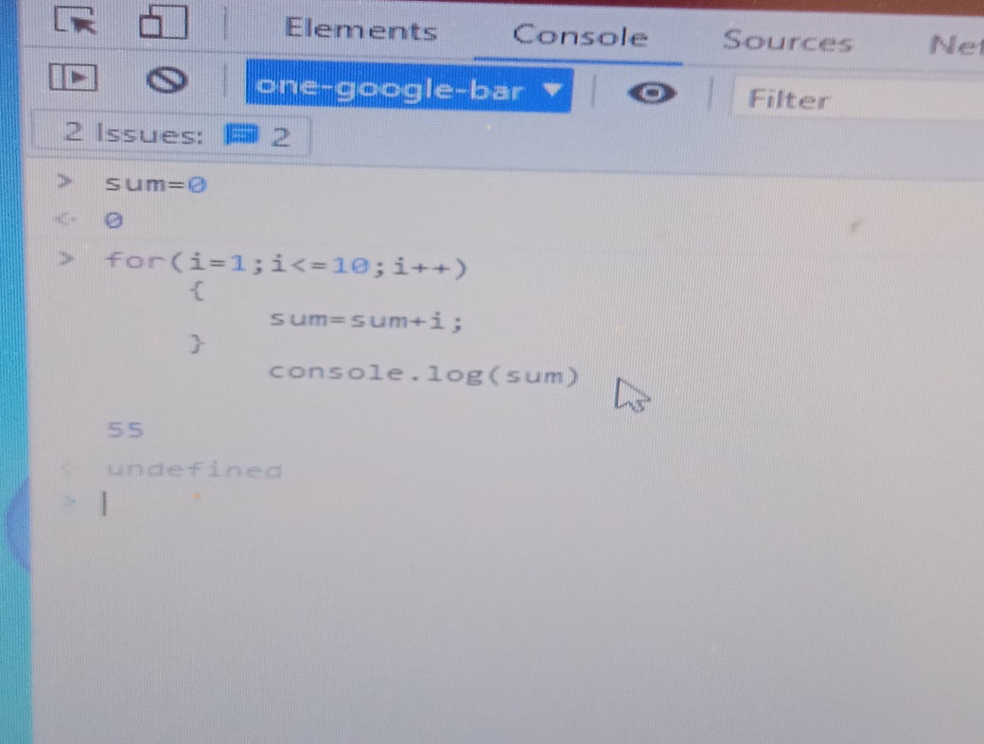

**3- Make the loop stop when I is 5**

Public class JumpStatement{

Public static void main(String[] args)

{

For(int i=1;i<=10;i++)

{

If(i==5)

Braek;

System.out.println(“value of I is”+i);

}

System.out.println(“End of loop..”);

}

}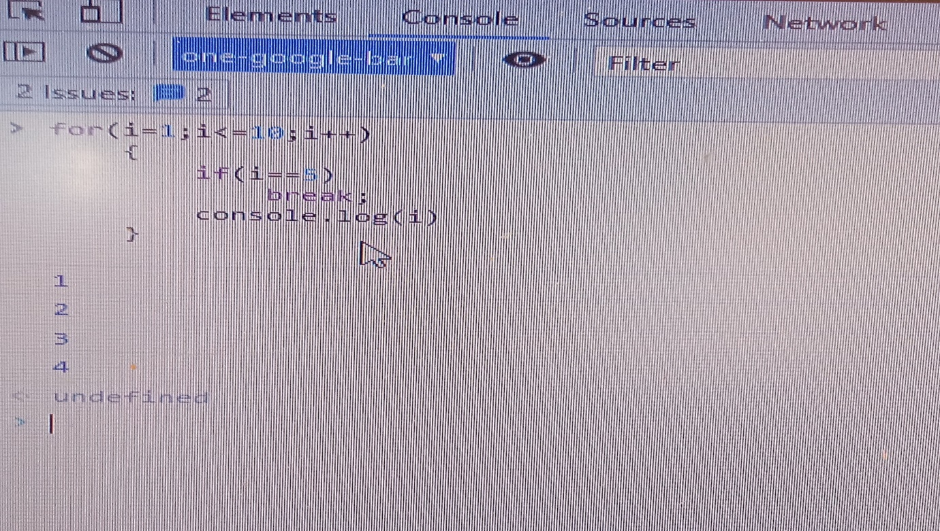

4-Write a program to print day of week name using switch case

class Geekyshows

{

Public static void main(String[] args)

{

Switch(2)

{

Case 1:

{

System.out.println(“Monday”);

Break;

}

Case 2:

{

System.out.println(“Sunday”);

Braek;

}

Default:

{

System.out.println(“Noday”);}

}

}

}

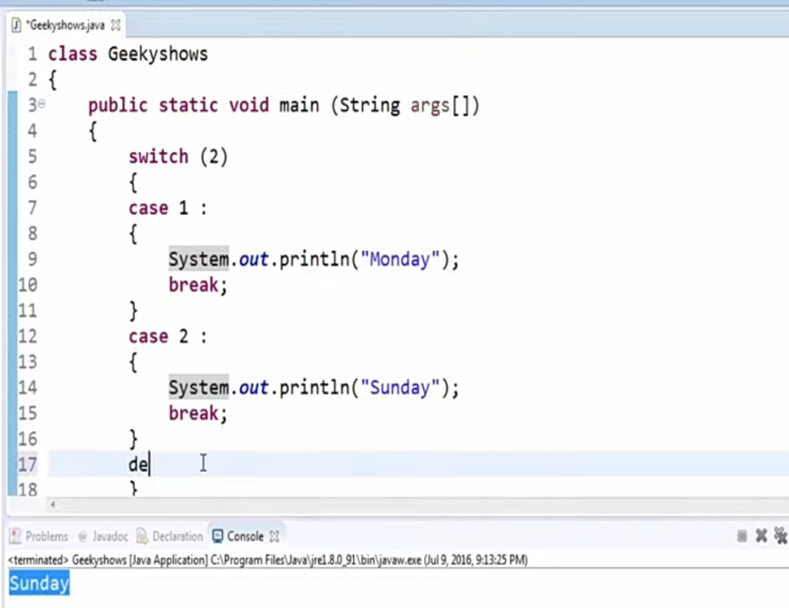

**5-Write a program print total number of days in a month using switch case.**

Public class printNumberofDaysInMonth {

Public static void main(String[] args)

Int number =6;

Switch(Number)

{

Case 1:

System.out.println(“31”);

Break;

Case 2:

System.out.println(“28/29”);

Case 3:

Sysyem.out.println(“31”);

Default:

System.out.println(“Enter valid inputs”);

}

}

}

