WORKFLOW DOCUMENTATION
Workflow Diagrams
End-to-end operational workflows starting with organisation creation
TiketVault · Product documentation

Document | TiketVault Workflow Diagrams
Version | 1.0 — current state
Date | 12 November 2026
Audience | Product, operations, engineering
Diagrams | 21 Mermaid workflows

CONFIDENTIAL — INTERNAL PRODUCT DOCUMENTATION

Contents
1. End-to-end platform workflow
2. Organisation creation and setup
2.1 Sequence
2.2 Organisation state
2.3 Role assignment
3. Venue and seating setup
3.1 Venue versioning
4. Event creation and publishing
4.1 Event lifecycle
5. Booking and checkout
5.1 Ticketed flow
5.2 Free registration flow
5.3 Booking status state
5.4 Seat hold lifecycle
6. Ticket issuance and transfer
7. Check-in
8. Membership lifecycle
9. Donation and tax receipt
10. Feature entitlements
11. Payout and reconciliation
12. Audit trail
13. Reporting
14. Detailed workflow handoffs
14.1 Organisation creation and setup
14.2 Venue to event
14.3 Booking to check-in
14.4 Donation to receipt
14.5 Transfer
15. Workflow ownership matrix

TiketVault — Complete Workflow Diagrams
Document status: Current-state operational workflows
Starting point: Organisation creation
Aligned to code: 12 November 2026

1. End-to-end platform workflow
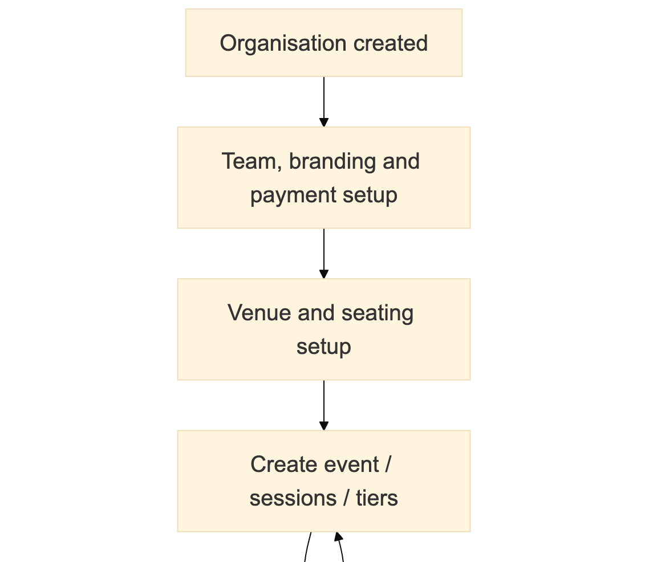
Figure 1 — workflow / architecture diagram (part 1 of 3)

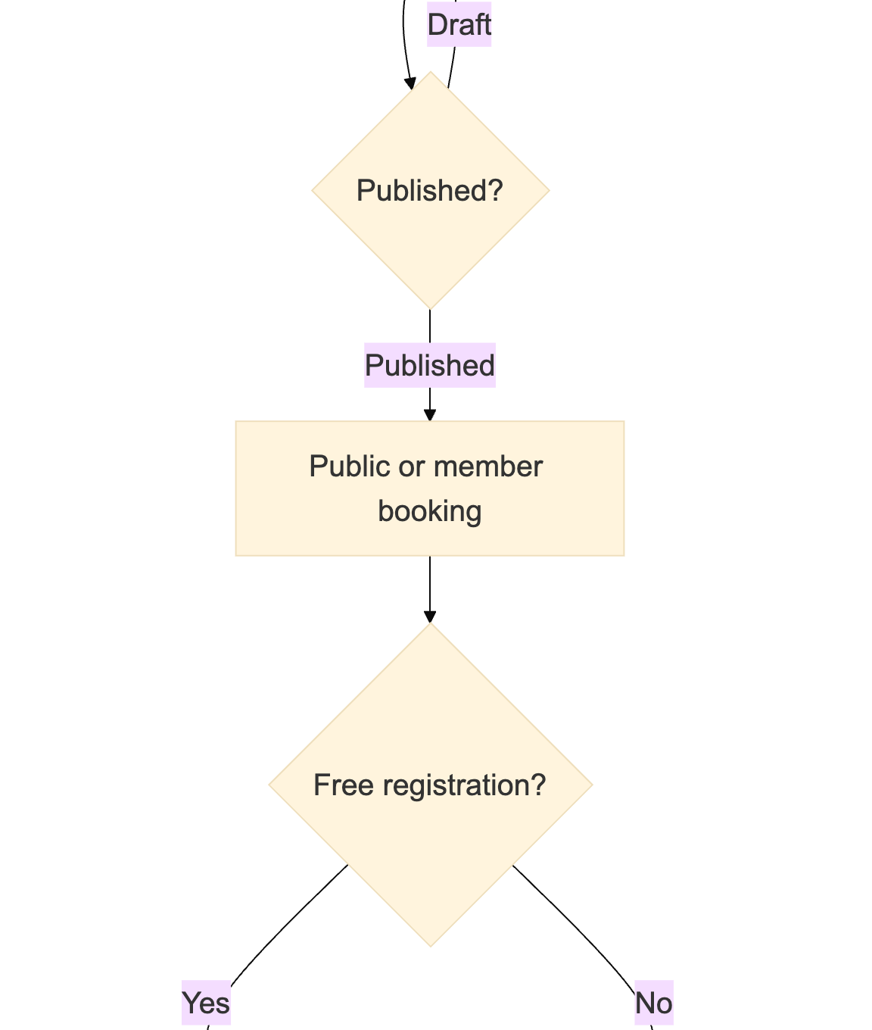
Figure 1 — workflow / architecture diagram (part 2 of 3)

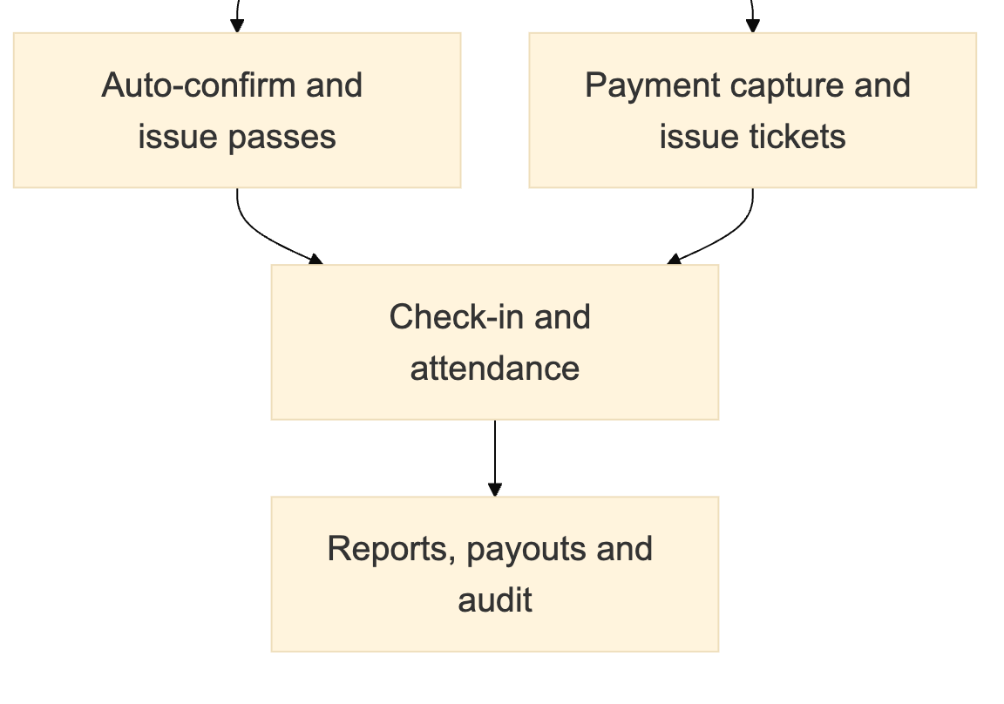
Figure 1 — workflow / architecture diagram (part 3 of 3)

2. Organisation creation and setup

2.1 Sequence
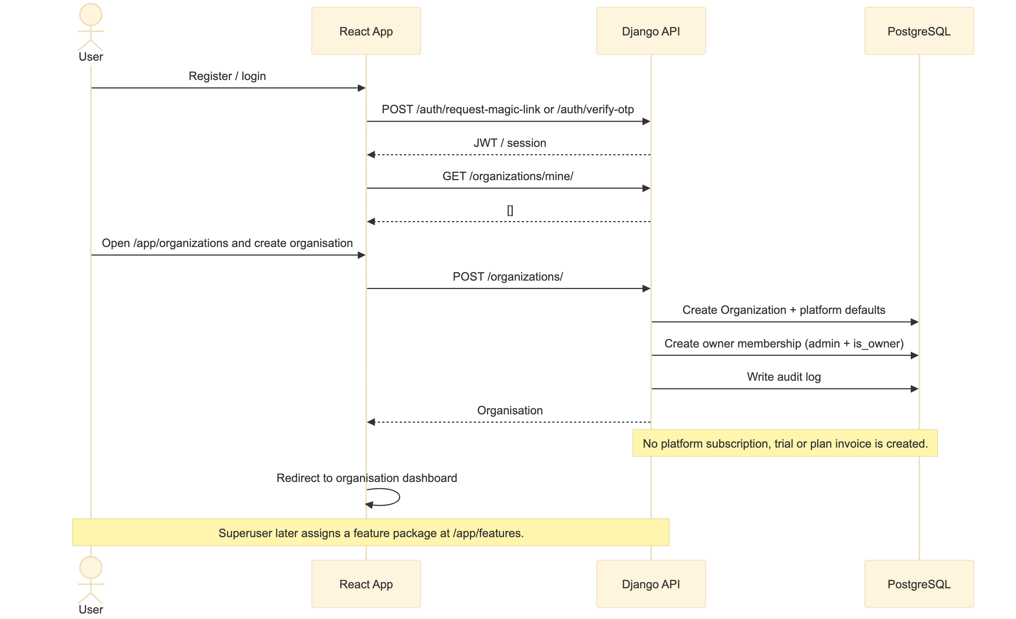
Figure 2 — workflow / architecture diagram

2.2 Organisation state
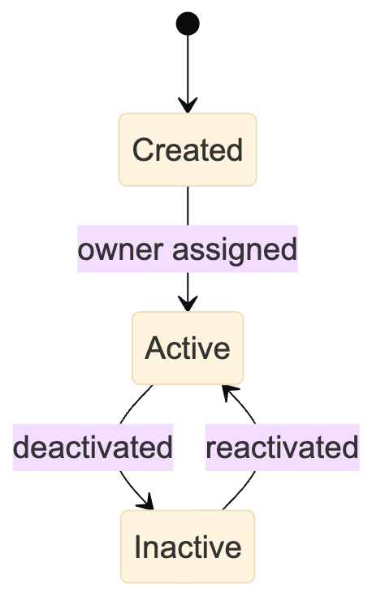
Figure 3 — workflow / architecture diagram
Feature package assignment does not change organisation lifecycle state. It changes the effective feature set only.

2.3 Role assignment
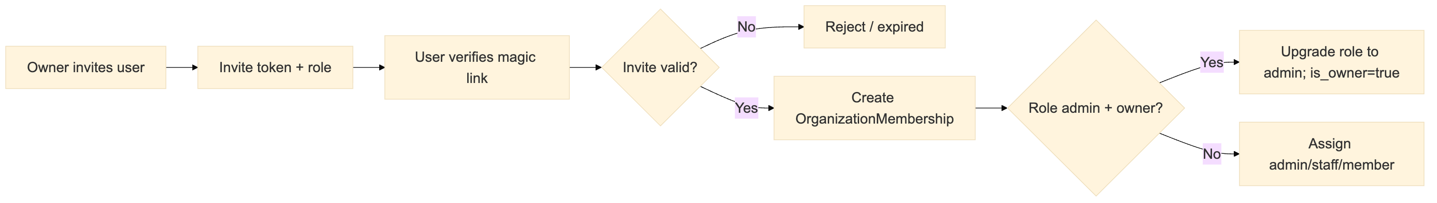
Figure 4 — workflow / architecture diagram

3. Venue and seating setup
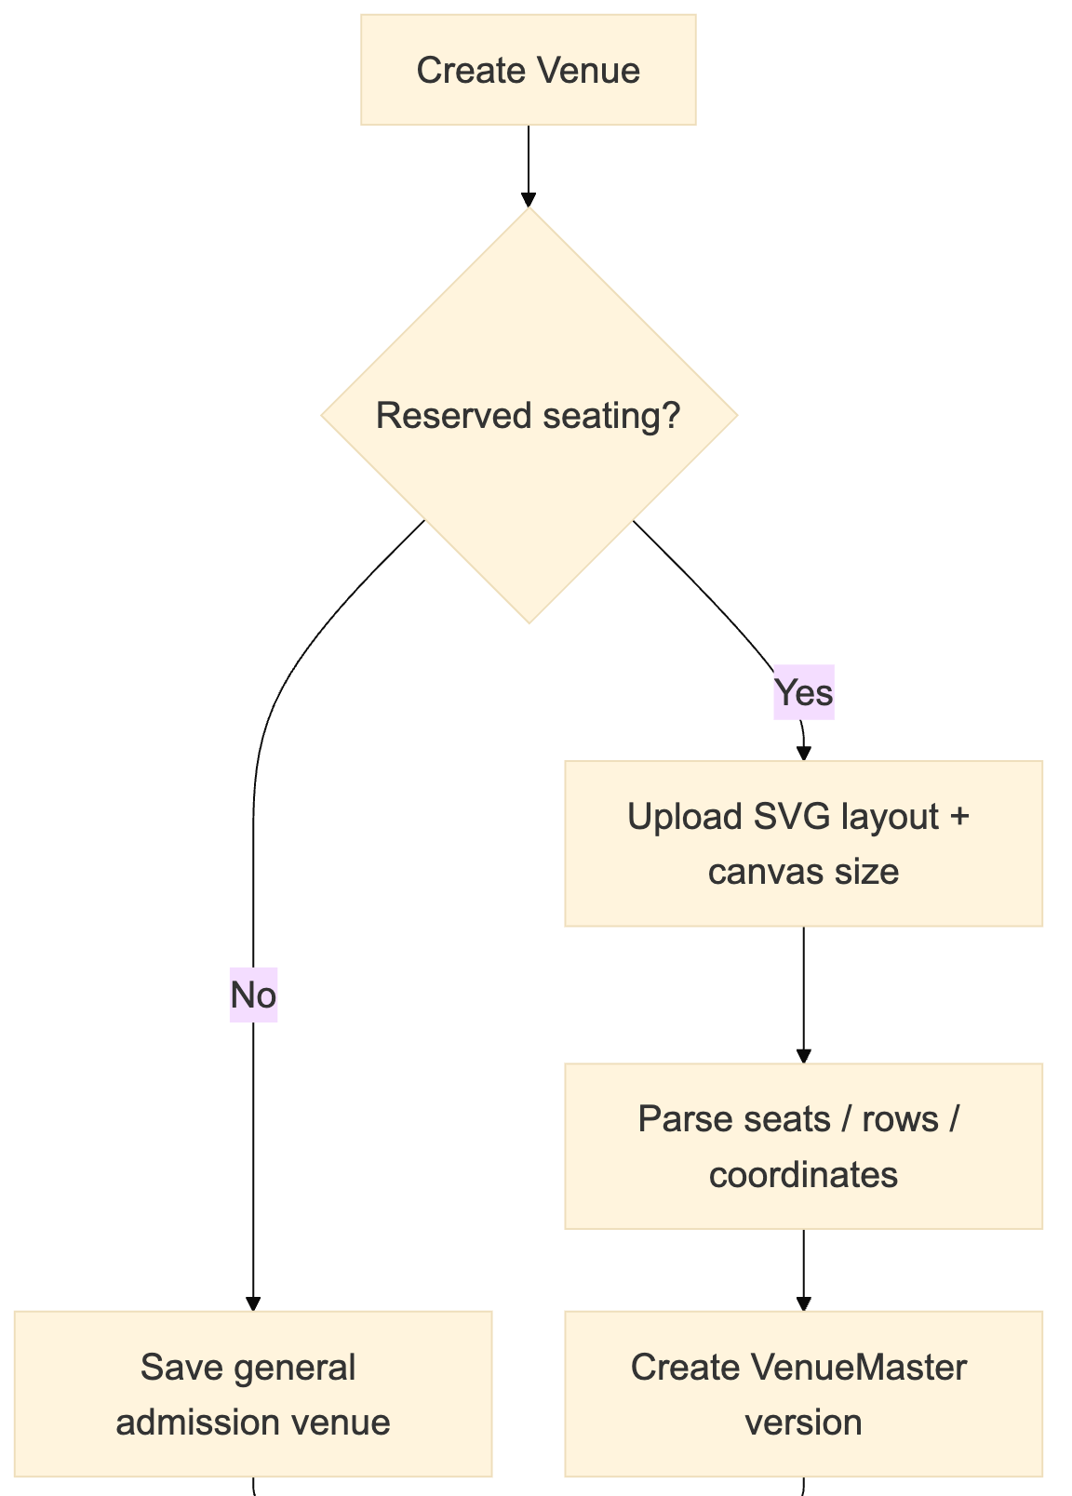
Figure 5 — workflow / architecture diagram (part 1 of 3)

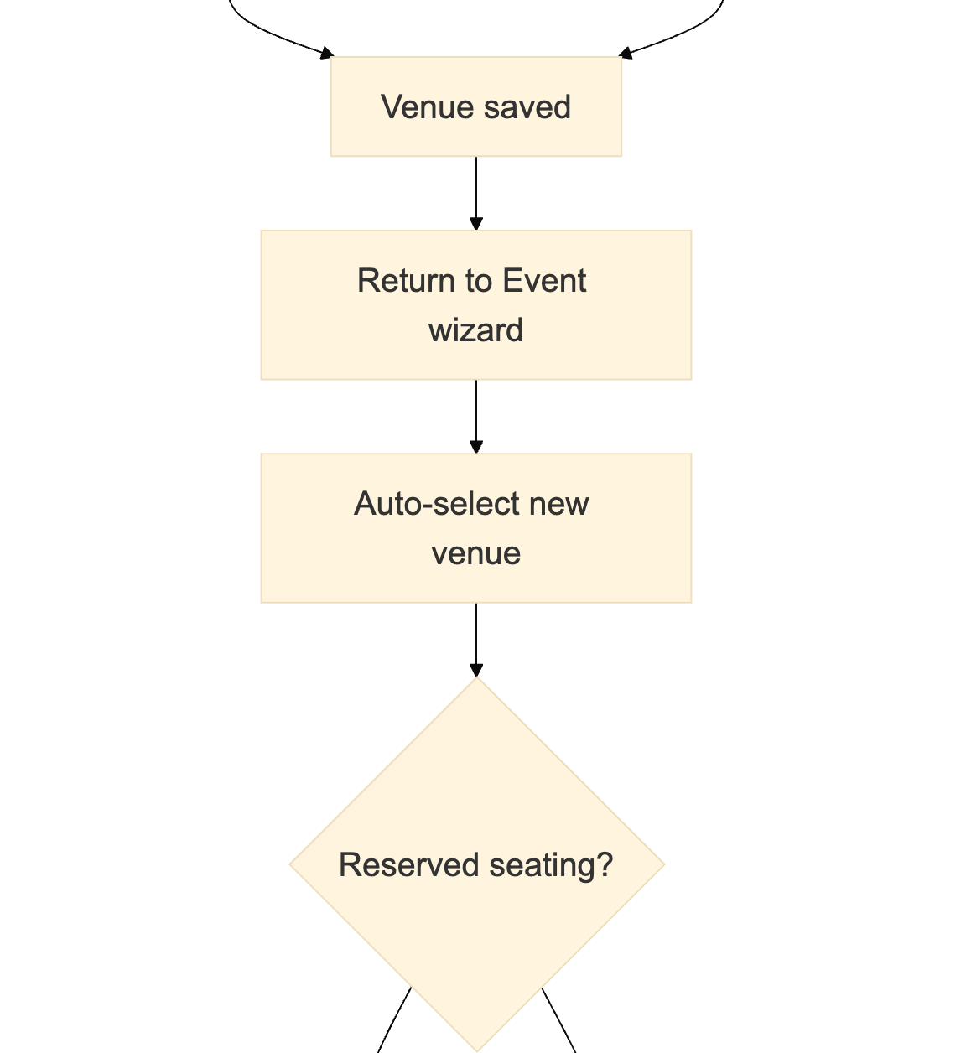
Figure 5 — workflow / architecture diagram (part 2 of 3)

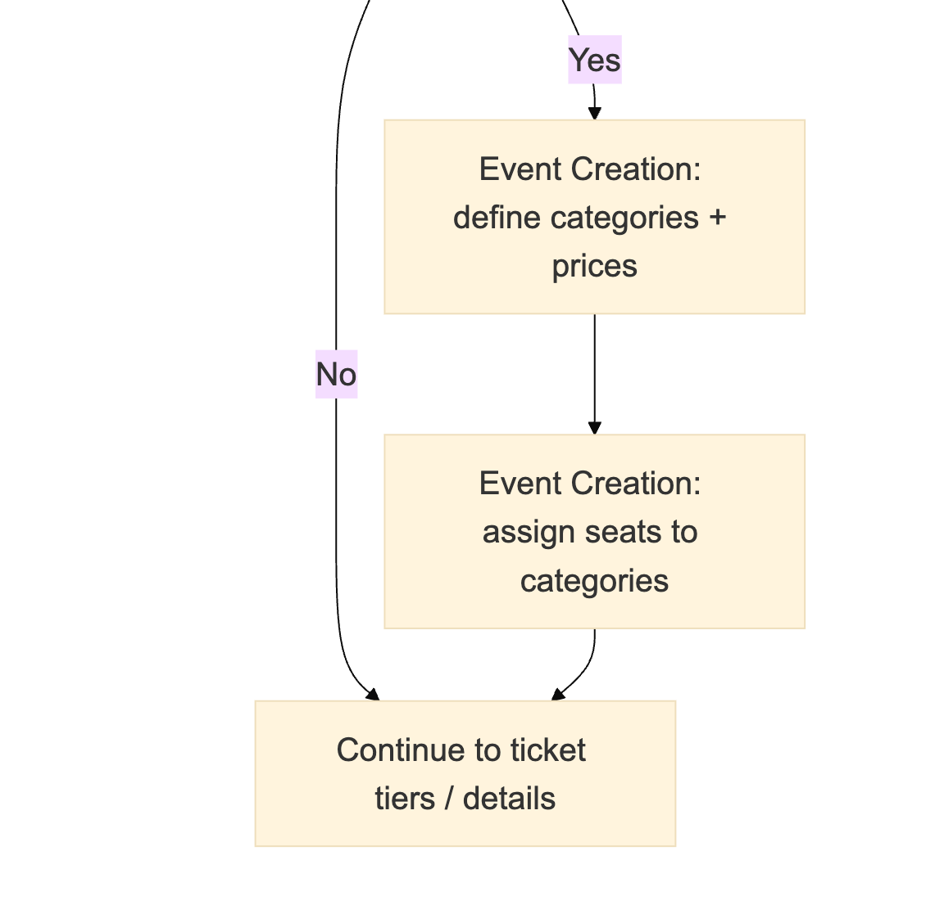
Figure 5 — workflow / architecture diagram (part 3 of 3)
Venue creation owns geometry. Event Creation owns category composition and pricing.

3.1 Venue versioning
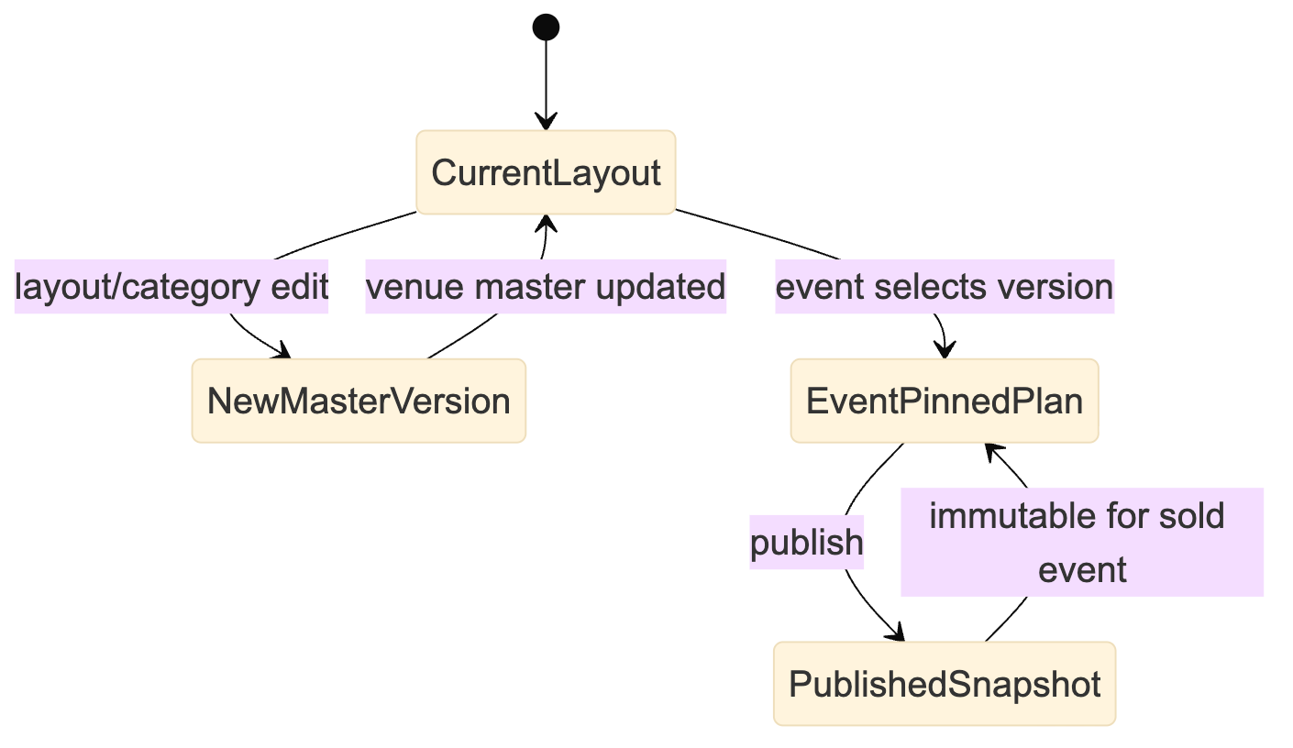
Figure 6 — workflow / architecture diagram

4. Event creation and publishing
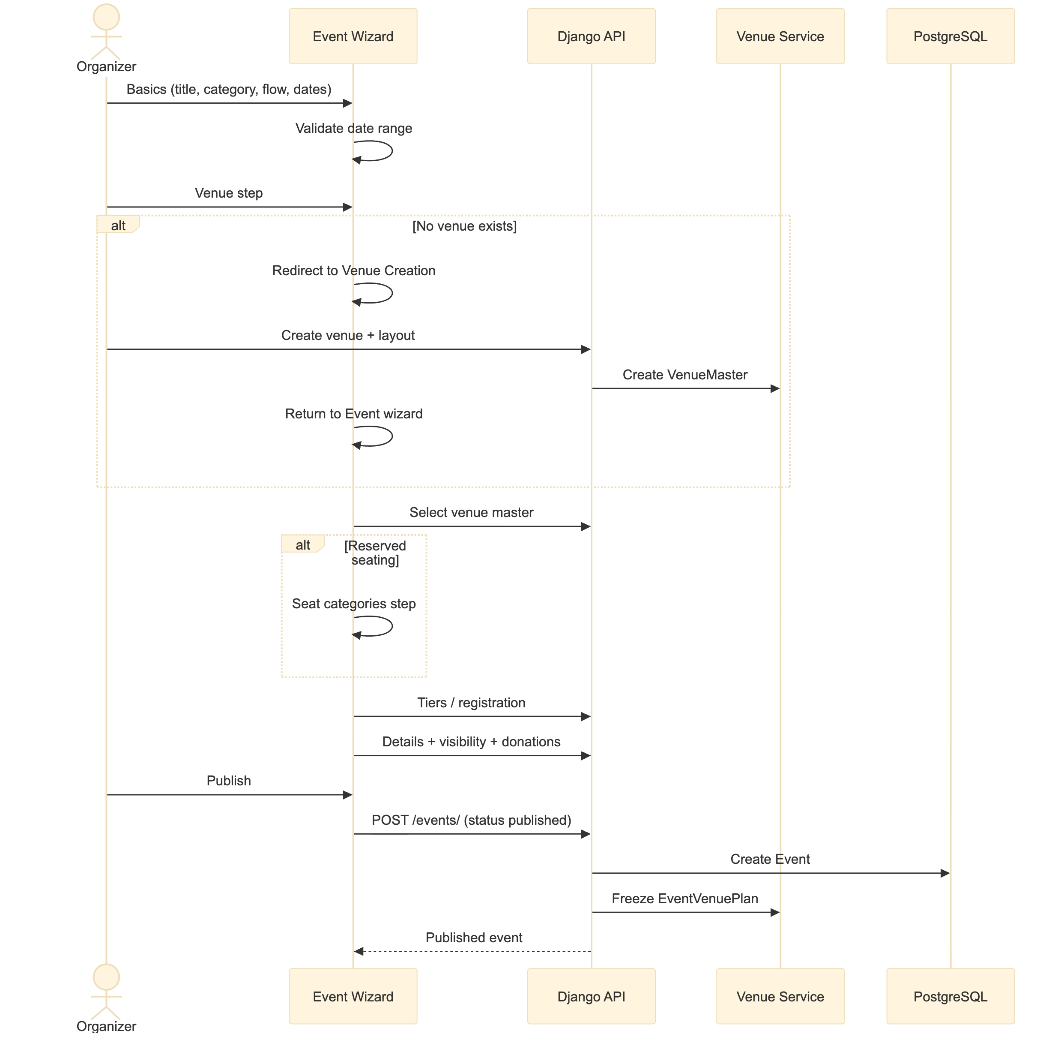
Figure 7 — workflow / architecture diagram

4.1 Event lifecycle
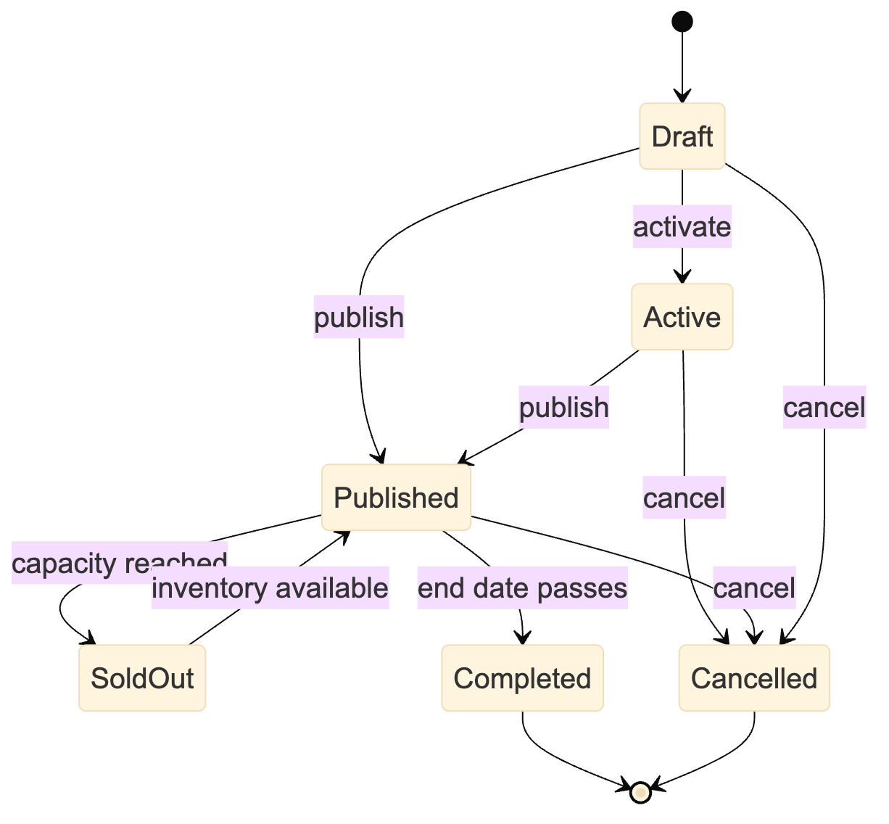
Figure 8 — workflow / architecture diagram

5. Booking and checkout

5.1 Ticketed flow
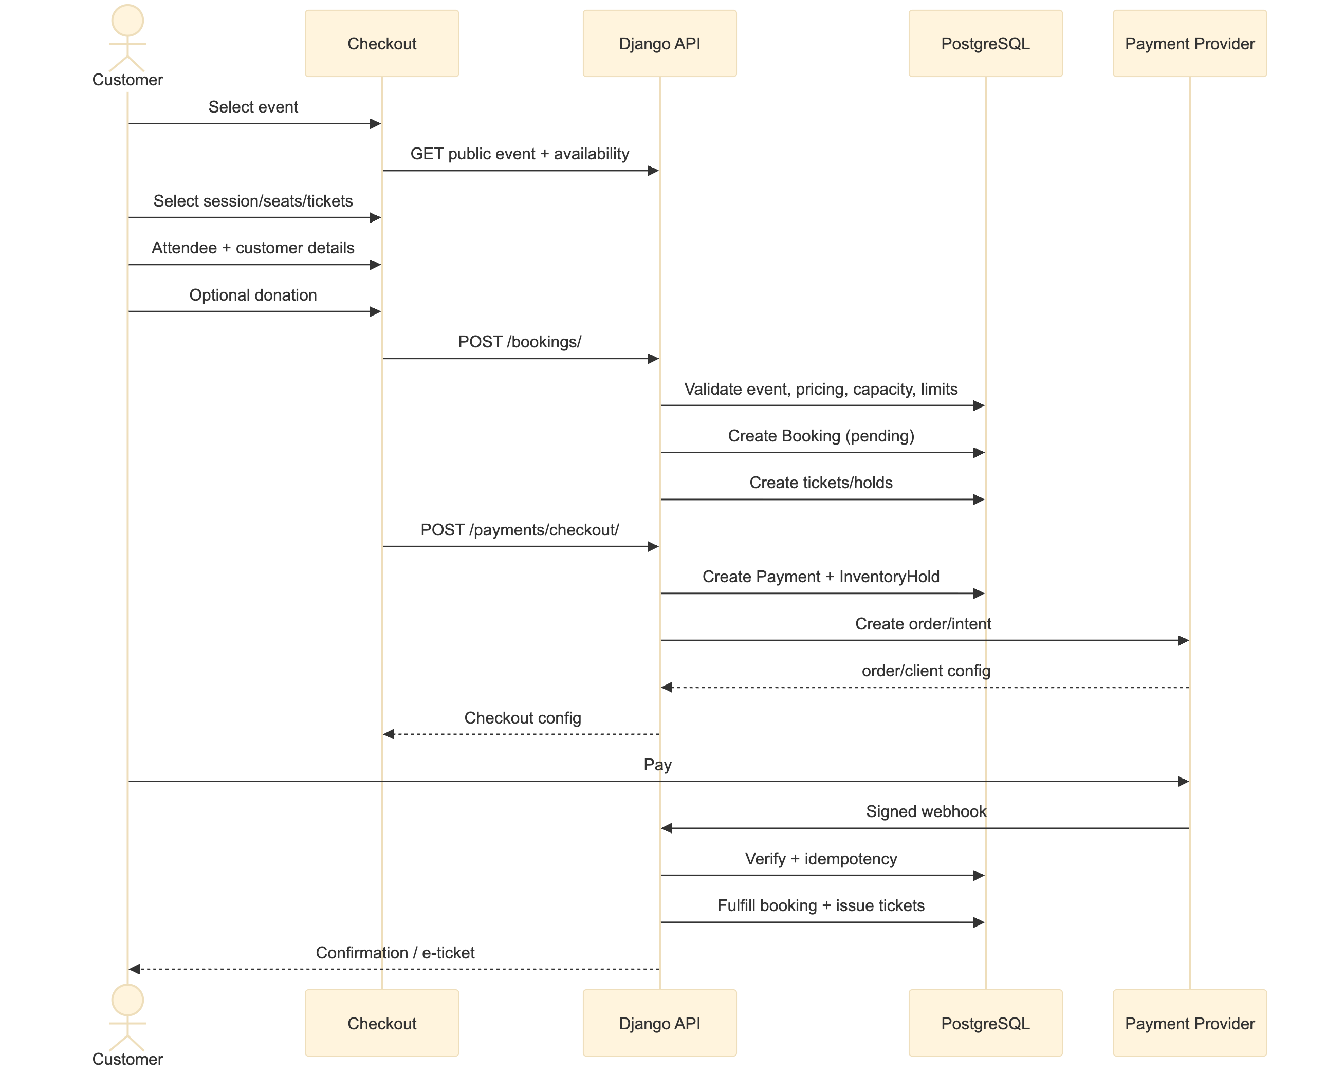
Figure 9 — workflow / architecture diagram

5.2 Free registration flow
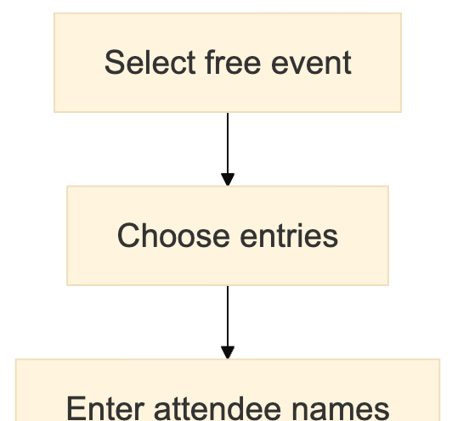
Figure 10 — workflow / architecture diagram (part 1 of 3)

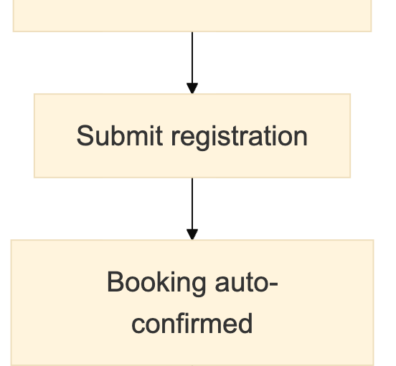
Figure 10 — workflow / architecture diagram (part 2 of 3)

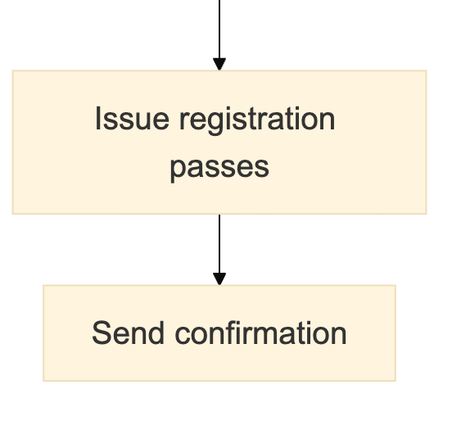
Figure 10 — workflow / architecture diagram (part 3 of 3)

5.3 Booking status state
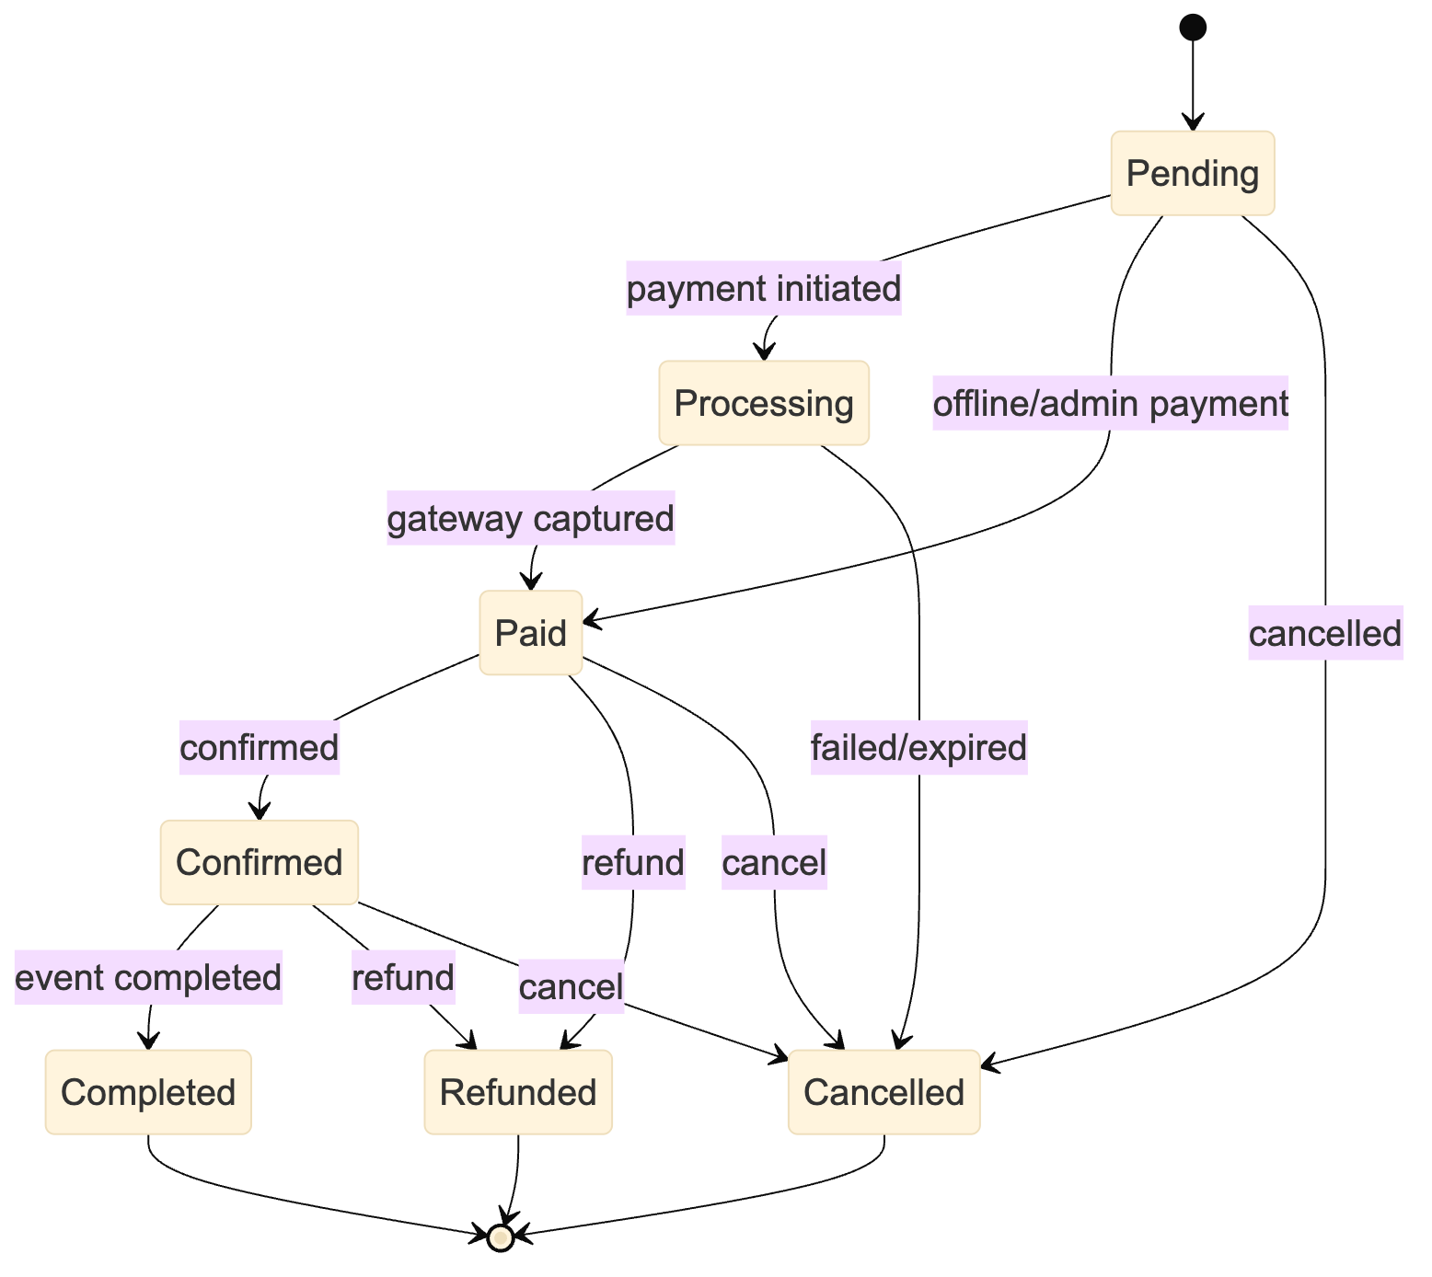
Figure 11 — workflow / architecture diagram

5.4 Seat hold lifecycle
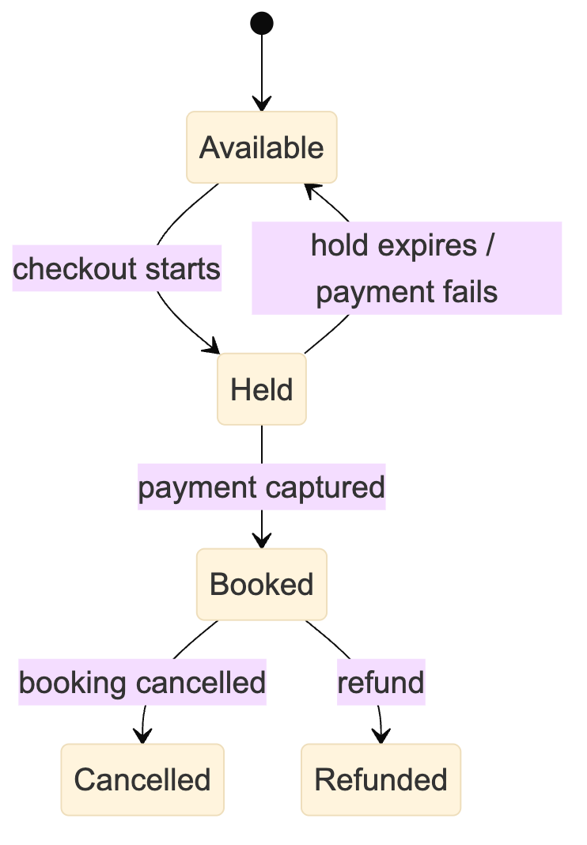
Figure 12 — workflow / architecture diagram

6. Ticket issuance and transfer
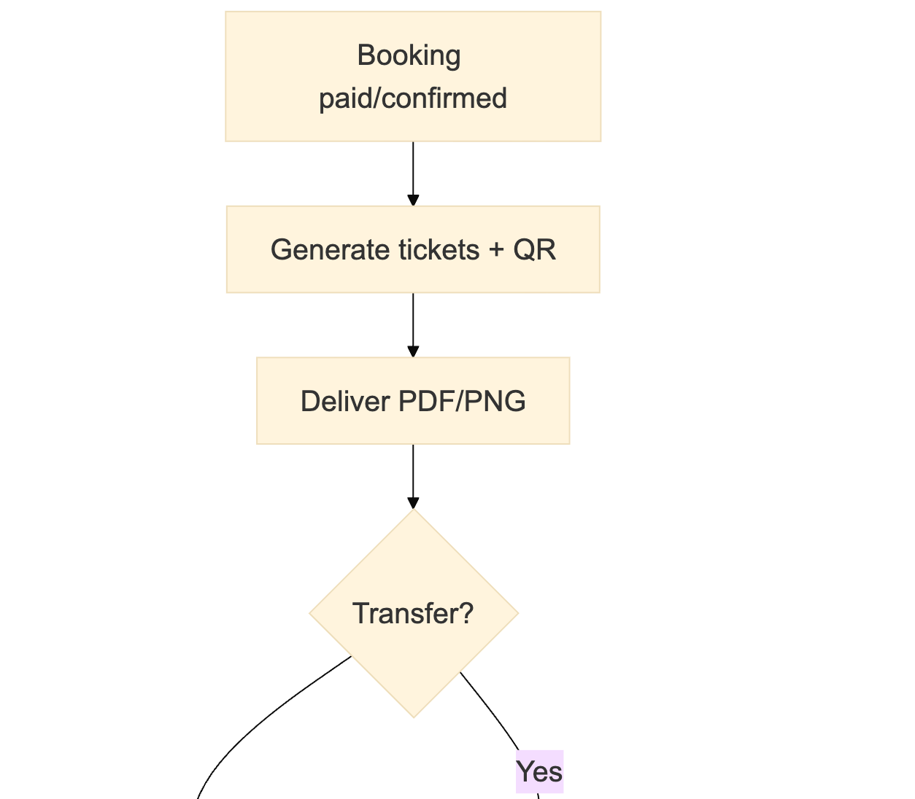
Figure 13 — workflow / architecture diagram (part 1 of 3)

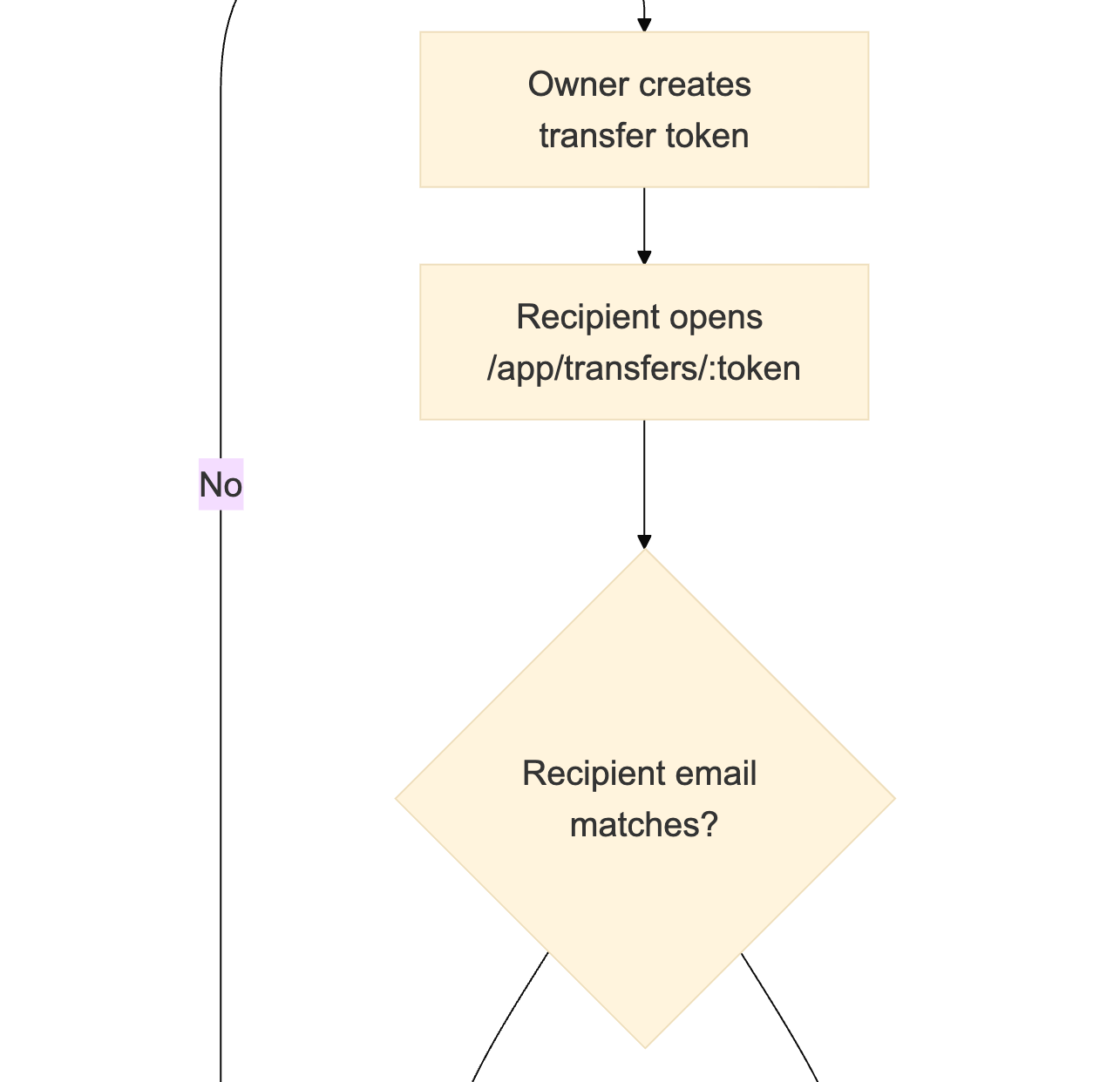
Figure 13 — workflow / architecture diagram (part 2 of 3)

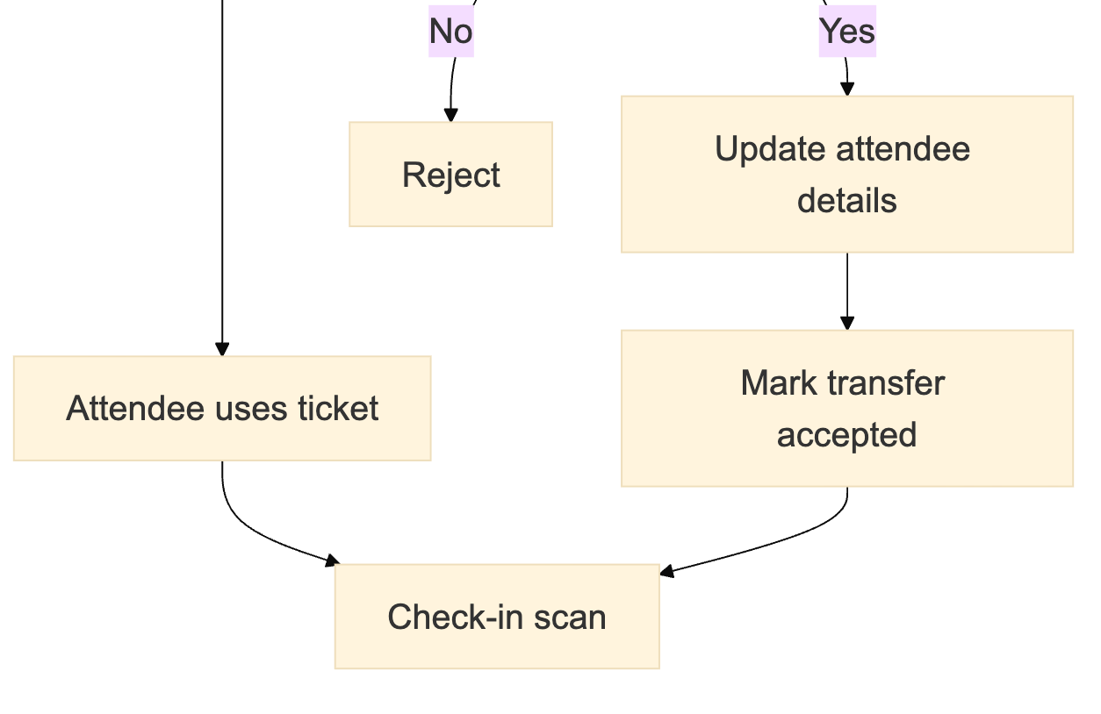
Figure 13 — workflow / architecture diagram (part 3 of 3)
Transfer acceptance also regenerates the ticket code and QR. The previous QR must no longer be accepted. The current implementation returns the accept token to the caller; it does not automatically email the recipient.

7. Check-in
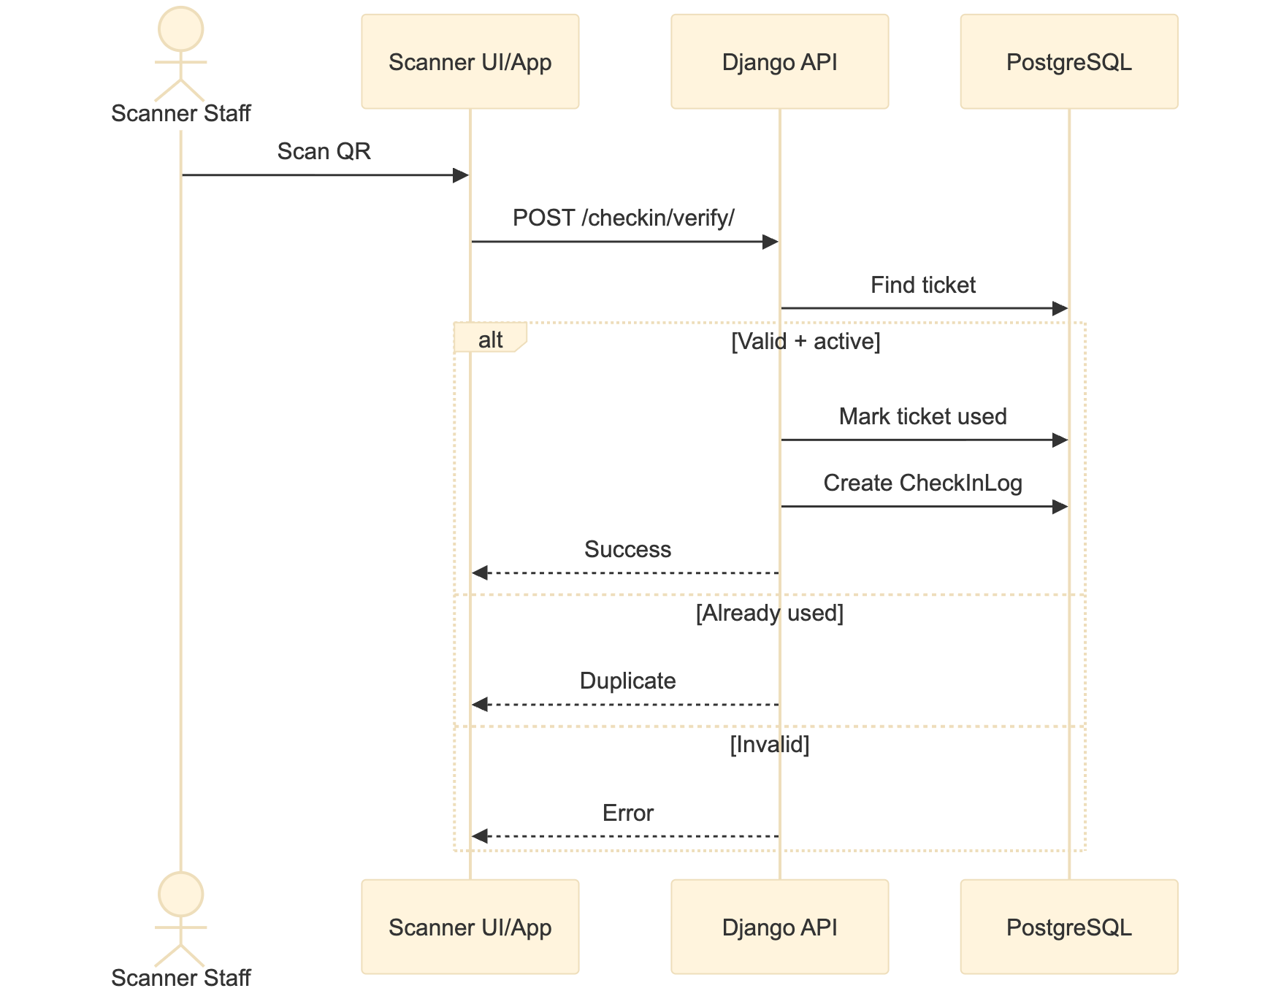
Figure 14 — workflow / architecture diagram
Offline mode:
- Download offline pack.
- Scan locally.
- Queue scans.
- Sync with /checkin/offline-sync/.
- Resolve conflicts idempotently.
Each successful check-in creates a CheckInLog containing the ticket, event/session, authenticated scanner_user, device id, IP, location, status and offline-sync fields.

8. Membership lifecycle
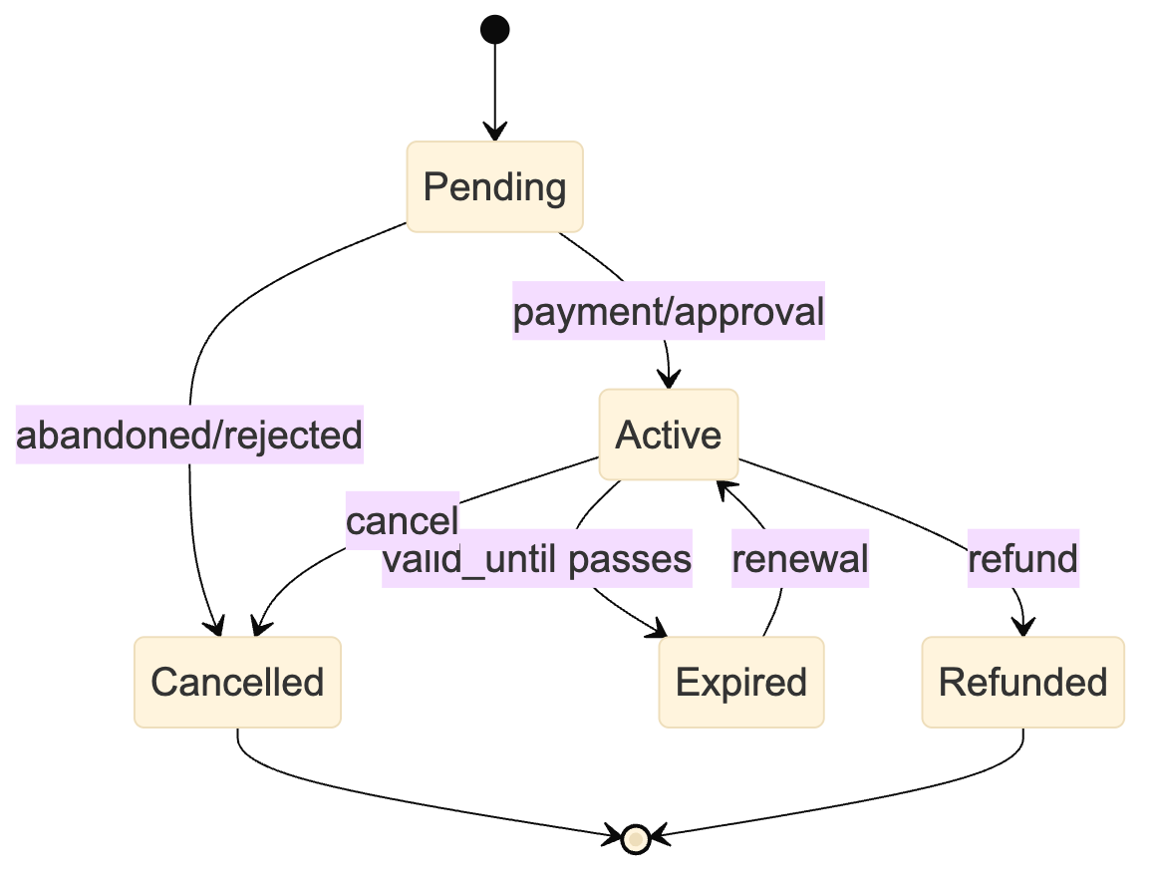
Figure 15 — workflow / architecture diagram
Offline membership:
- Admin uploads CSV or creates offline request.
- Membership = pending_offline.
- Owner/admin reviews.
- Approve → active; reject → cancelled.

9. Donation and tax receipt
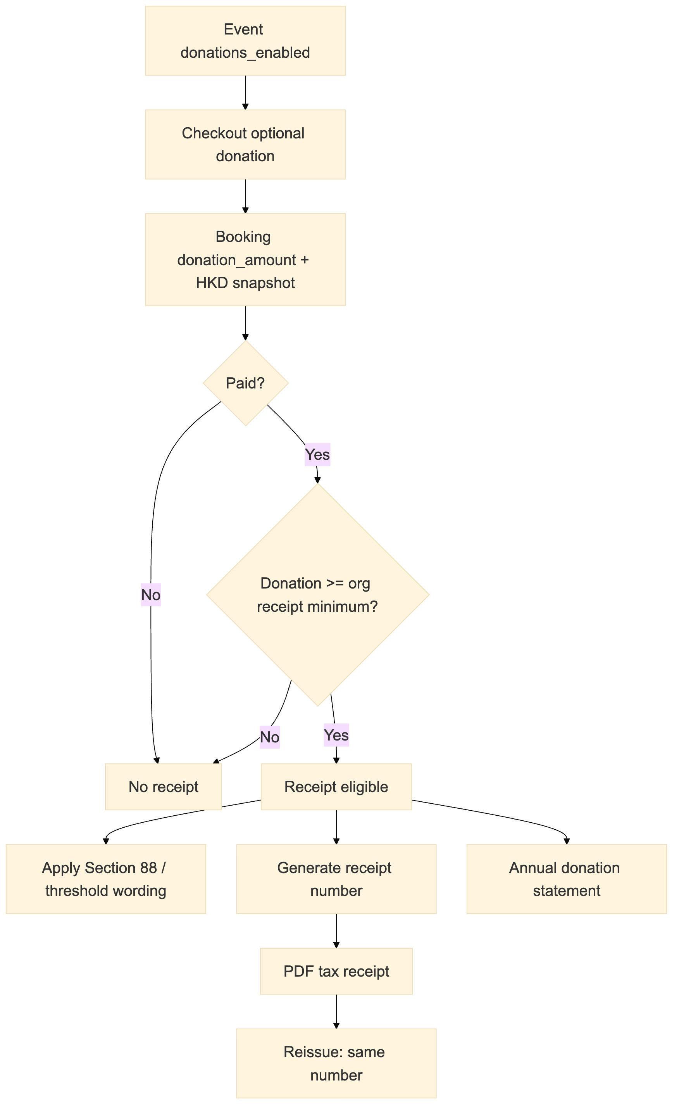
Figure 16 — workflow / architecture diagram
Receipt eligibility uses the organisation's donation_receipt_min_amount; the ird_section88 and tax_receipt_threshold settings decide whether statutory tax wording is printed. The old fixed HKD 2,000 rule is no longer the only criterion.

10. Feature entitlements
Feature access is resolved from the organisation's package plus per-tenant overrides. There is no subscription or plan billing in the current product.
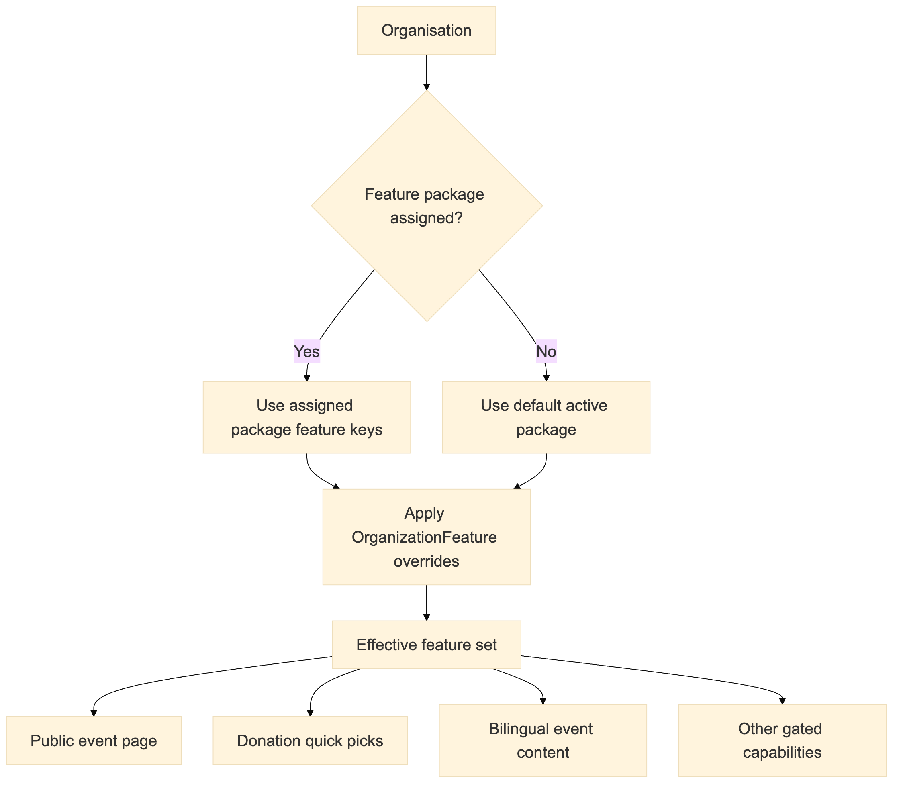
Figure 17 — workflow / architecture diagram
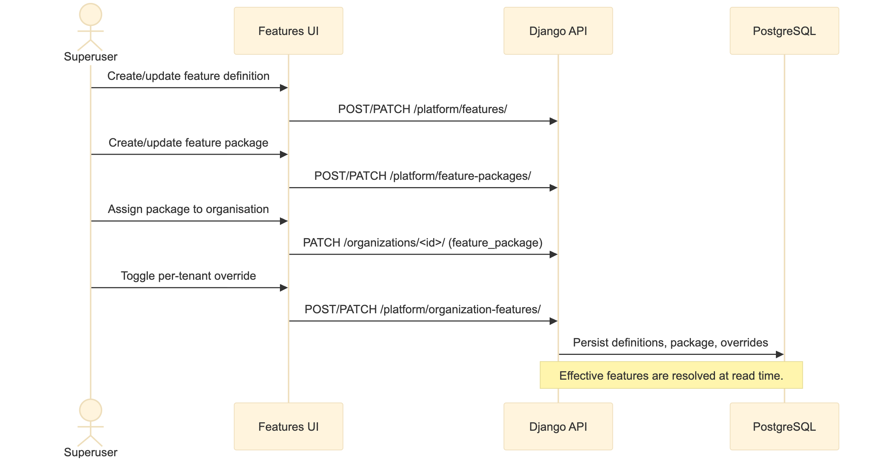
Figure 18 — workflow / architecture diagram

11. Payout and reconciliation
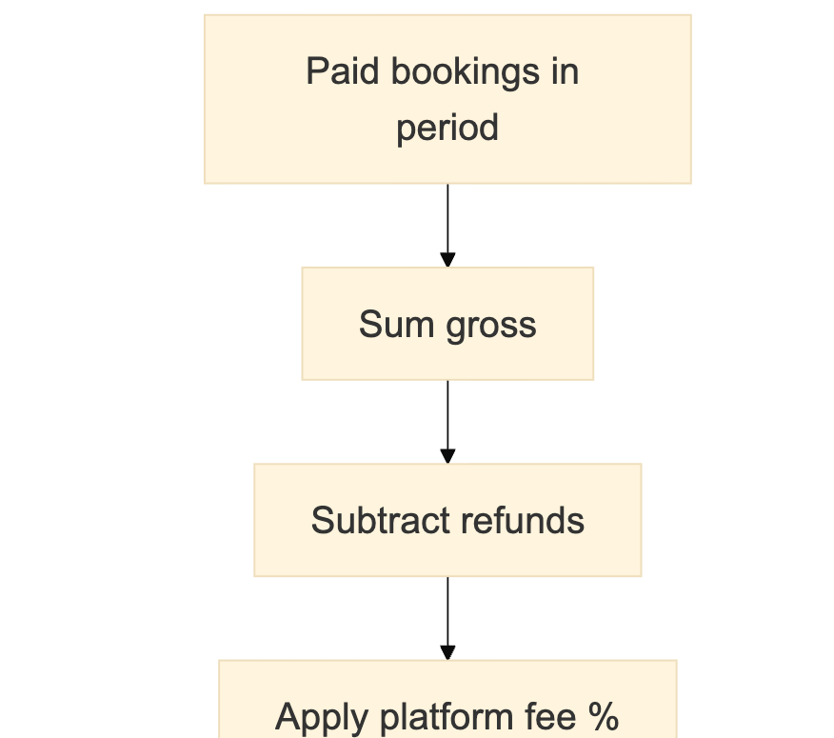
Figure 19 — workflow / architecture diagram (part 1 of 3)

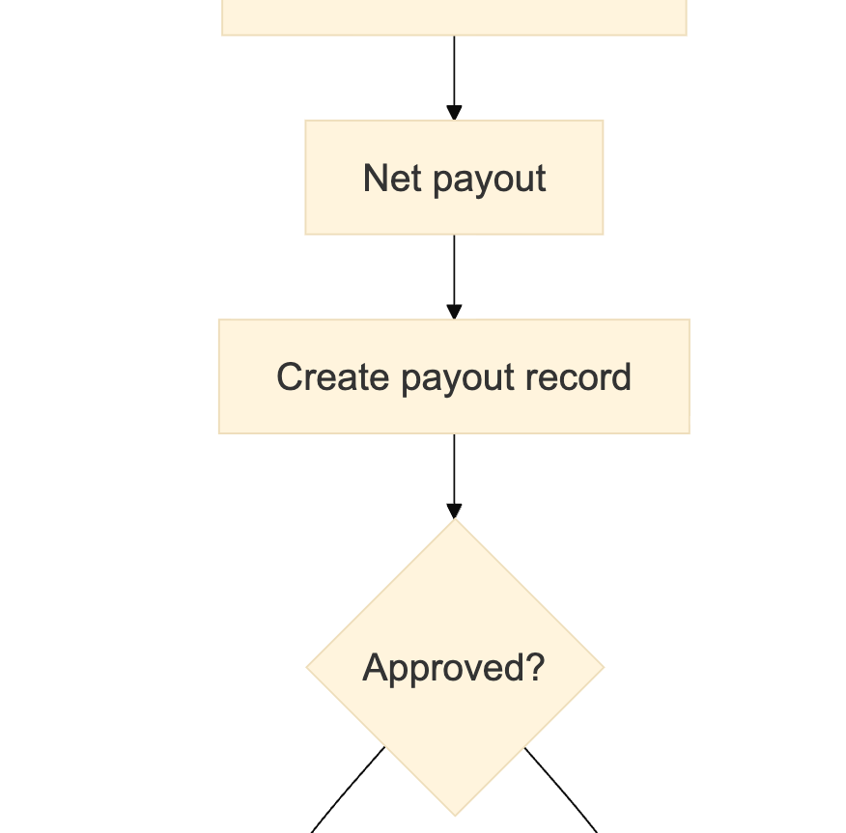
Figure 19 — workflow / architecture diagram (part 2 of 3)

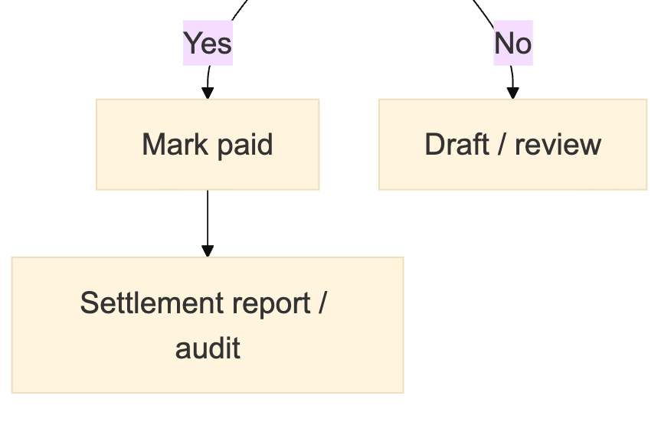
Figure 19 — workflow / architecture diagram (part 3 of 3)

12. Audit trail
Every mutating API request can produce an audit row:
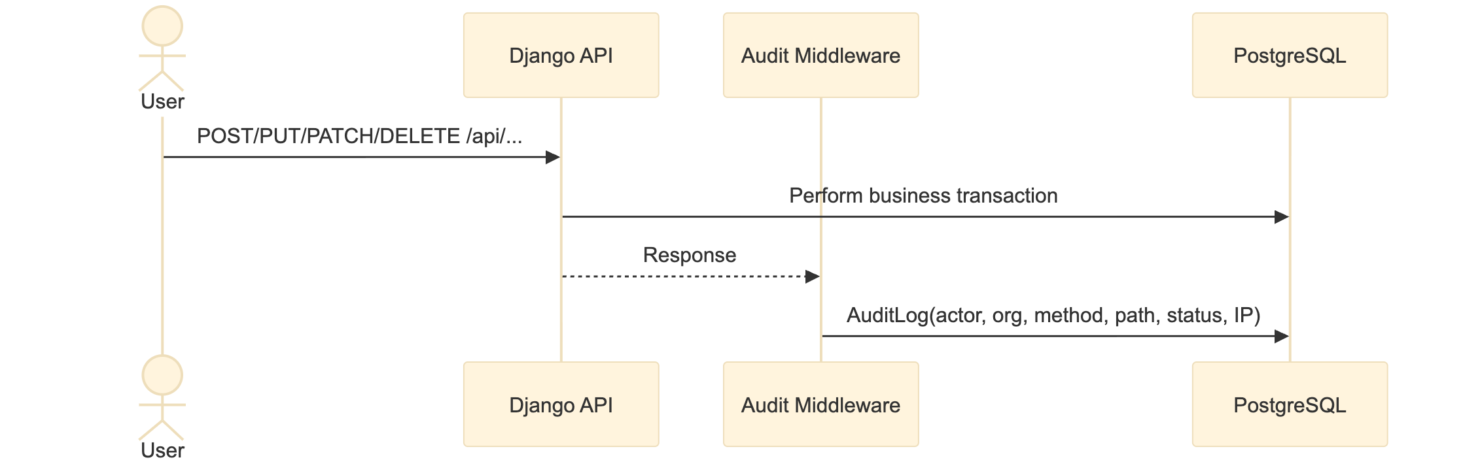
Figure 20 — workflow / architecture diagram

13. Reporting
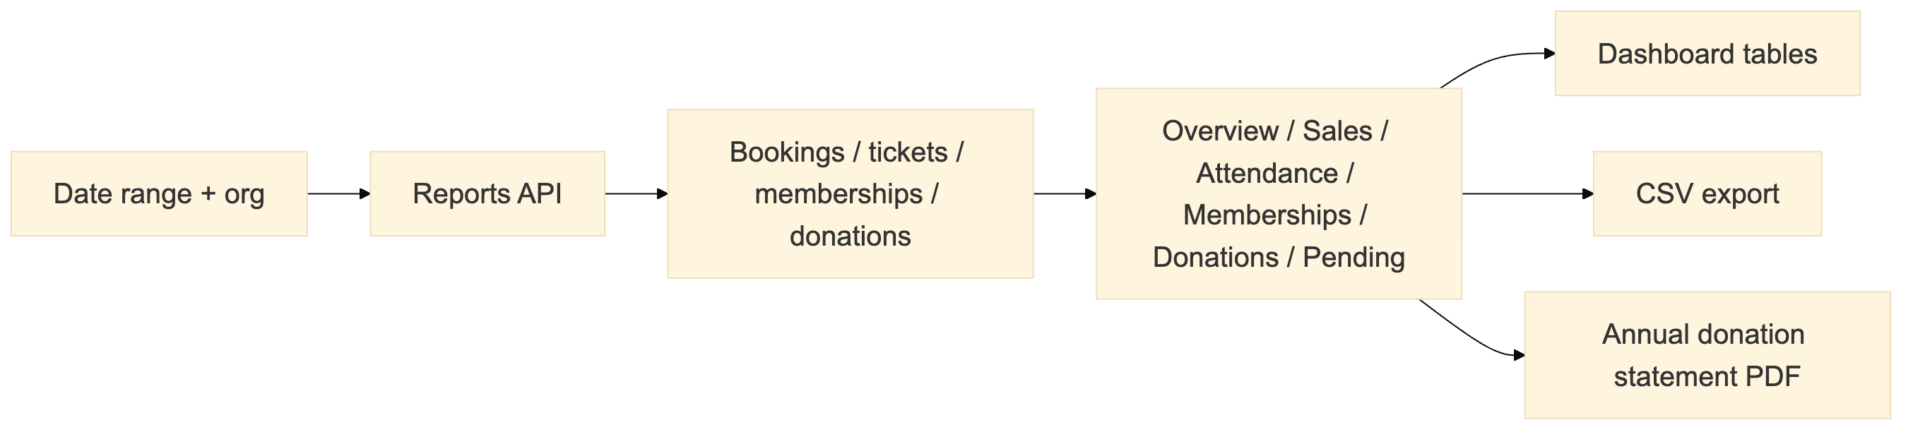
Figure 21 — workflow / architecture diagram

14. Detailed workflow handoffs

14.1 Organisation creation and setup
Step | Actor | Action | Data written | Next state
1 | User | Register/login | User, JWT | Authenticated
2 | User | Create organisation | Organization, owner membership | Organisation Active
3 | Superuser | Assign feature package | Organization.feature_package | Features effective
4 | Owner/Admin | Configure branding/contact | Organisation branding fields | Branding effective
5 | Owner/Admin | Configure payment gateway | OrganizationPaymentConfig | Tenant checkout available
6 | Owner/Admin | Invite team | OrganizationInvite → OrganizationMembership | Team ready

14.2 Venue to event
Step | Actor | Action | Data written
1 | Admin | Create venue | Venue
2 | Admin | Upload SVG + canvas | SeatLayout, Seat rows
3 | System | Create master version | VenueMaster
4 | Admin | Return to Event wizard | Event draft
5 | Admin | Select venue master | EventVenuePlan
6 | Admin | Define categories/prices | EventSeatCategory
7 | Admin | Assign seats | Event seat assignments
8 | Admin | Publish | Frozen plan snapshot

14.3 Booking to check-in
Step | Actor | Action | Data written
1 | Customer | Select event/session/tickets | Booking draft
2 | System | Validate pricing/inventory | Booking (pending), holds
3 | Customer | Pay | Payment attempt
4 | Gateway | Webhook | Payment paid
5 | System | Fulfill | Booking paid/confirmed, Ticket rows, QR
6 | Staff | Scan QR | CheckInLog, Ticket used
7 | System | Report/payout | Reports, OrganizerPayout, AuditLog

14.4 Donation to receipt
Step | Actor | Action | Data written
1 | Admin | Enable donations + presets | Event donation fields
2 | Customer | Add donation at checkout | Booking.donation_amount/currency
3 | System | Verify receipt eligibility | donation_tax_eligible
4 | Admin/Customer | Download/reissue receipt | Receipt number, PDF
5 | Admin | Annual statement | PDF statement

14.5 Transfer
Step | Actor | Action | Data written
1 | Ticket owner | Request transfer | TicketTransfer pending
2 | Recipient | Open token + accept | Transfer accepted
3 | System | Regenerate code/QR | Ticket unique_code, qr_code
4 | Recipient | Use new ticket | Check-in with new QR

15. Workflow ownership matrix
Workflow | Owner role | Admin | Staff | Member | Superuser
Create organisation | Self | Yes | No | No | Yes
Assign feature package | No | No | No | No | Yes
Invite team | Yes | Yes | No | No | Yes
Manage branding | Yes | Yes | No | No | Yes
Payment config | Yes | Yes | No | No | Yes
Create venue/event | Yes | Yes | No | No | Yes
Publish event | Yes | Yes | No | No | Yes
Manage bookings | Yes | Yes | Yes | Own only | Yes
Check-in | Yes | Yes | Yes | No | Yes
Reports | Yes | Yes | No | No | Yes
Payouts | Yes | Yes | No | No | Yes
Audit logs | Yes | Yes | No | No | Yes
Feature entitlements | No | No | No | No | Yes
Donation receipt | Yes | Yes | No | Own booking | Yes
Ticket transfer | Own | Own | Own | Own | Yes

