ARCHITECTURE DOCUMENT
Product Architecture
System architecture, tenancy, domain design, security and deployment
TiketVault · Product documentation

Document | TiketVault Product Architecture
Version | 1.0 — current state
Date | 12 November 2026
Audience | Engineering, product, security, operations
Status | Current-state architecture

CONFIDENTIAL — INTERNAL PRODUCT DOCUMENTATION

Contents
1. Purpose and scope
2. System context
Runtime components
3. Technology stack
Backend
Frontend
Infrastructure
4. Repository structure
5. Backend architecture
5.1 Layering
5.2 Tenancy
5.3 Role model
5.4 API surface
5.5 Key domain services
5.6 Async processing
6. Data architecture
6.1 Domain groups
6.2 Core relationships
6.3 Venue versioning
6.4 Event cancellation, transfers and check-in identity
6.5 Booking and inventory
7. Frontend architecture
7.1 Contexts
7.2 Theming
7.3 Route protection
7.4 Main routes
8. Payments architecture
8.1 Ticket payments
8.2 Feature entitlements and payments
9. Feature entitlements
9.1 Model
9.2 Resolution
9.3 Enforcement
10. Security architecture
10.1 Authentication
10.2 Authorization
10.3 Data protection
10.4 Known security limitations
11. Deployment and operations
11.1 Local Docker topology
11.2 Configuration
11.3 Migrations
11.4 Observability
12. Extensibility and constraints
Extensible
Current constraints
13. Recent product changes reflected in this document
14. Architecture decision summary

TiketVault — Product Architecture
Document status: Current-state architecture
Product: TiketVault multi-tenant event ticketing platform
Repository: /Users/roshankumarbharathan/Projects/TicketVolt
Last aligned to code: 12 November 2026

1. Purpose and scope
TiketVault is a multi-tenant ticketing and event-operations platform. It lets organisations create and publish events, sell or register attendees, manage seating and venues, issue tickets, check attendees in, sell memberships, accept donations, run reports, and use feature entitlements.
This document describes:
- system context and runtime topology
- backend and frontend architecture
- tenancy and access-control model
- domain modules and data ownership
- key services and workflows
- payment, feature entitlements, branding and reporting subsystems
- security, deployment and operational constraints
It is a current-state document. Planned capabilities that are not implemented are called out explicitly.

2. System context
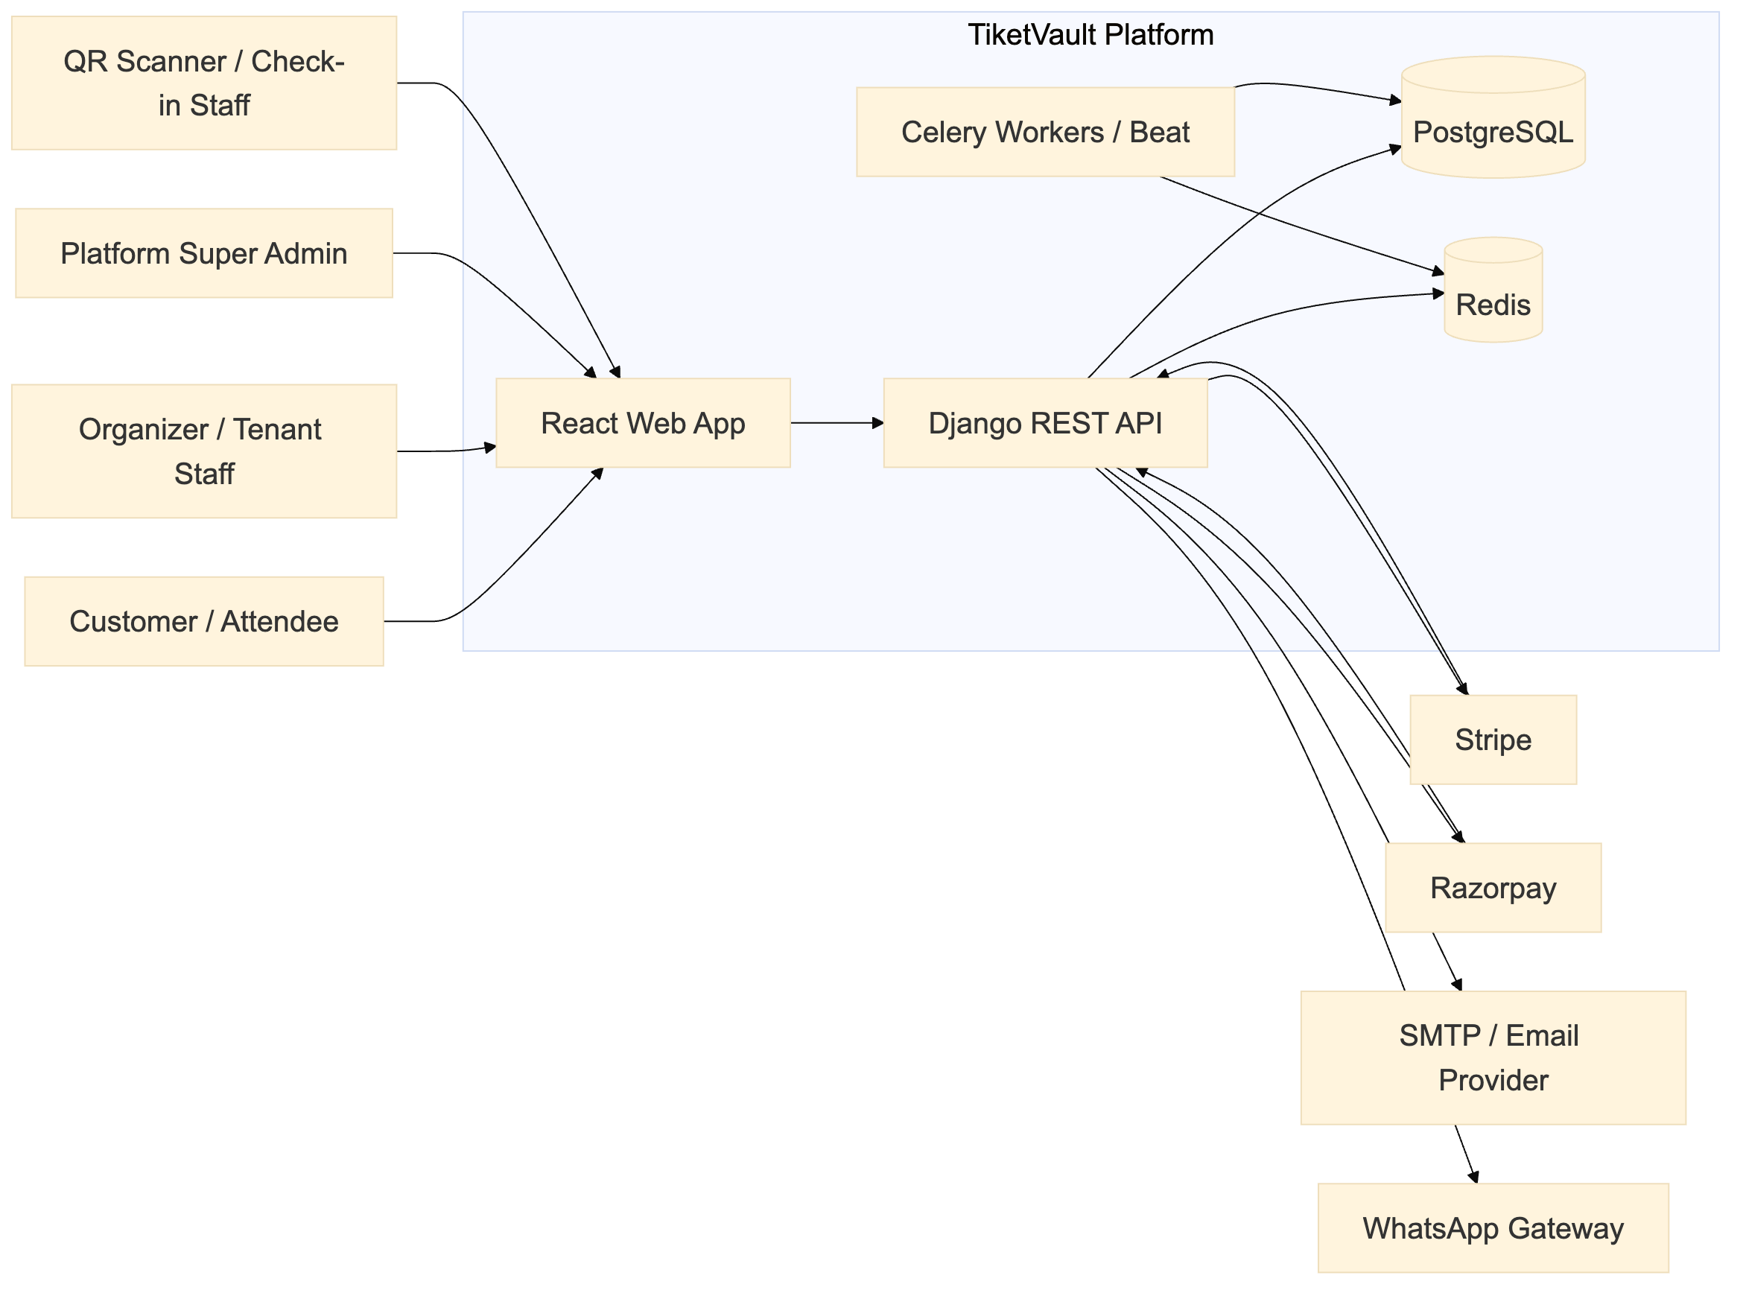
Figure 1 — workflow / architecture diagram

Runtime components
Component | Responsibility
React SPA | All tenant, customer and platform-admin UI
Django REST API | Business logic, authorization, payment orchestration, reports
PostgreSQL | System of record
Redis | Celery broker/cache and transient coordination
Celery worker/beat | Event status updates, payment reconciliation and cleanup
Stripe / Razorpay | Ticket and membership payments
SMTP | Magic links, OTPs, booking confirmations, receipts
WhatsApp gateway | Optional notification/booking channel

3. Technology stack

Backend
- Python 3.11
- Django 4.2.7
- Django REST Framework 3.14
- SimpleJWT 5.3
- PostgreSQL (psycopg2-binary)
- Celery 5.3 + django-celery-beat/results
- Redis
- ReportLab 4.0.9 for PDF tickets and donation receipts
- Pillow for image/ticket rendering
- cryptography for tenant payment-secret encryption
- Stripe and Razorpay SDKs

Frontend
- React 18.2
- React Router 6
- MUI 5 + Emotion
- styled-components 6
- Axios
- i18next / react-i18next (English, Traditional Chinese)
- Konva / react-konva for seating canvases
- Recharts for analytics
- react-toastify

Infrastructure
- Docker Compose for local development
- Nginx-served production React bundle
- PostgreSQL and Redis containers
- Environment-driven configuration for secrets and provider keys

4. Repository structure
TicketVolt/
├── backend/
│ ├── core/ # settings, middleware, permissions, URL root
│ ├── ticket_bookings/
│ │ ├── api/ # DRF viewsets, APIViews, serializers, PDFs
│ │ ├── migrations/
│ │ ├── services/ # tenancy, payments, features, venue versioning...
│ │ ├── management/commands/
│ │ ├── models.py # core models
│ │ ├── models_tenancy.py # Organization + memberships
│ │ ├── models_payments.py # payments, refunds, webhooks, tenant config
│ │ ├── models_seating.py # layouts, seats, reservations
│ │ ├── models_event_venue.py # event-pinned venue plans
│ │ ├── models_venue_master.py
│ │ ├── models_membership.py
│ │ ├── models_features.py
│ │ ├── models_commercial.py
│ │ ├── tasks.py
│ │ └── urls.py
│ └── requirements.txt
├── frontend/
│ ├── src/
│ │ ├── pages/
│ │ ├── components/
│ │ ├── context/ # auth, org, role, branding, entitlements, settings
│ │ ├── features/ # booking/event hooks and payload builders
│ │ ├── services/ # Axios API clients
│ │ ├── theme/ # brand tokens + MUI theme
│ │ ├── styles/ # global CSS and CSS variables
│ │ └── locales/
│ └── package.json
├── QRScannerApp/ # React Native scanner companion
├── shared/ # Shared assets/config
└── docker-compose.yml

5. Backend architecture

5.1 Layering
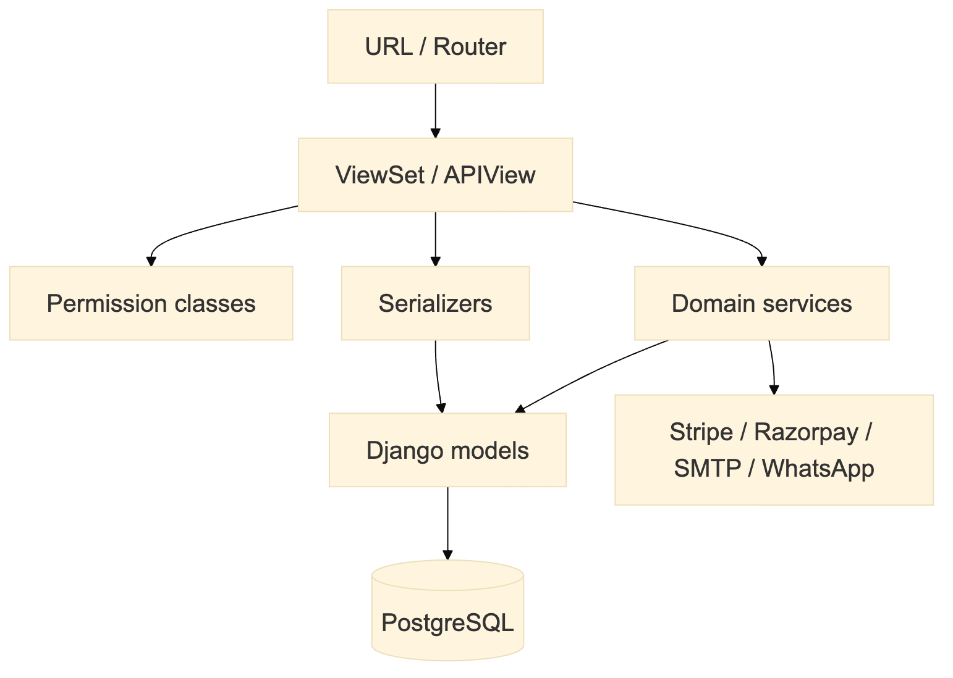
Figure 2 — workflow / architecture diagram
- Views handle HTTP shape, authentication, status codes and throttling.
- Serializers validate input and expose output fields.
- Services own invariants that must be shared across views, tasks and commands.
- Models own persistence, local invariants and derived properties.
- Managers/querysets own canonical status filters and tenancy scoping.

5.2 Tenancy
The tenant boundary is Organization.
Every tenant-owned row carries an organization FK — directly (Venue, Event, Discount, CancellationPolicy, MembershipTier, OrganizationFeature, Payout) or transitively (Booking → Event, Ticket → Booking, Seat → Layout → Venue).
services/tenancy.py is the canonical visibility layer:
- visible_events, visible_bookings, visible_tickets
- can_manage_org, can_operate_org
- user_org_ids, paid_membership_org_ids
- publicly_visible_events, events_visible_to_buyer
- filter_organization_param
Rule: only User.is_superuser sees all tenants. is_staff is Django-admin access, not a cross-tenant data privilege.

5.3 Role model
Layer | Role | Meaning
Platform | is_superuser | All organisations, all platform settings
Platform | authenticated user | Own data and permitted public/member content
Tenant | admin + is_owner=True | Organisation owner
Tenant | admin | Organisation administrator
Tenant | staff | Operational staff
Tenant | member | Organisation member

Ownership is a property of an Admin-level membership, not a separate role. A live owner is unique per organisation.
Paid Membership is a separate concept: a customer's paid subscription to a tenant's membership programme. It does not grant organisation management rights.

5.4 API surface
The API is versionless under /api/ and exposed through DRF routers plus explicit paths. Main resources:
- events, venues, bookings, discounts, templates
- organizations, users, memberships, membership-tiers
- payouts, audit-logs, reports, analytics, dashboard
- platform/features, platform/feature-packages, platform/organization-features
- payments, webhooks, checkin, qr
- seat maps, venue layouts, seat categories
Detailed endpoint list is in FUNCTIONAL_SPEC.md.

5.5 Key domain services
Service | Responsibility
services/tenancy.py | Tenant scoping and role gates
services/venue_versioning.py | Immutable venue-master versions and event pinning
services/event_venue_plan.py | Event-specific seat plan and snapshot
services/event_pricing.py | Ticket/seat pricing
services/seat_layout_parser.py | SVG seat extraction
services/payments/ | Provider abstraction, encryption, webhook parsing
services/payment_fulfillment.py | Payment → booking/ticket fulfillment
services/membership_fulfillment.py | Membership purchase lifecycle
services/features.py | Feature package and per-tenant entitlement resolution
services/commercial.py | Invoice numbering, payouts, transfers, audit
services/donation_receipt.py | HK donation tax receipts
services/booking_emails.py | Transactional email and PDF attachment
services/cancellation_policy.py | Refund policy snapshots/calculations

5.6 Async processing
Celery handles:
- event completion and sold-out transitions
- token/OTP cleanup
- payment reconciliation
- email/WhatsApp delivery where asynchronous
/api/cron/run-tasks/ provides a token-protected HTTP cron entrypoint for deployments without a scheduler.

6. Data architecture

6.1 Domain groups
Domain | Core models
Tenancy & identity | Organization, OrganizationMembership, OrganizationInvite, OrganizationContact, UserProfile
Venue & seating | Venue, SeatLayout, SeatCategory, Seat, SeatReservation, VenueMaster, EventVenuePlan, EventSeatCategory
Events | Event, Session, TicketTier, CancellationPolicy, EventTemplate
Commerce | Booking, Ticket, Discount, DiscountUsage, Payment, PaymentRefund, WebhookEvent, InventoryHold
Memberships | MembershipTier, Membership, MembershipDependent, MembershipPayment
Feature entitlements | FeatureDefinition, FeaturePackage, OrganizationFeature
Operations | CheckInLog, TicketTransfer, OrganizerPayout, AuditLog, PatronContact
Configuration | SystemSettings, OrganizationPaymentConfig

6.2 Core relationships
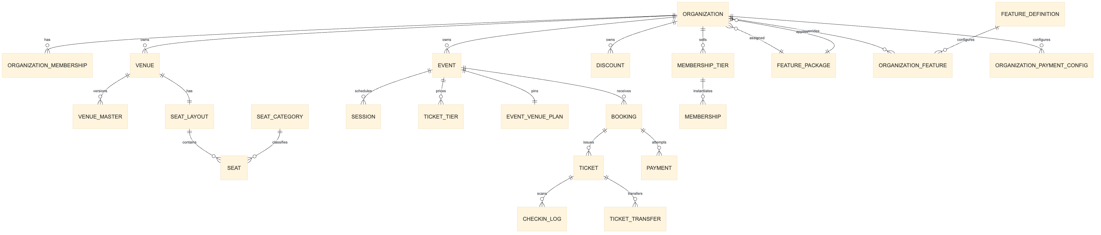
Figure 3 — workflow / architecture diagram

6.3 Venue versioning
Venue seating is versioned:
- A venue has a mutable current layout and a VenueMaster snapshot.
- Editing a layout creates an immutable master version.
- An event pins the exact EventVenuePlan version at creation/publish.
- Published events keep a frozen snapshot, so later venue edits do not mutate sold seating.

6.4 Event cancellation, transfers and check-in identity
- Cancelling an event captures a required cancellation_reason on the event; cancelled events are excluded from public sale.
- Accepting a ticket transfer regenerates the ticket unique_code and QR payload, invalidating the previous holder's QR.
- Check-in audit rows identify the authenticated admin/staff scanner_user in addition to device, IP and location.
- There is no scheduled job that transitions individual ticket statuses; those transitions are action-driven.

6.5 Booking and inventory
- Session.booked and TicketTier.quantity_sold are committed inventory.
- Session.reserved / TicketTier.quantity_reserved are in-flight holds.
- Seat reservations add a third layer for reserved seating.
- InventoryHold expires holds.
- Payment fulfillment converts holds into sold inventory and issues tickets.

7. Frontend architecture
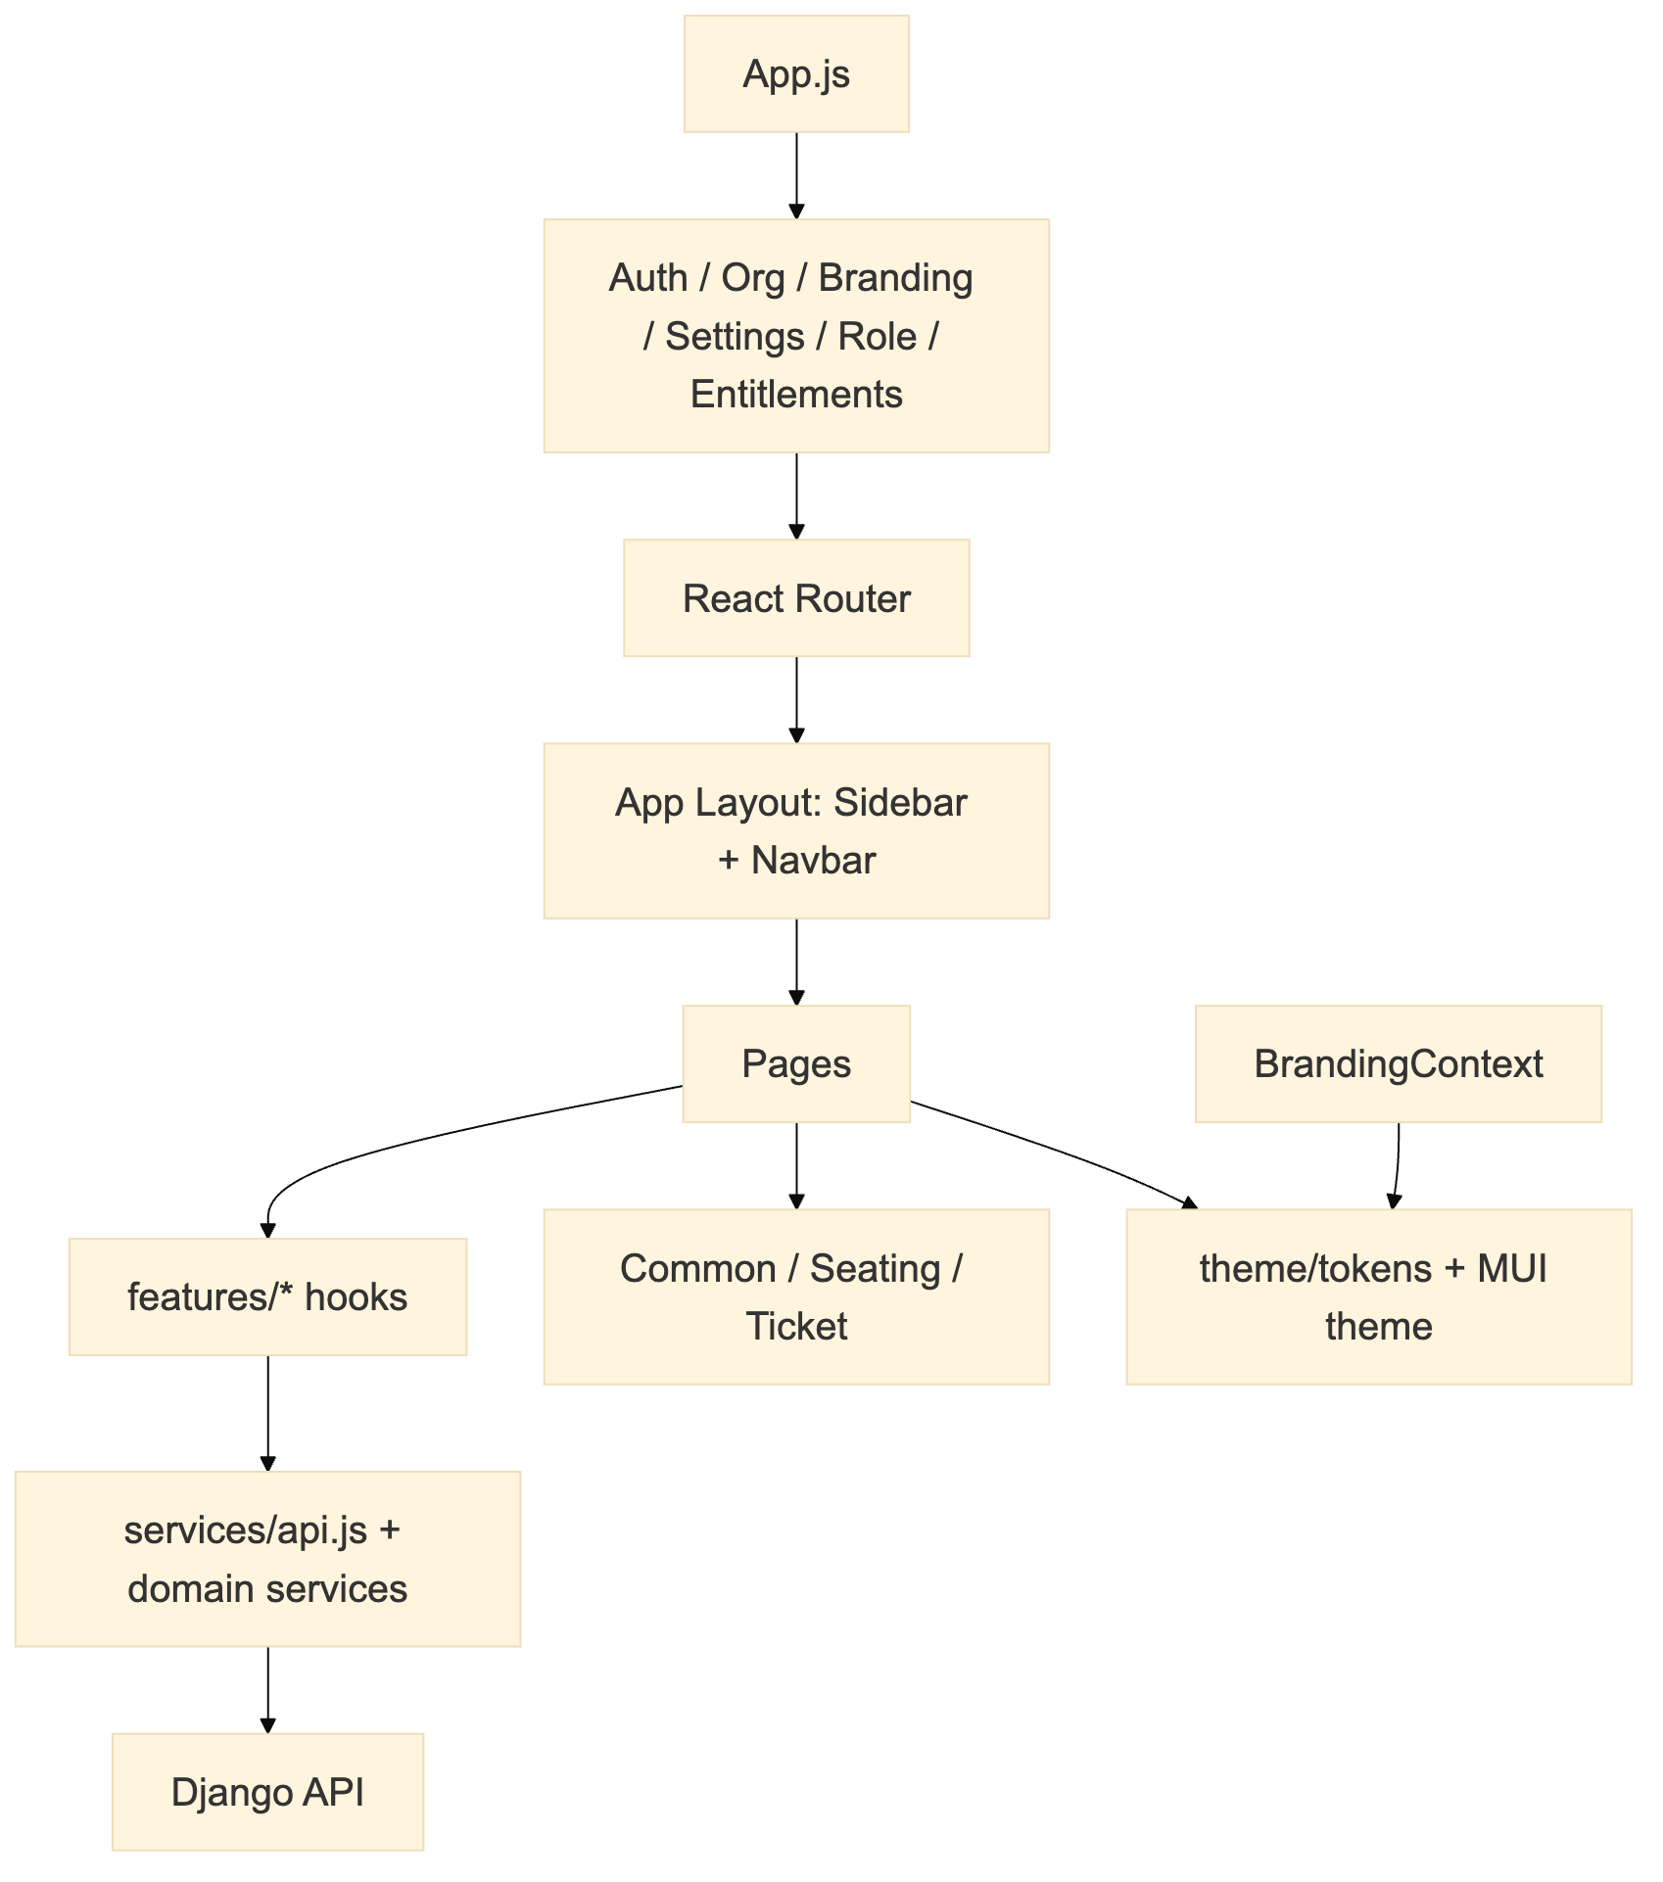
Figure 4 — workflow / architecture diagram

7.1 Contexts
Context | Responsibility
AuthContext | Login state, JWT, user, logout
OrgContext | Memberships, current org, role, owner flag
RoleContext | Platform and org role helpers
SettingsContext | Currency, locale, timezone; tenant overrides
EntitlementsContext | Effective feature package and feature flags
BrandingContext | Tenant name, logo, colours, favicon, language

7.2 Theming
- theme/tokens.js is the single source of brand tokens.
- theme/muiTheme.js maps tokens into MUI.
- styles/global.js exposes --tv-* CSS variables and global overrides.
- BrandingContext applies tenant colours/logo at runtime.
- No hardcoded hex colours should exist outside the theme layer.

7.3 Route protection
- ProtectedRoute — authenticated.
- RoleBasedRoute — platform superuser only.
- OrgRoleRoute — organization membership threshold.
- EventsEntry — chooses public browse vs workspace based on membership.
- GuestAllowedRoute — public booking checkout.

7.4 Main routes
Route | Purpose
/ | Public landing and events
/login, /register, /auth/verify | Authentication
/app/dashboard | Dashboard
/app/organizations | Organisation and team management
/app/events/* | Event list, create, edit, detail
/app/venues/* | Venue list, create, layout editor, detail
/app/bookings | Booking management
/app/bookings/create | Public/member checkout
/app/reports | Reports
/app/payouts | Payouts and settlements
/app/audit-logs | Audit trail
/app/payment-settings | Tenant gateway credentials
/app/features | Superuser feature definitions, packages and org overrides
/app/payouts | Organizer payouts and settlements
/app/audit-logs | Audit trail
/app/checkin | QR scanner
/app/analytics | Analytics
/app/settings | Platform/tenant settings

8. Payments architecture

8.1 Ticket payments
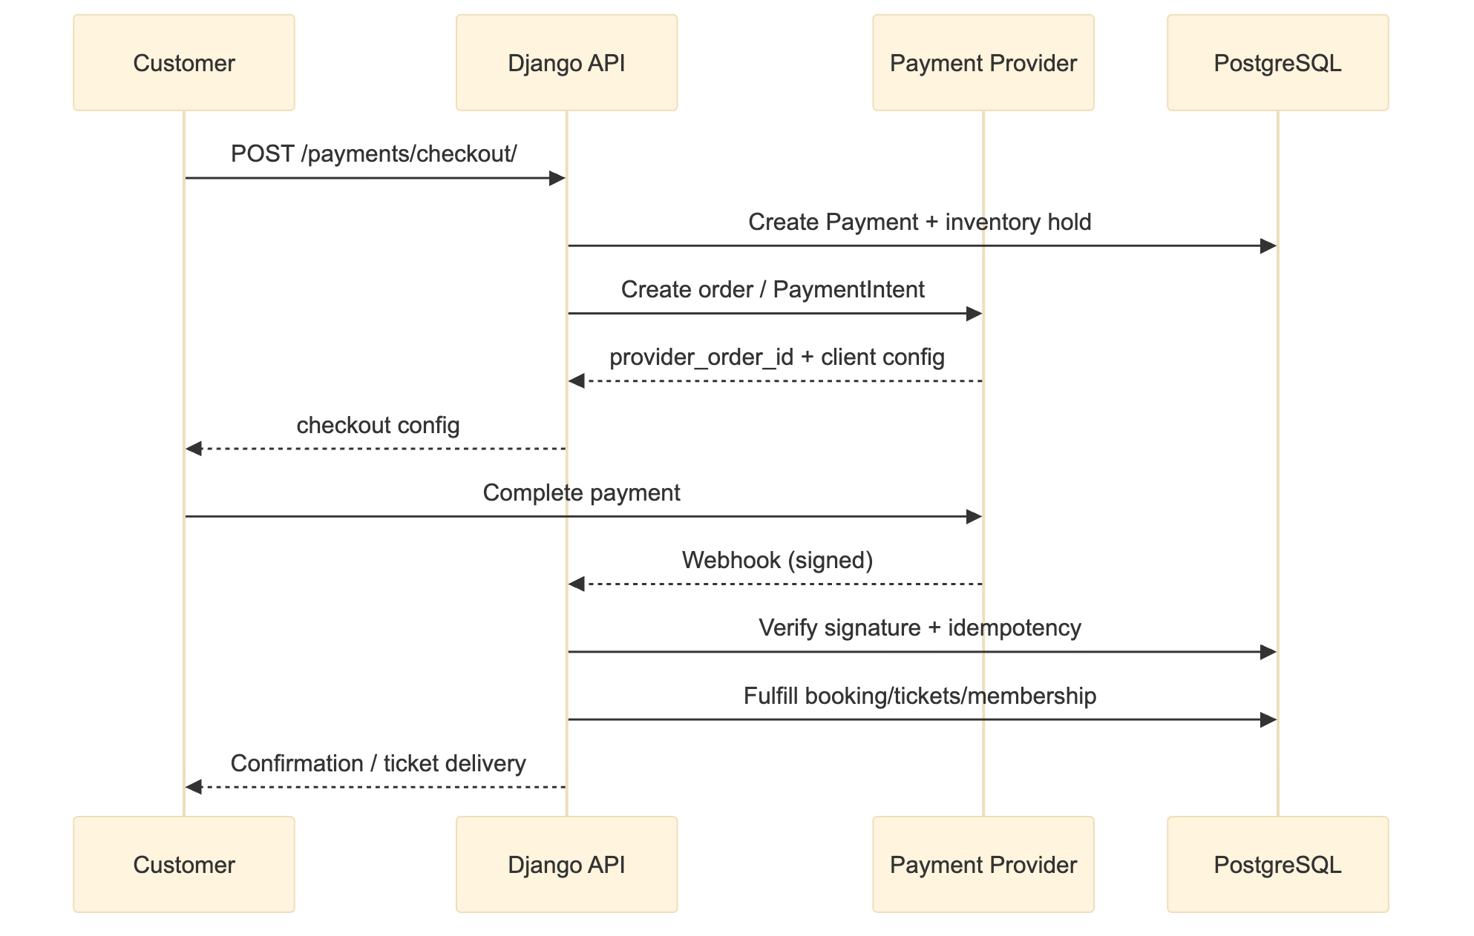
Figure 5 — workflow / architecture diagram
- Providers: Razorpay and Stripe.
- Credentials: platform-level environment keys, or per-tenant OrganizationPaymentConfig when active.
- Tenant secrets are encrypted at rest using a key derived from SECRET_KEY.
- Webhooks: global routes and per-tenant /payments/webhook/<org_id>/<gateway>/.
- Idempotency: WebhookEvent.
- Payment → booking fulfillment is transactional.

8.2 Feature entitlements and payments
Ticket and membership payments are tenant commerce. Feature entitlements do not process payments; they control which capabilities a tenant can use.

9. Feature entitlements

9.1 Model
- FeatureDefinition — a capability key (e.g. public_event_page, donation_quick_picks, event_bilingual), name, category, default state.
- FeaturePackage — a named set of feature keys; one may be the default package.
- OrganizationFeature — per-tenant enabled/disabled override with optional JSON config.
- Organization.feature_package — the assigned package.

9.2 Resolution
services/features.py resolves the effective feature set:
- Start with the organisation's assigned package.
- If no package is assigned, use the default active package.
- Apply per-organisation overrides (enable or disable).
- Ignore inactive feature definitions.

9.3 Enforcement
- Public event page requires public_event_page.
- Donation presets/contact text require donation_quick_picks.
- Bilingual event fields require event_bilingual.
- Feature management is superuser-only at /app/features and /api/platform/features/, /api/platform/feature-packages/, /api/platform/organization-features/.
- Tenant-readable effective features: /api/features/mine/.
There is no platform subscription billing in the current codebase. Platform pricing/subscription models were removed in migration 0060_remove_platform_licensing.

10. Security architecture

10.1 Authentication
- JWT access/refresh tokens.
- Password login and magic-link/OTP flows.
- Magic links are single-use, expiring, and audited.
- Active-session tracking for platform admins.

10.2 Authorization
- Platform superuser is the only cross-tenant role.
- Org roles enforced through can_manage_org / can_operate_org.
- Querysets are scoped through canonical visible_* helpers.
- Object-level access checks on bookings, tickets and payments.
- Feature entitlements.

10.3 Data protection
- Tenant payment secrets encrypted at rest.
- Webhook signatures verified.
- CORS allowlist.
- CSRF/session middleware for Django admin paths.
- Audit logs for mutating API requests.
- Soft deletion/removal timestamps for memberships.

10.4 Known security limitations
- SSO/SAML not implemented.
- No granular custom roles.
- No automated data-retention enforcement.
- No DPA/SLA workflow engine.
- No data-residency controls.
- Audit logs capture request metadata, not full before/after object diffs.
- Credential encryption key rotation is not automated.

11. Deployment and operations

11.1 Local Docker topology
Service | Role
backend | Django runserver
frontend | Nginx-served React build on port 3000
postgres | PostgreSQL
redis | Celery broker/cache

11.2 Configuration
Environment-driven configuration includes:
- SECRET_KEY, JWT_SIGNING_KEY, TICKET_SIGNING_SECRET
- database credentials
- Stripe/Razorpay keys and webhook secrets
- SMTP credentials
- WhatsApp gateway URL/token
- CORS/allowed hosts
- cron secret

11.3 Migrations
Django migrations are the schema source of truth and must be applied before deployment. Current migrations extend through 0068_event_cancellation_reason. They include branding, payment configuration, commercial operations, tax-receipt configuration, feature entitlements, PatronContact and event cancellation reason.

11.4 Observability
- Structured Django logging.
- Webhook and payment logs.
- Audit log table.
- Cron health endpoint.
- Celery task results.
- No external APM/tracing integration currently.

12. Extensibility and constraints

Extensible
- Add payment providers via PaymentProvider interface.
- Add feature keys to FeatureDefinition and packages via FeaturePackage.
- Add new report datasets in reports_api.py.
- Add ticket formats/templates.
- Extend tenant branding fields.
- Add operations models without changing tenancy boundaries.

Current constraints
- Public custom-domain routing is resolved in middleware but full domain-based frontend rendering/DNS automation is incomplete.
- Platform subscription billing is not part of the current product; feature packages are assigned by superusers.
- No resale marketplace or dynamic pricing engine.
- No automated organizer bank payouts.
- No SSO/SAML.
- Tax rates are stored per tenant but not yet applied to booking totals.
- Tenant logo/favicon are URL fields, not uploaded assets.
- Only English and Traditional Chinese locale bundles exist.

13. Recent product changes reflected in this document
Change | Effect
Platform licensing removed (0060) | No PlatformPlan/Subscription/Invoice; replaced by feature packages and per-org overrides
Tax-receipt configuration (0061–0062) | Organisation-level IRD/Section 88, registered address, signatory, receipt prefix, thresholds and bilingual fields
Checkout consent/reminders (0063) | Booking privacy acceptance, marketing opt-in, course question, reminder timestamps
Feature entitlements (0064–0065) | Feature definitions, packages and per-tenant overrides
Public donation fields (0066) | Donation presets, contact text, public page toggle and bilingual event content
PatronContact (0067) | Outreach tracking per booking
Event cancellation reason (0068) | Conditional reason captured when an event is cancelled

14. Architecture decision summary
Decision | Rationale
Organization is the tenant boundary | Simple, enforceable scoping
One live owner per org, stored on membership | Avoids dual ownership sources
Superuser-only cross-tenant visibility | Prevents staff privilege leakage
Immutable venue-master versions | Historical seat integrity
Event pins venue plan | Published events cannot change underneath buyers
Service layer for tenancy/payments/features | Single source of truth
Separate platform feature entitlements from customer memberships | Different access concerns
Feature entitlements in plan JSON | Fast plan changes without schema changes
Per-tenant payment config encrypted | Supports larger tenants without global merchant account

