

R.R.INSTITUTE OF MODERN TECHNOLOGY

Department of Computer Science & Engineering

**Quiz.a.thon!**

(A Website for Online quiz Plateform)

Submitted As­

Software Requirements Specification

COMPUTER SCIENCE & ENGINEERING.

**SUBITTED TO :**

**Ms Vartika Gupta**

(Department of CSE)

**Submitted By :**

1. **PRIYANSHU KUMAR (2103610100042)**
2. **PIYUSH YADAV (2103610100039)**
3. **ABHAY GUPTA (2103610100003)**
4. **ARPIT TIWARI (2103610100016)**
5. **DEEPAK YADAV(2103610100021)**

**CERTIFICATE**

This is to certify that this SRS report titled “**QUIZ.A.THON**” is the authentic work of **PRIYANSHU KUMAR** **(2103610100042),PIYUSH YADAV(2103610100039), ARPIT TIWARI(2103610100016),** **ABHAY GUPTA (2103610100003)** and **DEEPAK YADAV(2103610100021)** who carried out the SRS under my supervision and guidance. They have submitted their report during the academic year 2023-2024.

The project report, in my opinion, has reached the standards fulfilling the requirement for the award of the degree of **Bachelor of Technology** in **Computer Science & Engineering** in accordance with regulations of the Institute.

**Approved & Supervised By:**

MS VARTIKA GUPTA

(Asst. Professor)

(CSE Department)

**Forwarded To:**

**ACKNOWLEDGEMENT**

**CONTENTS**

**TITLE PAGE………………………………………………………………………………………….1**

**CERTIFICATE………………………………………………………………………………………..2**

**ACKNOWLEDGEMENT…………………………………………………………………………….3**

**1. INTRODUCTION………………………………………………………………………………….5**

1.1 Project Definition 5  
 1.2 Objective 5  
 1.3 Scope 5

1.4 Platform Specification 5

**2.** **SYSTEM ANALYSIS…………………………………………………………………………….6**

2.1 Identification of Need 6

**3. PROJECT SNAPSHOTS………………………...…………………………………………….12**

**4. FLOW CHART FOR QUIZ.Q.THON…………………………………………………………..25**

**5. PROJECT SOURCE CODE ………………………………………………………………….26**

**6. PROJECT BENEFITS ……….…………………………………………………………………64**

**7. FUTURE ENHANCEMENT..…………….……………………………………………………...64**

**8. WEBSITES REFERENCES…………………………………………………….………………65**

1. **INTRODUCTION**
   1. **Project Definition:**

QUIZ.A.THON is a web application to take online mcq test in an efficient manner and no time

wasting for checking paper. By using this plateform there is no need of using extra things like

pen and paper etc. There is no restrictions that a examiner has to be present when the candidate

takes the test.

* 1. **Objective:**

The main objective of QUIZ.A.THON is to efficiently evaluate the candidate through a fully

automated system that not only saves times but also gives faster results.

* 1. **Scope of the project:**

It can be implemented all over the India.

The students living in far places and also the students of this villages can give the mcq test of

Subject of Computer science department.

It reduces the use of extra things like pen and paper and also helps in digital INDIA programme.

Anyone can easily submit their test and can see their results easily to check their knowledge

and skills.

* 1. **Platform Specifications:**
* **Hardware Requirements:**
* Primary Memory (RAM): 512 MB.
* Secondary Memory (Hard Disk): 2 GB.
* Video Display Unit: VGA Monitor/LCD/TFT
* Keyboard: 101 Key Enhanced Keyboard.
* Mouse: Any Mouse.
* **Software Requirements:**
* Operating System: Windows XP, vista or later
* Programming Language: Javascript
* Markup Language: HTML
* IDE: Visual studio code /Notepad++

1. **SYSTEM ANALYSIS**

**2.1: Identification of needs:**

The need for QUIZ.A.THON arises because QUIZ.A.THON provide following points: -

* Facility to read about the questions for placements.
* Facility of giving test for placement.
* Facility to preparation of interviews.
* Facility to reduces the extra things like pen and paper.
* Facility to contact with the various well trained teachers.
* Facility to take quiz in efficient and fully automated system.

1. **PROJECT SNAPSHOTS**

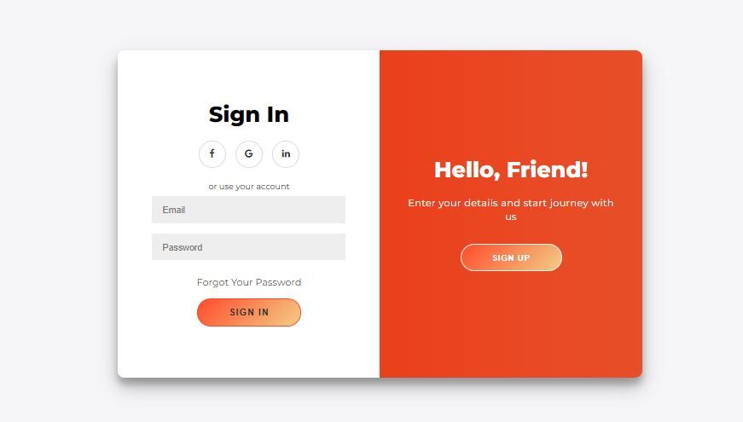

**Login credentials (Username and email)**

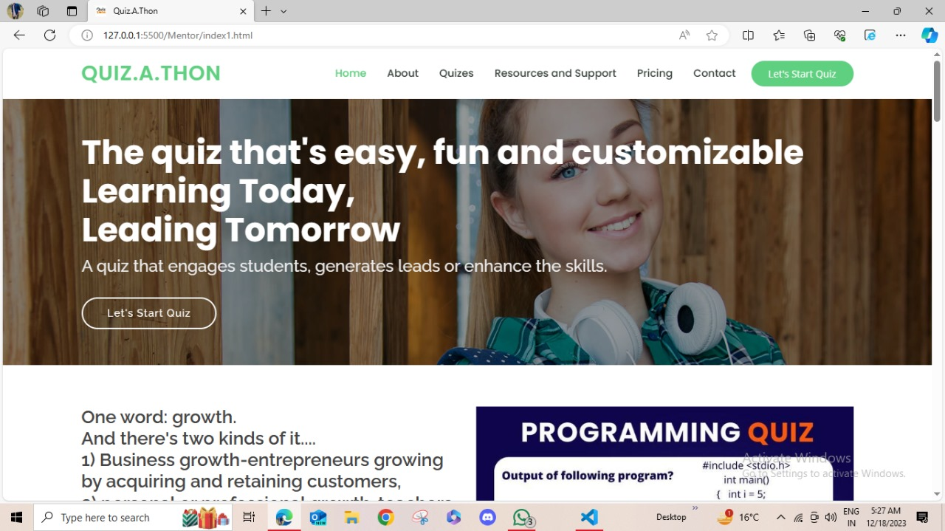

**( Home page of admin panel )**

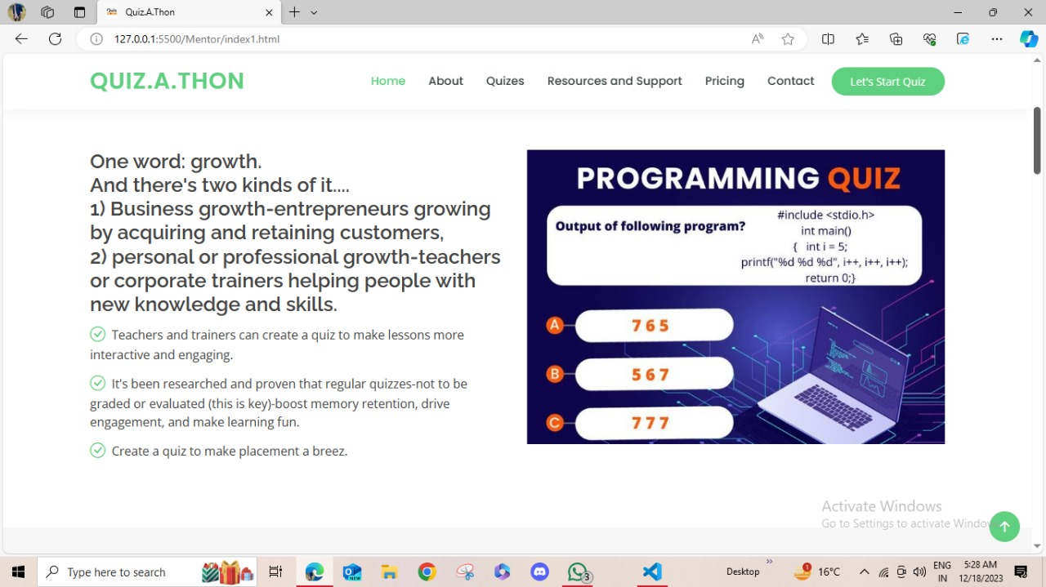

**About Quiz.A.Thon**

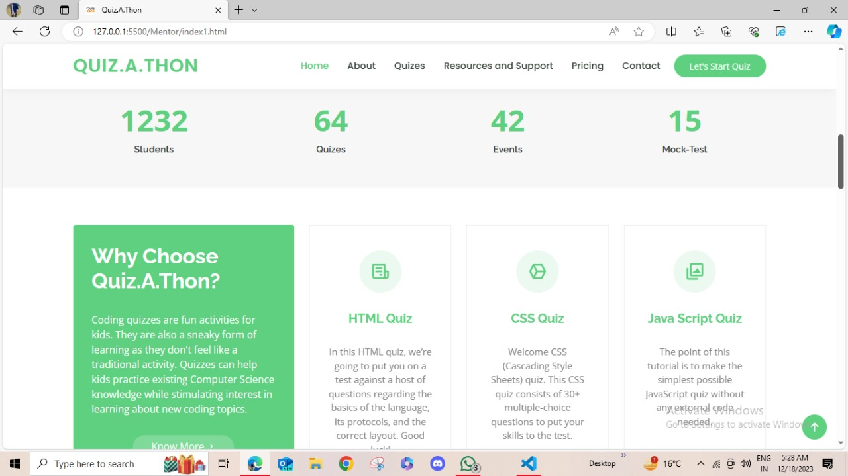

**(Why choose Quiz.A.Thon)**

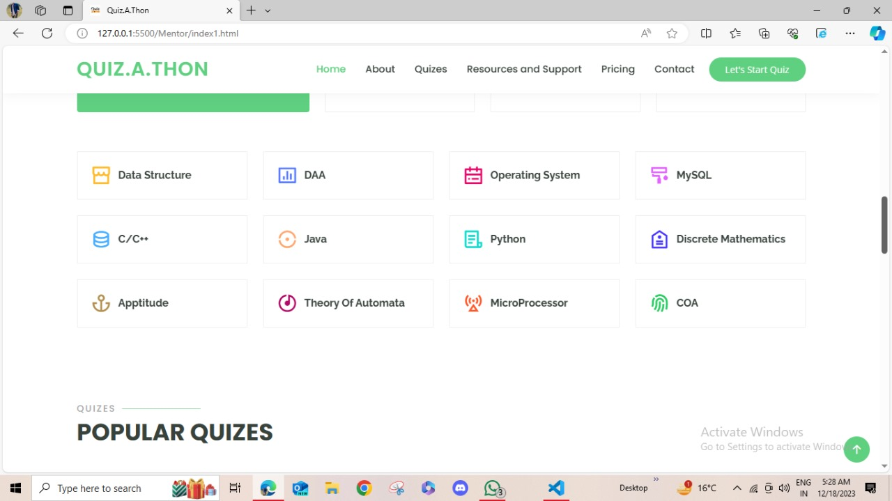

**(Subjects for MCQ test )**

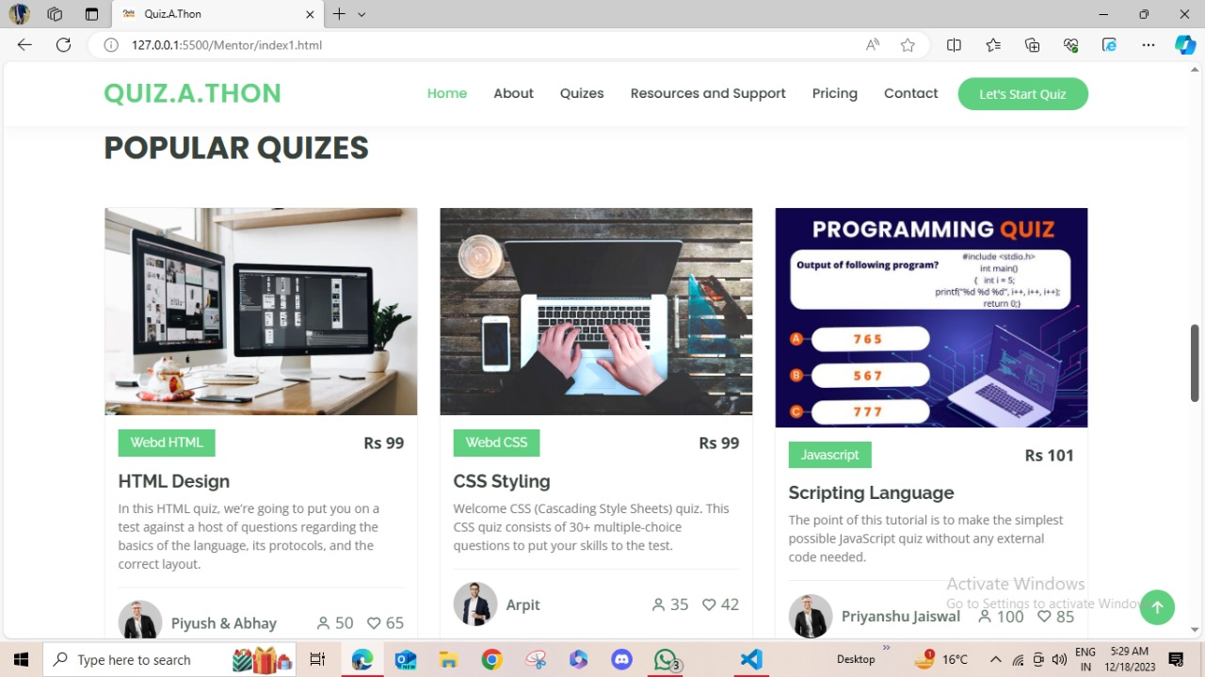

**( Popular Quizes for Quiz.A.Thon)**

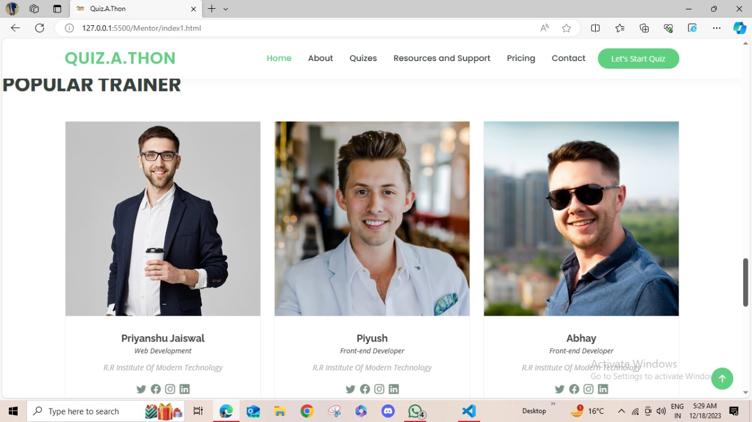

**(Popular Trainers for Quiz)**

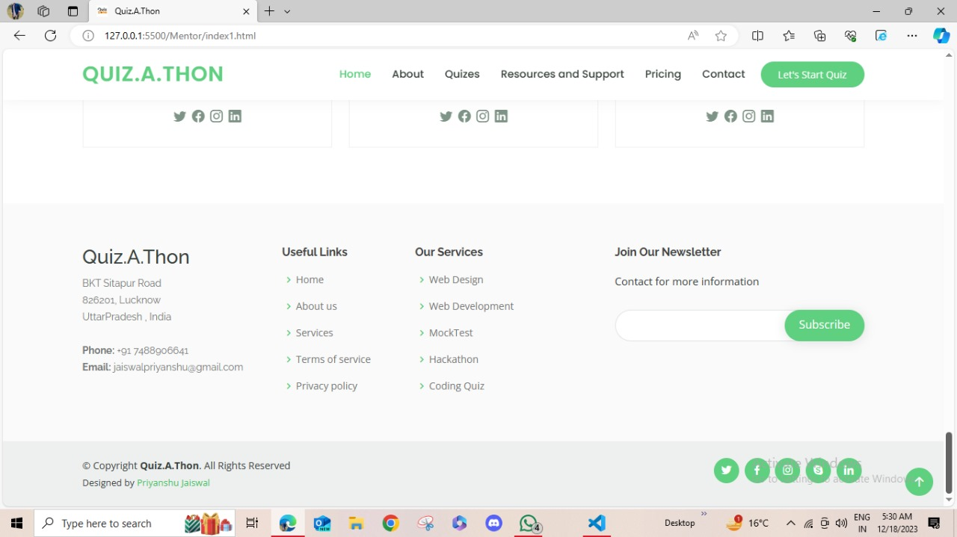

**( Contact us and other services )**

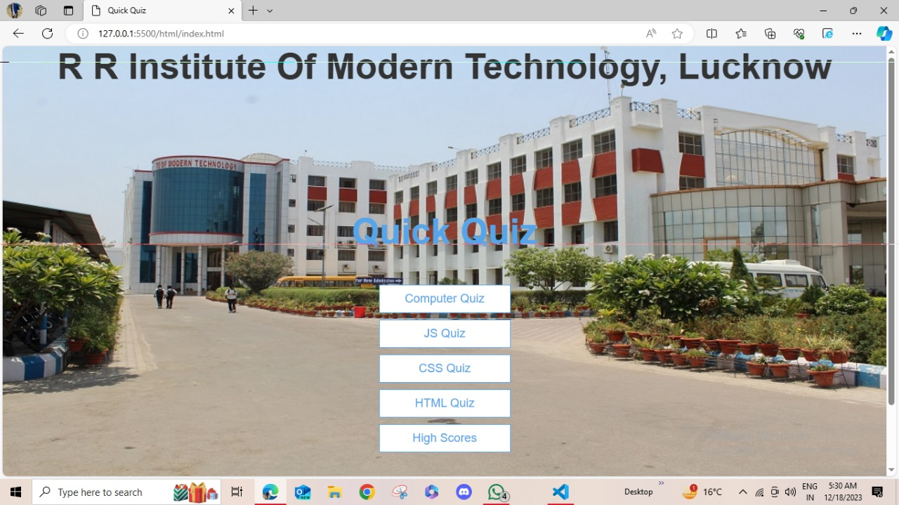

**( Quiz portal for Quiz.A.Thon )**

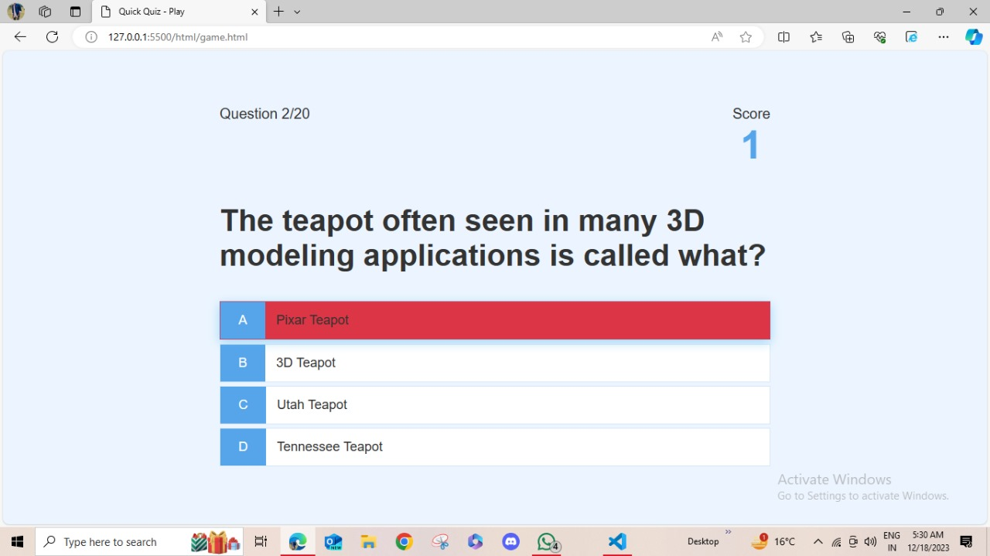

**( Wrong Answer for Quiz)**

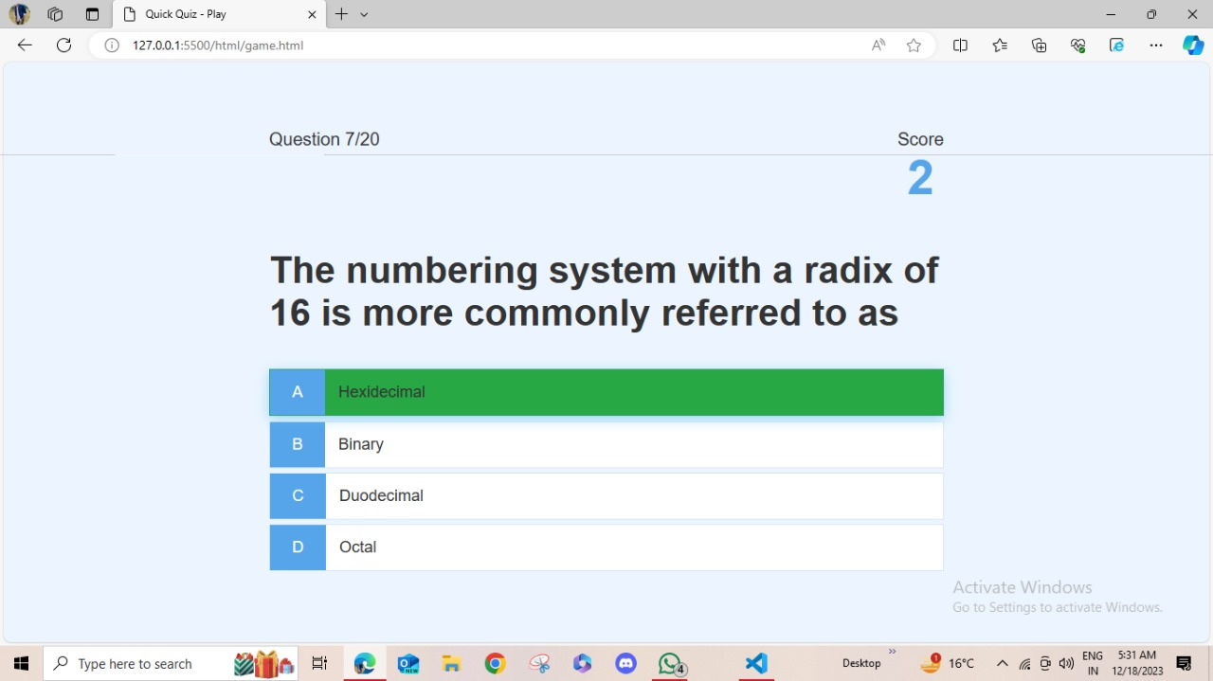

**( Right Answer for Quiz )**

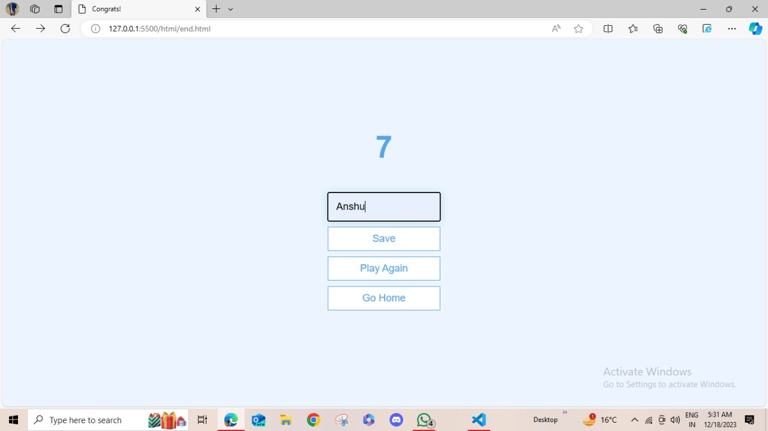

**(Total score obtained by candidate )**

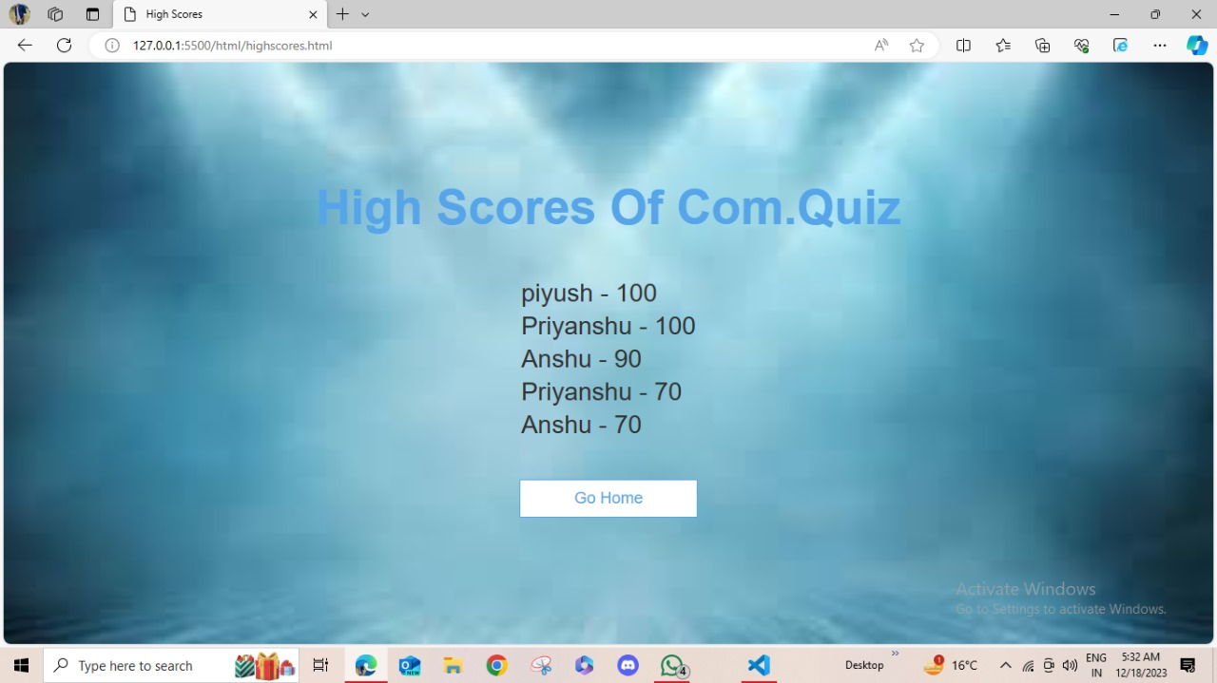

**( High score of candidates)**

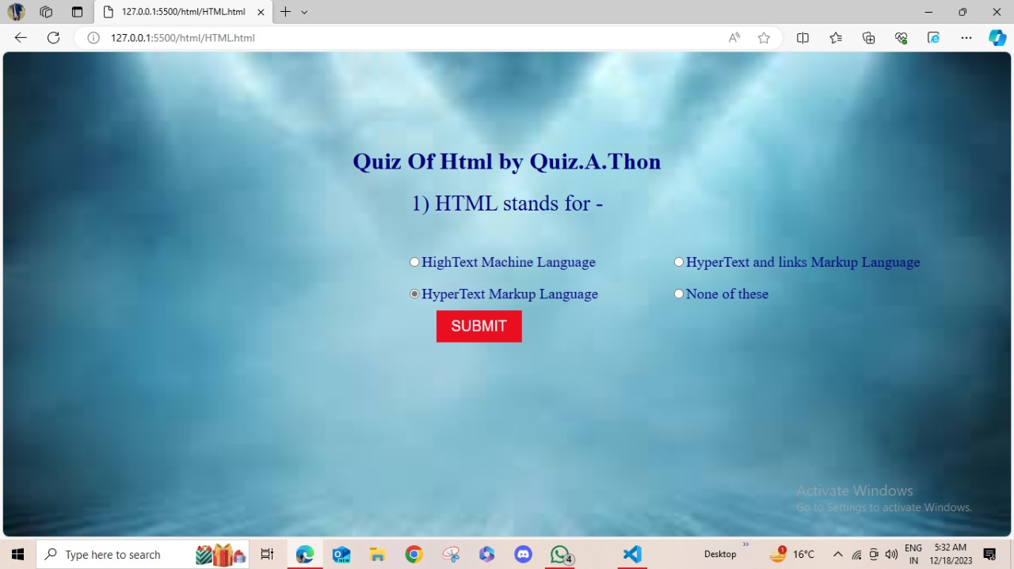

**(Questions in Quiz)**

1. **PROJECT FLOW CHART DIAGRAM**

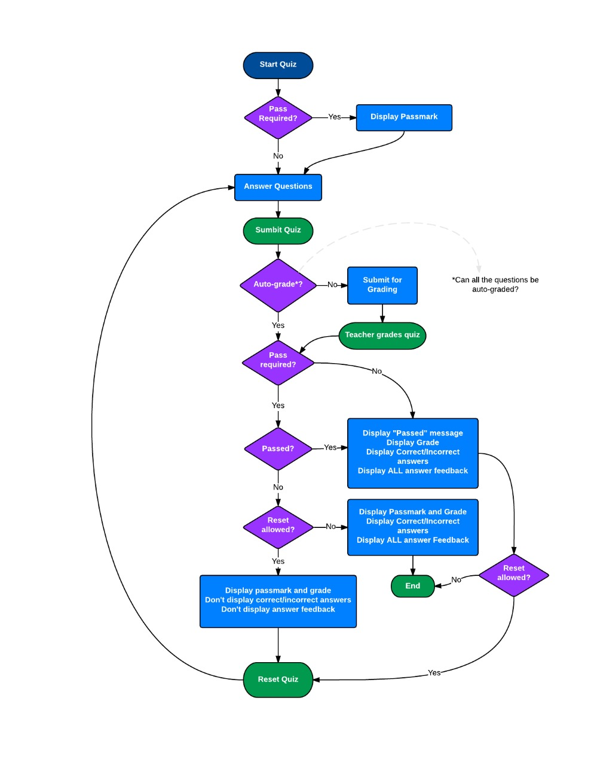

1. **PROJECT SOURCE CODE**
   1. **HTMLSOURCE CODE FOR LOG-IN PAGE**

<!DOCTYPE html>

<html lang="en" >

<head>

  <meta charset="UTF-8">

  <title>Login Page in HTML with CSS Code Example</title>

  <link href="https://fonts.googleapis.com/css?family=Open+Sans" rel="stylesheet">

<link href="https://maxcdn.bootstrapcdn.com/font-awesome/4.7.0/css/font-awesome.min.css" rel="stylesheet" integrity="sha384-wvfXpqpZZVQGK6TAh5PVlGOfQNHSoD2xbE+QkPxCAFlNEevoEH3Sl0sibVcOQVnN" crossorigin="anonymous"><link rel="stylesheet" href="./login.css">

</head>

<body>

<!-- partial:index.partial.html -->

<div class="box-form">

    <div class="left">

        <div class="overlay">

        <h1>W</h1>

        <h2>

        <p>"QUIZ.A.THON"</p></h2>

        <br><br><br><br><br><br>

        <h2>

            <p>

                "Created By -

              <h2>  "Priyanshu Kumar,Front-End Developer" </h2>

            </p>

        </h2>

        </div>

    </div>

        <div class="right">

        <h2>Login </h2>

        <div class="inputs">

            <input type="text" placeholder="Name">

            <br>

            <input type="password" placeholder="Phone Number">

            <br>

            <input type="text" placeholder=" Country Name">

            <br>

            <input type="email" name="Email" id="E-mail" placeholder="E-mail">

            <br>

            <p>

                <fieldset>

                    <legend>Gender</legend>

                    Male <input type="radio" name="gender" id="male">

                    Female <input type="radio" name="gender" id="female">

                </fieldset>

            </p>

        </div>

            <br><br>

        <div class="remember-me">

                            <!-- Angular -->

    <label>

        <input type="checkbox" name="item" checked/>

        <span class="text-checkbox">Remember me</span>

    </label>

        </div>

            <br>

            <a href="a.html"><button>Login</button></a>

    </div>

</div>…… further continues

4.2 **CSS SOURCE CODE FOR LOG-IN PAGE**

body {

  background-image:linear-gradient(135deg, #FAB2FF 20%, #da1717 90%);

  background-size: cover;

  background-repeat: no-repeat;

  background-attachment: fixed;

  font-family: "Open Sans", sans-serif;

  color: #B0B3B9;

}

.box-form {

  margin: 0 auto;

  width: 84%;

  background: #FFFFFF;

  border-radius: 10px;

  overflow: hidden;

  display: flex;

  flex: 1 1 100%;

  align-items: stretch;

  justify-content: space-between;

  box-shadow: 0 0 20px 6px #090b6f85;

}

@media (max-width: 980px) {

  .box-form {

    flex-flow: wrap;

    text-align: center;

    align-content: center;

    align-items: center;

  }

}

.box-form div {

  height: auto;

}

.box-form .left {

  color: #ffffff;

  background-size: cover;

  background-repeat: no-repeat;

…… further continues

**4.3 HTML SOURCE CODE FOR HOME PAGE**

<!DOCTYPE html>

<html lang="en">

<head>

  <meta charset="utf-8">

  <meta content="width=device-width, initial-scale=1.0" name="viewport">

  <title>Quiz.A.Thon</title>

  <meta content="" name="description">

  <meta content="" name="keywords">

  <link href="assets/img/download.png" rel="icon">

  <link href="assets/img/apple-touch-icon.png" rel="apple-touch-icon">

  <link href="https://fonts.googleapis.com/css?family=Open+Sans:300,300i,400,400i,600,600i,700,700i|Raleway:300,300i,400,400i,500,500i,600,600i,700,700i|Poppins:300,300i,400,400i,500,500i,600,600i,700,700i" rel="stylesheet">

  <link href="assets/vendor/animate.css/animate.min.css" rel="stylesheet">

  <link href="assets/vendor/aos/aos.css" rel="stylesheet">

  <link href="assets/vendor/bootstrap/css/bootstrap.min.css" rel="stylesheet">

  <link href="assets/vendor/bootstrap-icons/bootstrap-icons.css" rel="stylesheet">

  <link href="assets/vendor/boxicons/css/box……….further continues

4.4 CSS SOURCE CODE FOR HOME PAGE

/*

/* Navbar start */

nav {

    list-style-type: none;

    margin: 1.2px solid black;

    padding: 0;

    overflow: hidden;

    border: 1px solid #e7e7e7;

    background-color: #f3f3f3;

    font-size: 17px;

  }

  nav li {

    float: left;

  }

  nav li a {

    display: block;

    color: black;

    text-align: center;

    padding: 15px 25px;

    text-decoration: none;

    /*word-spacing: 2px;*/

    letter-spacing: 0.8px;

  }

  nav li a:hover:not(.active) {

    background-color: #ddd;

    text-decoration: none;

    text-underline-position: none;

  }

  nav li a.active {

    background-color: #000;

    padding: 2rem;

    text-align: center;

  }

  .social-media-links i{

    margin: 2rem;

  }

…… further continues

4.5 HTML SOURCE CODE FOR CONTENT PAGE

<!DOCTYPE html>

<html>

<head>

    <meta charset="UTF-8" />

    <meta name="viewport" content="width=device-width, initial-scale=1.0" />

    <meta http-equiv="X-UA-Compatible" content="ie=edge" />

    <title>Quick Quiz</title>

    <link rel="stylesheet" href="/css/app.css" />

    <!-- <link rel="stylesheet" href="../Mentor/assets/css/style.css"> -->

    <style>

        body{

            background-image: url("/img/best-mba-college.jpg");

            background-repeat: no-repeat;

            background-attachment: fixed;

            background-size: 100% 100%;

        }

        head{

            color: green;

        }

    </style>

</head>

<body>

    <div class="flex-center flex-column">

     ……further continues

4.6 CSS SOURCE CODE FOR CONTENT PAGE

/* Quick links */

#nav{

  display: flex;

}

.quicklinks {

  margin: 0 auto;

}

.slot{

  float: left;

  width: 20%;

  padding: 15px 35px 0 0;

  transition: transform .8s ease-in-out;

}

.infoboxes{

  margin-bottom: 20px;

  display: flex;

  justify-content:space-between;

  flex-wrap: wrap;

}

.infoboxes a {

  margin-bottom: 15px

4.6 JS SOURCE CODE FOR QUIZ PAGE

const question = document.getElementById("question");

const choices = Array.from(document.getElementsByClassName("choice-text"));

const progressText = document.getElementById("progressText");

const scoreText = document.getElementById("score");

const progressBarFull = document.getElementById("progressBarFull");

const loader = document.getElementById("loader");

const game = document.getElementById("game");

let currentQuestion = {};

let acceptingAnswers = false;

let score = 0;

let questionCounter = 0;

let availableQuestions = [];

let questions = [];

fetch("https://opentdb.com/api.php?amount=20&category=18&type=multiple")

  .then(res => {

    return res.json();

  })

  .then(loadedQuestions => {

    console.log(loadedQuestions.results);

    questions = loadedQuestions.results.map( loadedQuestion => {

      const formattedQuestion = {

        question: loadedQuestion.question

      };

………..Further continues

4.6 CSS SOURCE CODE FOR QUIZ PAGE

.choice-container{

    display: flex;

    margin-bottom: 0.5rem;

    width: 100%;

    font-size: 1.8rem;

    border: 0.1rem solid rgb(86,165,236,0.25);

    background-color: white;

}

.choice-container:hover{

    cursor: pointer;

    box-shadow: 0 0.4rem 1.4rem 0 rgba(86, 185, 235, 0.5);

    transform: translateY(-0.1rem);

    transition: transform 150ms;

}

.choice-prefix {

    padding: 1.5rem 2.5rem;

    background-color: #56A5EB;

    ………..further continues

**5.PROJECT BENEFITS**

* User will be able to explore and find important questions for placements.
* As it is a website, so it is accessible to everyone 24 * 7.
* Website is simple and easy to use.
* Website is responsive.
* As it is a website ,it will be be regularly maintained and will get updates in future.
* You can easily search for myths , symptoms, information, about various diseases.

**6.FUTURE ENHANCEMENTS**

* Sytem can be extended for other users.
* More information about placements.
* More subjects will be added.
* More engineering departments will be added.
* No new tab features will be added.
* Questions can be increased.

7. REFERENCES

* Images used in project is taken from Image search results.
* Social media icons are taken from tailwind css websites.
* Login page credentials validations will be taken from geeks for geeks.
* Java script code will be taken from github as well as gfg.

THANK YOU !