Reg. No: -12415237

Name: - Sachin Kumar Singh

Certificate ID: - 1720138339SS

Issue Date: - Nov 3, 2024

[https://learn.saylor.org/admin/tool/certificate/index.php?code=1720138339SS](https://learn.saylor.org/admin/tool/certificate/index.php?code=1720138339SS##)

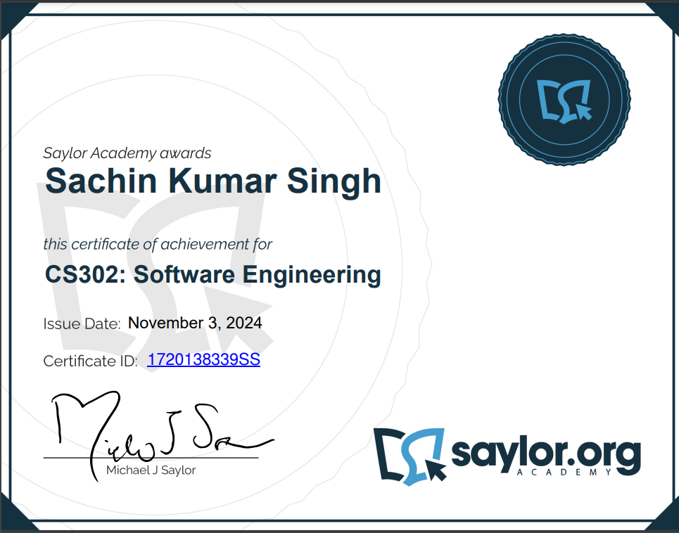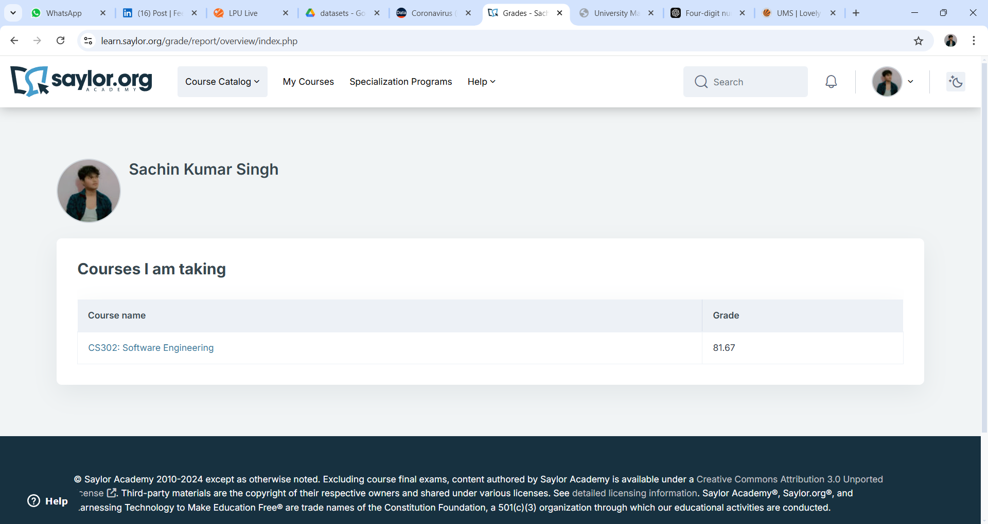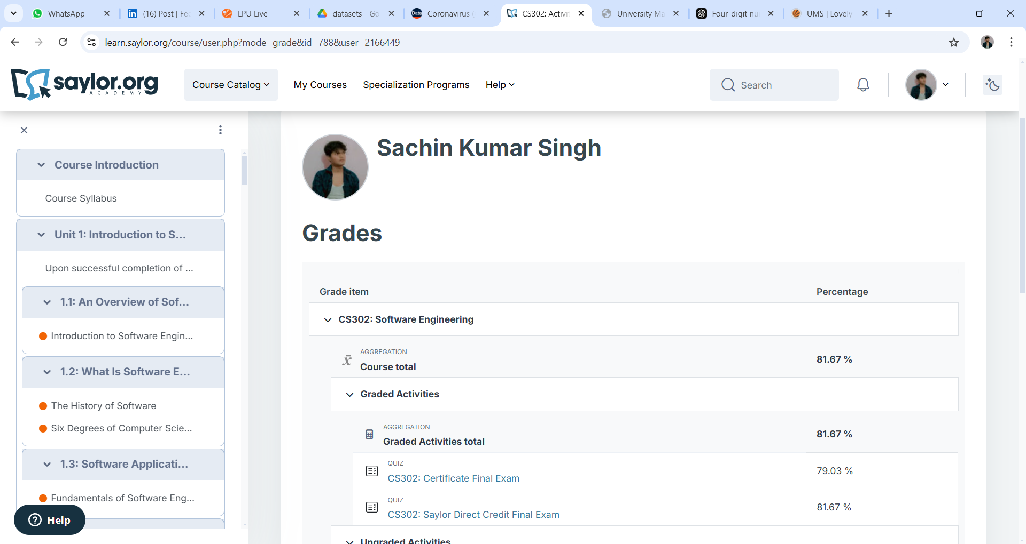

College Credit Final Exam

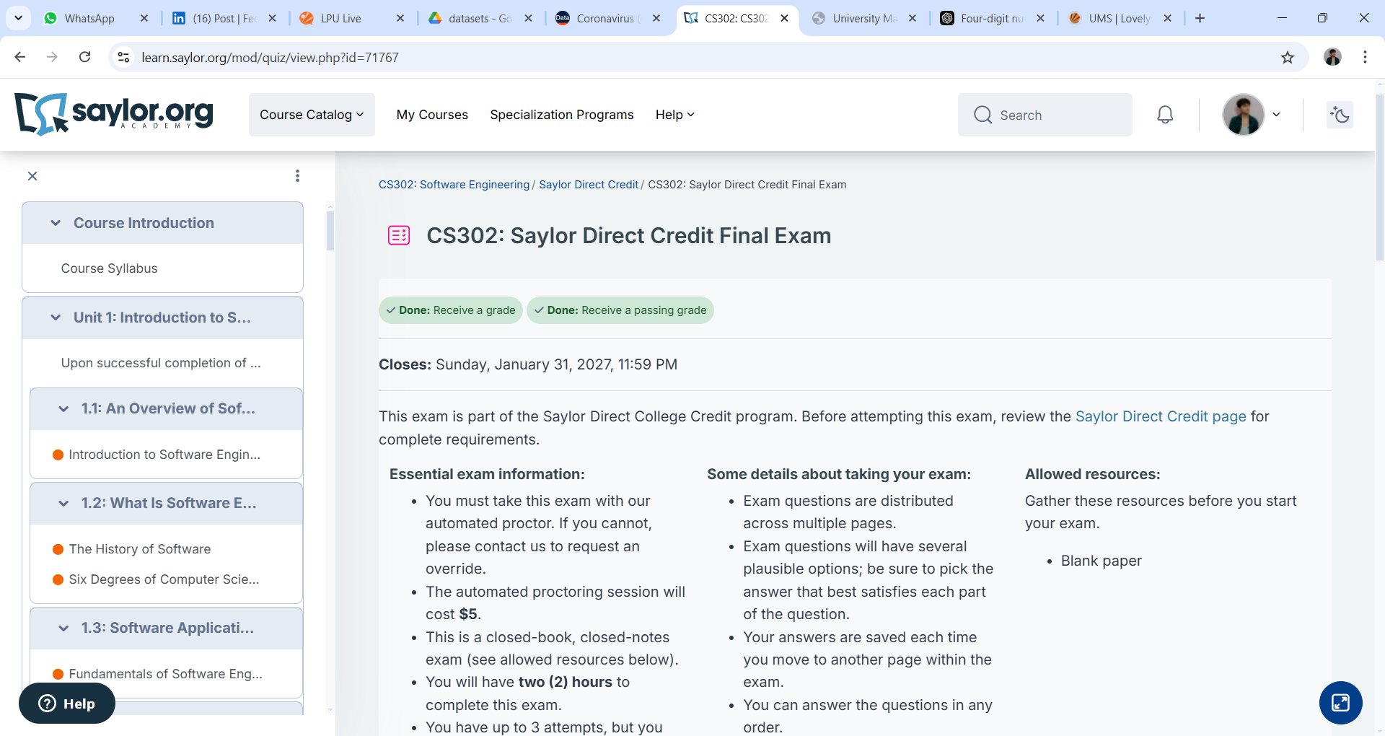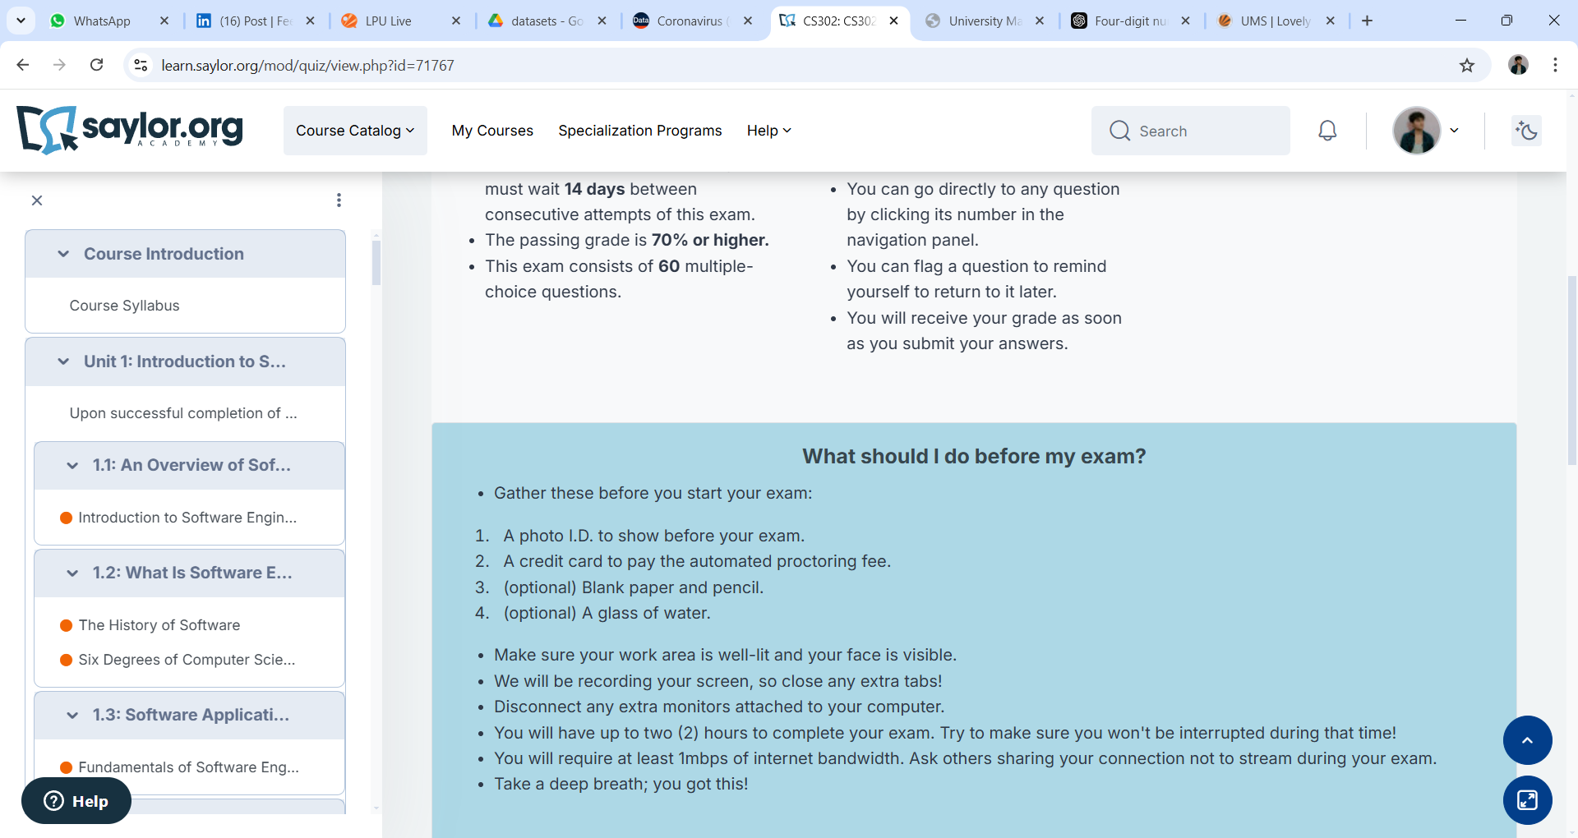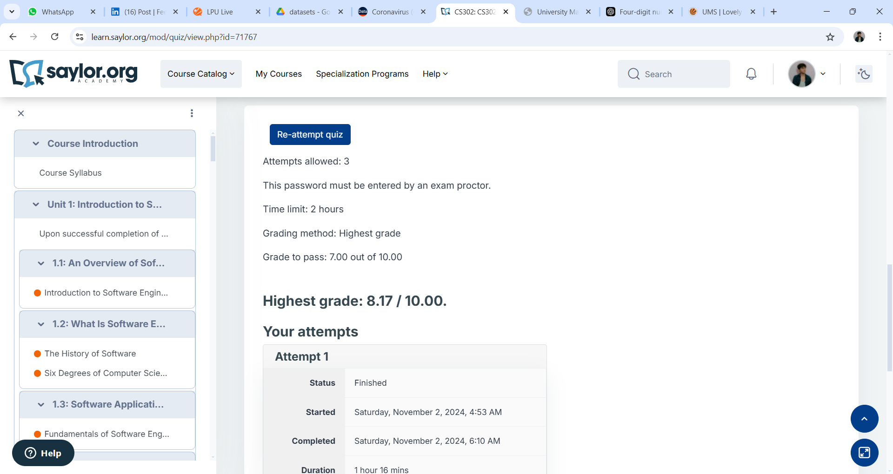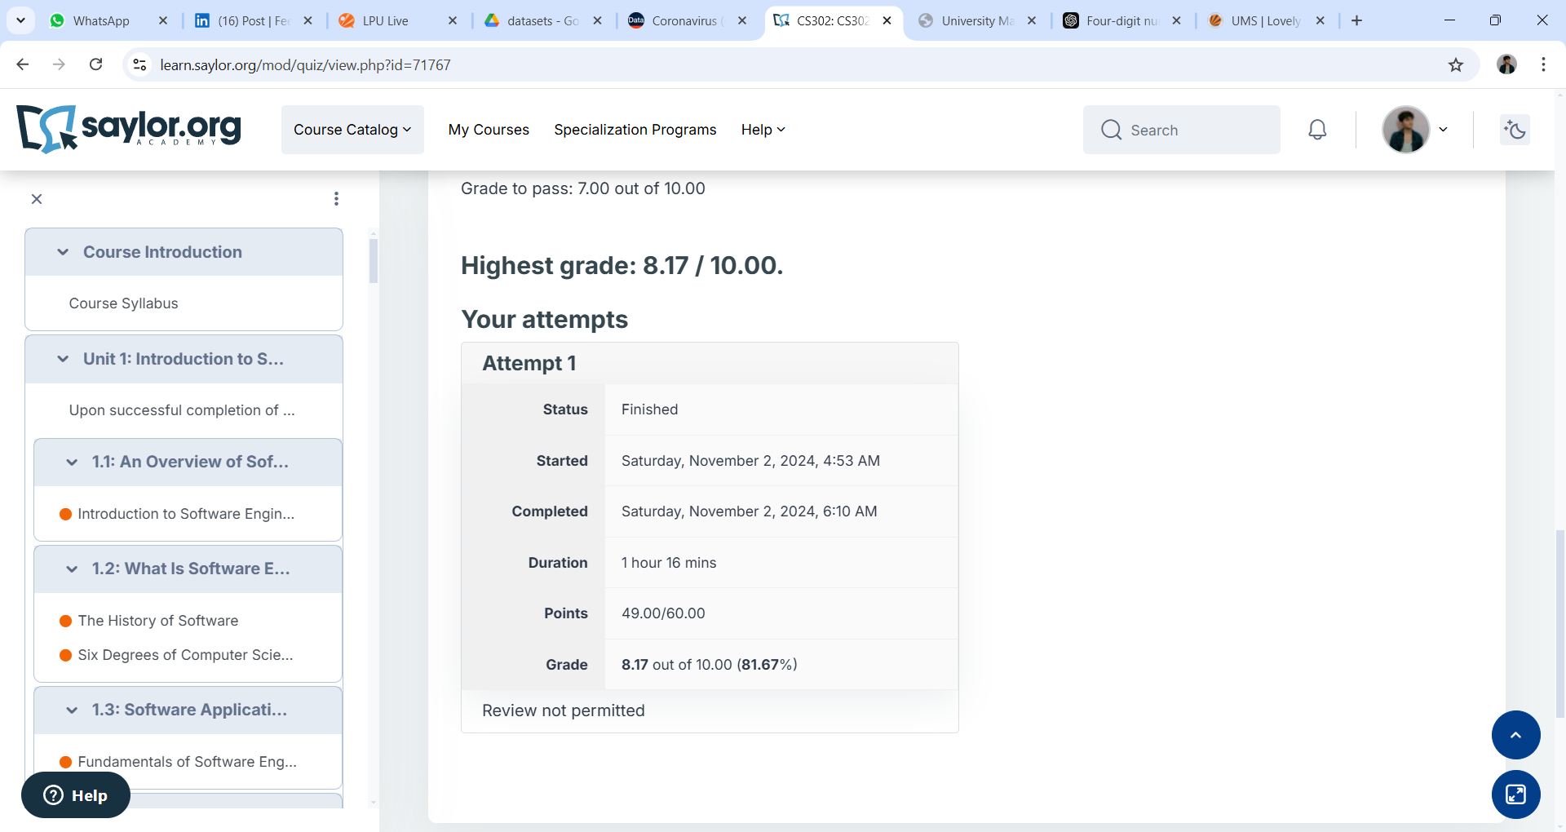

Certificate Final Exam

