DATA EXPLORATION AND VISUALIZATION
Complete 5-Unit Assignment Report
Dataset: Plotly Express Tips Dataset
Course Code: 24UAD512
Submission Deadline: 09.10.2026
Student Name: ______________________________
Register Number: ___________________________
GitHub Repository: https://github.com/<YOUR-USERNAME>/<YOUR-REPOSITORY>

1. Assignment and Syllabus Mapping
The uploaded syllabus organizes the course into five units: Unit 1 Exploratory Data Analysis, Unit 2 Visualizing Using Matplotlib, Unit 3 Univariate Analysis, Unit 4 Bivariate Analysis, and Unit 5 Multivariate Analysis and Insights. The practical exercises additionally require EDA, Matplotlib/Seaborn/Plotly/Bokeh, univariate and bivariate analysis, pair plots/correlation heatmaps, dimensionality reduction and a basic scikit-learn model.
Syllabus basis: uploaded course document, pages 1–2. fileciteturn0file0L2-L3

2. Dataset Selection and Source
The selected dataset is the Plotly Express 'tips' dataset. It contains restaurant bill and tip records with numerical variables (total_bill, tip, size) and categorical variables (sex, smoker, day, time), making it suitable for all five units.
Official source: Plotly Express documentation – https://plotly.com/python/plotly-express/
Dataset shape before cleaning: 244 rows × 7 columns.
Missing values: 0. Duplicate rows detected: 1; the duplicate row was removed before analysis.
The exact dataset copy used is stored as data/tips.csv.

3. Libraries Used
- Pandas
- NumPy
- SciPy
- Matplotlib
- Seaborn
- Plotly
- Bokeh
- Scikit-learn
- Jupyter Notebook

UNIT 1 – EXPLORATORY DATA ANALYSIS

1.1 Initial Inspection
The dataset contains 244 rows and 7 columns. Shape, data types, descriptive statistics, missing values and duplicates were inspected.

1.2 Data Quality
No missing values were found. 1 duplicate row was detected and removed.

1.3 Encoding, Transformation and Grouping
Categorical variables were one-hot encoded. `log_total_bill` and `tip_percentage` were created as transformations. Grouping was performed by day and time.
Day | Count | Mean Bill | Median Bill | Total Bill
Fri | 19 | 17.15 | 15.38 | 325.88
Sat | 87 | 20.44 | 18.24 | 1778.40
Sun | 76 | 21.41 | 19.63 | 1627.16
Thur | 61 | 17.76 | 16.40 | 1083.33
Observation: the dataset is clean after duplicate removal and contains the mixed variable types required for deeper exploration.

UNIT 2 – VISUALIZING USING MATPLOTLIB
Implemented: line plots, scatter plots, histograms, density/contour plots, legends, colors, subplots, text/annotations and 3D plotting. Seaborn, Plotly and Bokeh are also included.

Simple Line Plot
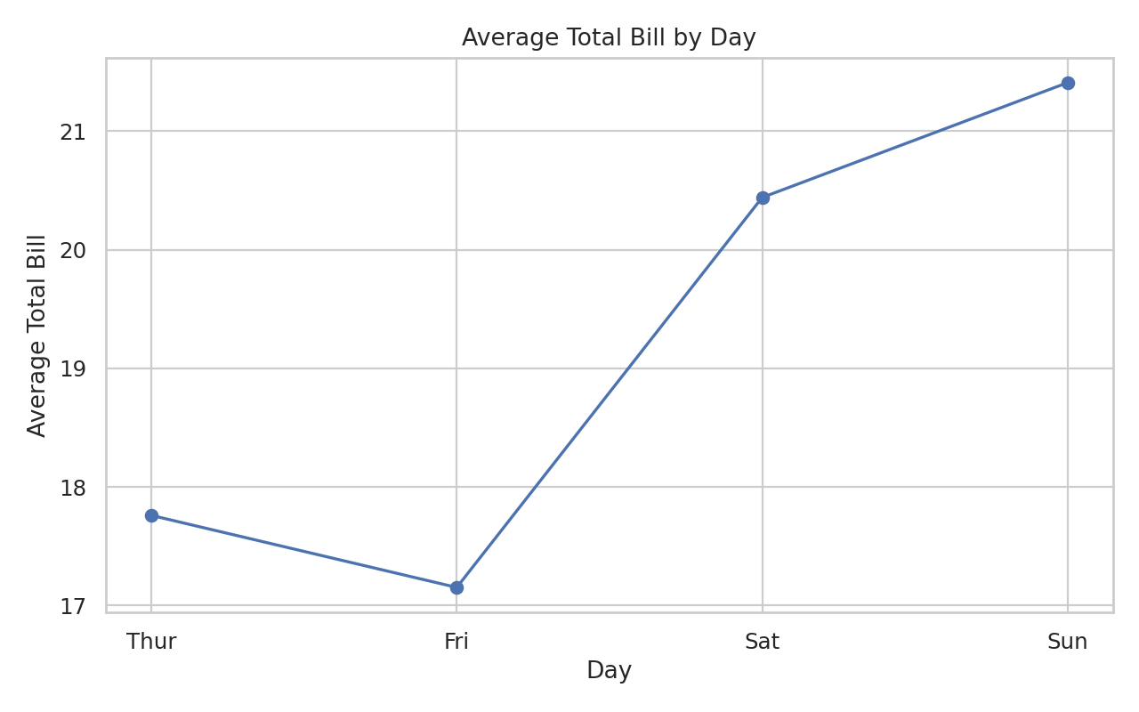
Average bill changes across the observed days.

Simple Scatter Plot
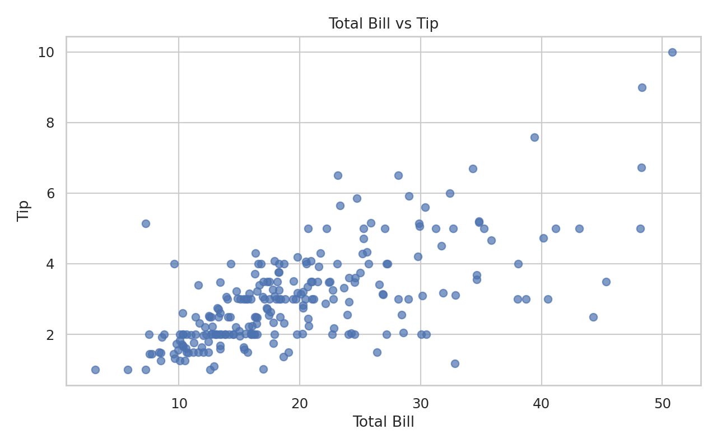
The scatter plot shows an upward pattern between total bill and tip.

Histogram and Density
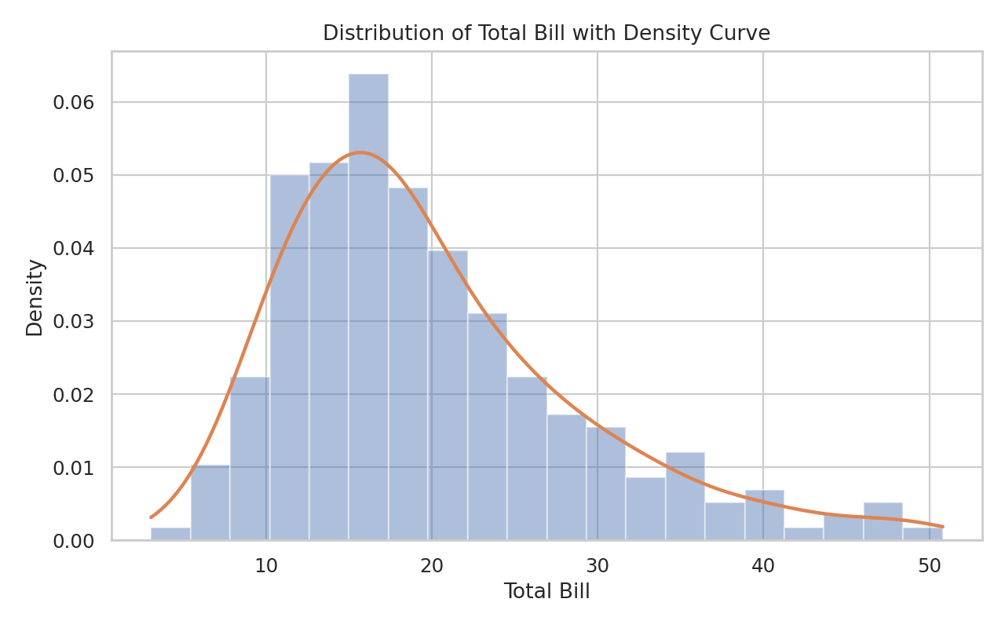
The bill distribution is concentrated at lower values with a longer right tail.

Density / Contour Plot
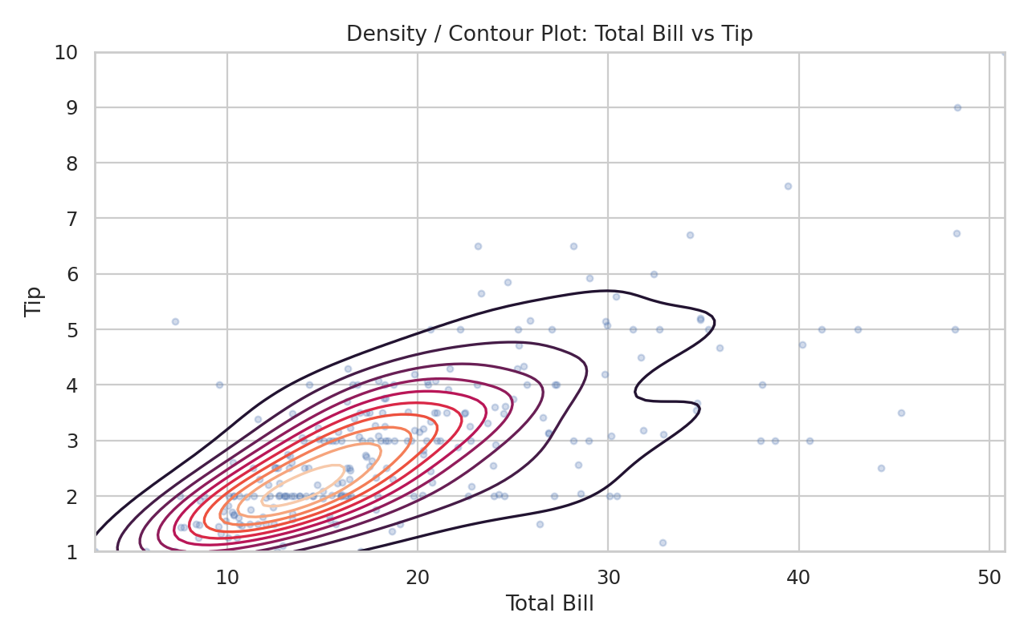
The contour view shows where bill-tip observations are most concentrated.

Subplots and Annotation
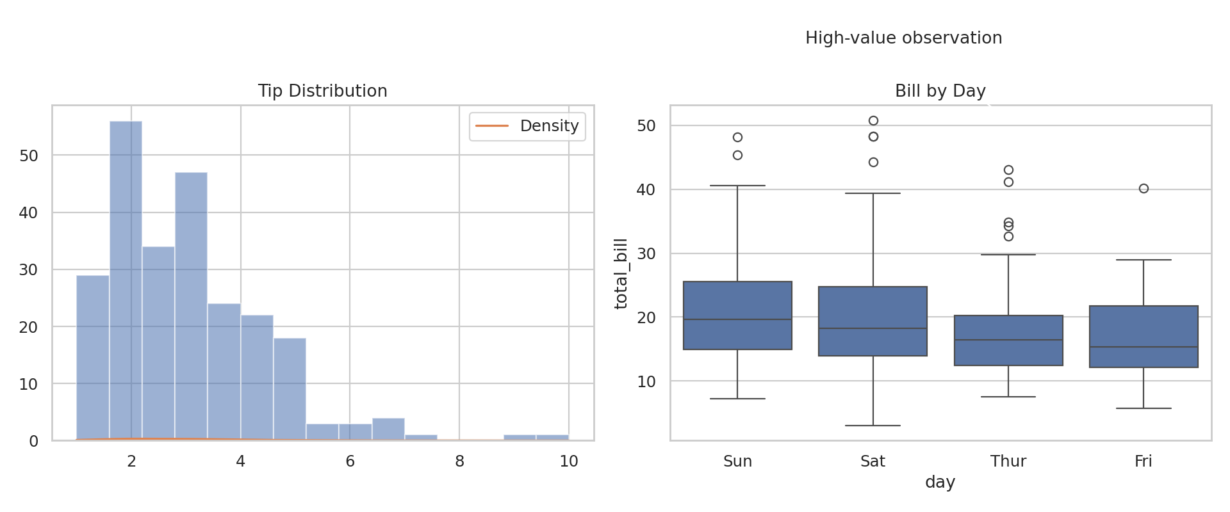
Two views are compared in one figure and an annotation highlights a high-value observation.

Three-Dimensional Plot
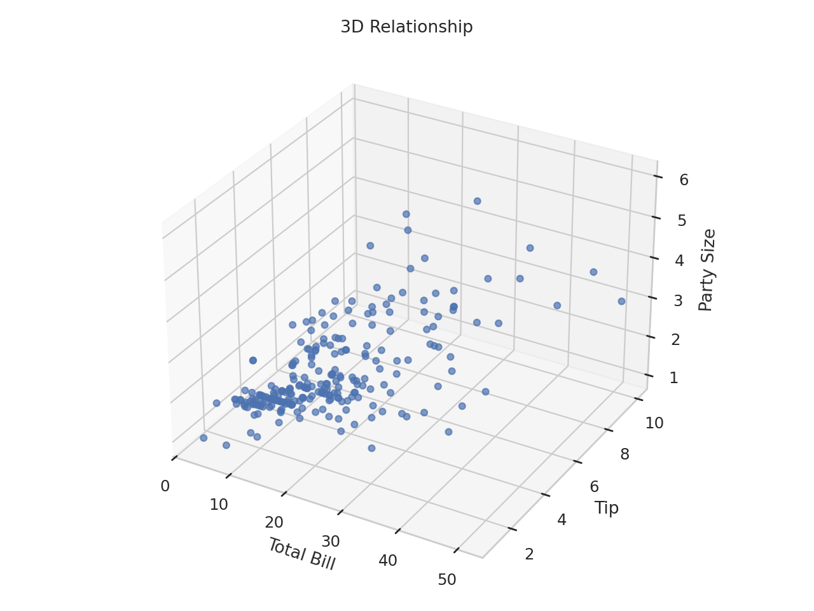
Three variables—total bill, tip and party size—are visualized together.
Interactive Plotly and Bokeh visualizations are provided in the interactive/ folder.

UNIT 3 – UNIVARIATE ANALYSIS
Numerical variables were examined with histograms, box plots, density plots and summary statistics. Categorical variables were examined with bar charts, pie charts and frequency tables.
total_bill: mean=19.814, median=17.810, std=8.910, Q1=13.380, Q3=24.175, skewness=1.127.
tip: mean=3.002, median=2.920, std=1.385, Q1=2.000, Q3=3.575, skewness=1.460.
size: mean=2.572, median=2.000, std=0.952, Q1=2.000, Q3=3.000, skewness=1.442.

Histogram of Tips
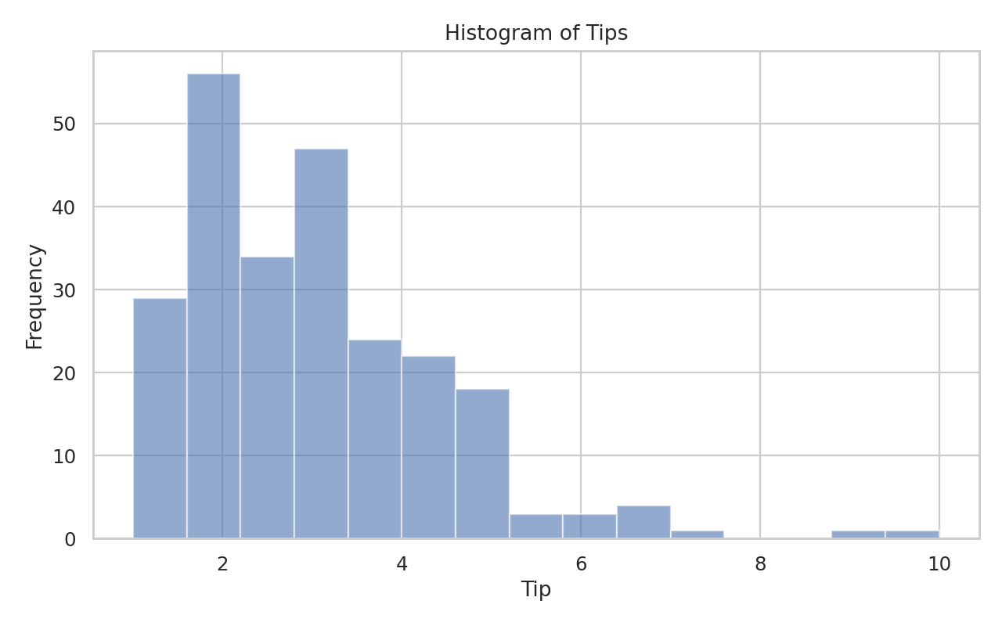
Tip values are concentrated in the lower range with fewer high-tip observations.

Box Plot of Total Bill
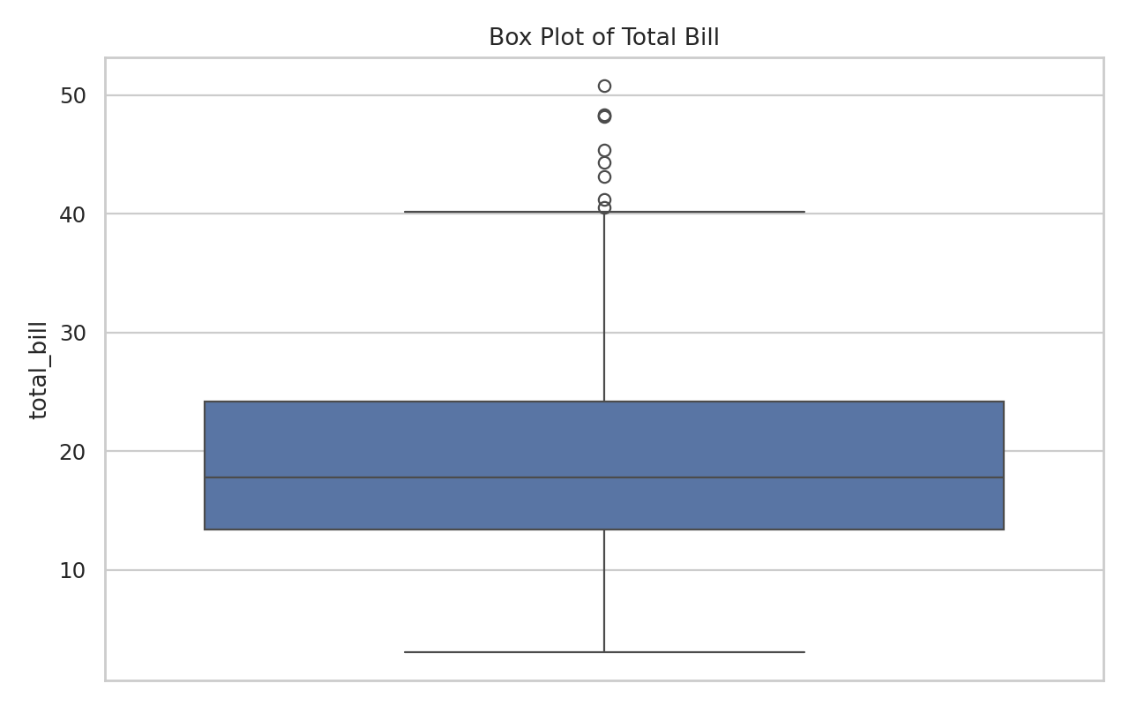
The box plot highlights the central spread and high-value observations.

Density Plot of Tip
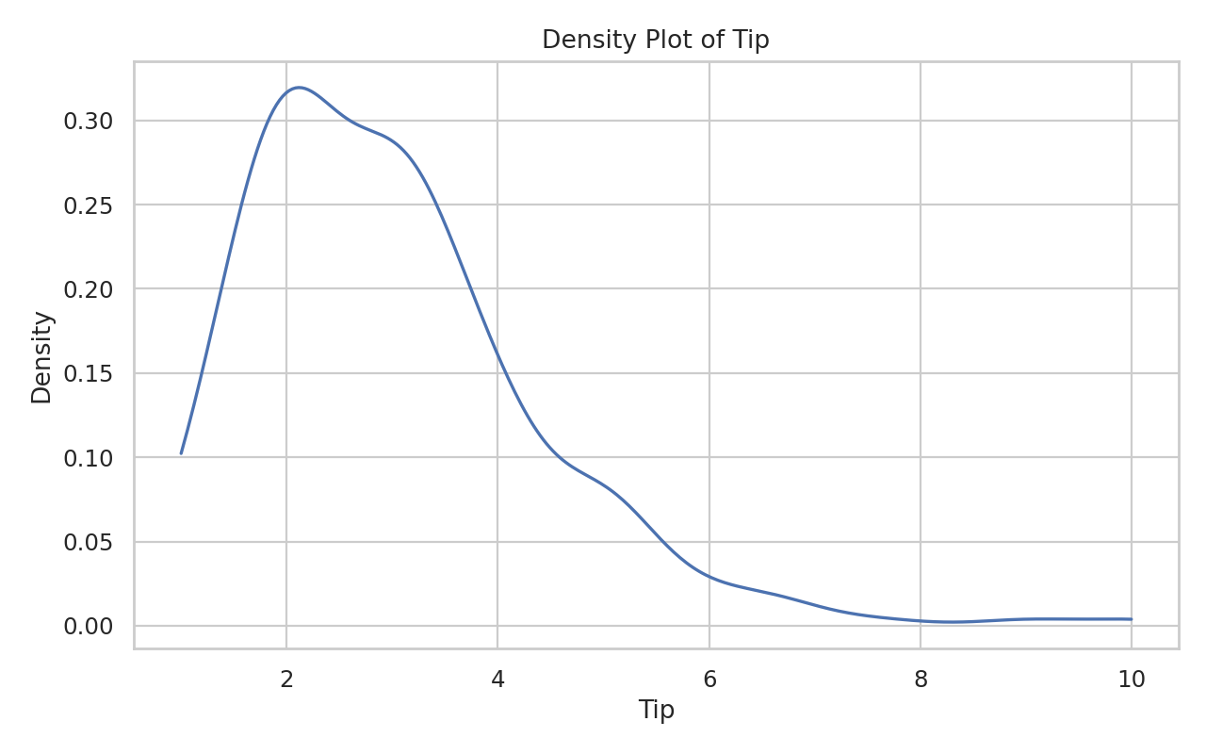
The density curve summarizes the shape of the tip distribution.

Bar Chart – Day Frequency
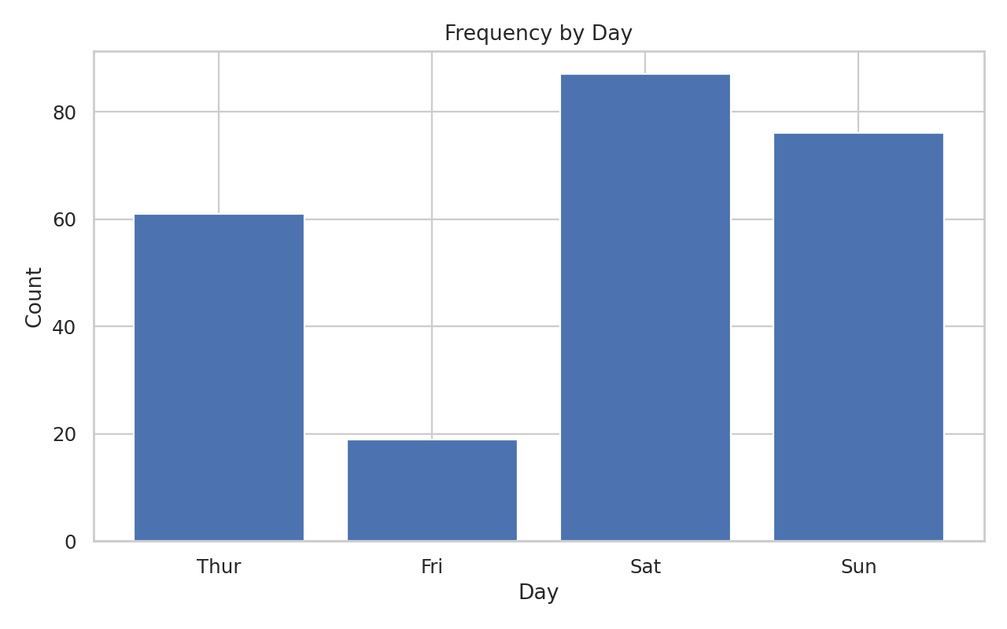
Saturday and Sunday contain more observations than Friday and Thursday.

Pie Chart – Lunch vs Dinner
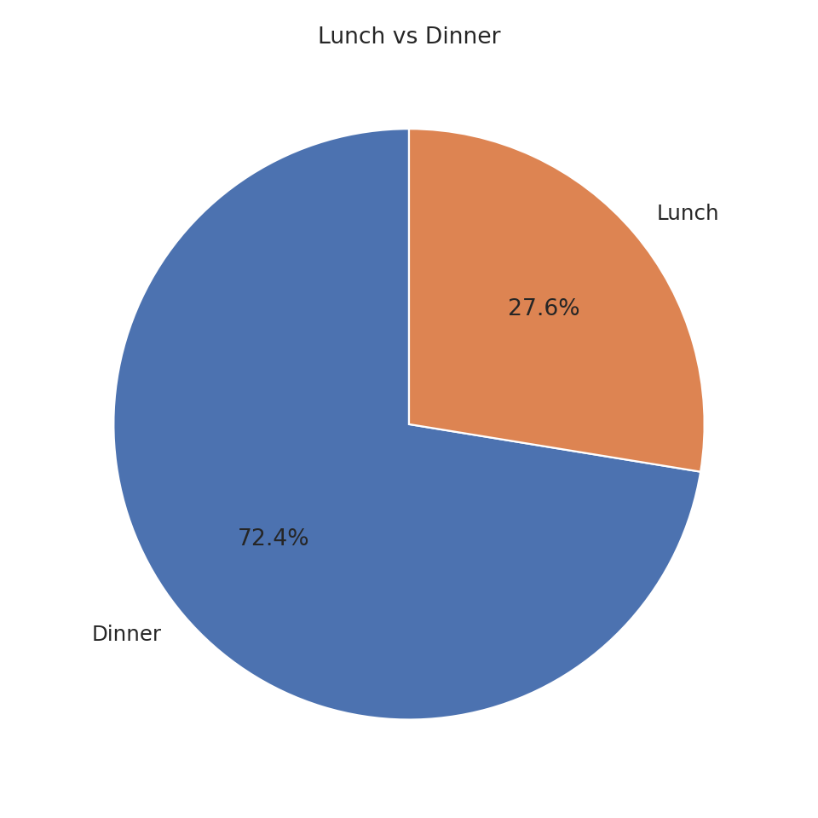
Dinner accounts for the larger share of observations.

Frequency Table
Day | Dinner | Lunch
Thur | 1 | 60
Fri | 12 | 7
Sat | 87 | 0
Sun | 76 | 0

UNIT 4 – BIVARIATE ANALYSIS
Pearson correlation between total bill and tip = 0.675. Spearman correlation = 0.677. Both show a positive association.

Scatter Plot with Regression Line
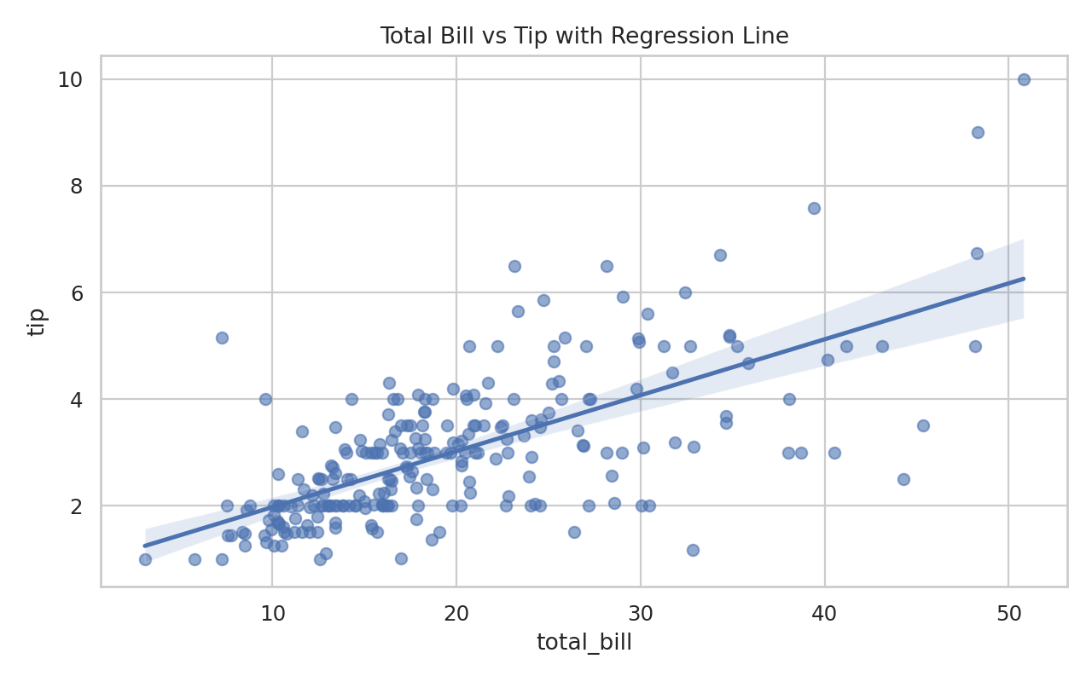
The regression line rises as total bill increases.

Grouped Bar Chart
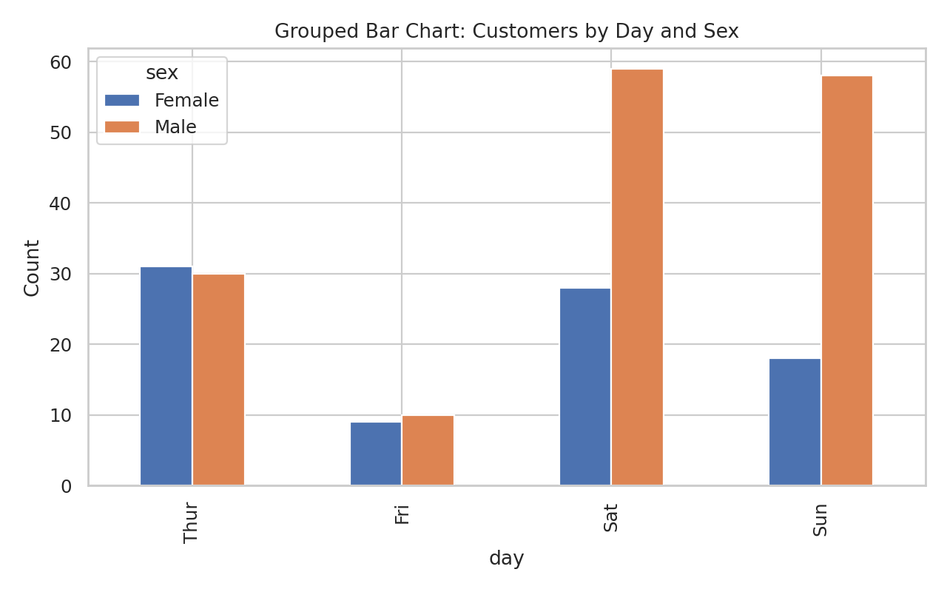
The chart compares male and female observations across days.

Stacked Bar Chart
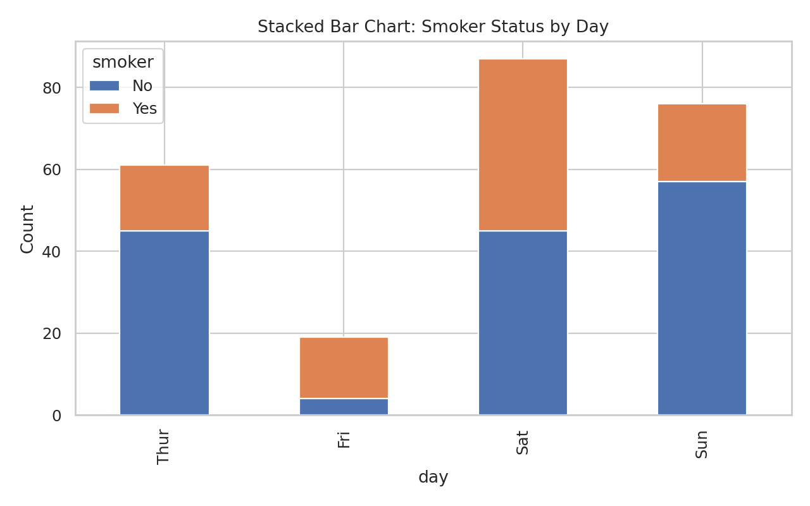
The chart compares smoker and non-smoker composition across days.

Box Plot and Violin Plot
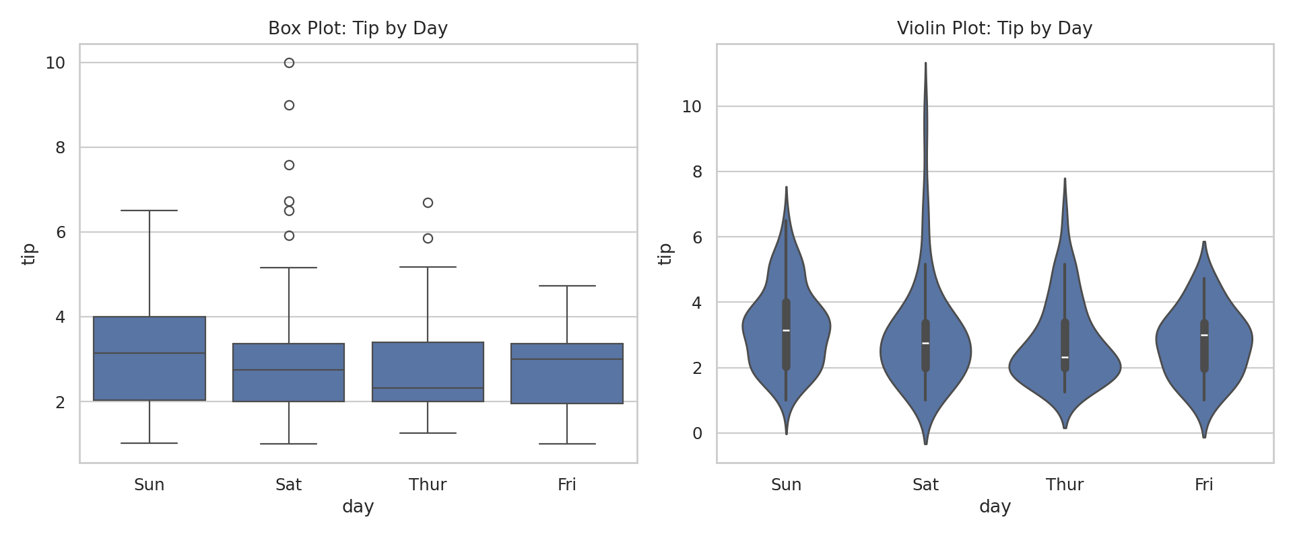
The plots compare tip distributions and spread across days.

UNIT 5 – MULTIVARIATE ANALYSIS AND INSIGHTS
Pair plots, correlation heatmaps, PCA and t-SNE were used to study multiple variables simultaneously. A basic Linear Regression model was implemented using scikit-learn.

Pair Plot / Scatter Matrix
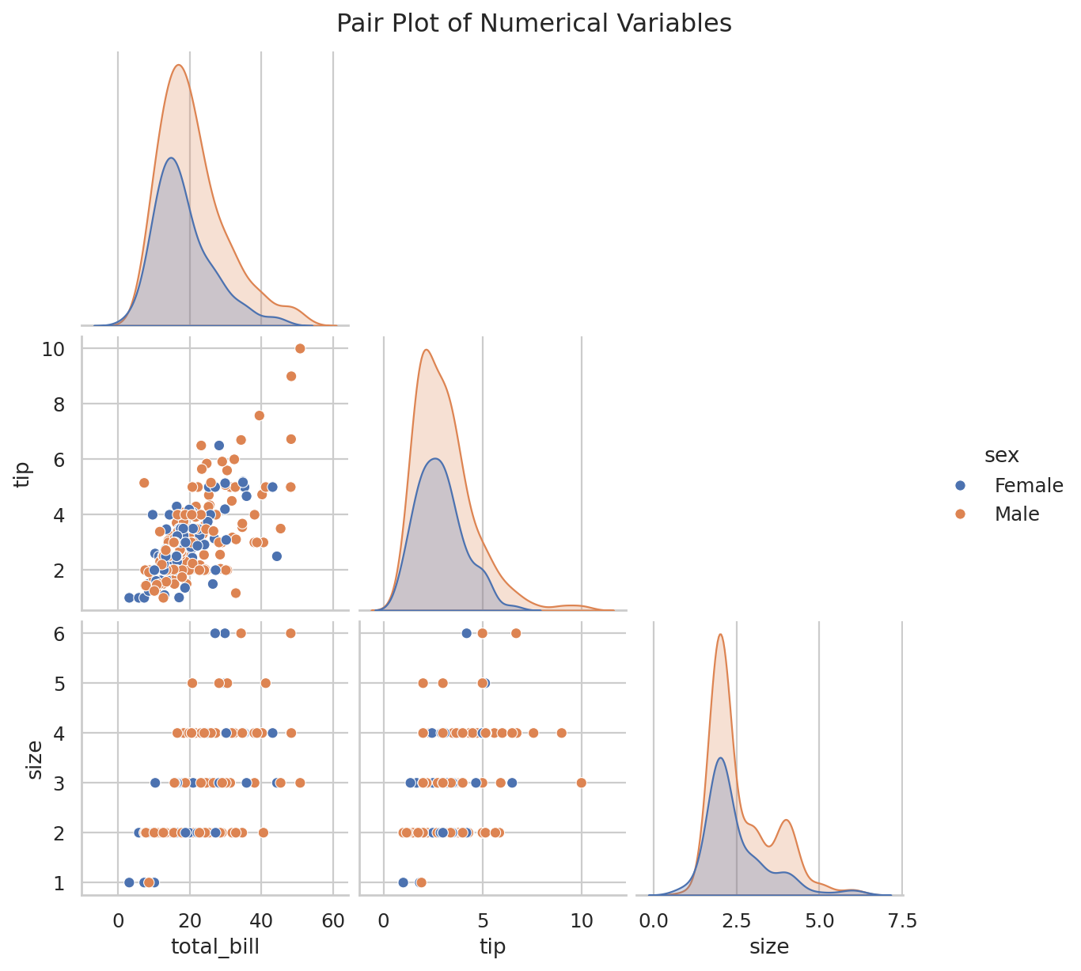
The pair plot compares numerical variables simultaneously and separates observations by sex.

Correlation Heatmap
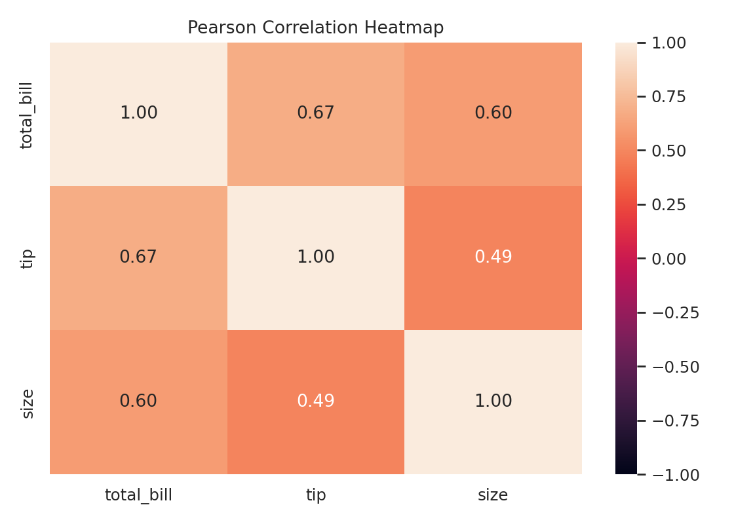
The heatmap summarizes pairwise linear relationships.

PCA Projection
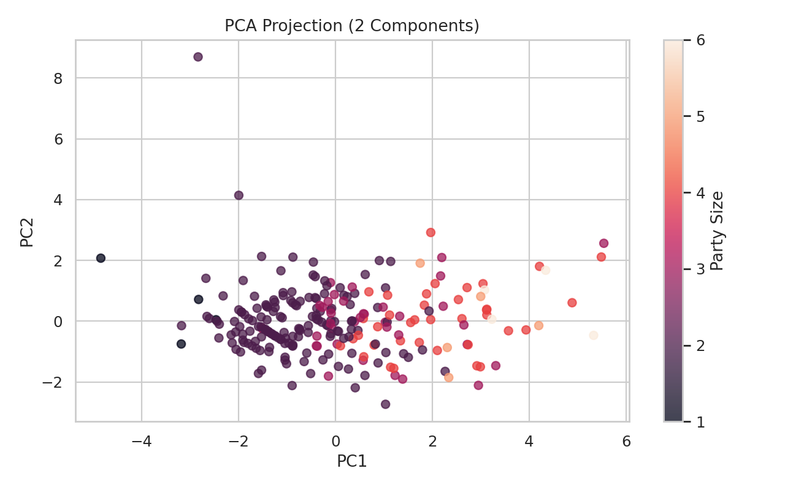
PCA reduces the scaled feature space to two principal components.

t-SNE Projection
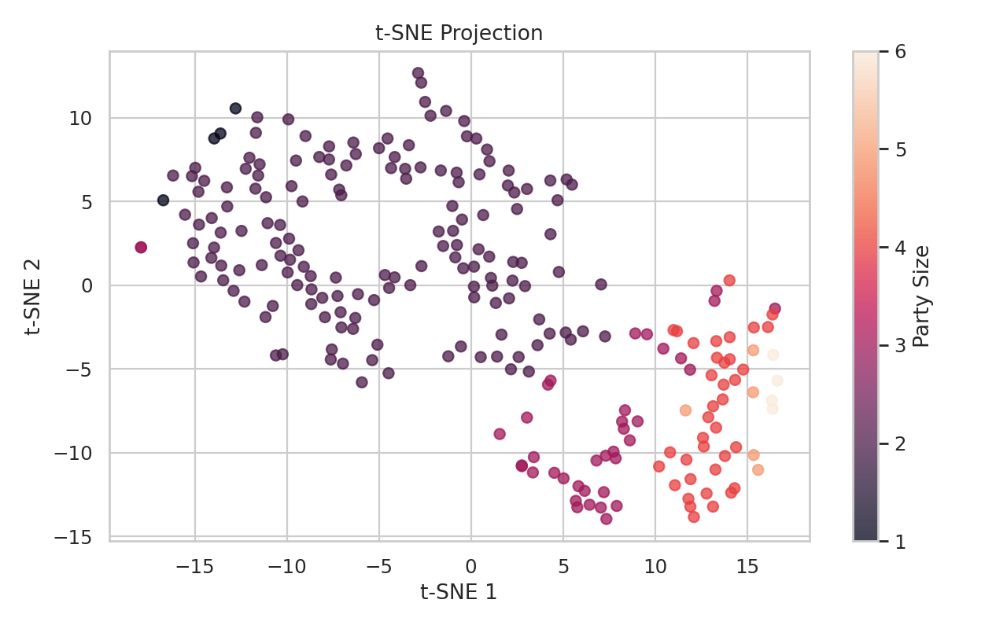
t-SNE gives a nonlinear two-dimensional representation.

PCA Explained Variance
PC1 = 0.611; PC2 = 0.261; combined = 0.872.

Basic Scikit-learn Model
Linear Regression predicts tip amount from total bill, party size and encoded categorical variables. The data was split into 80% training and 20% testing sets.
Metric | Test Result
MAE | 0.767
RMSE | 1.083
R² | 0.519

Complete Syllabus Coverage Checklist
Unit | Required Topics | Status
Unit 1 | EDA, data loading, initial inspection, missing values, duplicate values, encoding, transformations, grouping | Covered
Unit 2 | Matplotlib, line, scatter, density/contour, histograms, legends, colors, subplots, text/annotation, 3D, Seaborn, Plotly, Bokeh | Covered
Unit 3 | Histograms, box plots, density plots, mean, median, standard deviation, quartiles, skewness, outliers, bar charts, pie charts, frequency tables | Covered
Unit 4 | Scatter plots, Pearson/Spearman, grouped/stacked bars, box plots, violin plots | Covered
Unit 5 | Pair plots, heatmaps, multivariate visualization, PCA/t-SNE, scikit-learn model | Covered

Final Conclusion
The Tips dataset supports a complete five-unit Data Exploration and Visualization workflow. EDA identified structure and data quality, transformations and grouping prepared the data, multiple visualization libraries communicated patterns, univariate and bivariate methods described distributions and relationships, and multivariate methods summarized combined structure. PCA/t-SNE demonstrated dimensionality reduction and Linear Regression demonstrated a basic scikit-learn workflow.

Submission Checklist
- Report included
- Notebook included
- Dataset included
- Figures included
- Interactive Plotly/Bokeh files included
- requirements.txt included
- README.md included
- Upload the complete folder to GitHub
- Replace the placeholder GitHub URL
- Submit before 09.10.2026

References
1. Plotly Express documentation: https://plotly.com/python/plotly-express/
2. Uploaded 24UAD512 Data Exploration and Visualization syllabus.
3. Pandas, NumPy, Matplotlib, Seaborn, Bokeh and Scikit-learn documentation.

