CAOS
From Chaos to CAOS
Feature & Process Documentation
Prepared for Venture Assist / Srivatsan & Associates.

Version History
Version | Date | Summary
v0.1 | 2026-08-16 | First externally shareable release: process flows for all 10 automation agents in text form.
v0.2 | 2026-08-16 | Added visual flow diagrams for every process, expanded step-by-step detail, and worked examples for the three highest-priority agents (Bookkeeping, Reconciliation, Client Communication).
v0.3 | 2026-08-22 | Updated the Bookkeeping/Voucher Entry and Reconciliation sections to reflect parallel support for Tally and Zoho Books — roughly 20-40% of the client base keeps its books in Zoho Books rather than Tally, and CAOS now handles both the same way. No other process changed.
v0.4 | 2026-08-22 | Restored the visual flow diagram for all 10 processes (omitted from v0.3), redrawn in the Design B teal/amber style. The Bookkeeping and Reconciliation diagrams reflect Tally + Zoho Books parity throughout.
v0.5 | 2026-09-18 | Corrected the framing of the "Why This Matters — In Numbers" section. The figures were previously described as using the practice's own numbers as the baseline; the P0-01 finding (sprint plan v0.2.2, 2026-09-17) established that the practice does not currently track time-per-task, so they are discovery-conversation estimates rather than measured data, and are now presented that way. The numbers themselves are unchanged. No other section changed.
v0.6 | 2026-09-20 | Added one new section, “Task Management & Practice Measurement”, covering the task and engagement scope agreed in the September 2026 customer review: engagements, how tasks are created, sub-tasks, standard time per task type, time measured from task status rather than timesheets, waiting states, the status request, staff deadline reminders, per-service SOPs, and billing through to invoice. The section is explicitly marked as agreed scope that is not yet built, with delivery references given only where they are known and marked not yet scheduled otherwise. It raises one open question back to the practice: which billing cycles are actually used, since annual is not currently modelled. No other section changed.

What CAOS Is
CAOS is a practice-automation platform built specifically for this practice — designed to close the gap between servicing roughly 100 GST returns a month today and a target of 500 within 6 months, without adding headcount. The name reflects what it replaces: a set of manual, fragmented processes — document chasing, bookkeeping, GST reconciliation, client follow-up, billing — that today depend on individual discipline and don't scale on their own.
CAOS is not a single tool bolted onto existing software. It's a set of purpose-built automation agents, each targeting a specific bottleneck, all working through one shared task system — so nothing depends on someone remembering to check a spreadsheet or a separate inbox. Every judgment call an agent can't make on its own becomes a task, assigned to a specific person, with a due date. If it's not resolved in time, it escalates automatically.
Clients keep their books in different systems — most in Tally, some in Zoho Books. CAOS works the same way either way: staff never have to think about which system a given client uses, since the platform handles that difference automatically behind the scenes.
This document walks through each part of CAOS in detail — what it does, how the process flows, and exactly where a human stays in control — so the practice can see precisely how the system will work before it's built, not just what it's meant to achieve.

Why This Matters — In Numbers
These are estimates drawn from discovery conversations with the practice — not yet backed by measured data, since the practice doesn't currently track time-per-task. Once CAOS's own time-per-task tracking (Sprint 11) has been running for a while, these figures will be replaced with real measured numbers.
Area | Typical time today | Realistic automated time
GSTR-2A/2B reconciliation | 1–2 hrs/client/month | Minutes (review only)
Bookkeeping / voucher entry | Largest manual labor pool today | Review only, exceptions flagged
Document chasing/collection | A daily, unbilled time sink | Near-zero — auto-filed and tracked
Client follow-up | The single biggest stated pain point | Automated reminders, exceptions only
Working papers | Assembled manually per engagement | Auto-populated, auditor adds judgment only

The target — 500 returns a month with the same 10-person team — only works if the hours-per-return drop by a proportional amount. That's what each agent below is built to do.

How CAOS Keeps Work Accountable
Every agent below can handle the routine, repeatable part of its job on its own. What it can't decide — a judgment call, an exception, something that needs a human's sign-off — becomes a task, not a notification buried in an inbox.
Each task has an owner and a due date, assigned automatically by role (junior staff, senior staff, or the proprietor, depending on what the task requires). If a task isn't resolved in time, it escalates — first to a senior team member, and if still unresolved, to the proprietor directly.
Why this matters
The real bottleneck identified during discovery wasn't technology resistance — it was inconsistent follow-through on process. CAOS is built to enforce that discipline structurally, rather than depend on everyone remembering to check the task sheet at 10am every day.

Core Process Flows
Each process below follows the same structure: what it's meant to solve, a step-by-step walkthrough, and exactly where a human stays involved.

1. Document Intake
Goal: Eliminate manual chasing and filing of client documents.
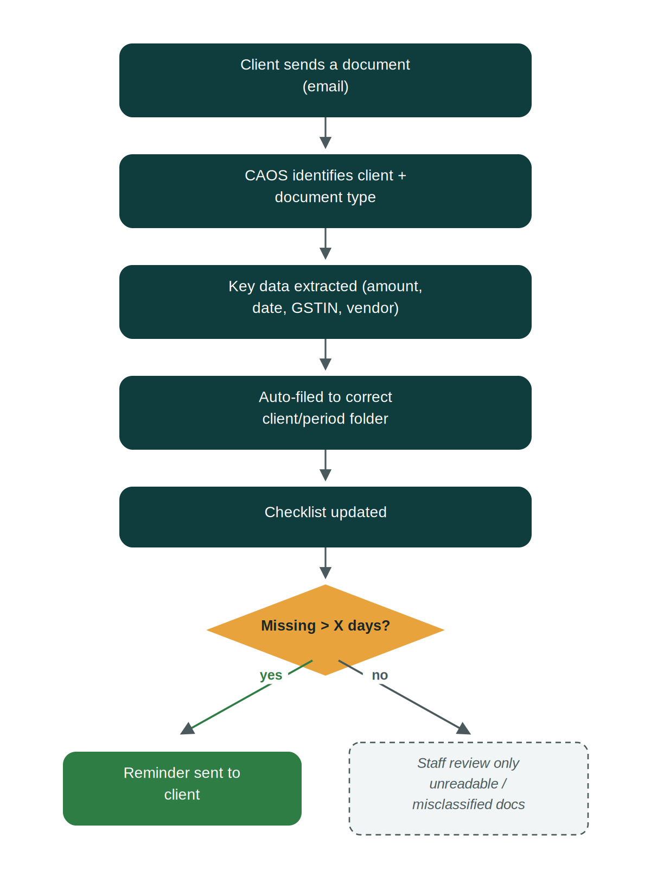
How it works
1. Client sends a document — By email, primarily — over 99% of the practice's document flow today already happens this way, so no change is needed on the client's end.
2. CAOS identifies client and document type — The system recognizes which client the document belongs to and classifies it — invoice, bank statement, GSTR filing, Form 26AS, and so on — automatically.
3. Key data is extracted — Amounts, dates, GSTIN, and vendor name are pulled out of the document, ready for the next agent (usually Bookkeeping) to use.
4. Document is filed automatically — It lands in the correct client and period folder — no one has to manually sort or rename anything.
5. Checklist stays current — A running view shows exactly what's still outstanding for each client and period, so nothing quietly falls through the cracks.
6. Reminders go out automatically — If something is still missing beyond a set number of days, the client gets a reminder without staff having to track it manually.

Human touchpoint: Staff review only the exceptions — a document CAOS can't confidently classify or read.

2. Bookkeeping / Voucher Entry
Goal: Automate the largest manual labor pool in the practice today — entering client purchase and sales records into the client's own bookkeeping system, whether that's Tally or Zoho Books.
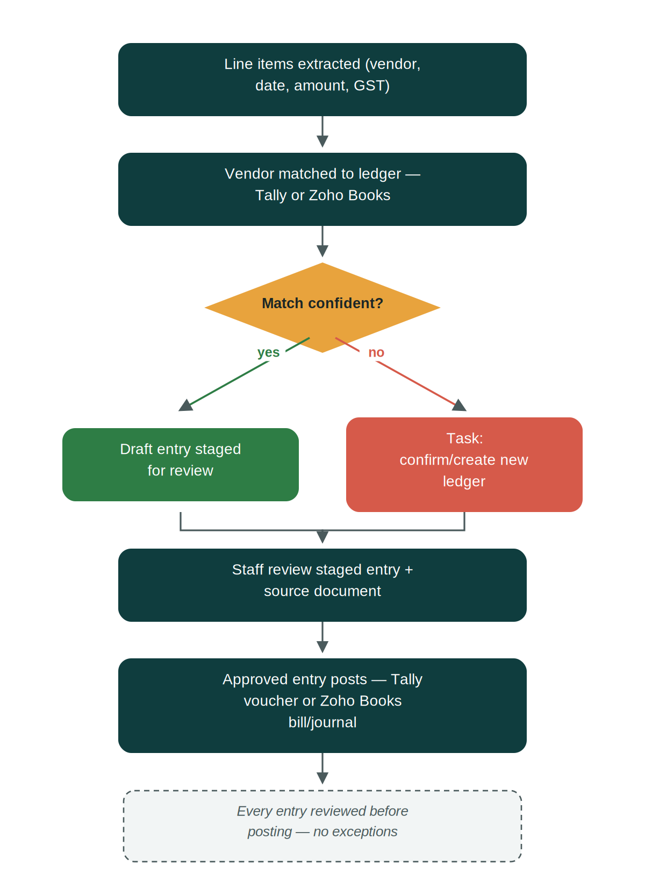
How it works
1. Line items are extracted — Vendor name, date, amount, GST, and HSN code are pulled from the intake document.
2. Vendor is matched to an existing ledger — CAOS compares the vendor name against the client's own bookkeeping records — Tally or Zoho Books, whichever the client uses — allowing for minor spelling and formatting variations between what's on the invoice and what's already set up there.
→ Confident match → a draft entry is staged automatically for review
→ No confident match → flagged as a task to confirm or create a new ledger/account, rather than guessing and risking a misposted entry
3. Staff review the staged entry — The original source document sits alongside the draft entry on screen, so a quick visual check against the invoice is all it takes to confirm accuracy.
4. Approved entries post directly — Once approved, the entry is posted straight into the client's own system — a Tally voucher or a Zoho Books bill/journal entry — no re-typing, and no difference in the staff experience either way.

Note: Some clients keep their books in Tally, others in Zoho Books. CAOS handles both the same way — staff work from one consistent review screen regardless of which system a given client is on.

Example: An invoice from "Coastal Components Pvt Ltd" arrives. CAOS matches it to the existing "Coastal Components" ledger — whether that ledger lives in Tally or Zoho Books — despite the slightly different name, extracts the amount and GST split, and stages a draft entry ready for a one-glance approval rather than manual re-entry.

Human touchpoint: Staff review every staged entry before it posts — nothing enters the client's books without a human confirming it, even on high-confidence matches.

3. Reconciliation (GSTR-2A/2B vs. Purchase Register)
Goal: Replace the single biggest manual time sink in GST compliance work.
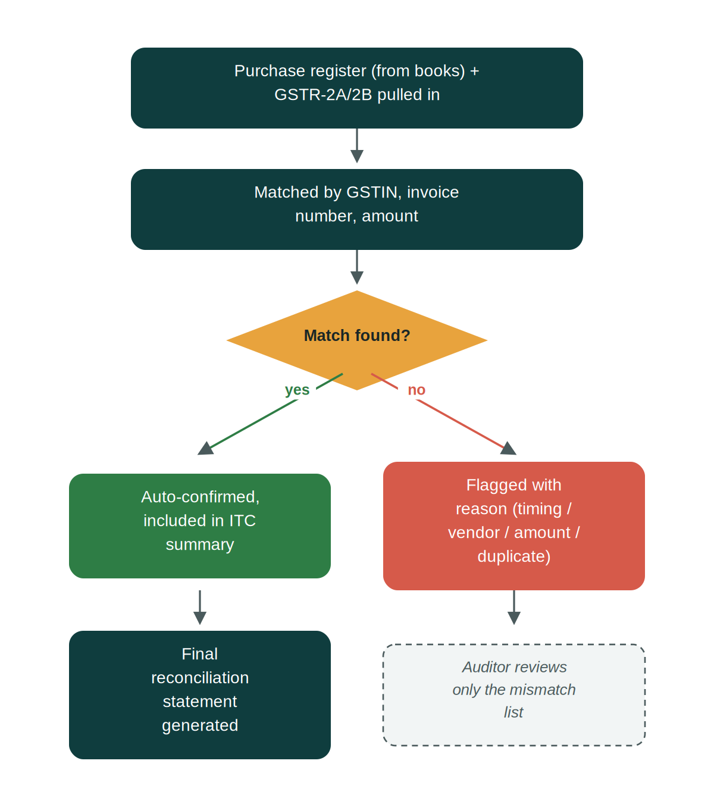
How it works
1. Data is pulled in automatically — Purchase register data from the client's bookkeeping system — Tally or Zoho Books — and GSTR-2A/2B data from the government system are fetched each period without anyone manually downloading or exporting anything.
2. Line items are matched — CAOS compares entries by GSTIN, invoice number, and amount.
→ Matched → confirmed automatically and included in the ITC claim summary — no review needed
→ Mismatched or missing → flagged with the specific reason (timing difference, vendor hasn't filed yet, amount mismatch, or duplicate entry)
3. A reconciliation statement is generated — Ready for filing, with matched items already accounted for.

Example: Of 350 purchase entries for a client in a given month, 340 match cleanly against GSTR-2B and are confirmed instantly. The remaining 10 are flagged — say, 6 because the vendor hasn't filed their return yet, 3 with a small amount mismatch, and 1 duplicate. The auditor reviews exactly those 10, not all 350.

Human touchpoint: The auditor reviews only the mismatch list — never the full ledger.

4. Validation / Compliance Checks
Goal: Catch errors before they become notices from the department.
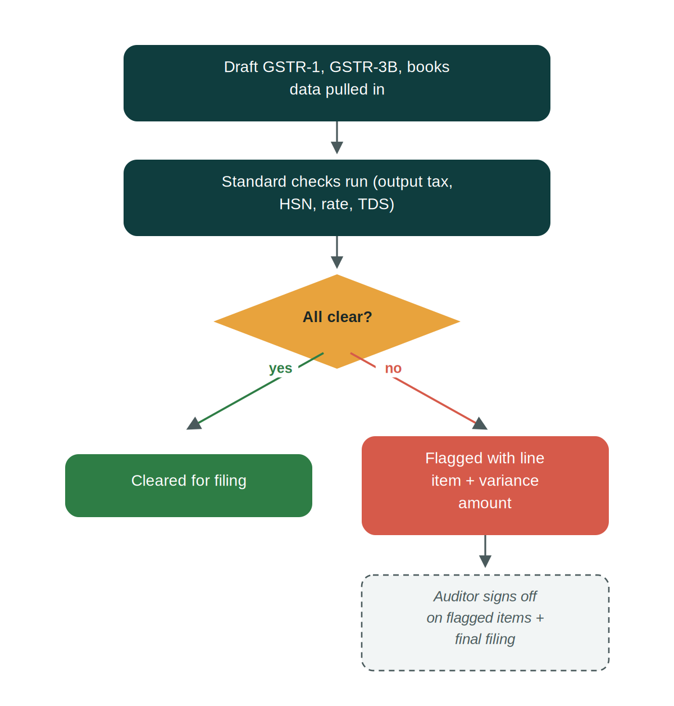
How it works
1. Draft return data is pulled in — GSTR-1, GSTR-3B, and books data are gathered ahead of the filing deadline, not at the last minute.
2. Standard checks run automatically — GSTR-1 output tax is compared against GSTR-3B, HSN codes are checked for correctness, tax rates are validated against the standard rate table, and TDS in Form 26AS is checked against the books.
→ All clear → cleared for filing
→ Discrepancy found → flagged to the auditor with the exact line item and variance amount, while there's still time to fix it before the deadline

Human touchpoint: The auditor signs off only on flagged items and the final filing.

5. Client Communication
Goal: Remove routine follow-up from the auditor's and staff's plate — the single biggest stated pain point in the practice today.
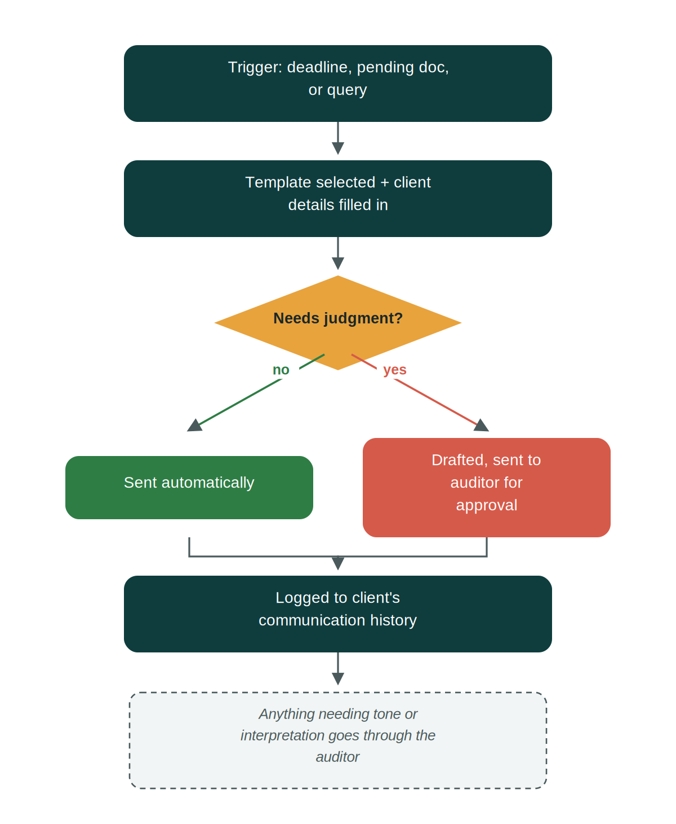
How it works
1. A trigger fires — An approaching deadline, a document still pending, or a query raised during reconciliation or validation.
2. The right message is prepared — CAOS selects the appropriate template and fills in the client-specific details automatically.
→ Routine reminder → sent automatically, no review needed
→ Anything needing judgment or tone → drafted, then routed to the auditor for approval before it goes out
3. The exchange is logged — Every communication is recorded against the client's record automatically, building a complete history without manual note-taking.

Example: A client's GSTR-1 filing requires OTP confirmation today. CAOS flags this as a time-sensitive task and prompts staff to call the client before a specific cutoff time — rather than the deadline being missed because no one realized today was the day it mattered.

Human touchpoint: Anything requiring interpretation or tone judgment goes through the auditor first — CAOS never sends a judgment call on its own.

6. TDS/TCS Return Automation
Goal: Apply the same reconciliation logic already built for GST to TDS/TCS compliance.
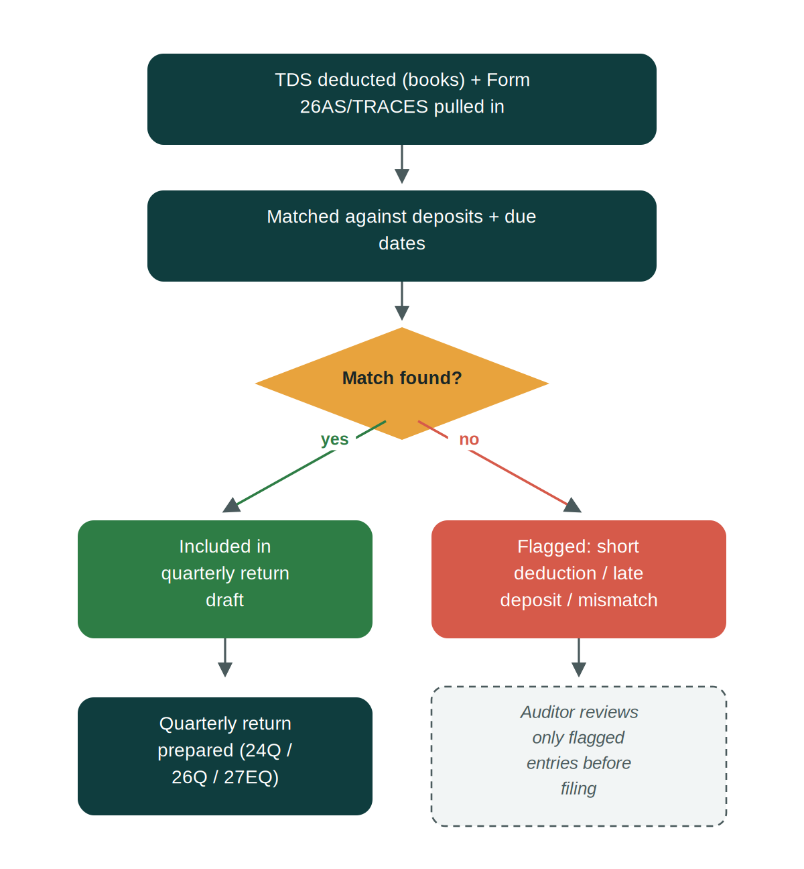
How it works
1. TDS data is pulled in — Deductions per books and Form 26AS/TRACES data are gathered automatically.
2. Deductions are matched — Against deposits and due dates, the same way GST reconciliation matches purchase entries.
→ Matched → included in the quarterly return draft automatically
→ Short deduction, late deposit, or mismatch → flagged to the auditor with the specific entry
3. The quarterly return is prepared — 24Q, 26Q, or 27EQ, ready for review and filing.

Human touchpoint: The auditor reviews only the flagged short-deductions or late deposits before filing.

7. Bank Reconciliation
Goal: Automate a task that's currently manual for most small and mid-size clients.
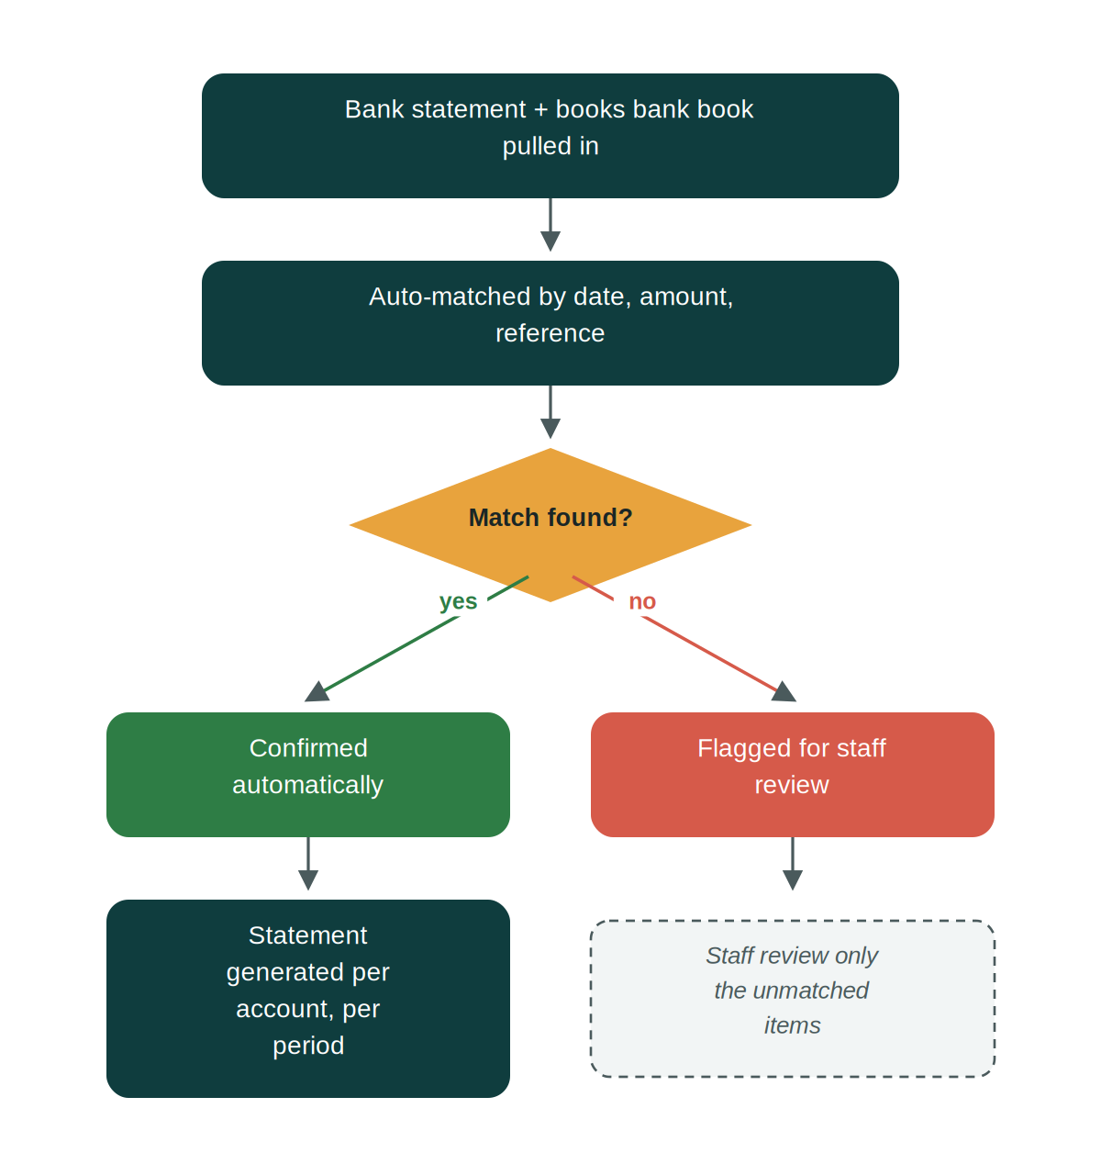
How it works
1. Bank and books data are pulled in — Across all of a client's bank accounts, not just one at a time.
2. Entries are auto-matched — By date, amount, and reference number.
→ Matched → confirmed automatically
→ Unmatched → flagged for staff review (bank charges, unrecorded entries, or simple timing differences)
3. A statement is generated — Per account, per period, ready for the client file.

Human touchpoint: Staff review only the unmatched items list.

8. Working Papers
Goal: Standardize and speed up documentation for every engagement.
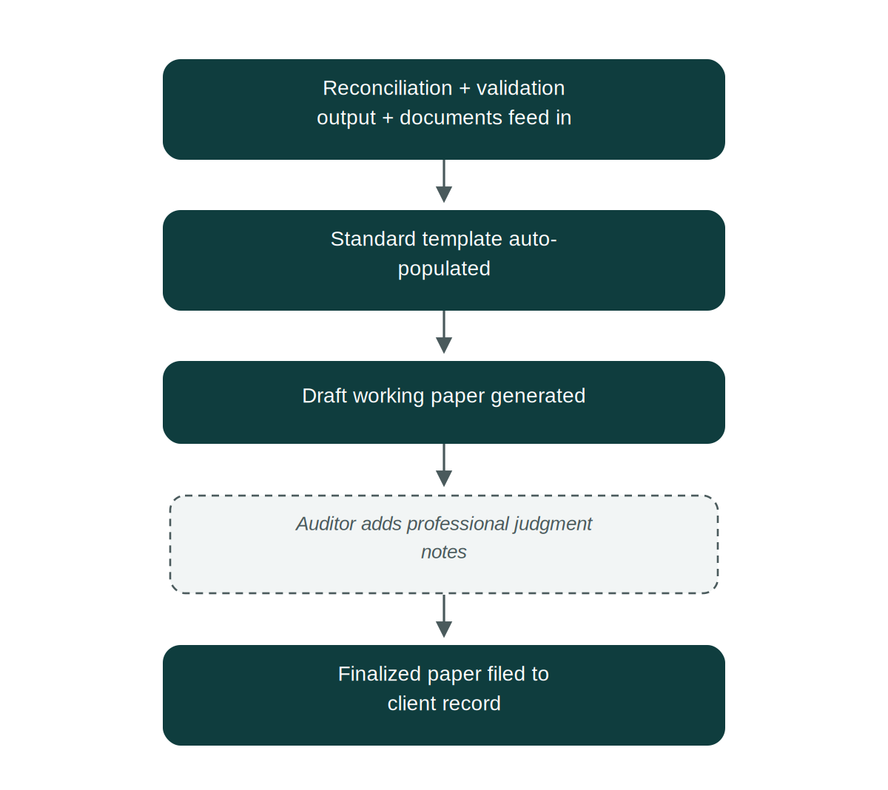
How it works
1. Output feeds in automatically — Reconciliation results, validation results, and client documents populate the working paper without manual assembly.
2. The standard template is populated — Scope, data sources, and exceptions noted — the factual backbone of the working paper — all assembled automatically.
3. The auditor adds judgment — Professional conclusions and notes remain entirely auditor-authored — CAOS never writes these.
4. The finalized paper is filed — To the client's record, complete and ready for reference.

Human touchpoint: All professional judgment and conclusions remain auditor-authored — CAOS only assembles the factual backbone.

9. Practice Visibility
Goal: Give the practice real visibility into its own capacity — the foundation for taking on more clients without more headcount.
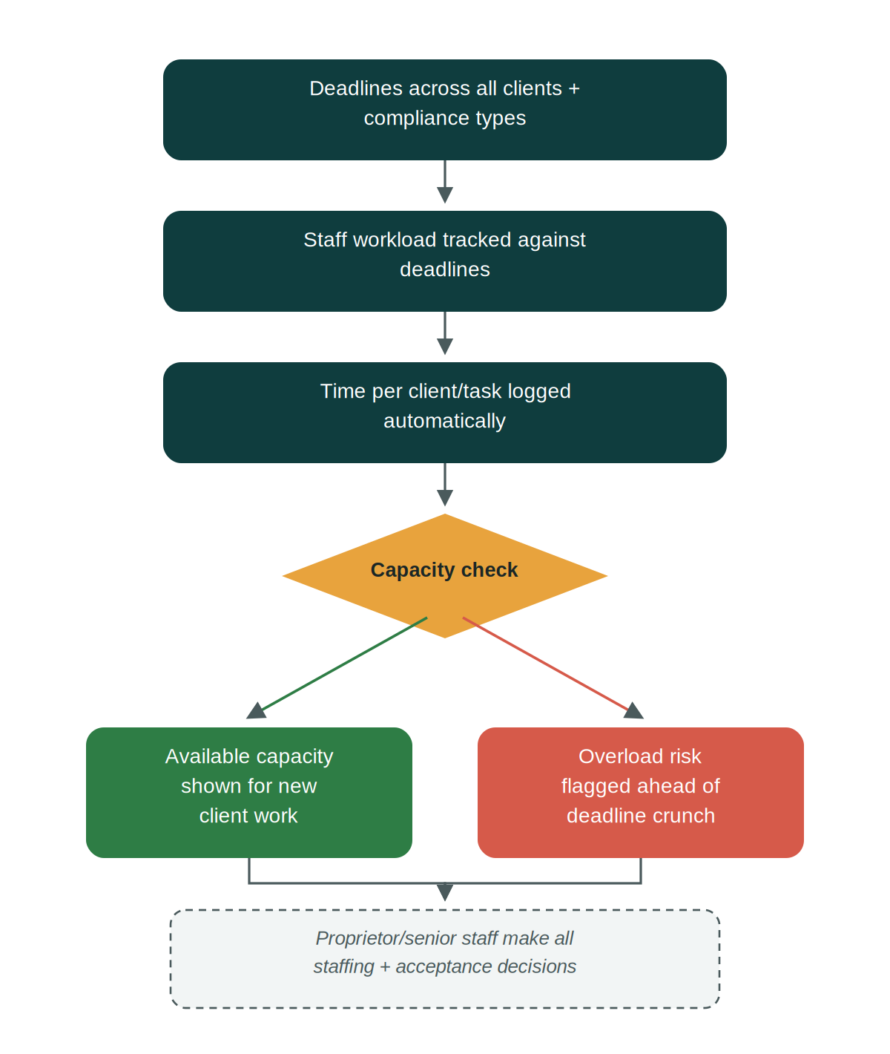
How it works
1. Deadlines are consolidated — Every client and every compliance type — GST, IT, TDS, ROC — appears on one calendar instead of being tracked separately.
2. Workload is tracked in real time — Staff capacity is measured against actual upcoming deadlines, not estimated after the fact.
3. Time is logged automatically — Per client and per task, building the real numbers the practice needs for its own planning.
→ Capacity available → the dashboard shows exactly which staff or time slots can take on new client work
→ Overload risk → flagged ahead of the deadline crunch, not discovered after it's already a problem

Human touchpoint: The proprietor and senior staff make all staffing and client-acceptance decisions — CAOS only surfaces the data.

10. Client Billing
Goal: Automate invoicing based on services actually delivered, replacing the current ad hoc, per-client billing approach.
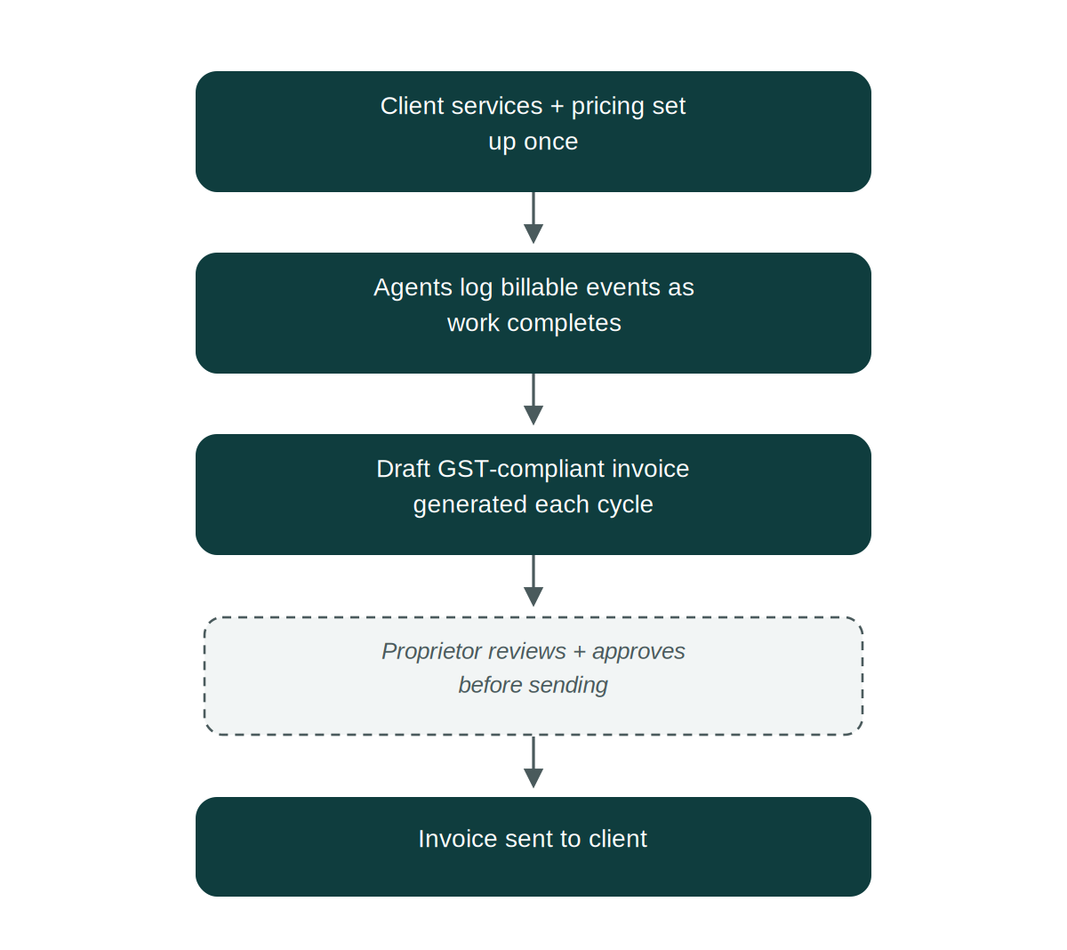
How it works
1. Services and pricing are set up once per client — Each client's subscribed services are configured against the practice's own service catalog.
2. Billable events are logged automatically — As agents complete work — a filing, a reconciliation, a bookkeeping cycle — it's recorded as a billable event without anyone tracking it manually.
3. A draft invoice is generated — GST-compliant, with the correct GSTIN, HSN/SAC codes, and tax breakup, each billing cycle.
4. The proprietor approves before sending — Nothing goes to a client without sign-off.

Human touchpoint: Every invoice is reviewed and approved by the proprietor before it goes out — nothing is billed automatically without sign-off.

Task Management & Practice Measurement
This section describes scope agreed in the September 2026 review. None of it is built yet — unlike the ten process flows above, which describe the platform as designed and scheduled, everything in this section is a design commitment rather than a delivered feature. It is written here so the practice can confirm the shape before it is built, and so nothing below is mistaken for something that exists today.
Delivery timing is given for each part below where it is genuinely known. Several pieces sit outside the current sprint plan and are honestly marked as not yet scheduled — the review moved time measurement to the centre of what the practice wants from CAOS, and the sequencing consequences of that have not been worked through yet.
Engagements — what connects a client, a service and the people doing the work
Today the platform holds clients, and it holds the services the practice sells, but it holds nothing that joins them. An engagement is that join: one service, delivered to one client, for one period — "Coastal Services, GSTR-3B, September 2026". It is the thing work attaches to, that time accrues against, and that eventually gets billed.
Every engagement will carry a named owner — one accountable person, not a group — and alongside them the wider team staffed to it. Both matter for different reasons. The owner is who answers for the engagement; the staffed team is who may work on it and whose availability the practice can see when deciding whether to take on more.
An engagement records | Which means, in practice
The client and the service | "Which of our services is this, for whom" — the basis for what gets invoiced
The period it covers | A month, a quarter or a year, depending on the service
A named owner | One person accountable for it reaching completion
The staffed team | Who else works on it — and, across all engagements, who has capacity
Its billing basis and cycle | How this piece of work turns into an invoice line

Note: Once engagements exist, "which services is this client actually buying" becomes a question the platform can answer from its own records rather than from memory — it is simply the list of services across that client's active engagements.

How tasks come into being
Work will reach a person's queue by one of three routes, and CAOS will record which one:
1. Raised automatically by the platform — The route that exists today. An agent hits something it cannot decide — an unmatched invoice, a reconciliation mismatch, a validation failure — and raises a task against the person whose call it is.
2. Created manually by a permitted role — Work that no agent would ever raise: a client phones with a question, the proprietor wants something checked. Who may create tasks manually, and for whom, will be set by role — that restriction is deliberate and still to be defined with the practice.
3. Generated from the service's task template when an engagement starts — Each service will carry its standard breakdown of work. Starting a GSTR-3B engagement creates that service's tasks automatically, so the standard steps never depend on someone remembering them.
The third route is the one that changes daily life most. It is also what makes the standard time below meaningful, because a task created from a template is a task the practice has a considered expectation for.
Sub-tasks — one level, deliberately
A task will be able to be broken into sub-tasks, by the person it is assigned to or by someone senior to them. Sub-tasks are ordinary tasks in every respect: their own assignee, their own due date, their own reminders and escalation.
They go one level deep and no further — a sub-task cannot itself be split. This is a deliberate limit rather than a technical one. Work broken down three and four levels deep stops being a breakdown and becomes a second system to keep up to date, and the totals that roll up to an engagement stop meaning anything definite.
Standard time per task type — a costing benchmark, not a target
Each task type in a service's template will carry a standard time: what this piece of work is reasonably expected to take. It exists for three purposes, and it is worth being exact about them, because a number attached to a person's work can easily be read as something it is not.
1. Costing — What a service actually costs to deliver, as against what it is priced at.
2. Capacity — Whether the practice can absorb twenty more returns a month — a question that needs hours, not a headcount.
3. Noticing the unusual — A task taking far longer than its standard is a signal worth looking at — normally a difficult client, a messy set of records or a task type whose standard was set wrong.

Note: Standard time is a benchmark for costing and capacity. It is not a performance target, and CAOS will not rank or score staff against it. A task that runs long is information about the work, not a verdict on the person doing it.

How time gets measured — without timesheets
The practice does not keep timesheets today, and CAOS will not introduce them. Time will be worked out from what a task's status already says: when someone starts a task, when they pause it and why, when they finish it. Nobody fills anything in at the end of the day.
That produces two separate measurements, and keeping them separate is the whole point:
1. Time the task was actively being worked — The stretch between someone starting a task and pausing or finishing it. This is the figure that belongs against standard time, and the one that says what the work actually costs the practice in effort.
2. Time the task was waiting — The stretch where nobody could act on it — waiting for a document, waiting for a client to reply. This is turnaround time, and it is not effort at all.

Note: These two answer genuinely different questions, which is why CAOS will keep them apart. A task that sat ten days waiting on a client took ten days to turn around and perhaps forty minutes of anyone's attention. Reported as one number, those ten days would look like ten days of someone's work — which is how a costing figure becomes wrong and an unfair one at the same time.

Human touchpoint: This depends on staff marking tasks started and paused as they go. CAOS removes the timesheet, not the habit — and it is a far lighter habit than a timesheet, since it is two taps in the course of doing the work rather than a reconstruction at the end of the week. It is worth saying plainly because it is what makes every number in this section trustworthy: the measurements are exactly as good as that marking is honest.

Waiting on the client, waiting on a system
When a task cannot move forward, the reason will be recorded — principally whether it is waiting on the client or waiting on a system. The distinction matters because the two have entirely different remedies, and only one of them is anyone at the practice's to fix.
Example: A month's bookkeeping shows a turnaround of eleven days. Separated out, that is one day of actual work and ten days waiting on the client for bank statements. The practice is not slow; the document chase is. That is a conversation to have with the client, and until now there has been no number to have it with.

Two things about this are worth being straight about. First, the waiting reason will be set by hand to begin with — someone pauses the task and says why. It becomes automatic later, once the client communication module is tracking outstanding requests directly (Sprint 6); the manual version is the starting state, not a fallback.
Second, a task's deadline does not pause while it waits. A statutory due date does not move because a client is slow, and a task still waiting as its deadline approaches is exactly the case that should be escalating.
Asking someone for a status — the buzz
Anyone will be able to ask for an update on a task without it turning into a phone call or a corridor conversation. The task shows a status-requested marker in the assignee's queue, attributed to whoever asked and when.
Deliberately, a buzz does not create a second task. Asking about work is not itself work, and a system where every enquiry spawns another item to close is a system people stop using. It is a flag on the thing being asked about, visible where the assignee is already looking.
Reminders for staff, before the deadline
CAOS already reminds clients ahead of deadlines. It does not currently remind the person preparing the work — internally, a task speaks up when it is assigned and again once it is already overdue, which is one notification too late.
Staff will get their own pre-deadline reminders on the tasks they hold, separate from anything a client sees and worded for internal use. A reminder can be acknowledged or silenced on a task already in hand, so the reminders stay worth reading.
SOPs and reference material, attached to the service
Each service will carry its own procedure notes and reference documents, reachable from any task under it — so the person doing a GSTR-3B for the first time finds the practice's way of doing it in front of them, rather than asking a colleague.
These are versioned, because a procedure that changes when the law changes needs to show what it said at the time. The documents themselves stay where documents already live, in the practice's Dropbox — CAOS points at them and never holds a second copy.
From completed work through to the invoice
Because work will be attached to an engagement, and an engagement to a client and a service, completed work can carry through to billing without anyone reassembling it by hand at month end. Billable work is recorded as it is completed rather than reconstructed afterwards, which is also what makes work that was done but never invoiced visible for the first time.
Pricing is effective-dated: an invoice raised in March stays reproducible in September, because the price that applied in March is still on record. Changing a price going forward will never quietly alter what a past invoice said. The client profiling and billing work lands in Sprint 10; the engagement layer that feeds it is not yet scheduled.

Note: One open question, and it needs the practice's answer rather than a design decision. CAOS currently models monthly and quarterly billing cycles. The review mentioned that some clients are billed quarterly or annually, and annual is not something the platform carries today — it is being designed to, but which cycles the practice actually bills on has not been confirmed. Statutory audit and ROC work looks annual from the outside, and advisory work may bill on completion rather than on any cycle at all. Worth settling before the billing work starts, since it is cheap to widen now and awkward afterwards.

Before Any of This: Standardization Checklist
Automation fails fast without this groundwork in place first.
# | What to Standardize | Owner
1 | Document naming & folder structure (per client/period) | Practice
2 | Client onboarding data-request format | Practice
3 | Chart of accounts consistency across clients (or a mapping layer) | Practice + delivery team
4 | Written SOP for each process above (steps + exception rules) | Auditor + staff
5 | Exception thresholds (what auto-flags vs. auto-clears) | Auditor

Potential Future Additions
Not part of the current build — worth a future conversation once the core platform is live and proven.
Notice / Scrutiny Tracking
Log GST/IT notices, draft first-cut responses using precedent, and track response deadlines. Deprioritized for now since notice volume is currently low.
Financial Statement Analysis / Ratio Tracking
Auto-generate trend analysis and industry ratio comparisons once books are fully digitized.
ROC / Companies Act Compliance Tracker
Track AOC-4, MGT-7, DIR-3 KYC and other corporate filing deadlines with auto-alerts.
Fixed Asset Register & Depreciation
Maintain the asset register and compute depreciation under both the Companies Act and Income Tax Act.
Audit Sampling & Risk-Scoring
Apply materiality thresholds and flag high-risk transactions for focused audit testing.

