USAGE

In this demo scenario, I have a Software Update Group called Critical and Security Patches – Windows Clients 2014-10-18 00:29:04. Within this group there’s several expired and superseded Software Updates, as shown in the picture below:

[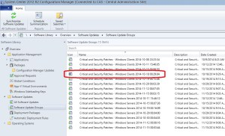](https://i2.wp.com/www.scconfigmgr.com/wp-content/uploads/2014/11/118_1.jpg)

To run the script and perform a clean up of this Software Update Group, follow the instructions below:

1. Download the script from the TechNet Gallery and save it in C:\Scripts.  
2. Open an elevated PowerShell console and browse to where you saved the script.  
3. Run the following command (remember to change the parameter values to suite your environment):

|  |  |
| --- | --- |
| 1 | .\Clean-CMSoftwareUpdateGroup.ps1 -SiteServer FRVLU1SVPS001 -SUGName "Global - Windows 2012 Updates" -ShowProgress -RemoveContent -Verbose |

[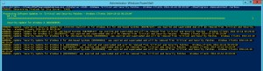](https://i0.wp.com/www.scconfigmgr.com/wp-content/uploads/2014/11/118_2.jpg)

[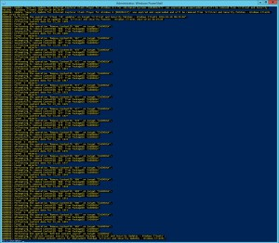](https://i1.wp.com/www.scconfigmgr.com/wp-content/uploads/2014/11/118_3.jpg)

As we can see in the pictures above, it found 18 updates that was matching the criteria of being expired and superseded. Since we gave the script both the ShowProgress and RemoveContent switches, it showed the progress bar and after it had cleaned the 18 eligible updates, it started to remove the content for those updates.

As a result of a successful execution, the Software Update Group should now have a green icon instead of the previous grey:

[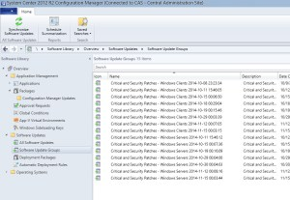](https://i0.wp.com/www.scconfigmgr.com/wp-content/uploads/2014/11/118_4.jpg)

TMF ScreenShots

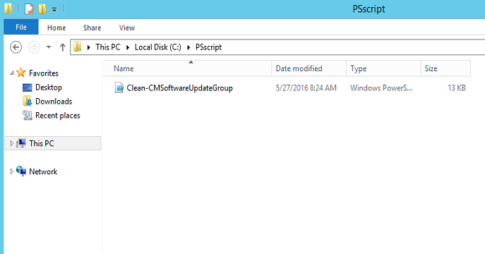

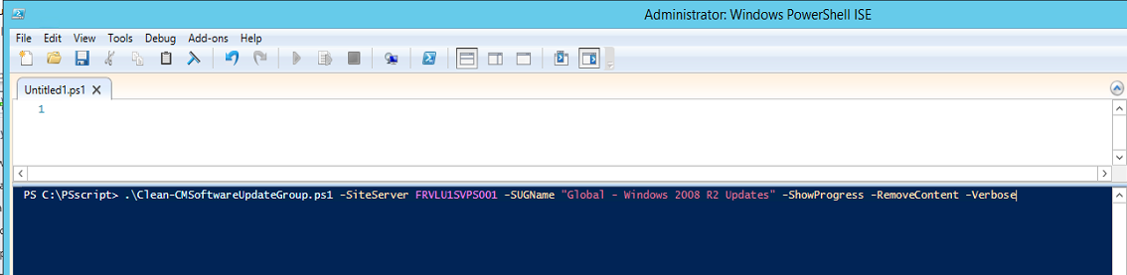

|  |
| --- |
| Global - Windows 2012 R2 Updates |
| Global - Windows 2012 R2 Updates 2019-01 |
| Global - Windows 2012 Updates |
| Global - Windows 2012 Updates 2019-01 |
| Global - Windows 2016 Updates 2018 |
| Global - Windows 2016 Updates 2018-11 |
| Global - Windows 2016 Updates 2019-01 |
| Global - Windows 2008 R2 Updates 2018 |
| Global - Windows 2008 R2 Updates 2019-01 |

.\Clean-CMSoftwareUpdateGroup.ps1 -SiteServer FRVLU1SVPS001 -SUGName "Global - Windows 2012 Updates" -ShowProgress -RemoveContent -Verbose

.\Clean-CMSoftwareUpdateGroup.ps1 -SiteServer FRVLU1SVPS001 -SUGName "Global - Windows 2012 R2 Updates" -ShowProgress -RemoveContent -Verbose

.\Clean-CMSoftwareUpdateGroup.ps1 -SiteServer FRVLU1SVPS001 -SUGName "Global - Windows 2012 R2 Updates 2019-01" -ShowProgress -RemoveContent -Verbose

.\Clean-CMSoftwareUpdateGroup.ps1 -SiteServer FRVLU1SVPS001 -SUGName "Global - Windows 2012 Updates 2019-01" -ShowProgress -RemoveContent -Verbose

.\Clean-CMSoftwareUpdateGroup.ps1 -SiteServer FRVLU1SVPS001 -SUGName "Global - Windows 2016 Updates 2018" -ShowProgress -RemoveContent -Verbose

.\Clean-CMSoftwareUpdateGroup.ps1 -SiteServer FRVLU1SVPS001 -SUGName "Global - Windows 2016 Updates 2018-11" -ShowProgress -RemoveContent -Verbose

.\Clean-CMSoftwareUpdateGroup.ps1 -SiteServer FRVLU1SVPS001 -SUGName "Global - Windows 2016 Updates 2019-01" -ShowProgress -RemoveContent -Verbose

.\Clean-CMSoftwareUpdateGroup.ps1 -SiteServer FRVLU1SVPS001 -SUGName "Global - Windows 2008 R2 Updates 2018" -ShowProgress -RemoveContent -Verbose

.\Clean-CMSoftwareUpdateGroup.ps1 -SiteServer FRVLU1SVPS001 -SUGName "Global - Windows 2008 R2 Updates 2019-01" -ShowProgress -RemoveContent -Verbose