GIT Assignment

1.)

2.)

3.)

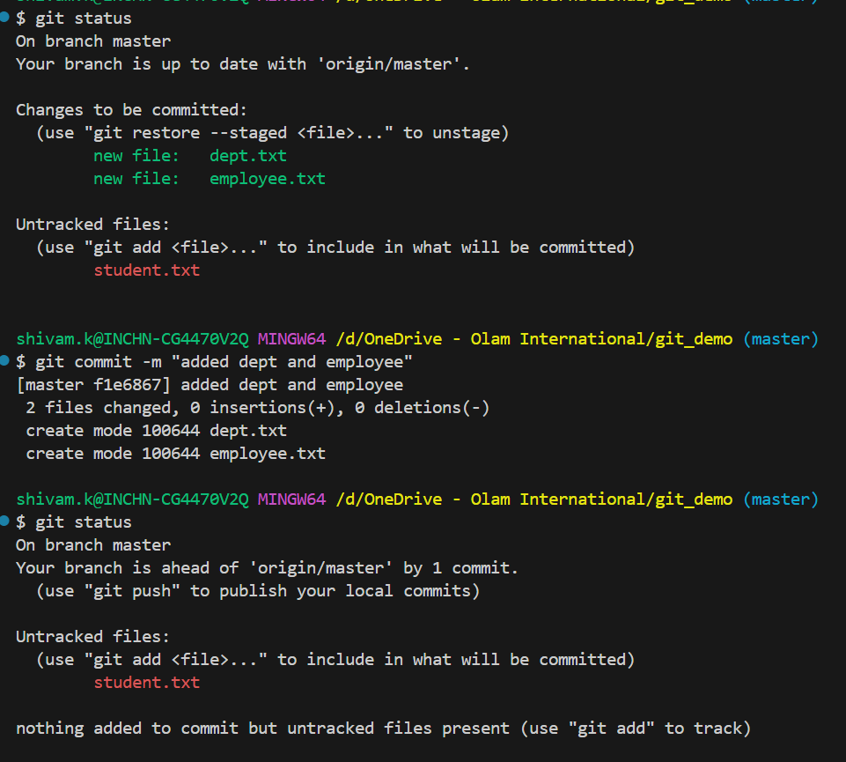

4.)

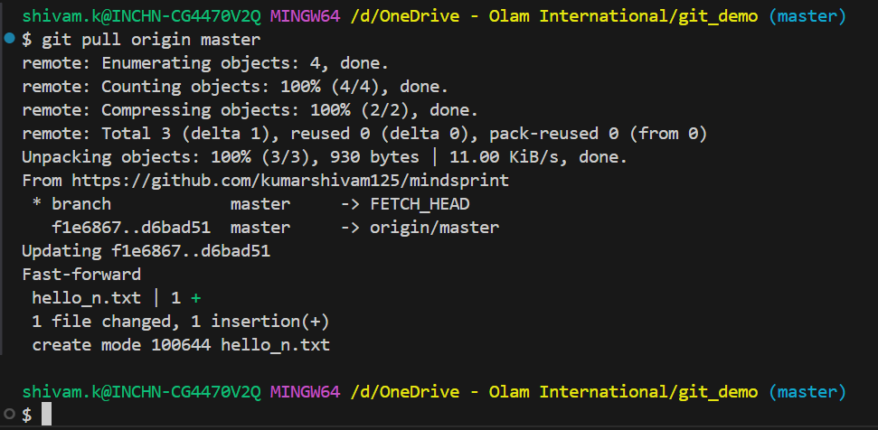

5.)

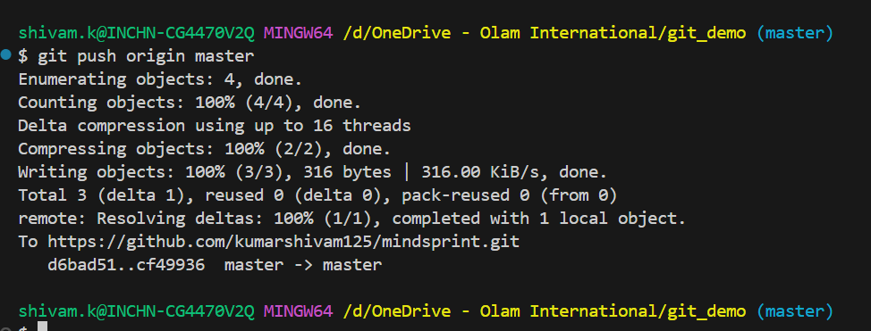

6.)

