1.)

2.)

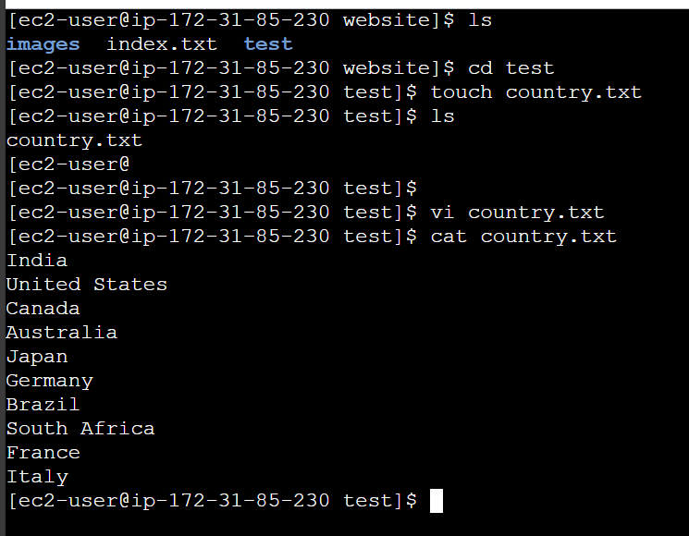

3.)

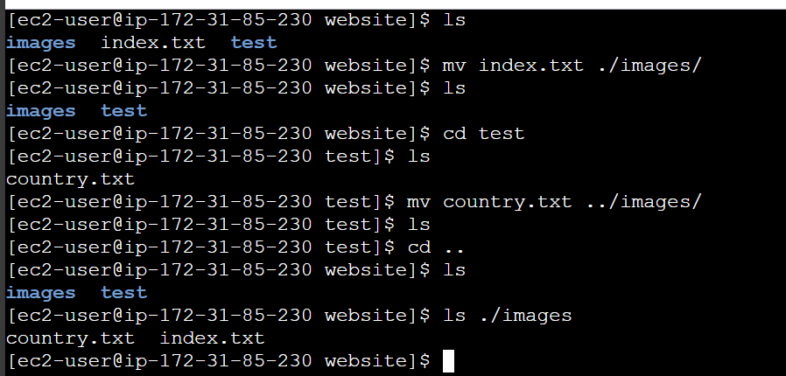

4.)

5.)

6.)

7.)



9.)

