

1 77777 66666

+91 9955422719

SHIVAM KUMAR
https://www.linkedin.com/in/2004shivamkumar/

Kumarshivam16062004@gmail.com

SOFTWARE ENGINEER
Phagwara, Punjab
https://github.com/kumarshivam27december

SUMMARY

Effective Student committed to learning, developing skills [in the area of technology ] and team contribution. Self-directed and energetic with superior performance in both autonomous or collaborative environments working independently and collaborating with others on group projects.

TECHNICAL SKILLS

Programming languages: Python, Javascript, NodeJS, C
and basics of JAVA
R, HTML5, CSS
Data Management:
MySQL
Platforms:
Microsoft office,Linux
OTHER:
GITBASH

CERTIFICATIONS

Become a Full-Stack Web Developer from linkedin learning | Feb '22
Leadership through social
Social influence from Infosys
Springboard | Feb '22

POWER SKILLS
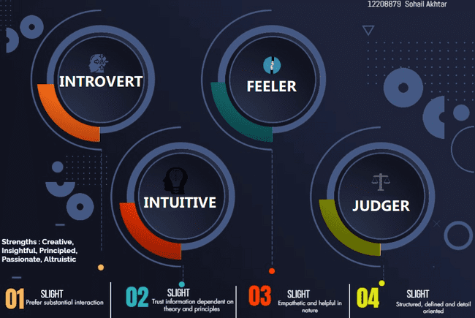

EXTRA CURRICULAR ACTIVITIES
Volunteer a workshop on public speaking Feb'23

More than 3000 contribution on github oct 22- present
Certificates
- Python certificate from cypherschools dec 22
- HTML5,CSS,JAVASCRIPT certificate from cypherschool jan 23
- Linux from great learning dec 22
- Gitbash from great learning dec 22
- C language from great learning feb 23
- SQL basic and intermediate certificate from HackerRank feb 23
- Microsoft office from coursera nov 22

PROJECTS
Random story generator Jan-23
- This project I made with the help of python
- Using random module from the library
- Like in this project, everytime the user run the program the result is a new story
Automization of monthly report Nov’22
- In this project I made this with the help of coursera and Microsoft 365
- In this the employees data is self updated with the help of Microsoft 365 maintaining the salary ,attendance of the employees etc.
Restaraurants website Jan'23
Domain: JavaScript | Programming Languages: HTML, CSS, Java | Built a website using HTML,CSS and JAVASCRIPT
Upgraded code to make the website more responsive
Created HTML, CSS, and javascript for user interaction

ACHIEVEMENTS
Achieved EXPLORER Batch on HackerEarth along with python language badge
and current Rank on HackerEarth is 5,132. JAN '22 - Apr '22
5 Star Rating in Python on HackerRank JAN '22 - Apr '22
4 Star Rating in SQL on HackerRank Feb '22 - Apr '22

EDUCATION

B.Tech. in Computer Science Sep '22 - Present Lovely Professional University | Phagwara, IN
CGPA 8.62

Higher Secondary Jun '19 - Mar '21
DISHA DELPHI GLOBAL SR SEC SCHOOL
PERCENTAGE 95.80%

