HR Analytics Dashboard – Project Report
Project: Employee Attrition & Workforce Analytics Dashboard
Tool: Microsoft Excel

1. Project Objective
The objective of this project is to analyze workforce demographics, employee attrition, job satisfaction, education background, department performance, and employee age groups. The dashboard enables HR leaders to identify key drivers of employee turnover and take proactive actions to improve retention.

2. Dashboard Screenshot
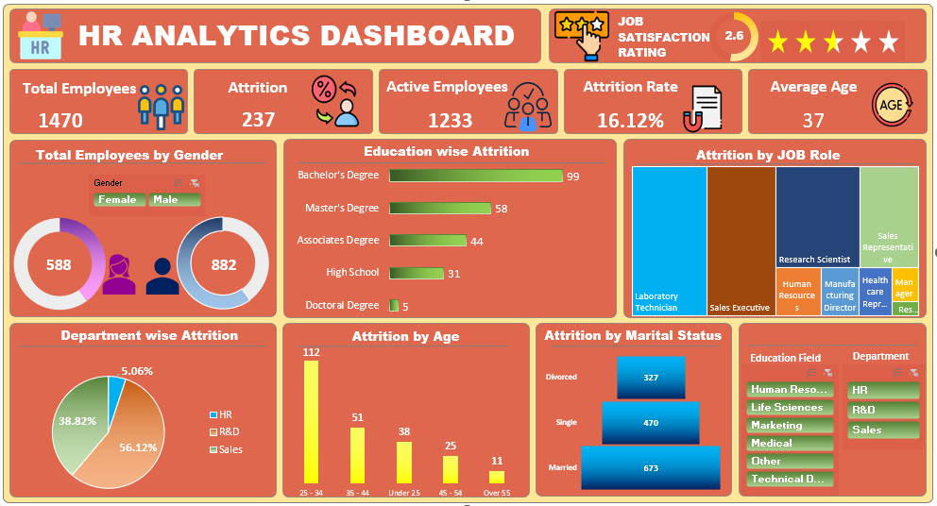

3. Executive Summary
The organization has 1,470 employees, of which 237 employees have left, resulting in an attrition rate of 16.12%. The average employee age is 37 years and the overall job satisfaction rating is 2.6. Analysis reveals that attrition is concentrated among employees aged 25–34, Bachelor's degree holders, and employees working in R&D and Sales functions.

4. KPI Analysis
• Total Employees: 1,470
• Active Employees: 1,233
• Attrition Count: 237
• Attrition Rate: 16.12%
• Average Age: 37
• Job Satisfaction Rating: 2.6

5. Gender Analysis
Male employees account for 882 employees (60%), while female employees account for 588 employees (40%). The workforce is predominantly male. Future workforce planning should ensure balanced opportunities and retention initiatives across both genders.

6. Education-wise Attrition Analysis
Attrition is highest among employees holding Bachelor's Degrees (99), followed by Master's Degrees (58), Associate Degrees (44), High School qualifications (31), and Doctoral Degrees (5). This indicates that mid-career professionals represent the largest turnover segment.

7. Department-wise Attrition Analysis
R&D contributes 56.12% of total attrition, making it the most affected department. Sales contributes 38.82%, while HR contributes only 5.06%. The findings suggest that technical and customer-facing functions face greater retention challenges.

8. Job Role Analysis
The highest attrition occurs among Laboratory Technicians (62), Sales Executives (57), Research Scientists (47), and Sales Representatives (33). These positions should be prioritized for retention programs, compensation reviews, and career development initiatives.

9. Age Group Analysis
Employees aged 25–34 represent the largest attrition group with 112 exits. This is followed by employees aged 35–44 (51), Under 25 (38), 45–54 (25), and Over 55 (11). The data indicates that early-career and growth-stage professionals are the most likely to leave.

10. Marital Status Analysis
The workforce consists of 673 married employees, 470 single employees, and 327 divorced employees. Further correlation analysis between marital status and attrition could help uncover retention patterns.

11. Key Business Insights
1. Employee attrition is relatively high at 16.12%.
2. R&D is responsible for more than half of all attrition.
3. Employees aged 25–34 are the highest-risk group.
4. Bachelor's degree holders show the highest turnover.
5. Laboratory Technicians and Sales Executives are the most affected job roles.
6. Job satisfaction score of 2.6 indicates room for improvement in employee engagement.

12. Recommendations
• Strengthen retention programs within R&D and Sales departments.
• Improve career growth and promotion opportunities for Bachelor's degree holders.
• Conduct employee engagement surveys focused on the 25–34 age segment.
• Review workload, compensation, and development opportunities for Laboratory Technicians and Sales Executives.
• Increase job satisfaction through recognition programs, training, and mentorship initiatives.

13. Business Impact
Reducing attrition can significantly decrease recruitment and onboarding costs, improve productivity, retain organizational knowledge, and increase employee morale. The dashboard provides leadership with actionable insights to make informed workforce decisions.

