Amazon Prime Video Analytics Dashboard

1. Project Overview
This project focuses on analyzing the Amazon Prime Video content catalog using Power BI. The dashboard provides insights into content distribution, genres, certifications/Ratings, directors, production countries, runtime, and release year trends.

2. Problem Statement
How can Power BI be used to analyze Amazon Prime Video content and uncover insights related to movies, TV shows, genres, certifications, production countries, and content growth over time?

3. Dataset Details
Dataset Name: Amazon Prime TV Shows and Movies Dataset
Description: The dataset contains metadata related to movies and TV shows available on Amazon Prime Video, including title, content type, release year, runtime, genres, production countries, certifications, directors, actors, seasons, and IMDb information.

4. Dashboard Objective
To build an interactive business intelligence dashboard that enables users to analyze Amazon Prime Video content, identify trends, and derive actionable insights from the platform's content library.

5. Data Cleaning and Transformation
• Replaced missing age certifications/Ratings with "Unknown"
• Cleaned genres by removing brackets and quotes
• Replaced empty genres and production countries with "Unknown"
• Handled movie season values with 0 where appropriate
• Preserved valid actor/director relationships without removing meaningful duplicate records
• Cleaned categorical fields for dashboard visualization

6. KPI Metrics Implemented
• Total Titles
• Avg Runtime (min)
• Total Genres
• Total Directors
• Total TV Shows
• Total Movies

7. Dashboard Visualizations
• Count of Certification by Total Shows
• Genres by Total Shows
• Movies vs TV Shows (Donut Chart)
• Total ID by Countries (Filled Map)
• Total Movies/Shows by Release Year (Trend Analysis)
• Release Year Slicer

8. Dashboard Screenshot
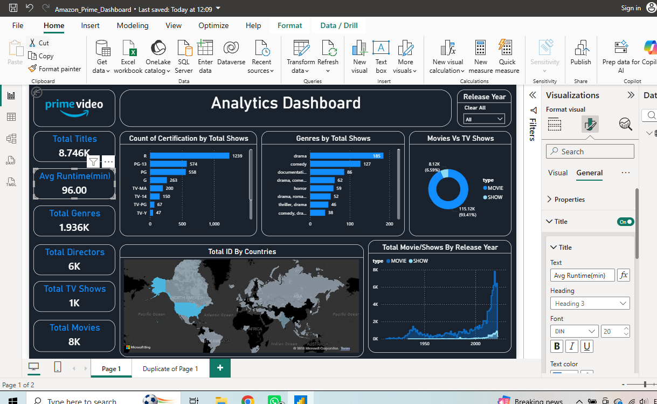

9. Key Insights
• Movies significantly outnumber TV shows on Amazon Prime Video.
• Drama and Comedy are among the most represented genres.
• Content is produced across multiple countries, indicating a strong global presence.
• Release year trends show substantial growth in content production in recent years.
• Certifications such as R, PG-13, and PG dominate the catalog.
• Average runtime provides insight into overall content consumption patterns.

10. Business Impact Summary
This dashboard helps stakeholders understand content composition, genre popularity, global content distribution, certification trends, and release year growth patterns. The insights can support content acquisition strategies, audience targeting, and platform planning.

11. Tools & Technologies Used
• Power BI Desktop
• Power Query
• DAX Measures
• Data Cleaning & Transformation
• Data Visualization

