HIVE

Contents
- Variable Substitution
- Hive Data Storage
  - File Format
      - Text Files
      - Compressed File Format
      - ORC File Format
  - Row Format :
      - LazySimpleSerDe
      - ColumnarSerDe
      - RegexSerDe
- Hive DDL
  - Partition
  - Bucket
- Hive DML (ACID Support)
  - UPDATE
  - INSERT
  - DELETE
- Hive Functions
  - UDF
    - Stateless
    - Statefull
    - Deterministic
  - UDAF
  - Temporary and Permanent Functions
  - Meta Functions
- Advance Features
  - Vectoriztion
  - Predicate Pushdown
  - TABLESAMPLE
  - Parallel Execution
  - Cost Based Optimization
- Hcatalog
- Hive Optimization
8.1 Database and column name

Variable Substitution
Dynamic query generation using variable substitution is very important while working with HiveQL Files. One such namespace Hive used in environment configuration was "HiveConf”. Initially Hive supported variable substitution using "HiveConf” namespace only, however this led to ambiguity of parameter duplication. In order to overcome this limitation Hive created another namespace "hivevar" with below set of enhancements:
- It creates a separate namespace for managing Hive variables.
- It adds support for setting variables on the command line (Shell) via '--hivevar x=y' and through the Hive CLI via 'set hivevar:x=y' .
- The variables can be referenced either using '$ {hivevar:var_name}' or '${var_name}'.
Provide a means for differentiating between hiveconf, hivevar, system, and environment properties in the output of 'set -v'
Example of Variable Substitution :
./hive -e 'select * from logdb.${hivevar:tab_name} where step_id =${s_id} limit 2' -- hivevar s_id=28 --hivevar tab_name=process_log_daily ;

varSub=10
retVal=$(hive -S --hiveconf hit=$varSub -e 'select hits from tide where hits=${hiveconf:hit}' )
echo $retVal
NOTE : use DEFINE
retVal=$(hive -S -define hit=11 -e 'select hits from bdp2casdb.timecheck where hits=${hit}' )
echo $retVal

Property File as Variable Substitution:
Using the shell script command ‘xargs’ and variable substitution it possible to use property file containing all the variable parameters and then passing them to Hive query as below.
sed 's/^/--hivevar\n/g' /home/impadmin/Documents/library/Docs/hive/asl/my_properties_file | xargs hive -e 'select * from ngbtest.${hivevar:tab_name} where account_id =${s_id} limit 2'
my_properties_file :
s_id=10578
tab_name=device_billing_summary_adjusted_112014

Note: HCatalog treats Hive variable substitution bit differently. Hcatalog uses the -D flag without a space to define key=value pairs but hive uses -d or --define with a space (also --hivevar) .
For example, "hcat -DA=B" versus "hive -d A=B".

Disabling Variable Substitution
Variable substitution is on by default (hive.variable.substitute=true) , but it can be disables using the command :
set hive.variable.substitute=false;

Hive Data Storage
Since any file in HDFS is accessible to Hive , it requires a mechanism to read and write files to HDFS. In Map Reduce paralance it is similar to Input and Ouput File formats , records of these container format needs to be broken down into an entity that maps to the schema defined by Hive.
  - File format: The container format for fields in a row is represented by file format. Different file formats supportd by Hive are:
    - Text Files : By default Hive stores data in Text File format , It is similar to using the clause STORED AS TEXTFILE in Hive QL.Though Text File format is very convenient while exchanging data between two different system such as Sqoop and hive or Pig but the drawback lies in the amount of disk space it consumes. Also since Map Reduce jobs are I/O bound , it is not very effiecient at intermediate read write stage(s).
    - Compressed File Format : Hadoop natively supports Gzip and Bzip2 files and treats them as regular Text Files ,but the trade off comes in the form that Gzip files cannot be split for parallel processing while Bzip2 files are slow to decompress. For eg if you have a gzipped file of 320 MB and block size is of 64 MB then such a file will be split into 5 blocks. Now ideally 5 mappers can be launched simultaneously one on each such block but since the second mapper will start at some arbitrary byte of 64 MB it would not make any sense for a Mpper to contextually read the split file and make sense out of it. Hence only one mapper gets launched to read the compressed Gzip file making the cluster underutilized. Hence to overcome this limitation Lzo compression with indexing is considered as an alternative. In Lzo, files are compressed in blocks and hence using index parallel mappers can be launched in different splits at specific blocks.
Steps of using Lzo compression:
Step 1: Install Lzo binaries (for Debian System)
$ sudo apt-get install liblzo2-dev
$ sudo apt-get install lzop
Step 2 : Clone the hadoop-lzo from github
$ git clone https://github.com/twitter/hadoop-lzo.git
$ cd hadoop-lzo
$ mvn clean package
Step 3 : Place the hadoop-lzo-*.jar somewhere on your cluste classpath
$ cp hadoop-lzo/target/hadoop-lzo-0.4.20-SNAPSHOT.jar $HADOOP_HOME/lib /
Step 4: Place the native hadoop-lzo binaries in hadoop native directory
$ cp hadoop-lzo/target/native/Linux-amd64-64/lib/* $HADOOP_HOME/lib/native/Linux-amd64-64/

Step 5 : Add the following to your core-site.xml:
<property>
<name>io.compression.codecs</name>
<value>
org.apache.hadoop.io.compress.GzipCodec,
org.apache.hadoop.io.compress.DefaultCodec,
org.apache.hadoop.io.compress.BZip2Codec,
com.hadoop.compression.lzo.LzoCodec,
com.hadoop.compression.lzo.LzopCodec
</value>
</property>
<property>
<name>io.compression.codec.lzo.class</name>
<value>com.hadoop.compression.lzo.LzoCodec</value>
</property>

Step 6 : Add the following to your mapred-site.xml:
<property>
<name>mapred.child.env</name>
<value>JAVA_LIBRARY_PATH=$HADOOP_HOME/lib/native/Linux-amd64-64/</value>
</property>
<property>
<name>mapred.map.output.compression.codec</name>
<value>com.hadoop.compression.lzo.LzoCodec</value>
</property>

Step 7 : Now compress the files using lzop
lzop -9 books.txt

Step 8 : Put the compressed file at some HDFS location

bin/hadoop fs -mkdir /books

bin/hadoop fs -copyFromLocal books.txt.lzo /books/

Step 9 : Now run the Lzo indexer over files

bin/hadoop jar lib/hadoop-lzo-0.4.15.jar com.hadoop.compression.lzo.LzoIndexer /books/b

you shall see an

Note :
- If you get an exception like “Error: java.io.IOException: cannot find class com.hadoop.mapred.DeprecatedLzoTextInputFormat “ , then probably the hadoop-lzo-XXX.jar is not in the classpath of hadoop or Hive ; whichever is being used to launch the MR jobs.
For Hadoop try :

$ export LIBJARS=/path/jar1,/path/jar2
$ export HADOOP_CLASSPATH=/path/jar1:/path/jar2
$ hadoop jar my-example.jar com.example.MyTool -libjars ${LIBJARS} -mytoolopt value

For Hive try :
Option 1: Add jar manually using the below command

ADD JAR hadoop-lzo-xxxx.jar

Option 2: Launch Hive using auxpath clause

hive --auxpath /home/impadmin/Documents/software/hadoop-2.4.0/lib/hadoop-lzo-0.4.20-SNAPSHOT.jar

Option 3: You can update your hive-site.xml
<property>
<name>hive.aux.jars.path</name>
<value>file:///path/to/JAR</value>
</property>

- If the compressed file size is less than the split size of hadoop cluster then it might be the case that Gzip will give you better performance along with parallelism as in that case individual mappers will work on each such Gzip files.

    - ORC Files : The Optimized Row Columnar (ORC) file format is optimised for compression and skipping of data/columns to reduce read and decompression load. It is an improvement over RC File format and includes features such as :
- It has light weight indexes stored within the file which helps in either skipping or seeking to a given row.
- The block mode compression is based on data type i.e for integers it uses run length encoding while for string it uses dictionary encoding.
- The metadata stored using Protocol Buffers, allows addition and removal of fields and has been instrumental in providing ACID support (discussed later) to Hive.
An ORC file consists of 1 or more "stripes". These strips contain rows that are grouped together and can be read independent of each other. Each stripe contains a row index every 10,000 rows, by default. The index is a data structure that includes min and max values for each column and the row positions within each column. These indexes can improve query performance by skipping data that does not meet the ‘WHERE’ clause conditions.By default ORC has ZLIB compression enabled which provides better compression however SNAPPY can be preferred if time based performance is required.
Different configuration parameters for using ORC file format are :
Key | Default | Notes
orc.compress | ZLIB | high level compression (one of NONE, ZLIB, SNAPPY)
orc.compress.size | 262,144 | number of bytes in each compression chunk
orc.stripe.size | 268435456 | number of bytes in each stripe
orc.row.index.stride | 10,000 | number of rows between index entries (must be >= 1000)
orc.create.index | true | whether to create row indexes
orc.bloom.filter.columns | “ ” | comma separated list of column names for which bloom filter should be created
orc.bloom.filter.fpp | 0.05 | false positive probability for bloom filter (must >0.0 and <1.0)

ORC File can be used in Hive by using any of the syntax below:
- CREATE TABLE ( ……. )
ROW FORMAT DELIMITED
FIELDS TERMINATED BY '~'
STORED AS ORC tblproperties ("orc.compress"="ZLIB" ,"orc.stripe.size"="268435456" ,"orc.row.index.stride"="50000");

- ALTER TABLE ... [PARTITION partition_spec] SET FILEFORMAT ORC

- SET hive.default.fileformat=Orc
NOTE : While designing table using ORC file format ,the nature of usage of the table should also be kept in mind . For example:
If Query response time is primary concern then SNAPPY should be preferred over ZLIB , similarly if index size is more than more no of rows can be skipped at a time and so goes the logic for smaller stripe size.
tblproperties ("orc.compress"="SNAPPY", "orc.stripe.size"="67108864","orc.row.index.stride"="50000")
If disk space utilization is of primary concern then below setting should be preferred.
tblproperties ("orc.compress"="ZLIB", "orc.stripe.size"="268435456", "orc.row.index.stride"="10000")

  - Row Format : Dictates how rows, and the fields in a particular row, are stored.In Hive parlance, the row format is defined by :
The SerDe interface allows you to instruct Hive as to how a record should be processed. A SerDe is a combination of a Serializer and a Deserializer (hence, Ser-De). The Deserializer interface takes a string or binary representation of a record, and translates it into a Java object that Hive can manipulate. The Serializer, however, will take a Java object that Hive has been working with, and turn it into something that Hive can write to HDFS or another supported system. Commonly, Deserializers are used at query time to execute SELECT statements, and Serializers are used when writing data, such as through an INSERT-SELECT statement.

    - RegexSerDe : Data can be loaded in Hive through "CREATE EXTERNAL TABLE" or
"LOAD DATA INPATH" . Since Hive does not control the file formats in which data is fed to HDFS. It requires a mechanism in which the files can be read, broken down into rows/tuples, converting the rows into a meaningful Object/entity and also writing it back to HDFS when the need be. (see fig)

The simplest way to achieve this is using the keyword "STORED AS" in CreateTable statements . However a triplet comprising of {SerDe, InputFormat, and OutputFormat} specification can also be used. SerDe stands for "Serializer and Deserializer" . Serde along with InputFileFormat and OutputFileFormat is used by Hive to read and write table rows. In the <key,value> pair of InputFileFormat the "key" part is ignored when reading, and is always a constant when writing. So basically row object is stored into the "value" part of the list/set. How this "value" part gets converted into Java Objects representing the column set of each row is decided by SerDe.But at the same time it should be noted that it is SerDe, not the DDL, that defines the table schema in Hive. Some SerDe implementations use the DDL for configuration, but the SerDe can also override that.

The Deserializer interface takes a string or binary representation of a record, and translates it into a Java object that Hive can manipulate. The Serializer, however, will take a Java object that Hive has been working with, and turn it into something that Hive can write to HDFS or another supported system.
Commonly, Deserializers are used at query time to execute SELECT statements, and Serializers are used when writing data, such as through an INSERT-SELECT statement.
create external table Unm_Dup
(EmployeeID String ,Salary String)
row format serde 'org.apache.hadoop.hive.contrib.serde2.RegexSerDe'
WITH serdeproperties("input.regex" = "(.+)::(.+)::(.+)::(.+)::(.+)",
"output.format.string" = "%1$s %2$s %3$s %4$s %5s")
STORED AS TEXTFILE
location '/user/hive/warehouse/ngbtest.db/unm_dup_parti'

Note :
Regex Serde only supports STRING data types hence you might get an error like below if our DDL query contains data type other than STRING.
FAILED: Execution Error, return code 1 from org.apache.hadoop.hive.ql.exec.DDLTask. java.lang.RuntimeException: MetaException(message:org.apache.hadoop.hive.serde2.SerDeException org.apache.hadoop.hive.contrib.serde2.RegexSerDe only accepts string columns, but column[0] named employeeid has type int)

Alternative to regexSerde :
CREATE EXTERNAL TABLE IF NOT EXISTS apache_log_new (
log_line STRING
)
STORED AS TEXTFILE
LOCATION '/user/hive/warehouse/ngbtest.db/access_log';

select regexp_extract(log_line,' ([0-9]{3}) (?:.*[0-9]{1,6})',1) as http_response_code,
count(1)
from apache_log_new
group by regexp_extract(log_line,' ([0-9]{3}) (?:.*[0-9]{1,6})',1);

    - Custom SerDe :
SerDe tells Hive how to map the column names in the table to values within the Writable object. Note that the Writable Object may be an arbitrarily complex object hierarchy.
Apart from primitive data types (int, float, bigint, string, etc) ,hive supports different data structures:
arrays/lists: can contain a set of elements, all of the same type
maps: can contain key/value pairs, with keys of one type and values of the some or other type
structs: they contain an ordered list of values, each one could be of a different type (like C structs)
A record in a table is modeled as a struct, as each record is a set of values, each one with possibly a different type.
From a theoretical point of view, it makes sense. When we issue a SELECT statement, we’re expecting a result that it’s a set of values that are of different type...which is the definition of a struct. For that we cannot use a primitive nor lists nor maps since they are homogenous collections (List, Map).
Whenever we need to read data from the serialized format, a java.lang.Object reference is passed as data, together with an associated ObjectInspector. ObjectInspectors have a category associated to it that can be one of PRIMITIVE, LIST, MAP, STRUCT , we see that each category maps to a different data structure.
public interface ObjectInspector {
public static enum Category {
PRIMITIVE, LIST, MAP, STRUCT
}; }

Each one of these 4 types has its own interface that extends ObjectInspector:
PrimitiveObjectInspector
ListObjectInspector
MapObjectInspector
StructObjectInspector

This way, hive does not need to use introspection to read the data, nor the deserialized object need to implement any interface or extend any subclass, but applies the Adapter Design Pattern to present a uniform interface to objects of different type.
The SerDe interface is simply the union of two interface: serialization and deserialization. Since hadoop expects a Writable, we serialize/deserialize to/from Writable.
public interface Serializer {
public void initialize(Configuration conf, Properties tbl) throws SerDeException;
public Class<? extends Writable> getSerializedClass();
public Writable serialize(Object obj, ObjectInspector objInspector) throws SerDeException;
}

public interface Deserializer {
public void initialize(Configuration conf, Properties tbl) throws SerDeException;
public Object deserialize(Writable blob) throws SerDeException;
public ObjectInspector getObjectInspector() throws SerDeException;
}

A Hive data row is a Struct, since it’s a collection of columns of different types. This means we have to write a StructObjectInspector capable of reading a JSON Object. A JSONObject also can contain JSONArrays, which we’ll map to Hive Lists. For primitives, we can use the standard Hive object inspectors.

there are three entry points: initialize, serialize, deserialize.
Initialization

During initialization, hive gives the SerDe information on the table that it’s trying to access. For example, it needs the number of columns and their type. The Serde get a Propertyobject, as you can see below, the properties
serdeConstants.LIST_COLUMNS
and
serdeConstants.LIST_COLUMN_TYPES

contain a comma-separated list of column names and column type respectively.
C0de

Next, we build our ObjectInspector. To do that, we have to build a TypeInfo object through the appropriate factory. The TypeInfo object contains the list of fields, and their types. Since a Struct can contain other types, we can see in the StructTypeInfo code that it can traverse the struct and build TypeInfos for its fields as needed. The TypeInfo is also used to build the signature of the ObjectInspector and cache it.

Deserialization

Deserialization is trivial: we get a Writable String with the JSON data and we have a JSONObject parse it. We then return that object. The ObjectInspector will tell Hive how to handle it:
Serialization
Your serializer could be getting any kind of object and the only assumption you can make is that its associated ObjectInspector will be some subclass of StructObjectInspector since that’s how a hive table is modeled. To serialize the record we’ll have to analyze the ObjectInspector, using it to instrospect the given data object and building our JSONObject as we go. We can see how the serializer just calls
SerializeStruct
and turns the JSONObject into a Text

Sometimes it may not be possible to solve all our use cases with the list of available serdes . It at these situations that we might consider leveraging the flexibility of developing a custom serde to suit our needs ,for e.g lets consider a use case where we need to :
- support for multi character delimiter (::)
- Ability to select data as specific field positions
- Support for primitive data types other than string.
There can be multiple ways in which all these requirement can be solved , developing customsede being one vialable option.
For developing a custom serde using Hive serde2 API (org.apache.hadoop.hive.serde2) , we should broadly take care of three methods :
initialize() :
The initialize() method is called only once and collects information of the table that it’s trying to access. For example, it needs the number of columns and their type. The initialize() method has as Properties Object from where we can get the properties : serdeConstants.LIST_COLUMNS
and
serdeConstants.LIST_COLUMN_TYPES
All this information is contained in a comma-separated list of column names and column type respectively.
public void initialize(Configuration conf, Properties tbl)
throws SerDeException {

// We can get the table definition from tbl.
// Read the configuration parameters
inputColIdx = tbl.getProperty("input.column.indexes");
inputDelimiter = tbl.getProperty("input.field.delimiter");

String columnNameProperty = tbl.getProperty(serdeConstants.LIST_COLUMNS);
String columnTypeProperty = tbl.getProperty(serdeConstants.LIST_COLUMN_TYPES);

// Parse the configuration parameters
List<String> columnNames = Arrays.asList(columnNameProperty.split(","));
columnTypes = TypeInfoUtils.getTypeInfosFromTypeString(columnTypeProperty);
numColumns = columnNames.size();
rowTypeInfo = (StructTypeInfo) TypeInfoFactory.getStructTypeInfo(columnNames, columnTypes);
List<ObjectInspector> columnOIs = new ArrayList<ObjectInspector>(columnNames.size());
for (int c = 0; c < numColumns; c++) {
ObjectInspector oi = TypeInfoUtils.getStandardWritableObjectInspectorFromTypeInfo(columnTypes.get(c));
columnOIs.add(oi);
}
// StandardStruct uses ArrayList to store the row.
rowOI = ObjectInspectorFactory.getStandardStructObjectInspector(columnNames, columnOIs);
row = new ArrayList<Object>(numColumns);

for (int c = 0; c < numColumns; c++) {
row.add(null);
}
outputFields = new Object[numColumns];
outputRowText = new Text();
}

Next, we build our ObjectInspector. To do that, we have to build a TypeInfo object through the appropriate factory. The TypeInfo object contains the list of fields, and their types.
A Hive data row is a Struct, since it’s a collection of columns of different types. This means we have to write a StructObjectInspector capable of reading the Java Object , Hence we choose StructTypeInfo .
//After building ObjectInspector in initialize() method we wi
serialize() :
Serialzation in hive serde means that we process the Java object into a hadoop Writable using the ObjectInspector Object created in initialize() method.

deserialize() :
The deserialize() method takes the data, and converts it into a Java object that Hive can process.
Code Sample
public class ColumnSelectionSerdeWODD implements SerDe {

public static final Log LOG = LogFactory.getLog(ColumnSelectionSerdeWODD.class.getName());

int numColumns;
String inputColIdx;
String inputDelimiter;

StructObjectInspector rowOI;
StructTypeInfo rowTypeInfo;
ArrayList<Object> row;
static List<TypeInfo> columnTypes;

Object[] outputFields;
Text outputRowText;
long rowNum = 0;

public void initialize(Configuration conf, Properties tbl)
throws SerDeException {

// We can get the table definition from tbl.
// Read the configuration parameters
inputColIdx = tbl.getProperty("input.column.indexes");
inputDelimiter = tbl.getProperty("input.field.delimiter");

String columnNameProperty = tbl.getProperty(serdeConstants.LIST_COLUMNS);
String columnTypeProperty = tbl.getProperty(serdeConstants.LIST_COLUMN_TYPES);

// Parse the configuration parameters
List<String> columnNames = Arrays.asList(columnNameProperty.split(","));
columnTypes = TypeInfoUtils.getTypeInfosFromTypeString(columnTypeProperty);
numColumns = columnNames.size();
rowTypeInfo = (StructTypeInfo) TypeInfoFactory.getStructTypeInfo(columnNames, columnTypes);
List<ObjectInspector> columnOIs = new ArrayList<ObjectInspector>(columnNames.size());
for (int c = 0; c < numColumns; c++) {
ObjectInspector oi = TypeInfoUtils.getStandardWritableObjectInspectorFromTypeInfo(columnTypes.get(c));
columnOIs.add(oi);
}
// StandardStruct uses ArrayList to store the row.
rowOI = ObjectInspectorFactory.getStandardStructObjectInspector(columnNames, columnOIs);
row = new ArrayList<Object>(numColumns);

for (int c = 0; c < numColumns; c++) {
row.add(null);
}
outputFields = new Object[numColumns];
outputRowText = new Text();
}

public ObjectInspector getObjectInspector() throws SerDeException {
return rowOI;
}

public Class<? extends Writable> getSerializedClass() {
return Text.class;
}

@Override
public Object deserialize(Writable blob) throws SerDeException {

//System.out.println("in deserialize");
if (inputColIdx == null) {
throw new SerDeException(
"This table does not have serde property \"input.column.indexes\"!");
}
if (inputDelimiter == null) {
throw new SerDeException(
"This table does not have serde property \"input.field.delimiter\"!");
}

Text rowText = (Text) blob;
Set<String> inputCols = new HashSet<String>(Arrays.asList(inputColIdx.split(",")));
String[] rowFields = rowText.toString().split(inputDelimiter);
String[] parsedData = new String[inputCols.size()];
int dataIdx=0;
try{
for(int i=1;i<=rowFields.length;i++){

if(inputCols.contains(i+"")){
parsedData[dataIdx] = rowFields[i-1];
dataIdx++;
}
}
for (int c = 0; c < numColumns; c++) {
try {
Writable data=getField(c, parsedData[c]);
row.set(c, data);
} catch (RuntimeException e) {
row.set(c, null);
}
}
}catch(Exception e){
e.printStackTrace();
}
return row;
}

public static Writable getField(int idx,String data){
TypeInfo type = columnTypes.get(idx);
//System.out.println("type="+type.getTypeName());
switch(type.getTypeName()){
case "int":
return new IntWritable(Integer.parseInt(data));
case "long":
return new LongWritable(Long.parseLong(data));
case "float":
return new FloatWritable(Float.parseFloat(data));
case "double":
return new DoubleWritable(Double.parseDouble(data));
default:
return new Text(data);
}

}

@Override
public Writable serialize(Object obj, ObjectInspector objInspector)
throws SerDeException {
// Get all the fields out.
// NOTE: The correct way to get fields out of the row is to use
// objInspector.
// The obj can be a Java ArrayList, or a Java class, or a byte[] or
// whatever.
// The only way to access the data inside the obj is through
// ObjectInspector.

//System.out.println("in serialize");
//System.out.println("The delimeter is "+inputDelimiter);
if (inputDelimiter == null) {
throw new SerDeException(
"This table does not have serde property \"input.field.delimiter\"!");
}

StructObjectInspector outputRowOI = (StructObjectInspector) objInspector;
List<? extends StructField> outputFieldRefs = outputRowOI.getAllStructFieldRefs();
if (outputFieldRefs.size() != numColumns) {
throw new SerDeException("Cannot serialize the object because there are "
+ outputFieldRefs.size() + " fields but the table has " + numColumns
+ " columns.");
}

// Get all data out.
for (int c = 0; c < numColumns; c++) {
Object field = outputRowOI
.getStructFieldData(obj, outputFieldRefs.get(c));

ObjectInspector fieldOI = outputFieldRefs.get(c)
.getFieldObjectInspector();

outputFields[c] = getFieldData(c,field,fieldOI);
}

return getRowFormat(outputFields);
}

public static Object getFieldData(int idx,Object data,ObjectInspector foi){
TypeInfo type = columnTypes.get(idx);
switch(type.getTypeName()){
case "int":
IntObjectInspector fieldIntOI = (IntObjectInspector) foi;
return fieldIntOI.getPrimitiveJavaObject(data);
case "long":
LongObjectInspector fieldLongOI = (LongObjectInspector) foi;
return fieldLongOI.getPrimitiveJavaObject(data);
case "float":
FloatObjectInspector fieldFloatOI = (FloatObjectInspector) foi;
return fieldFloatOI.getPrimitiveJavaObject(data);
case "double":
DoubleObjectInspector fieldDoubleOI = (DoubleObjectInspector) foi;
return fieldDoubleOI.getPrimitiveJavaObject(data);
default:
StringObjectInspector fieldStringOI = (StringObjectInspector) foi;
return fieldStringOI.getPrimitiveJavaObject(data);
}

}

public Text getRowFormat(Object[] fields){
StringBuffer sb=new StringBuffer("");
boolean isFirst=true;
for(Object o:fields){
if(isFirst){
isFirst = false;
sb.append(o.toString());
}else{
sb.append(inputDelimiter+o.toString());
}
}
return new Text(sb.toString());
}

public SerDeStats getSerDeStats() {
// no support for statistics
return null;
}
}

Usage :
add jar /home/impadmin/Documents/software/hive-0.14.0-bin/lib/CustomSerde.jar;
create external table rating(userId int,movieId int,urating float,time string) row format serde 'hive.serde.ColumnSelectionSerde' with serdeproperties(
"input.column.indexes" = "1,2,3,4",
"input.field.delimiter" = "::"
) stored as textfile
location '/home/input_all/rating';

    - ColumnarSerDe

3. Hive DDL
  - Partition : Partitioning of table is one such technique in which huge data files is broken down into chunks of smaller files based on certain key corresponding to a column in hive table. These key/column corresponds to the subdirectories within the main directory of hive table. As the data is stored as slices/parts, query response time is faster to process the small part of the data instead of looking for a search in the entire data set.
Syntax :
CREATE [EXTERNAL] TABLE table_name
(col_name_1 data_type_1, ....)
PARTITIONED BY (col_name_n data_type_n , ...) ;

Two points to note from syntax is that a table can be partitioned using more than one column, in such cases sub directory gets created within the partitioned directory . Another important point to take care is that the columns on which partitioning is done are not part of table definition . The same can be verified using the below command :

Hive> Describe formatted table_name;

Data can be inserted in table using two different modes :

Static Partition : In this mode, input data should contain the columns listed only in table definition but not the columns defined in partitioned by clause . Two ways in which data can be loaded into partitioned tables are :
- Directly loading form input files:

hive> LOAD DATA LOCAL INPATH
'${env:HOME}/input.txt'
INTO TABLE partitioned_table
PARTITION (partitioned_col1 = 'val1', partitioned_col2 ='val2');

- Using another table to insert in portioned table:

hive> INSERT OVERWRITE
TABLE partitioned_table
PARTITION (partitioned_col1 = 'val1', partitioned_col2 ='val2')
SELECT * FROM temp_table tt
WHERE tt.col1 = 'val1' AND tt.col2= 'val2';

Dynamic Partition: Static partitioning does not go well when we have to deal with multiple partitions or when the data to inserted in table is known only when the query gets executed . For such cases hive comes up with a concept called ‘Dynamic Partitioning’ , if it is enabled then hive will automatically split our data into separate partition files based on the values of partition keys present in the input file or query.

It gives the advantages of easy coding and no need of
manual identification of partitions. This dynamic partition
suits well for our example requirement on user records
provided above. Eg.

hive>INSERT INTO TABLE partitioned_table
PARTITION (partitioned_col1,partitioned_col2)
SELECT col1, col2 …..,partitioned_col1,partitioned_col2 form temp_table;

But by default, Dynamic Partitioning is disabled in Hive to prevent accidental partition creations. To use dynamic partitioning we need to set below properties either in Hive Shell or in hive-site.xml file.

set hive.exec.dynamic.partition=true;
set hive.exec.dynamic.partition.mode=nonstrict;
set hive.exec.max.dynamic.partitions=1000;
set hive.exec.max.dynamic.partitions.pernode=1000

Depending on use cases a combination of static and dynamic partition queries can also be used but it is to be noted that the dynamic partitioned columns will always come last and maintains the sequential order.

INSERT OVERWRITE TABLE T PARTITION (hr, dt='2010-03-03')
SELECT key, value, hr,dt FROM temp WHERE dt is not null and hr>10 ;

The above query will throw an exception while the below query will work .

INSERT OVERWRITE TABLE T PARTITION (dt='2010-03-03', hr)
SELECT key, value, dt, hr FROM temp WHERE dt is not null and hr>10 ;

Though partition in general improves the query performance if partitioned column matches predicates , However it may not always prove beneficial because:
- Having too many partitions in table creates large number of files and directories in HDFS, which is an overhead to NameNode since it must keep all the metadata in memory only. Also irrespective of the size of partition ,large number of partitions may lead to large number of MR jobs choking the JVM to run efficiently.
- Partitions may optimize some queries based on Where clauses, but may be less responsive for other important queries on grouping clauses.

  - Bucket : Partitioning may not be the best solution in cases when you have large number of partitions and comparatively of unequal sizes in such cases Bucket may be a better option to consider. Buckets divide the data into nearly equal size files and hence overcome the problem of uneven sized partitions , however buckets can and is used in conjunction with partition clause. Some of the features of bucket are :
- Bucketing concept is based on (hashing function on the bucketed column) mod (by total numberof buckets). The hash_function depends on the type of the bucketing column.
- Records with the same bucketed column will always be stored in the same bucket.
- Physically, each bucket is just a file in the table directory .
- Bucketing can be done along with Partitioning on Hive tables and even without partitioning.
- Bucketed tables will create almost equally distributed data file parts.

Syntax :
CREATE TABLE bucketed_table (
Col1 dataType,col2 dataType, bucket_col dataType, ……..)
PARTITIONED BY (part_col datatype,…..)
CLUSTERED BY (bucket_col) SORTED BY (col2) INTO 32 BUCKETS
STORED AS SEQUENCEFILE;

Note: Unlike partitioned columns (which are not included in table columns definition) , Bucketed columns are included in table definition as shown in above code . To populate the bucketed table, we need to set the property
hive.enforce.bucketing = true

Unlike partitioned tables, we cannot directly load data in bucketed table using LOAD DATA (LOCAL) INPATH . Hence we need a temporary table and use INSERT OVERWRITE
TABLE ... SELECT ...FROM clause to insert data in bucketed table.

Note :
- The property hive.enforce.bucketing = true similar to hive.exec.dynamic.partition=true property in partitioning. By Setting this property we will enable dynamic bucketing while loading data into hive table.
- It will automatically sets the number of reduce tasks to be equal to the number of buckets mentioned in the table definition and automatically selects the clustered by column from table definition.
- If we do not set this property in Hive Session, we have to manually convey same information to Hive that, number of reduce tasks to be run (by using set mapred.reduce.tasks=XX ) and CLUSTER BY (bucketed_col) and SORT BY (col2) clause in the INSERT ...SELECT statement at the end.

- Hive DML (ACID Support)
ACID is an acronym for four traits of database transactions: atomicity, consistency, isolation, and
durability.

Transaction Attribute | Description
Atomicity | An operation either succeeds completely or fails; it does not leave partial data.
Consistency | Once an application performs an operation, the results of that operation are visible to the application in every subsequent operation.
Isolation | Operations by one user do not cause unexpected side effects for other users.
Durability | Once an operation is complete, it is preserved in case of machine or system failure.

To use ACID based transaction , use ORC file format and enable hive transaction (by default it is disabled)

Add the below set of properties in hive-site.xml to enable ACID based transactions in hive.

<property>
<name>hive.enforce.bucketing</name>
<value>true</value>
</property>

<property>
<name>hive.exec.dynamic.partition.mode</name>
<value>nonstrict</value>
</property>

<property>
<name>hive.support.concurrency</name>
<value>true</value>
</property>

<property>
<name>hive.compactor.initiator.on</name>
<value>true</value>
</property>

<property>
<name>hive.compactor.worker.threads</name>
<value>1</value>
</property>

<property>
<name>hive.txn.manager</name>
<value>org.apache.hadoop.hive.ql.lockmgr.DbTxnManager</value>
</property>

Also only the tables with file format as ORC having TBLPROPERTIES as ('transactional'='true') will only support transactions. E.g
create table employee_support
(EmployeeID Int,FirstName String)
clustered by (EmployeeID) into 3 buckets
stored as orc TBLPROPERTIES ('transactional'='true') ;

  - UPDATE : As of Hive 0.14 arithmetic operators, UDFs, casts, literals, etc. are supported in update statement .

update employee_support set FirstName='done' where EmployeeID=1;
Note :
- Subqueries are not supported.
- Updation of partition and bucketed columns are not supported.

  - INSERT : For insert statements values must be provided for every column in the table. The standard SQL syntax that allows the user to insert values into only some columns is not yet supported.

insert into table employee_support values (1, 'test');

  - DELETE : After a successful operation of delete stamen the transaction will be auto commited.

delete from employee_support where EmployeeID=1;

Note : Only if you get an error “Error communicating with the metastore” , append the below property in hive-site.xml
<property>
<name>hive.in.test</name>
<value>true</value>
</property>

5. User Defined Function (UDF)

Hive comes with a handful set of User Defined Function (UDF) ,these UDF serve most of our basic operational needs like cast(), lower(),upper() etc. For some use cases Hive may not have the built in UDFs for such scenarios Hive provides three classes of UDFs :

UDFs -- User Defined Functions; these operate row-wise, generally during map execution. They're the simplest UDFs to write, but constrained in their functionality.

UDTFs -- User Defined Table-Generating Functions; these also execute row-wise, but they produce multiple rows of output (i.e., they generate a table). The most common example of this is Hive's explode function.

UDAFs -- User Defined Aggregating Functions; these can execute on either the map-side or the reduce-side and far more flexible than UDFs. The challenge, however, is that in writing UDAFs we have to think not just about what to do with a single row, or even a group of rows. Here, one has to consider partial aggregation and serialization between map and reduce processes.

5.1 Annotations : UDF comes with a set of annotations tags that can not only enrich but even change the functionality of UDFs .

@Description(name="my_udf", value="This will be the result returned by explain statement.", "This will be result returned by the explain extended statement.")

This annotation tells Hive the name of your UDF. It will also be used to populate the result of queries like `DESCRIBE FUNCTION MY_UDF` or `DESCRIBE FUNCTION EXTENDED MY_UDF`

@UDFType(deterministic = true)

A deterministic UDF is one which always gives the same result when passed the same parameters. An example of such UDF are length(string input), regexp_replace(string initial_string, string pattern, string replacement), etc. A non-deterministic UDF, on the other hand can return different result for the same set of parameters. For example, unix_timestamp() returns the current timestamp using the default time zone. Therefore, when unix_timestamp() is invoked with the same parameters (no parameters) at different times, different results are obtained, making it non-deterministic. This annotation allows Hive to perform some optimization if the UDF is deterministic.

@UDFType(stateful = true)

UDFs are stateful by default , also if an UDF has been explicitly mentioned as stateful=true then it also implies that the UDF is non deterministic.

An example of stateful UDF is below , where the state of the function is maintained to be validated in the next call cycle.

/** A simple UDF to convert Celcius to Fahrenheit */
public class ConvertToCelcius extends UDF {
public double evaluate(double value) {
return (value - 32) / 1.8;
}
}

Deploying and testing the UDF
Once your have built a JAR containing your UDF, you will have to run the following commands on Hive to make your UDF available for use:
hive> add jar my_udf.jar;
hive> create temporary function my_udf as 'com.me.udf. fahrenheit_to_celcius;
hive> select fahrenheit_to_celcius (col1 ) from my_table limit 5;

Note : Temporary functions are maintained in current sessions only , so if one wants to register the UDF that is available across different sessions then permanent function should be used.

Syntax :
create function my_db. function my_udf as 'com.me.udf.GenericMyUdf';

OR

CREATE FUNCTION myfunc AS 'myclass' USING JAR 'hdfs:///path/to/jar';

Types

Simple UDF can accept a large variety of types to represent the column types. Notably, it accepts both Java primitive types and Hadoop IO types

Hive column type | UDF types
string | java.lang.String, org.apache.hadoop.io.Text
int | int, java.lang.Integer, org.apache.hadoop.io.IntWritable
boolean | bool, java.lang.Boolean, org.apache.hadoop.io.BooleanWritable
array<type> | java.util.List<Java type>
map<ktype, vtype> | java.util.Map<Java type for K, Java type for V>
struct | Don't use Simple UDF, use GenericUDF

Genric UDF :

The main limitation of UDF is in handling of complex types. The system of simple UDFs is based on reflection and method overloading, which cannot accept everything.

For example, if you wanted to write an "array_sum" UDF, that would return the sum of elements in an array, you would write

public class ArraySum extends UDF {
public double evaluate(List<Double> value) {
double sum = 0;
for (int i = 0; i < value.size(); i++) {
if (value.get(i) != null) {
sum += value.get(i);
}
}
return sum;
}
}

But what happens if you would also handle arrays of integers ? You cannot overload with

public int evaluate(List<Integer> value)

because this is not valid in Java : the types of a method cannot differ by only the generic type. For more details, see the Generics article on Wikipedia .
For this UDF to work, we need to use a Generic UDF.

The following table summarizes the main differences between Simple UDF / UDAF and Generic UDF / UDAF

Simple | Generic
Reduced performance due to use of reflection : each call of the evaluate method is reflective. Furthermore, all arguments are evaluated and parsed. | Optimal performance : no reflective call, and arguments are parsed lazily
Limited handling of complex types. Arrays are handled but suffer from type erasure limitations | All complex parameters are supported (even nested ones like array<array>
Variable number of arguments are not supported | Variable number of arguments are supported
Very easy to write | Not very difficult, but not well documented

A generic UDF is written by extending the GenericUDF class.

public interface GenericUDF {
public Object evaluate(DeferredObject[] args) throws HiveException;
public String getDisplayString(String[] args);
public ObjectInspector initialize(ObjectInspector[] args) throws UDFArgumentException;
}
A key concept when working with Generic UDF and UDAF is the ObjectInspector.

In generic UDFs, all objects are passed around using the Object type. Hive is structured this way so that all code handling records and cells is generic, and to avoid the costs of instantiating and deserializing objects when it's not needed.

Therefefore, all interaction with the data passed in to UDFs is done via ObjectInspectors. They allow you to read values from an UDF parameter, and to write output values.

Object Inspectors belong to one of the following categories:

Primitive, for primitive types (all numerical types, string, boolean, …)

List, for Hive arrays

Map, for Hive maps

Struct, for Hive structs

When Hive analyses the query, it computes the actual types of the parameters passed in to the UDF, and calls

public ObjectInspector initialize(ObjectInspector[] args) throws UDFArgumentException;

The method receives one object inspector for each of the arguments of the query, and must return an object inspector for the return type. Hive then uses the returned ObjectInspector to know what the UDF returns and to continue analyzing the query.
initialize(ObjectInspector [] args): This function does three things in general -
- checks the total number of arguments and verifies if they are as expected
- checks the data types of all arguments, and sub-data types of complex data type arguments if necessary
- initializes the variable to return
- returns an ObjectInspector that points to a type of the variable to be returned

After that, rows are passed in to the UDF, which must use the ObjectInspectors it received in initialize() to read the deferred objects. UDFs generally stores the ObjectInspectors received and created in initialize() in member variables.

evaluate(DeferredObject[] arguments): This function is exactly like the evaluate function for simple UDF's, except, it takes in an array of type DeferredObject. Using private ObjectInspectors initialized during the initialize() call, we can recreate SerDe objects and manipulate them to get our results. Make sure that the object that evaluate() returns is of a type that is described by the ObjectInspector returned by initialize(). How to store and return the output is also important – the signature for the function says that it returns an Object, so we need to know what sorts of Object Hive will not object to when it gets them. What’s important for this particular UDF is the way in which array<> and struct<> are represented so that they can be passed back to hive.

array<> is represented by java ArrayList<>
struct<> is represented by java Object[], and only the values are stored in the Object array (the names are defined in the ObjectInspector for the output that was set up in initialize() ). The elements must be stored in the same order as the fields were added to the output ObjectInspector.

Other than that, use hadoop’s Writable and Text classes rather than java primitives.

getDisplayString(String[] strings): This function is called to print the name and arguments passed to the UDF whenever Hive logs error messages or whenever ‘explain’ is called. Making sure that this function shows the right function usage can save a lot of debugging time when going through long logs.

Here is another minimal sample of an UDF that takes an array as only parameter, and returns the first element of this array. We could not have done that with a simple UDF, because of type erasure.

import org.apache.hadoop.hive.ql.exec.UDFArgumentException;
import org.apache.hadoop.hive.ql.metadata.HiveException;
import org.apache.hadoop.hive.ql.udf.generic.GenericUDF;
import org.apache.hadoop.hive.serde2.objectinspector.ListObjectInspector;
import org.apache.hadoop.hive.serde2.objectinspector.ObjectInspector;
import org.apache.hadoop.hive.serde2.objectinspector.ObjectInspector.Category;

public class UDFArrayFirst extends GenericUDF {
ListObjectInspector listInputObjectInspector;

public ObjectInspector initialize(ObjectInspector[] args)
throws UDFArgumentException {
assert (args.length == 1); // This UDF accepts one argument
// The first argument is a list
assert (args[0].getCategory() == Category.LIST);

listInputObjectInspector = (ListObjectInspector) args[0];

/*
* Here comes the real usage for Object Inspectors : we know that our
* return type is equal to the type of the elements of the input array.
* We don't need to know in details what this type is, the
* ListObjectInspector already has it
*/
return listInputObjectInspector.getListElementObjectInspector();
}

public Object evaluate(DeferredObject[] args) throws HiveException {
if (args.length != 1)
return null;

// Access the deferred value. Hive passes the arguments as "deferred"
// objects
// to avoid some computations if we don't actually need some of the
// values
Object oin = args[0].get();

if (oin == null)
return null;

int nbElements = listInputObjectInspector.getListLength(oin);
if (nbElements > 0) {
// The list is not empty, return its head
return listInputObjectInspector.getListElement(oin, 0);
} else {
return null;
}
}

@Override
public String getDisplayString(String[] args) {
return "getDisplayString(String[] args)";
}
}

Note:
1.Writable versus Primitive
ObjectInspectors, especially primitive ones, exist in two versions: Writable versions and Primitive versions. Some tools like ObjectInspectorUtils.compare are very sensitive to this distinction. Using the wrong kind of ObjectInspector leads to cast exceptions.
To switch between modes, use:
ObjectInspector before;
after = ObjectInspectorUtils.getStandardObjectInspector(before,ObjectInspectorCopyOption.WRITABLE)

2.Threading

Hive creates one instance of your UDF per mapper, so you may store some data as instance variables safely : each instance of your UDF will only be used in a single thread. However, multiple instances of the UDF can be running concurrently in the same process.

6. Advance Features
  - Vectoriztion : Vectorization is a technique which allows Hive to process a batch of rows together instead of processing one row at a time. Each batch consists of a column vector which is usually an array of primitive types. Operations are performed on the entire column vector, which improves the query peformance.To enable vectorization, set this configuration parameter:
hive.vectorized.execution.enabled=true
hive.vectorized.execution.reduce.enabled = true;
Enabling vectorization only helps in requesting the Hive query engine to examine if vectorization can be supported on the given set of data and query . If it can not then it goes on to execute the query without vectorization.
As of Hive version 0.14 , below functionilties are supported in vectoriztion:
- Single table read only queries are only supported . DDL and DML queries are not supported .
- Partitioned tables are supported
- Only ORC Flie Format is supports vectorization.
- Logical operator ‘NOT’ and cast() function is not supported.

Note : Irrespective of Hive version if one wants to check if vectorization is being utilized for some query then it can be done by checking the Hive logs at ‘info’ and ‘debug’ level.

  - Predicate Pushdown : The filtration logic in terms of the condition mentioned in ‘WHERE’ clause of a Hive QL gets applied only after it has been read from HDFS. With the introduction of ‘Predicate Pushdown’, Hive can intelligently push the predicates to the storage layer (HDFS) and fetch only relevant data as required by predicates. The feature of Predicate Pushdown as of Hive (v 0.14) is only available in ORC File format. ORC File format utilizes the inline index of the ‘stripes’ to check if it meets the predicate criteria or not , and hence it filters the data at storage level itself.

Predicate Pushdown can be enabled using the parameter :
hive.optimize.ppd=true

The effectiveness of predicate pushdown can be enhanced if the columns on which predicates are to be applied are sorted , this is similar to a situation how indexing is applied in RDMS . So once we are aware how data will be fetched from the table , try creating the table using ‘SORT BY’ clause on the columns that will later be utilized in predicate pushdown along with the Hive setting of hive.enforce.sorting=true .

  - Parallel Execution : MapReduce jobs in Hadoop are executed parallely and since Hive uses the same underlining framework this parallelism gets applied to most of the queries run in hive. Some complex queries encompasses multiple MapReduce jobs which by default gets executed sequentially. There can be cases where one or more MapReduce jobs can be executed parallelly and are not interdependent . This will significantly improve cluster utilization as well as query exection latency. This mechanism of parallel execution can be enable in hive by setting the below parameter.
SET hive.exec.parallel=true

  - Cost Based Optimization : CBO enables the Hive query to self-optimize the shuffle/intermediate stages of MR job. It helps in ordering the join in such a way that different and better algorithms can be applied on them to process the query faster . CBO uses statistics about Hive tables, table partitions, and columns within a table to produce good query execution plans. More efficient query plans utilize better cluster resources and improved query latency.

Some of the propertiese for which CBO gathers stats are
Statistics level | Description
Table Level | Uncompressed size of table
Table Level | Number of rows
Table Level | Number of files
Column Level | Number of distinct values
Column Level | Number of NULL values
Column Level | Minimum value
Column Level | Maximum value

To enable CBO , set the below values to TRUE in hive-site.xml .
CBO Configuration Parameter | Description | Default Value
hive.cbo.enable | Enables cost-based query optimization. | FALSE
hive.stats.autogather | Enables automated gathering of table-level statistics for newly created tables and table partitions, such as tables created with the INSERT OVERWRITE statement. The parameter doesnot produce column-level statistics, such as those generated by CBO. If disabled, administrators must manually generate these table-level statistics with the ANALYZE TABLE statement. | TRUE

Additional parameter that are not directly used by CBO but are helpful in generating stats and there by helping CBO.
Configuration Parameter | Description | Default Value
hive.stats.fetch.column.stats | Instructs Hive to collect column-level statistics. | FALSE
hive.compute.query.using.stats | Instructs Hive to use statistics when generating query plans. | FALSE

To use cost-based optimization (also known as CBO), set the following parameters at the beginning of your query:
set hive.cbo.enable=true;
set hive.compute.query.using.stats=true;
set hive.stats.fetch.column.stats=true;
set hive.stats.fetch.partition.stats=true;

Then, prepare the data for CBO by running Hive’s “analyze” command to collect various statistics on the tables for which we want to use CBO.
For example, in a table tweets we want to collect statistics about the table and about 2 columns: “sender” and “topic”:
Hive>analyze table tweets compute statistics;
Hive>analyze table tweets compute statistics for columns sender, topic;
With HIVE 0.14 (on HDP 2.2) the analyze command works much faster, and you don’t need to specify each column, so you can just issue:
Hive>analyze table tweets compute statistics for columns;
That’s it. Now executing a query using this table should result in a different execution plan that is faster because of the cost calculation and different execution plan created by Hive.
  - TABLESAMPLE : Table Sampling in hive is nothing but extraction small fraction of data from the original large data sets. It is similar to LIMIT operator in Hive but LIMIT operator work on entire set of data where as TABLESAMPLE only works in a fraction of data . Few of the ways in which sampling can be achieved are :

hive> SELECT col1,col2,col3 FROM temp_table TABLESAMPLE(1 PERCENT);

hive> SELECT col1,col2,col3 FROM bucketed_table TABLESAMPLE(BUCKET 32 OUT OF 32 ON
Bucketed_col );

  - INDEXES : Indexes are maintained in a separate table in Hive so that it won’t affect the data inside the table, which contains the data. Another major advantage for indexing in Hive is that indexes can also be partitioned depending on the size of the data we have.

Types of Indexes in Hive:
Compact Indexing : Compact indexing stores the pair of indexed column’s value and its blockid.
Bitmap Indexing : Bitmap indexing stores the combination of indexed column value and list of rows as a bitmap. Bitmap indexing (http://en.wikipedia.org/wiki/Bitmap_index) is a standard technique for indexing columns with few distinct
values, such as gender.

Creating Index in Hive:
Syntax for creating a compact index in Hive is as follows:

CREATE INDEX index_name
ON TABLE table_name (columns,....)
AS 'org.apache.hadoop.hive.ql.index.compact.CompactIndexHandler'
WITH DEFERRED REBUILD;

- Here, in the place of index_name we can give any name of our choice, which will be the table’s INDEX NAME.
- In the ON TABLE line, we can give the table_name for which we are creating the index and the names of the columns in brackets for which the indexes are to be created. We should specify the columns which are available only in the table.
- The org.apache.hadoop.hive.ql.index.compact.CompactIndexHandler’ line specifies that a built in CompactIndexHandler will act on the created index, which means we are creating a compact index for the table.
- The WITH DEFERRED REBUILD statement should be present in the created index because we need to alter the index in later stages using this statement.

This syntax will create an index for our table, but to complete the creation, we need to complete the REBUILD statement. For this to happen, we need to add one more alter statement. A MapReduce job will be launched and the index creation is now completed.
ALTER INDEX index_nam on table_name REBUILD;
We can check the available indexes for the table using the below command:

show formatted index on olympic;

Note:
- With different types (compact,bitmap) of indexes on the same columns, for the same table, the index which is created first is taken as the index for that table on the specified columns.

Now let’s delete one index using the following command:

DROP INDEX IF EXISTS olympic_index ON olympic;

- Also set below config params :
set hive.optimize.autoindex=true;
set hive.optimize.index.filter=true;
set hive.optimize.index.filter.compact.minsize=0;
set hive.index.compact.query.max.size=-1;
set hive.index.compact.query.max.entries=-1;

HCatalog

HCatalog is a table and storage management service for Hadoop . It enables us to think of any data on HDFS as set of tables no matter what kind of different data processing tools – Pig, MapReduce,Storm (Straming) and Hive – we use . HCatalog maintains the relational view of data in the Hadoop distributed file system (HDFS) .HCatalog supports reading and writing of files in any format for which a Hive SerDe (serializer-deserializer) has been written. By default, HCatalog supports RCFile, CSV, JSON, and SequenceFile formats. To use a custom format, we must provide the InputFormat and OutputFormat as well as the SerDe.
Hive
Pig
M R Jobs
Sqoop
Storm

HCatalog

RC File
Sequence File
Text File
Custom File Format

Hcatalog Feature includes:
• Providing a shared schema and data type mechanism.
• Providing a table abstraction so that users need not be concerned with where or how their data is stored.
• Providing interoperability across data processing tools such as Pig, MapReduce, Storm (Streaming), Sqoop and Hive.
In March 2013, HCatalog graduated from the Apache Incubator and became part of the Apache Hive project. New releases of Hive include HCatalog, starting with Hive 0.11.0.
HCatalog can be accessed using
- HCatalog command line :

hcat -e "create table txn(txn_date string, cust_id string, amount float,
2. WebHCat : WebHCat is a REST API for HCatalog and related Hadoop components. WebHCat was originally named Templeton, and both terms may still be used interchangeably. For backward compatibility the Templeton name still appears in URLs, log file names, etc.
3. Sqoop integration : HCatalog has been integrated with Sqoop as well .
Examples
Create an HCatalog table, such as:
hcat -e "create table txn(txn_date string, cust_id string, amount float, store_id int) partitioned by (cust_id string) stored as rcfile;"

Then Sqoop import and export of the "txn" HCatalog table can be invoked as follows:
Import
$SQOOP_HOME/bin/sqoop import --connect <jdbc-url> -table <table-name> --hcatalog-table txn
Export
$SQOOP_HOME/bin/sqoop export --connect <jdbc-url> -table <table-name> --hcatalog-table txn

EXTRA:
- Stop Hive. On the Hive Metastore host machine and Hive Server2 host machine, execute the following command:
ps aux | awk '{print $1,$2}' | grep hive | awk '{print $2}' | xargs kill >/dev/null 2>&1
- If you are running the metastore in Remote mode, you must start the Hive metastore before you start HiveServer2. HiveServer2 tries to communicate with the metastore as part of its initialization bootstrap. If it is unable to do this, it fails with an error.

Hive
will add to its classpath all the files in a directory specified by either the
HIVE_AUX_JARS_PATH environment variable or the –auxpath command line
option for the hive shell. This is also how you add a SerDe, and an UDF
function.

Hive Joins
( http://www.openkb.info/2014/11/understanding-hive-joins-in-explain.html )

1. Shuffle Join(Common Join).

How:
The shuffle join is the default option and it includes a map stage and a reduce stage.
- Mapper: reads the tables and output the join key-value pairs into an intermediate file.
- Shuffle: these pairs are sorts and merged.
- Reducer: gets the sorted data and does the join.
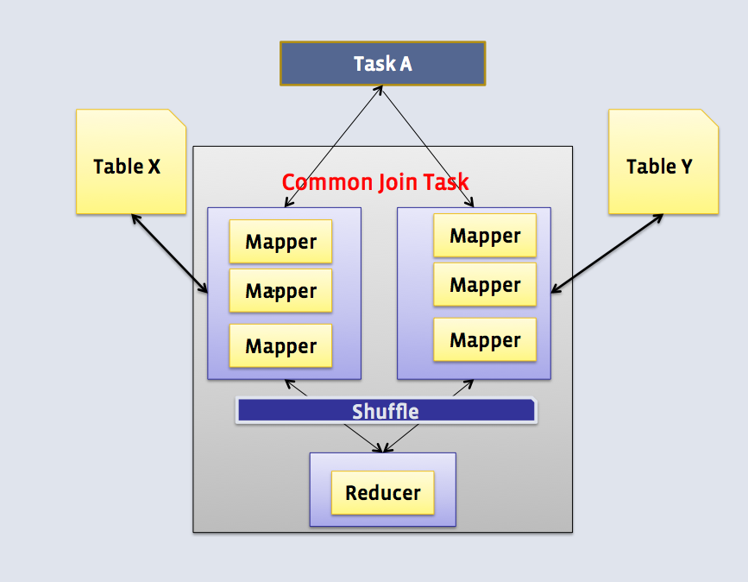

Use case:
It works for any table size.
Especially when other join types cannot be used, for example, full outer join.

Cons:
Most resource intensive since shuffle is an expensive operation.

Example:
hive> explain select a.* from passwords a, passwords2 b where a.col0=b.col1;
OK
STAGE DEPENDENCIES:
Stage-5 is a root stage , consists of Stage-1
Stage-1
Stage-0 is a root stage

STAGE PLANS:
Stage: Stage-5
Conditional Operator

Stage: Stage-1
Map Reduce
Map Operator Tree:
TableScan
alias: b
Statistics: Num rows: 9961472 Data size: 477102080 Basic stats: COMPLETE Column stats: NONE
Reduce Output Operator
key expressions: col1 (type: string)
sort order: +
Map-reduce partition columns: col1 (type: string)
Statistics: Num rows: 9961472 Data size: 477102080 Basic stats: COMPLETE Column stats: NONE
value expressions: col1 (type: string)
TableScan
alias: a
Statistics: Num rows: 9963904 Data size: 477218560 Basic stats: COMPLETE Column stats: NONE
Reduce Output Operator
key expressions: col0 (type: string)
sort order: +
Map-reduce partition columns: col0 (type: string)
Statistics: Num rows: 9963904 Data size: 477218560 Basic stats: COMPLETE Column stats: NONE
value expressions: col0 (type: string), col1 (type: string), col2 (type: string), col3 (type: string), col4 (type: string), col5 (type: string), col6 (type: string)
Reduce Operator Tree:
Join Operator
condition map:
Inner Join 0 to 1
condition expressions:
0 {VALUE._col0} {VALUE._col1} {VALUE._col2} {VALUE._col3} {VALUE._col4} {VALUE._col5} {VALUE._col6}
1 {VALUE._col1}
outputColumnNames: _col0, _col1, _col2, _col3, _col4, _col5, _col6, _col10
Statistics: Num rows: 10960295 Data size: 524940416 Basic stats: COMPLETE Column stats: NONE
Filter Operator
predicate: (_col0 = _col10) (type: boolean)
Statistics: Num rows: 5480147 Data size: 262470184 Basic stats: COMPLETE Column stats: NONE
Select Operator
expressions: _col0 (type: string), _col1 (type: string), _col2 (type: string), _col3 (type: string), _col4 (type: string), _col5 (type: string), _col6 (type: string)
outputColumnNames: _col0, _col1, _col2, _col3, _col4, _col5, _col6
Statistics: Num rows: 5480147 Data size: 262470184 Basic stats: COMPLETE Column stats: NONE
File Output Operator
compressed: false
Statistics: Num rows: 5480147 Data size: 262470184 Basic stats: COMPLETE Column stats: NONE
table:
input format: org.apache.hadoop.mapred.TextInputFormat
output format: org.apache.hadoop.hive.ql.io.HiveIgnoreKeyTextOutputFormat
serde: org.apache.hadoop.hive.serde2.lazy.LazySimpleSerDe

Stage: Stage-0
Fetch Operator
limit: -1

Time taken: 1.707 seconds, Fetched: 58 row(s)

Tips:
The largest table should be put on the rightmost since it should be the stream table.
However you can use hint "STREAMTABLE" to change the stream table in each map-reduce stage.
select /*+ STREAMTABLE(a) */ a.* from passwords a, passwords2 b, passwords3 c where a.col0=b.col0 and b.col0=c.col0;

2. Map Join(Broardcast Join)

How:
If one or more tables are small enough to fit in memory, the mapper scans the large table and do the joins. No shuffle and reduce stage.
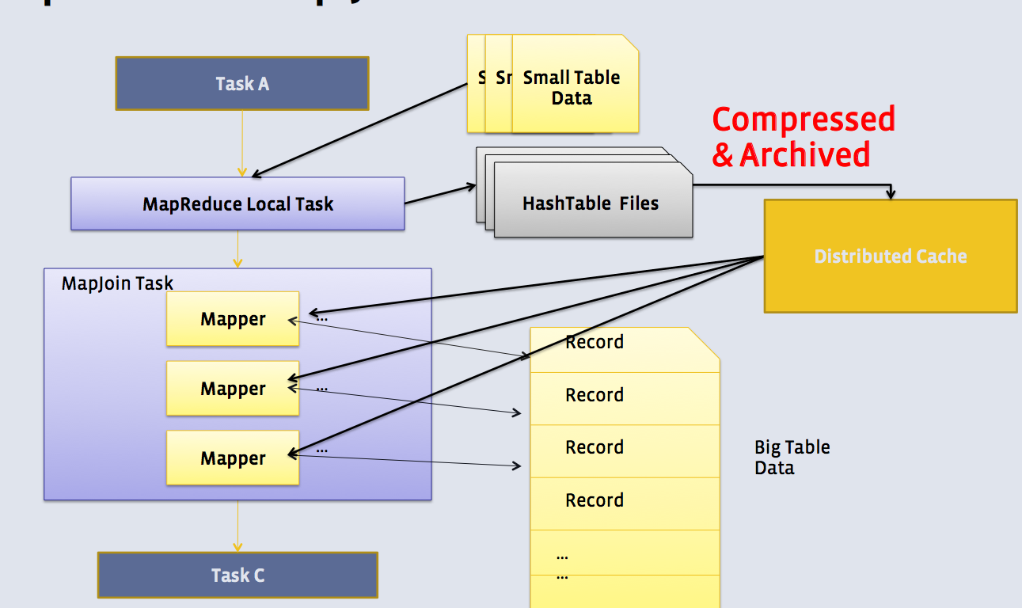

Use case:
Small table(dimension table) joins big table(fact table). It is very fast since it saves shuffle and reduce stage.

Cons:
It requires at least one table is small enough.
Right/Full outer join don't work.

Example:
Here passwords3 table is very small table while passwords table is huge.
hive> explain select a.* from passwords a,passwords3 b where a.col0=b.col0;
OK
STAGE DEPENDENCIES:
Stage-4 is a root stage
Stage-3 depends on stages: Stage-4
Stage-0 is a root stage

STAGE PLANS:
Stage: Stage-4
Map Reduce Local Work
Alias -> Map Local Tables:
b
Fetch Operator
limit: -1
Alias -> Map Local Operator Tree:
b
TableScan
alias: b
Statistics: Num rows: 1 Data size: 31 Basic stats: COMPLETE Column stats: NONE
HashTable Sink Operator
condition expressions:
0 {col0} {col1} {col2} {col3} {col4} {col5} {col6}
1 {col0}
keys:
0 col0 (type: string)
1 col0 (type: string)

Stage: Stage-3
Map Reduce
Map Operator Tree:
TableScan
alias: a
Statistics: Num rows: 9963904 Data size: 477218560 Basic stats: COMPLETE Column stats: NONE
Map Join Operator
condition map:
Inner Join 0 to 1
condition expressions:
0 {col0} {col1} {col2} {col3} {col4} {col5} {col6}
1 {col0}
keys:
0 col0 (type: string)
1 col0 (type: string)
outputColumnNames: _col0, _col1, _col2, _col3, _col4, _col5, _col6, _col9
Statistics: Num rows: 10960295 Data size: 524940416 Basic stats: COMPLETE Column stats: NONE
Filter Operator
predicate: (_col0 = _col9) (type: boolean)
Statistics: Num rows: 5480147 Data size: 262470184 Basic stats: COMPLETE Column stats: NONE
Select Operator
expressions: _col0 (type: string), _col1 (type: string), _col2 (type: string), _col3 (type: string), _col4 (type: string), _col5 (type: string), _col6 (type: string)
outputColumnNames: _col0, _col1, _col2, _col3, _col4, _col5, _col6
Statistics: Num rows: 5480147 Data size: 262470184 Basic stats: COMPLETE Column stats: NONE
File Output Operator
compressed: false
Statistics: Num rows: 5480147 Data size: 262470184 Basic stats: COMPLETE Column stats: NONE
table:
input format: org.apache.hadoop.mapred.TextInputFormat
output format: org.apache.hadoop.hive.ql.io.HiveIgnoreKeyTextOutputFormat
serde: org.apache.hadoop.hive.serde2.lazy.LazySimpleSerDe
Local Work:
Map Reduce Local Work

Stage: Stage-0
Fetch Operator
limit: -1

Time taken: 0.1 seconds, Fetched: 63 row(s)

Tips:
1. Auto convert shuffle/common join to map join.
3 parameters are related:
set hive.auto.convert.join=true;
set hive.auto.convert.join.noconditionaltask=true;
set hive.auto.convert.join.noconditionaltask.size=10000000;
Starting from Hive 0.11, hive.auto.convert.join=true by default.
You can disable this feature by setting hive.auto.convert.join=false.
When hive.auto.convert.join.noconditionaltask=true, if estimated size of small table(s) is smaller than hive.auto.convert.join.noconditionaltask.size(default 10MB), then common join can convert to map join automatically.
From above SQL plan output, we know estimated "Table b's Data Size=31" according to statistics.
If "set hive.auto.convert.join.noconditionaltask.size = 32;", the explain output shows map join operator:
Map Join Operator
If "set hive.auto.convert.join.noconditionaltask.size = 31;", then the join becomes common join operator:
Join Operator
2. Hint "MAPJOIN" can be used to force to use map join.
Before using the hint, firstly make sure below parameter is set to false(Default is true in Hive 0.13).
set hive.ignore.mapjoin.hint=false;
Then:
select /*+ MAPJOIN(a) */ a.* from passwords a, passwords2 b where a.col0=b.col0 ;

3. Bucket Map Join

How:
Join is done in Mapper only. The mapper processing bucket 1 for table A will only fetch bucket 1 of table B.
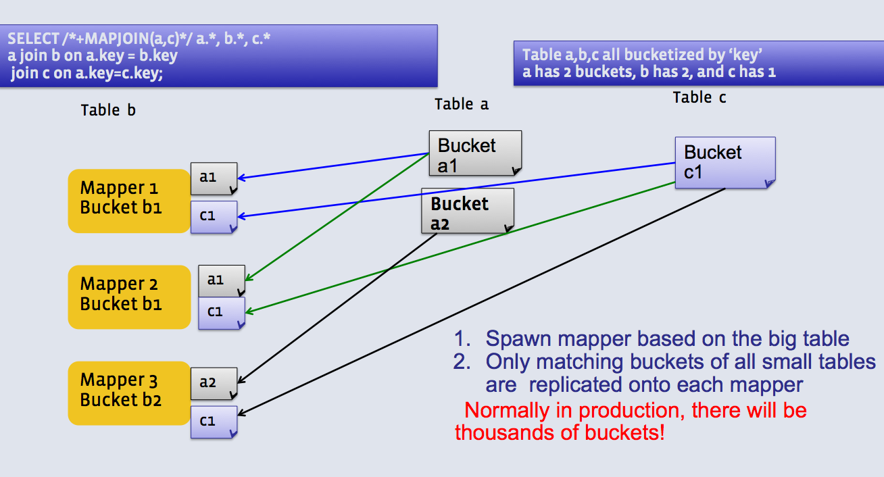

Use case:
When all tables are:
- Large.
- Bucketed using the join columns.
- The number of buckets in one table is a multiple of the number of buckets in the other table.
- Not sorted.

Cons:
Tables need to be bucketed in the same way how the SQL joins, so it cannot be used for other types of SQLs.

Tips:
1. The tables need to be created bucketed on the same join columns and also data need to be bucketed when inserting.
One way is to set "hive.enforce.bucketing=true" before inserting data.
For example:
create table b1(col0 string,col1 string,col2 string,col3 string,col4 string,col5 string,col6 string)
clustered by (col0) into 32 buckets;
create table b2(col0 string,col1 string,col2 string,col3 string,col4 string,col5 string,col6 string)
clustered by (col0) into 8 buckets;

set hive.enforce.bucketing = true;
From passwords insert OVERWRITE table b1 select * limit 10000;
From passwords insert OVERWRITE table b2 select * limit 10000;
2. hive.optimize.bucketmapjoin must to be set to true.
set hive.optimize.bucketmapjoin=true;
select /*+ MAPJOIN(b2) */ b1.* from b1,b2 where b1.col0=b2.col0 ;

4. Sort Merge Bucket(SMB) Map Join

How:
Join is done in Mapper only. The corresponding buckets are joined with each other at the mapper.
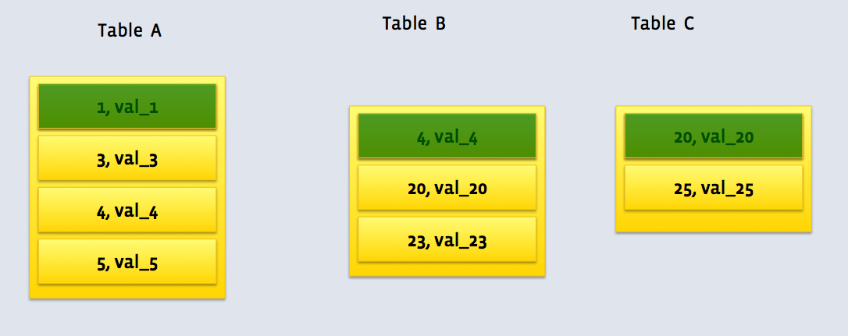

Use case:
When all tables are:
- Large.
- Bucketed using the join columns.
- Sorted using the join columns.
- All tables have the same number of buckets.

Cons:
Tables need to be bucketed in the same way how the SQL joins, so it cannot be used for other types of SQLs.
Partition tables might slow down.

Example:
hive> explain select c1.* from c1,c2 where c1.col0=c2.col0;
OK
STAGE DEPENDENCIES:
Stage-1 is a root stage
Stage-0 is a root stage

STAGE PLANS:
Stage: Stage-1
Map Reduce
Map Operator Tree:
TableScan
alias: c1
Statistics: Num rows: 9963904 Data size: 477218560 Basic stats: COMPLETE Column stats: NONE
Sorted Merge Bucket Map Join Operator
condition map:
Inner Join 0 to 1
condition expressions:
0 {col0} {col1} {col2} {col3} {col4} {col5} {col6}
1 {col0}
keys:
0 col0 (type: string)
1 col0 (type: string)
outputColumnNames: _col0, _col1, _col2, _col3, _col4, _col5, _col6, _col9
Filter Operator
predicate: (_col0 = _col9) (type: boolean)
Select Operator
expressions: _col0 (type: string), _col1 (type: string), _col2 (type: string), _col3 (type: string), _col4 (type: string), _col5 (type: string), _col6 (type: string)
outputColumnNames: _col0, _col1, _col2, _col3, _col4, _col5, _col6
File Output Operator
compressed: false
table:
input format: org.apache.hadoop.mapred.TextInputFormat
output format: org.apache.hadoop.hive.ql.io.HiveIgnoreKeyTextOutputFormat
serde: org.apache.hadoop.hive.serde2.lazy.LazySimpleSerDe

Stage: Stage-0
Fetch Operator
limit: -1

Time taken: 0.134 seconds, Fetched: 37 row(s)

Tips:
1. The tables need to be created bucketed and sorted on the same join columns and also data need to be bucketed when inserting.
One way is to set "hive.enforce.bucketing=true" before inserting data.
For example:
create table c1(col0 string,col1 string,col2 string,col3 string,col4 string,col5 string,col6 string)
clustered by (col0) sorted by (col0) into 32 buckets;
create table c2(col0 string,col1 string,col2 string,col3 string,col4 string,col5 string,col6 string)
clustered by (col0) sorted by (col0) into 32 buckets;
set hive.enforce.bucketing = true;
From passwords insert OVERWRITE table c1 select * order by col0;
From passwords insert OVERWRITE table c2 select * order by col0;
2. Below parameters need to set to convert SMB join to SMB map join.
set hive.auto.convert.sortmerge.join=true;
set hive.optimize.bucketmapjoin = true;
set hive.optimize.bucketmapjoin.sortedmerge = true;
set hive.auto.convert.sortmerge.join.noconditionaltask=true;
3. Big table selection policy parameter "hive.auto.convert.sortmerge.join.bigtable.selection.policy" determines which table is for only streaming.
It has 3 values:
org.apache.hadoop.hive.ql.optimizer.AvgPartitionSizeBasedBigTableSelectorForAutoSMJ (default)
org.apache.hadoop.hive.ql.optimizer.LeftmostBigTableSelectorForAutoSMJ
org.apache.hadoop.hive.ql.optimizer.TableSizeBasedBigTableSelectorForAutoSMJ
4. Hint "MAPJOIN" can determine which table is small and should be loaded into memory.
5. Small tables are read on demand which means not holding small tables in memory.
6. Outer join is supported.

5. Skew Join

How:
If table A join B, and A has skew data "1" in joining column.
First read B and store the rows with key 1 in an in-memory hash table. Now run a set of mappers to read A and do the following:
- If it has key 1, then use the hashed version of B to compute the result.
- For all other keys, send it to a reducer which does the join. This reducer will get rows of B also from a mapper.
This way, we end up reading only B twice. The skewed keys in A are only read and processed by the Mapper, and not sent to the reducer. The rest of the keys in A go through only a single Map/Reduce.
The assumption is that B has few rows with keys which are skewed in A. So these rows can be loaded into the memory.
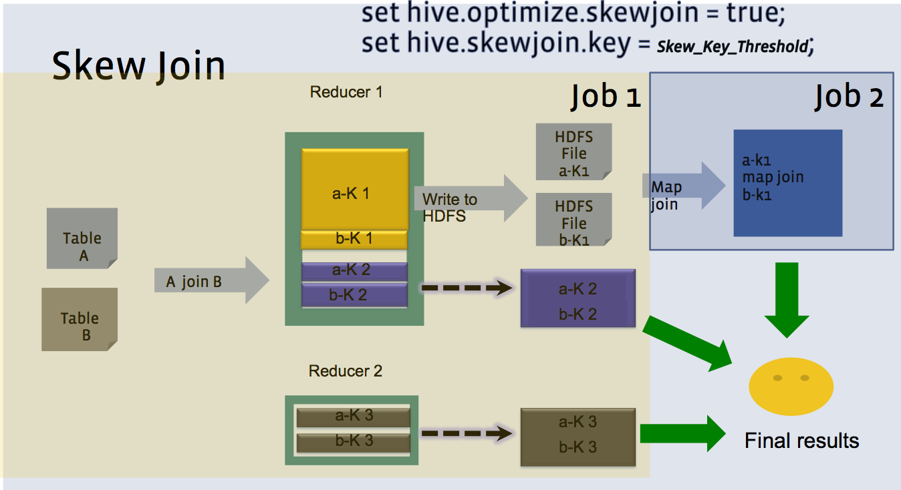

Use case:
One table has huge skew values on the joining column.

Cons:
One table is read twice.
Users should be aware of the skew key.

Example:
hive> explain select a.* from passwords a, passwords2 b where a.col0=b.col1;
OK
STAGE DEPENDENCIES:
Stage-7 is a root stage , consists of Stage-1
Stage-1
Stage-4 depends on stages: Stage-1 , consists of Stage-8
Stage-8
Stage-3 depends on stages: Stage-8
Stage-0 is a root stage

STAGE PLANS:
Stage: Stage-7
Conditional Operator

Stage: Stage-1
Map Reduce
Map Operator Tree:
TableScan
alias: b
Statistics: Num rows: 9961472 Data size: 477102080 Basic stats: COMPLETE Column stats: NONE
Reduce Output Operator
key expressions: col1 (type: string)
sort order: +
Map-reduce partition columns: col1 (type: string)
Statistics: Num rows: 9961472 Data size: 477102080 Basic stats: COMPLETE Column stats: NONE
value expressions: col1 (type: string)
TableScan
alias: a
Statistics: Num rows: 9963904 Data size: 477218560 Basic stats: COMPLETE Column stats: NONE
Reduce Output Operator
key expressions: col0 (type: string)
sort order: +
Map-reduce partition columns: col0 (type: string)
Statistics: Num rows: 9963904 Data size: 477218560 Basic stats: COMPLETE Column stats: NONE
value expressions: col0 (type: string), col1 (type: string), col2 (type: string), col3 (type: string), col4 (type: string), col5 (type: string), col6 (type: string)
Reduce Operator Tree:
Join Operator
condition map:
Inner Join 0 to 1
condition expressions:
0 {VALUE._col0} {VALUE._col1} {VALUE._col2} {VALUE._col3} {VALUE._col4} {VALUE._col5} {VALUE._col6}
1 {VALUE._col1}
handleSkewJoin: true
outputColumnNames: _col0, _col1, _col2, _col3, _col4, _col5, _col6, _col10
Statistics: Num rows: 10960295 Data size: 524940416 Basic stats: COMPLETE Column stats: NONE
Filter Operator
predicate: (_col0 = _col10) (type: boolean)
Statistics: Num rows: 5480147 Data size: 262470184 Basic stats: COMPLETE Column stats: NONE
Select Operator
expressions: _col0 (type: string), _col1 (type: string), _col2 (type: string), _col3 (type: string), _col4 (type: string), _col5 (type: string), _col6 (type: string)
outputColumnNames: _col0, _col1, _col2, _col3, _col4, _col5, _col6
Statistics: Num rows: 5480147 Data size: 262470184 Basic stats: COMPLETE Column stats: NONE
File Output Operator
compressed: false
Statistics: Num rows: 5480147 Data size: 262470184 Basic stats: COMPLETE Column stats: NONE
table:
input format: org.apache.hadoop.mapred.TextInputFormat
output format: org.apache.hadoop.hive.ql.io.HiveIgnoreKeyTextOutputFormat
serde: org.apache.hadoop.hive.serde2.lazy.LazySimpleSerDe

Stage: Stage-4
Conditional Operator

Stage: Stage-8
Map Reduce Local Work
Alias -> Map Local Tables:
1
Fetch Operator
limit: -1
Alias -> Map Local Operator Tree:
1
TableScan
HashTable Sink Operator
condition expressions:
0 {0_VALUE_0} {0_VALUE_1} {0_VALUE_2} {0_VALUE_3} {0_VALUE_4} {0_VALUE_5} {0_VALUE_6}
1 {1_VALUE_0}
keys:
0 joinkey0 (type: string)
1 joinkey0 (type: string)

Stage: Stage-3
Map Reduce
Map Operator Tree:
TableScan
Map Join Operator
condition map:
Inner Join 0 to 1
condition expressions:
0 {0_VALUE_0} {0_VALUE_1} {0_VALUE_2} {0_VALUE_3} {0_VALUE_4} {0_VALUE_5} {0_VALUE_6}
1 {1_VALUE_0}
keys:
0 joinkey0 (type: string)
1 joinkey0 (type: string)
outputColumnNames: _col0, _col1, _col2, _col3, _col4, _col5, _col6, _col10
Filter Operator
predicate: (_col0 = _col10) (type: boolean)
Select Operator
expressions: _col0 (type: string), _col1 (type: string), _col2 (type: string), _col3 (type: string), _col4 (type: string), _col5 (type: string), _col6 (type: string)
outputColumnNames: _col0, _col1, _col2, _col3, _col4, _col5, _col6
File Output Operator
compressed: false
table:
input format: org.apache.hadoop.mapred.TextInputFormat
output format: org.apache.hadoop.hive.ql.io.HiveIgnoreKeyTextOutputFormat
serde: org.apache.hadoop.hive.serde2.lazy.LazySimpleSerDe
Local Work:
Map Reduce Local Work

Stage: Stage-0
Fetch Operator
limit: -1

Time taken: 0.331 seconds, Fetched: 110 row(s)
As above shows, there are 2 join operators, one is common join and the other one is map join.
And it shows "handleSkewJoin: true".

Tips:
1. Below parameter needs to be set to enable skew join.
set hive.optimize.skewjoin=true;
2. Below parameter determine if we get a skew key in join.
If we see more than the specified number of rows with the same key in join operator, we think the key as a skew join key.
set hive.skewjoin.key=100000;

Hive Optimization

8.1 Display database name and column headers
After start Hive command line interface (CLI), type
• hive> set hive.cli.print.current.db=true;
• hive> set hive.cli.print.header=true;

8.2 Avoid NULLs in inner join (default join)
Assume we have two tables (impressions and creative) and we want to join them on id.

SELECT * FROM
FROM impression I JOIN creative C on (I.creativeid = C.id)

The joining procedure in Hive is demonstrated in the following picture

Records with the NULL key all end up at the same reducer. This will skew the load and break parallelism. Null keys will never be used in INNER JOIN, so it is pointless for them to get to the reducer. Reducing is slow. Try to avoid reducing phase if possible. We should adjust our query as

SELECT * FROM
FROM impression I JOIN creative C on (I.creativeid = C.id
AND I.creativeid IS NOT NULL
AND C.id IS NOT NULL)

8.3 Export a Hive table into a CSV file

insert overwrite local directory '/path/of/local/dir' row format delimited fields terminated by ',' select * from hugetable;

hive -e 'select CONCAT_WS(',',cola,colb,colc...,coln) from Mytable' > /home/user/Mycsv.csv

8.4 join query performance optimization
First of all large tables should be placed as last one in join order: SELECT small., large. FROM small JOIN large ON small.joinkey=large.joinkey; You can use a hint to tell optimazier which table is biggest:
SELECT/*+ STREAMTABLE(large) */ small.*, large.* FROM large
JOIN small ON small.joinkey=large.joinkey;
Second the small tables could be cached in memory on join by Map-side join:
set hive.auto.convert.join = true;
SELECT a.*, b.* FROM a
JOIN b ON a.joinkey=b.joinkey;
Size of map-join table is set by:
set hive.mapjoin.smalltable.filesize = 1000000;

8.5 Make use of map joins where possible
Set the hive.auto.convert.join property to true in hive-site.xml or your Hive CLI session, and Hive will use a conditional task to determine if it is possible to run a map join instead of a regular join.

8.6 Hadoop dfs commands inside Hive shell
Exclude hadoop keyword and end the command with semicolon(;) as below:
hive> dfs -ls / ;
(Note: This method of accessing hadoop commands is actually more efficient than using the hadoop dfs … equivalent at the bash shell, because the latter starts up a new JVM instance each time, whereas Hive just runs the same code in its current process.)

8.7 Hadoop and Hive configuration
hive> set –v ; -- Prints all Hadoop and Hive configuration variables.

8.8 Executes a script file inside the CLI.
hive> source /path/of/file ;
hive> source FILE <filepath>

8.9 SHOW Statement
The SHOW statement is a flexible way to get information about different types of hive objects.
show columns from part_bkp;
show create table part_bkp;
show table stats store_sales;
show column stats customer;

show partitions census;

show functions

DESCRIBE FUNCTION add_months

DESCRIBE FUNCTION EXTENDED add_months

Refrences :
http://www.dataiku.com/blog/2013/05/01/a-complete-guide-to-writing-hive-udf.html
http://blog.matthewrathbone.com/2013/08/10/guide-to-writing-hive-udfs.html
https://hortonworks.com/blog/5-ways-make-hive-queries-run-faster/

