Contents
1. Spark Job Submission 2
Dynamic Allocation 5
Configuration 6
Speculative Execution 8
How does one know a task was marked for re-scheduling due to speculation? 9
2. Degree of Parallelism: Partition Tuning (Avoid Small Partition Problems) 9
Spark Partition Tuning 12
3. Spark Memory: 13
Demonstration of the Problem 13
The Math Behind 16
Tuning Suggestions 18
4. Skew data 18
Spark History Server UI 18
Spark UI and understanding Skewness 18
Approaches : 19
5. File Formats 23
6. Best Practices 24
Degree of Parallelism 24
Determine the Spark configuration parameters 24
7. Questions 25
reduceByKey vs groupBykey vs aggregateByKey vs combineByKey 25
Spark Session vs Spark Context: 26
Small File problem 27
getmerge 27
Coalesce 27
Compacting Parquet files 28
Compacting ORC files 28
Spark Tips : 29
Spark Logs 29
Returning application id after spark-submit 29
Enabling Pyspark auto completion 29
Hive Permissions Bug 30

https://www.xenonstack.com/blog/ingestion-processing-big-data-iot-stream/

To check
https://www.waitingforcode.com/apache-spark/apache-spark-data-bigger-than-memory/read

Sprak
https://blog.usejournal.com/spark-study-notes-core-concepts-visualized-5256c44e4090

Spark Job Submission
https://blog.cloudera.com/blog/2015/03/how-to-tune-your-apache-spark-jobs-part-2/
https://spoddutur.github.io/spark-notes/distribution_of_executors_cores_and_memory_for_spark_application.html
It’s also important to think about how the resources requested by Spark will fit into what YARN has available. The relevant YARN properties are:
- yarn.nodemanager.resource.memory-mb controls the maximum sum of memory used by the containers on each node.
- yarn.nodemanager.resource.cpu-vcores controls the maximum sum of cores used by the containers on each node.
Asking for five executor cores will result in a request to YARN for five virtual cores. The memory requested from YARN is a little more complex for a couple reasons:
- --executor-memory/spark.executor.memory controls the executor heap size, but JVMs can also use some memory off heap, for example for interned Strings and direct byte buffers. The value of the spark.yarn.executor.memoryOverhead property is added to the executor memory to determine the full memory request to YARN for each executor. It defaults to max(384, .10 * spark.executor.memory).
- YARN may round the requested memory up a little. YARN’s yarn.scheduler.minimum-allocation-mb (default 1024 MB) and yarn.scheduler.increment-allocation-mb properties control the minimum and increment request values respectively.

Factors to be considered before job submission:
- Hadoop/Yarn/OS Deamons: When we run spark application using a cluster manager like Yarn, there’ll be several daemons that’ll run in the background like NameNode, Secondary NameNode, DataNode, JobTracker and TaskTracker. So, while specifying num-executors, we need to make sure that we leave aside enough cores (~1 core per node) for these daemons to run smoothly.
- Yarn ApplicationMaster (AM): ApplicationMaster is responsible for negotiating resources from the ResourceManager and working with the NodeManagers to execute and monitor the containers and their resource consumption. If we are running spark on yarn, then we need to budget in the resources that AM would need (~1024MB and 1 Executor).
- HDFS Throughput: HDFS client has trouble with tons of concurrent threads. It was observed that HDFS achieves full write throughput with ~5 tasks per executor. So, it’s good to keep the number of cores per executor below that number.
- MemoryOverhead: Following picture depicts spark-yarn-memory-usage.

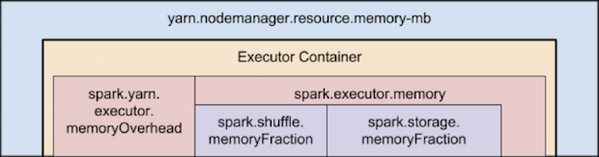

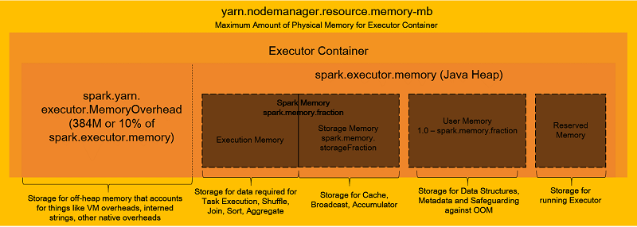
Two things to make note of from this picture:
Full memory requested to yarn per executor = spark-executor-memory + spark.yarn.executor.memoryOverhead

spark.yarn.executor.memoryOverhead = Max(384MB, 10% of spark.executor-memory)

Now Lets say we have a cluster configuration of :
**Cluster Config:**
10 Nodes
16 cores per Node
64GB RAM per Node

Then as per recommendations discussed above, the calculation would be:
- Based on the recommendations mentioned above, Let’s assign 5 core per executors => --executor-cores = 5 (for good HDFS throughput)
- Leave 1 core per node for Hadoop/Yarn daemons => Num cores available per node = 16-1 = 15
- So, Total available number of cores in cluster = 15 x 10 = 150
- Number of available executors = (total cores/num-cores-per-executor) = 150/5 = 30
- Leaving 1 executor for ApplicationManager => --num-executors = 29
- Number of executors per node = 30/10 = 3
- Total memory AVAILABLE per executor = 64GB/3 = 21GB
- Counting off heap overhead i.e Max(384MB, 10% of spark.executor-memory)=> 10% of 21GB = 2.1GB. Now the actual AVAILABLE memory is 21GB-2.1GB => 18.9.
- But, since the allocation is done by YARN whose default yarn.scheduler.minimum-allocation-mb=1024 . Which means the allocation will be in multiples of 1GB.
- Hence taking the lower end of calculation and leaving some room for the memory in node, actual --executor-memory = 21 - 3 = 18GB
So, recommended config is: 29 executors, 18GB memory each and 5 cores each!!

Note:
- Running executors with too much memory often results in excessive garbage collection delays. 64GB is a rough guess at a good upper limit for a single executor.
- Running tiny executors (with a single core and just enough memory needed to run a single task, for example) throws away the benefits that come from running multiple tasks in a single JVM. For example, broadcast variables need to be replicated once on each executor, so many small executors will result in many more copies of the data.
- The application master, which is a non-executor container with the special capability of requesting containers from YARN, takes up resources of its own that must be budgeted in. In yarn-client mode, it defaults to a 1024MB and one vcore. In yarn-cluster mode, the application master runs the driver, so it’s often useful to bolster its resources with the --driver-memory and --driver-cores properties.
https://www.waitingforcode.com/apache-spark/apache-spark-off-heap-memory/read

Dynamic Allocation
When a Spark application is submitted to a cluster, the cluster allocates the resources requested by the application for the entire duration of the application lifecycle. This paradigm is suitable for batch processing applications.
But for NON BATCH application job, the demand for high resources is only needed during peak time. During idle time, it is a waste of resources to allocate high capacity that is not used. Some example being :
- streaming application
- Notebook IDE such as Apache Zeppelin that allows interactive analytics using Spark over a cluster of nodes.
Static memory allocation also produces 2 situations: underuse and starvation of resources. The first one means that too many resources were reserved but only a small part of them is used. The second case means that one processing takes all available resources and prevents other applications to start.

The main idea of Spark Dynamic Allocation is : the Spark application will request minimal (or even no) resources during idle time, but when there are tasks to be performed, it will request more resources to complete those tasks. When the load is done, Spark will release those resources back to the cluster. In this way, we can utilize our cluster's resources in an efficient way. This feature is controlled by spark.dynamicAllocation.enabled configuration entry. And thanks to other parameters we can specify the initial/minimal/maximal number of executors (spark.dynamicAllocation.(initialExecutors|minExecutors|maxExecutors).

Configuration
Since a single Executor is the smallest unit an application can request and remove, it is wise to set a small amount of resources per executor.
Scaling Policy
Spark has some other configuration parameters helping to define scaling policy:
- scaling up : If some of these task remain in pending state for more than the time defined in spark.dynamicAllocation.schedulerBacklogTimeout, a request for adding more executors will be sent (of course, only if dynamic allocation is enabled). After sending the first request of this type, the subsequent requests are sent every spark.dynamicAllocation.sustainedSchedulerBacklogTimeout. By default, this value is the same as in the case of schedulerBacklogTimeout. The number of added executors in each round of requests grows exponentially (1, 2, 4, 8...).
- scaling down : the executors can also be given back to the cluster if the workload decreases. The parameter spark.dynamicAllocation.executorIdleTimeout defines the acceptable idle state for each executor. If there are executors remaining idle for more than this duration, they are removed. However, if the executor to remove stores some blocks in its cache, it won't be destroyed immediately but after the time specified in spark.dynamicAllocation.cachedExecutorIdleTimeout parameter (of course, only if it's still idle after this duration).

External shuffle service
The external shuffle service MUST also be activated (spark.shuffle.service.enabled configuration entry) along with dynamic resource allocation. Shuffle data is exposed outside of executor, in separate server, and thus can survive after the removal of given executor. In consequence, executors fetch shuffle data from the service and not from each other.
Check spark doc in the link to start the shuffle service on each NodeManager in YARN

Limit Resources
Each application can set the minimal and maximal resources the cluster should allocate to. This is done by setting the minimum and the maximum number of executors. The configuration keys to control those numbers are spark.dynamicAllocation.minExecutors (default value: zero) and spark.dynamicAllocation.maxExecutors (default value: infinity).

Resource Removal Policy
When no tasks are to be executed, the executor becomes idle. By default, 60 seconds of idle executor will be removed. This value can be controlled through the key spark.dynamicAllocation.executorIdleTimeout.

Caching
When an application caches a dataset or RDD in memory or disk, this cache memory is lost when the executor is removed. As a default policy, dynamic allocation will not remove Executors that cache data. I found it a bit harsh for my applications, as I needed the applications to cache the dataset for a limited amount of time. Luckily, it is possible to change that policy by setting the number of seconds an executor can be removed even if it cached data spark.dynamicAllocation.cachedExecutorIdleTimeout. In future versions of Spark, it is planned to manage caches in an external service, much in the same way shuffles management is done.
In summary following should be the spark submit option.
spark-submit --master yarn-cluster \
--driver-cores 2 \
--driver-memory 2G \
--num-executors 10 \
--executor-cores 5 \
--executor-memory 2G \
--conf spark.dynamicAllocation.enabled=true \
--conf spark.shuffle.service.enabled = true \
--conf spark.dynamicAllocation.minExecutors=5 \
--conf spark.dynamicAllocation.maxExecutors=30
--conf spark.dynamicAllocation.initialExecutors=10 \
--class com.spark.sql.jdbc.SparkDFtoOracle2 \
Spark-hive-sql-Dataframe-0.0.1-SNAPSHOT-jar-with-dependencies.jar

For more:
https://dzone.com/articles/spark-dynamic-allocation
https://www.waitingforcode.com/apache-spark/dynamic-resource-allocation-spark/read

Speculative Execution

Sparks Speculation engine is a tool able to detect slow running tasks and re-schedule their execution.

Key | Default Value | Description
spark.speculation | false | If set to “true”, performs speculative execution of tasks. This means if one or more tasks are running slowly in a stage, they will be re-launched.
spark.speculation.interval | 100ms | How often Spark will check for tasks to speculate.
spark.speculation.multiplier | 1.5 | task slowness is checked against the median time of execution of all launched tasks. This entry defines how many times slower a task must be to be considered for speculation. The default value is 1.5. It means that tasks running 1.5 times slower than the median will be considered for speculation.
spark.speculation.quantile | 0.75 | Percentage of tasks which must be complete before speculation is enabled for a stage.

You can add these flags to your spark-submit as follows:
spark-submit \
--conf "spark.speculation=true" \
--conf "spark.speculation.multiplier=5" \
--conf "spark.speculation.quantile=0.90" \
--class "org.asyncified.myClass" "path/to/testjar.jar"

For each stage in the current batch:
- Look if the amount of finished tasks in the stage are equal to or greater than speculation.quantile * numOfTasks, otherwise don’t speculate. (i.e. if a stage has 20 tasks and the quantile is 0.75, at least 15 tasks need finish for speculation to start).
- Scan all successfully executed tasks in the given stage and calculate a median of task execution time.
- Calculate the threshold that a task has to exceed in order to be eligible for re-launching. This is defined by speculation.multiplier * median.
- Iterate all the current running tasks in the stage. If there exists a task that’s running time is larger than threshold, re-launch the task.

How does one know a task was marked for re-scheduling due to speculation?

If a task was re-scheduled, it’s name will be decorated with “(speculated)”, and you’ll usually see a different locality for that given task.
When the speculative task finishes before the original one, the second task is killed and in Spark UI we can see its as annotated with killed intentionally. The opposite can also happen, i.e. the original task can finish before the speculative one. The behavior is the same - the speculative task is annotated with "(killed intentionally)".

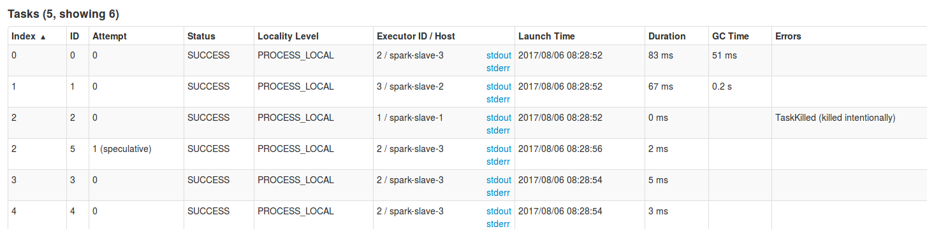

For more:
https://www.coursera.org/lecture/big-data-analysis/speculative-execution-mTnbZ
https://www.waitingforcode.com/apache-spark/speculative-execution-spark/read

Degree of Parallelism: Partition Tuning (Avoid Small Partition Problems)
The general principles to be followed when tuning partition for parallelism in Spark application is as follows:
- Too few partitions – Cannot utilize all cores available in the cluster.
- Too many partitions – Excessive overhead in managing many small tasks.
- Reasonable partitions – Helps us to utilize the cores available in the cluster and avoids excessive overhead in managing small tasks.
The two configuration properties in Spark to tune the number of partitions at run time are as follows:
Property | Default Value
spark.default.parallelism | 12
spark.sql.shuffle.partitions | 200
Note: spark.sql.shuffle.partitions property is not applicable for RDD API based implementation.
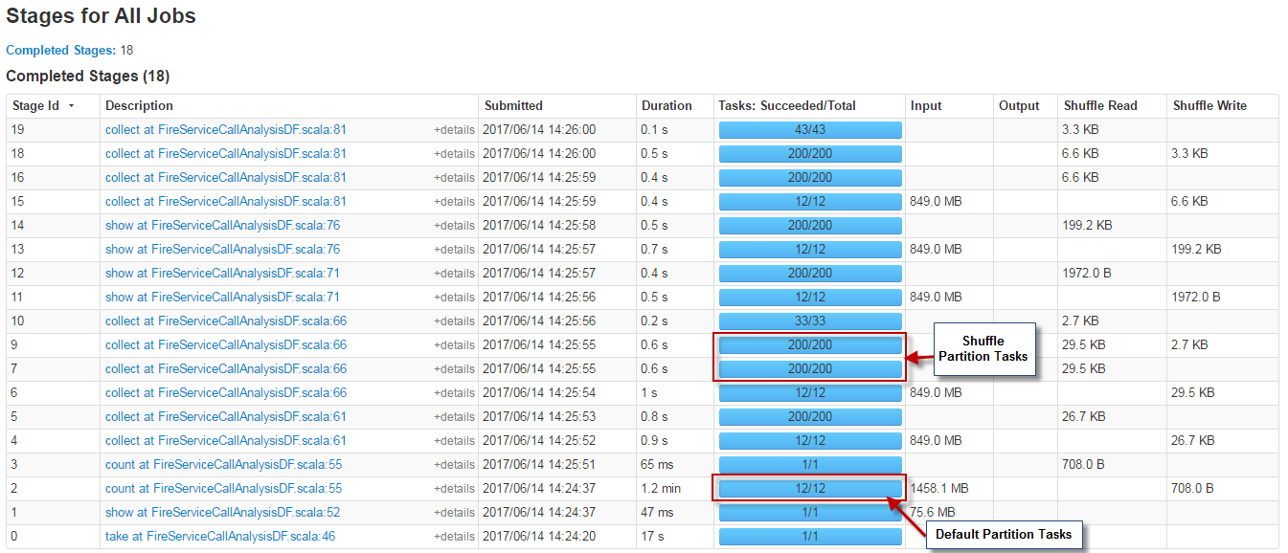
While collect() action uses shuffle hence parallelism is (200/200 tasks/partition) and count () action stage uses default parallelism (12 partitions).
If we click on “details” of count() stage then we will notice that input size/records ~ 128 MB (partition size)
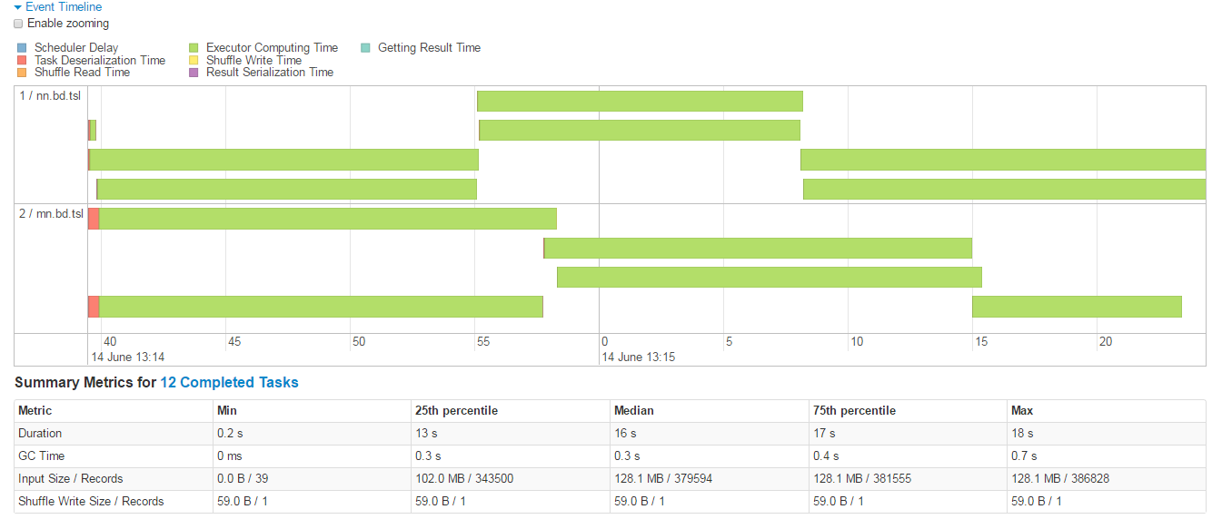

Similarly, to understand those 200 shuffled partition tasks, there are tasks with more scheduler delay and less computation time. It indicates 200 tasks are not necessary here and can be tuned to decrease the shuffle partition to reduce scheduler burden.

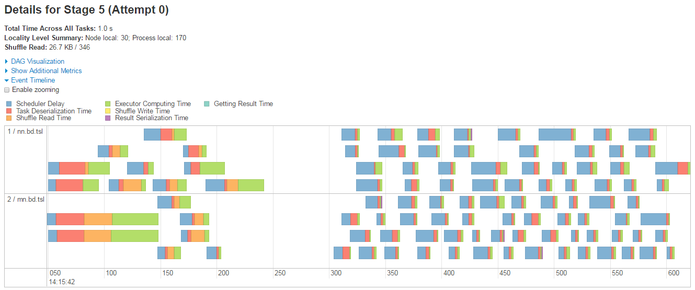

The Stages view in Spark UI indicates that most of the tasks are simply launched and terminated without any computation as shown in the below diagram:
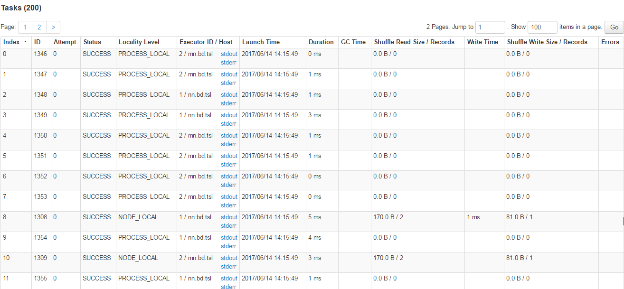

Spark Partition Tuning
The Thumb Rule to decide the partition size while working with HDFS is 128 MB. As our input dataset size is about 1.5 GB (1500 MB) and going with 128 MB per partition, the number of partitions will be:
Total input dataset size / partition size => 1500 / 128 = 11.71 = ~12 partitions
This is equal to the Spark default parallelism (spark.default.parallelism) value.
But we also notice that there are plenty of shuffle partitions which are not being utilized fully and unnecessarily creating scheduling delay.
So lets just consider partition size as 64 MB
Number of partitions = Total input dataset size / partition size => 1500 / 64 = 23.43 = ~23 partitions
And now we can apply various permutations to see what more suitable values for default and shuffle parameters will be.
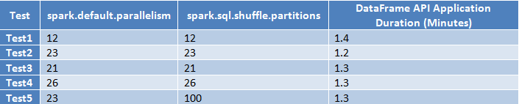
For more : http://www.treselle.com/blog/apache-spark-performance-tuning-degree-of-parallelism/

Spark Memory:
http://www.wdong.org/spark-on-yarn-where-have-all-the-memory-gone.html

Efficient processing of big data, especially with Spark, is really all about how much memory one can afford, or how efficient use one can make of the limited amount of available memory. Efficient memory utilization, however, is not what one can take for granted with default configuration shipped with Spark and Yarn. Rather, it takes very careful provisioning and tuning to get as much as possible from the bare metal. In this post I’ll demonstrate a case when not-so-careful configuration of Spark on Yarn leads to poor memory utilization for caching, explain the math that leads to all the observed numbers, and give some tips on parameter tuning to address the problem.
A little bit background first. I’m not working with one of those big names, and do not have thousands of machines at my disposal. My group has less than ten for data crunching. Months of experimental usage of Spark in a standalone configuration showed very promising results, and we want to use those few machines for both production and development. That is, we want to be able to run two instances of Spark apps in parallel. Since we already have Hadoop, Spark on Yarn seems to be a natural choice. It is not difficult at all to setup Spark on Yarn, but I quickly found that I was not able to fire up the second instance of Spark because I was, as seen by Yarn, out of memory. I’ll use the following simplified one-machine setup to demonstrate the problem I’ve seen.

Demonstration of the Problem
This demo was run on a desktop with 64g memory. I used the following setting:
yarn.nodemanager.resource.memory-mb = 49152 # 48G
yarn.scheduler.maximum-allocation-mb = 24576 # 24G
SPARK_EXECUTOR_INSTANCES=1
SPARK_EXECUTOR_MEMORY=18G
SPARK_DRIVER_MEMORY=4G
The Yarn parameters went into yarn-site.xml, and the Spark ones in spark-env.sh. I didn’t set any other memory-related parameters.
So the total memory allocated to Yarn was 48G, with 24G maximum for one app. Spark should use 18+4 = 22G memory, which is below the 24G cap. So I should be able to run two Spark apps in parallel.
Following are the numbers I got from all the logs and Web UIs when I actually fired up one Spark app.
- (Yarn) Memory Total: 48G
- (Yarn) Memory Used: 25G
- (Yarn) Container 1, TotalMemoryNeeded: 5120M
- (Yarn) Container 2, TotalMemoryNeeded: 20480M
- (Spark) Driver memory requirement: 4480 MB memory including 384 MB overhead (From output of Spark-Shell)
- (Spark) Driver available memory to App: 2.1G
- (Spark) Executor available memory to App: 9.3G
Below are the relevant screen shots.
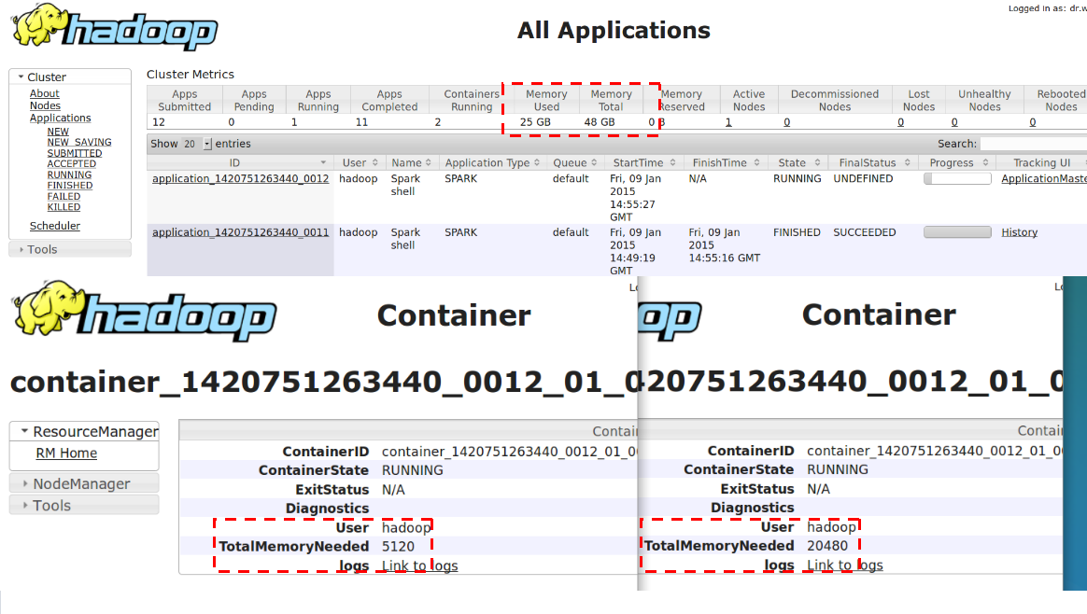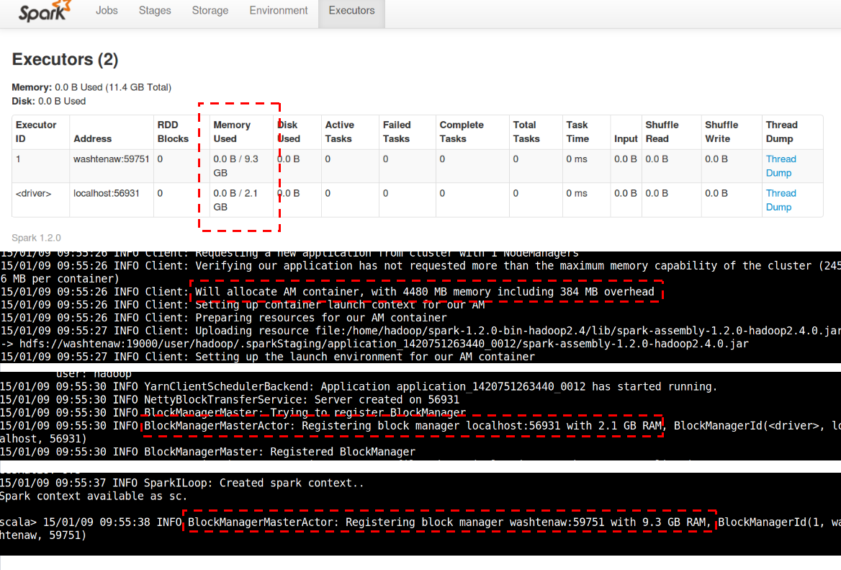
So here are the problems that I see with the driver:
I’ve configured Spark driver to use 4G, and Spark asked Yarn for 4G plus an overhead of 384MB. What reflected in Yarn is that the driver has used 5G. What’s really available in the driver’s block manager is only 2.1G. One has to understand that Spark has to reserve a portion of memory for code execution and cannot give everything to the block manager (the cache), but still,
WHERE HAVE ALL THE MEMORY GONE???

The Math Behind
Rule 1. Yarn always rounds up memory requirement to multiples of yarn.scheduler.minimum-allocation-mb, which by default is 1024 or 1GB. That’s why the driver’s requirement of 4G+384M showed up as 5G in Yarn. The parameter yarn.scheduler.minimum-allocation-mb is really “minimum-allocation-unit-mb”. This can be easily verified by setting the parameter to a prime number, such as 97, and see Yarn allocate by multiples of the number.
Rule 2. Spark adds an overhead to SPARK_EXECUTOR_MEMORY/SPARK_DRIVER_MEMORY before asking Yarn for the amount. The rule of overhead is the same for both executor and driver, which is
//yarn/common/src/main/scala/org/apache/spark/deploy/yarn/YarnSparkHadoopUtil.scala
val MEMORY_OVERHEAD_FACTOR = 0.07
val MEMORY_OVERHEAD_MIN = 384

//yarn/common/src/main/scala/org/apache/spark/deploy/yarn/YarnAllocator.scala
protected val memoryOverhead: Int = sparkConf.getInt("spark.yarn.executor.memoryOverhead",
math.max((MEMORY_OVERHEAD_FACTOR * executorMemory).toInt, MEMORY_OVERHEAD_MIN))
......
val totalExecutorMemory = executorMemory + memoryOverhead
numPendingAllocate.addAndGet(missing)
logInfo(s"Will allocate $missing executor containers, each with $totalExecutorMemory MB " +
s"memory including $memoryOverhead MB overhead")
This overhead is necessary because when a JVM program is allowed certain amount of memory (by -Xmx), the overall memory usage of JVM could be more than that, and Yarn literally kills programs which uses more memory than allowed (with complicated rules). One can only adjust the two magic numbers by modifying the source.
The above two rules determine how the configured SPARK_XXX_MEMORY finally show up in Yarn.
Rule 3. How much memory does driver/executor see.
One limits the maximal heap memory of JVM by the option “-Xmx”. Part of the specified memory get used by the Scala runtime and other system component, and what a Scala program sees is less then the specified amount. This can be illustrated with the following example.
$ scala -J-Xmx4g
Welcome to Scala version 2.10.3 (OpenJDK 64-Bit Server VM, Java 1.7.0_51).
Type in expressions to have them evaluated.
Type :help for more information.

scala> Runtime.getRuntime.maxMemory
res0: Long = 3817865216
scala>
The runtime eats about 455M. (The above process has an RSS of 140.3M in Linux, so a big portion of the 455M is more like being reserved than actually being used.)
The Spark driver is allocated the configured 4G by JVM options. This can be verified by running the following from inside the Spark shell.
scala>

scala> import java.lang.management.ManagementFactory
import java.lang.management.ManagementFactory

scala> ManagementFactory.getRuntimeMXBean.getInputArguments
res0: java.util.List[String] = [-XX:MaxPermSize=128m, -Djava.library.path=/home/hadoop/hadoop-2.4.1/lib/native, -Xms4G, -Xmx4G]

scala> Runtime.getRuntime.maxMemory
res1: Long = 4116709376

scala>
Rule 4. How Spark determines maximal usable memory
//core/src/main/scala/org/apache/spark/storage/BlockManager.scala
/** Return the total amount of storage memory available. */
private def getMaxMemory(conf: SparkConf): Long = {
val memoryFraction = conf.getDouble("spark.storage.memoryFraction", 0.6)
val safetyFraction = conf.getDouble("spark.storage.safetyFraction", 0.9)
(Runtime.getRuntime.maxMemory * memoryFraction * safetyFraction).toLong
}
We have 4116709376 * 0.6 * 0.9 = 2.07G. That is where the 2.1G value comes from. The maximal available memory of executor is derived in the same way.
Overall, the following two formulas guide memory allocation:
What’s seen by Yarn: (SPECIFIED_MEMORY + OVERHEAD) round up to multiples of minimum-allocation-mb , with OVERHEAD = max(SPECIFIED_MEMORY * 0.07, 384M) What’s usable for cache: (SPECIFIED_MEMORY – MEMORY_USED_BY_RUNTIME) * spark.storage.memoryFraction * spark.storage.safetyFraction

Tuning Suggestions
We see that the root of memory under utilization is the over-provisioning done in almost each step. Even if a process really reaches the configured memory cap, it’s unlikely it will keep using that amount of memory all the time. Because Yarn actually kills a process when it exceeds the memory cap, we have to keep SPARK_XXX_MEMORY big enough. It is also very difficult to determine the actual amount of memory gets used by Spark code execution, so dealing with spark.storage.memoryFraction is tricky. But if one is sure that it’s unlikely for the overall memory consumption of parallel Spark apps to exceed the physical memory, the easiest way to improve memory utilization is to counter the over-provisioning with overcommitment. That is, to set the Yarn parameter yarn.nodemanager.resource.memory-mb to MORE THAN THE AVAILABLE PHYSICAL MEMORY (luckily Yarn does not check that). It also helps a little bit to set yarn.scheduler.minimum-allocation-mb to a small value like 100M, so an app does not get much more that what it asks for.

Skew data

Spark History Server UI

For more : http://www.treselle.com/blog/text-normalization-with-spark-part-2/

Spark UI and understanding Skewness

https://dzone.com/articles/apache-spark-performance-tuning-straggler-tasks

http://www.treselle.com/blog/text-normalization-with-spark-part-2/
http://www.treselle.com/blog/apache-spark-performance-tuning-straggler-tasks/

Approaches :

- Broadcast Join :
Copy the smaller of the 2 datasets in all nodes of the spark cluster using Broadcast Join, Spark now will not need to shuffle the data across the network and can refer to the local copy of the file.
from pyspark.sql.functions import broadcast
result = broadcast(A).join(B,["join_col"],"left")

If we are doing a join operation on a skewed dataset increase the “spark.sql.autoBroadcastJoinThreshold” value so that smaller tables get broadcasted.
- Repartition :
Repartitioning (never coalesce) can help with Skew data by
- Changing partitioner/Custom partition.
- Adjusting number of partitions to minimize possible impact of data
Calling df.repartition(COL, numPartitions=k) will create a dataframe with k partitions using a hash-based partitioner. COL here defines the partitioning key--it can be a single column or a list of columns. The hash-based partitioner takes each input row's partition key, hashes it into a space of k partitions via something like partition = hash(partitionKey) % k. This guarantees that all rows with the same partition key end up in the same partition. However, rows from multiple partition keys can also end up in the same partition (when a hash collision between the partition keys occurs) and some partitions might be empty.
Another way to look at data skew and partitionby clause :
// All keys are unique - no obvious data skew
val rdd = sc.parallelize(Seq(0, 3, 6, 9, 12)).map((_, None))

// Drastic data skew
rdd.partitionBy(new org.apache.spark.HashPartitioner(3)).glom.map(_.size).collect
// Array[Int] = Array(5, 0, 0)
When you run df.write.partitionBy('day'), how many output files should you expect? The answer is 'it depends'. If each partition of your starting partitions in df contains data from each day, then the answer is 70. If each of your starting partitions in df contains data from exactly one day, then the answer is 10.
Note : For more about partitions https://medium.com/parrot-prediction/partitioning-in-apache-spark-8134ad840b0
- Data Preprocess :
If there are too many null values in a join or group-by key they would skew the operation. Try to preprocess the null values with some random ids and handle them in the application.
- Modify Query:
Break your query/dataset into 2 parts - one containing only skew and the other containing non-skewed data. The query will become -
1. select A.id from A join B on A.id = B.id where A.id <> 1;
2. select A.id from A join B on A.id = B.id where A.id = 1 and B.id = 1;
The first query will not have any skew, so all the tasks will finish at roughly the same time.

- Salting:
In a SQL join operation, the join key is changed to redistribute data in an even manner so that processing for a partition does not take more time. This technique is called salting.
Steps:
- Add a column in the larger table (A), say skewLeft and populate it with random numbers between 0 to N-1 for all the rows.
- Add a column in the smaller table (B), say skewRight. Replicate the smaller table N times. So values in new skewRight column will vary from 0 to N-1 for each copy of original data. For this, you can use the explode sql/dataset operator.
After 1 and 2, join the 2 datasets/tables with updated join condition.
The idea is if the join condition is satisfied by key1 == key1, it should also get satisfied by key1_<salt> = key1_<salt>. The value of salt will help the dataset to be more evenly distributed. Also note that Spark can only partition on equality join conditions hence the above approach.

https://unraveldata.com/common-failures-slowdowns-part-ii/
TODO : Implement in SQL example.
https://coxautomotivedatasolutions.github.io/datadriven/spark/data%20skew/joins/data_skew/

For Hive →
https://medium.com/hotels-com-technology/skew-join-optimization-in-hive-b66a1f4cc6ba

https://unraveldata.com/common-failures-slowdowns-part-ii/
https://coxautomotivedatasolutions.github.io/datadriven/spark/data%20skew/joins/data_skew/
https://bigdatacraziness.wordpress.com/2018/01/05/oh-my-god-is-my-data-skewed/
https://medium.com/simpl-under-the-hood/spark-protip-joining-on-skewed-dataframes-7bfa610be704
https://datarus.wordpress.com/2015/05/04/fighting-the-skew-in-spark/

https://unraveldata.com/common-reasons-spark-applications-slow-fail-part-1/
https://medium.com/expedia-engineering/operationalizing-spark-streaming-part-1-ecc544120479

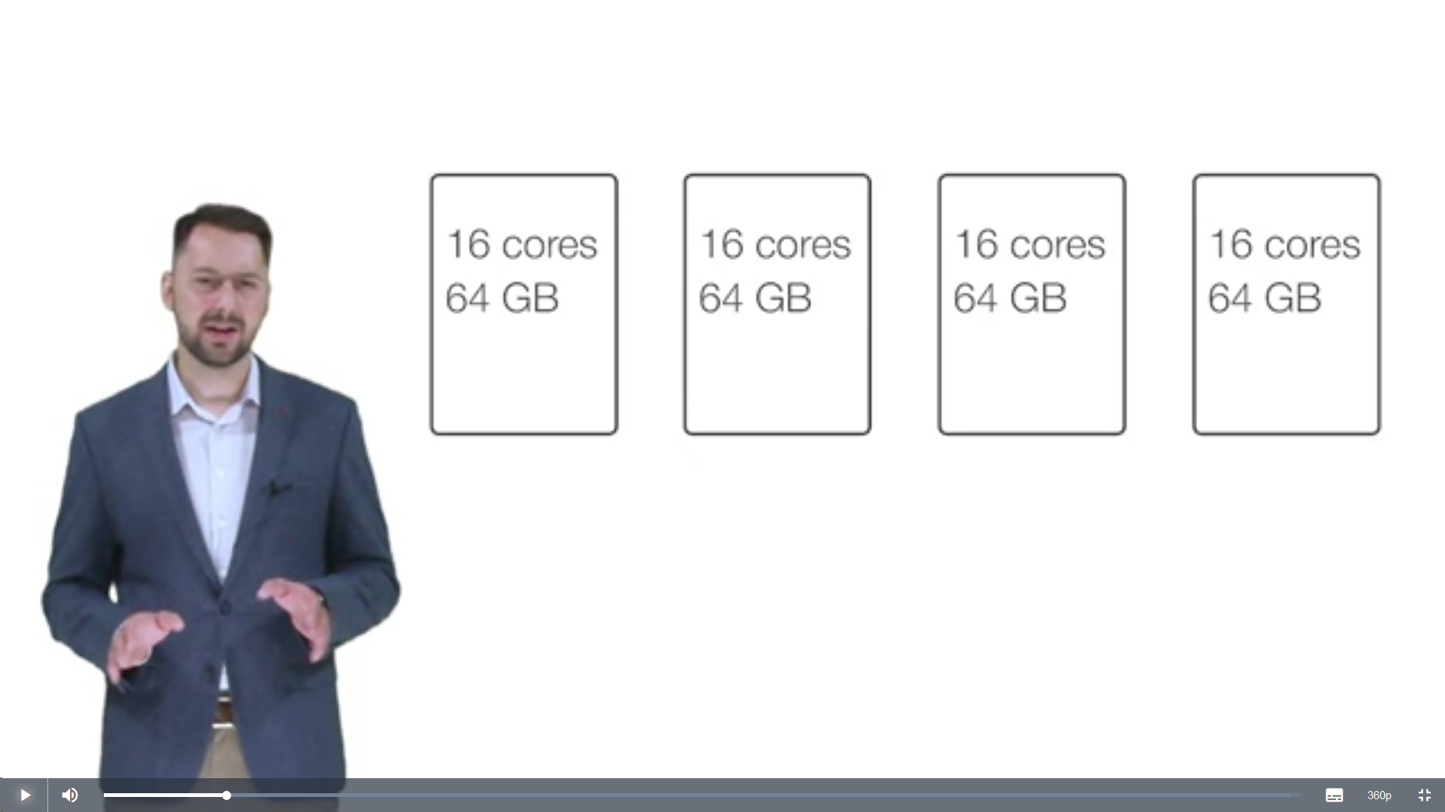

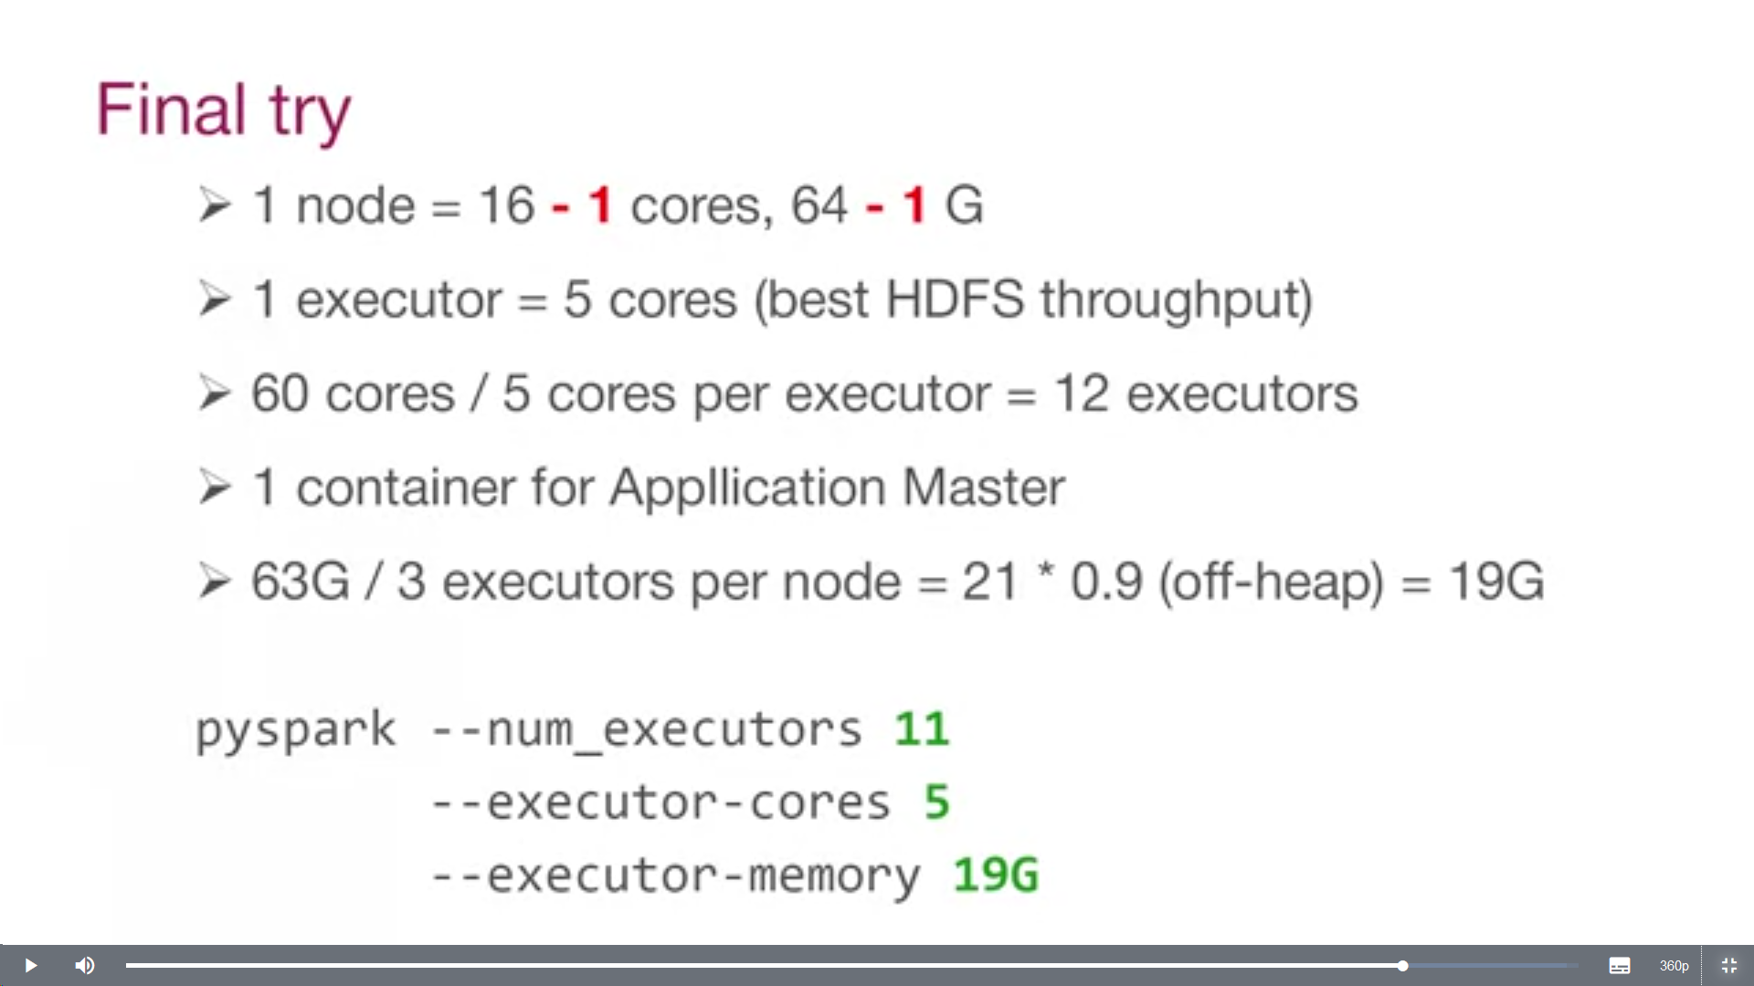

https://spoddutur.github.io/spark-notes/distribution_of_executors_cores_and_memory_for_spark_application.html

https://www.linkedin.com/pulse/resource-allocation-spark-jobs-amol-kale
https://medium.com/@omidvd/how-to-work-with-maximize-resource-allocation-and-spark-dynamic-allocation-aws-emr-spark-68a18a7c1f33
https://www.coursera.org/learn/big-data-analysis
https://www.coursera.org/lecture/big-data-analysis/speculative-execution-mTnbZ
https://www.coursera.org/lecture/big-data-analysis/pagerank-optimization-gGbZo

File Formats

File Format | Action | Procedure | Remarks
Text File | Read | sc.textFile('ages.csv')  spark.read.text('sql/text-test.txt')
Text File | Write | codec = "org.apache.hadoop.io.compress.GzipCodec"  rdd.saveAsTextFile(tempFile3.name, codec)  OR  spark.df.write.mode(“overwrite”).text(“path”)
CSV File | Read | spark.read.csv('python/ages.csv')
CSV File | Write | dfWrite.coalesce(numPartitions).write.mode("overwrite").format("csv").option("compression",compression).option("header",true).option("delimiter",",").option("quote","'").save(path)
JSON File | Read | spark.read.json("people.json")  spark.read.format('json').load('people.json')
JSON File | Write | dfWrite.coalesce(numPartitions).write.partitionBy(partition).mode("overwrite").format("json").option("compression", compression).save("path")
SEQUENCE FILE | Read
SEQUENCE FILE | Write
PARQUET FILE | Read | spark.read.parquet("...")
PARQUET FILE | Write | dfWrite.coalesce(numPartitions).write.partitionBy(partition).mode("overwrite").format("parquet").option("compression", compression).save("path")
ORC FILE | Read | spark.read.orc('sql/orc_partitioned')
ORC FILE | Write | dfWrite.coalesce(numPartitions).write.partitionBy(partition).mode("overwrite").format("orc").option("compression", compression).save("path")
AVRO FILE | Read | spark.read.format("avro").load("/tmp/episodes.avro")
AVRO FILE | Write | import com.databricks.spark.avro._;
Hive Table | Read | spark.read.table('tmpTable')  spark.sql('SELECT * from tmpTable’)
Hive Table | Write | dataFrame.write.mode(SaveMode.Append).partitionBy("entity","date").format("orc").saveAsTable("baseTable")
JDBC | Read | spark.read.format("jdbc").option("url", "jdbd://").option("driver","org.mysql").option("dbtable", "table").option("user", "root").option("password", "cloudera").load()
JDBC | Write | dfWrite.coalesce(numPartitions).write.partitionBy(partition).mode("overwrite").format("jdbc").option("url","jdbdc:://" ).option("driver", "org.mysql.").option("user", "root").option("password", "password").option("dbtable", "table").save()

https://spark.apache.org/docs/latest/sql-data-sources.html

Best Practices

Degree of Parallelism

http://www.treselle.com/blog/apache-spark-performance-tuning-degree-of-parallelism/

Determine the Spark configuration parameters
Calculate and set the following Spark configuration parameters carefully for the Spark application to run successfully:
- spark.executor.memory – Size of memory to use for each executor that runs the task.
- spark.executor.cores – Number of virtual cores.
- spark.driver.memory – Size of memory to use for the driver.
- spark.driver.cores – Number of virtual cores to use for the driver.
- spark.executor.instances – Number of executors. Set this parameter unless spark.dynamicAllocation.enabled is set to true.
- spark.default.parallelism – Default number of partitions in resilient distributed datasets (RDDs) returned by transformations like join, reduceByKey, and parallelize when no partition number is set by the user.

https://aws.amazon.com/blogs/big-data/best-practices-for-successfully-managing-memory-for-apache-spark-applications-on-amazon-emr/

https://spark.apache.org/docs/latest/sql-performance-tuning.html

Questions

reduceByKey vs groupBykey vs aggregateByKey vs combineByKey

Let's look at two different ways to compute word counts, one using reduceByKey and the other using groupByKey:
val words = Array("one", "two", "two", "three", "three", "three")
val wordPairsRDD = sc.parallelize(words).map(word => (word, 1))

val wordCountsWithReduce = wordPairsRDD
.reduceByKey(_ + _)
.collect()

val wordCountsWithGroup = wordPairsRDD
.groupByKey()
.map(t => (t._1, t._2.sum))
.collect()
While both of these functions will produce the correct answer, the reduceByKey example works much better on a large dataset. That's because Spark knows it can combine output with a common key on each partition before shuffling the data.
Look at the diagram below to understand what happens with reduceByKey. Notice how pairs on the same machine with the same key are combined (by using the lamdba function passed into reduceByKey) before the data is shuffled. Then the lamdba function is called again to reduce all the values from each partition to produce one final result.

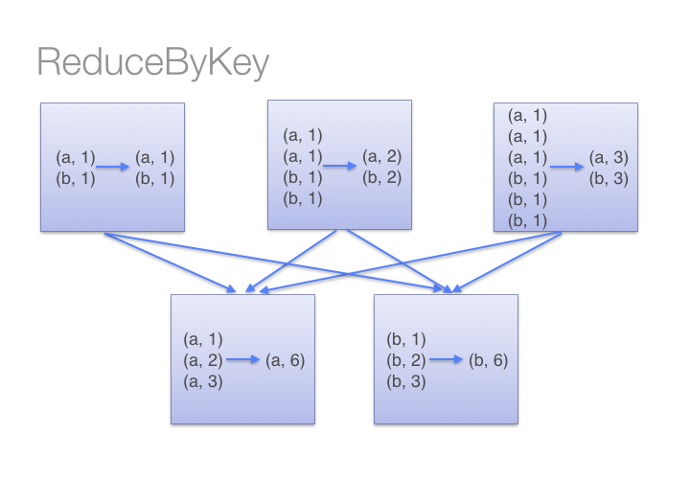
On the other hand, when calling groupByKey - all the key-value pairs are shuffled around. This is a lot of unnessary data to being transferred over the network.
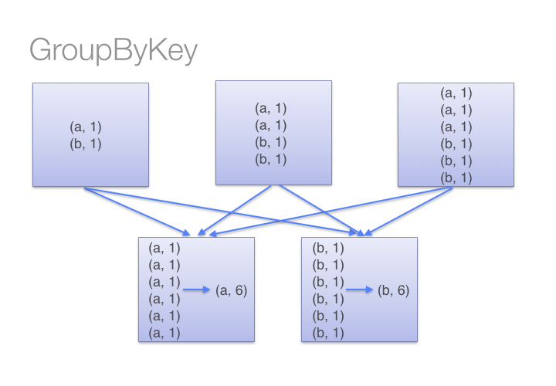
To determine which machine to shuffle a pair to, Spark calls a partitioning function on the key of the pair. Spark spills data to disk when there is more data shuffled onto a single executor machine than can fit in memory. However, it flushes out the data to disk one key at a time - so if a single key has more key-value pairs than can fit in memory, an out of memory exception occurs. This will be more gracefully handled in a later release of Spark so the job can still proceed but should still be avoided - when Spark needs to spill to disk, performance is severely impacted.
You can imagine that for a much larger dataset size, the difference in the amount of data you are shuffling becomes more exaggerated and different between reduceByKey and groupByKey.
Here are more functions to prefer over groupByKey:
- combineByKey can be used when you are combining elements but your return type differs from your input value type.
- foldByKey merges the values for each key using an associative function and a neutral "zero value".

Spark Session vs Spark Context:
SparkSession gives a straight forward API to create a new session which shares the same spark context. spark.newSession() creates a new spark session object. If we look closely at the hash of different spark sessions, created using newSession() method, they both are different. In contrast, the underneath spark context is the same.
Note: we can have multiple spark contexts by setting spark.driver.allowMultipleContexts to true . But having multiple spark contexts in the same jvm is not encouraged and is not considered as a good practice as it makes it more unstable and crashing of 1 spark context can affect the other.
https://medium.com/@achilleus/spark-session-10d0d66d1d24

Small File problem

When writing DataFrame to Parquet even in “Append Mode”, Spark Streaming does NOT append to already existing parquet files – it simply adds new small parquet files to the same output directory

getmerge
Usage: hadoop fs -getmerge [-nl] <src> <localdst>
Takes a source directory and a destination file as input and concatenates files in src into the destination local file. Optionally -nl can be set to enable adding a newline character (LF) at the end of each file. -skip-empty-file can be used to avoid unwanted newline characters in case of empty files.
Examples:
- hadoop fs -getmerge -nl /src /opt/output.txt
- hadoop fs -getmerge -nl /src/file1.txt /src/file2.txt /output.txt
Exit Code:
Returns 0 on success and non-zero on error.

Coalesce
First, the easiest in a spark-shell:
scala> val ac = SomeAggregateCountRDD(sc).cache

/* Spark log output elided */

scala> ac.coalesce(1).saveAsTextFile("s3n://analytics/counts")
Using that solution you still end up with a "directory" in your S3 bucket named analytics/counts/ with a _SUCCESS and part-00000 file, but the part-00000 file contains all of the results.

Compacting Parquet files
The command concatenates the parquet blocks in binary without serialization/deserialization, merges footers and modifies the path and the offset metadata.
To run the parquet-tools merge command in HDFS:
hadoop jar parquet-tools-1.9.0.jar merge <input> <output>
where, input is the source parquet files or directory and output is the destination parquet file merging the original content. This merge command does not remove or overwrite the original files. So, it requires a manual exercise of creating a temporary directory and replacing the original small files by the compacted ones

Compacting ORC files
Using Hive Data Definition Language (Hive DDL), users can request an efficient merge of small ORC files into larger ones by issuing a concatenate action on their table or partition. The command looks like:
ALTER TABLE table_name [PARTITION (partition_key = 'partition_value')] CONCATENATE;
Hive will merge the ORC files at stripe level avoiding the overhead of compressing/decompressing and coding/decoding the data.

Spark Tuning :
http://blog.cloudera.com/blog/2015/03/how-to-tune-your-apache-spark-jobs-part-1/
http://blog.cloudera.com/blog/2015/03/how-to-tune-your-apache-spark-jobs-part-2/
https://www.coursera.org/lecture/big-data-analysis/resource-allocation-eCA3W

Spark on Hadoop
Part 1:
https://www.altiscale.com/blog/spark-on-hadoop/
Part 2:
https://www.altiscale.com/blog/tips-and-tricks-for-running-spark-on-hadoop-part-2-2/
Part 3:
https://www.altiscale.com/blog/tips-and-tricks-for-running-spark-on-hadoop-part-3-rdd-persistence/
Part 4:
https://www.altiscale.com/blog/tips-and-tricks-for-running-spark-on-hadoop-part-4-memory-settings/

Submit Job :
https://stackoverflow.com/questions/34900023/read-files-sent-with-spark-submit-by-the-driver

Spark Tips :

Spark Logs
yarn logs -applicationId <application ID> <options>

yarn queue [options]

Returning application id after spark-submit
applicationId=`./bin/spark-submit <options> 2>&1 | tee /dev/tty | grep -i "Application report for" | grep -o application_.*[0-9]`

echo $applicationId
application_1650248755754_0023

Enabling Pyspark auto completion

import rlcompleter, readline
readline.parse_and_bind('tab: complete')

To make sure this setting is persistent every time when pyspark is launched. Below was done.

Step1: Add below to ~/.pythonrc

import rlcompleter, readline
readline.parse_and_bind('tab: complete')

Step2: Add below to ~/.bash_profile
export PYTHONSTARTUP="$HOME/.pythonrc"

Hive Permissions Bug
1. Execute the following command in cmd started using the option Run as administrator
cmd> winutils.exe chmod -R 777 C:\tmp\hive
2. Check the permissions
cmd> winutils.exe ls -F C:\tmp\hive

