AWS Kinesis
AWS Kinesis is a managed alternative to Kafka. It is four components each serving a specific need of streaming.

Kinesis Video Streams

Kinesis Data Streams
Kinesis data streams is highly customizable and best suited for developers building custom applications or streaming data for specialized needs.
- Going to write custom code
- Real time (200ms latency for classic, 70ms latency for enhanced fan-out)
- You must manage scaling (shard splitting/merging)
- Data storage for 1 to 7 days, replay capability, multi consumers
- Use with Lambda to insert data in real-time to ElasticSearch
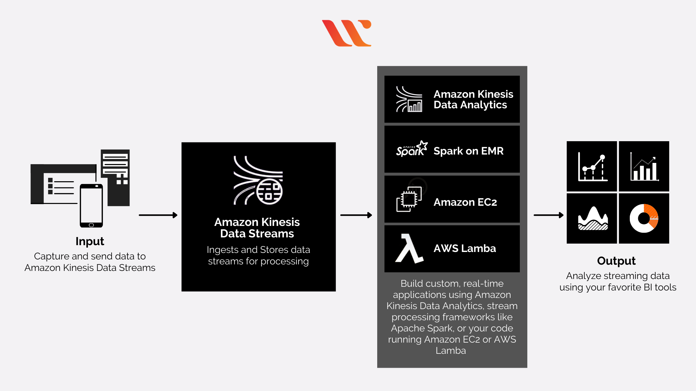

A record in Kinesis stream contains following part

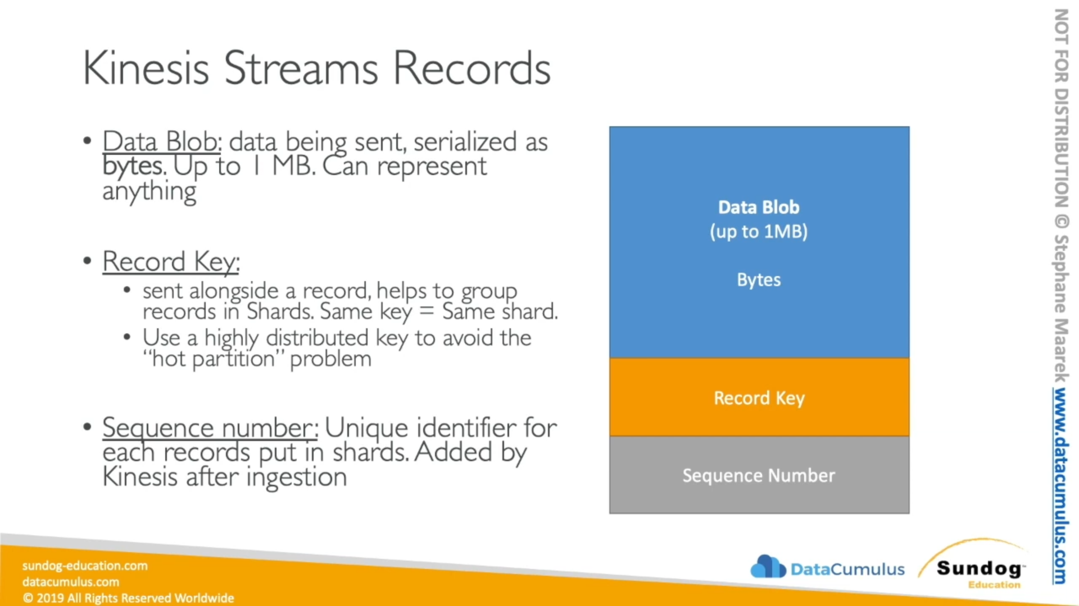

Kinesis Data Firehose
Firehose handles loading data streams directly into AWS products for processing.
- Fully managed, send to S3, Splunk, Redshift, ElasticSearch
- Serverless data transformations with Lambda
- Near real time (lowest buffer time is 1 minute)
- Automated Scaling
- No data storage

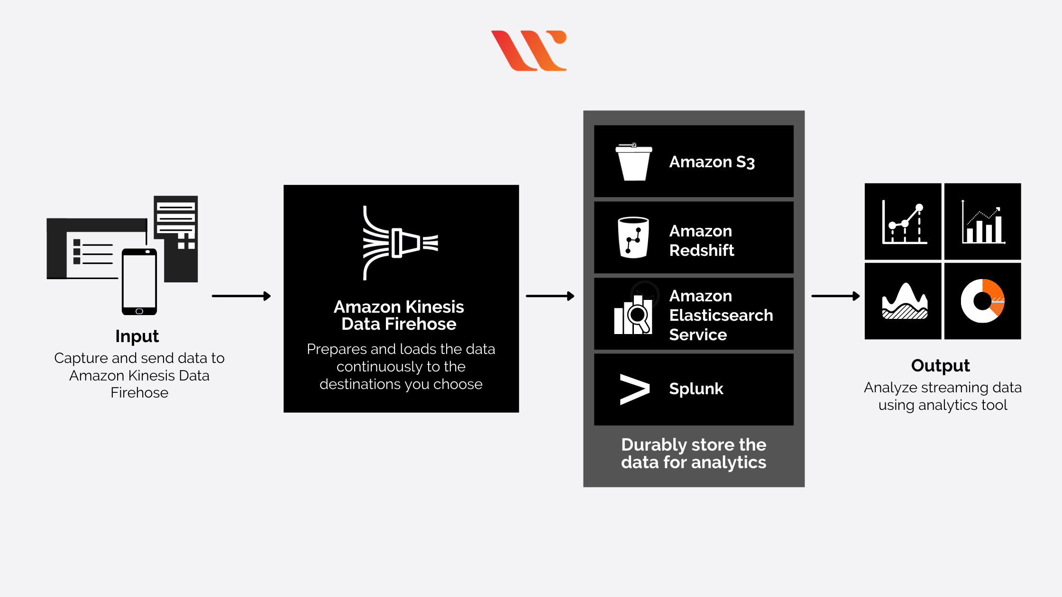
https://www.whizlabs.com/blog/aws-kinesis-data-streams-vs-aws-kinesis-data-firehose/
https://www.youtube.com/watch?v=Jw5Pqwn1doE

Kinesis Data Analytics
sfd

